# vim网络ip配置

vim /etc/sysconfig/network-script/ifcfg-ens32

修改onboot yes

# 刷新网络配置

systemctl restart sshd

# 安装并开启ssh

sudo yum install sshd

service sshd start

# 查看IP地址,连接winscp

ipaddr

# 安装gcc与vim

yum -y install gcc gcc-c++ autoconf pcre pcre-devel automake

gcc --version

# 安装mysql

tar -xxf

依次安装

mysql-community-common-5.7.29-1.el7.x86_64.rpm  
mysql-community-libs-5.7.29-1.el7.x86_64.rpm  
mysql-community-client-5.7.29-1.el7.x86_64.rpm

解决第四个server包的安装依赖

1.确认镜像光盘已连接

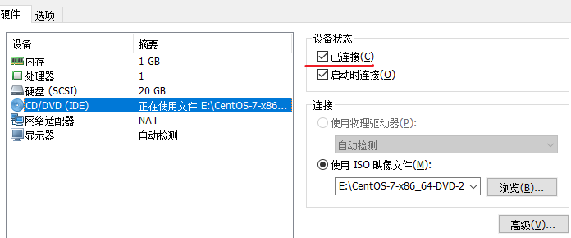

2.进行光盘的挂载

mount /dev/cdrom /media/

3.rpm安装net-tools

rpm -ivh net-tools-2.0-0.25.20131004git.el7.x86_64.rpm

4.安装mysql server包

mysql-community-server-5.7.29-1.el7.x86_64.rpm

## 关闭并设置开机不启动防火墙

systemctl stop firewalld

systemctl disable firewalld

## 获取mysql的root用户的初始密码

grep 'password' /var/log/mysqld.log

4444444

mysql -u root -p

## 修改初始密码

密码初始等级中等,不允许过于简单的密码

alter user 'root'@'localhost' identified by '2020root$PWD';

设置密码等级low

set global validate_password_policy=LOW;

设置最小密码位数6

set global validate_password_length=6;

设置简易密码

ALTER USER 'root'@'localhost' IDENTIFIED BY '159753';

使密码立即生效

flush privileges;

## 允许root远程登录mysql

GRANT ALL PRIVILEGES ON *.* TO 'root'@'%' IDENTIFIED BY '159753' WITH GRANT OPTION;

修改mysql的字符集为utf8

vi /etc/my.cnf

关闭大小写敏感

lower_case_table_names=1

添加字符配置

character-set-server=utf8

collation-server=utf8_general_ci

[client]

default-character-set=utf8

## 重启mysql服务

service mysqld restart

# 安装docker

配置镜像加速

vim /etc/docker/daemon.json

{

"registry-mirrors":["http://f1361db2.m.daocloud.io"]

}