MNIST database

The MNIST database (Modified National Institute of Standards and Technology database) is a large database of handwritten digits that is commonly used for training various image processing systems. The database is also widely used for training and testing in the field of machine learning. It was created by "re-mixing" the samples from NIST's original datasets. Furthermore, the black and white images from NIST were normalized to fit into a 28x28 pixel bounding box and anti-aliased, which introduced grayscale levels.

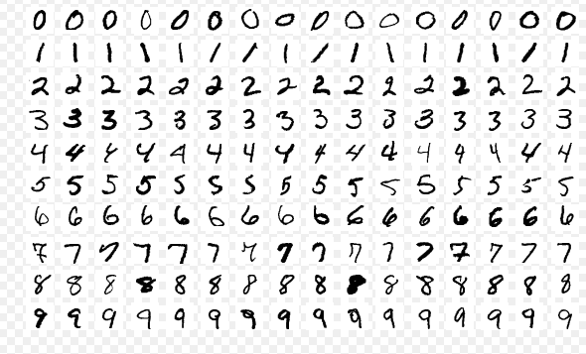

samples from MNIST

The MNIST database contains 60,000 training images and 10,000 testing images. Half of the training set and half of the test set were taken from NIST's training dataset, while the other half of the training set and the other half of the test set were taken from NIST's testing dataset. There have been a number of scientific papers on attempts to achieve the lowest error rate; one paper, using a hierarchical system of convolutional neural networks, manages to get an error rate on the MNIST database of 0.23 percent. The original creators of the database keep a list of some of the methods tested on it. In their original paper, they use a support vector machine to get an error rate of 0.8 percent.

The data format of MNIST database is handwritten digit. Each individual digit is an array with 784 (28x28) values. Each value represents the color for one pixel. If we reshape a training sample to 28x28 and plot it, we can see the original digit, and we could also see the label of this digit. The label format is the one-hot encoding style. This means that the label corresponds to the index of the array where the value is 1.

