- 目录规范见下图：
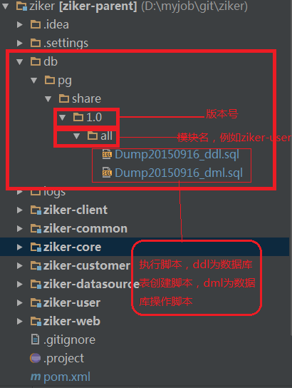
- 在总目录ziker下的pom.xml添加如下配置，
<build>
<finalName>ziker</finalName>
<plugins>
<!-- sql plugins -->
<plugin>
<groupId>org.codehaus.mojo</groupId>
<artifactId>sql-maven-plugin</artifactId>
<dependencies>
<dependency>
<groupId>postgresql</groupId>
<artifactId>postgresql</artifactId>
<version>9.3-1103.jdbc3</version>
</dependency>
</dependencies>
<executions>
<!-- 删除同名库 -->
<execution>
<id>drop-db-before-test-if-any</id>
<phase>process-test-resources</phase>
<goals>
<goal>execute</goal>
</goals>
<configuration>
<!-- need another database to drop the targeted one -->
<driver>org.postgresql.Driver</driver>
<url>jdbc:postgresql://127.0.0.1:5432/postgres</url>
<username>postgres</username>
<password>postgres</password>
<autocommit>true</autocommit>
<sqlCommand>drop database test2</sqlCommand>
<!-- ignore error when database is not avaiable -->
<onError>continue</onError>
</configuration>
</execution>
<!-- 创建数据库 -->
<execution>
<id>create-db</id>
<phase>process-test-resources</phase>
<goals>
<goal>execute</goal>
</goals>
<configuration>
<driver>org.postgresql.Driver</driver>
<url>jdbc:postgresql://127.0.0.1:5432/postgres</url>
<username>postgres</username>
<password>postgres</password>
<autocommit>true</autocommit>
<sqlCommand>create database test2</sqlCommand>
</configuration>
</execution>
<!-- 创建表 schema -->
<execution>
<id>create-schema</id>
<phase>process-test-resources</phase>
<goals>
<goal>execute</goal>
</goals>
<configuration>
<autocommit>true</autocommit>
<driver>org.postgresql.Driver</driver>
<url>jdbc:postgresql://127.0.0.1:5432/test2</url>
<username>postgres</username>
<password>postgres</password>
<orderFile>ascending</orderFile>
<fileset>
<basedir>${basedir}</basedir>
<includes>
<include>db/pg/share/1.0/all/Dump20150916_ddl.sql</include>
</includes>
</fileset>
<!-- <srcFiles>
<srcFile>../db/pg/share/1.0/Dump20150916_dll.sql</srcFile>
</srcFiles> -->
</configuration>
</execution>
<!-- 创建数据 -->
<execution>
<id>create-data</id>
<phase>process-test-resources</phase>
<goals>
<goal>execute</goal>
</goals>
<configuration>
<autocommit>true</autocommit>
<driver>org.postgresql.Driver</driver>
<url>jdbc:postgresql://127.0.0.1:5432/test2</url>
<username>postgres</username>
<password>postgres</password>
<orderFile>ascending</orderFile>
<fileset>
<basedir>${basedir}</basedir>
<includes>
<include>db/pg/share/1.0/all/Dump20150916_data.sql</include>
</includes>
</fileset>
<!-- <srcFiles>
<srcFile>../db/pg/share/1.0/Dump20150916_dll.sql</srcFile>
</srcFiles> -->
</configuration>
</execution>
<!-- drop db after test -->
<!-- <execution>
<id>drop-db-after-test</id>
<phase>test</phase>
<goals>
<goal>execute</goal>
</goals>
<configuration>
<autocommit>true</autocommit>
<sqlCommand>drop database test2</sqlCommand>
</configuration>
</execution> -->
</executions>
</plugin>
</plugins>
<pluginManagement>
<plugins>
<!-- compiler插件, 设定JDK版本 -->
<plugin>
<groupId>org.apache.maven.plugins</groupId>
<artifactId>maven-compiler-plugin</artifactId>
<version>2.3.2</version>
<configuration>
<source>1.7</source>
<target>1.7</target>
<showWarnings>true</showWarnings>
</configuration>
</plugin>
<!-- tomcat 插件 -->
<plugin>
<groupId>org.apache.tomcat.maven</groupId>
<artifactId>tomcat7-maven-plugin</artifactId>
<version>2.1</version>
<configuration>
<port>9090</port>
<path>/ziker</path>
<uriEncoding>UTF-8</uriEncoding>
<finalName>ziker</finalName>
<server>tomcat7</server>
</configuration>
</plugin>
<!-- jetty插件 -->
<plugin>
<groupId>org.mortbay.jetty</groupId>
<artifactId>maven-jetty-plugin</artifactId>
<version>${jetty.version}</version>
</plugin>
</plugins>
</pluginManagement>
</build>
- 由于项目中用到了PostgreSQL，所以需要添加驱动程序包，可以添加如下配置：
<dependency>
<groupId>postgresql</groupId>
<artifactId>postgresql</artifactId>
<version>9.3-1103.jdbc3</version>
</dependency>

