
计算机工程学院课程设计报告

设计名称： java数据库课程设计
姓 名： 张禛鑫 学 号： 2013122721
专业班级： 计算机131
系 （院）： 计算机工程学院
设计时间： 2015.6.23~2015.7.3
设计地点： 计算机楼206

指导教师评语：

成绩：

签名：
年 月 日

1．课程设计目的
1．通过课程设计，使学生进一步巩固所学的知识，考察学生对数据库理论及知识的理解能力和综合运用能力；
2．培养学生自主学习的能力、独立思考的能力，学会查找资料并善于分析资料的能力；
3．培养学生独立设计、独立调式程序的能力；
4．培养学生初步的软件设计能力、形成良好的编程风格

2．课程设计任务与要求：
2.1．设计任务
任务：
认真学习老师所教内容，正确运用常用的包、工具类和算法，熟练进行对象类的定义和使用，综合运用图形界面元素构造应用程序界面， 对于JDBC技术能有较全面准确的把握并会综合运用解决实际问题。
题目：达内在线测试系统
[ 问题描述 ]
设计一个应用程序，用来进行在线测试，可以完成简单的登录、考试、退出等基本操作。
[ 基本要求 ]
- 用户登陆界面中会有错误提示信息；
- 主界面有四个按钮，用户可进行选择；
- 考试结束后，系统会返回考试成绩。
要求：
1、从分析题目的需求入手，设计适当的结构，按设计抽象类、构思方法、通过设计实现编制上机程序和上机调试等若干步骤完成题目，最终写出完整的分析报告。前期准备工作完备与否直接影响到后序上机调试工作的效率。在程序设计阶段应尽量利用已有的标准函数，加大代码的重用率。
2、为每个类设计正确的成员变量和方法，为每个方法设计合理的方法体。同时，为类及内部的成员变量和方法运用正确的修饰符，如访问控制符等。
3、编程简练，程序功能齐全，能正确运行。
4、课题完成后必须按要求提交课程设计报告，格式规范，内容详实。

3.需求分析
该程序是用来进行在线测试，实现登录、考试、退出等基本功能。
功能需求：
该程序是基于MyEclipse平台下使用Java语言开发的一款在线测评系统。数据库使用MySQL、采用的技术主要是JDBC技术。用户登陆界面中会有错误提示信息，用户登录成功后进入主菜单界面，在主界面有开始考试、查询成绩、考试注意事项、离开四个按钮，用户可进行选择。考试结束后，系统会返回考试成绩。
平台开发需求：
编程环境：MyEclipse 编程语言：Java 数据库：MySQL
数据需求：
需要建立一个数据库，有两个表分别为user,question。这个现在txt文件中，然后改成“.sql”文件，将其内容导入即可。
性能需求：
界面友好，交互性强，响应及时。
类需求：
包含基本的实体类和测试类，用封装好的类方便用户测试。
能力需求：
有一定的java语言编写功能，老师教了关于窗口、面板、布局和数据库等连接方面的知识，并带我们做了月下雪花飘的动图，和小球运动的程序。

4.概要设计
整体的流程图：
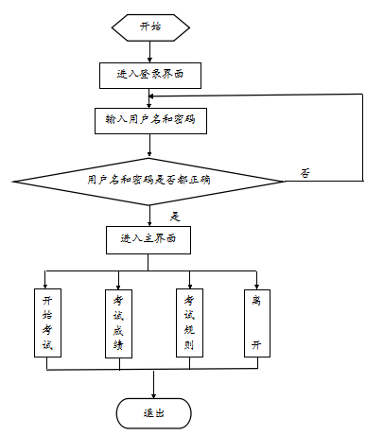
系统定义的接口：
public interface UserDao {
public abstract List<User> getAllUser();
public abstract User getUserByNameAndPassword(String name,String password);
public abstract void addUser(User user);
public abstract User getUserById(int id);
public void updateUser(User user);
}
public interface QuestionDao {
public abstract List<Question> getAllQuestions();
public abstract Question getQuestionById(int qid);
public abstract void addQuestion(Question question);
public abstract void deleteQuestionById(int qid);
public abstract void updateQuestion(Question question);
public abstract int getCount();
}

5.详细设计
- 建立数据库连接和关闭连接
public class JDBC {
public static Connection getConnection() {
Connection conn = null;
try {
Class.forName("com.mysql.jdbc.Driver");
conn = DriverManager.getConnection("jdbc:mysql://localhost:3306/hg_1?user=root&password=");
} catch (ClassNotFoundException e) {
e.printStackTrace();
} catch (SQLException e) {
e.printStackTrace();
}
return conn;

}
public static void release(Connection conn,ResultSet rs,Statement stmt) {
if(conn!=null) {
try {
conn.close();
} catch (SQLException e) {
e.printStackTrace();
}
}
if(rs!=null) {
try {
rs.close();
} catch (SQLException e) {
e.printStackTrace();
}
}
if(stmt!=null) {
try {
stmt.close();
} catch (SQLException e) {
e.printStackTrace();
}
}
}

}

- 查询数据库数据
public class test {
public static void main(String[] args) {
jdbc(0002, "Jerry", "f", 0002);
jdbc();
}
public static void jdbc() {
Connection conn = JDBC.getConnection();
String sql = "select * from emp";
Statement stmt = null;
ResultSet rs = null;
try {
stmt = conn.createStatement();
rs = stmt.executeQuery(sql);
while(rs.next()) {
System.out.println(rs.getInt(1));
System.out.println(rs.getString(2));
System.out.println(rs.getString(3));
System.out.println(rs.getInt(4));
}
} catch (SQLException e) {
e.printStackTrace();
} finally {
JDBC.release(conn, rs, stmt);
}
}
public static void jdbc(int id,String name,String gender,int deptno) {
Connection conn = JDBC.getConnection();
String sql = "insert into emp values ("+id+",'"+name+"','"+gender+"',"+deptno+")";
Statement stmt = null;
ResultSet rs = null;
try {
stmt = conn.createStatement();
int i = stmt.executeUpdate(sql);
if(i !=0 ){
System.out.println("插入成功！");
}
} catch (SQLException e) {
e.printStackTrace();
} finally {
JDBC.release(conn, rs, stmt);
}
}
}

6．程序代码
package com.zzx.dao;
import java.util.List;
import com.zzx.entity.Question;
public interface QuestionDao {
public abstract List<Question> getAllQuestions();
public abstract Question getQuestionById(int qid);
public abstract void addQuestion(Question question);
public abstract void deleteQuestionById(int qid);
public abstract void updateQuestion(Question question);
public abstract int getCount();
}
package com.zzx.dao;
import java.util.List;
import com.zzx.entity.User;
public interface UserDao {
public abstract List<User> getAllUser();
public abstract User getUserByNameAndPassword(String name,String password);
public abstract void addUser(User user);
public abstract User getUserById(int id);
public void updateUser(User user);
}
package com.zzx.dao.impl;
import java.sql.Connection;
import java.sql.PreparedStatement;
import java.sql.ResultSet;
import java.sql.SQLException;
import java.util.ArrayList;
import java.util.List;
import com.zzx.dao.UserDao;
import com.zzx.entity.User;
import com.zzx.util.JDBC;
public class UserDaoImpl implements UserDao {
//获得所有用户
@Override
public List<User> getAllUser() {
Connection conn = JDBC.getConnection();
String sql = "select * from user";
PreparedStatement pstmt = null;
ResultSet rs = null;
List<User> users = new ArrayList<User>();
try {
pstmt = conn.prepareStatement(sql);
rs = pstmt.executeQuery();

while(rs.next()) {
User user = new User();
user.setId(rs.getInt("id"));
user.setName(rs.getString("name"));
user.setPassword(rs.getString("password"));
user.setStart(rs.getBoolean("start"));
users.add(user);
}
} catch (SQLException e) {
e.printStackTrace();
} finally {
JDBC.release(conn, rs, pstmt);
}
return users;
}
//登录验证用户名和密码
@Override
public User getUserByNameAndPassword(String name, String password) {
// TODO Auto-generated method stub
Connection conn = JDBC.getConnection();
String sql = "select * from user where name=? and password=?";
PreparedStatement pstmt = null;
ResultSet rs = null;
User user = null;
try {
pstmt = conn.prepareStatement(sql);
pstmt.setString(1, name);
pstmt.setString(2, password);
rs = pstmt.executeQuery();
if(rs.next()) {
user = new User();
user.setId(rs.getInt("id"));
user.setName(rs.getString("name"));
user.setPassword(rs.getString("password"));
user.setStart(rs.getBoolean("start"));
}

} catch (SQLException e) {
e.printStackTrace();
} finally {
JDBC.release(conn, rs, pstmt);
}
return user;
}
//添加用户
@Override
public void addUser(User user) {
// TODO Auto-generated method stub
Connection conn = JDBC.getConnection();
String sql = "insert into user values(?,?,?,?)";
PreparedStatement pstmt = null;
ResultSet rs = null;
try {
pstmt = conn.prepareStatement(sql);
pstmt.setInt(1, user.getId());
pstmt.setString(2, user.getName());
pstmt.setString(3, user.getPassword());
pstmt.setBoolean(4, user.isStart());
pstmt.executeUpdate();
} catch (SQLException e) {
e.printStackTrace();
} finally {
JDBC.release(conn, rs, pstmt);
}
}
//根据id查询用户
@Override
public User getUserById(int id) {
// TODO Auto-generated method stub
Connection conn = JDBC.getConnection();
String sql = "select * from user where id=?";
PreparedStatement pstmt = null;
ResultSet rs = null;
User user = null;
try {
pstmt = conn.prepareStatement(sql);
pstmt.setInt(1, id);
rs = pstmt.executeQuery();
if(rs.next()) {
user = new User();
user.setId(rs.getInt("id"));
user.setName(rs.getString("name"));
user.setPassword(rs.getString("password"));
user.setStart(rs.getBoolean("start"));
user.setGrade(rs.getInt("grade"));
}
} catch (SQLException e) {
// TODO Auto-generated catch block
e.printStackTrace();
} finally {
JDBC.release(conn, rs, pstmt);
}
return user;
}
//修改用户信息
@Override
public void updateUser(User user) {
// TODO Auto-generated method stub
Connection conn = JDBC.getConnection();
String sql = "update user set name=?,password=?,grade=?,start=? where id=?";
PreparedStatement pstmt = null;
ResultSet rs = null;
try {
pstmt = conn.prepareStatement(sql);
pstmt.setString(1, user.getName());
pstmt.setString(2, user.getPassword());

pstmt.setInt(3, user.getGrade());
pstmt.setBoolean(4, user.isStart());
pstmt.setInt(5, user.getId());
pstmt.executeUpdate();
} catch (SQLException e) {
// TODO Auto-generated catch block
e.printStackTrace();
} finally {
JDBC.release(conn, rs, pstmt);
}
}
}
package com.zzx.entity;
public class Question {
private int qid;
private String title;
private String answer;
private int score;
public Question() {
super();
// TODO Auto-generated constructor stub
}
public Question(int qid, String title, String answer, int score) {
super();
this.qid = qid;
this.title = title;
this.answer = answer;
this.score = score;
}
public int getQid() {
return qid;
}
public void setQid(int qid) {
this.qid = qid;
}
public String getTitle() {
return title;
}
public void setTitle(String title) {
this.title = title;
}
public String getAnswer() {
return answer;
}
public void setAnswer(String answer) {
this.answer = answer;
}
public int getScore() {
return score;
}
public void setScore(int score) {
this.score = score;
}
}
package com.zzx.entity;
public class User {
private int id;
private String name;
private String password;
private boolean start;
private int grade;
public User() {
super();
// TODO Auto-generated constructor stub
}
public User(int id, String name, String password, boolean start,int grade) {
super();
this.id = id;
this.name = name;
this.password = password;
this.start = start;
this.grade = grade;
}
public int getGrade() {
return grade;
}
public void setGrade(int grade) {
this.grade = grade;
}
public int getId() {
return id;
}
public void setId(int id) {
this.id = id;
}
public String getName() {
return name;
}
public void setName(String name) {
this.name = name;
}
public String getPassword() {
return password;
}
public void setPassword(String password) {
this.password = password;
}
public boolean isStart() {
return start;
}
public void setStart(boolean start) {
this.start = start;
}
}
package com.zzx.test;
import com.zzx.ui.LoginFrame;
public class Test {
public static void main(String[] args) {
LoginFrame login = new LoginFrame();
login.setVisible(true);
}
}
package com.zzx.ui;
import java.awt.BorderLayout;
import java.awt.Component;
import java.awt.event.ActionEvent;
import java.awt.event.ActionListener;
import java.util.ArrayList;
import java.util.Arrays;
import java.util.Iterator;
import java.util.List;
import java.util.Random;
import java.util.Timer;
import java.util.TimerTask;
import javax.swing.ImageIcon;
import javax.swing.JButton;
import javax.swing.JCheckBox;
import javax.swing.JFrame;
import javax.swing.JLabel;
import javax.swing.JOptionPane;
import javax.swing.JPanel;
import javax.swing.JTextArea;
import javax.swing.border.EmptyBorder;
import com.zzx.dao.QuestionDao;
import com.zzx.dao.UserDao;
import com.zzx.dao.impl.QuestionDaoImpl;
import com.zzx.dao.impl.UserDaoImpl;
import com.zzx.entity.Question;
import com.zzx.entity.User;
public class ExamFrame extends JFrame{
JLabel showlabel;
int times = 600;
private int i = 0;
int ii = 0;
JTextArea area;
JLabel djslabel2;
private User user;
int totalscore = 0;
JButton btn2;
JCheckBox a;
JCheckBox b;
JCheckBox c;
JCheckBox d;
private int[] count = new int[20];//用于存放生成的20个随机数
private int[] arranswer = new int[20];//存放20个答案答案
private QuestionDao dao = new QuestionDaoImpl();//存放随机抽出的20个题目
List<Question> questions = new ArrayList<Question>();
public ExamFrame() {
init();
}
public ExamFrame(User user) {

//随机生成20个题目
Random r = new Random();
for (int i = 0; i < count.length; i++) {
count[i] = r.nextInt(58)+1;
}
this.getQuestion();
this.user = user;
init();
//计时器
Timer timer = new Timer();
timer.schedule(new TimerTask() {

@Override
public void run() {
times--;
djslabel2.setText("剩余时间: "+times+"秒");
}
},0, 1000);

}
//通过题号，拿出20个题目，添加到集合中
public void getQuestion() {
questions = new ArrayList<Question>();
for (int i = 0; i < count.length; i++) {
Question q = dao.getQuestionById(count[i]);
questions.add(q);
}
//System.out.println("size"+questions.size());
}

private void init() {
this.setTitle("在线考试系统");
this.setLocationRelativeTo(this);//
//this.setDefaultCloseOperation(JFrame.EXIT_ON_CLOSE);
this.setSize(600, 400);
this.setContentPane(createContentPane());
}

private JPanel createContentPane() {
JPanel panel = new JPanel(new BorderLayout());
ImageIcon icon = new ImageIcon(this.getClass().getResource("exam_title.png"));
JLabel label = new JLabel(icon);
panel.add(label,BorderLayout.NORTH);
panel.add(createCenterPane(),BorderLayout.CENTER);
panel.add(createBottomPane(),BorderLayout.SOUTH);
return panel;
}

private JPanel createBottomPane() {
JPanel panel = new JPanel(new BorderLayout());
panel.setBorder(new EmptyBorder(8, 8, 8, 8));
showlabel = new JLabel("题号:"+20+"题的第"+(i+1)+" 题");
djslabel2 = new JLabel("剩余时间: "+times+"秒");
panel.add(showlabel,BorderLayout.WEST);
panel.add(djslabel2,BorderLayout.EAST);
panel.add(createBtnPane(),BorderLayout.CENTER);
return panel;
}

private Component createBtnPane() {
JPanel panel = new JPanel();
final JButton btn1 = new JButton("<<上一个");

//如果第一个，按钮就变灰。
if(i==0) {
btn1.setEnabled(false);
}
btn1.addActionListener(new ActionListener() {
public void actionPerformed(ActionEvent e) {

btn2.setEnabled(true);
i--;

if(arranswer[i] == 0) {
a.setSelected(true);
b.setSelected(false);
c.setSelected(false);
d.setSelected(false);
}
if(arranswer[i] == 1) {
b.setSelected(true);
a.setSelected(false);
c.setSelected(false);
d.setSelected(false);

}
if(arranswer[i] == 2) {
c.setSelected(true);
a.setSelected(false);
b.setSelected(false);
d.setSelected(false);
}
if(arranswer[i] == 3) {
d.setSelected(true);
a.setSelected(false);
b.setSelected(false);
c.setSelected(false);
}

//System.out.println("上一个i="+i);
area.setText(questions.get(i).getTitle());
if(i<=0) {
btn1.setEnabled(false);
}
showlabel.setText("题号:"+20+"题的第"+(i+1)+" 题");
//System.out.println(Arrays.toString(arranswer));

}
});
btn2 = new JButton("下一个>>");
btn2.addActionListener(new ActionListener() {
public void actionPerformed(ActionEvent e) {
if(!a.isSelected()&&!b.isSelected()&&!c.isSelected()&&!d.isSelected()) {
showBtn();
return;
}

//如果点击下一步，上一个按钮就变成可点击
btn1.setEnabled(true);
if(a.isSelected()) {
arranswer[i] = 0;
}
if(b.isSelected()) {
arranswer[i] = 1;
}
if(c.isSelected()) {
arranswer[i] = 2;
}
if(d.isSelected()) {
arranswer[i] = 3;
}

i++;
//System.out.println("下一个i="+i);
area.setText(questions.get(i).getTitle());
showlabel.setText("题号:"+20+"题的第"+(i+1)+" 题");
if(i>=19) {
btn2.setEnabled(false);
}
a.setSelected(false);
b.setSelected(false);
c.setSelected(false);
d.setSelected(false);

}
});
JButton btn3 = new JButton("提交");
btn3.addActionListener(new ActionListener() {

@Override
public void actionPerformed(ActionEvent e) {
//i=arranswer.length;
commit();
}
});
panel.add(btn1);
panel.add(btn2);
panel.add(btn3);
return panel;
}
private void showBtn() {
JOptionPane.showMessageDialog(this, "必须选一个");

}
private Component createCenterPane() {
JPanel panel = new JPanel(new BorderLayout());
panel.setBorder(new EmptyBorder(8, 8, 8, 8));
String name = user.getName();
int bh = user.getId();
String txtlabel = "姓名:"+name+" 编号:"+bh+" 考试时间:10分钟 "+"考试科目:JAVASE"+"题目数量:"+20;
JLabel label = new JLabel(txtlabel,JLabel.CENTER);
area = new JTextArea();
area.setText(questions.get(i).getTitle());
area.setEditable(false);
panel.add(label,BorderLayout.NORTH);
panel.add(area,BorderLayout.CENTER);
panel.add(createCheck(),BorderLayout.SOUTH);
return panel;
}
private JPanel createCheck() {
JPanel panel = new JPanel();
a = new JCheckBox("A");
b = new JCheckBox("B");
c = new JCheckBox("C");
d = new JCheckBox("D");
panel.add(a);
panel.add(b);
panel.add(c);
panel.add(d);
return panel;
}
//交卷
private void commit() {
if(!a.isSelected()&&!b.isSelected()&&!c.isSelected()&&!d.isSelected()) {
showBtn();
return;
}
if(a.isSelected()) {
arranswer[i] = 0;
}
if(b.isSelected()) {
arranswer[i] = 1;
}
if(c.isSelected()) {
arranswer[i] = 2;
}
if(d.isSelected()) {
arranswer[i] = 3;
}
//计算成绩，我们的选项和正确答案相比较，对的加分，错的不加分。
for (int i = 0; i < questions.size(); i++) {
Question question = questions.get(i);
if(Integer.parseInt(question.getAnswer())==arranswer[i]) {
totalscore = totalscore + 5;
}
}
//提交分数并且设置为已考过
UserDao dao = new UserDaoImpl();
user.setGrade(totalscore);
user.setStart(true);
JOptionPane.showMessageDialog(this, "得分:"+totalscore+"分");
dao.updateUser(user);
this.dispose();//关闭当前页面
}
}
package com.zzx.ui;
import java.awt.BorderLayout;
import java.awt.GridLayout;
import java.awt.event.ActionEvent;
import java.awt.event.ActionListener;
import javax.swing.JButton;
import javax.swing.JFrame;
import javax.swing.JLabel;
import javax.swing.JPanel;
import javax.swing.JPasswordField;
import javax.swing.JTextField;
import javax.swing.border.EmptyBorder;
import com.zzx.dao.UserDao;
import com.zzx.dao.impl.UserDaoImpl;
import com.zzx.entity.User;
public class LoginFrame extends JFrame implements ActionListener {
private JTextField idtext;
private JPasswordField pwdtext;
private JLabel errorlabel;
private JButton cancel;
private User user;
public LoginFrame() {
init();
}
private void init() {
this.setTitle("登录");
this.setSize(260,200);
this.setLocationRelativeTo(null);
this.setDefaultCloseOperation(JFrame.EXIT_ON_CLOSE);
this.setContentPane(createContentPan());
}
private JPanel createContentPan() {
JPanel panel = new JPanel(new BorderLayout());
panel.setBorder(new EmptyBorder(10, 10, 10, 10));//设置边距
JLabel label = new JLabel("登录系统",JLabel.CENTER);
panel.add(label,BorderLayout.NORTH);
panel.add(createCenterPane(),BorderLayout.CENTER);
panel.add(createButtonPane(),BorderLayout.SOUTH);
return panel;
}
private JPanel createButtonPane() {
JPanel panel = new JPanel();
JButton login = new JButton("登录");
login.addActionListener(this);
cancel = new JButton("取消");
cancel.addActionListener(new ActionListener() {
public void actionPerformed(ActionEvent e) {
System.exit(0);
}
});
panel.add(login);
panel.add(cancel);
return panel;
}
private JPanel createCenterPane() {
JPanel panel = new JPanel(new BorderLayout());
panel.setBorder(new EmptyBorder(8, 8, 8, 8));//设置边框
panel.add(createIdAndPasswordPane(),BorderLayout.NORTH);
errorlabel = new JLabel("",JLabel.CENTER);
panel.add(errorlabel,BorderLayout.CENTER);
return panel;
}
private JPanel createIdAndPasswordPane() {
JPanel panel = new JPanel(new GridLayout(2,1,0,6));
panel.add(createIdPane());
panel.add(createPwdPane());
return panel;
}
private JPanel createPwdPane() {
JPanel panel = new JPanel(new BorderLayout(6,0));
JLabel label = new JLabel("密码:");
pwdtext = new JPasswordField();
panel.add(label,BorderLayout.WEST);
panel.add(pwdtext, BorderLayout.CENTER);
return panel;
}
private JPanel createIdPane() {
JPanel panel = new JPanel(new BorderLayout(6,0));
JLabel label = new JLabel("编号:");
idtext = new JTextField();
panel.add(label,BorderLayout.WEST);
panel.add(idtext, BorderLayout.CENTER);
return panel;
}
public void bukejian() {
this.setVisible(false);
}
@Override
public void actionPerformed(ActionEvent e) {
UserDao userDao = new UserDaoImpl();
String id = idtext.getText();
char[] password = pwdtext.getPassword();
try {
user = userDao.getUserById( Integer.parseInt(id));
}catch(NumberFormatException e1) {
errorlabel.setText("编号不合法,请重新输入");
return;
}

if(user==null) {
errorlabel.setText("用户不存在,请重新输入");
} else {
if(String.valueOf(password).equals(user.getPassword())) {
this.setVisible(false);
MenuFrame frame = new MenuFrame(user);
frame.setVisible(true);
} else {
errorlabel.setText("用户名或密码不正确，请重新输入");
}
}
}
}
package com.zzx.ui;
import java.awt.BorderLayout;
import java.awt.Component;
import java.awt.FlowLayout;
import java.awt.event.ActionEvent;
import java.awt.event.ActionListener;
import javax.swing.ImageIcon;
import javax.swing.JButton;
import javax.swing.JFrame;
import javax.swing.JLabel;
import javax.swing.JOptionPane;
import javax.swing.JPanel;
import com.zzx.dao.UserDao;
import com.zzx.dao.impl.UserDaoImpl;
import com.zzx.entity.User;
public class MenuFrame extends JFrame implements ActionListener {
private User user;
JButton btn1;
JButton btn2;
JButton btn3;
JButton btn4;
public MenuFrame() {
init();
}
public MenuFrame(User u) {
this.user = u;
init();
}
private void init() {
this.setTitle("在线测评");
this.setSize(600,400);
this.setLocationRelativeTo(null);
this.setDefaultCloseOperation(JFrame.EXIT_ON_CLOSE);
this.setContentPane(createContentPane());
}
private JPanel createContentPane() {
JPanel panel = new JPanel(new BorderLayout());
ImageIcon icon = new ImageIcon(this.getClass().getResource("title.png"));
JLabel label = new JLabel(icon);
panel.add(label,BorderLayout.NORTH);
JLabel label2 = new JLabel("版权所有，盗版必究 ",JLabel.RIGHT);
panel.add(label2,BorderLayout.SOUTH);
panel.add(createCenterPane(),BorderLayout.CENTER);

return panel ;
}
private Component createCenterPane() {
JPanel panel = new JPanel(new BorderLayout());
String str ;
if(user!=null) {
str = user.getName();
} else {
str = "";
}

JLabel userlabel = new JLabel(str+",欢迎登录在线考试系统",JLabel.CENTER);
panel.add(userlabel,BorderLayout.NORTH);
panel.add(createBtnPane(), BorderLayout.CENTER);
return panel;
}
/* JButton button = new JButton(text, ico);
button.setIconTextGap(2);
button.setHorizontalTextPosition(JButton.CENTER);
button.setVerticalTextPosition(JButton.BOTTOM);
*/
private Component createBtnPane() {
JPanel panel = new JPanel(new FlowLayout());
ImageIcon icon1 = new ImageIcon(this.getClass().getResource("exam.png"));
btn1 = new JButton("开始",icon1);
btn1.setIconTextGap(2); //字和图标的间距
btn1.setHorizontalTextPosition(JButton.CENTER); //字在图片中的水平位置
btn1.setVerticalTextPosition(JButton.BOTTOM); //字在图片中的垂直位置
btn1.addActionListener(this);
panel.add(btn1);

ImageIcon icon2 = new ImageIcon(this.getClass().getResource("result.png"));
btn2 = new JButton("考试成绩",icon2);
btn2.setIconTextGap(2);
btn2.setHorizontalTextPosition(JButton.CENTER);
btn2.setVerticalTextPosition(JButton.BOTTOM);
btn2.addActionListener(this);
panel.add(btn2);
ImageIcon icon3 = new ImageIcon(this.getClass().getResource("message.png"));
btn3 = new JButton("考试规则",icon3);
btn3.setIconTextGap(2);
btn3.setHorizontalTextPosition(JButton.CENTER);
btn3.setVerticalTextPosition(JButton.BOTTOM);
btn3.addActionListener(this);
panel.add(btn3);
ImageIcon icon4 = new ImageIcon(this.getClass().getResource("exit.png"));
btn4 = new JButton("离开",icon4);
btn4.setIconTextGap(2);
btn4.setHorizontalTextPosition(JButton.CENTER);
btn4.setVerticalTextPosition(JButton.BOTTOM);
btn4.addActionListener(this);
panel.add(btn4);
return panel;
}
@Override
public void actionPerformed(ActionEvent e) {
if(e.getSource()==btn1) {
if(user.isStart()) {
JOptionPane.showMessageDialog(this, "你已经考过了，不能再次考试了");
} else {
ExamFrame examFrame = new ExamFrame(user);
examFrame.setVisible(true);
/* btn1.addActionListener(new ActionListener() {
public void actionPerformed(ActionEvent e) {
}
});*/
}
}else if(e.getSource()==btn2) {
UserDao dao = new UserDaoImpl();
User u = dao.getUserById(user.getId());
JOptionPane.showMessageDialog(this, "你考了"+u.getGrade()+"分");

}

else if(e.getSource()==btn3){
JOptionPane.showMessageDialog(this," 违规行为的认定与处理第五条 考生不遵守考场纪律，不服从考试工作人员的安排与要求，有下列行为之一的，应当认定为考试违纪：\n" +
"（一）携带与考试无关的物品进入考场或者未放在指定位置的；"+"\n（二）未在规定的考点、考场和座位参加考试的；"+
"\n（三）考试开始信号发出前答题或者考试结束信号发出后继续答题的；"+
"\n（四）在考试过程中旁窥、交头接耳、互打暗号或者手势的；"+
"\n（五）在考场或者教育考试机构禁止的范围内，喧哗、吸烟或者实施其他影响考场秩序的行为的；"+
"\n（六）未经考试工作人员同意在考试过程中擅自离开考场的；"+
"\n（七）将试卷、答卷（含答题卡、答题纸等，下同）、草稿纸等考试用纸带出考场的；"+
"\n（八）用规定以外的笔或者纸答题或者在试卷规定以外的地方书写姓名、考号或者以其他方式在答卷上标记信息的；"+
"\n（九）其他违反考场规则但尚未构成作弊的行为。");
} else if(e.getSource()==btn4) {
int value = JOptionPane.showConfirmDialog(this, "确定退出吗");
if(value==0) {
System.exit(0);
}
}
}
}
package com.zzx.util;
import java.sql.Connection;
import java.sql.DriverManager;
import java.sql.ResultSet;
import java.sql.SQLException;
import java.sql.Statement;
public class JDBC {
public static Connection getConnection() {
Connection conn = null;
try {
Class.forName("com.mysql.jdbc.Driver");
conn = DriverManager.getConnection("jdbc:mysql://localhost:3306/hg_1?user=root&password=");
} catch (ClassNotFoundException e) {
e.printStackTrace();
} catch (SQLException e) {
e.printStackTrace();
}
return conn;

}
public static void release(Connection conn,ResultSet rs,Statement stmt) {
if(conn!=null) {
try {
conn.close();
} catch (SQLException e) {
e.printStackTrace();
}
}
if(rs!=null) {
try {
rs.close();
} catch (SQLException e) {
e.printStackTrace();
}
}
if(stmt!=null) {
try {
stmt.close();
} catch (SQLException e) {
e.printStackTrace();
}
}
}
}

7.课程设计成果（截图）
- 雪飘月动的程序
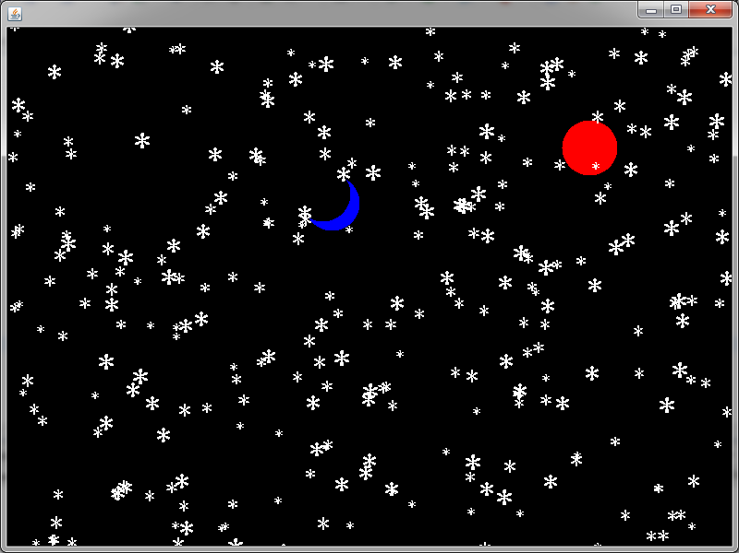
2、小球运动
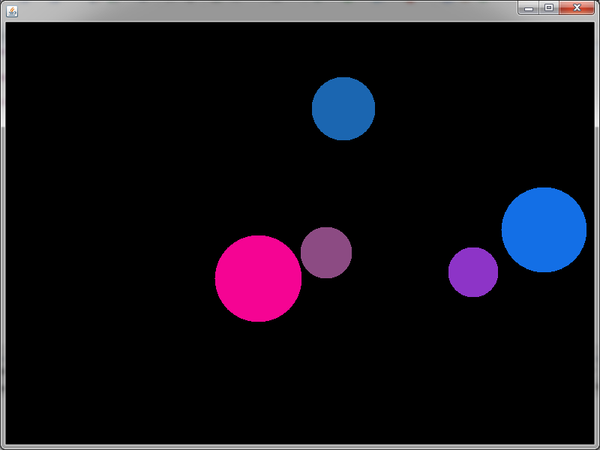

3、刷数据库
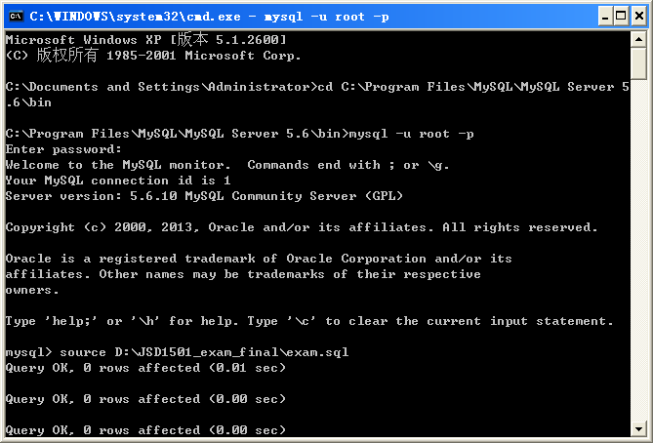
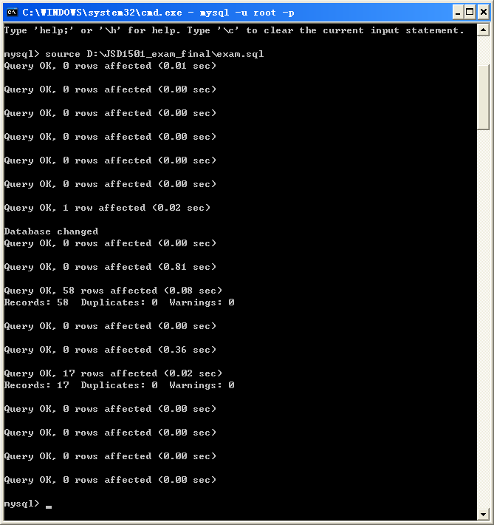
- 登录界面
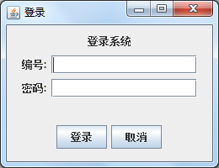
- 输入错误密码
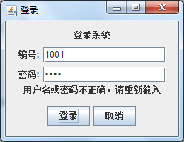
- 主界面
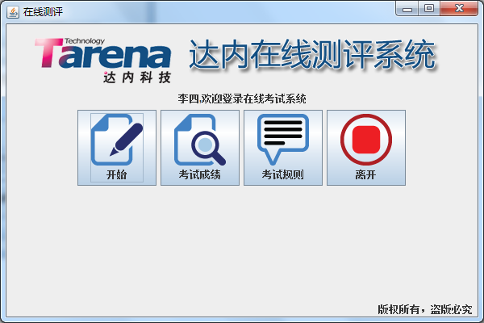

- 按开始考试后
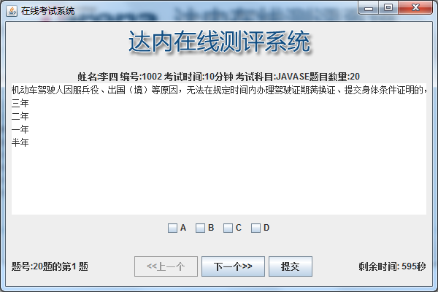
- 按考试成绩按钮后
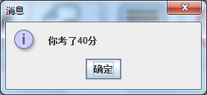
- 按考试规则按钮后
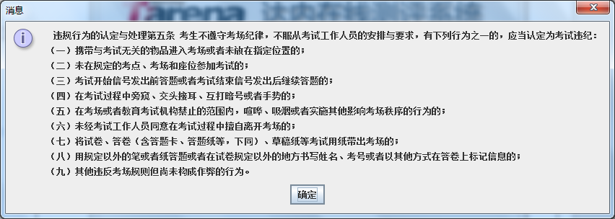
- 按离开按钮后
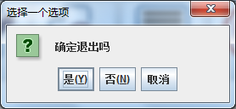

- 课程设计心得
这一次课程设计是跟着达内的老师做的，要求是最后做出一个可以在线测试的系统，在这短暂的教学过程中，我收获了很多。
老师的教学是一个循序渐进的过程，为了完成最后的应用程序，老师一开始先教给我们一些基础的关于java的知识，然后再开始给我们将一些关于窗口和面板的相关知识。窗口的建立就几个关键步骤，让窗口可见，设置窗口大小和窗口居中，还有将窗口关闭时及关闭应用程序。窗口要继承JFrame，面板要继承JPanel。窗口是一个无底的，要让他展现出东西，必须要在窗口里添加面板，在面板上画的东西，最终才会显示在窗口中。面板的设计主要的是paint方法，在画东西时先确定画笔的颜色，然后再确定所画的形状和坐标位置。后来我们还讲了关于让面板中的东西动起来，讲了两种方法，一个是用继承thread类，此时也可以用匿名内部类的方法，用线程实现物体的移动，这个是老师重点讲的，还有一个就是重写runnable接口。这个是我们前面一段所学的知识，感觉内容充实，上课也很有意思。老师会用幽默风趣的语调，给我们将自己的人生经历，所讲的一些知识是我们上课很少触及到的，感觉很有实用价值。当跟着老师的步骤做出那些能动的东西时，有一种满足感，自己的确收获了很多。
接着后面我们开始讲有关数据库的内容。建数据库，建表，然后再学简便的一次性刷数据库，反复的教学给了我很深的印象。JDBC的连接中讲了三个关键的部分，connection创立连接，preparedStatement要做的数据库操作，还有resultset收集结果集。在建立数据库连接的时候，老师再三强调的是一定在最后要关掉连接，如果在公司写程序时忘掉关连接有可能被开除。
紧接着的老师给我们讲做在线测试系统的相关内容。这个用到了我们前面讲的所有知识，老师还多给我们讲了有关布局的内容，三种基本布局，即流布局、网格布局、边框布局。
在设计面板的时候，我们是让面板叠加，多次叠加，变成我们最后看到的那样。在写代码的时候，重复的部分可以抽象成一个类，供其他对象调用。当代码很多很复杂时，我们要学会封装，将所要测试的对象封装成一个实体类，再设计专门的测试类进行测试检验。
整个设计教学过程，让我懂得了一些编程的基本思想，掌握了能让敲代码更快的快捷键。
老师的教学也很生动形象，会用具体的贴近生活的一些东西类比给我们讲课，便于大家的理解。这一次课程设计可以算是我有史以来收获最大的一次课程设计，学会了一些很实用的，对我以后发展有真正帮助的知识，希望以后还能有机会向这些老师学习。

