BIT 693 TMA4 Solution Document

# Use Cases

1. **Opens Application.** The user opens the application and is presented with a list of all farms and a list of herds for the first farm on the list with relevant MaxT values and statistics. If no farms exist the user is given an appropriate message. If no herds exist for the first farm on the list the user is given an appropriate message. (*Use case E.*)
2. **Create Farm.** The user enters name and location of farm. The system creates a new Farm with a unique identification number and add to list of farms displayed in the application.
3. **Create Herd.** The user selects a farm that the herd belongs to, enters a name to identify the herd and chooses a milking frequency for the herd. The system creates a new Herd with a unique identification number and adds to the list of herds associated with the farm.
4. **Create Cow.** The user selects a farm and a herd (that belongs to the farm) that the cow will belong to. The system creates a new Cow with a unique identification number and adds to the list of cows associated with the herd.
5. **Select a Farm.** The user selects a farm on the main window. The system presents a list of herds associated with the farm and relevant MaxT values and statistics. If no herds exist the user is given an appropriate message.
6. **Select a Herd.** The user selects a farm (*Use case E.*) then selects a herd from the presented list. The system presents a list of cows associated with the herd. If a cow has current milk taking values associated with it an indicator is displayed next to the cow. If no cows belong to the herd the user is given an appropriate message.
7. **Select a Cow.** The user selects a farm, (*Use case E.*), selects a herd (*Use case F.*), then selects a cow from the list. The system changes the display to a milk taking window presenting the current information held by the system for the selected cow.
8. **Add/Update/Delete Milk Taking.** The user enters or alters the information held for the morning and evening milking. The system stores the relevant data associated with the cow and displays an appropriate message. If the user does not enter all information or correct data, the system does not store the information and displays an appropriate message. If a user deletes the milk taking values the system removes associated values from the cow and displays an appropriate message.
9. **Calculate Values.** When **all** cows in a herd have milk takings associated with them, the system calculates the average milk yield per cow for the herd and determines the MaxT values for the morning and evening milking. This information is displayed on the main window when a user has selected a herd. (*Use case F.*)
10. **Delete Cow.** A user selects a cow (*Use case G.*) and can delete them from the main window (or milk taking window). The system deletes all information associated with the cow and displays an appropriate message.
11. **Delete Herd.** A user selects a Herd (*Use case F.*) and requests to delete. The system checks if there are cows associated with the herd. If there are no cows, the system deletes all information for the herd and displays an appropriate message. If there are cows associated with the herd, the system does not perform any deletion methods and displays an appropriate message to the user.
12. **Delete Farm.** The user selects a farm (*Use case E.*) and requests to delete. The system checks if there are any herds associated with the farm. If there are no herds associated with the farm the system deletes all information for the farm and displays an appropriate message. If there are herds associate with the farm, the system does not perform any deletion methods and displays an appropriate message to the user.

# Class Diagram

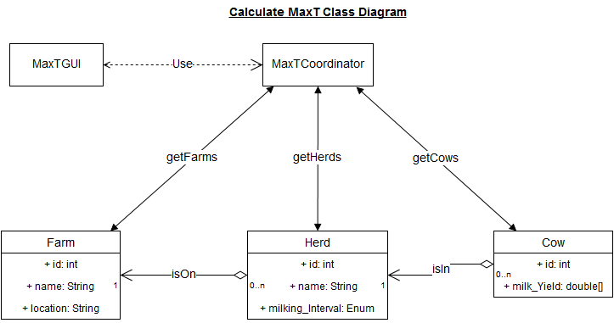

# Storyboards