BIT 695 TM4 Task 2: Github Setup

# Creating a Github account.

As I already have an active Github Account, registering a new account was not an appropriate activity for me to complete.

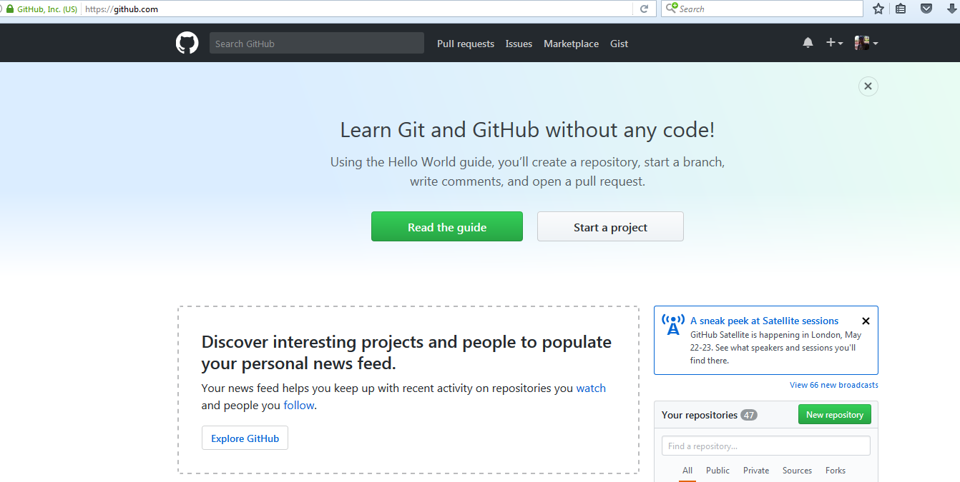

Here is my profile page:

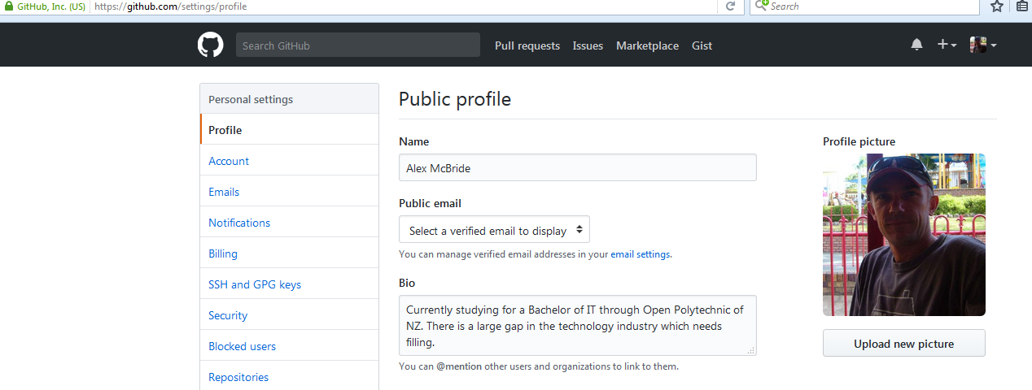

I choose the evolus/pencil Repository to fork

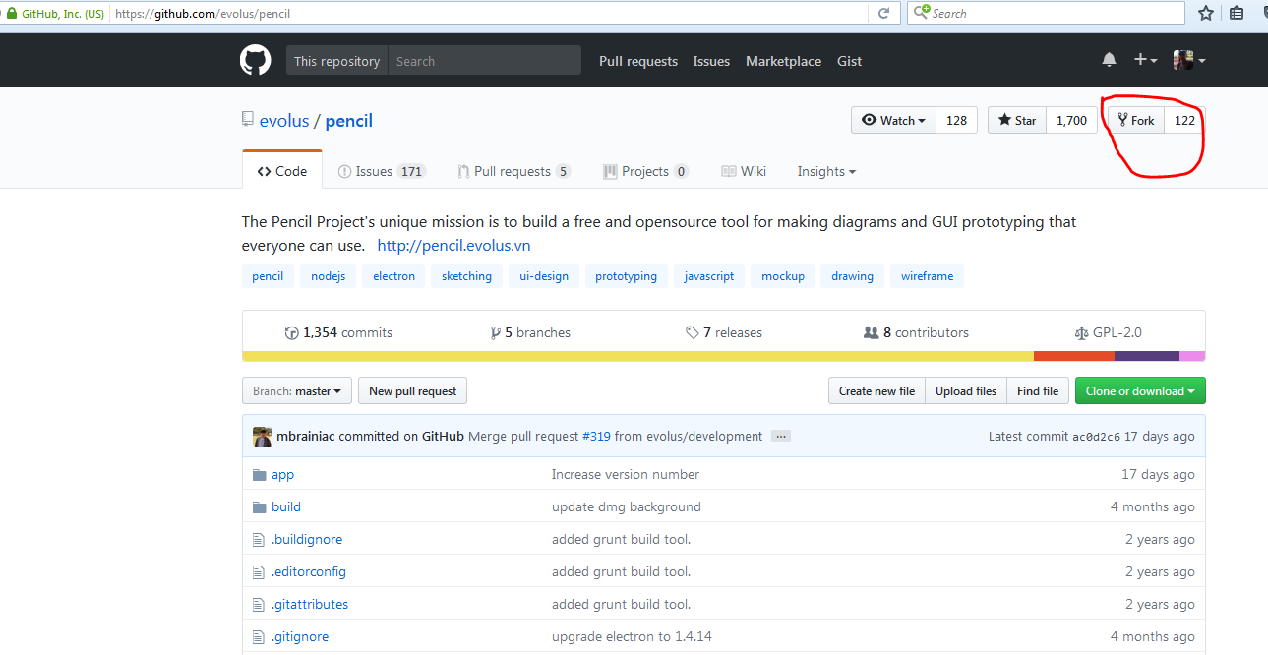

Here it is forked to my account.

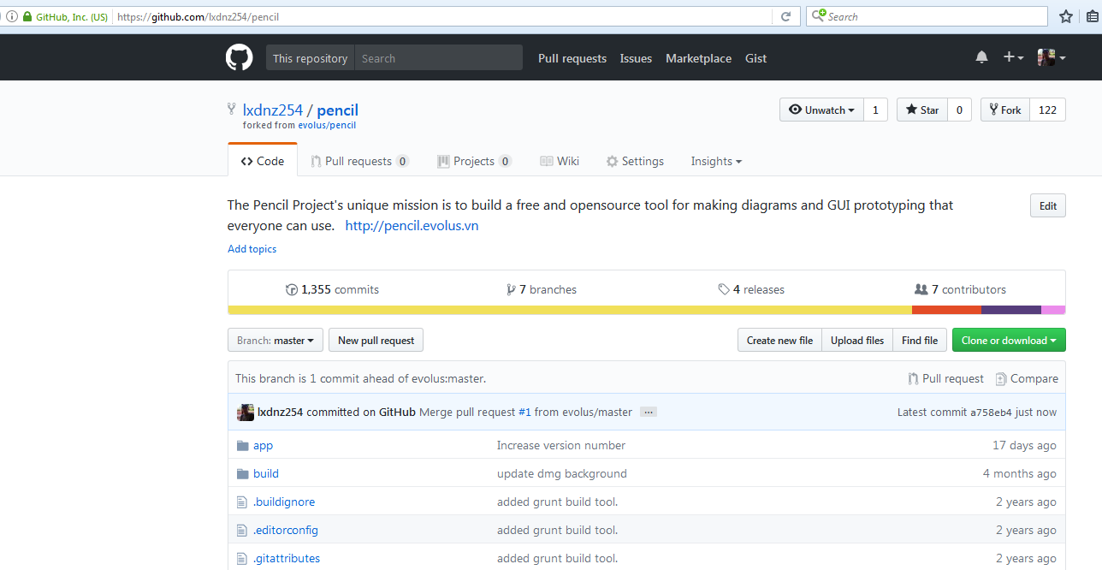

This is the overview of my account.

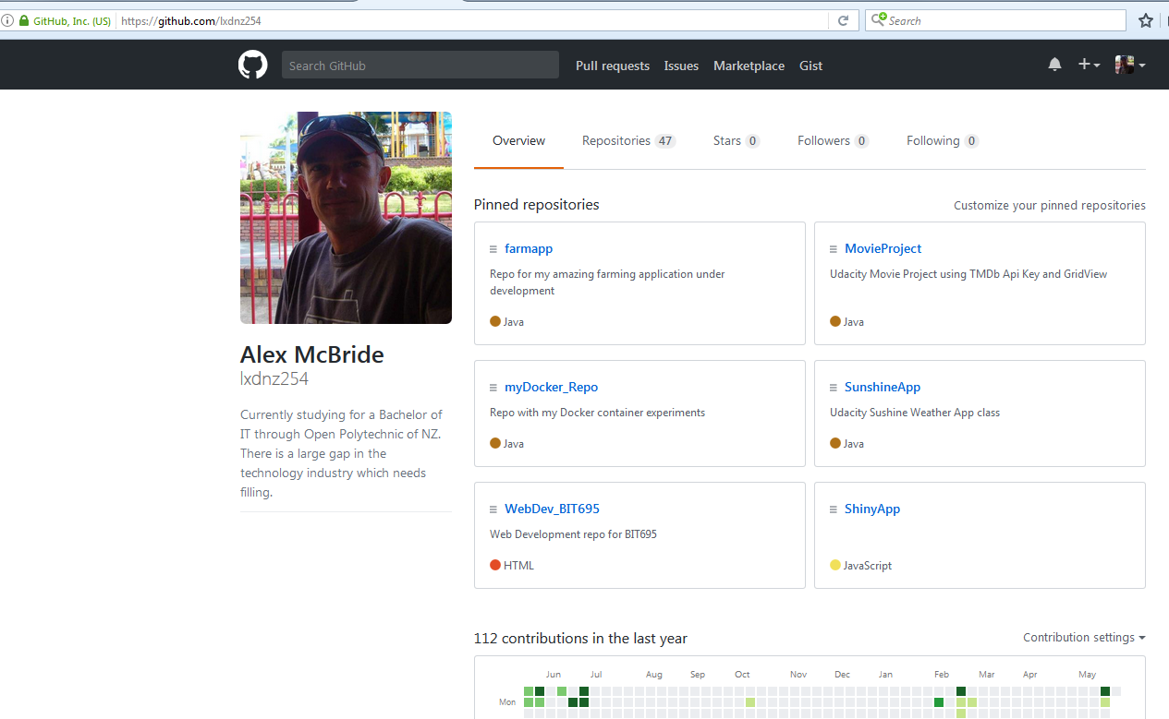

# Creating new Github repositories and cloning freeCodecamp.

Using Github for Windows desktop client. I created a new repo, in the UniServerZ/www folder to allow for local testing.

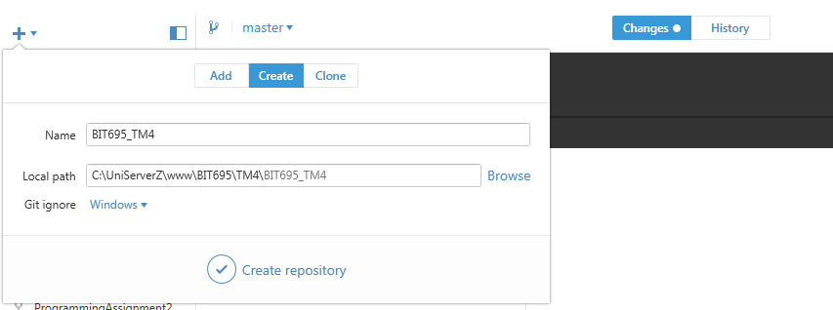

Here is the local repo before the first commit.

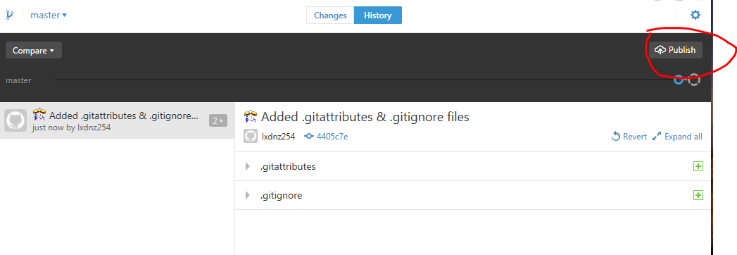

Create the initial commit

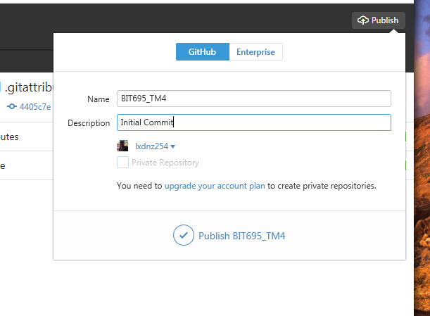

Visit the remote Github repository

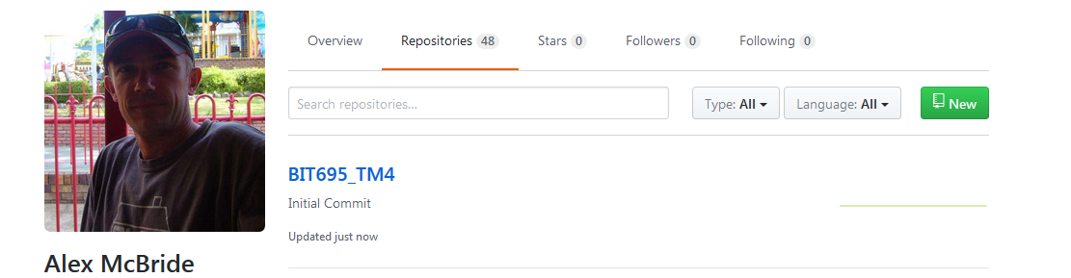

Inside the remote repository

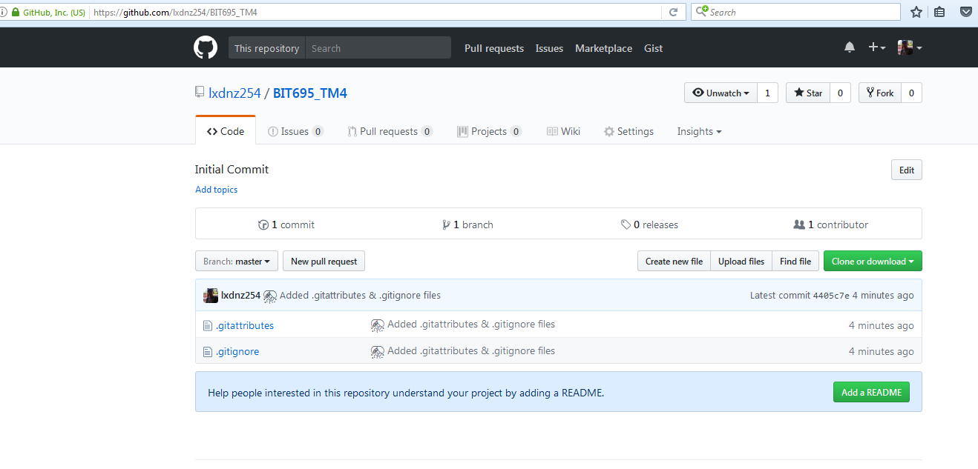

Clone the freeCodeCamp repository remotely first.

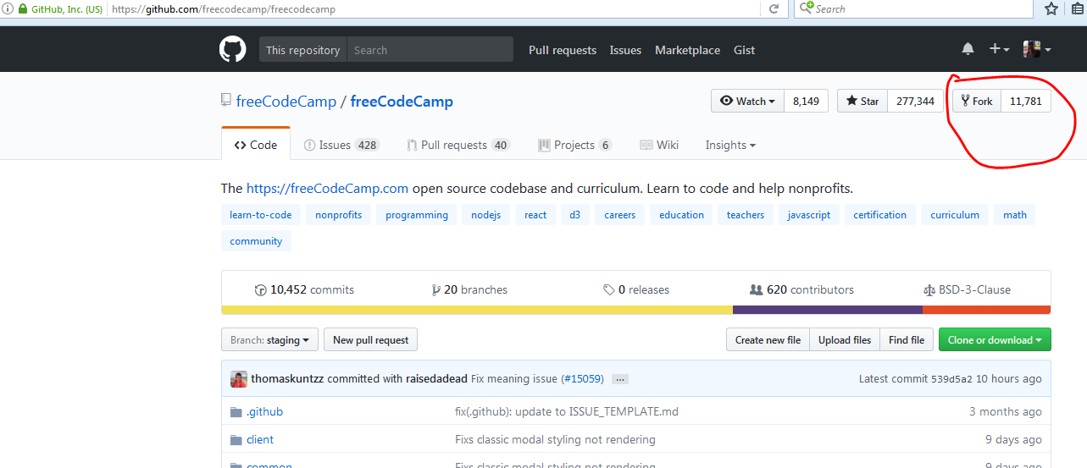

Here it is being remotely forked.

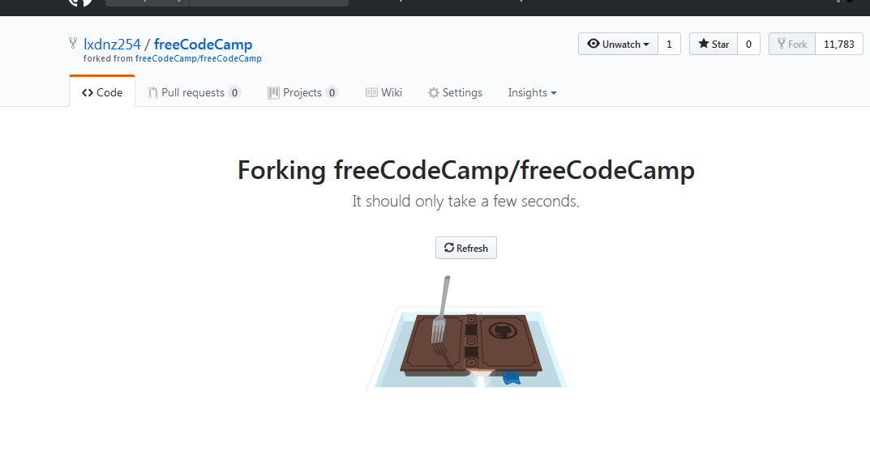

This is the remote forked version of the freeCodeCamp repository.

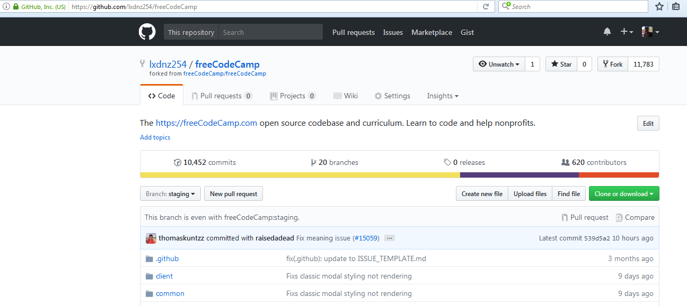

Using the Windows Github Desktop client, search for the freeCodeCamp repository

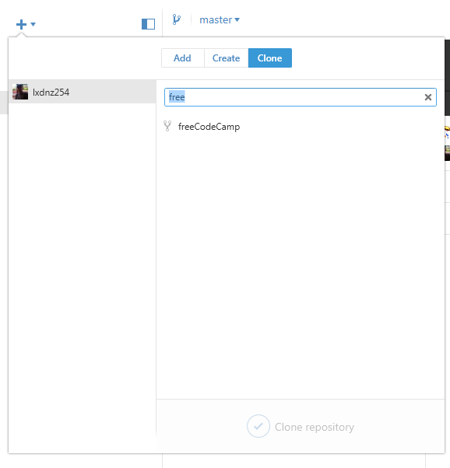

Once found, clone the repository.

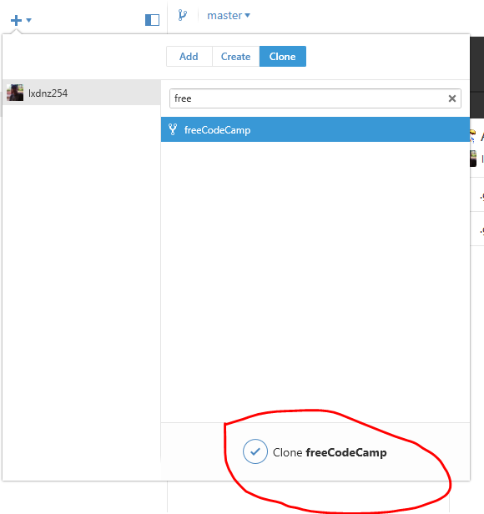

Here is the Desktop Client cloning the repository so it is now locally accessible

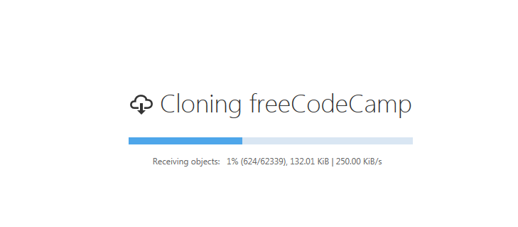

Here is the local folders of the cloned freeCodeCamp repository

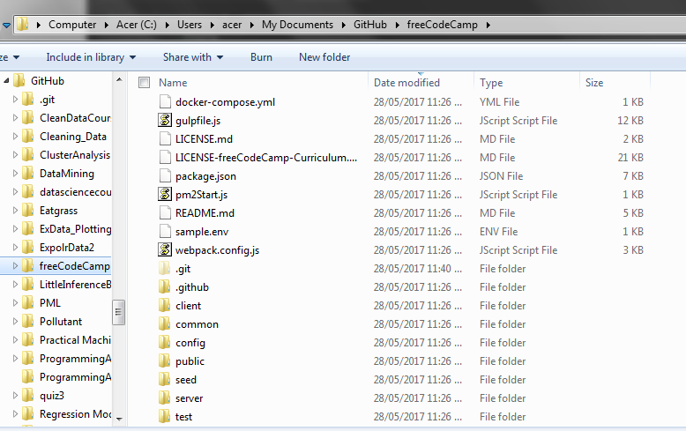

# Comparing Github to BitBucket

|  |  |  |
| --- | --- | --- |
| **Feature** | **Github** | **Bitbucket** |
| Private repositories on free accounts | No, all free accounts must use public repositories. | Yes, for small teams, under 5 users, there is unlimited private repositories. |
| Available storage | No size limit. Github recommends that no repository be larger than 1GB and may send an email warning a user, and has a strict limit on files larger than 100MB | Free accounts have a 1GB soft limit per repository and a hard limit of 2GB and provide users with 50 minutes of build time per month on Bitbucket Pipelines. |
| Academic plans | Yes, provides access to unlimited repos and access to an extensive range of tools and platforms whilst a student | Yes, lets users have unlimited private repositories with 5GB of storage and 500 build minutes. |
| Tutorials and support | Extensive tutorials and good community support. Easy to follow instructions for getting started with a Github account. | Extensive tutorials for using Git, and easy to follow instructions for getting started with a BitBucket account. |
| Number of users | Unlimited number of users for any account. | Maximum of 5 users for a free account across all repositories. Once more than 5 users are accessing there is a requirement to pay fees. |
| Merge checking | Yes. Github checks all pull requests for conflicts before allowing a merge to complete | Not available for free accounts. |
| Pull request reviews | Yes, this is an integral part of how Git and Github operates. | Yes, this is an integral part of how Git and BitBucket operates. |
| Branch restrictions | Yes, a repository owner is allowed to assign who has access to what branches. | Yes, a repository owner can control who has access to what branches. |
| Documentation for a project/repository | A project/repository is able to have documents on a Wiki and Github-pages (a static public facing web-site) | BitBucket allows for a Wiki or each project/repository. |
| Cost for expansion or access to private repositories. All pricing in $US | Single Developer cost $7/month.  Teams start at $9/user/month ($25/moth minimum covering first 5 users)  Business plans are $21/user/month | Standard plan: $2/user/month  With 5GB storage for large files and 500mins of build minutes  Premium plan $5/user/month  Unlocks merge reviewing, 1000 minutes of build time and 10GB file storage. |