详细设计报告

1 概述
办公系统面向各企事业单位的办公管理，以“沟通、协调、控制”为核心思想，将现代化办公思想和先进的科学技术手段结合在一起，为您提供办公管理的新环境、新助手，以达到提高工作效率、提高管理水平、增强交流与协作的目的。
它具有以下特点:
- 集成了现代办公思想,计算机理念,网络,通讯等现代化工具；
- 为企业管理者提供有力的决策支持,有效的提高个人的办公效率；
- 实现部门之间的合作办公以及企业信息交流和大规模的协作。

2 用程序流程图或盒图或PAD图详细描述每个功能

1）权限处理程序流程图
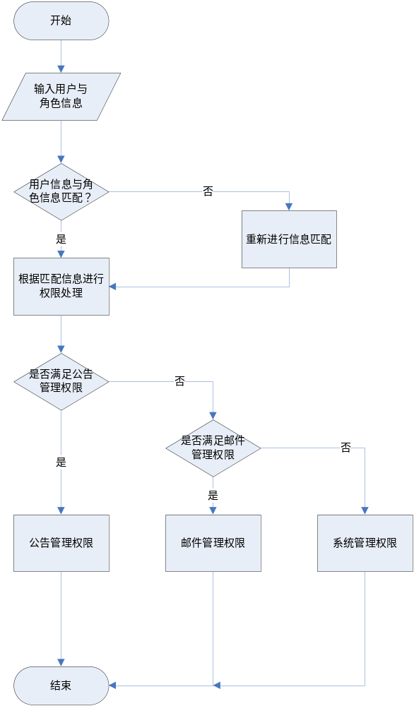

2）公告处理程序流程图
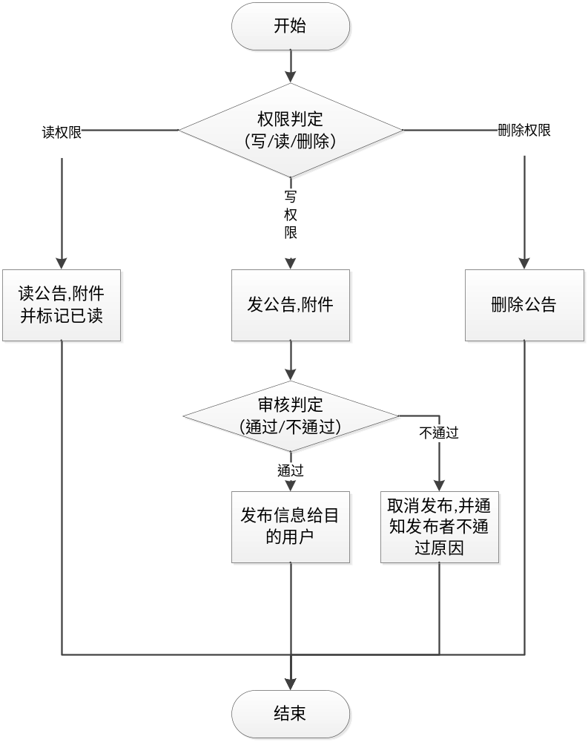

- 邮件信息处理程序流程图
发送邮件
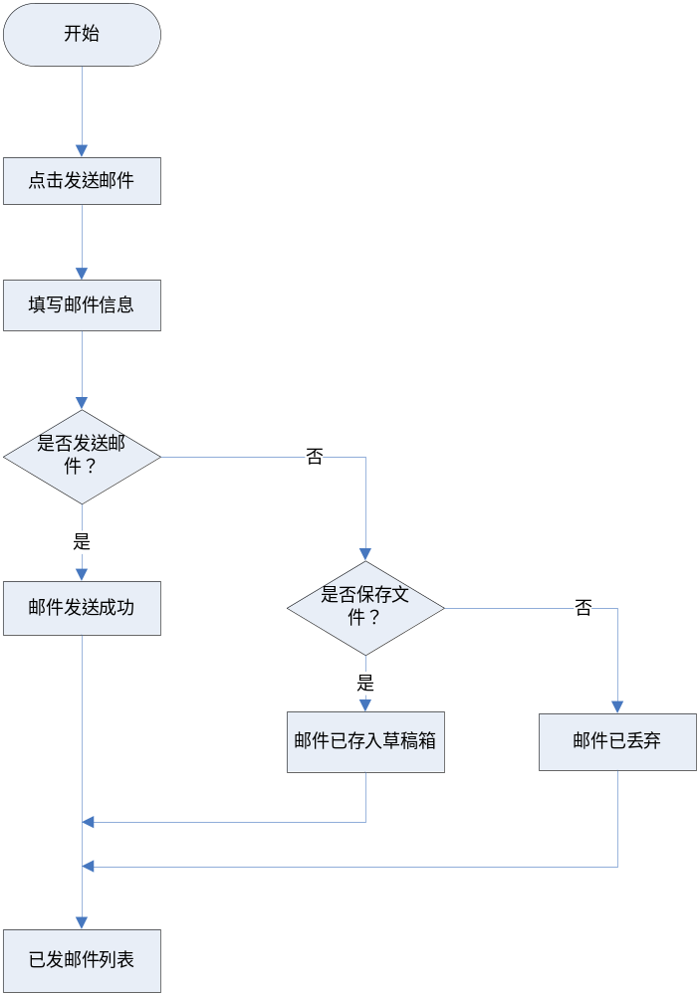

接收邮件

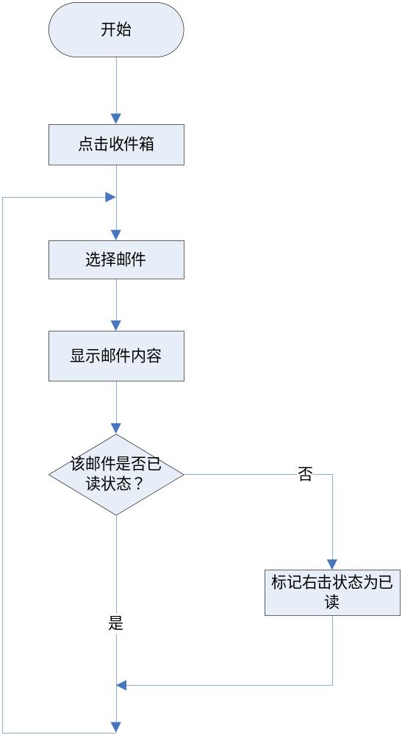

删除邮件
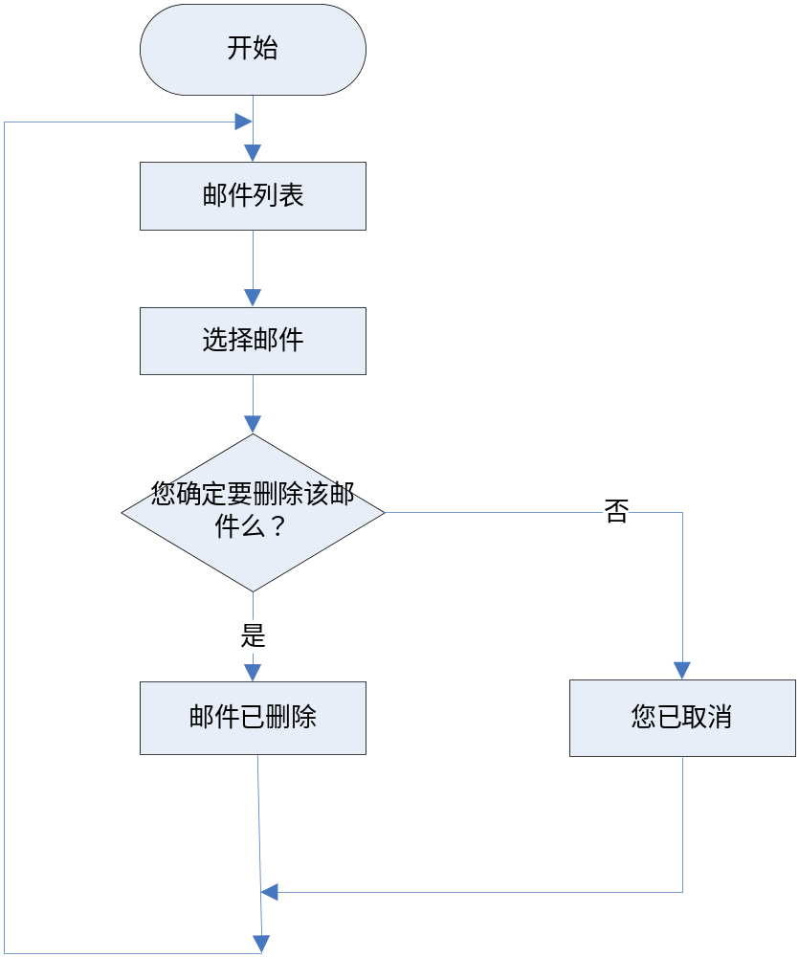

4）系统信息处理程序流程图
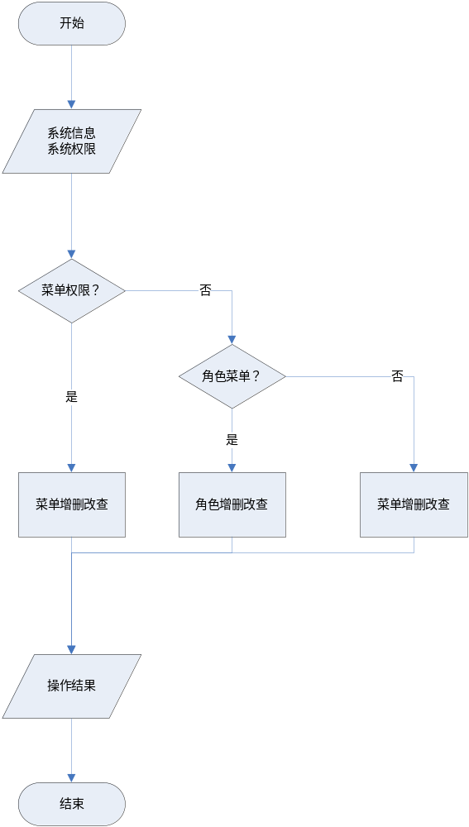

5）统计处理程序流程图
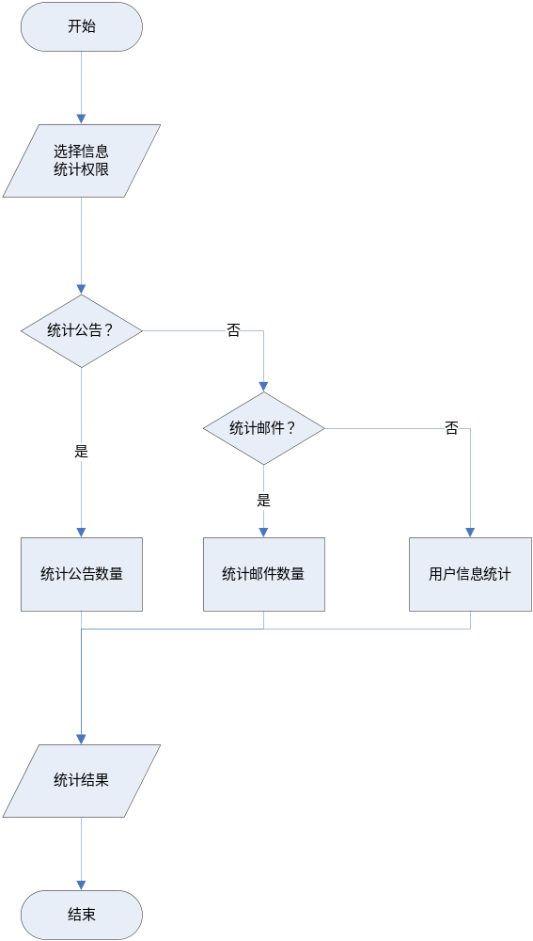

3 详细设计数据库中的存储过程、触发器、视图等

1）用户公告视图
CREATE OR REPLACE VIEW "OAPRO"."v_postofuser" AS
SELECT "p".SUSER,"p".STITLE,"p".SCONTENT,"p".BEGINDATE,"p".ENDDATE,"p".NSTATUS,"p".NISFILE,"p".ADDTIME,"p".UPDATEUSER,"p".UPDATETIME,"pu".NISREAD,"u".USERNAME
FROM OAPRO.T_POST "p" ,OAPRO.T_POST_USER "pu" ,OAPRO.T_USER "u"
WHERE
"p".POSTID = "pu".POSTID AND "u".USERID = "pu".SUSERID;

2）用户角色菜单视图
CREATE OR REPLACE VIEW "OAPRO"."v_userRoleMenu" AS
SELECT
"u".USERNAME,
"r".ROLENAME,
"m".MENUNAME,
"m".LINK,
"r".ROLEINFO
FROM
OAPRO.T_USER_ROLE "ur" ,
OAPRO.T_USER "u" ,
OAPRO.T_ROLE "r" ,
OAPRO.T_ROLE_MENU "rm" ,
OAPRO.T_MENU "m"
WHERE
"ur".USERID = "u".USERID AND
"ur".ROLEID = "r".ROLEID AND
"rm".ROLEID = "r".ROLEID AND
"rm".MENUID = "m".MENUID;

3）邮件信息视图
CREATE OR REPLACE VIEW "OAPRO"."v_emailInfo" AS
SELECT
"e".TITLE,
"e".CONTENT,
"e".SENDDATE,
"re".USERNAME
FROM
OAPRO.T_EMAIL "e" ,
OAPRO.T_RECEIVEEMAIL "re"
WHERE
"e".ID = "re".EMAILID;

CREATE OR REPLACE VIEW "OAPRO"."v_efileInfo" AS
SELECT
"e".TITLE,
"e".CONTENT,
"e".SENDDATE,
"ef".OLDNAME
FROM
OAPRO.T_EMAIL "e" ,
OAPRO.T_EMAIL_FILE "ef"
WHERE
"e".ID = "ef".EMAILID;

- 触发器
CREATE OR REPLACE TRIGGER "OAPRO"."tri_delemail" BEFORE DELETE ON "OAPRO"."T_EMAIL" REFERENCING OLD AS "OLD" NEW AS "NEW" FOR EACH ROW
BEGIN
delete from t_email_file t where t.emailid = :OLD.id;
END;;

CREATE OR REPLACE TRIGGER "OAPRO"."TRI_DELPOST" BEFORE DELETE ON "OAPRO"."T_POST" REFERENCING OLD AS "OLD" NEW AS "NEW" FOR EACH ROW
BEGIN
DELETE FROM T_POST_FILE T WHERE T. POSTID = :OLD.POSTID;
END;;

