**CSE5232 - Network Programming**

**Milestone 2**

**Report**

**Xiang Li**

**Objective**

Program an iterative server that stores locally in a sqlite database a set of peers and gossip text messages that were already seen by this machine. The server recognizes commands both over TCP and UDP. There are 3 types of accepted messages:

To store a gossip message:

**GOSSIP:mBHL7IKilvdcOFKR03ASvBNX//ypQkTRUvilYmB1/OY=:2017-01-09-16-18-20-001Z:Tom eats Jerry%**

The server will check if it already new it and simply discard it if it was known.

To store a peer message:

**PEER:John:PORT=2356:IP=163.118.239.68%**

The server will store the name and address of this peer if it is not yet known, or to update its address.

To query for the list of peers:

**PEERS?**

The expected answer has the format:

**PEERS|2|John:PORT=2356:IP=163.118.239.68|Mary:PORT=2355:IP=163.118.237.60|%"**

**Technology**

Java: For TCP/UDP server and client interaction

Sqlite: Database

Make File: For compilation of project

Bash Script: For running the TCP/UDP server and client

**Architecture**

**1. Project Directory Structure**

src - contains .java files

lib - contains the library which are needed for project

bin - contains compiled java files. It is empty at first.

Script files - for executing TCP/UDP Server and Client Java files

makefile - file used to compile the project

xiangli_m2.db - Database file

**2. Java files Details**

Main.java - starts server

TcpClient.java - starts TCP client

TcpServer.java - listens to client and starts TCP server thread

TcpServerThread.java - communicates with the client

UdpClient.java - starts UDP client

UdpServer.java - starts UDP server thread

UdcpServerThread.java - communicates with the client

Database.java - all database related methods

TableValue.java - defines form for tables

GetOpt.java - processes GetOpt input

**3. Database Structure**

Database Name - xiangli_m2.db

Table Name - gossip

Columns - id Primary Key

encoded

datetime

message

Table Name – peers

Columns - id Primary Key

peername

port

ip

The database has already been stored a gossip message and two peer messages. If you want to test a new database, you should delete **xiangli_m2.db** first.

**User Manual**

**1. Unzip the “xiangli_m2.tar.bz2”.**

**2. Compile:**

|  |
| --- |
| cd <Project Path>  make |

Or

|  |
| --- |
| chmod +x compile.sh  ./compile.sh |

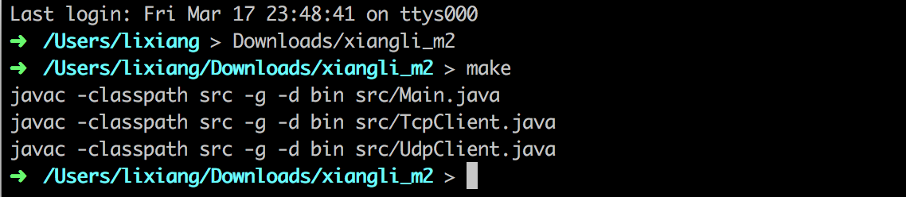

**3. Execute:**

Start a server:

|  |
| --- |
| chmod +x runServer.sh  ./runServer.sh < Protocol Type> <Port Number> |

Example for start a TCP server with port 2356:

|  |
| --- |
| ./runServer.sh t 2356 |

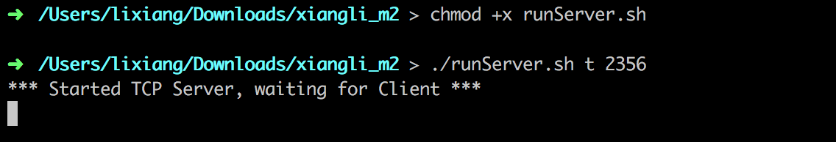

Then, open a new window of terminal. Start a TCP client:

|  |
| --- |
| cd <Project Path>  chmod +x runTcpClient.sh  ./runTcpClient.sh <Port Number> |

We should use the same port:

|  |
| --- |
| ./runTcpClient.sh 2356 |

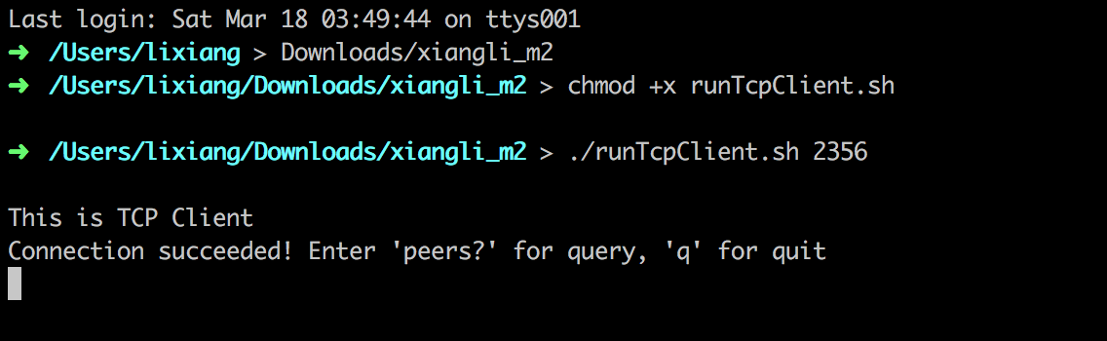

Enter in client window:

**GOSSIP:mBHL7IKilvdcOFKR03ASvBNX//ypQkTRUvilYmB1/OY=:2017-01-09-16-18-20-001Z:Tom eats Jerry**%

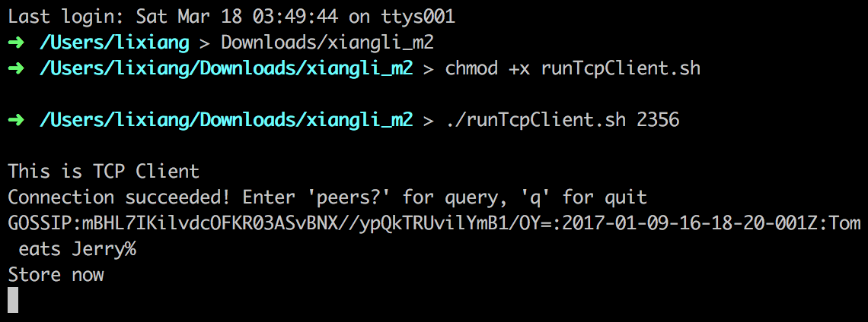

The server will receive this message and store it to database.

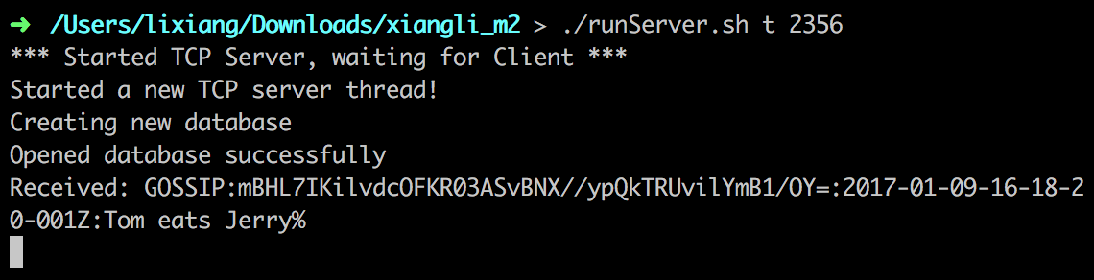

Enter in client window:

**PEER:John:PORT=2356:IP=163.118.239.68**%

and

**PEER:Mary:PORT=2355:IP=163.118.237.60**%

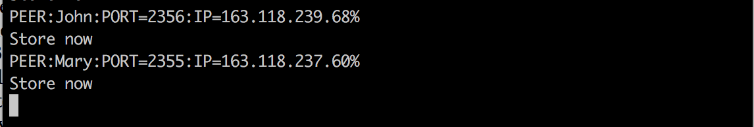

Enter in client window:

**PEERS**?

We will get the result for querying for stored peers in database

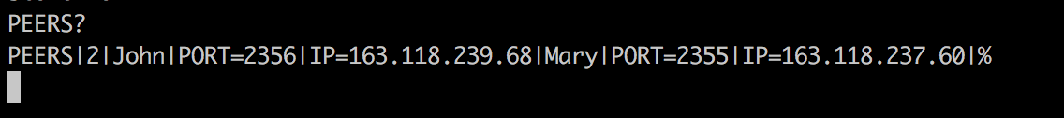

Enter **q** to quit for client:

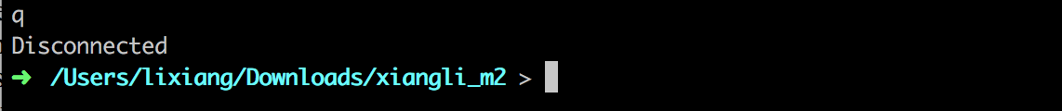

Example for start a UDP server with port 2356:

|  |
| --- |
| ./runServer.sh u 2356 |

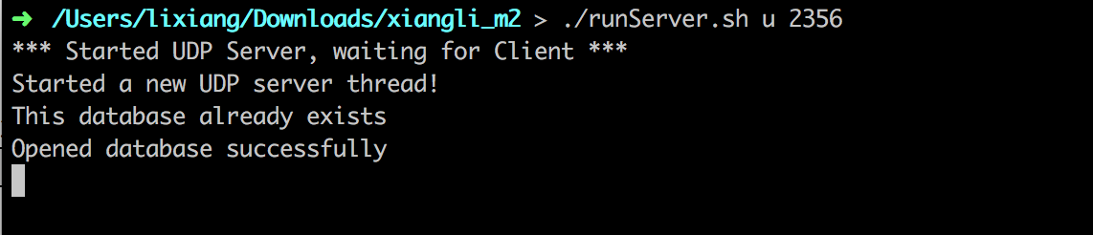

Then, open a new window of terminal. Start a UCP client:

|  |
| --- |
| cd <Project Path>  chmod +x runUdpClient.sh  ./runUdpClient.sh <Port Number> |

We should use the same port:

|  |
| --- |
| ./runUdpClient.sh 2356 |

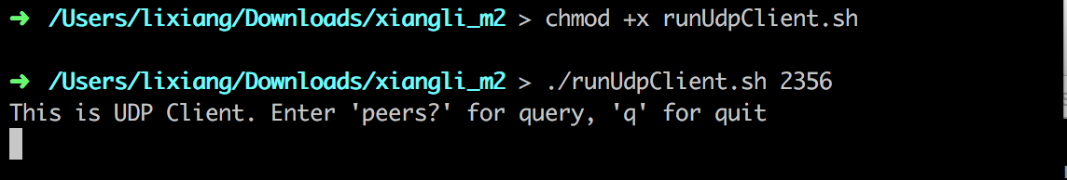

The following steps is same with the TCP part.

In my codes, I used SQL command INSERT OR IGNORE INTO to store message for gossip, and set the **message** column (i.e. **Tom eats Jerry)** as Unique, so the database will store message if it is new, or discard it by default.

I used SQL command INSERT OR REPLACE INTO to store message for peers, and set the **peername** column (i.e. **John)** as Unique, so the database will update message if its information of other columns is new, or discard it by default.

**4. Remove class files and the database file:**

|  |
| --- |
| cd <Project Path>  make clean |

In the execution phase, if there is an exception:

java.net.BindException: Address already in use (Bind failed)

You can use this command to list the process (pid) running on port.

lsof -i:<port>

Then kill the process with:

kill <pid>

I tried to run my program in my account on code01.fit.edu, but it always display the following information, so I run my program locally.

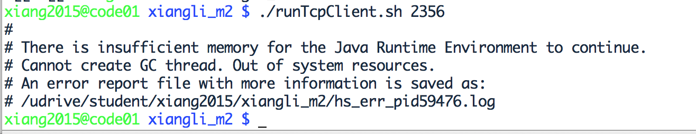

**Conclusion**

Through this project, I learned how to implement communication between client and server bash on TCP and UDP, and interact with the Sqlite database. This project successfully responds to multiple clients on TCP and UDP, storing the data for messages which meet the required format in a local database file.

**References**

Projects2015/P2/anita_devi-rini_simon. (n.d.). Retrieved from <http://cs.fit.edu/~msilaghi/17/2017sprNPG/Projects2015/P2/anita_devi-rini_simon/>

Projects2015/P2/biro_maxim/maxim_biro_andrew_binns. (n.d.). Retrieved from <http://cs.fit.edu/~msilaghi/17/2017sprNPG/Projects2015/P2/biro_maxim/maxim_biro_andrew_binns/>