DIET MANAGER/ RELEASE

Diet Manager Design Document

Group1

Matija Selak <mxs4350@g.rit.edu>

Ivan Susnjara <ixs1924@g.rit.edu>

Leon Grubišić <lxg6892[@g.rit.edu](mailto:jtoa@rit.edu)>

Boris Fjorović <bxf4579@g.rit.edu>

Lehady Sani-Agatha <lxs4287@g.rit.edu>

# Project Summary

This project was completed in several stages: planning, designing, development, and implementation. The planning stage main goal was to develop the Diet Manager application following the specifications given to us in my courses. Diet manager is used to keep track and calculate the food intake by the user. The project development team consisted of 5 members that worked closely hand in hand. The team was using GitHub for better coordination of development stage. In the design, the stage team has created UML sequence and class diagrams. Discussed class names and applications overall design. Development stage consisted of solidifying the ideas into code. The team members used the design principles and patterns that they all agreed upon. In the implementation stage, the team has tested, modified and refactored the application.

# Design Overview

We divided our application into several modules and add an abstract layer at the top of each module. Such as food interface that holds methods which are used in both food and ingredient class. For this project, we will depend on the abstraction layer. To make our application open for future extensions. We will hold duplicate functionalities in our composite pattern to make it accessible through the whole application. This will make our modification a lot easier. We will give each class, method, and module a single responsibility for each of them in order to minimize regressions. Each module knows what another module does, but it will not know its functionalities.

# Subsystem Structure

# 

# Subsystems

**Subsystem Food**

|  |  |
| --- | --- |
| **Interface** Food (interface) | |
| **Responsibilities** | Implements variables and methods to log new foods |
| **Collaborators**  **(implements)** | Basicfoods.java and Recipe.java |

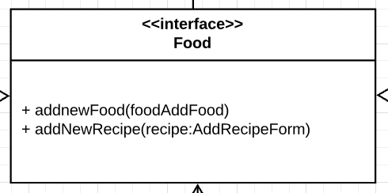

# 

|  |  |
| --- | --- |
| **Class** BasicFood | |
| **Responsibilities** | Logs new basic foods into the basicfoods.csv file |
| **Collaborators**  **(uses)** | Food |

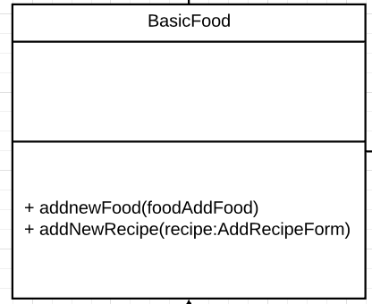

# 

|  |  |
| --- | --- |
| **Class** Recipe | |
| **Responsibilities** | Logs new recipes to recipefoods.csv file |
| **Collaborators**  **(uses)** | Food.java |

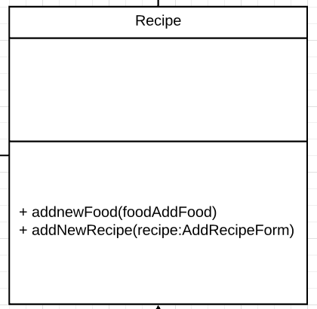

|  |  |
| --- | --- |
| **Class** DailyIntake | |
| **Responsibilities** | DailyIntake class logs the users’ daily food consumption |
| **Collaborators**  **(uses)** | GUIComponent |

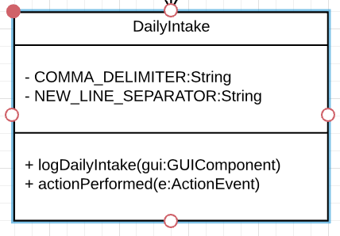

|  |  |
| --- | --- |
| **Class** GUIComponent | |
| **Responsibilities** | Creates the visual interface for the user to log daily intake, calories, weight and viewing the daily log by date |
| **Collaborators**  **(implements)** | DailyIntake, DailyCalories, DailyWeight, AddRecipeForm, AddFood |

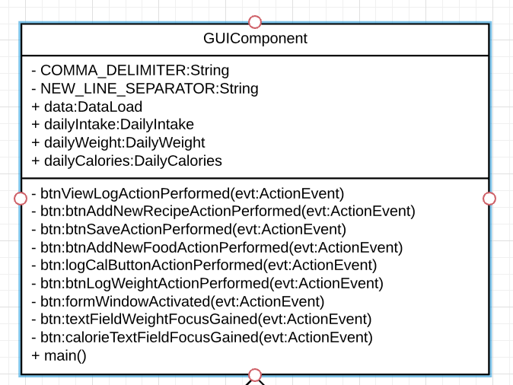

|  |  |
| --- | --- |
| **Class** DailyCalories | |
| **Responsibilities** | Logs the users’ daily calorie limit |
| **Collaborators**  **(implements)** |  |

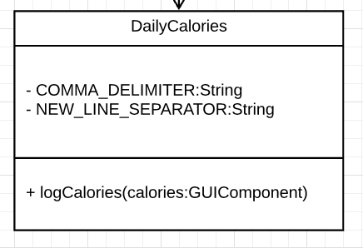

|  |  |
| --- | --- |
| **Class** DailyWeight | |
| **Responsibilities** | Logs the users’ daily weight |
| **Collaborators**  **(uses)** |  |

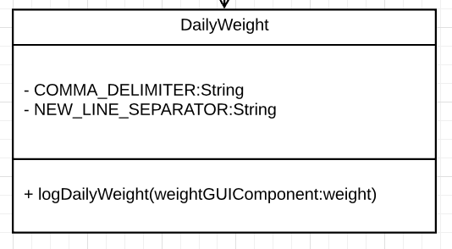

|  |  |
| --- | --- |
| **Class DataLoad** | |
| **Responsibilities** | Loads the data in to the internal structure |
| **Collaborators**  **(uses)** |  |

# 

|  |  |
| --- | --- |
| **Class** AddRecipeForm | |
| **Responsibilities** | GUI class that takes the input for a new recipe |
| **Collaborators**  **(uses)** |  |

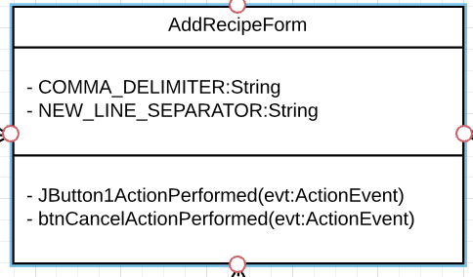

# 

|  |  |
| --- | --- |
| **Class** AddFood | |
| **Responsibilities** | GUI class that takes the input for creating a new basic food |
| **Collaborators**  **(uses)** | BasicFood.java |

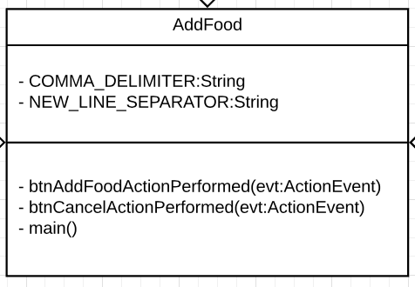

# Sequence Diagrams

## **Sequence diagram 1.**

This diagram shows calculation of calories within the daily intake

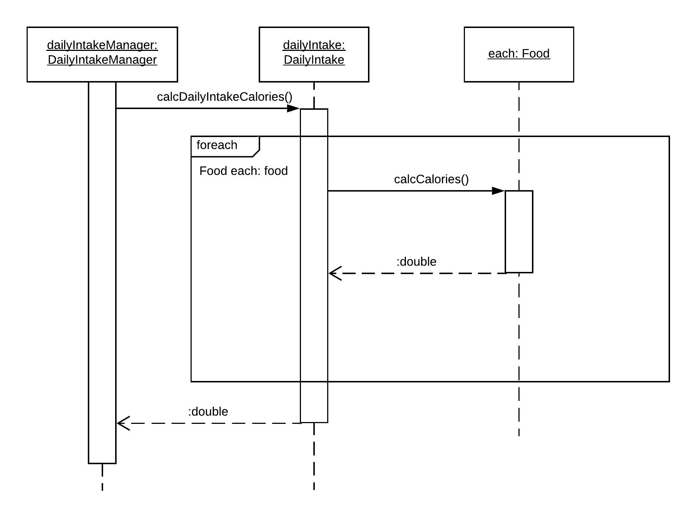

## **Sequence diagram 2**

## This diagram shows the calculation of total intake calories in a day.

## 

## **Pattern Usage**

Currently in this phase of development we are using one pattern and it is composite pattern.

Pattern #1 Composite pattern

|  |  |
| --- | --- |
| **Composite pattern** | |
| **Leaf(s)** | Ingredients |
| **<interface> Component** | Food |
| **Component** | Recipe |

