**软件使用说明书**

1. 软件概述

软件为一个简单的文件同步器，可以将本地指定的目录与S3指定的Bucket进行文件同步。

1. 运行环境
2. 语言：Java
3. 扩展包
4. aws-java-sdk-1.11.781
5. commons-io-2.6
6. 使用说明
7. 初始化

同步S3和本地的文件

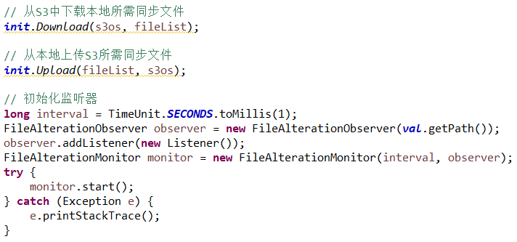

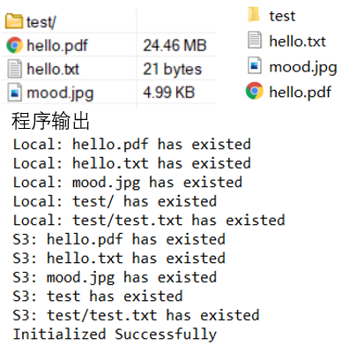

1. 输出数据格式
2. 从S3中下载本地所需同步文件

创建文件夹：Local: <Dirname> has created

已存在文件夹：Local: <Dirname> has existed

下载文件：Local: <Filename> has downloaded

已存在文件：Local: <Filename> has existed

分片下载文件：

Local: <Filename> part <number> downloading...

Local: <Filename> part <number> has downloaded

1. 从本地上传S3所需同步文件

创建文件夹：S3: <Dirname> has created

已存在文件夹：S3: <Dirname> has existed

上传文件：S3: <Filename> has uploaded

已存在文件：S3: <Filename> has existed

分片上传文件：

S3: <Filename> part <number> uploading...

S3: <Filename> part <number> has uploaded

1. 监听本地目录

添加文件：

Local: create File <Filename>

S3: <Filename> has uploaded

修改文件：

Local: change File <Filename>

S3: <Filename> has uploaded

删除文件：

Local: delete File <Filename>

S3: <Filename> has deleted

创建文件夹：

Local: create Dir <Dirname>

S3: <Dirname> has created

删除文件夹：

Local: delete Dir <Dirname>

S3: <Dirname> has deleted