<http://blog.csdn.net/teng_ontheway/article/details/51307440>

[【Git+Source Tree使用教程之一】commit & push](http://blog.csdn.net/teng_ontheway/article/details/51307440)

About SourceTree

[SourceTree](https://www.atlassian.com/software/sourcetree/overview) is a powerful Git and Mercurial desktop client for developers on Mac or Windows. In this tutorial, we're using OSX 10.9.5 and SourceTree 2.0.4.

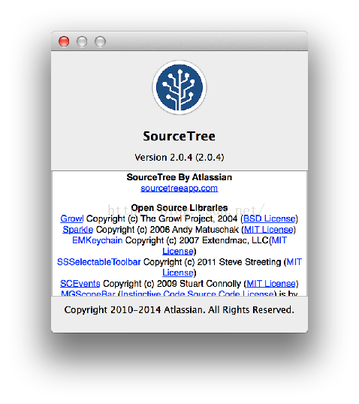 

GitHub

Here is our GitHub repository.

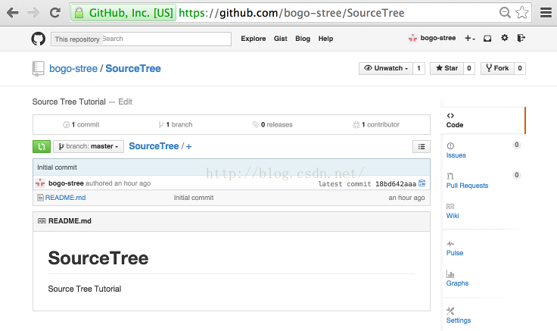 

Cloning from GitHub

Let's clone the repo:

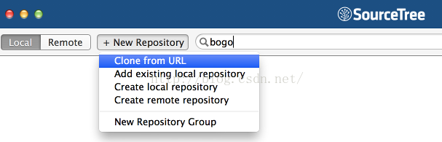   
  
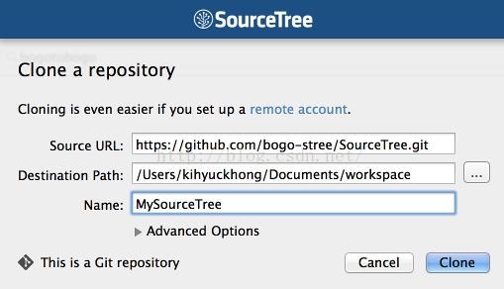   
  
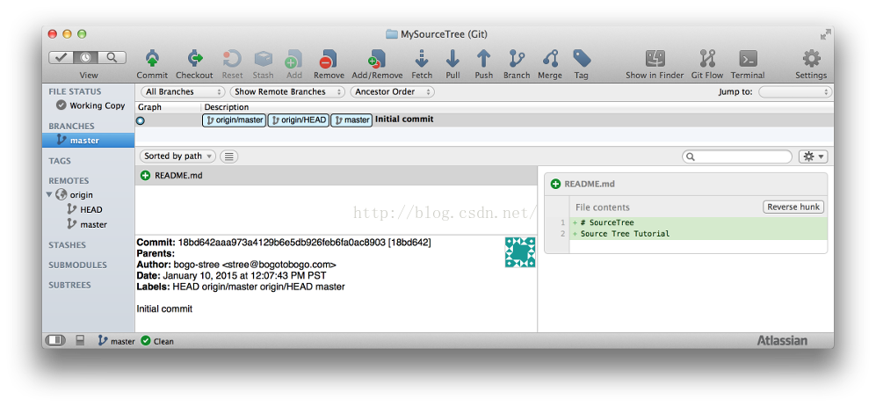  
  
Staged & Unstaged

If we make a new file on our local machine, we'll have "Uncommited" changes:

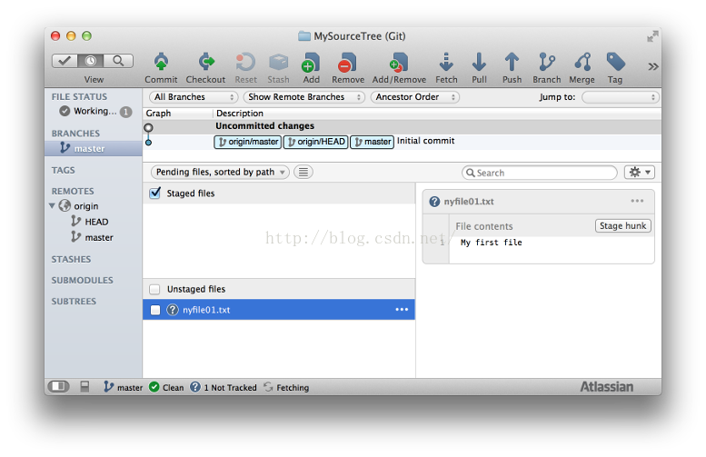 

We can put the file into staging either by checking "Unstaged files" or:

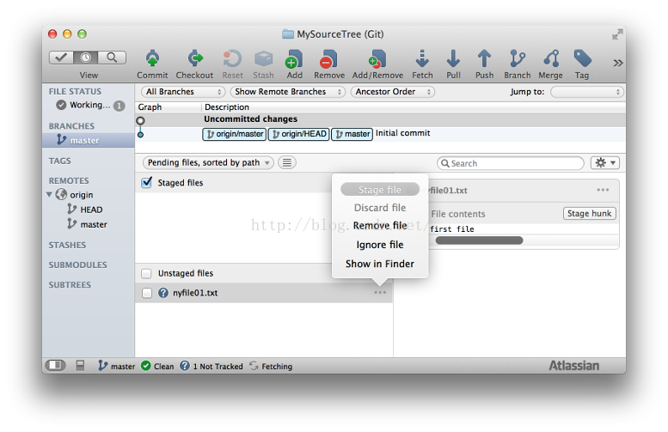   
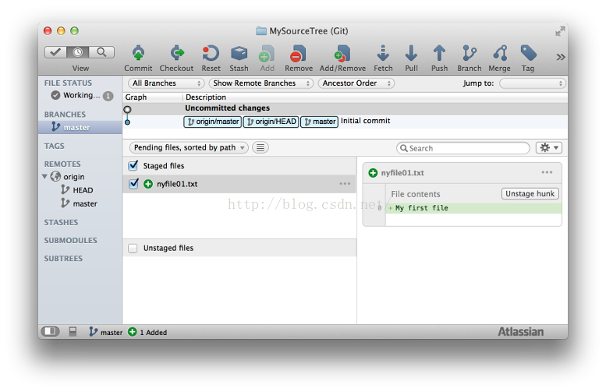 

commit to a local repo

Now commit the file in the staging area:

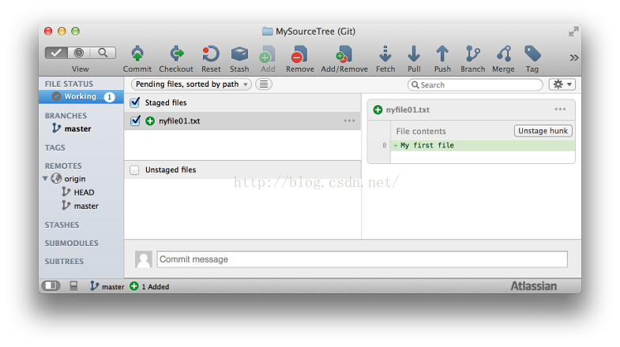 

If we press "Commit" on the top menu, we get the following:

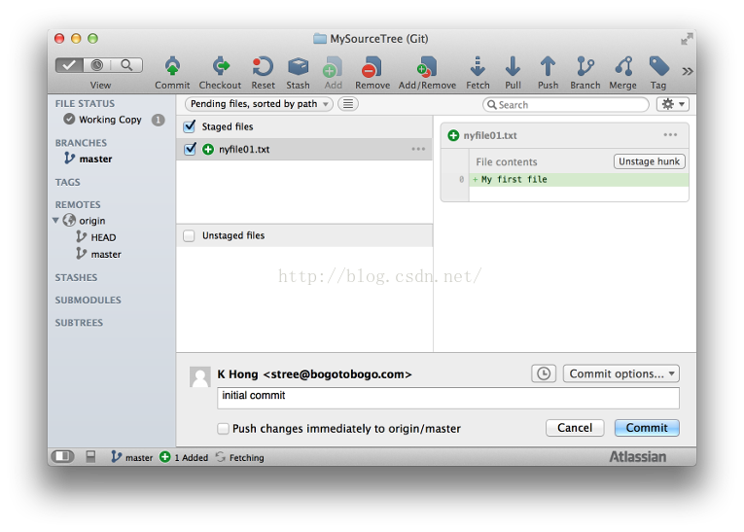 

Fill in out comment, and the hit "Commit" button:

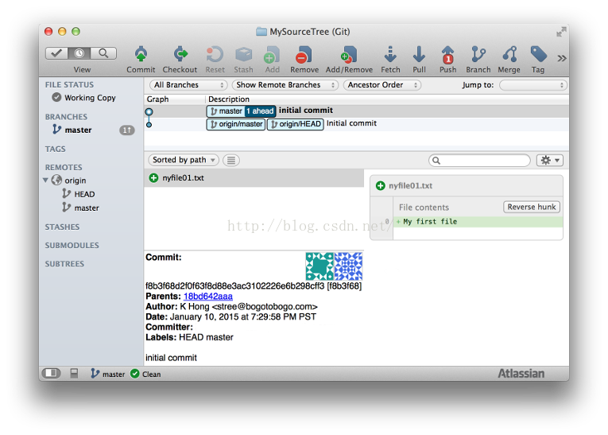

Now, we can see our local repo is 1 ahead of remote repo (origin/master) 

pushing to GitHub

After adding two more files to our local repo, we want to push to a remote repo:

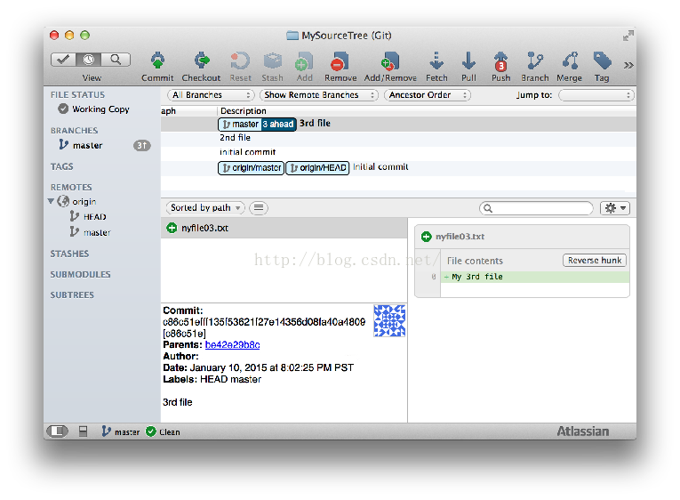 

Before we do Push, we need to Pull first, so hit the Pull on the top menu:

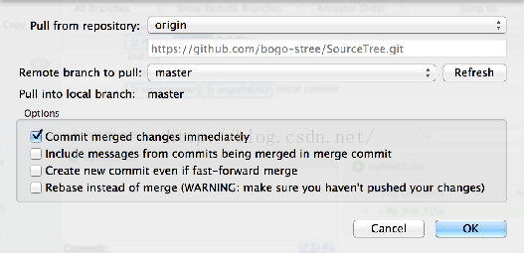 

Now, press "Push" on the top menu:

Push3Button.png   
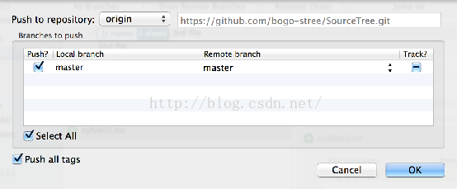   
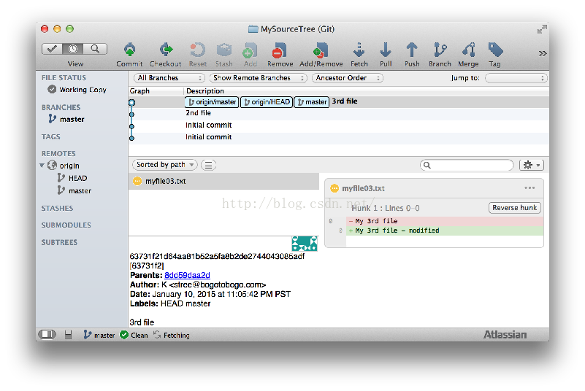 

As we can see, now our local and remote repositories are in sync!

In_Sync.png 

GitHub after the push

After our push, the GitHub looks like this:

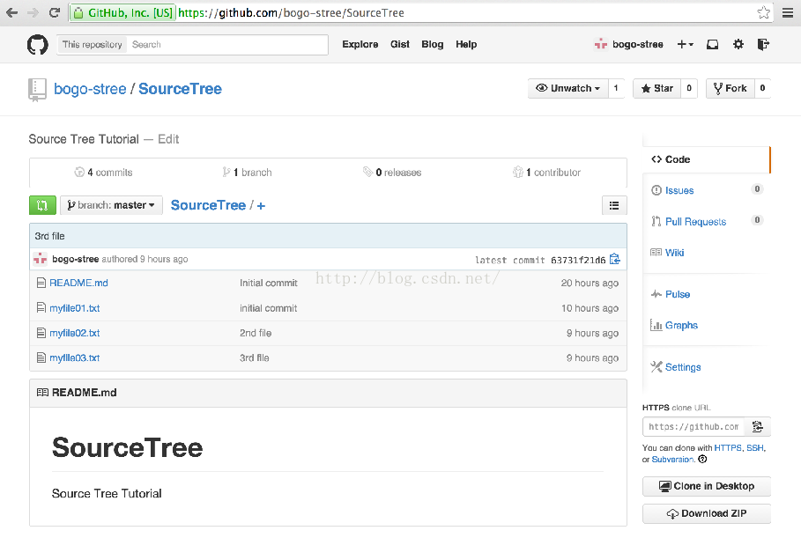

Source Tree Preferences

In this tutorial, we used the preferences as shown below:

