[【Git+Source Tree使用教程之二】Branching & Merging](http://blog.csdn.net/teng_ontheway/article/details/51307521)

Current git graph

Now we want to create a new branch called **dev** from our master branch. Here is our current state of our git graph before the branching:

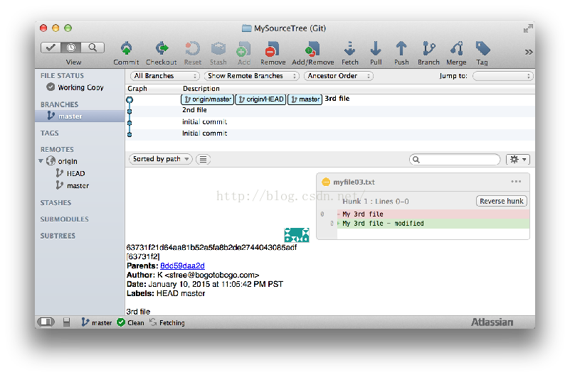 

Creating a dev branch

To create a new branch (**dev**), we need click "Branch" on the top menu.

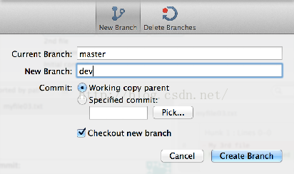 

Hit "Create Branch", then our git looks like this:

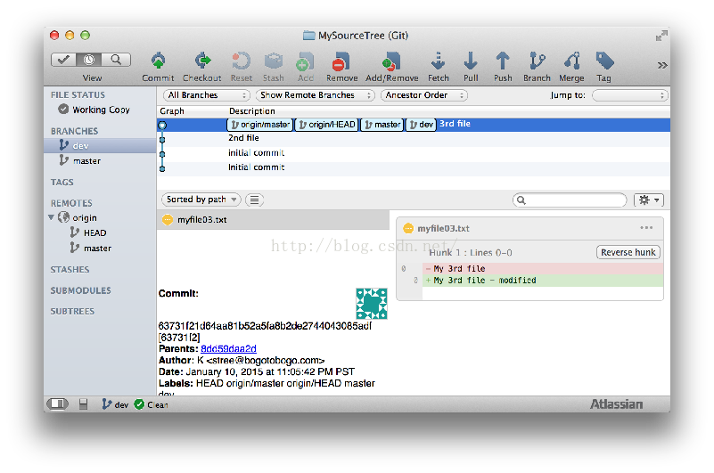 

Pushing the dev branch to GitHub

Let's push our new **dev** branch to our remote repo:

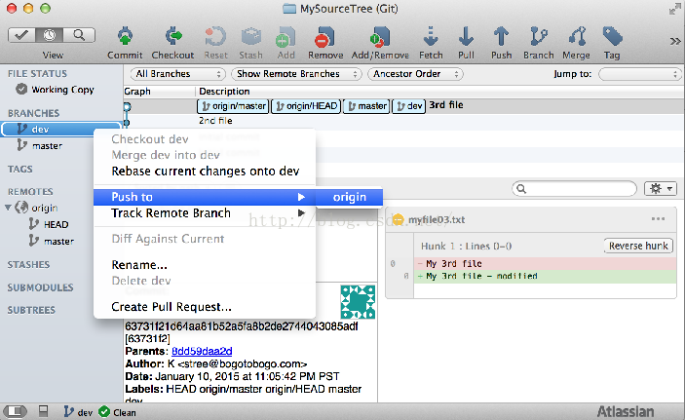   
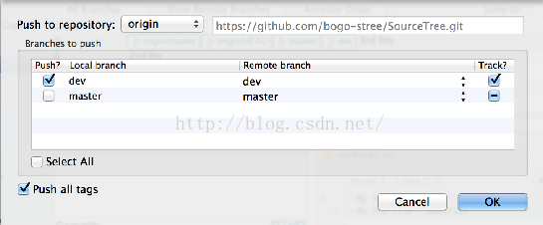 

After the **dev** branch push, we can check our GitHub now has two branches: **master** and **dev** branches:

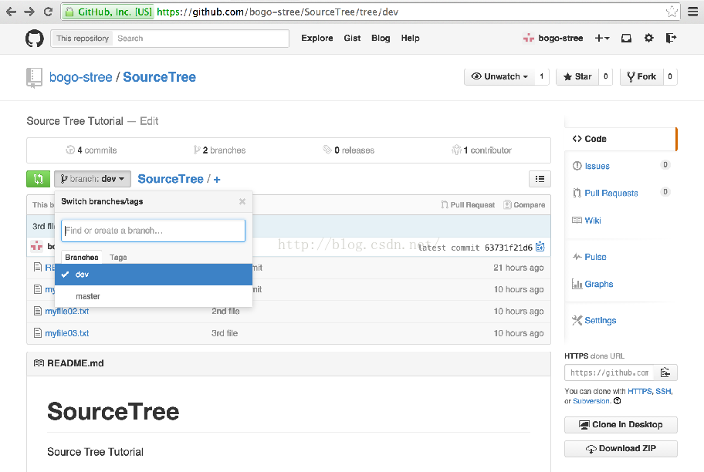

Committing to the new dev branch

If we want to commit a new file (myfile04.txt) to our new **dev** branch:

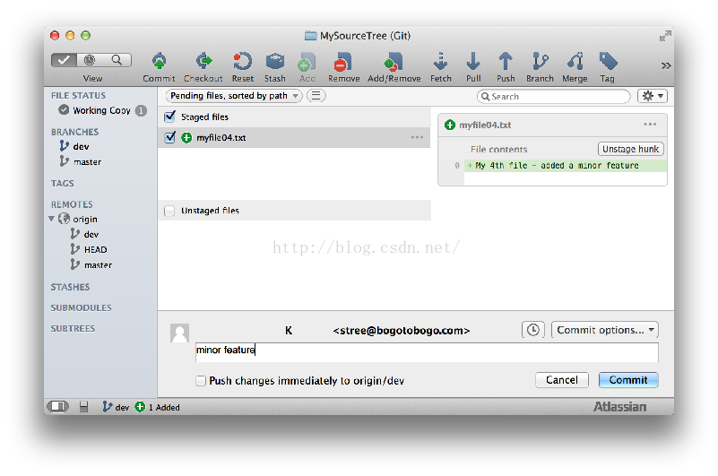   
  
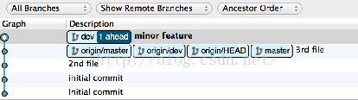 

Pushing to Dev branch:

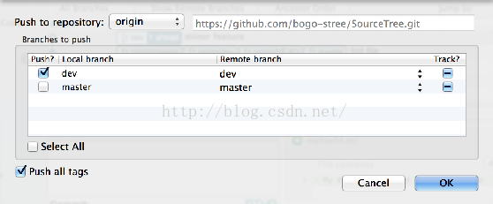   
  
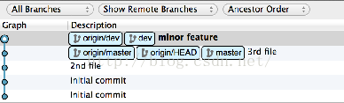 

After another push:

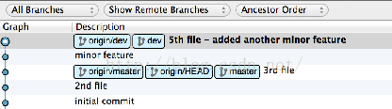 

Feature Branch

When we want to add major feature, it's better work on a separate branch. So, we will create a new branch called **feature1** from the **dev** branch:

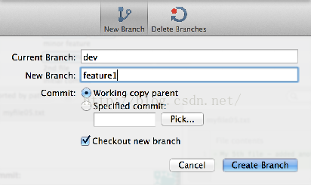   
  
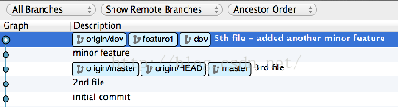 

After two more commits to our new **feature1** branch:

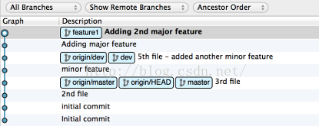 

Pushing **feature1** branch to GitHub:

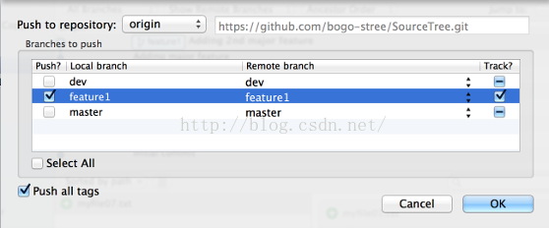   
  
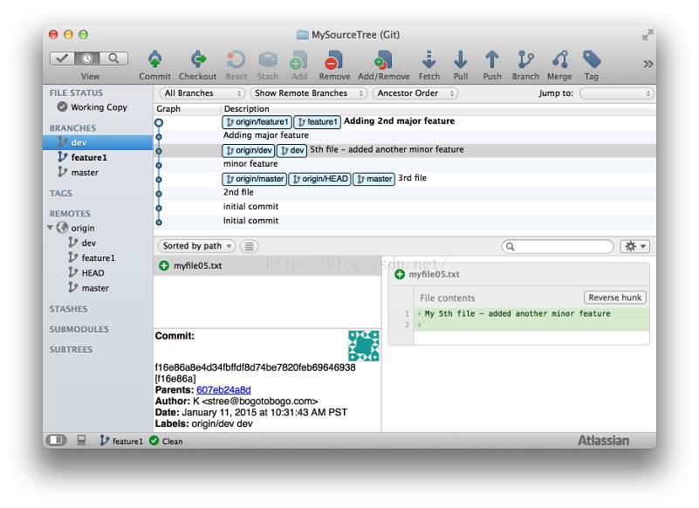 

Current branch

We can select current branch by double clicking a branch under "Branches" side menu. We can tell by its**bold** font face.

**dev** branch is the current branch:

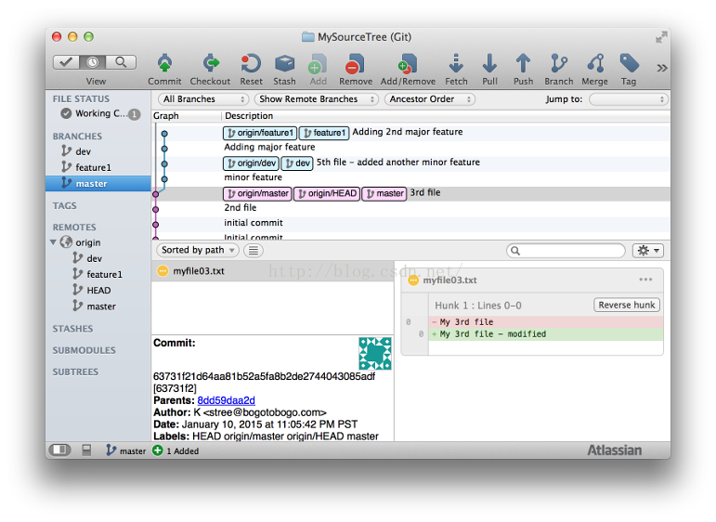 

**master** is the current branch:

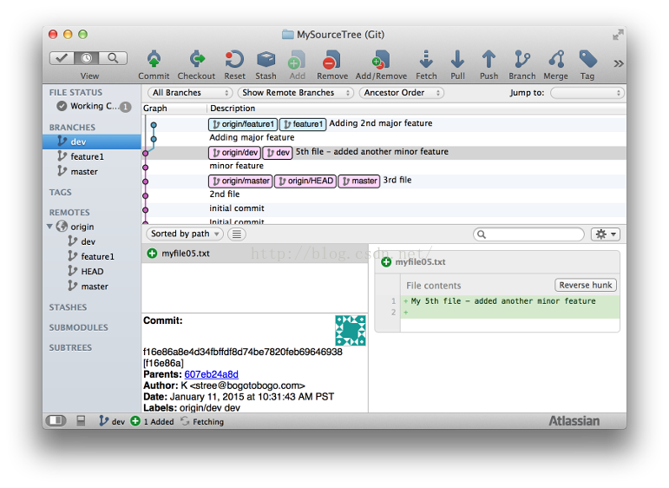

Before we do merge **feature1** to **dev**, to make it more interesting, we want to do additional commit to **dev**and push to GitHub:

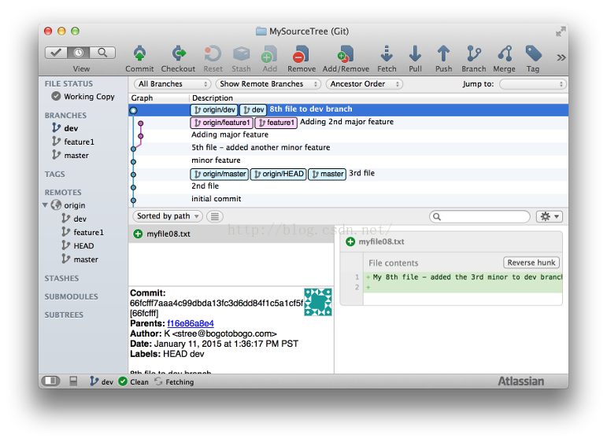 

Merge Feature Branch into dev branch

After working on **feature1** branch, now we want to merge it into **dev** branch. Set **dev** branch as the our current branch.

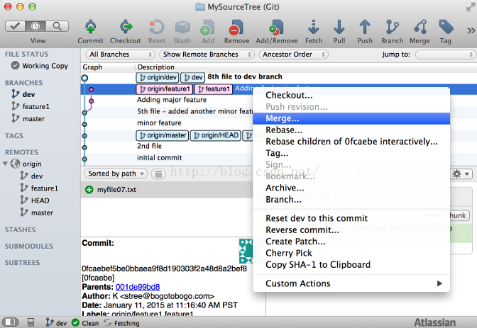   
  
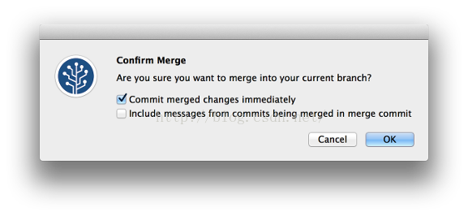

Hit "OK":

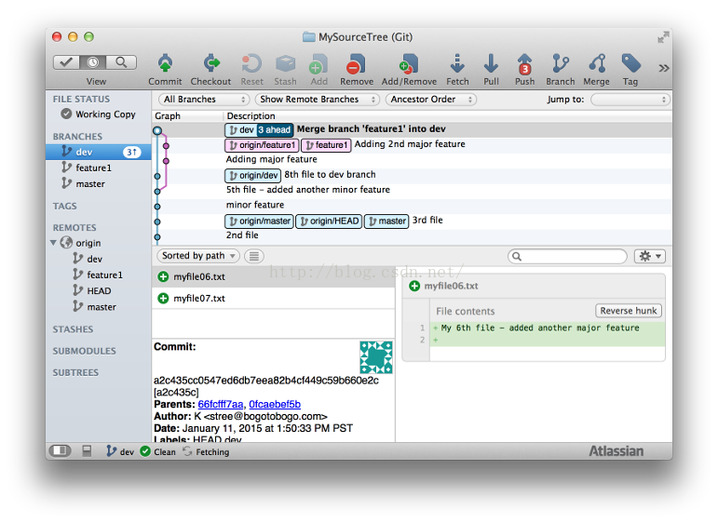

Now, **feature1** branch merged into **dev** branch.

原文链接：<http://www.bogotobogo.com/cplusplus/Git/Git_GitHub_Source_Tree_2_Branching_Merging.php>