### Netty 深入剖析

#### 一 netty简介

##### 1.1 业界使用netty的开源框架

* dubbo
* RocketMQ
* Spark
* ElasticSearch
* Cassandra 开源分布式nosql数据库
* Flink 分布式高性能高可用的流处理框架
* Netty-SocketIo socketIo协议的java服务端实现
* Spring5 使用netty作为http协议框架
* Grpc 谷歌开源的高性能Rpc框架
* 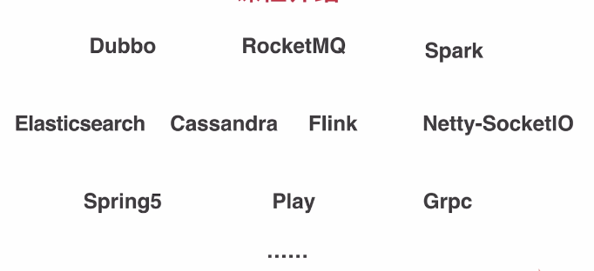

##### 1.2. Netty是什么？ 为什么使用netty之后，几乎不用担心性能问题

* 异步事件驱动框架，用于快速开发高性能服务端和客户端
* 封装了JDK底层BIO和NIO模型，提供高度可用的API（提供了非常多的扩展点，使API更加灵活丰富，channelHandler热插拔机制，解放了业务逻辑之外的细节问题，使业务逻辑的热添加和删除变得容易）
* 自带编解码器解决了拆包粘包问题，用户只用关心业务逻辑
* 精心设计的reactor线程模型支持高并发海量连接（为什么netty只使用了少量的线程，就能管理成千上万甚至几十万的连接）
* 自带各种协议栈让你处理任何一种通用协议都几乎不用亲自动手

##### 1.3. 为什么学netty

* 各大开源框架选择netty作为底层通信框架
* 更好的使用，少走弯路
* 单机连接数上不去？性能遇到瓶颈？如何调优
* 详解reactor线程模型，实践中举一反三
* 庞大的项目是如何组织的，设计模式，体验优秀的设计
* 阅读源码 -- 可以作为第一个深入研究的开源框架

##### 1.4. 目标

* 掌握netty底层核心原理，解决各类问题，深度调优
* 给netty官方提issue
* 实现一个简易版的netty
* 开启阅读源码之旅
* 加速掌握基于netty的各类中间件

##### 1.5. 技术储备

* java基础，多线程
* TCP原理， NIO

#### 二 netty基本组件

包括：NioEventLoop（发动机：起了两种类型的线程），Channel（对连接的封装，数据读写），ByteBuf（数据流），Pipeline（逻辑处理链），ChannelHandler（逻辑）

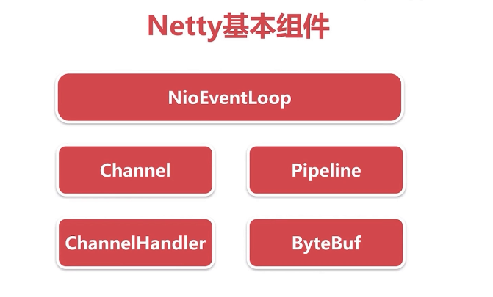

##### 2.1 不使用netty情况下，模拟传统的客户端与服务端通信

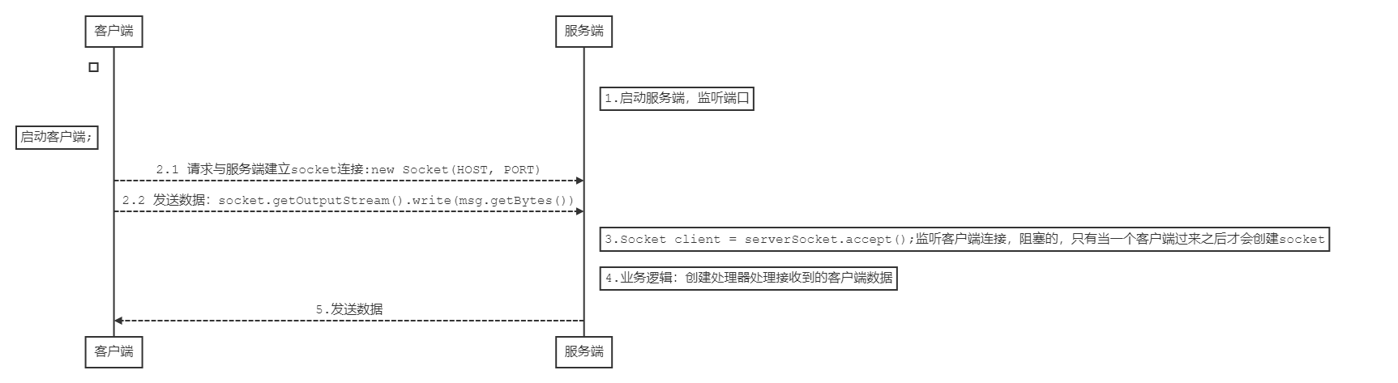

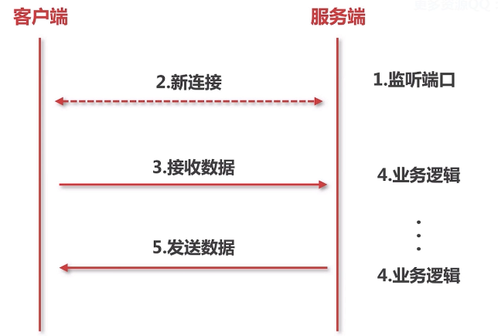

###### 2.1.1 监听端口实际包含两层含义：对应两个while循环

a）server不断的在某个端口上监听新用户的连接

b）新用户的连接建立完成后，在对应的端口上不断的监听新连接的数据

netty实现：

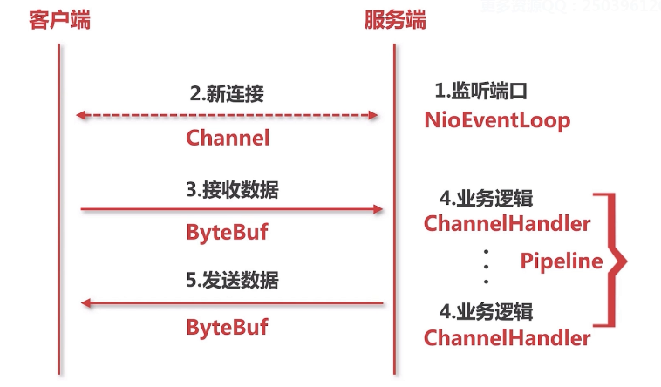

##### 2.2 netty - NioEventLoop

**对应socket编程的线程**

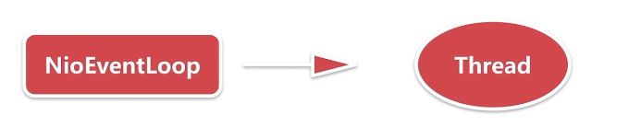

NioEventLoop ：nio事件循环

###### 2.2.1 新连接的接入

###### 2.2.2 当前存在的连接上数据流的读写

##### 2.3 netty - channel

channel 定义：  
* A nexus to a network socket or a component which is capable of I/O  
* operations such as read, write, connect, and bind.

**对应socket编程的socket**

**端口上监听到的新用户的连接**



io.netty.channel.nio.AbstractNioMessageChannel#doReadMessages

SocketChannel ch = javaChannel().accept();

java IO编程模型 -- 当作socket处理

NIO编程模型 -- socketChannel

netty -- 封装成自定义的channel

基于channel，一系列的读写都可以在这个连接上操作，其实就是对socket的抽象

##### 2.4 netty - ByteBuf

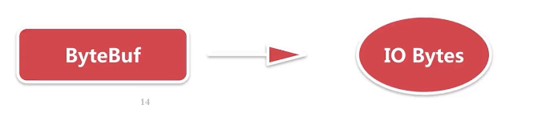

**服务端接受用户的数据流的载体都是基于ByteBuf，封装了很多api可以与底层的连接的数据流通信**

##### 2.5 netty - channelHandler

**服务端处理业务逻辑的处理器**



io.netty.channel.DefaultChannelPipeline#addFirst(io.netty.channel.ChannelHandler...)

通过ChannelPipeline可以动态的添加channelHandler

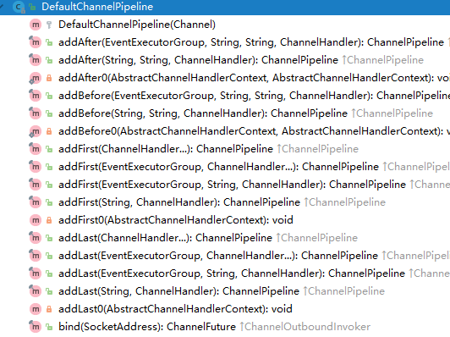

@Override  
public final ChannelPipeline addFirst(ChannelHandler... handlers) {  
 return addFirst(null, handlers);  
}

实际生产环境下，客户端与服务端的通信的时候都很复杂，

一般都需要定义二进制的协议，对二进制协议的数据进行数据包的拆分，对不同类型的协议数据包转换成不同的java对象并作不同的处理。

netty把每一个处理过程都当作ChannelHandler。

将不同的处理过程交给不同的channelHandler处理。

用户可以自定义channelHandler。

例如：数据包分包器

##### 2.6 netty - Pipeline - 逻辑链

netty什么时候将Pipeline加入到每一个客户端连接的处理过程的。

protected AbstractChannel(Channel parent, ChannelId id) {  
 this.parent = parent;  
 this.id = id;  
 unsafe = newUnsafe();  
 pipeline = newChannelPipeline();  
}

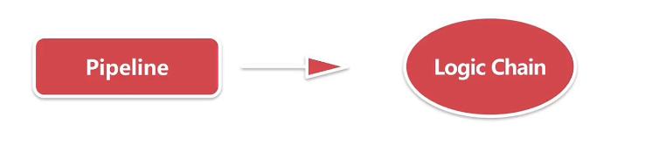

#### 三. netty服务端启动

public final class Server {  
 public static void main(String[] args) {  
 // bossGroup 对应 socket编程中 server端 的 线程  
 EventLoopGroup bossGroup = new NioEventLoopGroup(1);  
 // workGroup 对应 socket编程中 client端 的 线程  
 EventLoopGroup workGroup = new NioEventLoopGroup();  
  
 ServerBootstrap bootstrap = new ServerBootstrap();  
  
 bootstrap.group(bossGroup, workGroup)  
 .channel(NioServerSocketChannel.class)  
 .childOption(ChannelOption.TCP_NODELAY, true)  
 .childAttr(AttributeKey.newInstance("childAttr"), "childAttrValue")  
 .handler(new ServerHandler())  
 .childHandler(new ChannelInitializer<SocketChannel>() {  
  
 @Override  
 protected void initChannel(SocketChannel ch) throws Exception {  
 ch.pipeline().addLast();  
 }  
 });  
 try {  
 //服务端创建的入口 bind()  
 ChannelFuture channelFuture = bootstrap.bind(8888).sync();  
 channelFuture.channel().closeFuture().sync();  
 } catch (InterruptedException e) {  
 e.printStackTrace();  
 }  
 }  
}

##### 3.1 思考：服务端的socket在哪里初始化？在哪里accept连接？

##### 3.2 netty服务端启动的四个过程

###### 3.2.1 创建服务端channel

ChannelFuture channelFuture = bootstrap.bind(8888).sync();

private ChannelFuture doBind(final SocketAddress localAddress) {  
 final ChannelFuture regFuture = initAndRegister();  
 final Channel channel = regFuture.channel();  
 ....  
}

final ChannelFuture initAndRegister() {  
 Channel channel = null;  
 try {  
 channel = channelFactory.newChannel();//创建服务端channel  
 init(channel);//初始化服务端channel  
 } catch (Throwable t) {  
 .....  
}

@Override  
public T newChannel() {  
 try {  
 // 这里的clazz指什么？ --> NioServerSocketChannel.class  
 return clazz.newInstance();//反射  
 } catch (Throwable t) {  
 throw new ChannelException("Unable to create Channel from class " + clazz, t);  
 }  
}

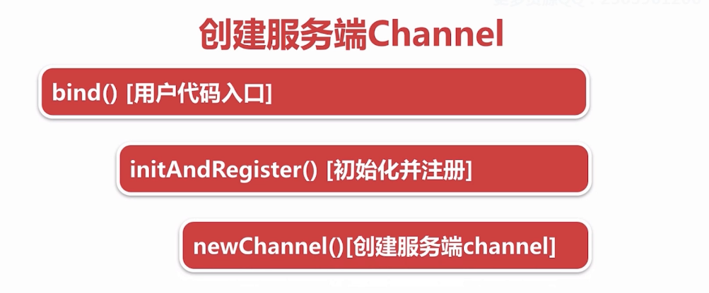

NioServerSocketChannel**如何构造的

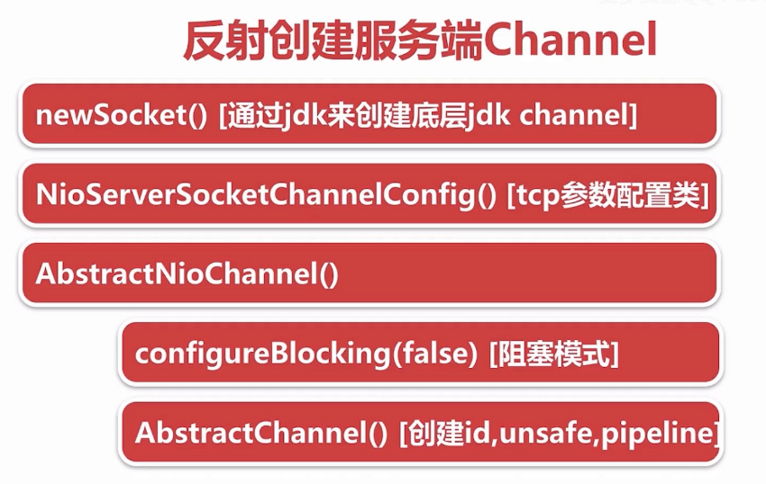

io.netty.channel.socket.nio.NioServerSocketChannel#NioServerSocketChannel()  
public NioServerSocketChannel() {  
 this(newSocket(DEFAULT_SELECTOR_PROVIDER));  
}

io.netty.channel.socket.nio.NioServerSocketChannel#NioServerSocketChannel(java.nio.channels.ServerSocketChannel)  
   
public NioServerSocketChannel(ServerSocketChannel channel) {  
 super(null, channel, SelectionKey.OP_ACCEPT);  
 config = new NioServerSocketChannelConfig(this, javaChannel().socket());  
}

io.netty.channel.nio.AbstractNioChannel#AbstractNioChannel  
protected AbstractNioChannel(Channel parent, SelectableChannel ch, int readInterestOp) {  
 super(parent);  
 this.ch = ch;  
 this.readInterestOp = readInterestOp;  
 try {  
 ch.configureBlocking(false);  
 } catch (IOException e) {  
 ...  
 }  
}

io.netty.channel.AbstractChannel#AbstractChannel(io.netty.channel.Channel)  
protected AbstractChannel(Channel parent) {  
 this.parent = parent;  
 id = newId();  
 unsafe = newUnsafe();  
 pipeline = newChannelPipeline();  
}

###### 3.2.2 初始化服务端channel

* io.netty.bootstrap.AbstractBootstrap#init() 初始化入口
  + set ChannelOptions， ChannelAttrs
  + set ChildOptions，ChildAttrs
  + config handler [配置服务端Pipeline]
  + add ServerBootStrapAcceptor[添加连接接入器]

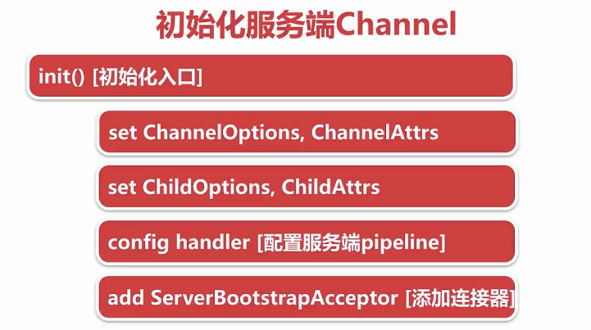

---》保存用户自定义的属性

---》ServerBootstrapAcceptor 创建新连接接入器（一个特殊的channelHandler）

---》将用户自定义的属性传到新连接接入器中，当accept到一个新连接，通过这几个属性对新的连接进行配置，就可以把一个新的连接绑定到一个新的线程上去。

@Override  
void init(Channel channel) throws Exception {  
 final Map<ChannelOption<?>, Object> options = options0();  
 synchronized (options) {  
 channel.config().setOptions(options);  
 }  
  
 final Map<AttributeKey<?>, Object> attrs = attrs0();  
 synchronized (attrs) {  
 for (Entry<AttributeKey<?>, Object> e: attrs.entrySet()) {  
 @SuppressWarnings("unchecked")  
 AttributeKey<Object> key = (AttributeKey<Object>) e.getKey();  
 channel.attr(key).set(e.getValue());  
 }  
 }  
  
 ChannelPipeline p = channel.pipeline();  
  
 final EventLoopGroup currentChildGroup = childGroup;  
 final ChannelHandler currentChildHandler = childHandler;  
 final Entry<ChannelOption<?>, Object>[] currentChildOptions;  
 final Entry<AttributeKey<?>, Object>[] currentChildAttrs;  
 synchronized (childOptions) {  
 currentChildOptions = childOptions.entrySet().toArray(newOptionArray(childOptions.size()));  
 }  
 synchronized (childAttrs) {  
 currentChildAttrs = childAttrs.entrySet().toArray(newAttrArray(childAttrs.size()));  
 }  
  
 p.addLast(new ChannelInitializer<Channel>() {  
 @Override  
 public void initChannel(Channel ch) throws Exception {  
 final ChannelPipeline pipeline = ch.pipeline();  
 ChannelHandler handler = config.handler();  
 if (handler != null) {  
 pipeline.addLast(handler);  
 }  
 ch.eventLoop().execute(new Runnable() {  
 @Override  
 public void run() {  
 pipeline.addLast(new ServerBootstrapAcceptor(  
 currentChildGroup, currentChildHandler, currentChildOptions, currentChildAttrs));  
 }  
 });  
 }  
 });  
}

###### 3.2.3 将channel注册到事件轮询器selector

* io.netty.channel.AbstractChannel.AbstractUnsafe#register（channel）[入口]
* this.eventLoop = eventLoop [绑定线程]
* io.netty.channel.AbstractChannel.AbstractUnsafe#register0 [实际注册]
  + io.netty.channel.AbstractChannel#doRegister [调用底层JDK底层注册]
  + io.netty.channel.DefaultChannelPipeline#invokeHandlerAddedIfNeeded [添加channelHandler的时候触发用户回调]
  + io.netty.channel.DefaultChannelPipeline#fireChannelActive [传播channel注册成功事件到用户代码方法]

#ChannelFuture regFuture = config().group().register(channel);  
  
@Override  
 public final void register(EventLoop eventLoop, final ChannelPromise promise) {  
 if (eventLoop == null) {  
 throw new NullPointerException("eventLoop");  
 }  
 if (isRegistered()) {  
 promise.setFailure(new IllegalStateException("registered to an event loop already"));  
 return;  
 }  
 if (!isCompatible(eventLoop)) {  
 promise.setFailure(  
 new IllegalStateException("incompatible event loop type: " + eventLoop.getClass().getName()));  
 return;  
 }  
 // 处理所有I/O事件  
 AbstractChannel.this.eventLoop = eventLoop;  
 if (eventLoop.inEventLoop()) {  
 register0(promise);  
 } else {  
 try {  
 eventLoop.execute(new Runnable() {  
 @Override  
 public void run() {  
 register0(promise);  
 }  
 });  
 } catch (Throwable t) {  
 logger.warn(  
 "Force-closing a channel whose registration task was not accepted by an event loop: {}",  
 AbstractChannel.this, t);  
 closeForcibly();  
 closeFuture.setClosed();  
 safeSetFailure(promise, t);  
 }  
 }  
 }

private void register0(ChannelPromise promise) {  
 try {  
 // check if the channel is still open as it could be closed in the mean time when the register  
 // call was outside of the eventLoop  
 if (!promise.setUncancellable() || !ensureOpen(promise)) {  
 return;  
 }  
 boolean firstRegistration = neverRegistered;  
 doRegister();  
 neverRegistered = false;  
 registered = true;  
  
 // Ensure we call handlerAdded(...) before we actually notify the promise. This is needed as the  
 // user may already fire events through the pipeline in the ChannelFutureListener.  
 pipeline.invokeHandlerAddedIfNeeded();  
  
 safeSetSuccess(promise);  
 pipeline.fireChannelRegistered();  
 // Only fire a channelActive if the channel has never been registered. This prevents firing  
 // multiple channel actives if the channel is deregistered and re-registered.  
 if (isActive()) {  
 if (firstRegistration) {  
 pipeline.fireChannelActive();  
 } else if (config().isAutoRead()) {  
 // This channel was registered before and autoRead() is set. This means we need to begin read  
 // again so that we process inbound data.  
 //  
 // See https://github.com/netty/netty/issues/4805  
 beginRead();  
 }  
 }  
 } catch (Throwable t) {  
 // Close the channel directly to avoid FD leak.  
 closeForcibly();  
 closeFuture.setClosed();  
 safeSetFailure(promise, t);  
 }  
}

io.netty.channel.nio.AbstractNioChannel#doRegister

@Override  
protected void doRegister() throws Exception {  
 boolean selected = false;  
 for (;;) {  
 try {  
 //调用jdk底层的注册方法 this代表 NioServerSocketChannel.class  
 //将NioServerSocketChannel作为一个attachment传到jdk底层的channel  
 selectionKey = javaChannel().register(eventLoop().selector, 0, this);  
 return;  
 } catch (CancelledKeyException e) {  
 if (!selected) {  
 eventLoop().selectNow();  
 selected = true;  
 } else {  
 // We forced a select operation on the selector before but the SelectionKey is still cached  
 // for whatever reason. JDK bug ?  
 throw e;  
 }  
 }  
 }  
}

java.nio.channels.SelectableChannel#register(java.nio.channels.Selector, int, java.lang.Object)

* @param sel  
* The selector with which this channel is to be registered  
* @param ops  
* The interest set for the resulting key  
* @param att  
* The attachment for the resulting key; may be <tt>null</tt>  
 public abstract SelectionKey register(Selector sel, int ops, Object att)  
 throws ClosedChannelException;

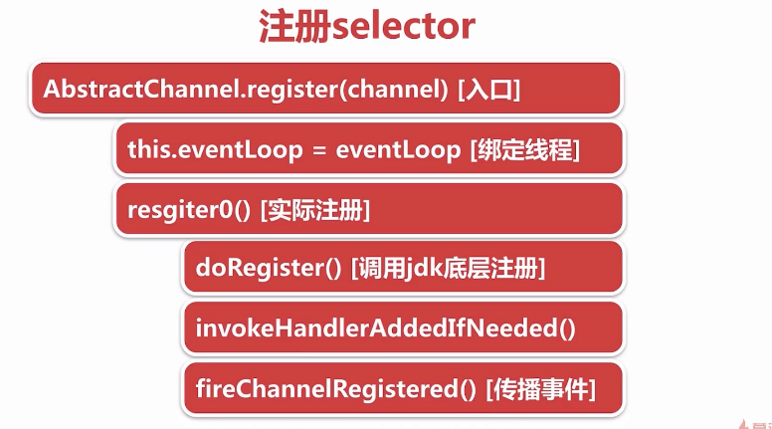

###### 3.2.4 端口绑定

###### fig:

* io.netty.channel.AbstractChannel.AbstractUnsafe#bind [入口]
* io.netty.channel.AbstractChannel#doBind

@Override  
public final void bind(final SocketAddress localAddress, final ChannelPromise promise) {  
 assertEventLoop();  
  
 if (!promise.setUncancellable() || !ensureOpen(promise)) {  
 return;  
 }  
 if (Boolean.TRUE.equals(config().getOption(ChannelOption.SO_BROADCAST)) &&  
 localAddress instanceof InetSocketAddress &&  
 !((InetSocketAddress) localAddress).getAddress().isAnyLocalAddress() &&  
 !PlatformDependent.isWindows() && !PlatformDependent.isRoot()) {  
 logger.warn(  
 "A non-root user can't receive a broadcast packet if the socket " +  
 "is not bound to a wildcard address; binding to a non-wildcard " +  
 "address (" + localAddress + ") anyway as requested.");  
 }  
 //端口绑定之前是false，doBind之后变为true  
 boolean wasActive = isActive();  
 try {  
   
 doBind(localAddress);  
   
 } catch (Throwable t) {  
 safeSetFailure(promise, t);  
 closeIfClosed();  
 return;  
 }  
  
 //端口绑定之前不是active，绑定之后编程active  
 if (!wasActive && isActive()) {  
 invokeLater(new Runnable() {  
 @Override  
 public void run() {  
 //传播事件  
 pipeline.fireChannelActive();  
 }  
 });  
 }  
  
 safeSetSuccess(promise);  
}

io.netty.channel.socket.nio.NioServerSocketChannel#doBind

@Override  
protected void doBind(SocketAddress localAddress) throws Exception {  
 if (PlatformDependent.javaVersion() >= 7) {  
 //调用java底层api  
 javaChannel().bind(localAddress, config.getBacklog());  
 } else {  
 javaChannel().socket().bind(localAddress, config.getBacklog());  
 }  
}

io.netty.channel.DefaultChannelPipeline.HeadContext#channelActive

@Override  
public void channelActive(ChannelHandlerContext ctx) throws Exception {  
 ctx.fireChannelActive();  
  
 readIfIsAutoRead();  
}

io.netty.channel.DefaultChannelPipeline.HeadContext#readIfIsAutoRead

private void readIfIsAutoRead() {  
 if (channel.config().isAutoRead()) {  
 channel.read();  
 }  
}

io.netty.channel.AbstractChannel#read

@Override  
public Channel read() {  
 pipeline.read();  
 return this;  
}

io.netty.channel.AbstractChannelHandlerContext#read

@Override  
public ChannelHandlerContext read() {  
 final AbstractChannelHandlerContext next = findContextOutbound();  
 EventExecutor executor = next.executor();  
 if (executor.inEventLoop()) {  
 next.invokeRead();  
 } else {  
 Runnable task = next.invokeReadTask;  
 if (task == null) {  
 next.invokeReadTask = task = new Runnable() {  
 @Override  
 public void run() {  
 next.invokeRead();  
 }  
 };  
 }  
 executor.execute(task);  
 }  
  
 return this;  
}

io.netty.channel.DefaultChannelPipeline.HeadContext#read

@Override  
public void read(ChannelHandlerContext ctx) {  
 unsafe.beginRead();  
}

io.netty.channel.AbstractChannel.AbstractUnsafe#beginRead

@Override  
public final void beginRead() {  
 assertEventLoop();  
  
 if (!isActive()) {  
 return;  
 }  
 try {  
 doBeginRead();  
 } catch (final Exception e) {  
 invokeLater(new Runnable() {  
 @Override  
 public void run() {  
 pipeline.fireExceptionCaught(e);  
 }  
 });  
 close(voidPromise());  
 }  
}

io.netty.channel.nio.AbstractNioChannel#doBeginRead

@Override  
protected void doBeginRead() throws Exception {  
 // Channel.read() or ChannelHandlerContext.read() was called  
 //channel注册到selector上后返回的key，key对应channel  
 final SelectionKey selectionKey = this.selectionKey;  
 if (!selectionKey.isValid()) {  
 return;  
 }  
  
 readPending = true;  
  
 //Retrieves this key's interest set  
 final int interestOps = selectionKey.interestOps();  
 //与运算  
 if ((interestOps & readInterestOp) == 0) {  
 //将2者进行或运算以后重新注册到selectionKey上 即在之前事件的基础上再增加一个事件  
 //readInterestOp 其实是NioServerSocketChannel的构造函数传进来的SelectionKey.OP_ACCEPT  
 //是个accept事件  
 selectionKey.interestOps(interestOps | readInterestOp);  
 }  
}

小结：

---》端口绑定bind

---》触发active事件

---》服务端channe doBeginRead方法, 向selector注册accept事件，这样netty就可以接收新的连接

tip:

与(&)运算： 同为 1 才为1

5 二进制 101  
3 二进制 011  
 结果 001

或(|)运算：有一个为1，则为1

5 二进制 101  
3 二进制 011  
 结果 111

异或(^)运算：不相同则为 1

5 二进制 101  
3 二进制 011  
 结果 110

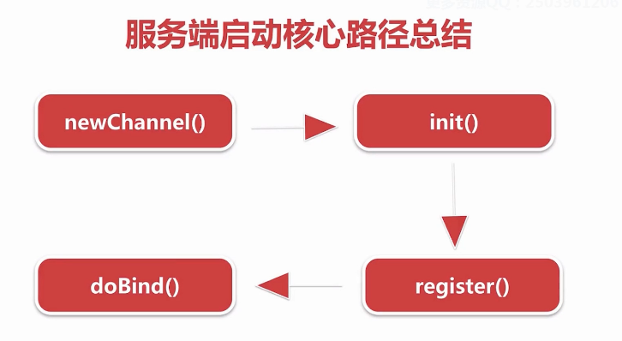

#### 四、NioEventLoop

##### 4.1 思考三个问题

* 默认情况下，Netty服务端起多少线程？何时启动？
  + 2*cpu 调用execute方法时，判断当前线程是EventLoop线程，若是说明线程已启动，若是外部线程，则会调用startThread方法，判断当前线程是否启动，没有则启动当前线程。
* Netty如何解决JDK空轮询bug，避免cpu飙高的？
* 超过512次，重新创建selector，并把原selector的所有的key移交到新的select or
* Netty如何保证异步串行无锁化？
* netty通过inEventLoop方法判断是外部线程，将所有操作封装成一个task丢到MpscQueue中，挨个执行。
  + 拿到客户端的一个channel，不需要对这个channel同步就可以进行多线程并发读写。
  + channelHandler中的所有操作都是线程安全的，不需要进行同步

##### 4.2 NioEventLoop创建

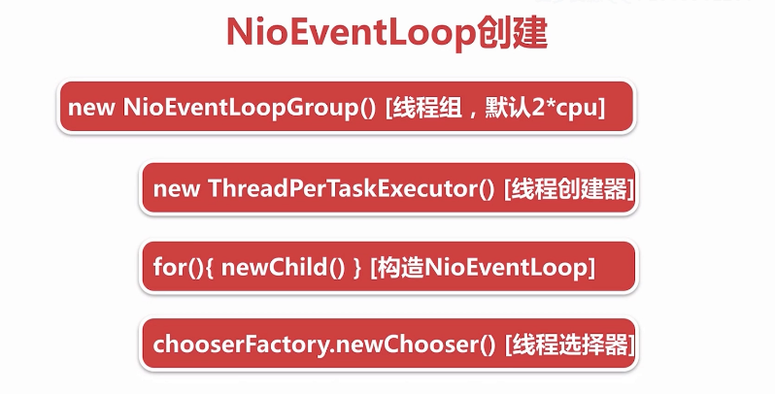

* new NioEventLoopGroup(1) [线程组，默认 2*CPU] ：若不传构造参数，默认创建2倍cpu核心数的NioEventLoopGroup
* protected MultithreadEventLoopGroup(int nThreads, Executor executor, Object... args) {  
   super(nThreads == 0 ? DEFAULT_EVENT_LOOP_THREADS : nThreads, executor, args);  
  }
* new ThreadPerTaskExecutor(newDefaultThreadFactory()) [线程创建器]：负责创建NioEventLoop底层对应的线程
  + 每次执行任务都会创建一个线程 : netty自己封装的FastThreadLocalThread，并非原生的线程。
  + NioEventLoop线程命名规则 nioEventLoop-1-xx
* for(){ new Child() } [构造NioEventLoop]
  + 保存线程执行器 ThreadPerTaskExecutor
  + 创建一个MpscQueue
  + io.netty.channel.nio.NioEventLoopGroup#newChild
  + @Override  
    protected EventLoop newChild(Executor executor, Object... args) throws Exception {  
     return new NioEventLoop(this, executor, (SelectorProvider) args[0],  
     ((SelectStrategyFactory) args[1]).newSelectStrategy(), (RejectedExecutionHandler) args[2]);  
    }
  + protected SingleThreadEventLoop(EventLoopGroup parent, Executor executor,  
     boolean addTaskWakesUp, int maxPendingTasks,  
     RejectedExecutionHandler rejectedExecutionHandler) {  
     super(parent, executor, addTaskWakesUp, maxPendingTasks, rejectedExecutionHandler);  
     tailTasks = newTaskQueue(maxPendingTasks);  
    }
  + io.netty.channel.nio.NioEventLoop#newTaskQueue
  + @Override  
    protected Queue<Runnable> newTaskQueue(int maxPendingTasks) {  
     // This event loop never calls takeTask()  
     //Mpsc MUltiply producer（外部线程） single consumer（NioEventLoop线程）   
     return PlatformDependent.newMpscQueue(maxPendingTasks);  
    }
  + /**  
     * Create a new {@link Queue} which is safe to use for multiple producers (different threads) and a single  
     * consumer (one thread!).  
     */  
    public static <T> Queue<T> newMpscQueue(final int maxCapacity) {  
     return Mpsc.newMpscQueue(maxCapacity);  
    }
  + 创建一个selector
  + NioEventLoop(NioEventLoopGroup parent, Executor executor, SelectorProvider selectorProvider,  
     SelectStrategy strategy, RejectedExecutionHandler rejectedExecutionHandler) {  
     super(parent, executor, false, DEFAULT_MAX_PENDING_TASKS, rejectedExecutionHandler);  
     if (selectorProvider == null) {  
     throw new NullPointerException("selectorProvider");  
     }  
     if (strategy == null) {  
     throw new NullPointerException("selectStrategy");  
     }  
     provider = selectorProvider;  
     //一个selector和一个NioEventLoop绑定  
     selector = openSelector();  
     selectStrategy = strategy;  
    }
* chooserFactory.newChooser(children) [线程选择器]：为每一个新连接，分配NioEventLoop线程
* io.netty.util.concurrent.MultithreadEventExecutorGroup#next
* 第1个连接进来的时候选择第1个nioEventLoop进行绑定
* .....
* 第n个连接进来的时候选择第n个nioEventLoop进行绑定
* 第n+1个连接进来的时候选择第1个nioEventLoop进行绑定,循环进行

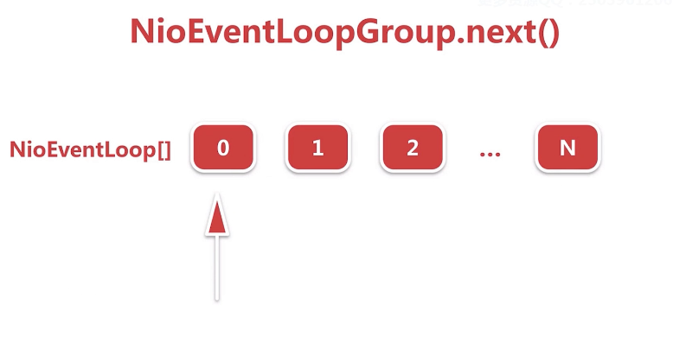

**netty经过优化：**与运算实现循环取数组下标，要比取模运算高效的多,因为在计算机底层，与运算是二进制的运算。

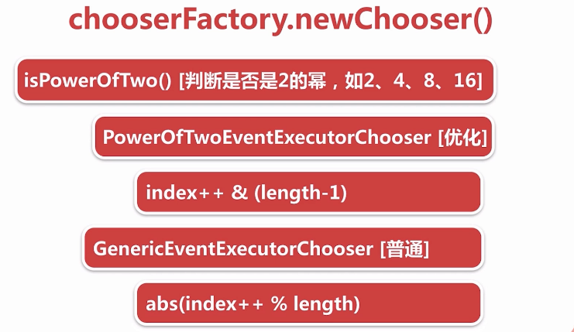

public EventExecutorChooser newChooser(EventExecutor[] executors) {  
 if (isPowerOfTwo(executors.length)) {  
 return new PowerOfTowEventExecutorChooser(executors);  
 } else {  
 return new GenericEventExecutorChooser(executors);  
 }  
}

io.netty.util.concurrent.DefaultEventExecutorChooserFactory.GenericEventExecutorChooser#next

@Override  
 public EventExecutor next() {  
 return executors[Math.abs(idx.getAndIncrement() % executors.length)];  
 }

io.netty.util.concurrent.DefaultEventExecutorChooserFactory.PowerOfTowEventExecutorChooser#next

public EventExecutor next() {  
 return executors[idx.getAndIncrement() & executors.length - 1];  
}

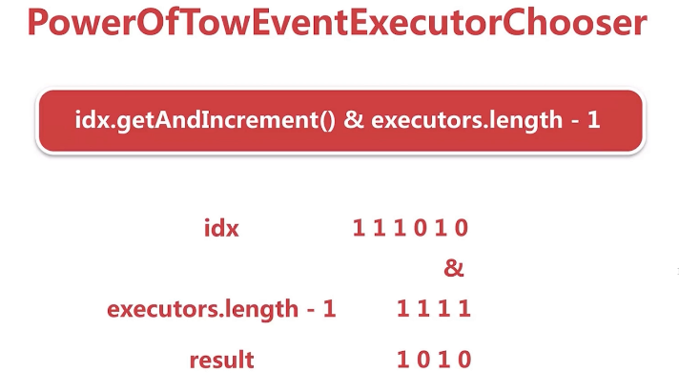

##### 4.3 NioEventLoop启动流程

NioEventLoop启动两大触发器：

* 服务端启动绑定端口
  + 服务端将具体绑定端口的操作封装成一个task，调用NioEventLoop的execute方法
  + netty判断调用execute方法的线程是否是Nio线程，若不是，调用startThread()方法尝试创建线程。
  + 通过线程执行器 ThreadPerTaskExecutor创建nio线程 - FastThreadLocalThread
  + NioEventLoop对象会将创建的线程保存，目的是为了：判断后续对NioEventLoop相关的执行线程是否是本身，若不是，就封装成一个task，扔到一个taskQueue中串行执行，保证线程安全
  + 调用驱动NioEventLoop运转的核心方法：run()
* 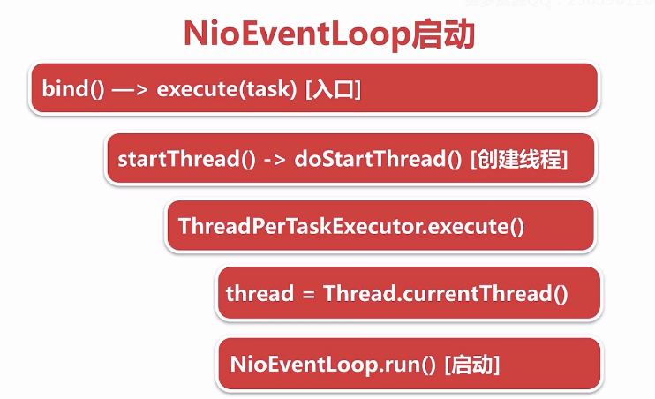
* io.netty.bootstrap.AbstractBootstrap#doBind0  
  private static void doBind0(  
   ......  
   channel.eventLoop().execute(new Runnable() {  
   @Override  
   public void run() {  
   if (regFuture.isSuccess()) {  
   channel.bind(localAddress, promise).addListener(ChannelFutureListener.CLOSE_ON_FAILURE);  
   } else {  
   promise.setFailure(regFuture.cause());  
   }  
   }  
   });
* io.netty.util.concurrent.SingleThreadEventExecutor#execute  
  @Override  
  public void execute(Runnable task) {  
   if (task == null) {  
   throw new NullPointerException("task");  
   }  
   boolean inEventLoop = inEventLoop();  
   if (inEventLoop) {  
   addTask(task);  
   } else {  
   startThread();  
   addTask(task);  
   if (isShutdown() && removeTask(task)) {  
   reject();  
   }  
   }  
   if (!addTaskWakesUp && wakesUpForTask(task)) {  
   wakeup(inEventLoop);  
   }  
  }
* io.netty.util.concurrent.AbstractEventExecutor#inEventLoop  
  判断线程是否是EventLoop线程  
  @Override  
  public boolean inEventLoop() {  
   return inEventLoop(Thread.currentThread());  
  }
* io.netty.util.concurrent.SingleThreadEventExecutor#inEventLoop  
  io.netty.util.concurrent.SingleThreadEventExecutor#thread  
    
  private volatile Thread thread;  
  @Override  
  public boolean inEventLoop(Thread thread) {  
   return thread == this.thread;  
  }
* private void startThread() {  
   if (STATE_UPDATER.get(this) == ST_NOT_STARTED) {  
   if (STATE_UPDATER.compareAndSet(this, ST_NOT_STARTED, ST_STARTED)) {  
   doStartThread();  
   }  
   }  
  }
* private void doStartThread() {  
   assert thread == null;  
   executor.execute(new Runnable() {  
   @Override  
   public void run() {  
   thread = Thread.currentThread();  
   if (interrupted) {  
   thread.interrupt();  
   }  
    
   boolean success = false;  
   updateLastExecutionTime();  
   try {  
   SingleThreadEventExecutor.this.run();  
   success = true;  
   } catch (Throwable t) {  
   logger.warn("Unexpected exception from an event executor: ", t);  
   } finally {  
   for (;;) {  
   int oldState = STATE_UPDATER.get(SingleThreadEventExecutor.this);  
   if (oldState >= ST_SHUTTING_DOWN || STATE_UPDATER.compareAndSet(  
   SingleThreadEventExecutor.this, oldState, ST_SHUTTING_DOWN)) {  
   break;  
   }  
   }  
    
   // Check if confirmShutdown() was called at the end of the loop.  
   if (success && gracefulShutdownStartTime == 0) {  
   logger.error("Buggy " + EventExecutor.class.getSimpleName() + " implementation; " +  
   SingleThreadEventExecutor.class.getSimpleName() + ".confirmShutdown() must be called " +  
   "before run() implementation terminates.");  
   }  
    
   try {  
   // Run all remaining tasks and shutdown hooks.  
   for (;;) {  
   if (confirmShutdown()) {  
   break;  
   }  
   }  
   } finally {  
   try {  
   cleanup();  
   } finally {  
   STATE_UPDATER.set(SingleThreadEventExecutor.this, ST_TERMINATED);  
   threadLock.release();  
   if (!taskQueue.isEmpty()) {  
   logger.warn(  
   "An event executor terminated with " +  
   "non-empty task queue (" + taskQueue.size() + ')');  
   }  
    
   terminationFuture.setSuccess(null);  
   }  
   }  
   }  
   }  
   });  
  }

#### 4.4 NioEventLoop执行逻辑 （底层干了哪些事情，如何保证高效运转）

* 
* 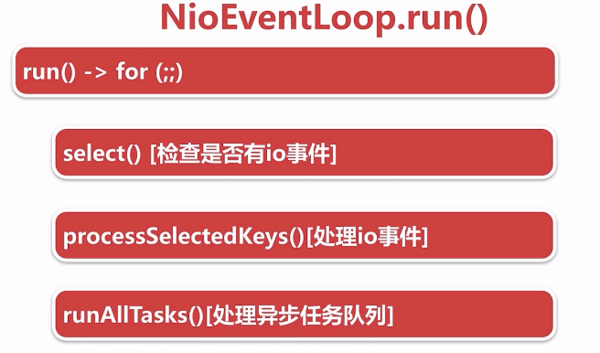
* NioEventLoop 执行逻辑：
* for循环体做三件事情：
* ---》调用select方法轮询注册到selector上的连接的i/o事件
* ---》调用processSelectedKeys()处理轮询出来的i/o事件
* ---》调用runAllTasks()方法处理外部线程扔到taskQueue中的任务
* @Override  
  protected void run() {  
   for (;;) {  
   try {  
   switch (selectStrategy.calculateStrategy(selectNowSupplier, hasTasks())) {  
   case SelectStrategy.CONTINUE:  
   continue;  
   case SelectStrategy.SELECT:  
   select(wakenUp.getAndSet(false));  
   if (wakenUp.get()) {  
   selector.wakeup();  
   }  
   default:  
   // fallthrough  
   }  
    
   cancelledKeys = 0;  
   needsToSelectAgain = false;  
   //默认50，处理i/o事件和运行任务时间是1 ：1  
   final int ioRatio = this.ioRatio;  
   if (ioRatio == 100) {  
   try {  
   processSelectedKeys();  
   } finally {  
   // Ensure we always run tasks.  
   runAllTasks();  
   }  
   } else {  
   final long ioStartTime = System.nanoTime();  
   try {  
   processSelectedKeys();  
   } finally {  
   // Ensure we always run tasks.  
   final long ioTime = System.nanoTime() - ioStartTime;  
   runAllTasks(ioTime * (100 - ioRatio) / ioRatio);  
   }  
   }  
   } catch (Throwable t) {  
   handleLoopException(t);  
   }  
   // Always handle shutdown even if the loop processing threw an exception.  
   try {  
   if (isShuttingDown()) {  
   closeAll();  
   if (confirmShutdown()) {  
   return;  
   }  
   }  
   } catch (Throwable t) {  
   handleLoopException(t);  
   }  
   }  
  }
  + **检测i/o事件，select方法执行逻辑**
    - deadline及任务穿插逻辑处理
      * select操作进行deadline处理，判断如果当前有任务在taskQueue里面就终止本次select操作
    - 阻塞式select
      * 如果没有到截止时间并且taskQueue没有任务，就进行阻塞式select操作
    - 避免jdk空轮询bug
      * 阻塞式select操作结束之后，判断这次select操作是否真的阻塞这么长时间，如果没有阻塞这么长时间，则表示可能触发了jdk nio空轮询的bug，接下来netty判断触发空轮询次数是否达到一定的阈值（512），如果达到阈值，就通过替换原来select操作的方式，巧妙的避开了空轮询的bug
  + io.netty.channel.nio.NioEventLoop#select
  + private void select(boolean oldWakenUp) throws IOException {  
     Selector selector = this.selector;  
     try {  
     int selectCnt = 0;  
     long currentTimeNanos = System.nanoTime();  
     long selectDeadLineNanos = currentTimeNanos + delayNanos(currentTimeNanos);  
     for (;;) {  
     long timeoutMillis = (selectDeadLineNanos - currentTimeNanos + 500000L) / 1000000L;  
     if (timeoutMillis <= 0) {  
     if (selectCnt == 0) {  
     selector.selectNow();  
     selectCnt = 1;  
     }  
     break;  
     }  
     if (hasTasks() && wakenUp.compareAndSet(false, true)) {  
     selector.selectNow();  
     selectCnt = 1;  
     break;  
     }  
     int selectedKeys = selector.select(timeoutMillis);  
     selectCnt ++;  
      
     if (selectedKeys != 0 || oldWakenUp || wakenUp.get() || hasTasks() || hasScheduledTasks()) {  
     break;  
     }  
     if (Thread.interrupted()) {  
     if (logger.isDebugEnabled()) {  
     logger.debug("Selector.select() returned prematurely because " +  
     "Thread.currentThread().interrupt() was called. Use " +  
     "NioEventLoop.shutdownGracefully() to shutdown the NioEventLoop.");  
     }  
     selectCnt = 1;  
     break;  
     }  
      
     long time = System.nanoTime();  
     if (time - TimeUnit.MILLISECONDS.toNanos(timeoutMillis) >= currentTimeNanos) {  
     // timeoutMillis elapsed without anything selected.  
     selectCnt = 1;  
     } else if (SELECTOR_AUTO_REBUILD_THRESHOLD > 0 &&  
     selectCnt >= SELECTOR_AUTO_REBUILD_THRESHOLD) {  
     logger.warn(  
     "Selector.select() returned prematurely {} times in a row; rebuilding Selector {}.",  
     selectCnt, selector);  
      
     rebuildSelector();  
     selector = this.selector;  
     // Select again to populate selectedKeys.  
     selector.selectNow();  
     selectCnt = 1;  
     break;  
     }  
     currentTimeNanos = time;  
     }  
      
     if (selectCnt > MIN_PREMATURE_SELECTOR_RETURNS) {  
     if (logger.isDebugEnabled()) {  
     logger.debug("Selector.select() returned prematurely {} times in a row for Selector {}.",  
     selectCnt - 1, selector);  
     }  
     }  
     } catch (CancelledKeyException e) {  
     if (logger.isDebugEnabled()) {  
     logger.debug(CancelledKeyException.class.getSimpleName() + " raised by a Selector {} - JDK bug?",  
     selector, e);  
     }  
     }  
    }
  + io.netty.channel.nio.NioEventLoop#rebuildSelector
  + public void rebuildSelector() {  
     if (!inEventLoop()) {  
     execute(new Runnable() {  
     @Override  
     public void run() {  
     rebuildSelector();  
     }  
     });  
     return;  
     }  
      
     final Selector oldSelector = selector;  
     final Selector newSelector;  
      
     if (oldSelector == null) {  
     return;  
     }  
      
     try {  
     newSelector = openSelector();  
     } catch (Exception e) {  
     logger.warn("Failed to create a new Selector.", e);  
     return;  
     }  
      
     // Register all channels to the new Selector.  
     int nChannels = 0;  
     for (;;) {  
     try {  
     for (SelectionKey key: oldSelector.keys()) {  
     Object a = key.attachment();  
     try {  
     if (!key.isValid() || key.channel().keyFor(newSelector) != null) {  
     continue;  
     }  
      
     int interestOps = key.interestOps();  
     key.cancel();  
     SelectionKey newKey = key.channel().register(newSelector, interestOps, a);  
     if (a instanceof AbstractNioChannel) {  
     // Update SelectionKey  
     ((AbstractNioChannel) a).selectionKey = newKey;  
     }  
     nChannels ++;  
     } catch (Exception e) {  
     logger.warn("Failed to re-register a Channel to the new Selector.", e);  
     if (a instanceof AbstractNioChannel) {  
     AbstractNioChannel ch = (AbstractNioChannel) a;  
     ch.unsafe().close(ch.unsafe().voidPromise());  
     } else {  
     @SuppressWarnings("unchecked")  
     NioTask<SelectableChannel> task = (NioTask<SelectableChannel>) a;  
     invokeChannelUnregistered(task, key, e);  
     }  
     }  
     }  
     } catch (ConcurrentModificationException e) {  
     // Probably due to concurrent modification of the key set.  
     continue;  
     }  
      
     break;  
     }  
      
     selector = newSelector;  
      
     try {  
     // time to close the old selector as everything else is registered to the new one  
     oldSelector.close();  
     } catch (Throwable t) {  
     if (logger.isWarnEnabled()) {  
     logger.warn("Failed to close the old Selector.", t);  
     }  
     }  
      
     logger.info("Migrated " + nChannels + " channel(s) to the new Selector.");  
    }
  + io.netty.channel.nio.NioEventLoop#openSelector
  + private Selector openSelector() {  
     final Selector selector;  
     try {  
     //调用jdkApi创建selector  
     selector = provider.openSelector();  
     } catch (IOException e) {  
     throw new ChannelException("failed to open a new selector", e);  
     }  
     //如果不需要优化，直接返回原生selector  
     if (DISABLE_KEYSET_OPTIMIZATION) {  
     return selector;  
     }  
     //SelectedSelectionKeySet 底层是用数组 + keySize的方式实现的  
     final SelectedSelectionKeySet selectedKeySet = new SelectedSelectionKeySet();  
      
     Object maybeSelectorImplClass = AccessController.doPrivileged(new PrivilegedAction<Object>() {  
     @Override  
     public Object run() {  
     try {  
     return Class.forName(  
     "sun.nio.ch.SelectorImpl",  
     false,  
     PlatformDependent.getSystemClassLoader());  
     } catch (ClassNotFoundException e) {  
     return e;  
     } catch (SecurityException e) {  
     return e;  
     }  
     }  
     });  
      
     if (!(maybeSelectorImplClass instanceof Class) ||  
     // ensure the current selector implementation is what we can instrument.  
     !((Class<?>) maybeSelectorImplClass).isAssignableFrom(selector.getClass())) {  
     if (maybeSelectorImplClass instanceof Exception) {  
     Exception e = (Exception) maybeSelectorImplClass;  
     logger.trace("failed to instrument a special java.util.Set into: {}", selector, e);  
     }  
     return selector;  
     }  
     final Class<?> selectorImplClass = (Class<?>) maybeSelectorImplClass;  
     Object maybeException = AccessController.doPrivileged(new PrivilegedAction<Object>() {  
     @Override  
     public Object run() {  
     try {  
     Field selectedKeysField = selectorImplClass.getDeclaredField("selectedKeys");  
     Field publicSelectedKeysField = selectorImplClass.getDeclaredField("publicSelectedKeys");  
      
     selectedKeysField.setAccessible(true);  
     publicSelectedKeysField.setAccessible(true);  
      
     selectedKeysField.set(selector, selectedKeySet);  
     publicSelectedKeysField.set(selector, selectedKeySet);  
     return null;  
     } catch (NoSuchFieldException e) {  
     return e;  
     } catch (IllegalAccessException e) {  
     return e;  
     } catch (RuntimeException e) {  
     // JDK 9 can throw an inaccessible object exception here; since Netty compiles  
     // against JDK 7 and this exception was only added in JDK 9, we have to weakly  
     // check the type  
     if ("java.lang.reflect.InaccessibleObjectException".equals(e.getClass().getName())) {  
     return e;  
     } else {  
     throw e;  
     }  
     }  
     }  
     });  
     if (maybeException instanceof Exception) {  
     selectedKeys = null;  
     Exception e = (Exception) maybeException;  
     logger.trace("failed to instrument a special java.util.Set into: {}", selector, e);  
     } else {  
     selectedKeys = selectedKeySet;  
     logger.trace("instrumented a special java.util.Set into: {}", selector);  
     }  
     return selector;  
    }
  + java.lang.Class#isAssignableFrom 判断是否是一个类的实现
  + - **处理i/o事件，processSelectedKeys执行逻辑**
    - select操作每次都会把已经就绪状态的i/o事件，放到底层一个HashSet的数据结构中。
    - netty默认情况下，会通过反射将select底层的HashSet转换成数组的方式进行优化，
    - 在处理每一个Keyset的时候，都会拿到对应的一个attachment，这个attachment就是
    - 向selector注册i/o事件的时候绑定的经过netty封装之后的channel。
      * selected keySet优化
        + 用数组替换select HashSet的实现，做到add方法时间复杂度为o(1)
      * processSelectedKeysOptimized()
        + 真正处理I/O事件
  + private void processSelectedKeysOptimized(SelectionKey[] selectedKeys) {  
     for (int i = 0;; i ++) {  
     final SelectionKey k = selectedKeys[i];  
     if (k == null) {  
     break;  
     }  
     // null out entry in the array to allow to have it GC'ed once the Channel close  
     // See https://github.com/netty/netty/issues/2363  
     selectedKeys[i] = null;  
      
     final Object a = k.attachment();  
      
     if (a instanceof AbstractNioChannel) {  
     processSelectedKey(k, (AbstractNioChannel) a);  
     } else {  
     @SuppressWarnings("unchecked")  
     NioTask<SelectableChannel> task = (NioTask<SelectableChannel>) a;  
     processSelectedKey(k, task);  
     }  
      
     if (needsToSelectAgain) {  
     // null out entries in the array to allow to have it GC'ed once the Channel close  
     // See https://github.com/netty/netty/issues/2363  
     for (;;) {  
     i++;  
     if (selectedKeys[i] == null) {  
     break;  
     }  
     selectedKeys[i] = null;  
     }  
      
     selectAgain();  
     // Need to flip the optimized selectedKeys to get the right reference to the array  
     // and reset the index to -1 which will then set to 0 on the for loop  
     // to start over again.  
     //  
     // See https://github.com/netty/netty/issues/1523  
     selectedKeys = this.selectedKeys.flip();  
     i = -1;  
     }  
     }  
    }
* io.netty.channel.nio.NioEventLoop#processSelectedKey(java.nio.channels.SelectionKey, io.netty.channel.nio.AbstractNioChannel)
* private void processSelectedKey(SelectionKey k, AbstractNioChannel ch) {  
   final AbstractNioChannel.NioUnsafe unsafe = ch.unsafe();  
   if (!k.isValid()) {  
   final EventLoop eventLoop;  
   try {  
   eventLoop = ch.eventLoop();  
   } catch (Throwable ignored) {  
   // If the channel implementation throws an exception because there is no event loop, we ignore this  
   // because we are only trying to determine if ch is registered to this event loop and thus has authority  
   // to close ch.  
   return;  
   }  
   // Only close ch if ch is still registerd to this EventLoop. ch could have deregistered from the event loop  
   // and thus the SelectionKey could be cancelled as part of the deregistration process, but the channel is  
   // still healthy and should not be closed.  
   // See https://github.com/netty/netty/issues/5125  
   if (eventLoop != this || eventLoop == null) {  
   return;  
   }  
   // close the channel if the key is not valid anymore  
   unsafe.close(unsafe.voidPromise());  
   return;  
   }  
    
   try {  
   //读取事件  
   int readyOps = k.readyOps();  
   // We first need to call finishConnect() before try to trigger a read(...) or write(...) as otherwise  
   // the NIO JDK channel implementation may throw a NotYetConnectedException.  
   if ((readyOps & SelectionKey.OP_CONNECT) != 0) {  
   // remove OP_CONNECT as otherwise Selector.select(..) will always return without blocking  
   // See https://github.com/netty/netty/issues/924  
   int ops = k.interestOps();  
   ops &= ~SelectionKey.OP_CONNECT;  
   k.interestOps(ops);  
    
   unsafe.finishConnect();  
   }  
   // Process OP_WRITE first as we may be able to write some queued buffers and so free memory.  
   if ((readyOps & SelectionKey.OP_WRITE) != 0) {  
   // Call forceFlush which will also take care of clear the OP_WRITE once there is nothing left to write  
   ch.unsafe().forceFlush();  
   }  
   // Also check for readOps of 0 to workaround possible JDK bug which may otherwise lead  
   // to a spin loop  
   if ((readyOps & (SelectionKey.OP_READ | SelectionKey.OP_ACCEPT)) != 0 || readyOps == 0) {  
   unsafe.read();  
   if (!ch.isOpen()) {  
   // Connection already closed - no need to handle write.  
   return;  
   }  
   }  
   } catch (CancelledKeyException ignored) {  
   unsafe.close(unsafe.voidPromise());  
   }  
  }
  + **runAllTask()执行逻辑**
  + 任务分为两种，普通任务和定时任务，netty执行这些任务的时候，首先会将定时任务聚合到普通任务队列中，再挨个执行这些任务，并且每执行64个任务之后，计算当前执行时间是否超过最大允许执行时间，如果超过，就直接中断，中断之后就执行下一次nioEventLoop的循环
    - task的分类和添加
    - 普通任务队列 MpscQueue
      * 定时任务队列
  + io.netty.util.concurrent.AbstractScheduledEventExecutor#schedule(java.lang.Runnable, long, java.util.concurrent.TimeUnit)
  + public ScheduledFuture<?> schedule(Runnable command, long delay, TimeUnit unit) {  
     ObjectUtil.checkNotNull(command, "command");  
     ObjectUtil.checkNotNull(unit, "unit");  
     if (delay < 0) {  
     throw new IllegalArgumentException(  
     String.format("delay: %d (expected: >= 0)", delay));  
     }  
     return schedule(new ScheduledFutureTask<Void>(  
     this, command, null, ScheduledFutureTask.deadlineNanos(unit.toNanos(delay))));  
     }  
      
    ......  
     <V> ScheduledFuture<V> schedule(final ScheduledFutureTask<V> task) {  
     if (inEventLoop()) {  
     scheduledTaskQueue().add(task);  
     } else {  
     //scheduledTaskQueue 是一个普通的PriorityQueue，非线程安全的  
     //为了保证线程安全，将添加定时任务的操作也当作一个普通的task，来保证所有的定时任务的操作都是在nioEventLoop中实现的  
     execute(new Runnable() {  
     @Override  
     public void run() {  
     scheduledTaskQueue().add(task);  
     }  
     });  
     }  
     return task;  
     }
    - 任务的聚合
    - io.netty.util.concurrent.SingleThreadEventExecutor#fetchFromScheduledTaskQueue
    - 定时任务队列排队机制
    - io.netty.util.concurrent.ScheduledFutureTask#compareTo
    - public int compareTo(Delayed o) {  
       if (this == o) {  
       return 0;  
       }  
        
       ScheduledFutureTask<?> that = (ScheduledFutureTask<?>) o;  
       long d = deadlineNanos() - that.deadlineNanos();  
       if (d < 0) {  
       return -1;  
       } else if (d > 0) {  
       return 1;  
       } else if (id < that.id) {  
       return -1;  
       } else if (id == that.id) {  
       throw new Error();  
       } else {  
       return 1;  
       }  
      }
    - reactor线程任务的执行
    - io.netty.util.concurrent.SingleThreadEventExecutor#runAllTasks(long)
    - protected boolean runAllTasks(long timeoutNanos) {  
       fetchFromScheduledTaskQueue();  
       Runnable task = pollTask();  
       if (task == null) {  
       afterRunningAllTasks();  
       return false;  
       }  
        
       final long deadline = ScheduledFutureTask.nanoTime() + timeoutNanos;  
       long runTasks = 0;  
       long lastExecutionTime;  
       for (;;) {  
       safeExecute(task);  
        
       runTasks ++;  
        
       // Check timeout every 64 tasks because nanoTime() is relatively expensive. 耗时的  
       // XXX: Hard-coded value - will make it configurable if it is really a problem.  
       if ((runTasks & 0x3F) == 0) {   
       lastExecutionTime = ScheduledFutureTask.nanoTime();  
       if (lastExecutionTime >= deadline) {  
       break;  
       }  
       }  
        
       task = pollTask();  
       if (task == null) {  
       lastExecutionTime = ScheduledFutureTask.nanoTime();  
       break;  
       }  
       }  
        
       afterRunningAllTasks();  
       this.lastExecutionTime = lastExecutionTime;  
       return true;  
      }
* 新连接接入通过chooser绑定一个NioEventLoop

#### 五. netty-新连接接入

##### 5.1 netty 新连接接入概述及思考问题

1）netty是在哪里检测有新连接接入的

2）新连接是怎样注册到NioEventLoop线程的

NIO模型的多路复用，多个连接复用一个线程，对netty而言，就是NioEventLoop

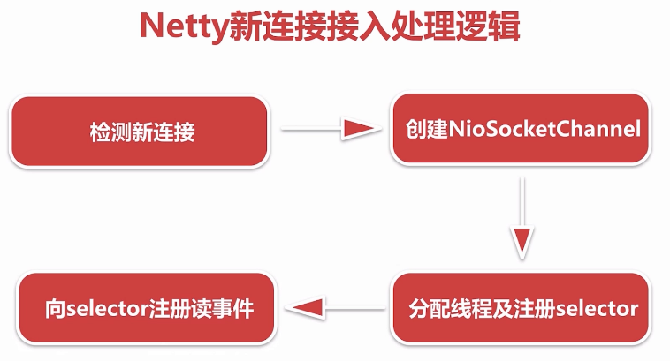

##### 5.2.1 检测新连接

新连接通过服务端channel绑定的selector轮询出accpet事件（即I/O事件）

##### 5.2.2 创建NioSocketChannel

基于JDK nio的channel创建一个netty的nioSocketChannel，也就是客户端channel

##### 5.2.3 分配线程及注册selector

netty给客户端channel分配NioEventLoop并把这条channel注册到NioEventLoop对应的selector上，至此这条channel后续相关的读写都由此NioEventLoop管理

##### 5.2.4 向selector注册读事件

注册的过程和服务端启动注册的accept事件复用同一段逻辑

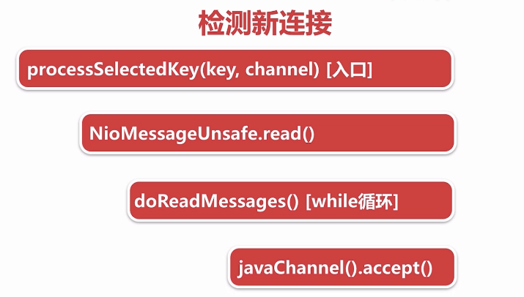

断点调试：启动服务端 ---》telnet 127.0.0.1 8888方式创建新的连接

小结：

在服务端channel的NioEventLoop run（）的 第二个过程：

--》NioEventLoop#processSelectedKey(SelectionKey, AbstractNioChannel) 检测出accept事件之后，

--》通过jdk的accept方法创建jdk的channel，

--》并包装成netty自定义的channel，

--》List readBuf 临时存放channnel，

--》此过程中通过Handle对象控制连接接入的速率，默认情况下一次性读取16个连接

io.netty.channel.nio.AbstractNioMessageChannel.NioMessageUnsafe#read

public void read() {  
 assert eventLoop().inEventLoop();  
 final ChannelConfig config = config();  
 final ChannelPipeline pipeline = pipeline();  
 final RecvByteBufAllocator.Handle allocHandle = unsafe().recvBufAllocHandle();  
 allocHandle.reset(config);  
 boolean closed = false;  
 Throwable exception = null;  
 try {  
 try {  
 do {  
 int localRead = doReadMessages(readBuf);  
 if (localRead == 0) {  
 break;  
 }  
 if (localRead < 0) {  
 closed = true;  
 break;  
 }  
  
 allocHandle.incMessagesRead(localRead);  
 } while (allocHandle.continueReading());  
 } catch (Throwable t) {  
 exception = t;  
 }  
  
 int size = readBuf.size();  
 for (int i = 0; i < size; i ++) {  
 readPending = false;  
 pipeline.fireChannelRead(readBuf.get(i));  
 }  
 readBuf.clear();  
 allocHandle.readComplete();  
 pipeline.fireChannelReadComplete();  
  
 if (exception != null) {  
 closed = closeOnReadError(exception);  
  
 pipeline.fireExceptionCaught(exception);  
 }  
  
 if (closed) {  
 inputShutdown = true;  
 if (isOpen()) {  
 close(voidPromise());  
 }  
 }  
 } finally {  
 // See https://github.com/netty/netty/issues/2254  
 if (!readPending && !config.isAutoRead()) {  
 removeReadOp();  
 }  
 }  
 }  
}

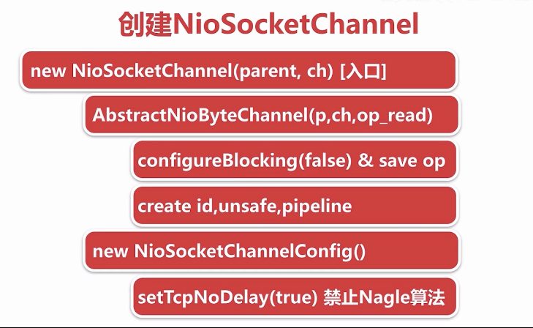

客户端channel创建完成之后，将服务端channel和客户端channel作为参数传递到NioSocketChannel的构造函数中，接下来进行一系列的创建过程。

// this 代表创建客户端channel的服务端nioServerSocketChannel（通过反射创建） ch 代表jdk accept创建的channel   
//new NioSocketChannel 构造出来的netty的客户端channel  
new NioSocketChannel(this, ch)；  
...  
public NioSocketChannel(Channel parent, SocketChannel socket) {  
 super(parent, socket);  
 config = new NioSocketChannelConfig(this, socket.socket());  
 }

NioSocketChannel的构造函数是入口。做两件事情：

* 逐层调用父类的构造函数
  + 配置此channel为非阻塞，将感兴趣的读事件OP_READ,保存到成员变量方便后续注册到selector上
  + protected AbstractNioChannel(Channel parent, SelectableChannel ch, int readInterestOp) {  
     super(parent);  
     this.ch = ch;  
     this.readInterestOp = readInterestOp;  
     try {  
     ch.configureBlocking(false);  
     } catch (IOException e) {  
     try {  
     ch.close();  
     } catch (IOException e2) {  
     if (logger.isWarnEnabled()) {  
     logger.warn(  
     "Failed to close a partially initialized socket.", e2);  
     }  
     }  
     throw new ChannelException("Failed to enter non-blocking mode.", e);  
     }  
    }
  + 创建和此channel相关的一些组件 id 作为channel的唯一标识 unsafe作为底层数据读写 pipeline作为业务逻辑的载体。
  + protected AbstractChannel(Channel parent) {  
     this.parent = parent;  
     id = newId();  
     unsafe = newUnsafe();  
     pipeline = newChannelPipeline();  
    }
* 创建一个和NioSocketChannel绑定的配置类
  + 设置此channel tcpNoDeply为 true，禁止negle算法（使小的数据包集合成大的数据包再发送出去），保证小的数据包尽可能发出去，降低延时
  + public DefaultSocketChannelConfig(SocketChannel channel, Socket javaSocket) {  
     super(channel);  
     if (javaSocket == null) {  
     throw new NullPointerException("javaSocket");  
     }  
     this.javaSocket = javaSocket;  
      
     // Enable TCP_NODELAY by default if possible.  
     if (PlatformDependent.canEnableTcpNoDelayByDefault()) {  
     try {  
     setTcpNoDelay(true);  
     } catch (Exception e) {  
     // Ignore.  
     }  
     }  
    }

思考：与创建服务端channel不同的是，服务端channel是利用反射创建，而这里直接使用new 关键词，netty为什么这么设计？

##### 5.3 Netty中channel的分类

* NioServerSocketChannel
  + Netty服务端channel的创建：用户代码传进来一个class类，netty拿到这个类通过反射方式创建。
* NioSocketChannel
  + 新连接接入过程中，拿到jdk底层创建的channel之后，通过显式的new关键字创建客户端channel
* unsafe
  + 用于实现每一种channel底层具体的协议

###### 5.3.1 netty中channel的层级关系

* **io.netty.channel.Channel：**
* A nexus to a network socket or a component which is capable of I/O  
  * operations such as read, write, connect, and bind.
* **io.netty.channel.AbstractChannel**
* A skeletal {@link Channel} implementation.  
  ...  
   private final Channel parent;  
   private final ChannelId id;  
   private final Unsafe unsafe;  
   private final DefaultChannelPipeline pipeline;  
  ...  
   private volatile EventLoop eventLoop;

**io.netty.channel.nio.AbstractNioChannel**

使用select轮询的的方式进行读写事件的监听

抽象出来，只关心I/O事件

Abstract base class for {@link Channel} implementations which use a Selector based approach.  
 ...  
 private final SelectableChannel ch;  
 protected final int readInterestOp;  
 volatile SelectionKey selectionKey;  
   
 ...  
 protected AbstractNioChannel(Channel parent, SelectableChannel ch, int readInterestOp) {  
 super(parent);  
 this.ch = ch;  
 this.readInterestOp = readInterestOp;  
 try {  
 ch.configureBlocking(false);  
 } catch (IOException e) {  
 ...

**io.netty.channel.nio.AbstractNioByteChannel**

io.netty.channel.nio.AbstractNioByteChannel#AbstractNioByteChannel

protected AbstractNioByteChannel(Channel parent, SelectableChannel ch) {  
 super(parent, ch, SelectionKey.OP_READ);  
}

客户端channel ：创建的时候调用父类AbstractNioChannel 的构造函数，传递 read事件（I/O事件） 读取数据

{@link AbstractNioChannel} base class for {@link Channel}s that operate on bytes.  
...  
public final void read() {  
 final ChannelConfig config = config();  
 final ChannelPipeline pipeline = pipeline();  
 final ByteBufAllocator allocator = config.getAllocator();  
 final RecvByteBufAllocator.Handle allocHandle = recvBufAllocHandle();  
 allocHandle.reset(config);  
 ByteBuf byteBuf = null;  
 boolean close = false;  
 try {  
 do {  
 byteBuf = allocHandle.allocate(allocator);  
 //读取字节数据  
 allocHandle.lastBytesRead(doReadBytes(byteBuf));  
 ...  
 } while (allocHandle.continueReading());  
 ...  
}

**io.netty.channel.nio.AbstractNioMessageChannel**

服务端channel：创建的时候调用父类AbstractNioChannel 的构造函数，传递accept事件（I/O事件），监听连接

* {@link AbstractNioChannel} base class for {@link Channel}s that operate on messages.  
   
 public void read() {  
 assert eventLoop().inEventLoop();  
 final ChannelConfig config = config();  
 final ChannelPipeline pipeline = pipeline();  
 final RecvByteBufAllocator.Handle allocHandle = unsafe().recvBufAllocHandle();  
 allocHandle.reset(config);  
 boolean closed = false;  
 Throwable exception = null;  
 try {  
 try {  
 do {  
 ...  
 int localRead = doReadMessages(readBuf);  
 ...  
 allocHandle.incMessagesRead(localRead);  
 } while (allocHandle.continueReading());  
 } catch (Throwable t) {  
 exception = t;  
 }  
  
 }

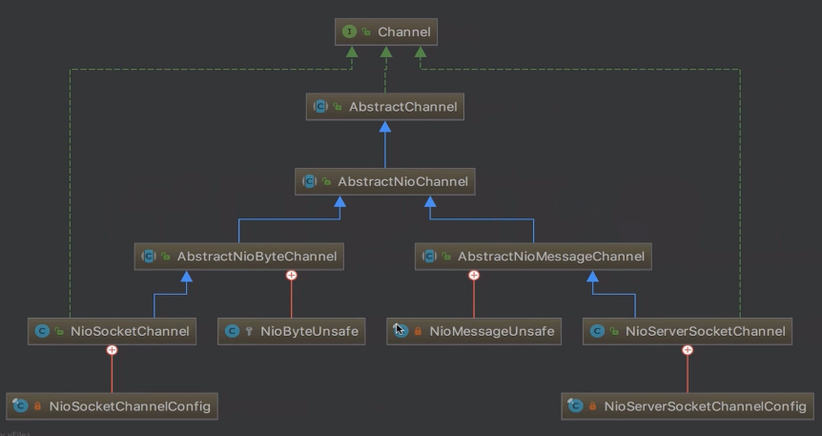

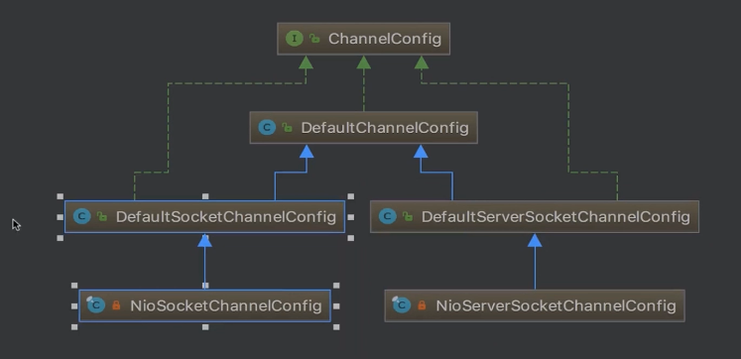

##### 5.4 新连接 NioEventLoop分配和Selector注册

io.netty.channel.nio.AbstractNioMessageChannel.NioMessageUnsafe#read

--》io.netty.channel.nio.AbstractNioMessageChannel#doReadMessages 创建客户端channel

@Override  
protected int doReadMessages(List<Object> buf) throws Exception {  
 SocketChannel ch = javaChannel().accept();  
 try {  
 if (ch != null) {  
 buf.add(new NioSocketChannel(this, ch));  
 return 1;  
 }  
 } catch (Throwable t) {  
 ...   
 }  
 return 0;  
}

* --》io.netty.channel.ChannelPipeline#fireChannelRead for循环遍历每一条客户端连接，调用服务端channel的PipeLine的fireChannelRead 方法

...  
for (int i = 0; i < size; i ++) {  
 readPending = false;  
 pipeline.fireChannelRead(readBuf.get(i));  
}  
...

* --》回顾netty服务端启动：io.netty.bootstrap.ServerBootstrap#init
* --》 服务端channel PipeLine的构成

服务端channel PipeLine传播channelRead事件会从head开始--ServerBootstrapAcceptor--最后到Tail

即 pipeline.fireChannelRead(readBuf.get(i)) 会将每一条客户端连接通过fireChannelRead逐层传到ServerBootstrapAcceptor，即调用io.netty.bootstrap.ServerBootstrap.ServerBootstrapAcceptor#channelRead

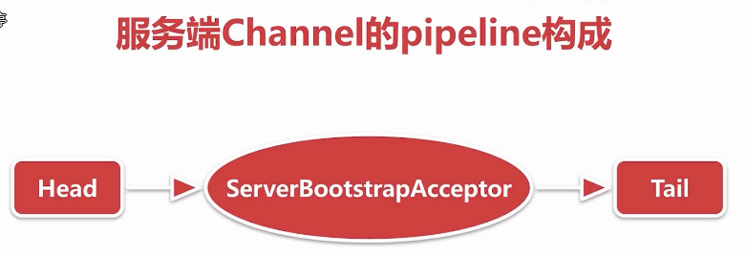

* --》ServerBootstrapAcceptor#channelRead主要做以下几件事情
  + 添加childHandler
  + 设置options和attrs
  + 选择NioEventLoop并注册selector

public void channelRead(ChannelHandlerContext ctx, Object msg) {  
 final Channel child = (Channel) msg;  
 //这里的childHandler是以一个特殊的handler，即服务端启动时传进来的ChannelInitializer  
 child.pipeline().addLast(childHandler);  
 //childOptions 底层jdk读写相关的参数  
 for (Entry<ChannelOption<?>, Object> e: childOptions) {  
 try {  
 if (!child.config().setOption((ChannelOption<Object>) e.getKey(), e.getValue())) {  
 logger.warn("Unknown channel option: " + e);  
 }  
 } catch (Throwable t) {  
 logger.warn("Failed to set a channel option: " + child, t);  
 }  
 }  
 //childAttrs 在客户端channel上绑定一些自定义的属性 如密钥 channel存活时间等  
 for (Entry<AttributeKey<?>, Object> e: childAttrs) {  
 child.attr((AttributeKey<Object>) e.getKey()).set(e.getValue());  
 }  
  
 try {  
 // childGroup 是一个workGroup 注册的时候选择一个NioEventLoop进行注册  
 childGroup.register(child).addListener(new ChannelFutureListener() {  
 @Override  
 public void operationComplete(ChannelFuture future) throws Exception {  
 if (!future.isSuccess()) {  
 forceClose(child, future.cause());  
 }  
 }  
 });  
 } catch (Throwable t) {  
 forceClose(child, t);  
 }  
}

io.netty.channel.ChannelInitializer#handlerAdded --》

io.netty.channel.ChannelInitializer#initChannel(io.netty.channel.ChannelHandlerContext)

private boolean initChannel(ChannelHandlerContext ctx) throws Exception {  
 if (initMap.putIfAbsent(ctx, Boolean.TRUE) == null) { // Guard against re-entrance.  
 try {  
 //这里会回调到用户代码里的方法ChannelInitializer#initChannel(io.netty.channel.socket.SocketChannel)  
 initChannel((C) ctx.channel());  
 } catch (Throwable cause) {  
 // Explicitly call exceptionCaught(...) as we removed the handler before calling initChannel(...).  
 // We do so to prevent multiple calls to initChannel(...).  
 exceptionCaught(ctx, cause);  
 } finally {  
 //调用remove将自身删除  
 remove(ctx);  
 }  
 return true;  
 }  
 return false;  
}  
//这就是netty为新连接添加channelHandler的逻辑

io.netty.channel.EventLoopGroup#register(io.netty.channel.Channel)

io.netty.channel.MultithreadEventLoopGroup#register(io.netty.channel.Channel)  
@Override  
public ChannelFuture register(Channel channel) {  
 return next().register(channel);  
}

next()返回一个NioEventLoop

@Override  
public EventLoop next() {  
 return (EventLoop) super.next();  
}

io.netty.util.concurrent.MultithreadEventExecutorGroup#next

@Override  
public EventExecutor next() {  
 return chooser.next();  
}

客户端channel选择nioEventLoop并注册selector的过程

io.netty.channel.SingleThreadEventLoop#register(io.netty.channel.ChannelPromise)  
@Override  
public ChannelFuture register(final ChannelPromise promise) {  
 ObjectUtil.checkNotNull(promise, "promise");  
 promise.channel().unsafe().register(this, promise);  
 return promise;  
}

io.netty.channel.nio.AbstractNioChannel#doRegister  
protected void doRegister() throws Exception {  
 boolean selected = false;  
 for (;;) {  
 try {  
 selectionKey = javaChannel().register(eventLoop().selector, 0, this);  
 return;  
 } catch (CancelledKeyException e) {  
 if (!selected) {  
 eventLoop().selectNow();  
 selected = true;  
 } else {  
 throw e;  
 }  
 }  
 }  
}

小结：服务端channel在检测到新连接并且创建完客户端channel之后，会调用一个连接器做一些处理，

包括给客户端channel填充逻辑处理器channelHanler，配置options和attrs，选定一个NioEventLoop进行绑定，并把channel注册到NioEventLoop的selector上，这时不关心任何事件。

##### 5.5 NioSocketChannel读事件的注册

io.netty.channel.AbstractChannel.AbstractUnsafe#register0

通过debug方式了解相应代码

io.netty.channel.DefaultChannelPipeline.HeadContext#channelActive

@Override  
public void channelActive(ChannelHandlerContext ctx) throws Exception {  
 //传播channelActive 事件  
 ctx.fireChannelActive();  
  
 readIfIsAutoRead();  
}

private void readIfIsAutoRead() {  
 if (channel.config().isAutoRead()) {//默认只要绑定端口就会接收连接，只要当前连接绑定到selector上就会自动读，即向selector上注册读事件  
 channel.read();  
 }  
}

io.netty.channel.AbstractChannel#read

public Channel read() {  
 pipeline.read();  
 return this;  
}

io.netty.channel.DefaultChannelPipeline#read

public final ChannelPipeline read() {  
 tail.read();  
 return this;  
}

io.netty.channel.AbstractChannelHandlerContext#invokeRead

private void invokeRead() {  
 if (invokeHandler()) {  
 try {  
 ((ChannelOutboundHandler) handler()).read(this);  
 } catch (Throwable t) {  
 notifyHandlerException(t);  
 }  
 } else {  
 read();  
 }  
}

io.netty.channel.DefaultChannelPipeline.HeadContext#read

public void read(ChannelHandlerContext ctx) {  
 unsafe.beginRead();  
}

io.netty.channel.AbstractChannel.AbstractUnsafe#beginRead

public final void beginRead() {  
 assertEventLoop();  
 ...  
 try {  
 doBeginRead();  
 } catch (final Exception e) {  
 ...  
 }  
}

io.netty.channel.nio.AbstractNioChannel#doBeginRead

protected void doBeginRead() throws Exception {  
 // Channel.read() or ChannelHandlerContext.read() was called  
 final SelectionKey selectionKey = this.selectionKey;  
 if (!selectionKey.isValid()) {  
 return;  
 }  
  
 readPending = true;  
   
 final int interestOps = selectionKey.interestOps();  
 //readInterestOp 即创建nioSocketChannel时传进来的OP_READ  
 if ((interestOps & readInterestOp) == 0) {  
 selectionKey.interestOps(interestOps | readInterestOp);  
 }  
}

#### 六. netty-PipeLine

PipeLine是netty的大动脉，主要负责读写事件的传播

##### 6.1 思考问题

* netty是如何判断ChannelHandler类型的
* 对于ChannelHandler的添加应遵循什么样的顺序
* 用户手动触发事件传播，不同的触发方式有什么样的区别？

##### 6.2 学习内容

* pipeLine的初始化
* 添加和删除ChannelHandler
* 事件和异常的传播

##### 6.3 pipeLine的初始化