南昌航空大学实验报告
2018 年 11 月 30 日

课程名称：面向对象程序设计A 实验名称： Java程序控制结构
学号： 17201106 姓名： 李雨时 同组人：
指导教师评定： 签名：

一、实验目的
1、理解基类与子类的关系，实现继承操作，达到代码复用的目的；
2、理解基类与子类的构造方法之间的关系，并实现相应的代码；
3、理解不同访问权限的必要性，并实现相应的代码；
4、理解多态，并利用继承和override实现多态操作。
5、掌握UML基本用法和画法，并能根据题目描述画出类、类之间的关系。
二、参考
参考教材第11章；
三、实验步骤
1、阅读给出的题目描述；
2、根据题目描述，画出类（类名，属性、方法）、类之间的关系
3、先写出各部分的注释（常见的注释有：类的功能注释；类的继承关系；类的属性注释和方法的功能注释；类方法的入口参数和返回值注释、选择结构和循环结构注释）；
4、书写代码，首先保证无语法错误、类的使用错误、类的继承错误；
4、测试代码并修正代码中的可能的逻辑错误；
5、在规定的最后期限前提交代码。
四．实验结果
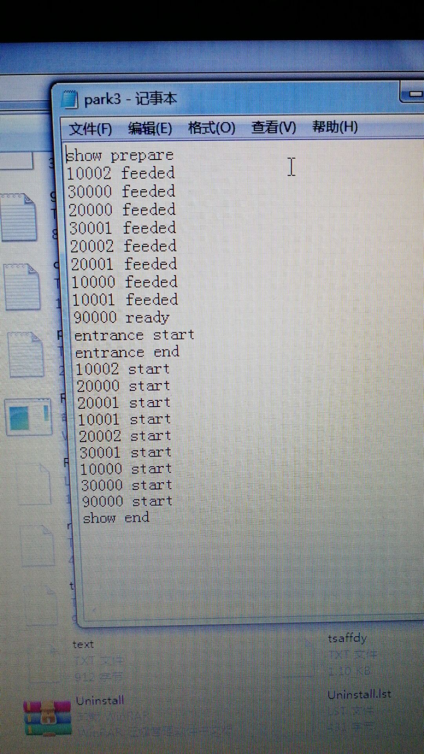

五．实验小结
本次实验主要采用继承的方法来写，刚开始的时候把时间放进了主函数中导致运行一直出现问题，后来把时间单独写成了一个类然后就可以正常运行了，但是对象数组的应用以及代码的复用性做的还是很差希望下次实验中可以进行改正。
六、附录

package three_exercise;
import java.io.*;
import java.util.*;
public class main {
public static void main(String[] args){
Random rand = new Random();
Scanner input = new Scanner(System.in);
File file = new File();
Mytime time = new Mytime(); //时间对象
mermaid mer = new mermaid(18,"jojo",1);
climb[] climb={new crocodile(),new lizard()}; //动物对象数组
lactation[] lac={new dolphin(),new seal(),new sealion()};
fish[] fish={new flyingfish(),new shark(),new uglyfish()};
file.openWrite("input.txt");
file.output("show prepare");
file.output("enterance start");
for (int i=0;i<3;i++){
file.output(fish[i].number+"start");
}
for (int i=0;i<3;i++){
file.output(lac[i].number+"start");
}
for (int i=0;i<2;i++){
file.output(climb[i].number+"start");
}
file.output(mer.number+"ready");
file.openRead("input.txt");
file.openWrite("ouput.txt");
for (int i=0;i<3;i++){
file.output(fish[i].toString(time));
}
for (int i=0;i<3;i++){
file.output(lac[i].toString(time));
}
for (int i=0;i<2;i++){
file.output(climb[i].toString(time));
}
}
}
package three_exercise;

import java.util.Random;

//编号、类别、昵称、年龄、性别、喂食时长
public class Animals {
protected int number=1;
protected String tier=" ";//类别
protected String name=" ";
protected int age=1;
protected String sex=" ";
protected int feedtime=1;
protected perform[] perform=new perform[2];
protected Interact[] interact=new Interact[2];
protected trainer trainer=new trainer();
String type = " ";
Random rand = new Random();
public Animals(){

}
public Animals(String name,int age,String sex,int feedtime,trainer trainer){
super();
this.name=name;
this.age=age;
this.sex=sex;
this.feedtime=feedtime;
trainer =new trainer(name);
}
public void setnumber(int number){
this.number=number;
}
public int getnumber(){
return number;
}
public String gettier(){
return tier;
}
public void settier(String tier){
this.tier=tier;
}
public void setname(String name){
this.name=name;
}
public String getname(){
return name;
}
public void setage(int age){
this.age=age;
}
public int getage(){
return age;
}
public void setsex(String sex){
this.sex=sex;
}
public String getsex(){
return sex;
}
public void setfeedtime(int feedtime){
this.feedtime=feedtime;
}
public int getfeedtime(){
return feedtime;
}
public String toString(Mytime time) {
return (type+",今天表演的"+type+"叫"+name+","+age+"岁,"+sex+",现在有请训兽师"+trainer.getname()+"带领"+name+"出场\r\n"+time.Go(1)+" "+name+"的表演正式开始，现在表演的是"+perform[0].getName()+"\r\n"+time.Go(perform[0].pertime)+" "+name+"表演"+perform[1].pername+"\r\n"+time.Go(perform[1].pertime)+" "+name+"与观众互动，现在征选"+interact[0].intenum+"位幸运观众跟"+name+interact[0].intename+"\r\n"+time.Go(interact[0].intetime)+" "+name+"表演结束，下一个出场的是");
}
}
package three_exercise;

public class Interact {
String intename;
int intenum;
int intetime;
public Interact(String intename,int intenum,int intetime){
this.intename=intename;
this.intenum=intenum;
this.intetime=intetime;
}
public void setname(String intename){
this.intename=intename;
}
public String getname(){
return intename;
}
public void setnum(int intenum){
this.intenum=intenum;
}
public int getnum(){
return intenum;
}
public void intetime(int intetime){
this.intetime=intetime;
}
public int gettime(){
return intetime;
}
}
package three_exercise;

public class perform {
String pername;
int pertime;
public perform(String pername,int pertime){
this.pername=pername;
this.pertime=pertime;
}
public void setName(String pername){
this.pername=pername;
}
public String getName(){
return pername;
}
public void setTime(int pertime){
this.pertime=pertime;
}
public int getTime(){
return pertime;
}
}
package three_exercise;

public class Mytime {

private int hour;
private int minute;
private String nowTime = "8:00";
public Mytime(){
this.hour = 8;
this.minute = 0;
}
public String Go(int minute) {
this.minute += minute;
if(this.minute >= 60) {
this.hour++;
this.minute -= 60;
}
if(this.minute < 10) {
this.nowTime = this.hour + ":0" + this.minute;
}else {
this.nowTime = this.hour + ":" + this.minute;
}
return this.nowTime;
}

public String toString() {
return this.nowTime;
}

}
package three_exercise;
//员工类
public class staff {
protected String name;
public staff(){

}
public void setname(String name){
this.name=name;
}
public String getname(){
return name;
}
}
package three_exercise;
//驯兽师
public class trainer extends staff{
public trainer(){

}
public trainer(String name) {
this.name=name;
}
}
package three_exercise;

//美人鱼
public class mermaid extends staff {
String classify = "美人鱼";
String mermaidName = null;
int number = 900000;
perform[] perform;
Interact[] interact;

public mermaid(int age, String mermaidName, int number) {
this.mermaidName = mermaidName;
this.number = number + 900000;
Interact[] temp = {new Interact("握手",5,3),new Interact("拍照",3,1)};
this.interact=temp;
perform[] ans = { new perform("舞蹈", 5), new perform("歌唱", 3), new perform("化为泡沫", 2) };
this.perform=ans;
}
}
package three_exercise;
//爬行
public class climb extends Animals{

final static int numberRange =300000;
public climb(String name, int age, String sex, int feedTime, trainer trainer) {
super(name, age, sex, feedTime, trainer);
tier = "爬行类";
}
public climb(){

}

}
package three_exercise;

public class crocodile extends climb {
public crocodile() {
super("李大笨",2,"雄性",3,new trainer("jiejie"));
// TODO 自动生成的构造函数存根
type = "鳄鱼";
this.number = 1+ numberRange;
getPerformance();
getInteraction();
}

public void getPerformance() {
perform[0] = new perform("极限鳄鱼", rand.nextInt(10)+5);
perform[1] = new perform("冲吧鳄鱼", rand.nextInt(10)+5);
}

public void getInteraction() {
interact[0] = new Interact("骑鳄鱼", 5, rand.nextInt(5)+5);
interact[1] = new Interact("鳄鱼亲亲", 4, rand.nextInt(5)+5);
}

}
package three_exercise;

public class lizard extends climb{

public lizard() {
super("时时", 2, "雄性", 3,new trainer("meimei"));
// TODO 自动生成的构造函数存根
type = "蜥蜴";
this.number = 2 + numberRange;
getPerformance();
getInteraction();
}

public void getPerformance() {
perform[0] = new perform("蜥蜴喂食", rand.nextInt(10)+5);
perform[1] = new perform("蜥蜴跳舞", rand.nextInt(10)+5);
}

public void getInteraction() {
interact[0] = new Interact("蜥蜴转圈", 5, rand.nextInt(5)+5);
interact[1] = new Interact("蜥蜴亲亲", 4, rand.nextInt(5)+5);
}

}

package three_exercise;
//鱼
public class fish extends Animals{

final static int numberRange = 100000;
public fish(String name, int age, String sex, int feedTime, trainer trainer) {
super(name, age, sex, feedTime, trainer);
tier = "鱼类";
}
public fish(){

}

}
package three_exercise;

public class flyingfish extends fish{

public flyingfish() {
super("倩倩", 1, "雌性", 3,new trainer("xuxu"));
// TODO Auto-generated constructor stub
type = "飞鱼";
this.number = 3+ numberRange;
getperform();
getInteract();
}

private void getInteract() {
// TODO Auto-generated method stub
interact[0] = new Interact("飞鱼喂食", 3, rand.nextInt(5)+5);
interact[1] = new Interact("飞鱼游水", 3, rand.nextInt(5)+5);
}

private void getperform() {
// TODO Auto-generated method stub
perform[0] = new perform("吐水", rand.nextInt(10)+5);
perform[1] = new perform("飞鱼飞杆", rand.nextInt(10)+5);
}

}
package three_exercise;

public class shark extends fish {

public shark() {
super("肖恩",1,"雄性",3, new trainer("时时"));
type = "鲨鱼";
this.number = 2 + numberRange;
getPerformance();
getInteraction();
}

public void getPerformance() {
perform[0] = new perform("鲨鱼亲亲", rand.nextInt(10)+5);
perform[1] = new perform("凶猛鲨鱼", rand.nextInt(10)+5);
}

public void getInteraction() {
interact[0] = new Interact("鲨鱼摸摸", 2, rand.nextInt(5)+5);
interact[1] = new Interact("鲨鱼转圈", 1 , rand.nextInt(5)+5);
}
}
package three_exercise;

public class uglyfish extends fish{
public uglyfish() {
super( "基德", 1, "雄性", 1,new trainer("JOJO"));
// TODO 自动生成的构造函数存根
type = "小丑鱼";
this.number = 1 + numberRange;
getPerformance();
getInteraction();

}
public void getPerformance() {
perform[0] = new perform("小丑吓人", rand.nextInt(10)+5);
perform[1] = new perform("小丑转圈", rand.nextInt(10)+5);
}
public void getInteraction() {
interact[0] = new Interact("小丑亲亲", 2, rand.nextInt(5)+5);
interact[1] = new Interact("小丑吐水", 2 , rand.nextInt(5)+5);
}

}
package three_exercise;
//海洋哺乳动物
public class lactation extends Animals {

final static int numberRange = 200000;

public lactation(String name, int age, String sex, int feedTime, trainer trainer) {
super(name, age, sex, feedTime, trainer);
tier = "海洋哺乳动物类";
}
public lactation(){

}
}
package three_exercise;

public class dolphin extends lactation{
public dolphin() {
super("笑笑",3,"雄性",1,new trainer("didi"));
// TODO Auto-generated constructor stub
type = "海豚";
this.number = 3 + numberRange;
getperform();
getInteract();
}

private void getInteract() {
// TODO Auto-generated method stub
interact[0] = new Interact("海豚喂食", 3, rand.nextInt(5)+5);
interact[1] = new Interact("海豚游水", 3, rand.nextInt(5)+5);
}

private void getperform() {
// TODO Auto-generated method stub
perform[0] = new perform("海豚吐水", rand.nextInt(10)+5);
perform[1] = new perform("海豚亲亲", rand.nextInt(10)+5);
}

}
package three_exercise;

public class seal extends lactation{

public seal() {
super("恺恺",3,"雄性",2,new trainer("gege"));
// TODO Auto-generated constructor stub
type = "海豹";
this.number = 2 + numberRange;
getperform();
getInteract();
}

private void getInteract() {
// TODO Auto-generated method stub
interact[0] = new Interact("海豹跳跳", 3, rand.nextInt(5)+5);
interact[1] = new Interact("海豹转圈", 3, rand.nextInt(5)+5);
}

private void getperform() {
// TODO Auto-generated method stub
perform[0] = new perform("海豹过杆", rand.nextInt(10)+5);
perform[1] = new perform("海豹喂食", rand.nextInt(10)+5);
}

}
package three_exercise;

public class sealion extends lactation{
public sealion() {
super("蛋糕",2,"雌性",3,new trainer("xixi"));
// TODO Auto-generated constructor stub
type = "海师";
this.number = 1+ numberRange;
getperform();
getInteract();
}

private void getInteract() {
// TODO Auto-generated method stub
interact[0] = new Interact("海师喂食", 3, rand.nextInt(5)+5);
interact[1] = new Interact("海师游水", 3, rand.nextInt(5)+5);
}

private void getperform() {
// TODO Auto-generated method stub
perform[0] = new perform("海狮吐水", rand.nextInt(10)+5);
perform[1] = new perform("海狮亲亲", rand.nextInt(10)+5);
}

}
package three_exercise;

//用于文件操作的类
import java.util.Scanner;
import java.io.FileInputStream;
import java.io.InputStream;
import java.io.PrintStream;
public class File {
InputStream inputFile;//文件输入
PrintStream outputFile;//文件输出
Scanner fileInput;
public File(){//类的构造
inputFile = System.in;
outputFile = System.out;
}
public boolean openRead(String filename){//打开文件的读入
try{
inputFile = new FileInputStream(filename);
// outputFile = new PrintStream("output.txt");
fileInput = new Scanner(inputFile);
return true;
}
catch (Exception e){
return false;
}
}
public boolean openWrite(String filename){// 打开文件的输出
try{
// inputFile = new FileInputStream("input.txt");
outputFile = new PrintStream(filename);
return true;
}
catch (Exception e){
return false;
}
}
public void output(String s){
outputFile.println(s);
}
public String input(){
// Scanner fileInput = new Scanner(inputFile);
if (fileInput.hasNext()){
String k = fileInput.nextLine();
return k;
}
else
{
return null;
}
}
public boolean hasnext(){
return fileInput.hasNext();
}
}
package three_exercise;

//美人鱼
public class mermaid extends staff {
String classify = "美人鱼";
String mermaidName = null;
int number = 900000;
perform[] perform;
Interact[] interact;

public mermaid(int age, String mermaidName, int number) {
this.mermaidName = mermaidName;
this.number = number + 900000;
Interact[] temp = {new Interact("握手",5,3),new Interact("拍照",3,1)};
this.interact=temp;
perform[] ans = { new perform("舞蹈", 5), new perform("歌唱", 3), new perform("化为泡沫", 2) };
this.perform=ans;
}
}

