**Go to your email and check for aws academy course invitation**

**Open it and click on create my account**

**Provide a password**

**Select a time zone ,Check all the boxes**

**Scroll down and click on register.**

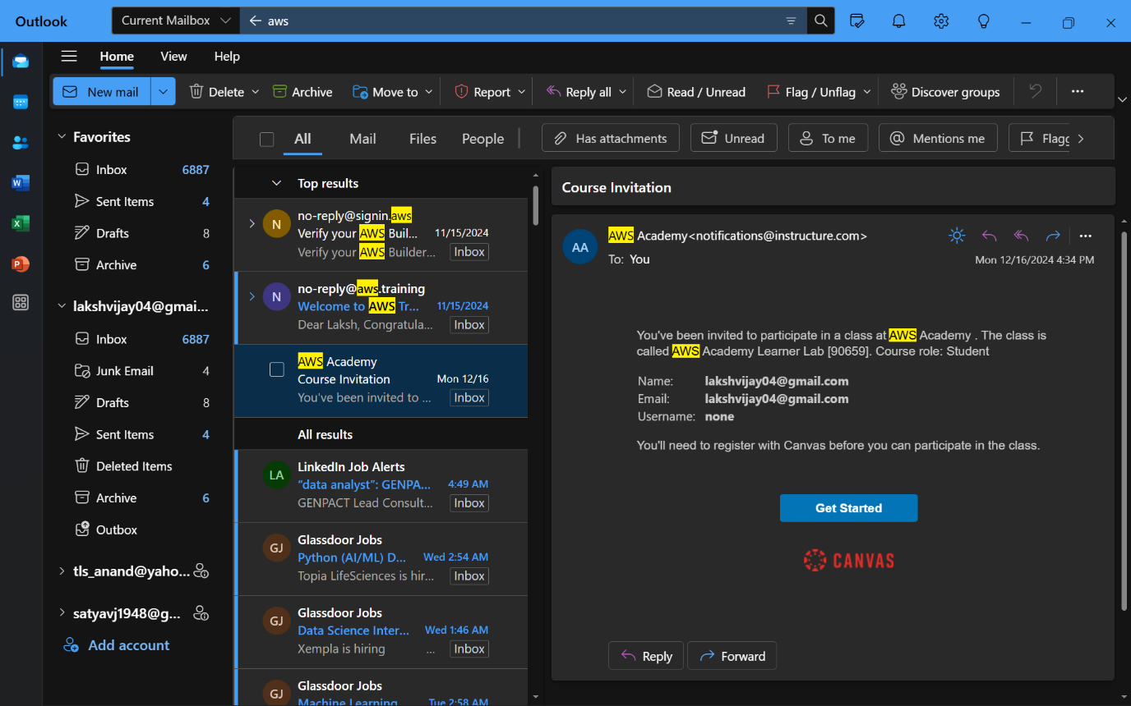

**Click on Student Login.**

**Fill the username and password and click on login**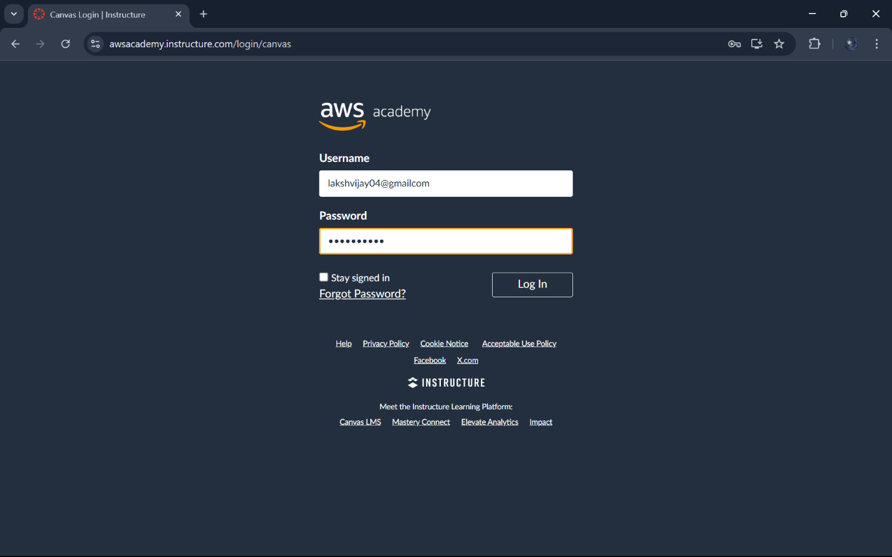

**This is main page of AWS.**

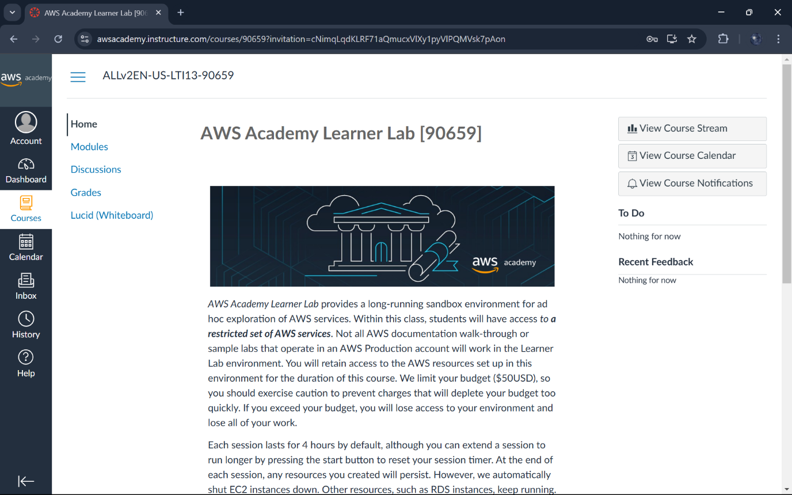

**Click on the AWS academy learner lab.** 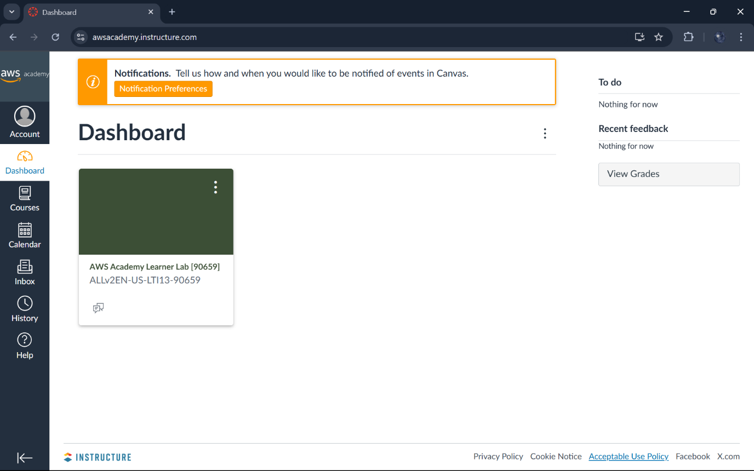

**Click on Modules.**

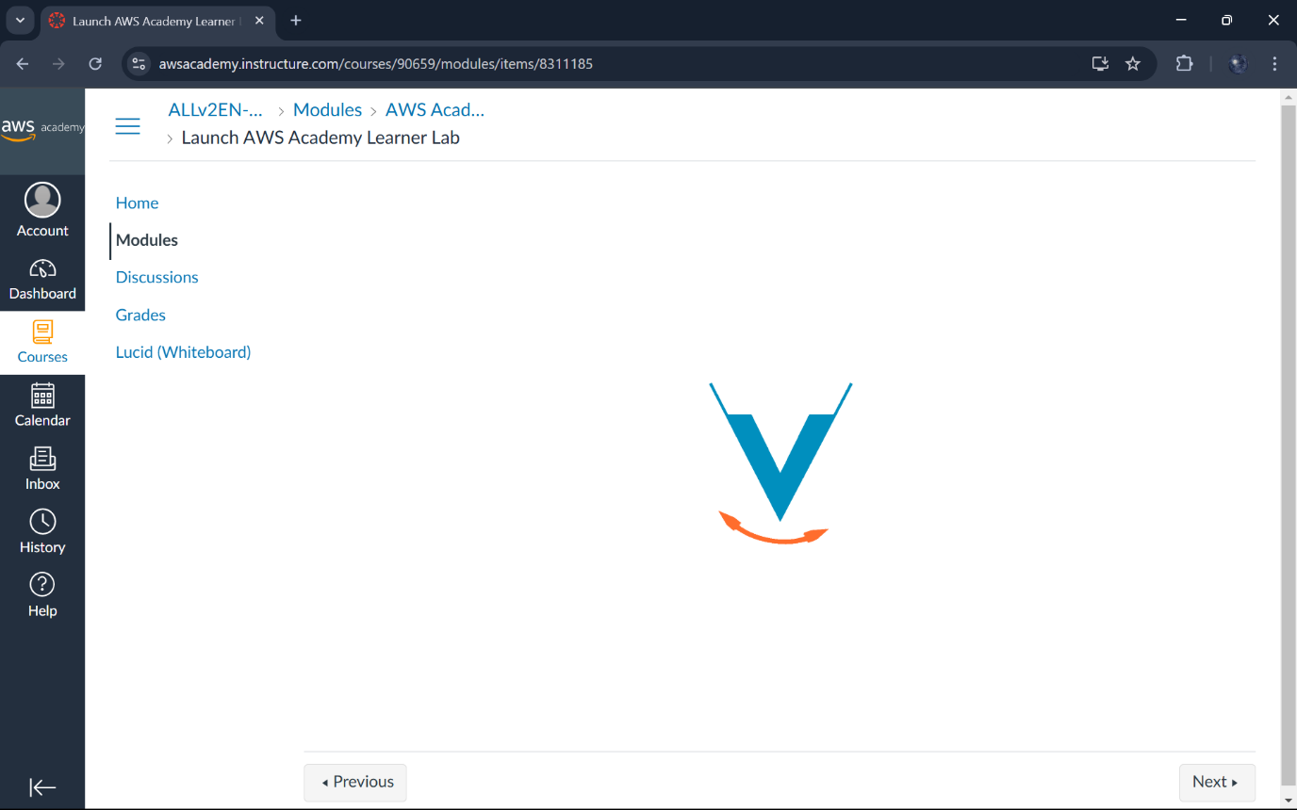

**Scroll down and click on AWS academy learner lab.**

**Scroll down and agree to terms and conditions.**

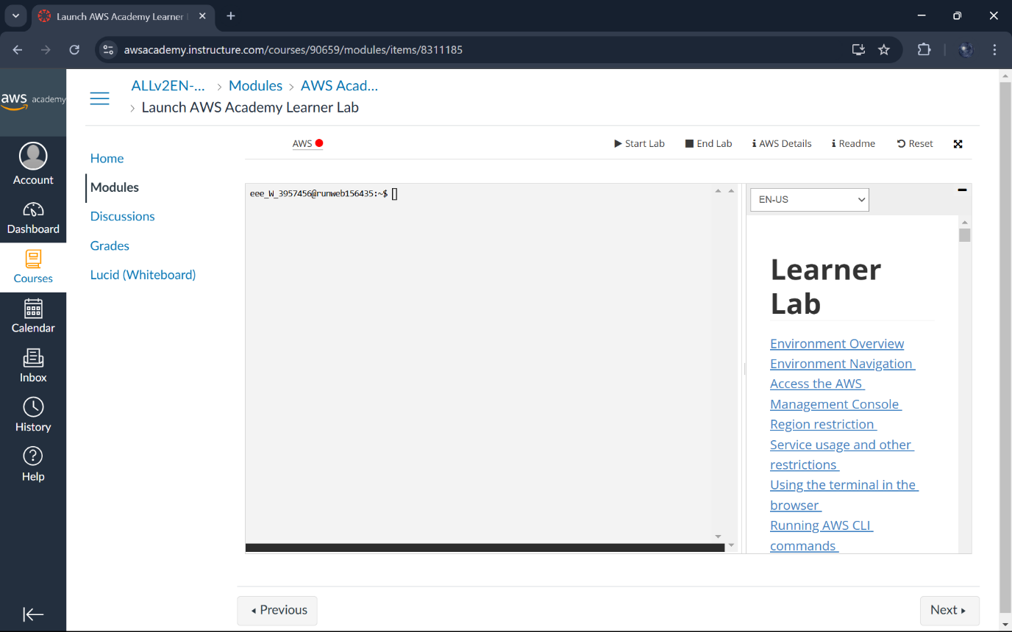

**If there is a red dot beside AWS it means the sandbox is in stop state click on Start Lab.**

**Once you start the lab it will last for 4hours if you want to extend then comeback and start again.**

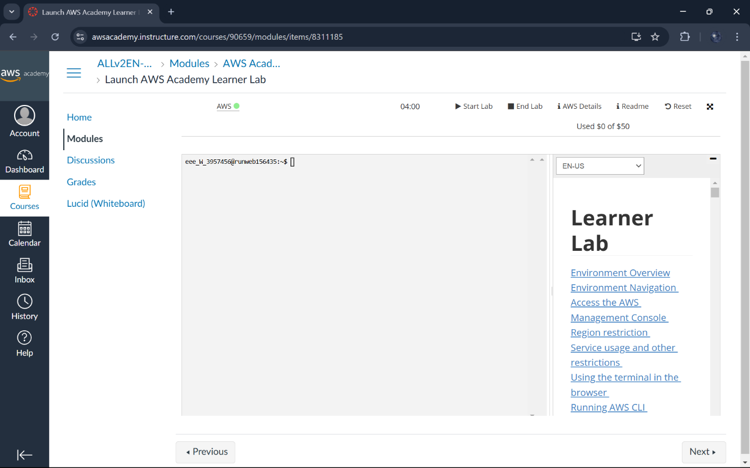

**You are given free 50$, if you exceed you will not be able to access AWS with this email id again**

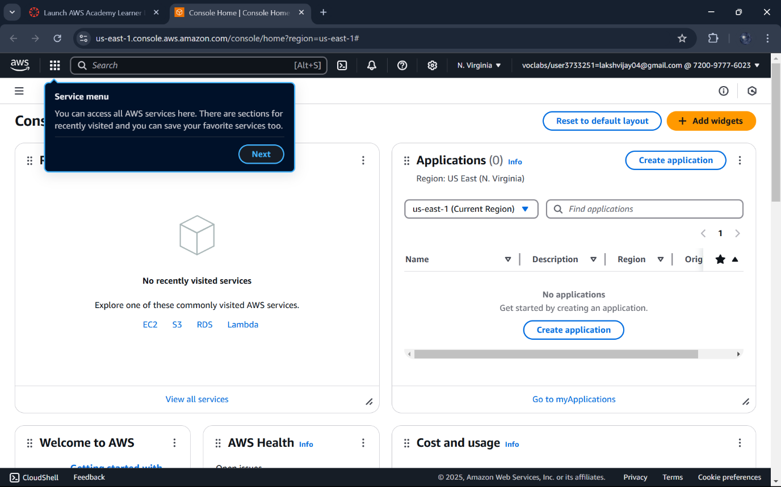

**Once your lab work is done ,click on End lab.**

