*RUNNING MULTIPLE CONTAINERS USING DOCKER COMPOSE*

Login to docker using command prompt.

Create a folder named compose in which we will create a yaml file.

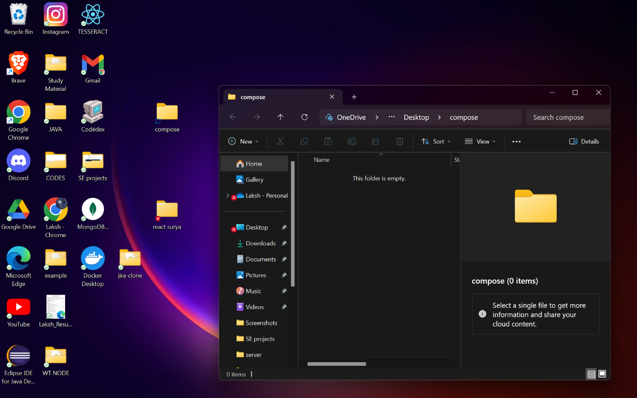

Go to <https://gist.github.com/bradtraversy/faa8de544c62eef3f31de406982f1d42> to copy the yml file for running mysql and wordpress in a single container.

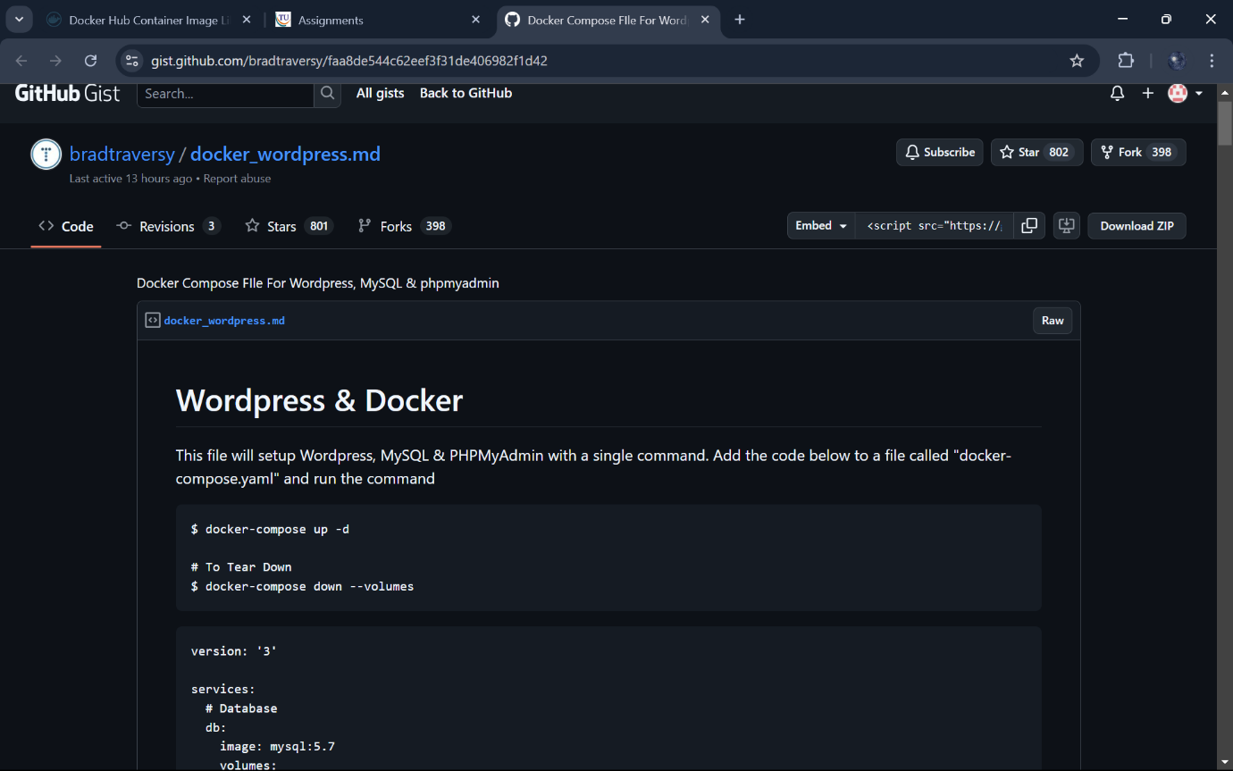

Now create a docker-compose.yaml file and paste the content that we copied.

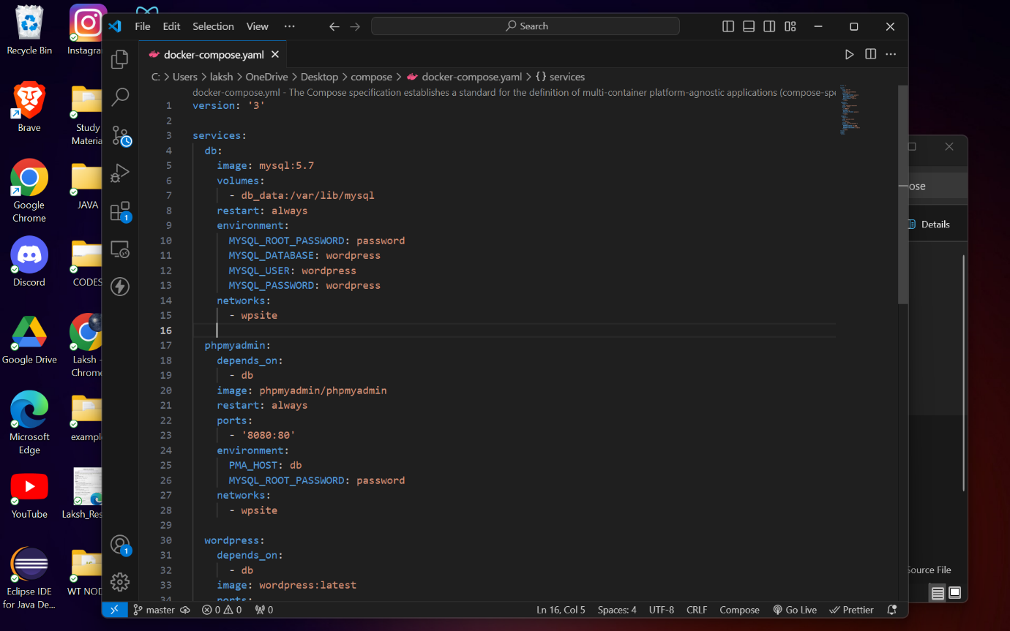

Navigate to the folder that we just created.

Check if the docker-compose Is available by checking its version using the following command.

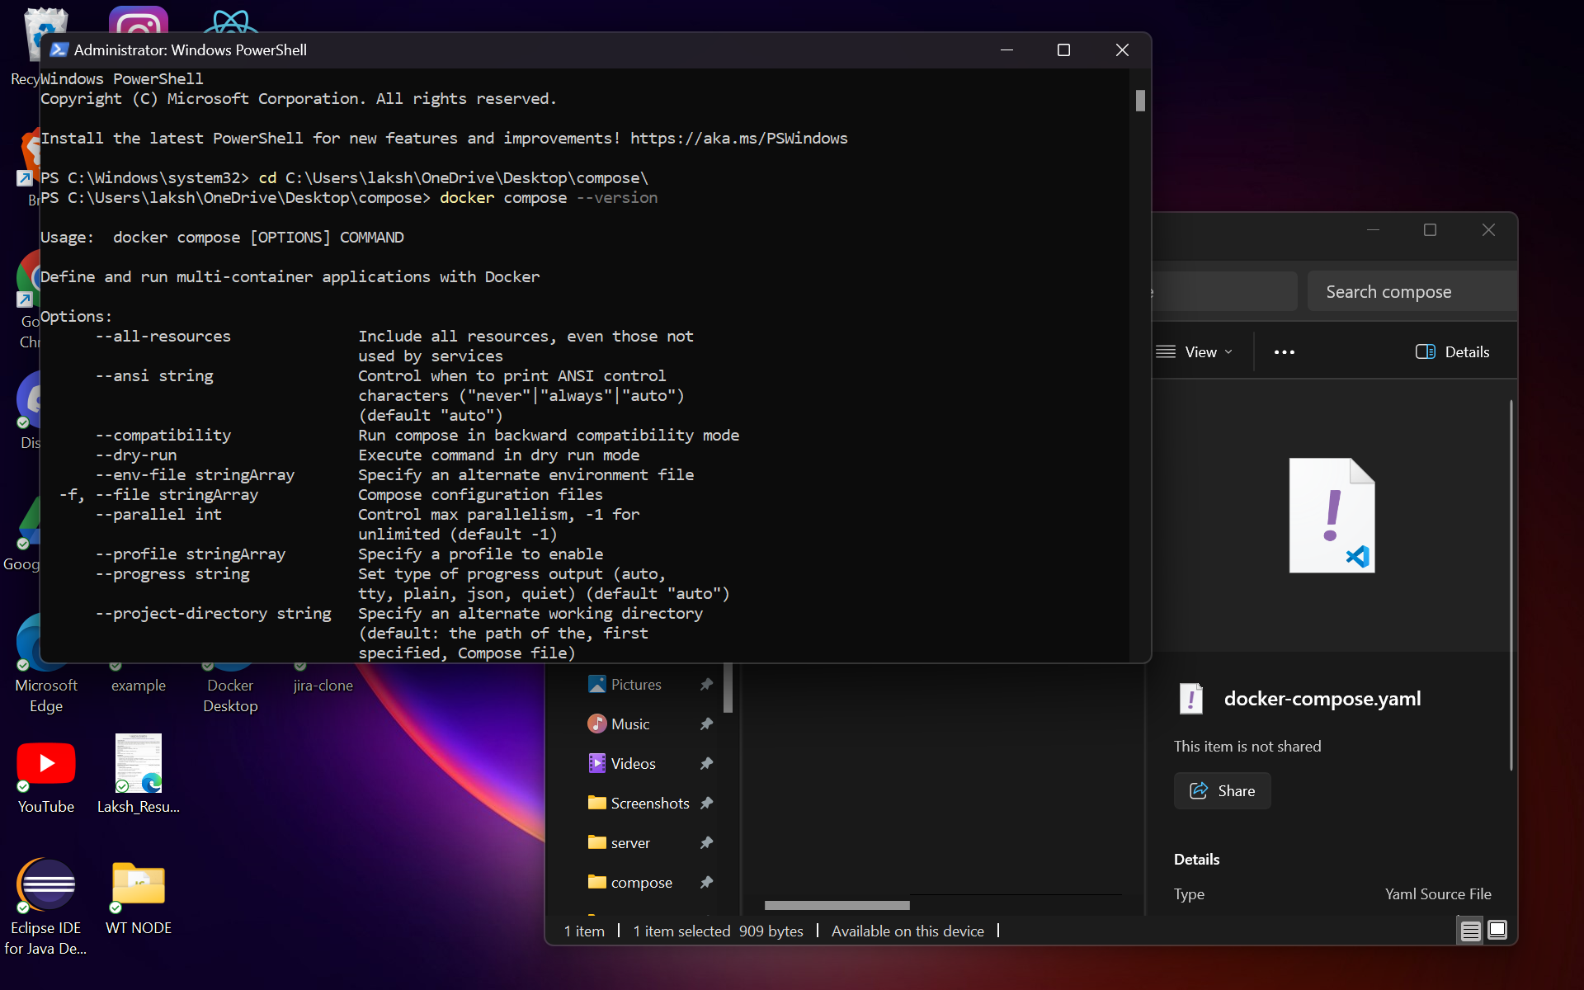

Run docker-compose up -d that will pull the images and run them in a single container ..We can see that we the mysql and wordpress are running in the single container

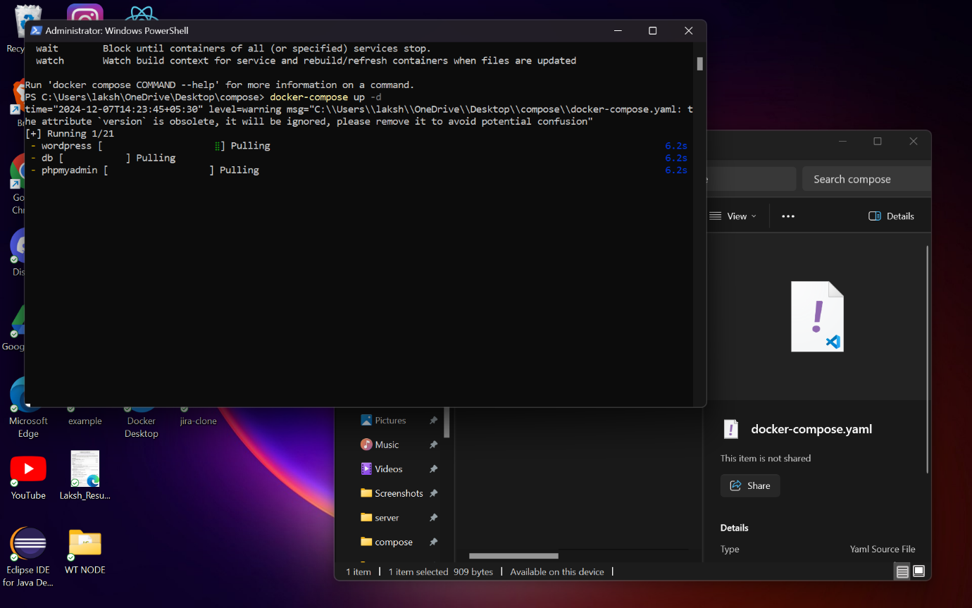

Check if the container is created using docker ps -a. 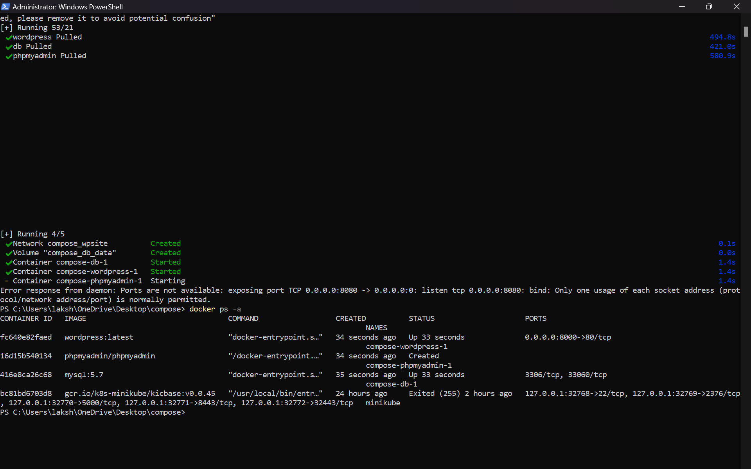

Now since the container is running visit the localhost:8000 to open the wordpress file.

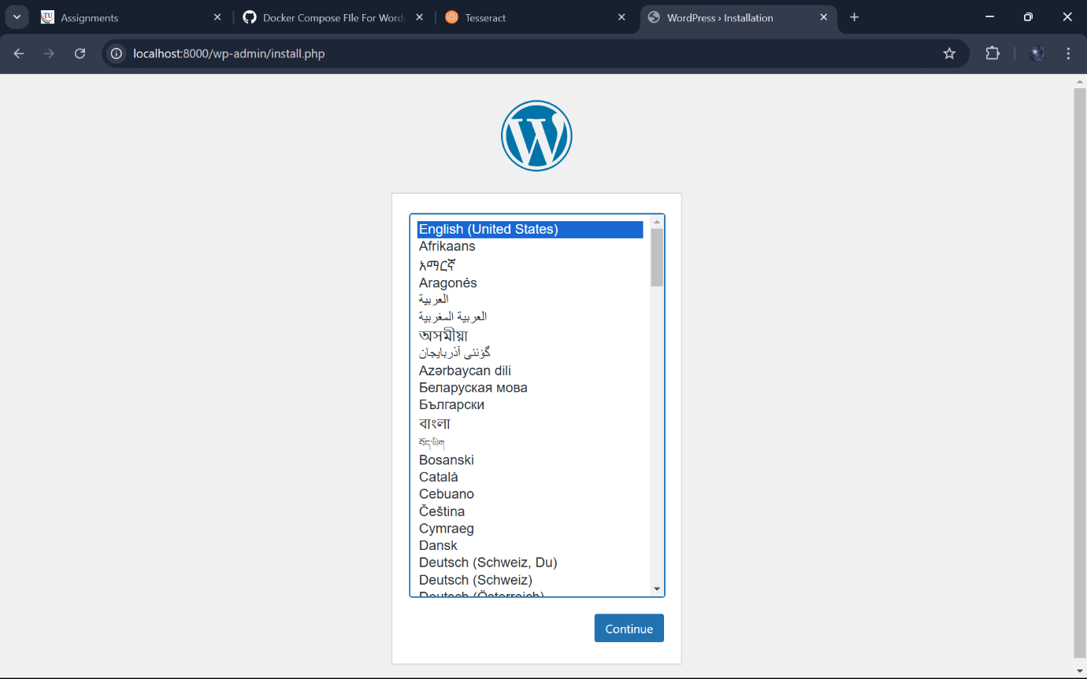

Filling the required information to Register into wordporess.

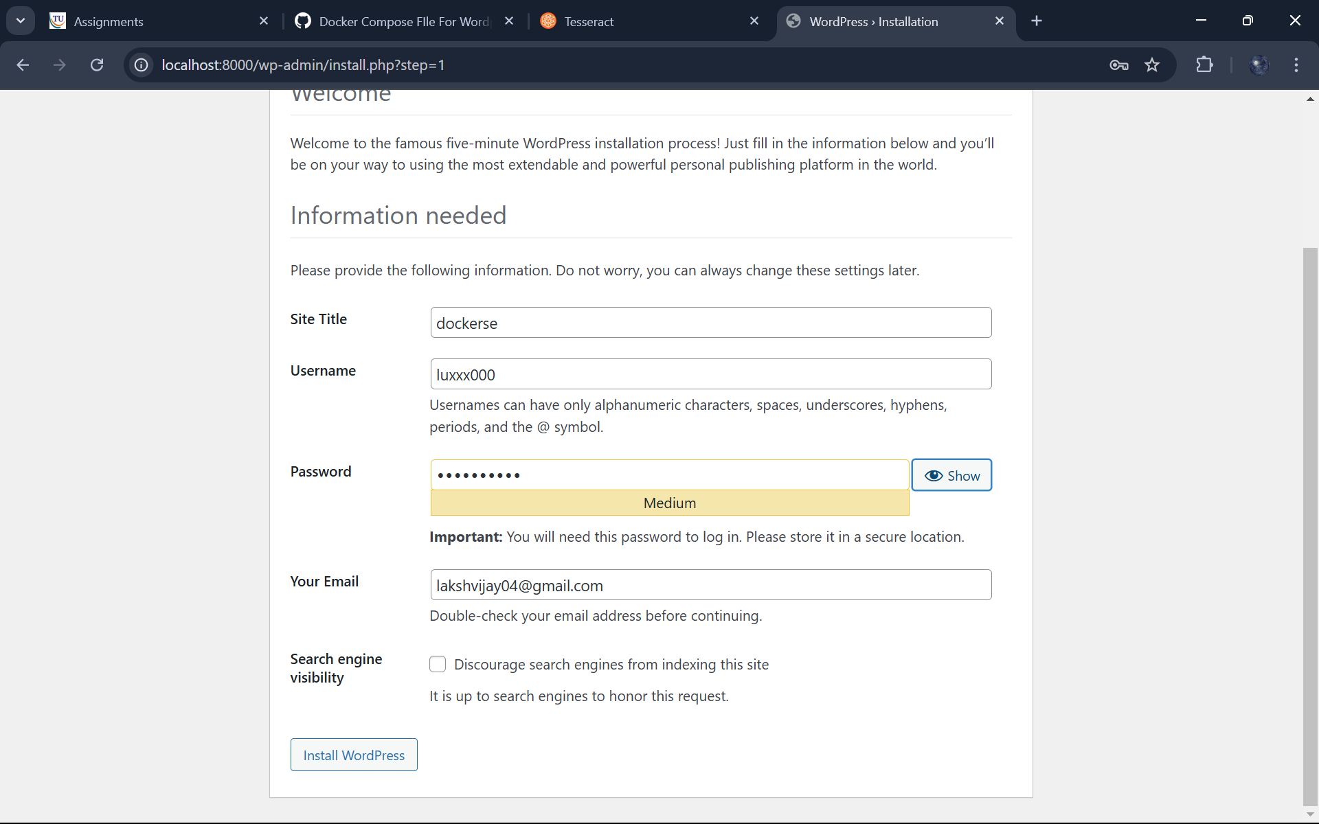

Continue to login.

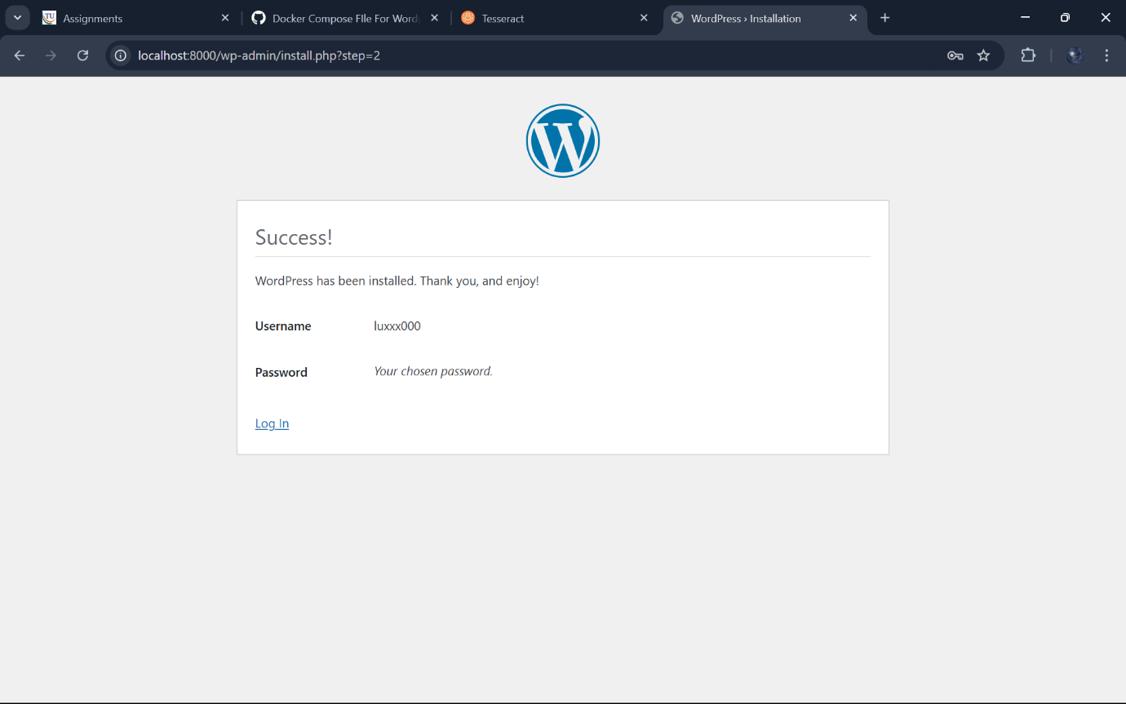

Login with the credentials that you just provided.

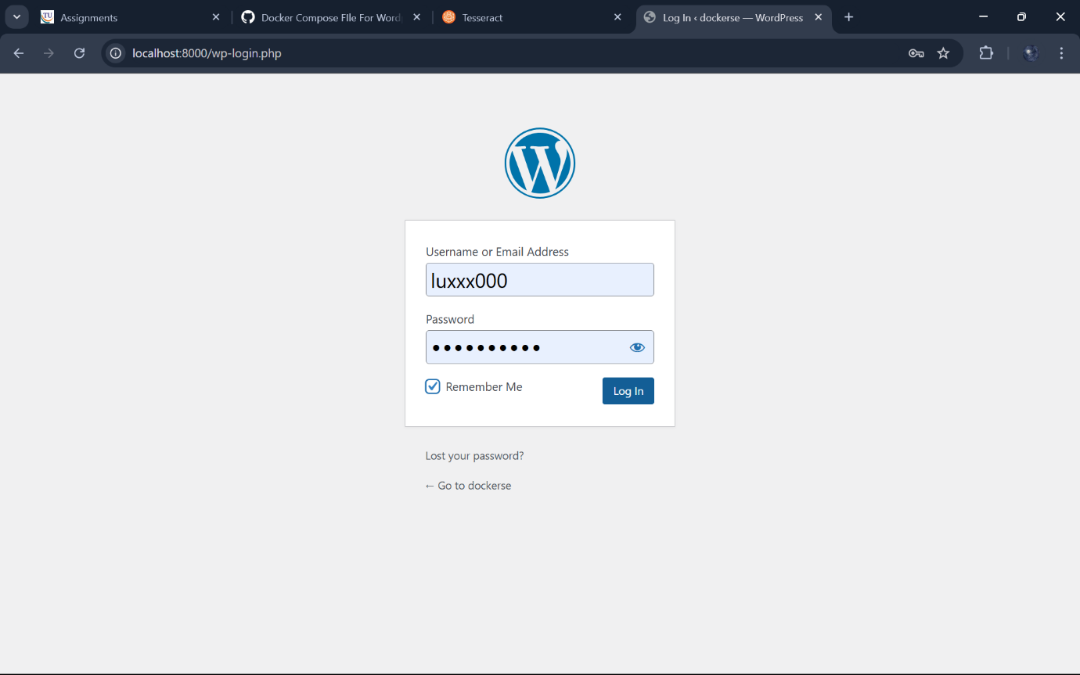

We have successfully created the account in wordpress inside the docker.

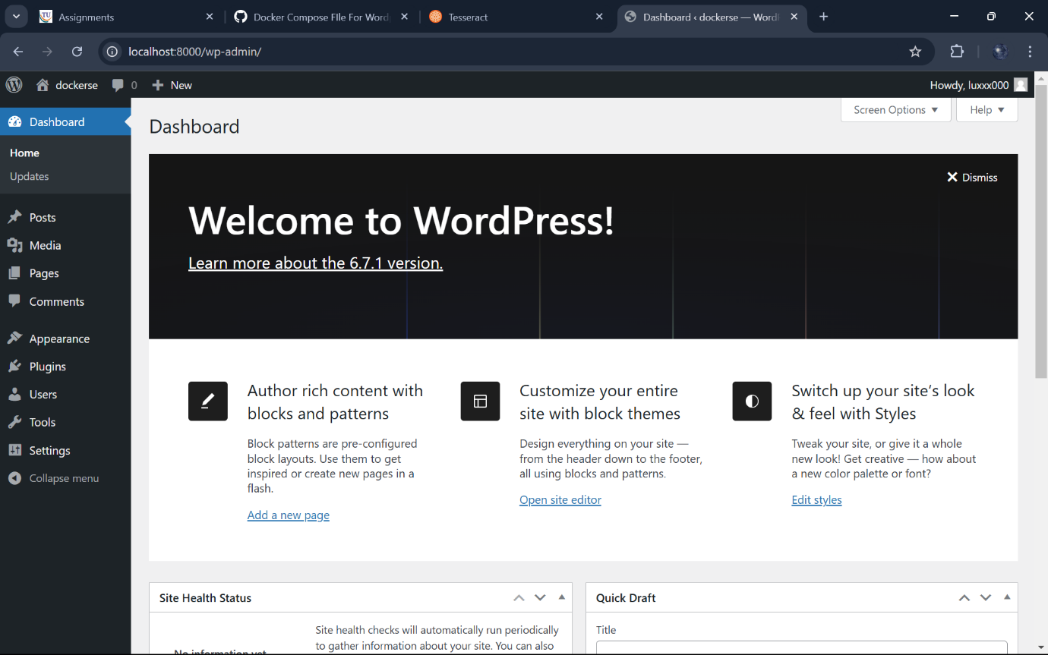

Stop the compose using docker-compose stop.

Starting the compose using docker-compose start.

Stop the compose using docker-compose stop.

Deleting/Removing the compose using docker-compose down.

