*CREATE AND PUSH DOCKER FILE IMAGE*

Create a Folder named dockerCalculator.

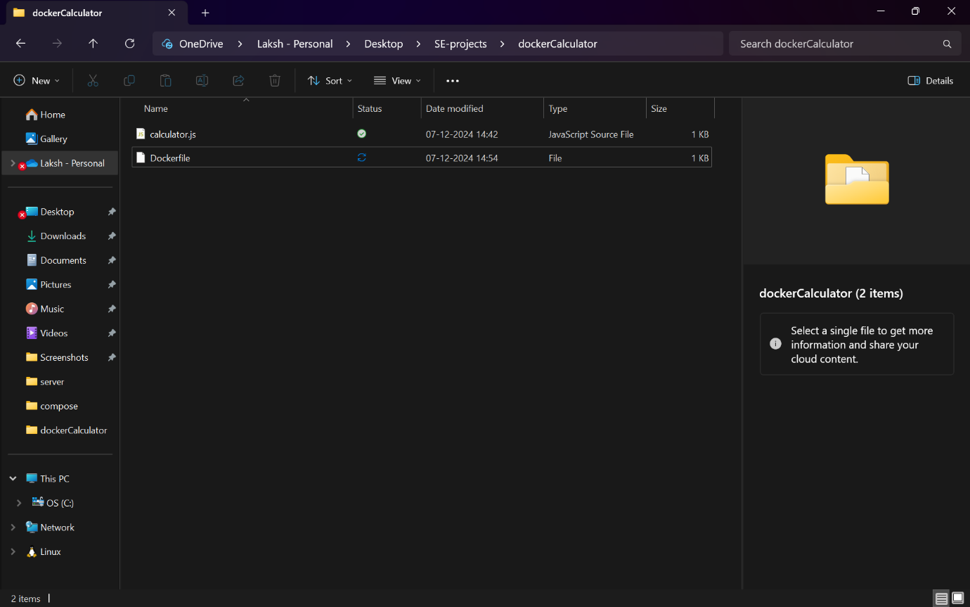

Using command prompt create a file with no extension

Inside that Folder create 2 files DockerFile and Calulator.js file with the Js calculator program.

DockerFile and Calulator.js file..

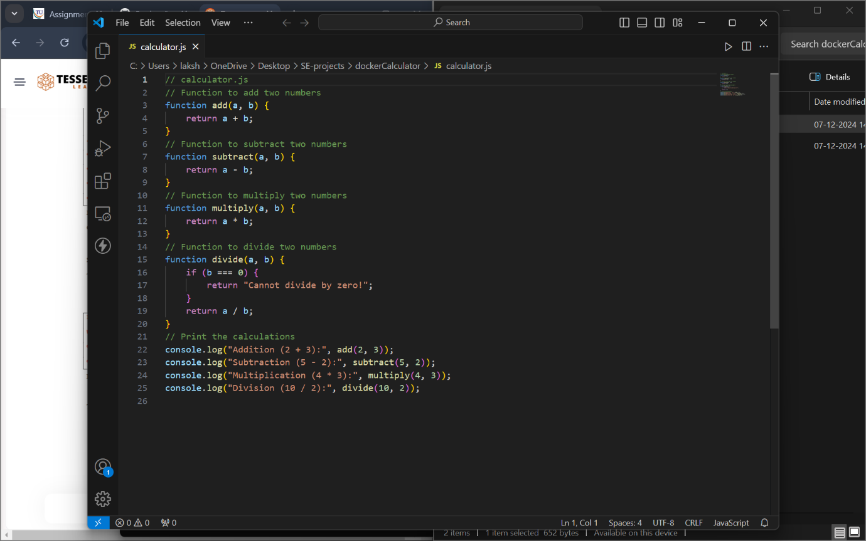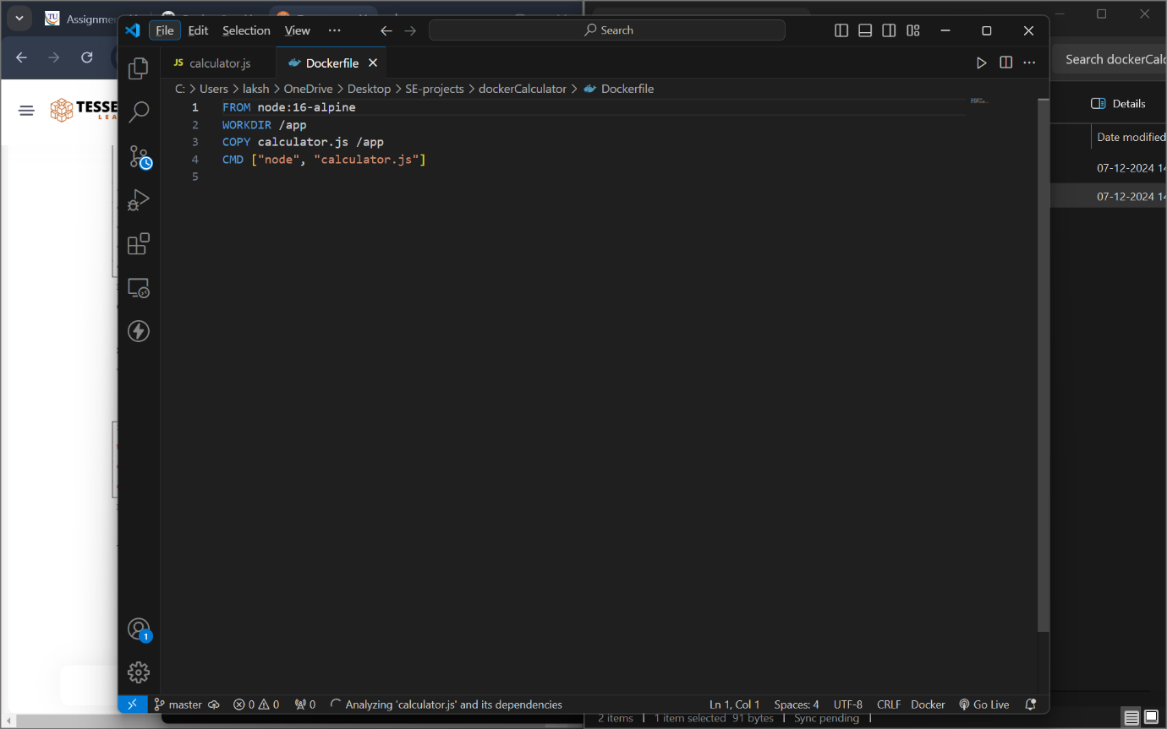

Now Let us Navigate to that path and build the image using the following command.Image of Calculator is Build successfully. 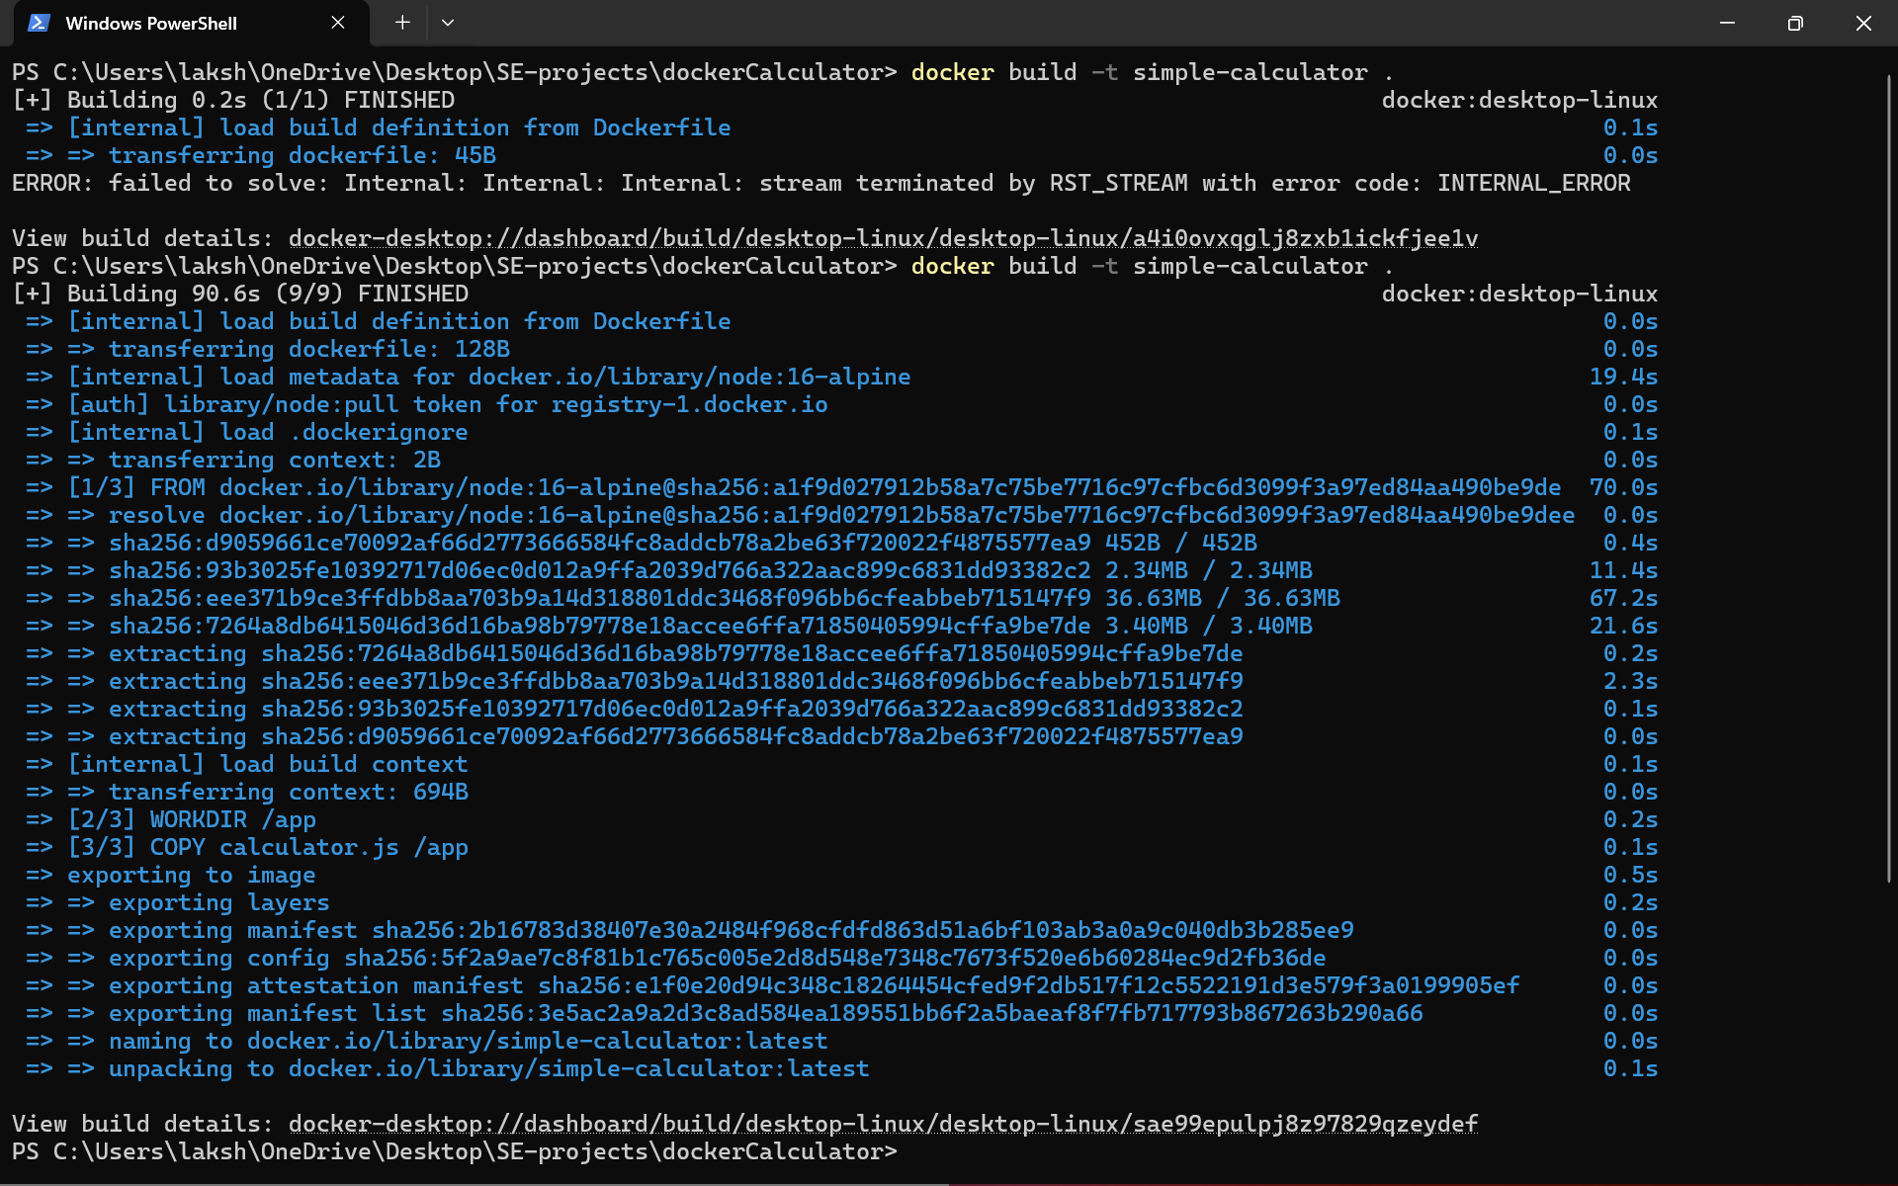

Running the Calculator image.

Login to docker hub to push the image.

Using docker tag command to save the changes into the image.

Pushing the image into my docker hub . 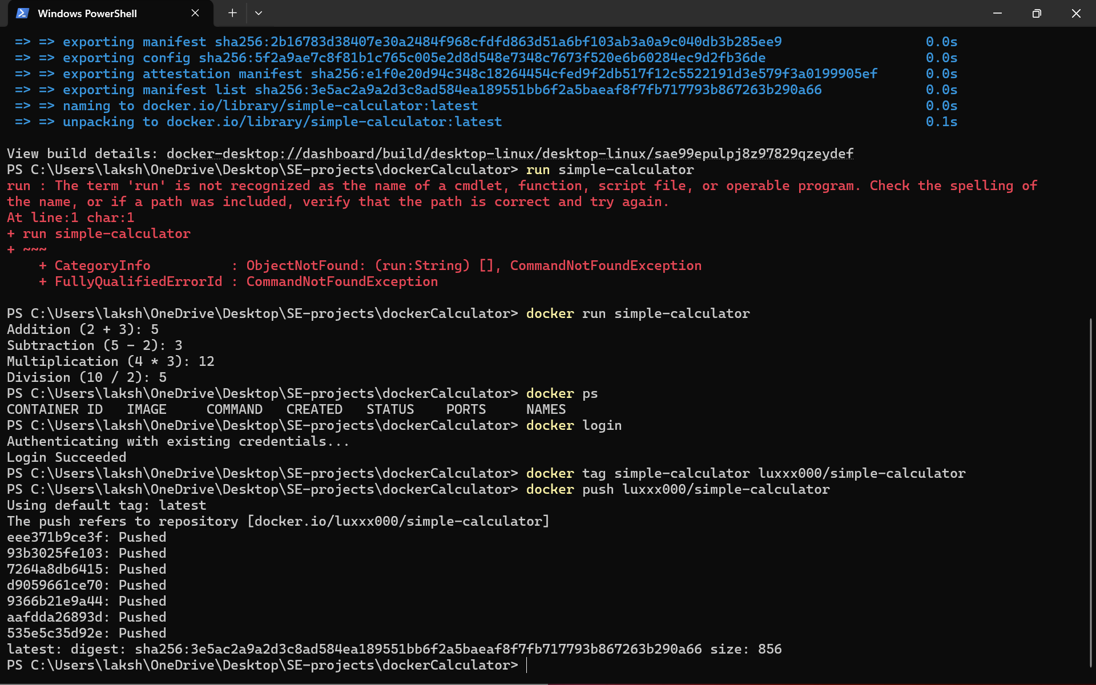

We can see that image is pushed into the docker hub.

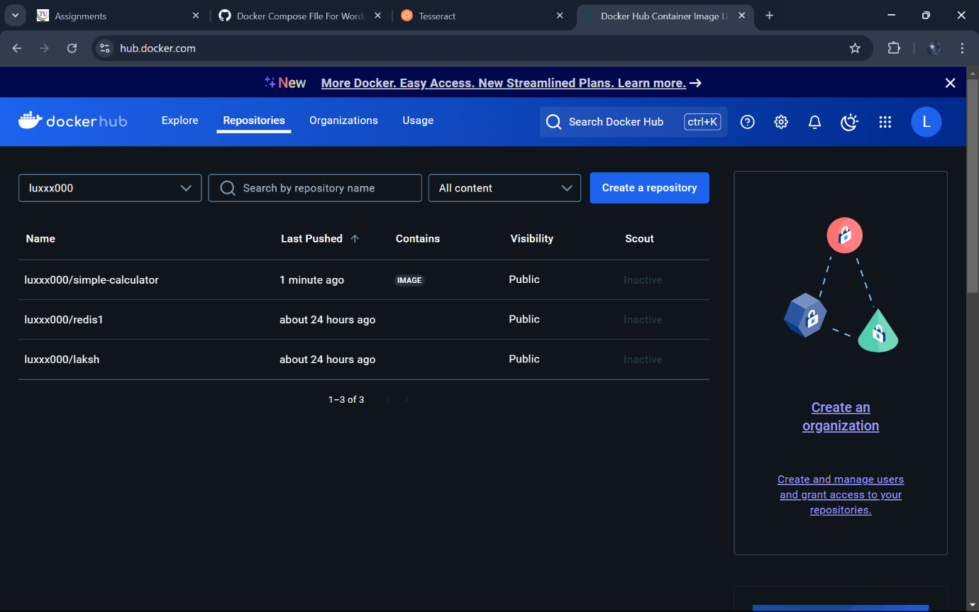

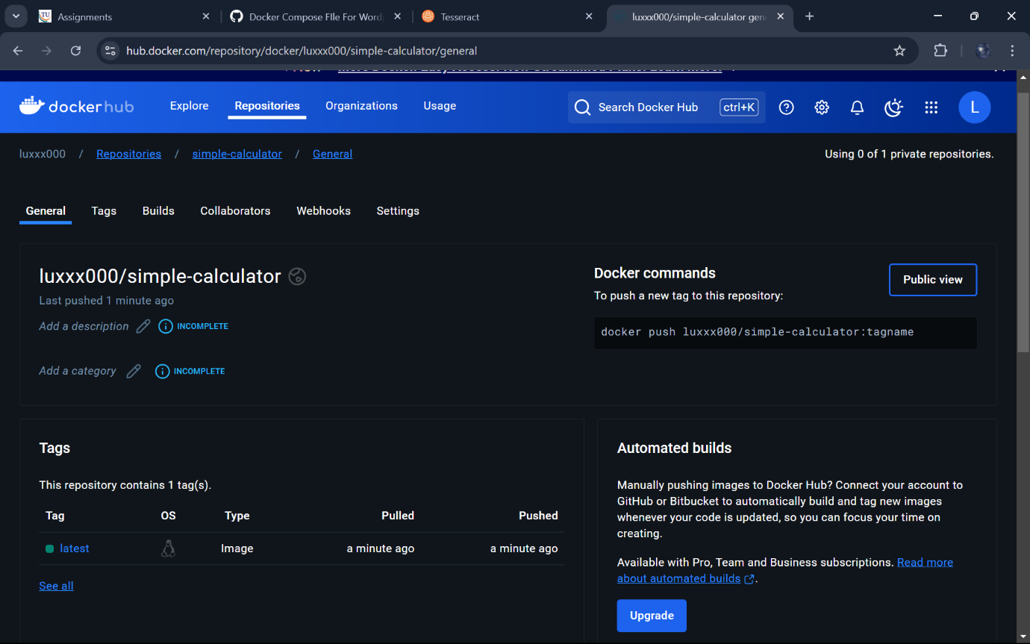Removing the container locally.

Removing the image locally

Pulling the latest image that we just pushed into the docker hub.

Running the image that we just pulled from docker hub. 