*DOCKER, UBUNTU AND GIT*

1. Login to the docker using docker login -u username. In administration mode
2. Let us first pull the ubuntu image . Pulling the latest ubuntu image.
3. Running the ubuntu image in a container that we just pulled.
4. Now let us enter into ubuntu interactive operation of git.
5. Updating the apt using the command “apt update”.

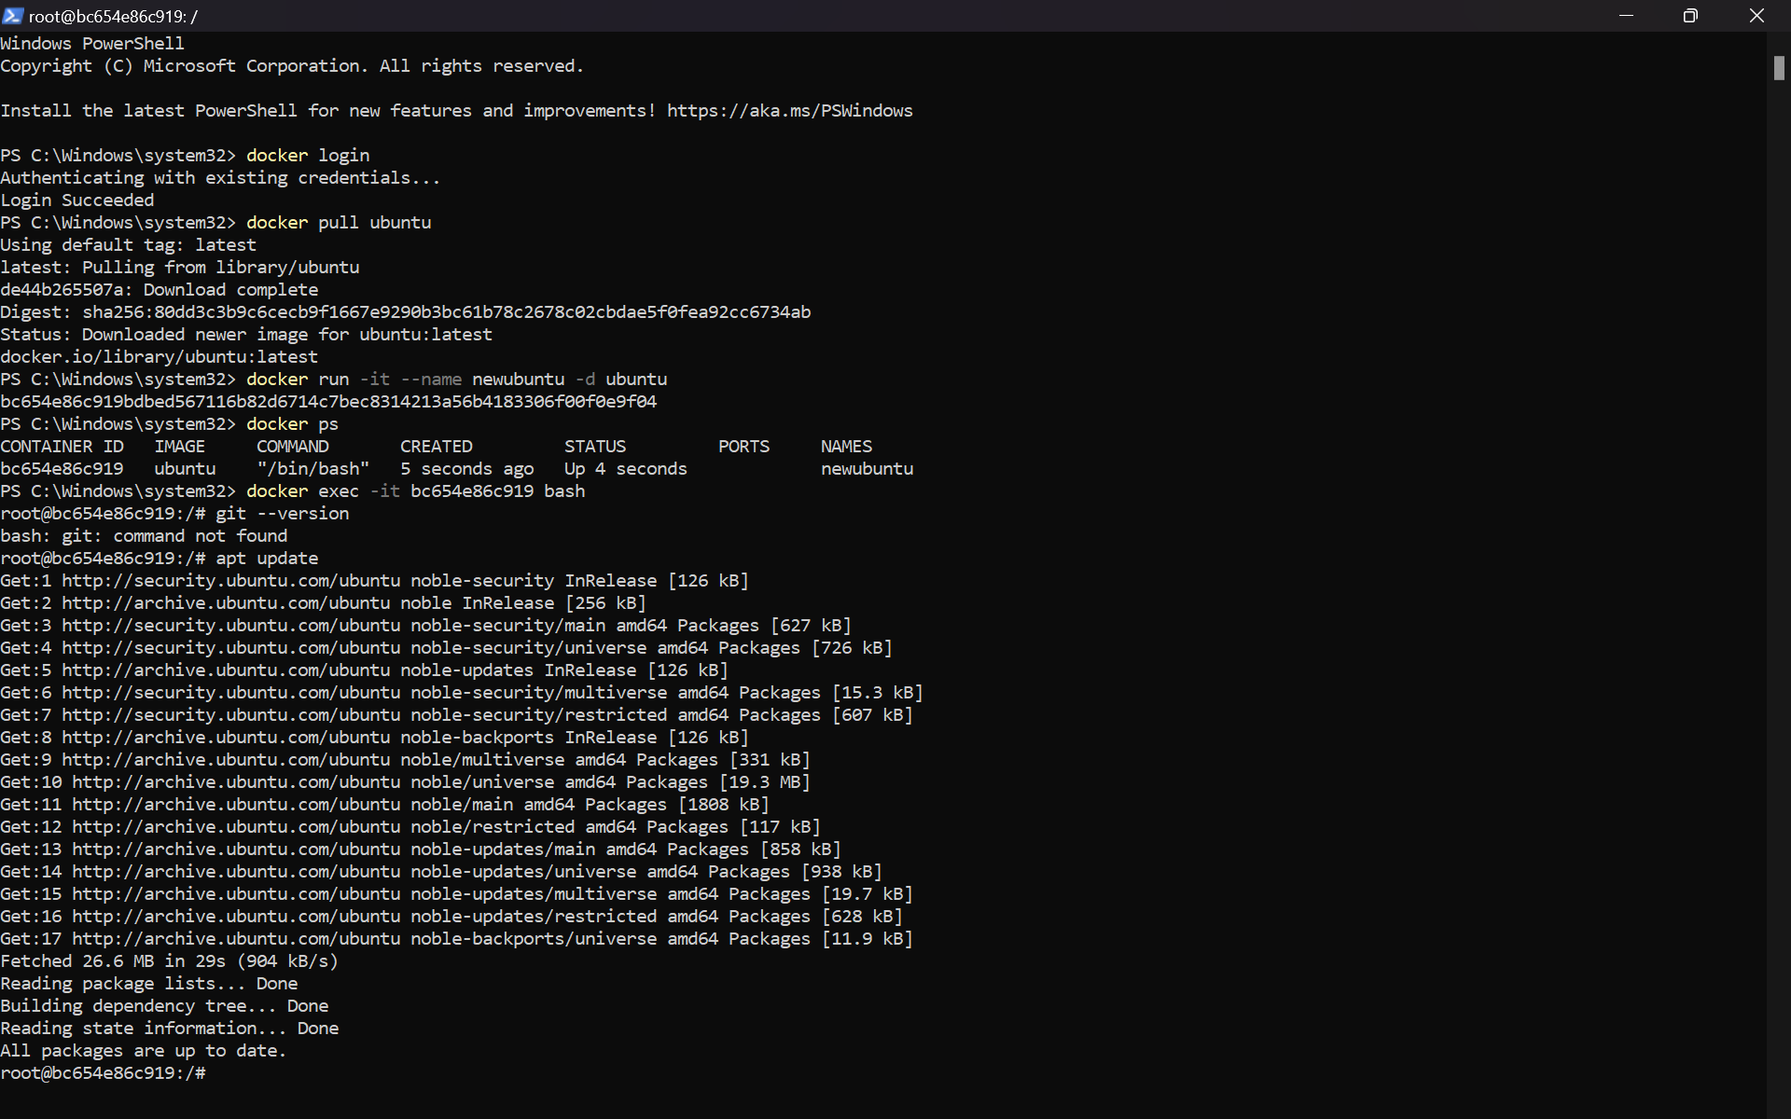

1. Installing the git using apt install git -y.

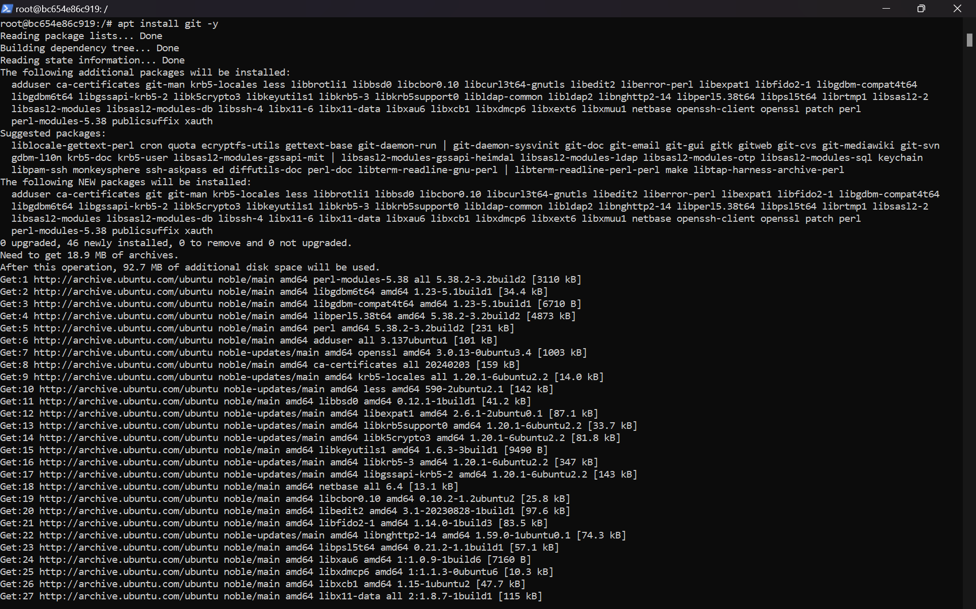

Git installation.

1. Checking the git version using git –version.
2. Exiting the git using exit command.
3. Stopping the git container that we just started
4. Commit the changes and saving the image.
5. Checking the docker images.

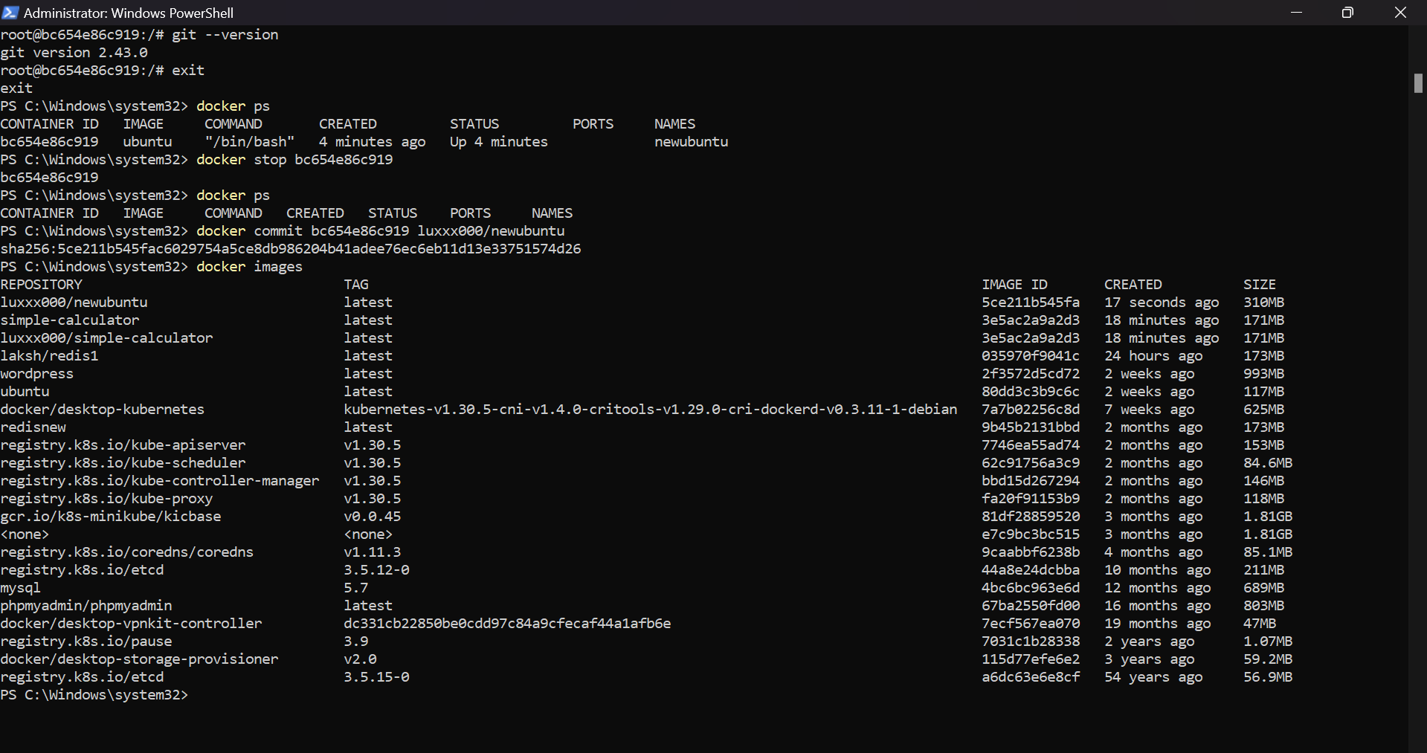

1. Login to the docker hub using docker login.
2. Push the latest updated image into the docker hub.

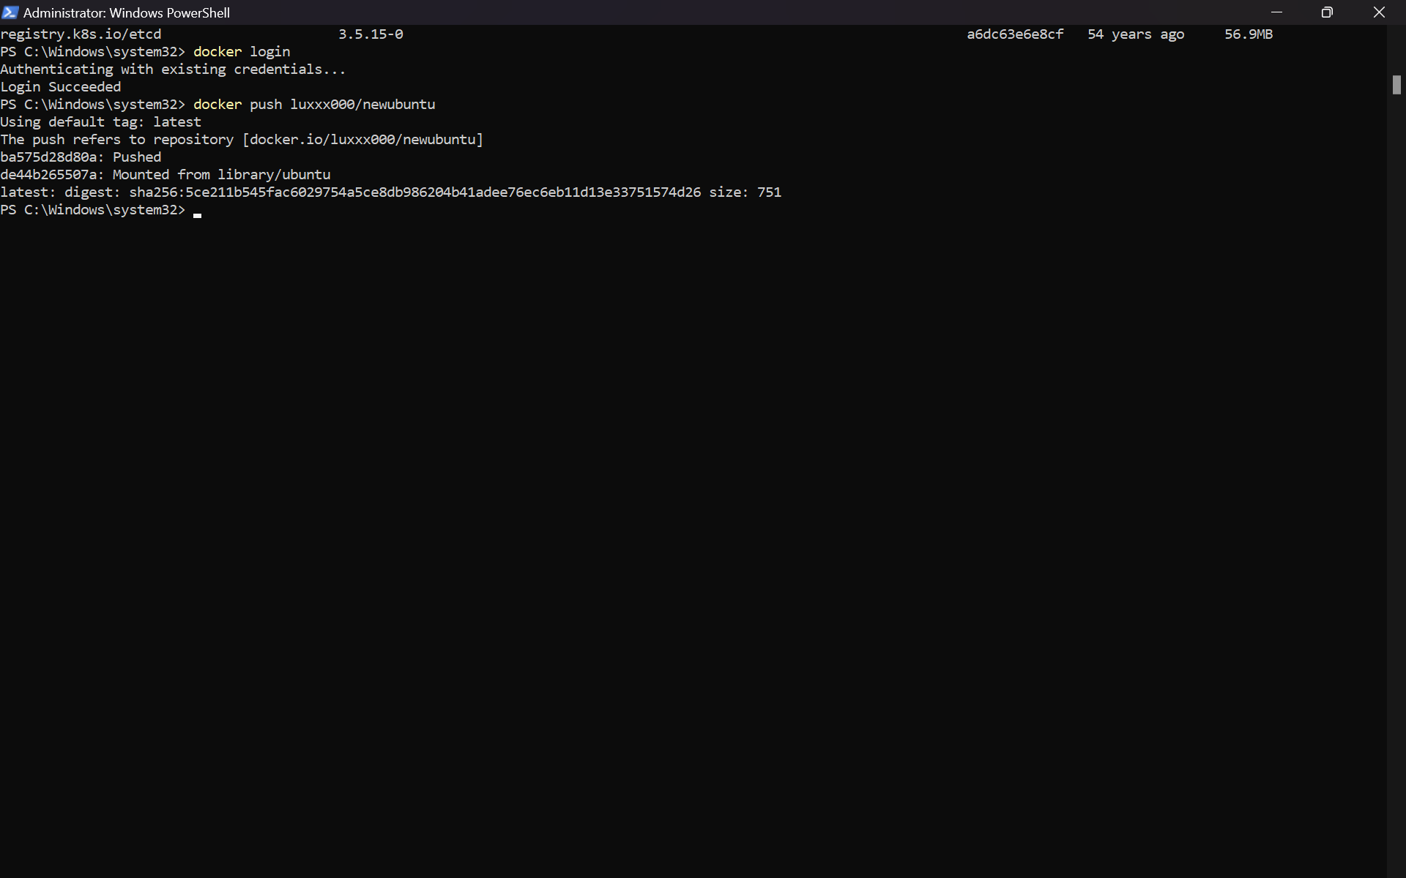

1. We can see that the ubuntu image is uploaded into the docker hub.

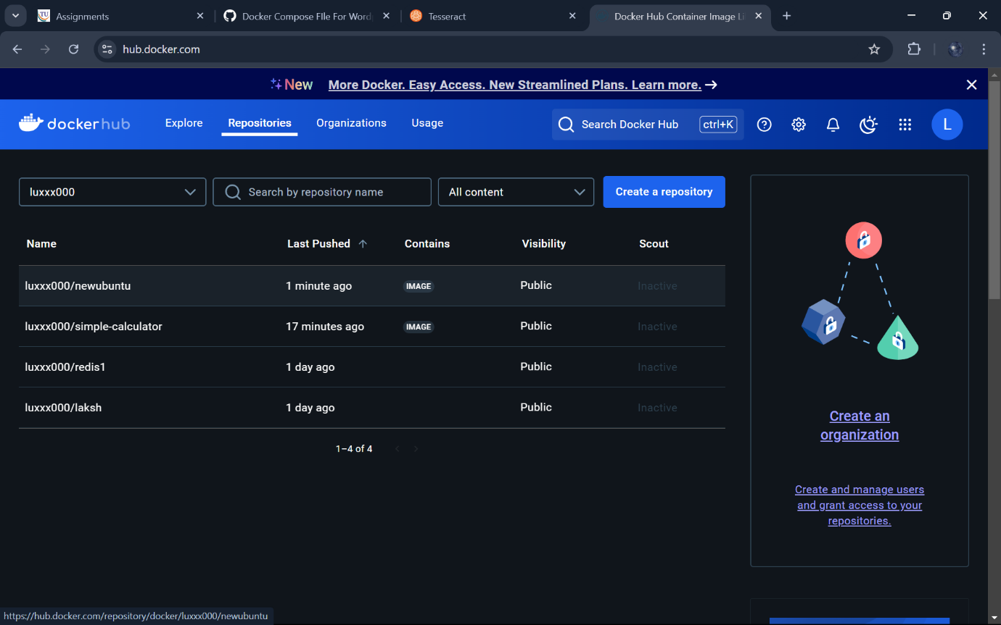

1. Deleting the container locally .
2. Deleting the image locally.
3. We can see the container is deleting.
4. Pulling the image that we just pushed. 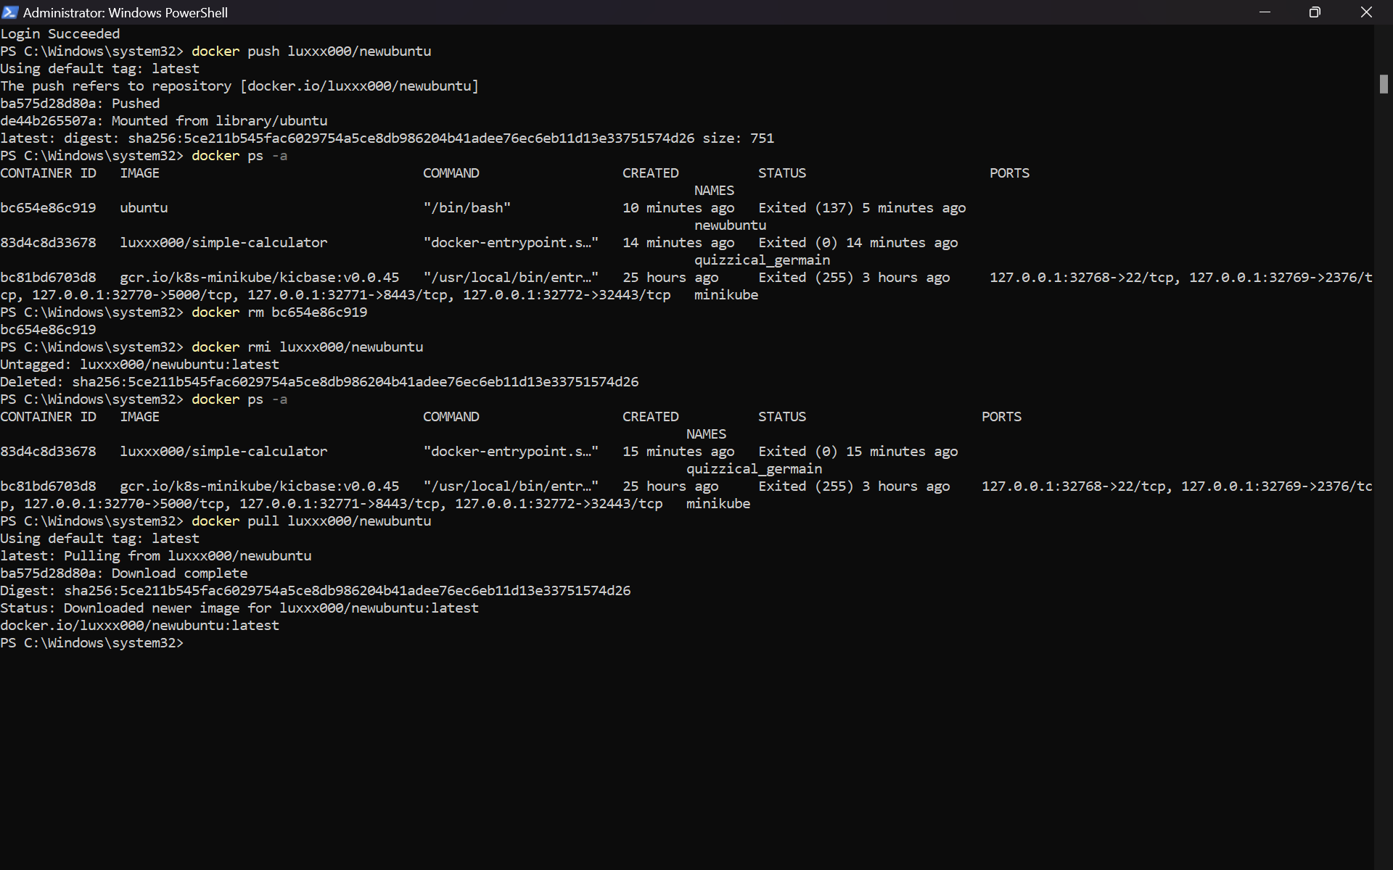
5. Running the image into a container.
6. Checking the git version and making sure that the same git version is seen. 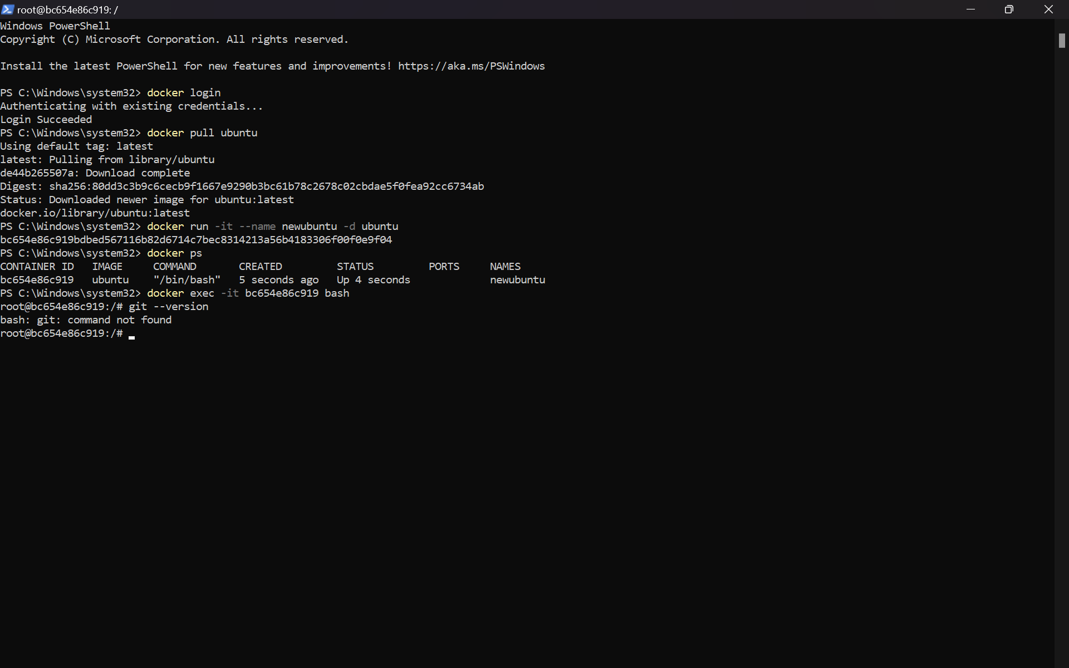
7. Exiting the Git.
8. Deleting the container that we pulled from docker hub locally.
9. Deleting the image that we pulled from docker hub locally