CREATE A FREESTYLE PROJECT NAMED MavenJavaProject_build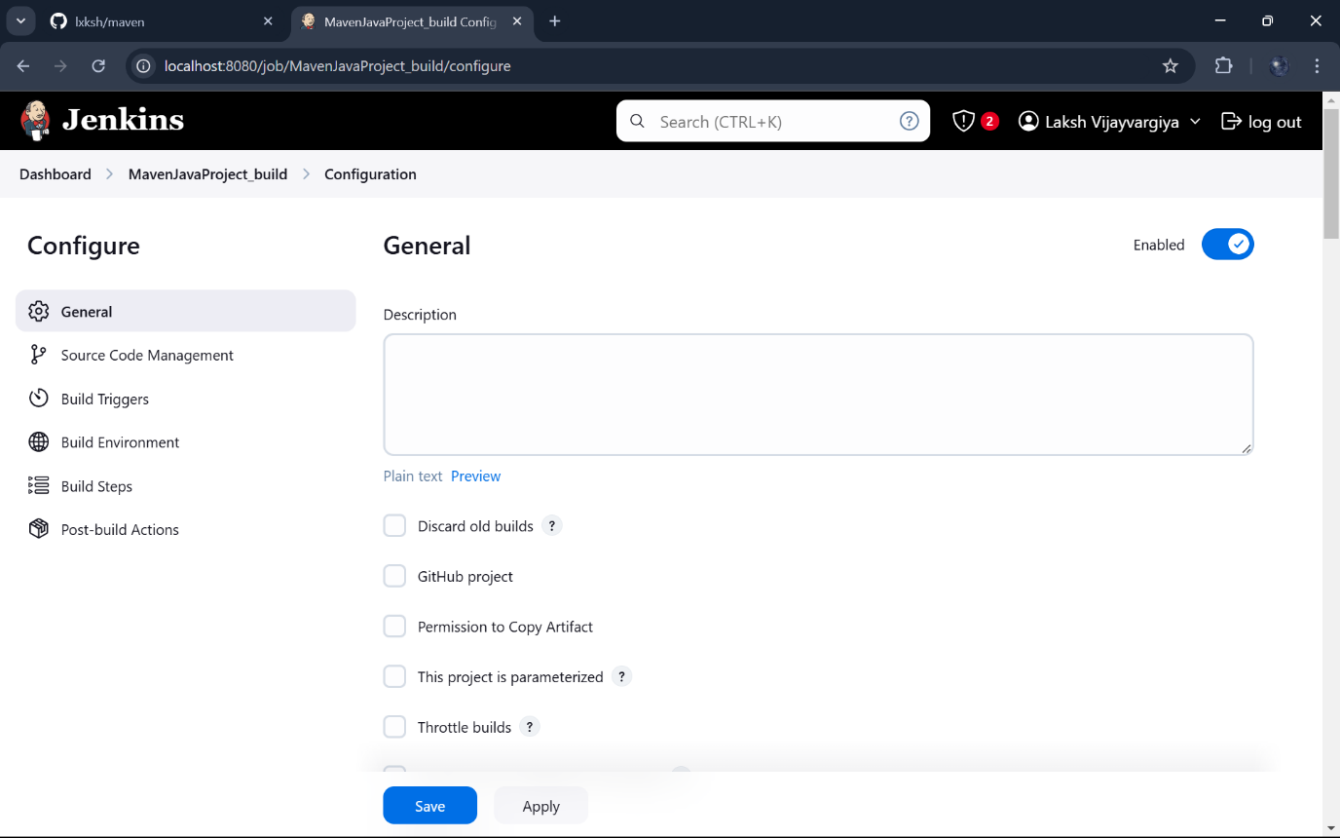Give Git repository URL of project: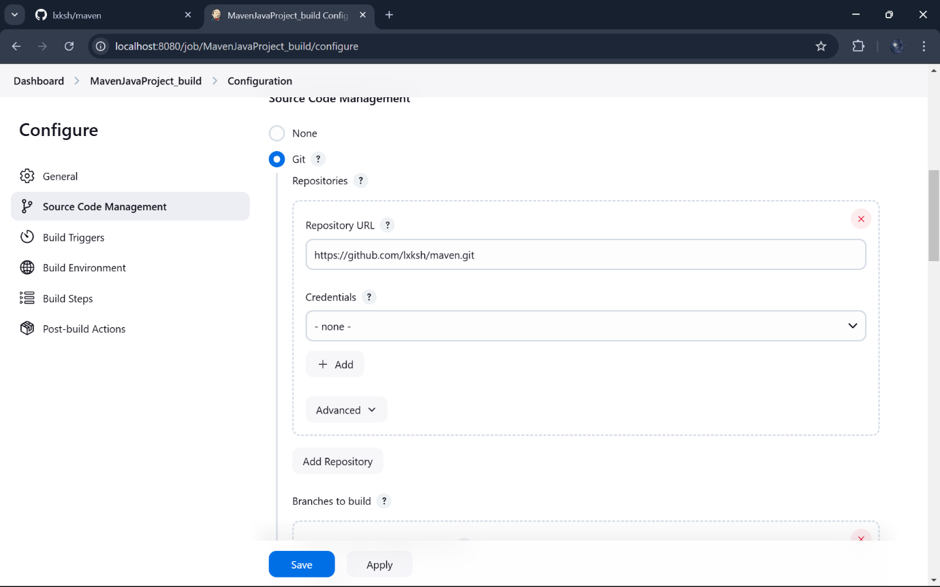Build and Invoke top-level Maven Targets:

Add maven_home with clean and install: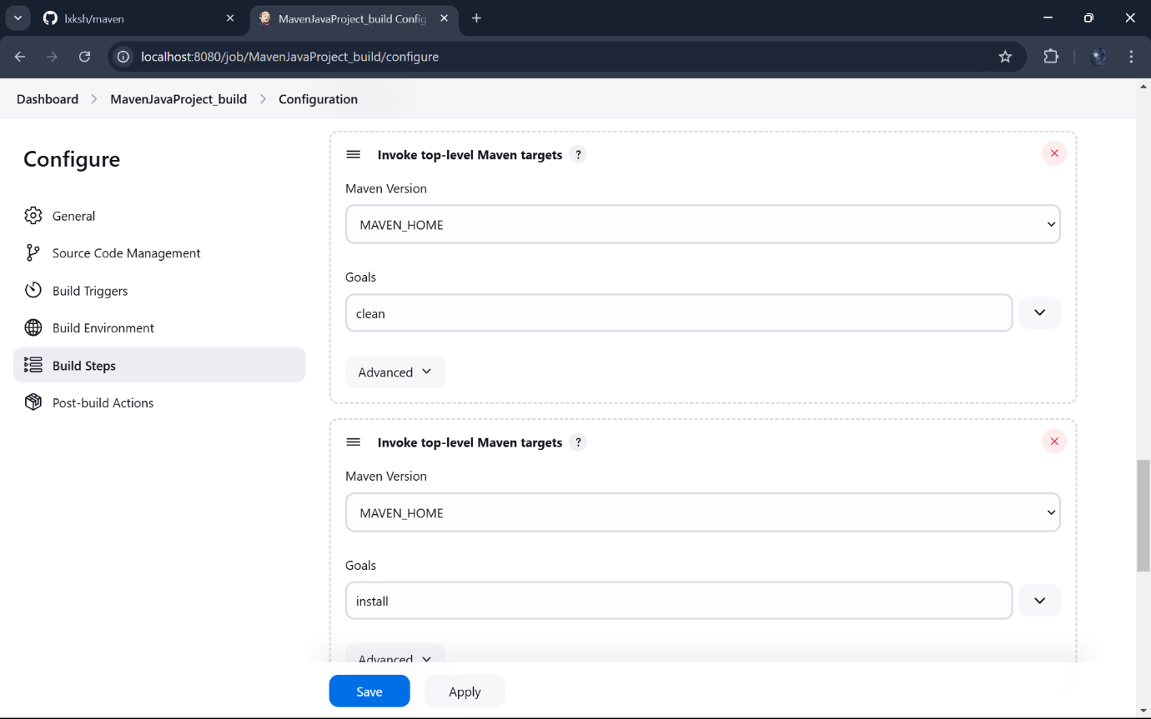In post build actions-> select Archive the artifacts,to send output of build project to testing team , select archive “**” and in build other projects connect MavenJavaProject_test: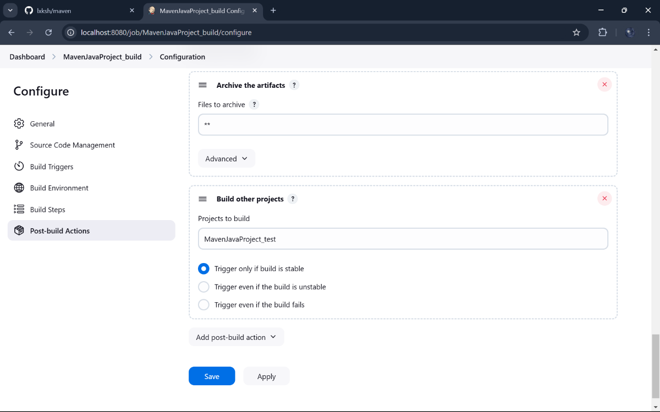Create a new freestyle project test :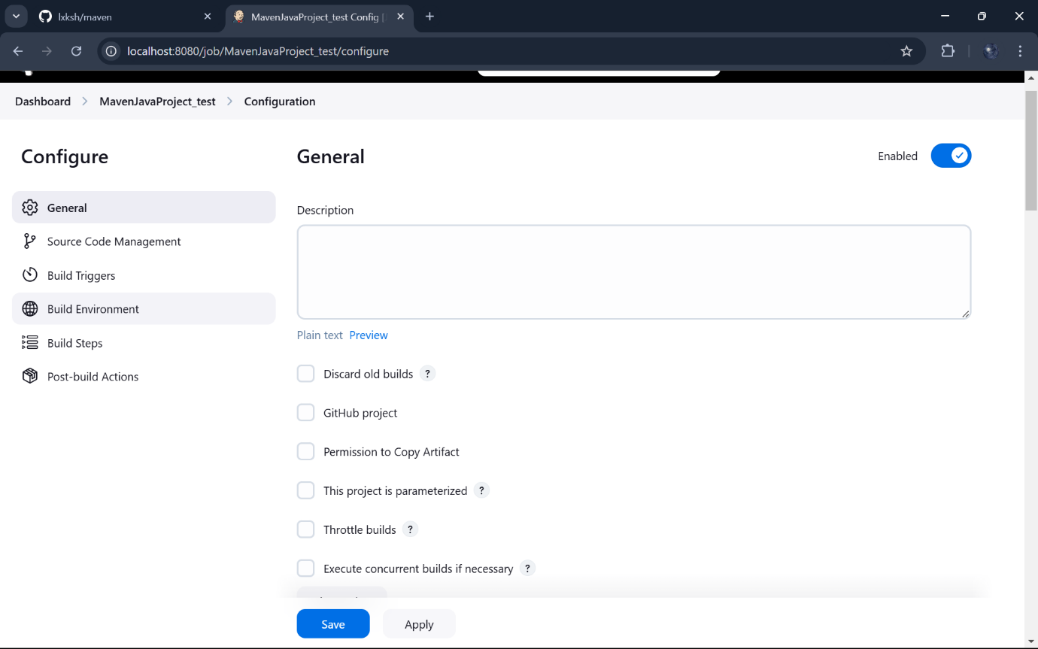We can mention git repository as None: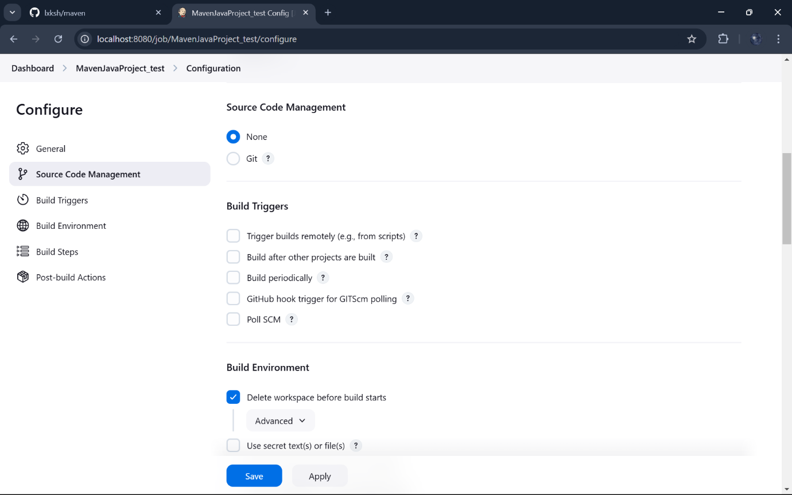Add Build Steps and copy artifacts from build project: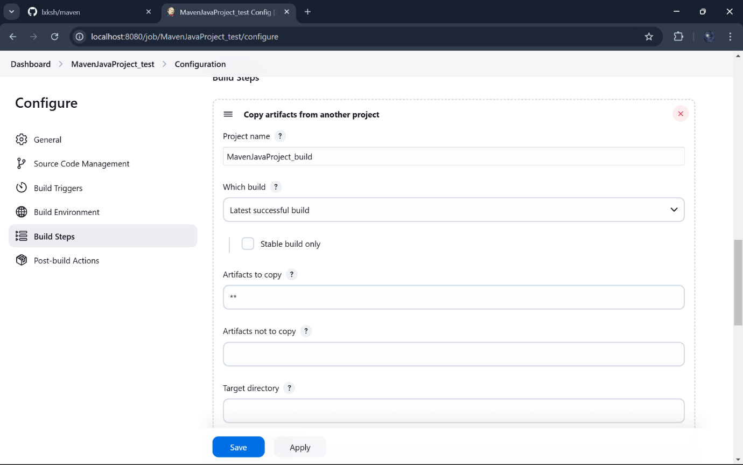Select Invoke top _ level Maven targets and add test in Goals: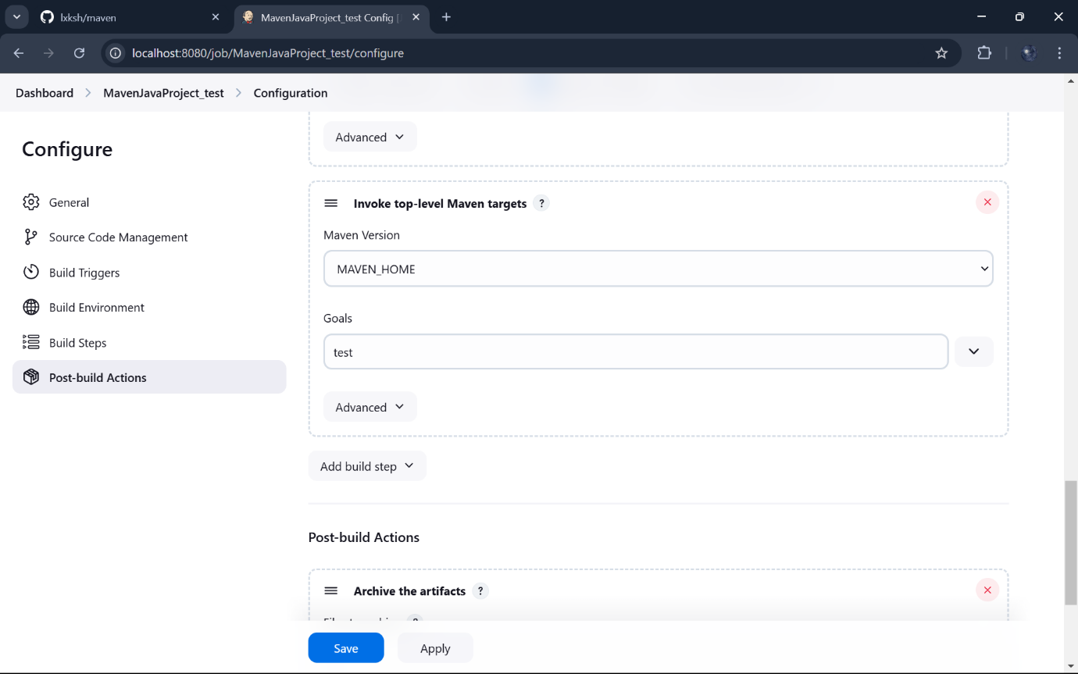In post build actions -> select Archive the artifacts: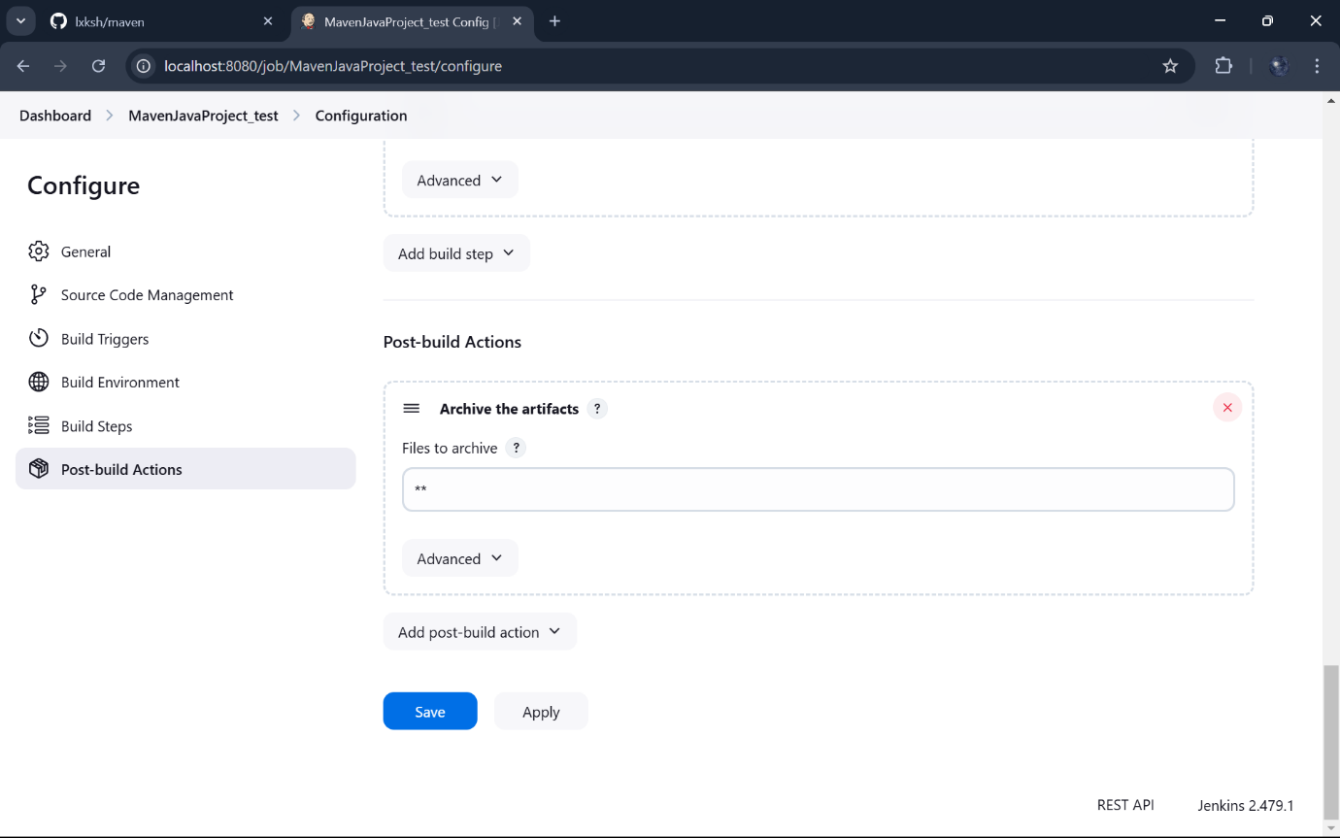

Create a pipeline by clicking on + symbol in the dashboard ->a pipeline is a collection of events or jobs which are interlinked with one another in a sequence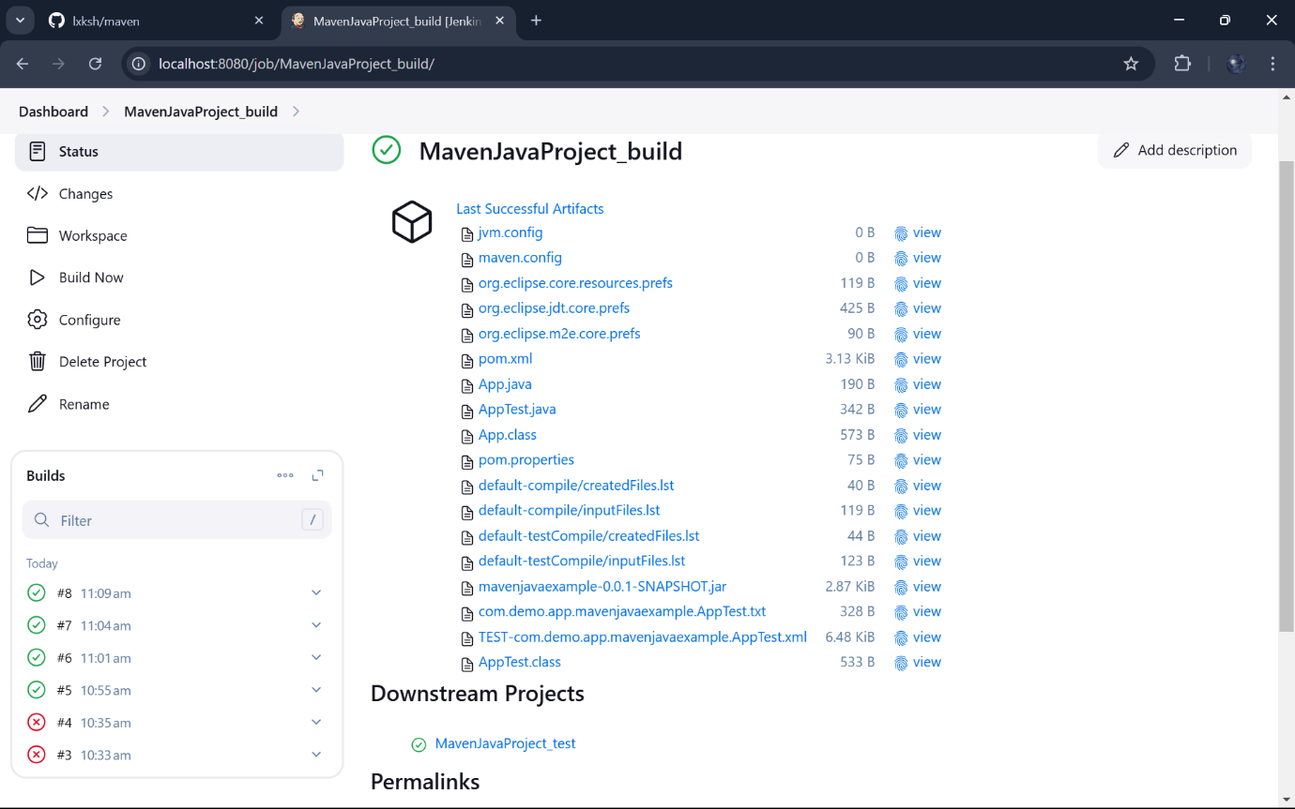name to the pipeline->select Build Pipeline View->create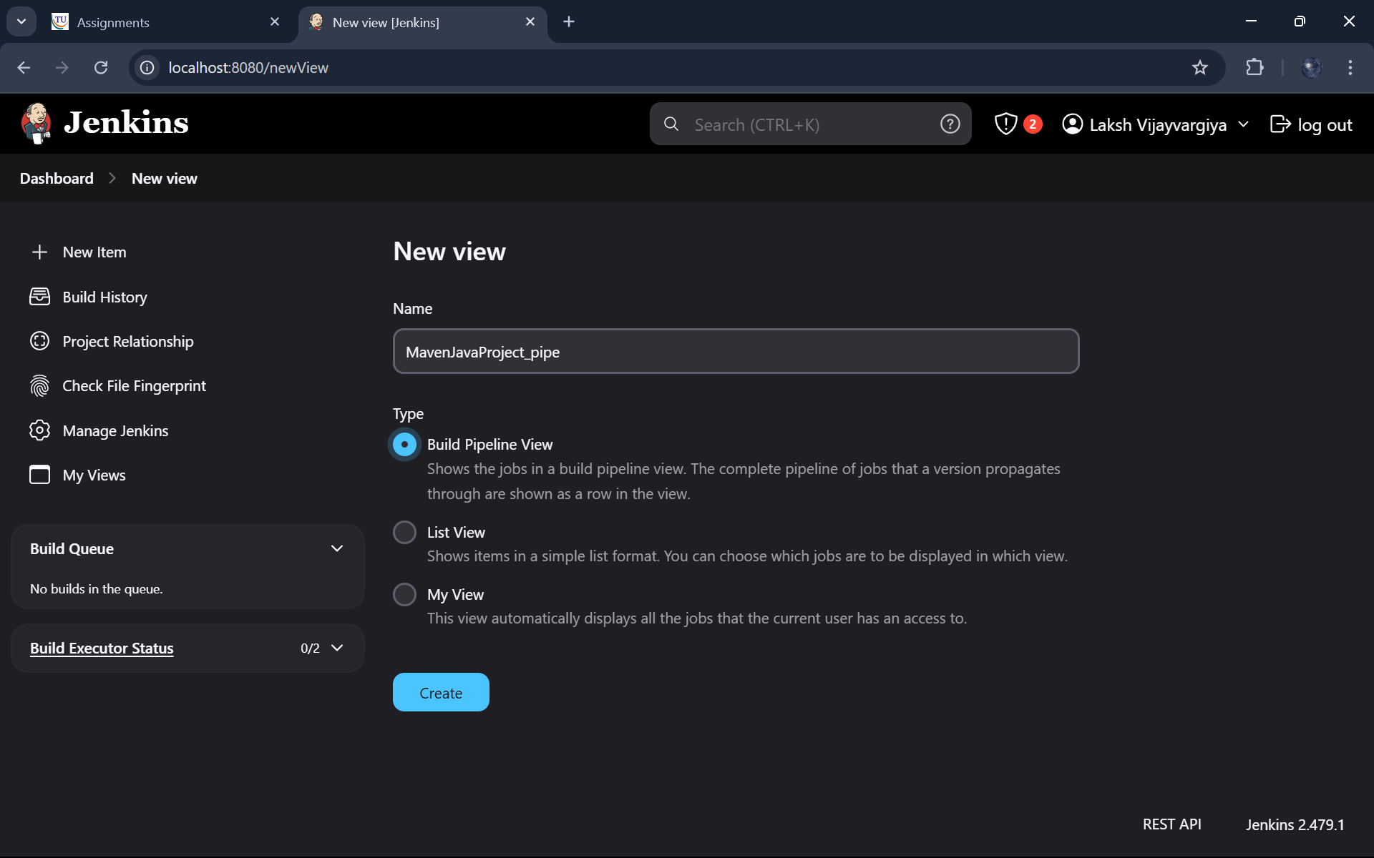Select the first project to trigger the execution->build project: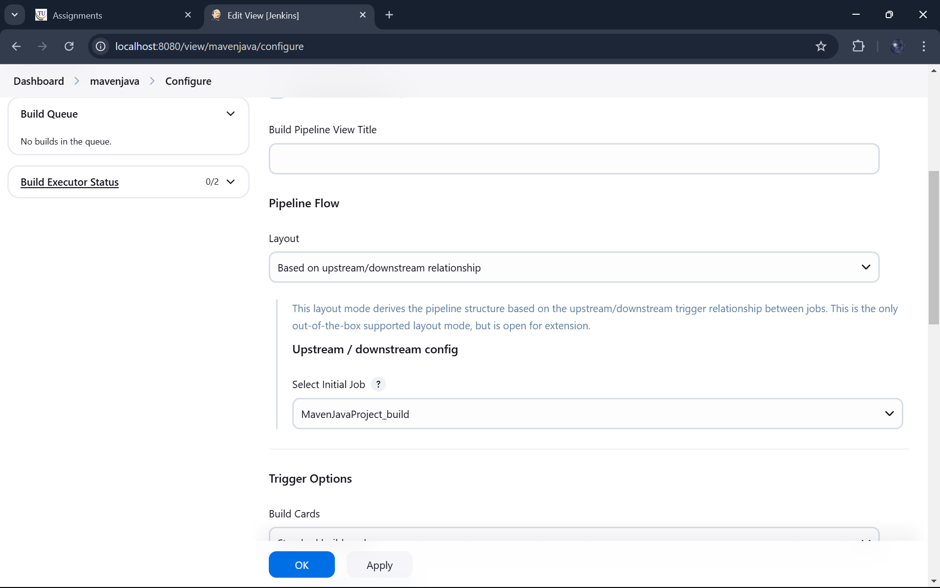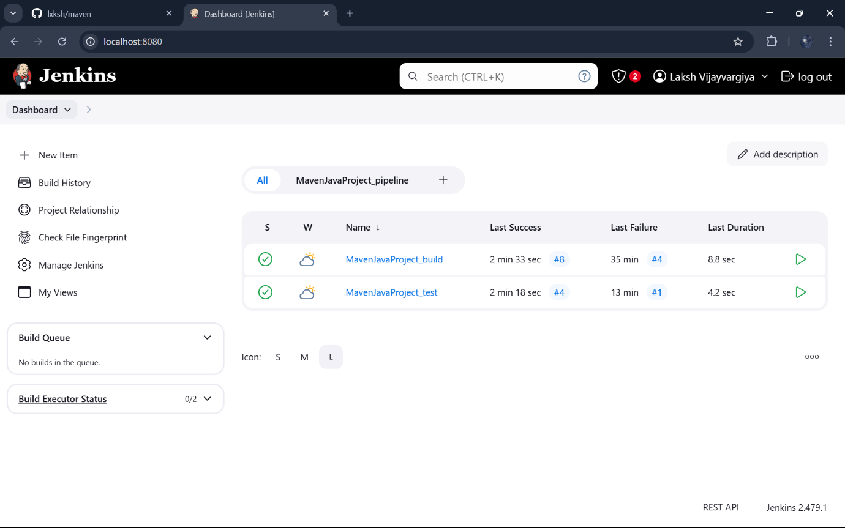

The pipeline is successful if it is in green color as shown ->check the console of the test project: