Sample hello script

Check for the java, git and maven version whether they are installed

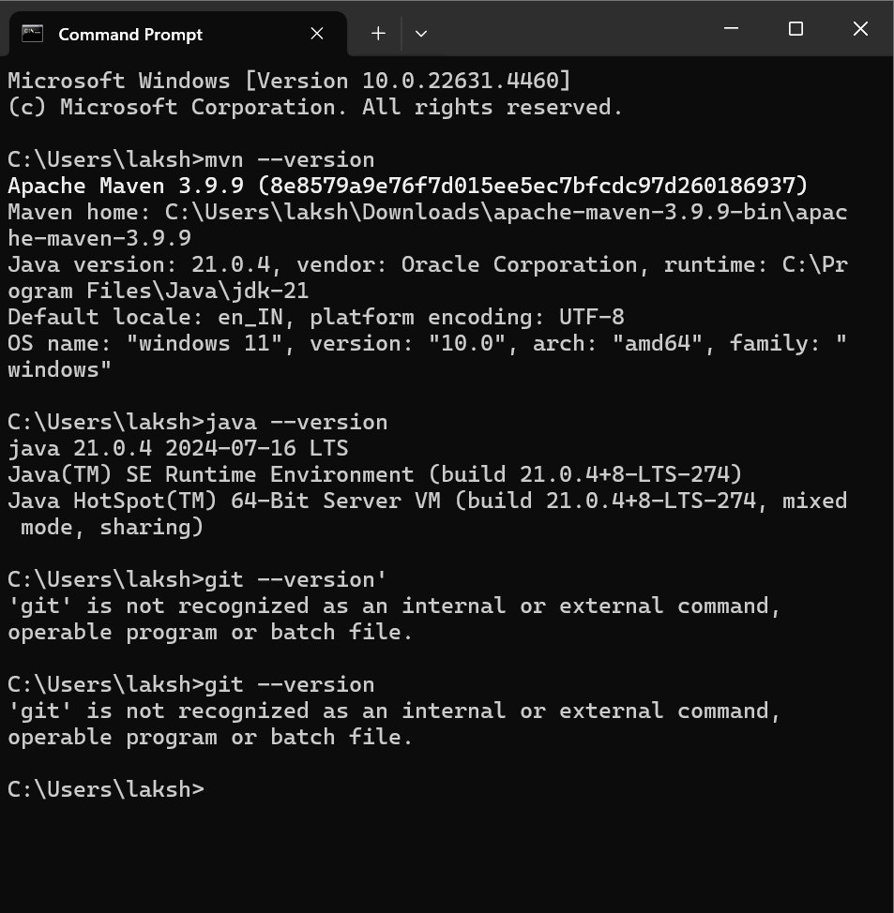

Go to manage Jenkins and click on manage Jenkins , go to tools and enable maven, git , jdk

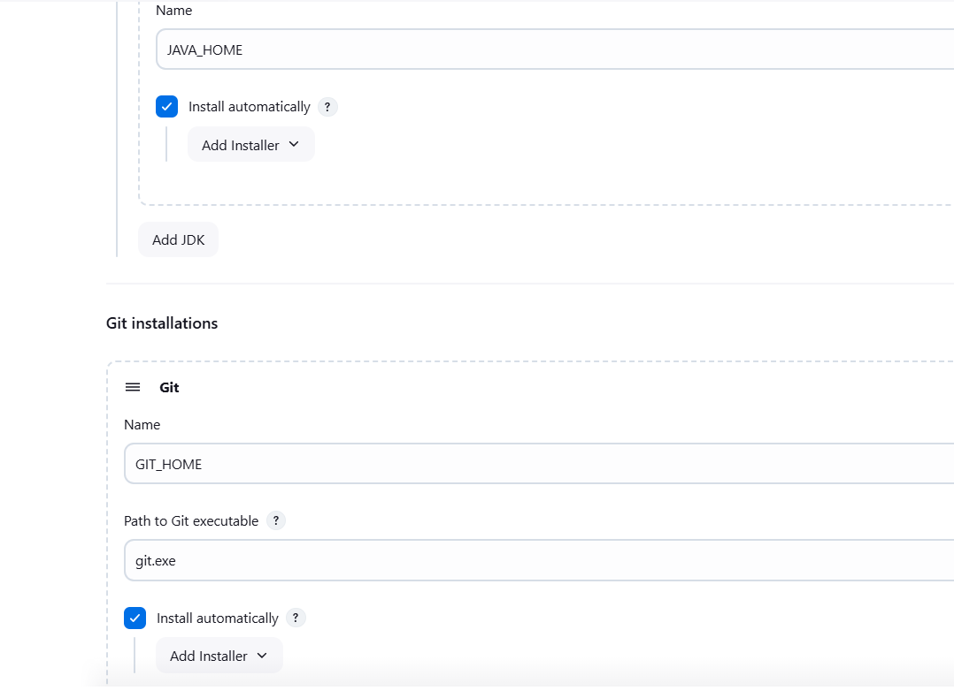

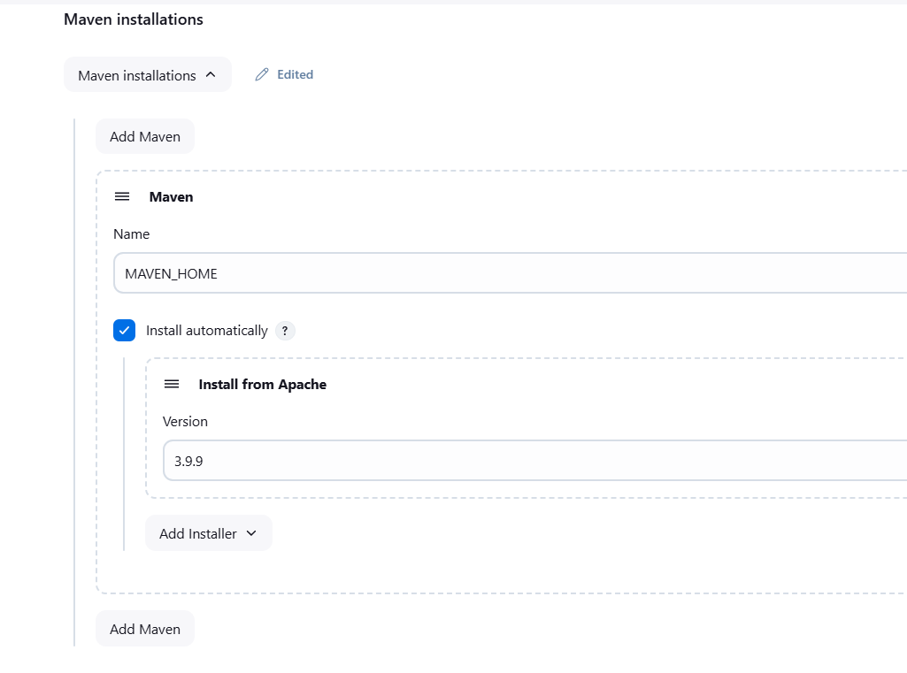

Come to dashboard and click on the new item and name it as script and select pipeline and click ok

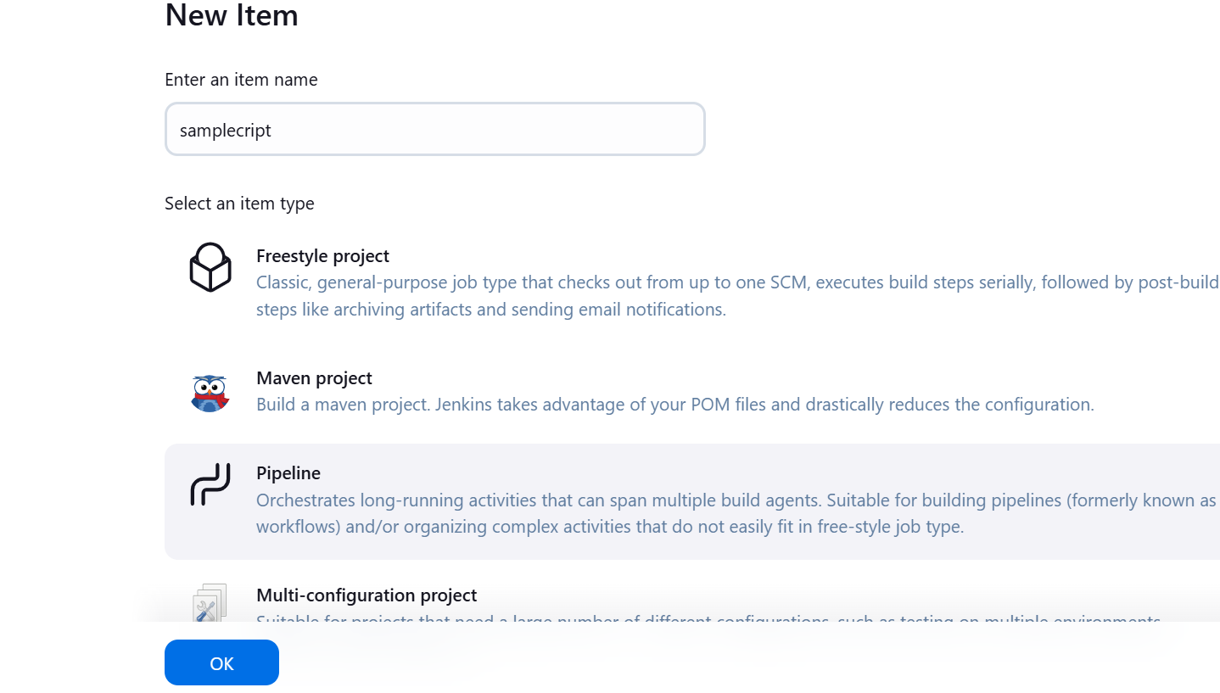

Now in configuration go to pipeline and enable pipeline script , drag on the hello world and change the sample hello world script program

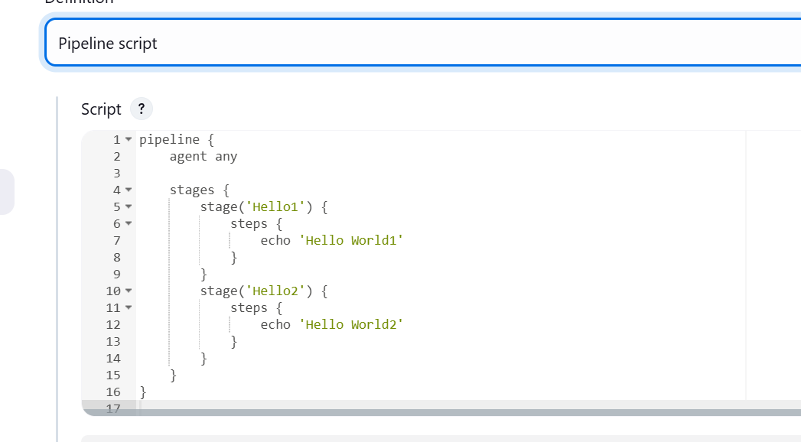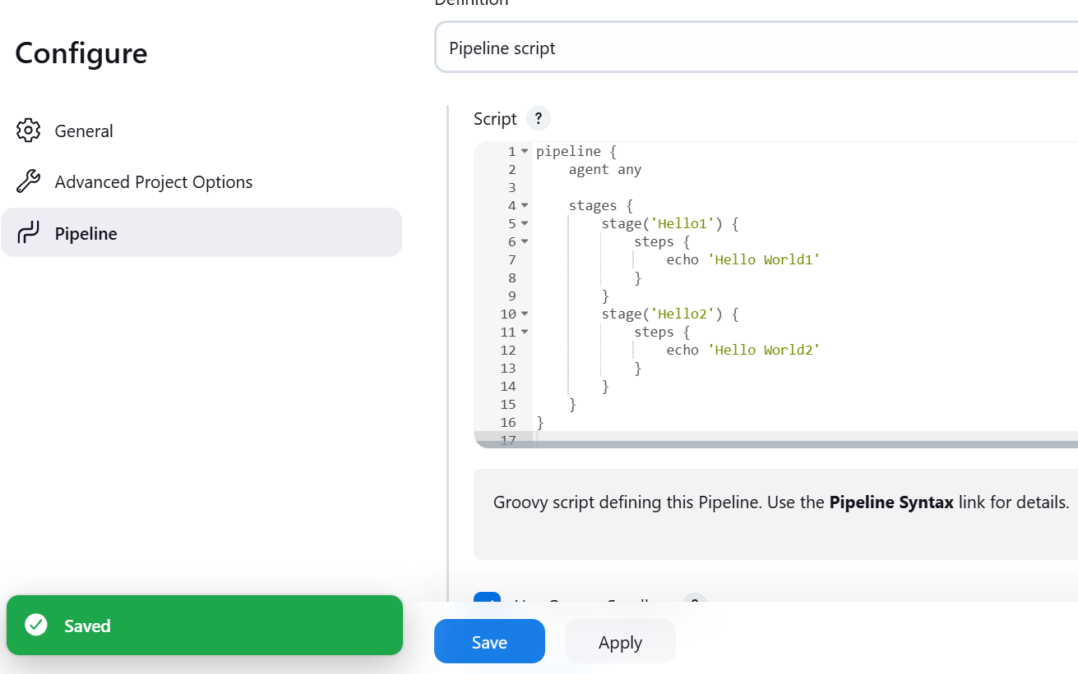

Apply and save it

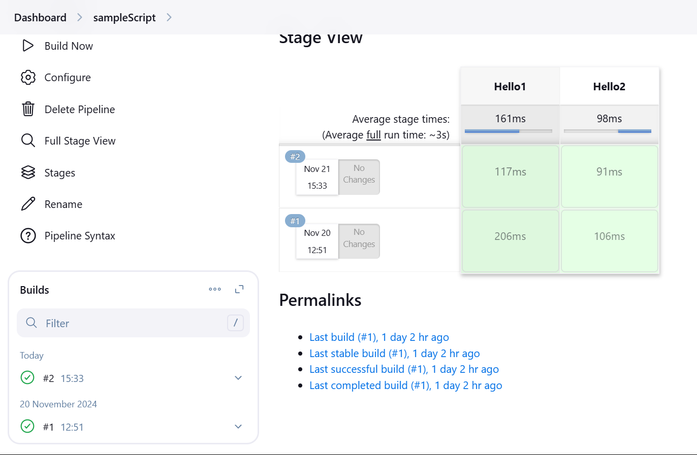

Now build it , u will observe the stage view of it on the right

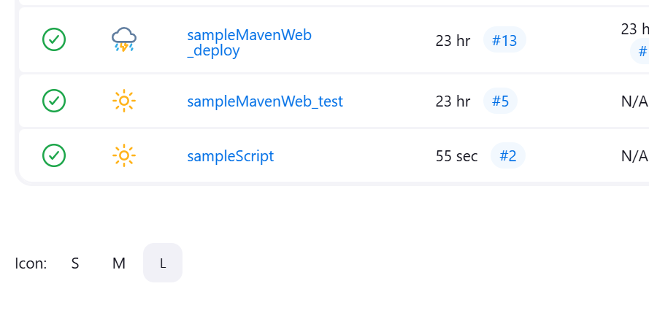

Declarative script

Create a declarative script in new item and change the pipeline script as needed for you

Change the script to function clean, install, test and download package

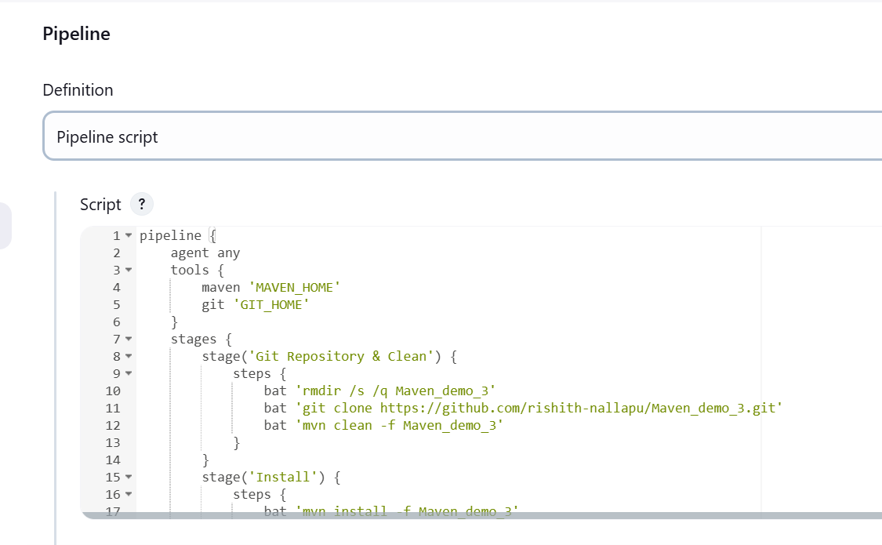

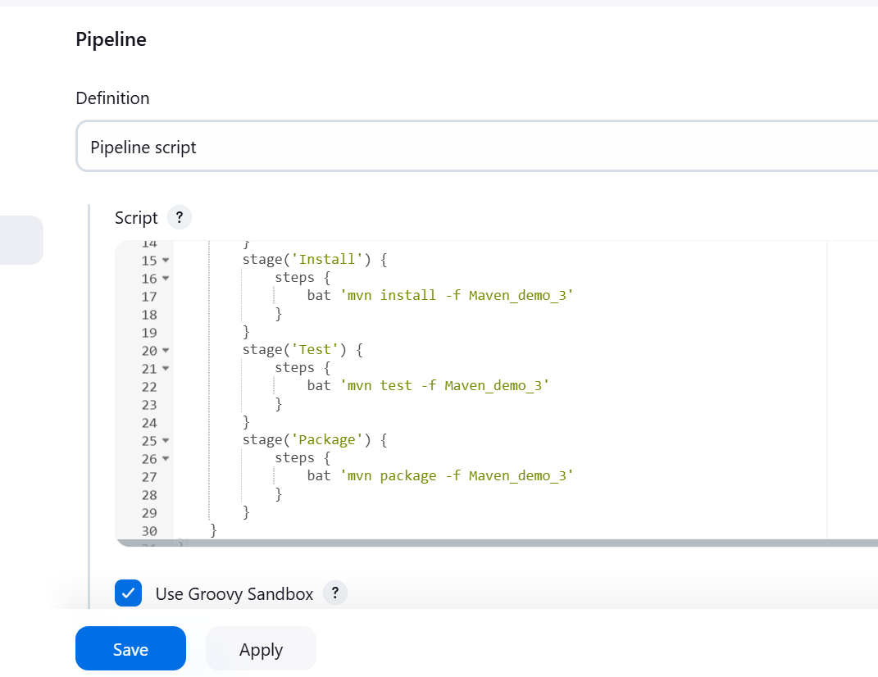

Click on build now and observe the staging view on the right

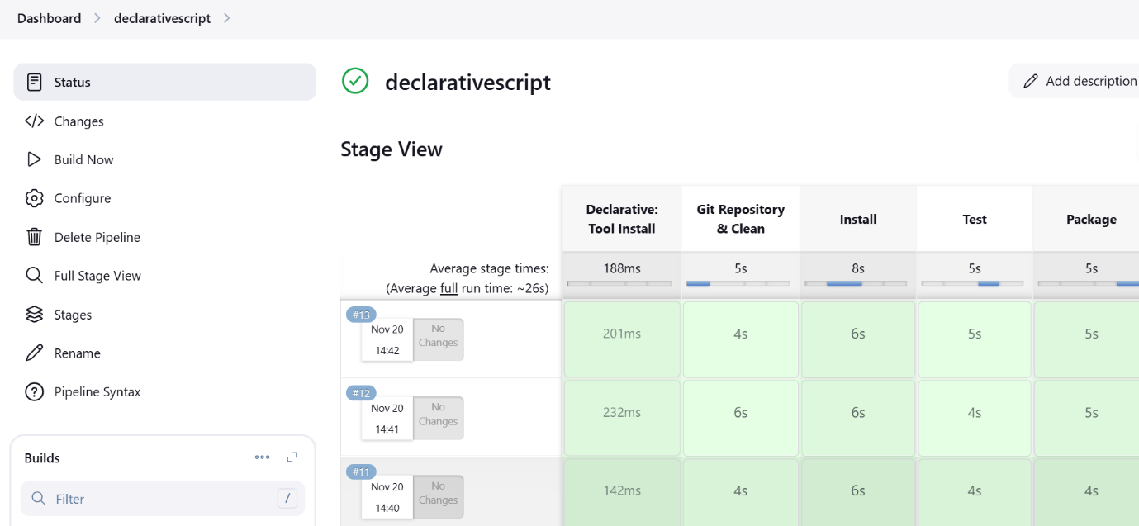

Our stages are build