CREATE A FREESTYLE PROJECT NAMED MavenWebProject_build 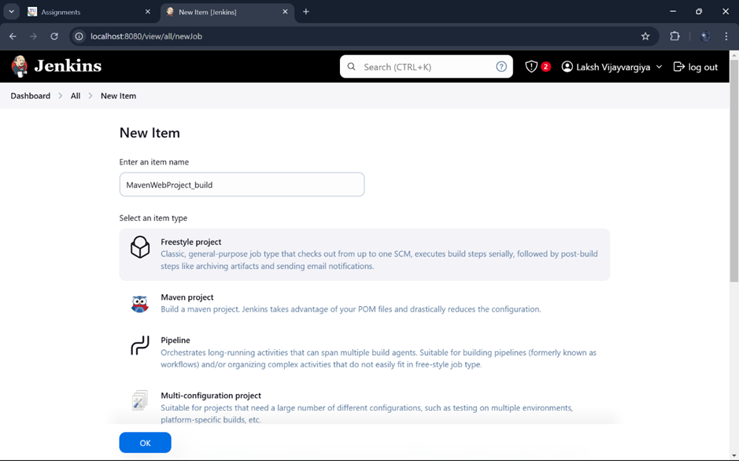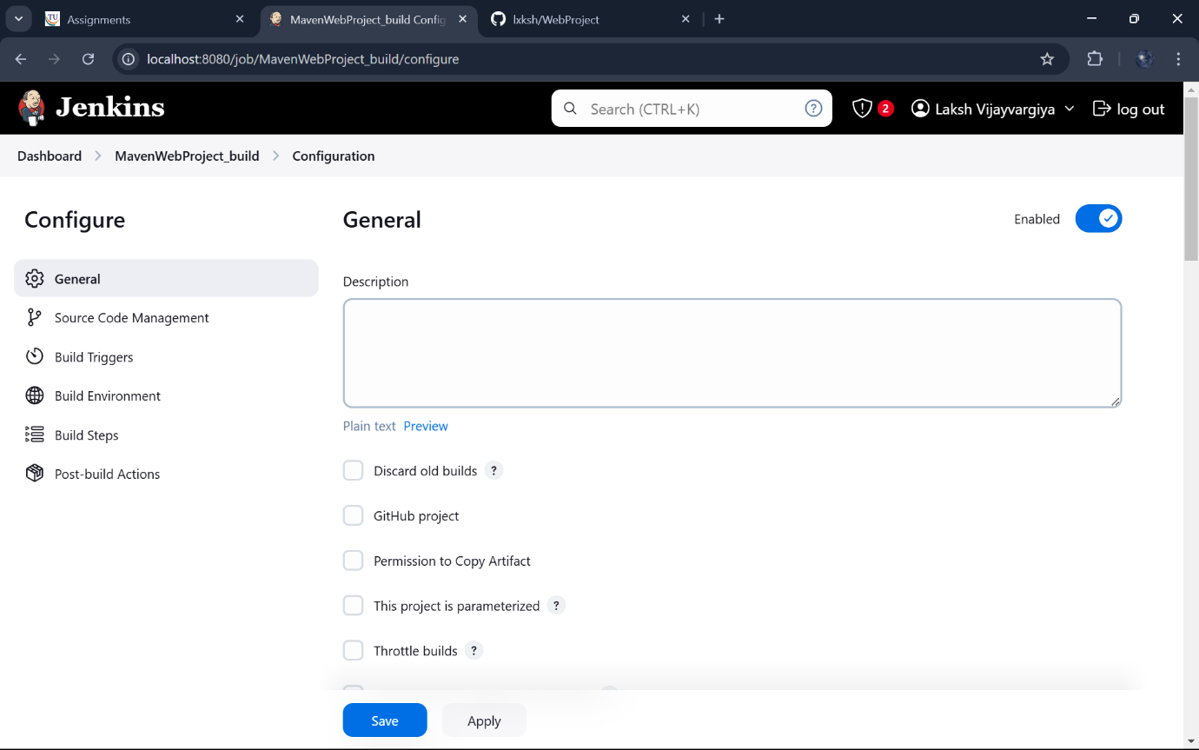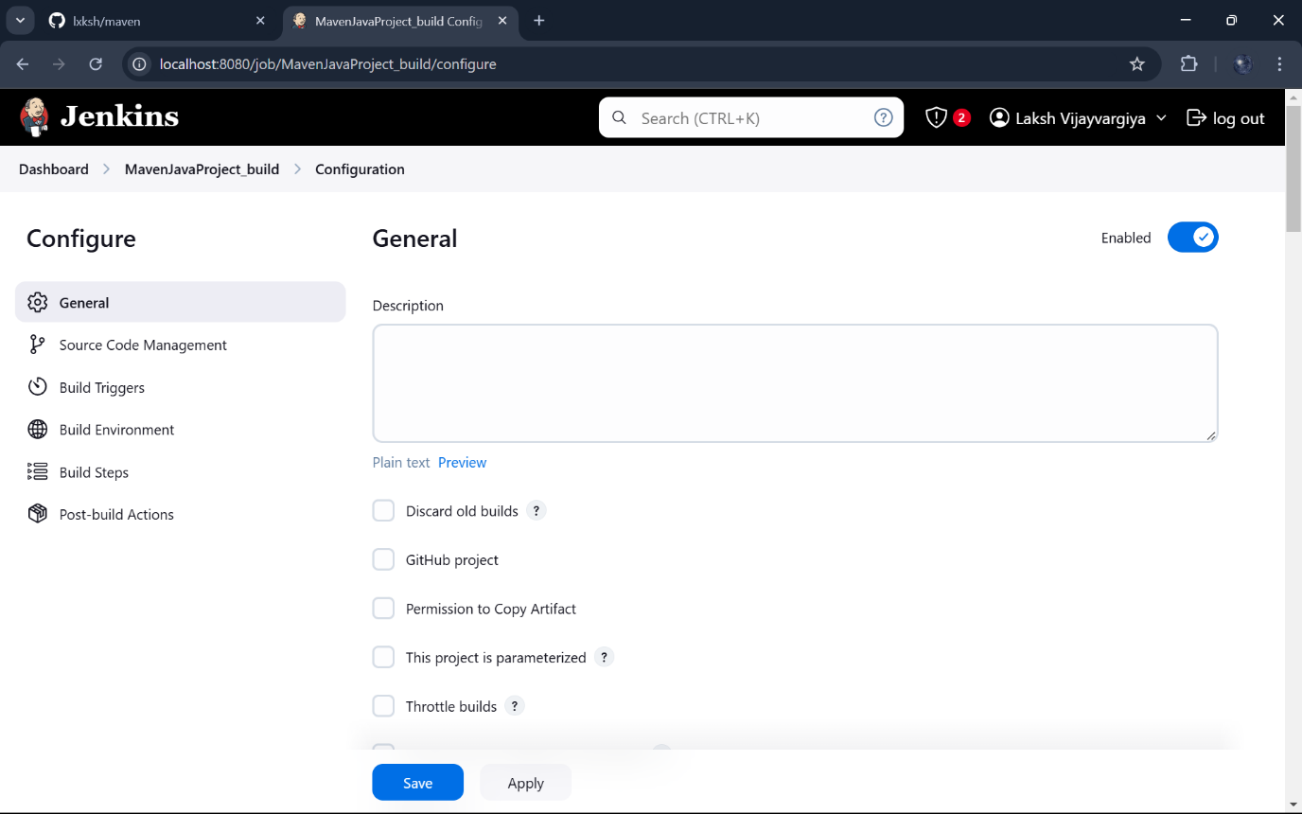Give Git repository URL of project: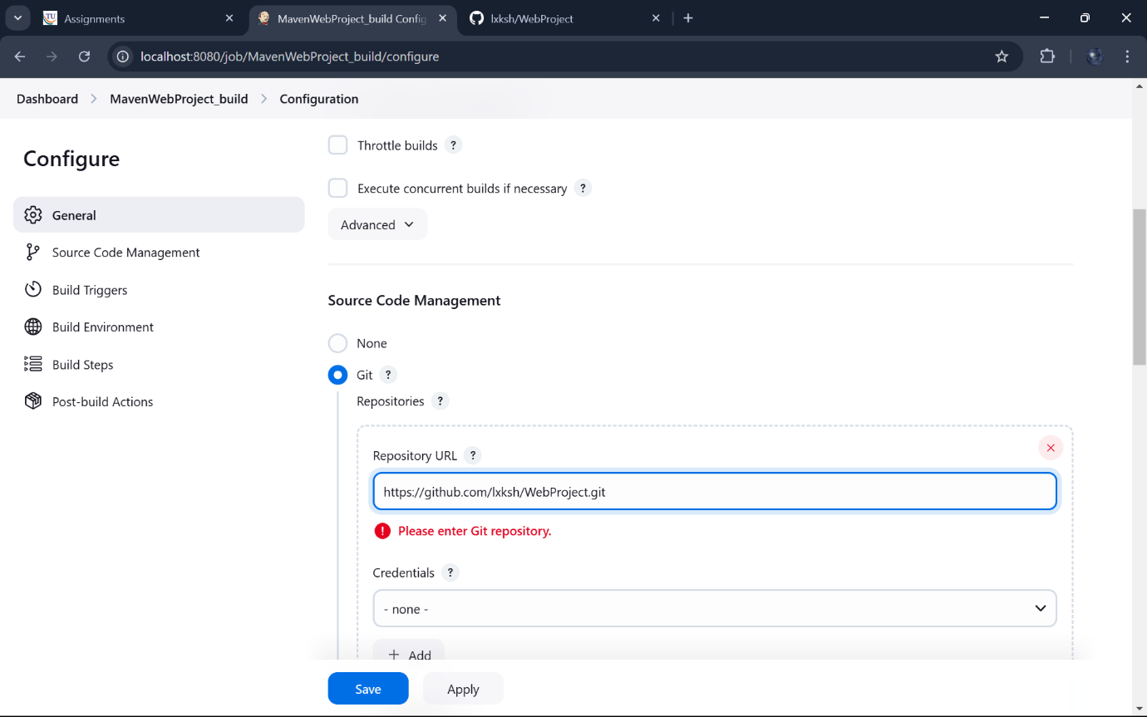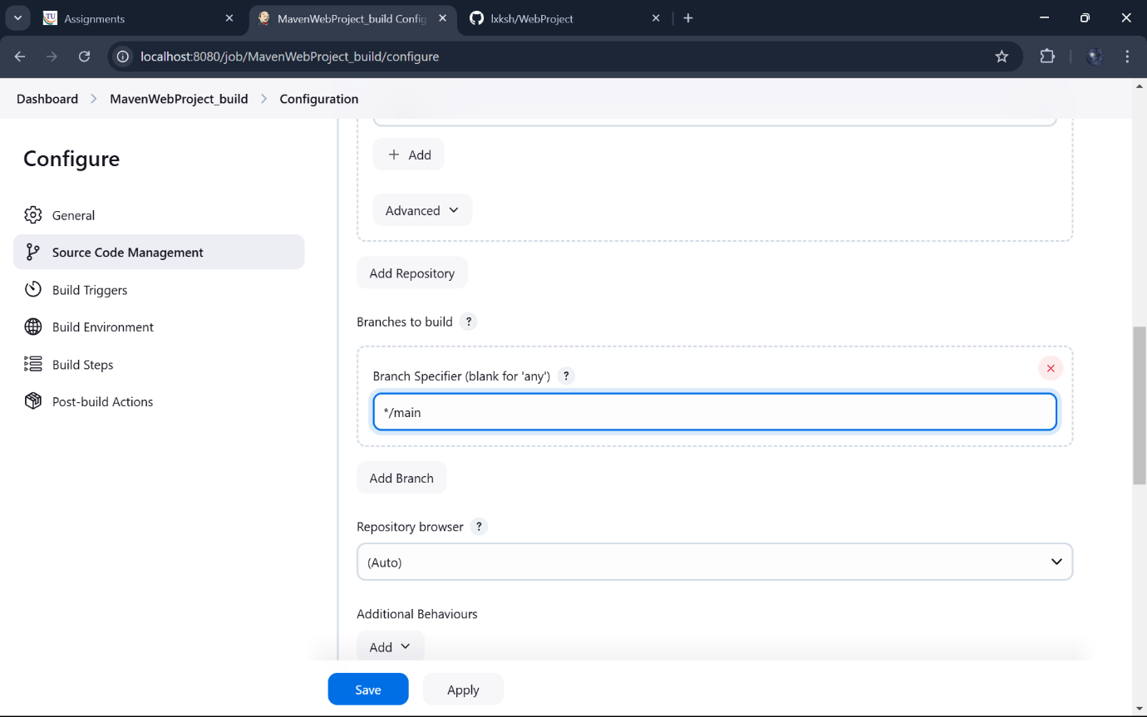Add * * * * * in Poll SCM: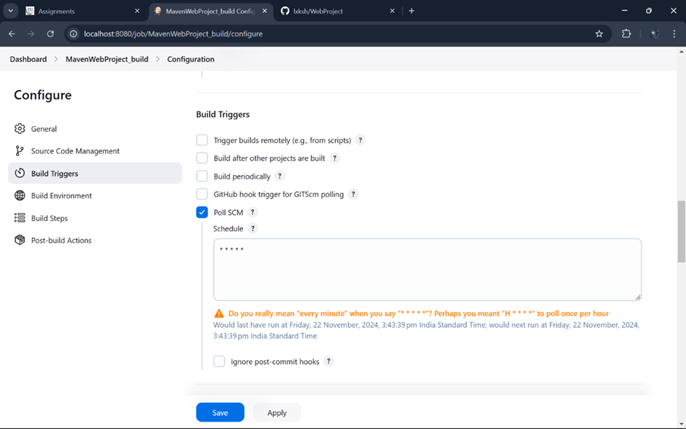

Build and Invoke top-level Maven Targets: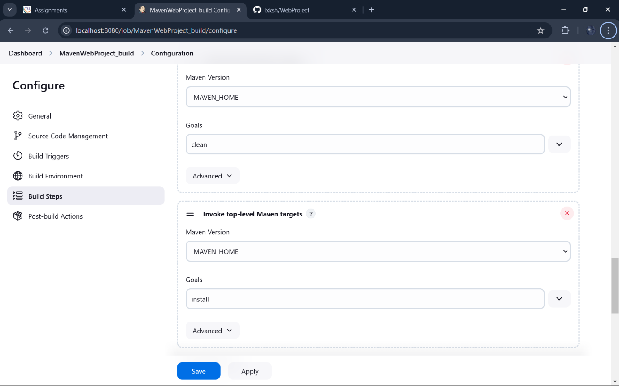 Add maven_home with clean and install: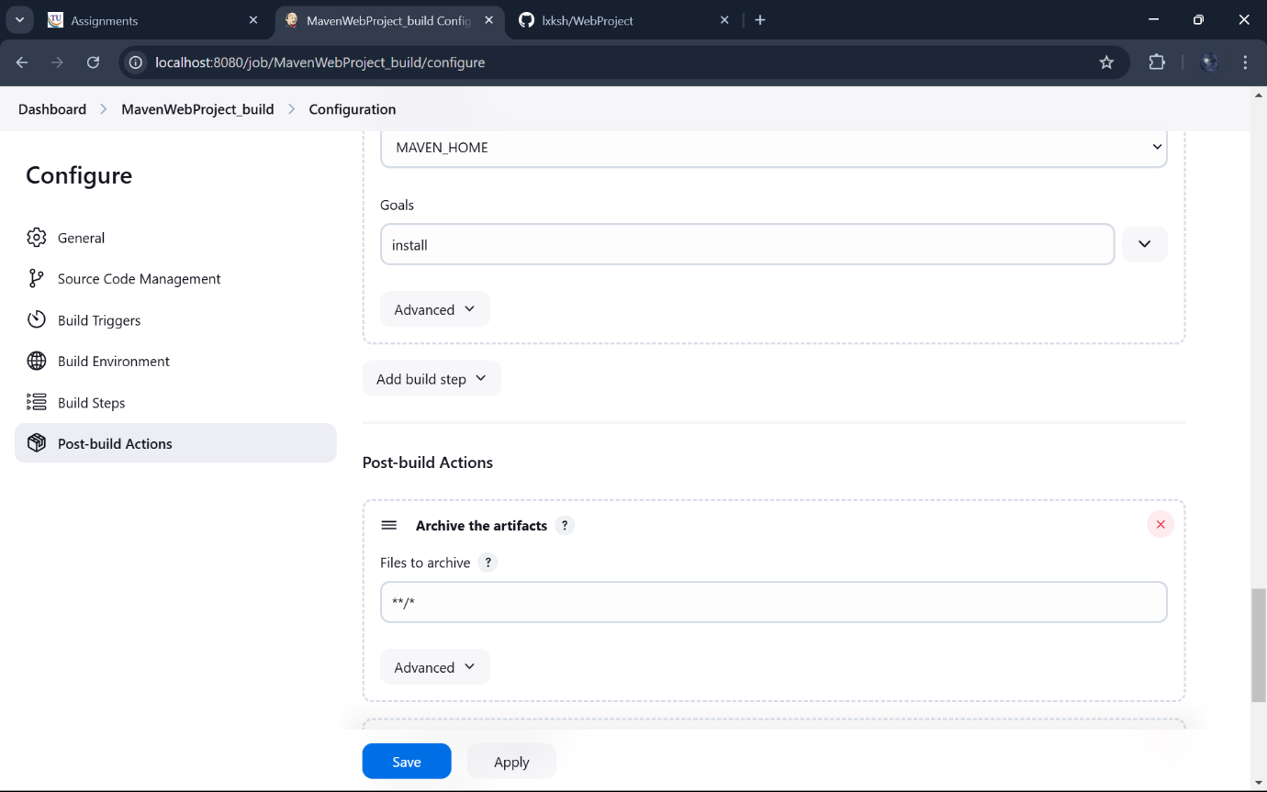

In post build actions-> select Archive the artifacts,to send output of build project to testing team , select archive “**/*” and in build other projects connect MavenWebProject_test :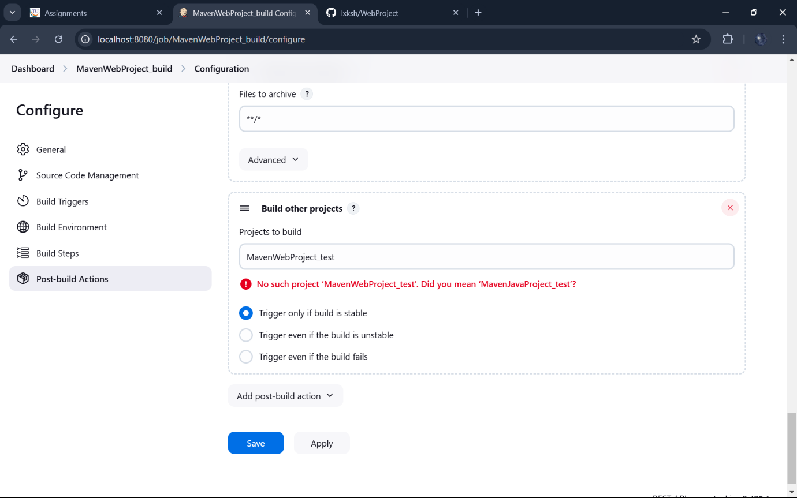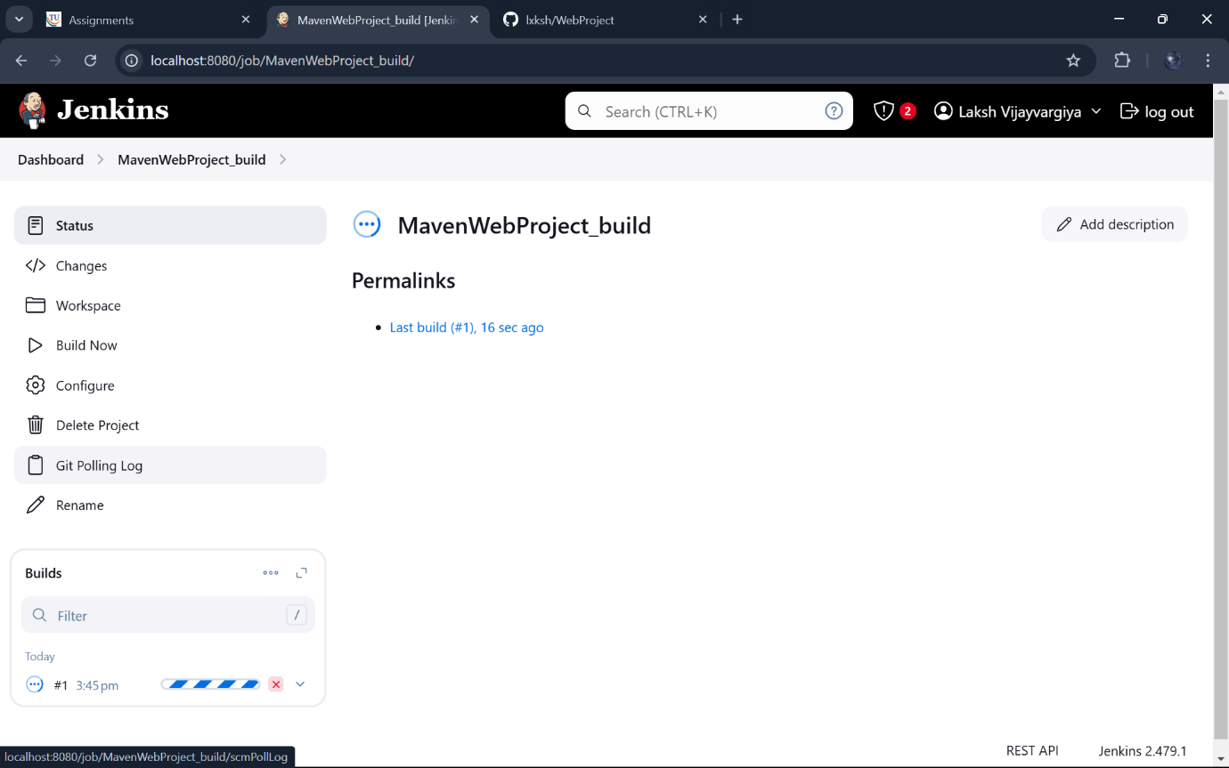 Create a new freestyle project test :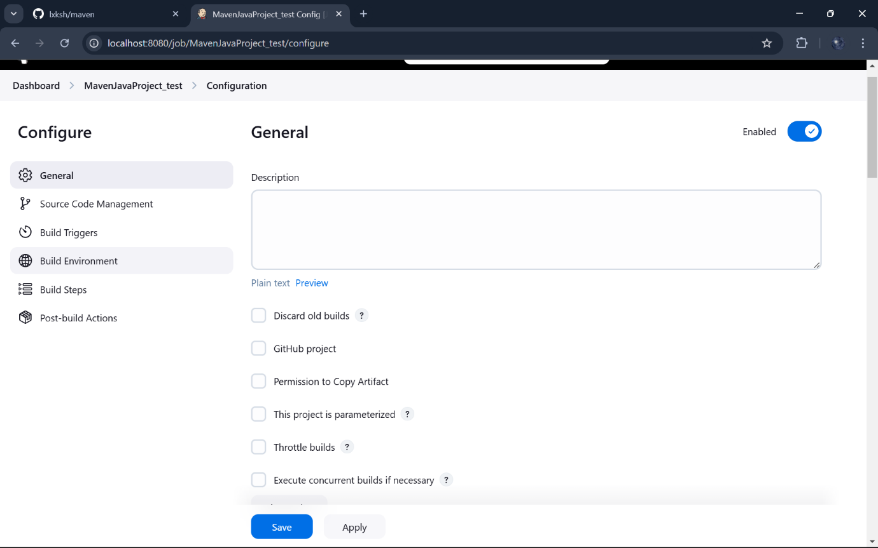 Create a new freestyle project test :

Delete workspace before build starts: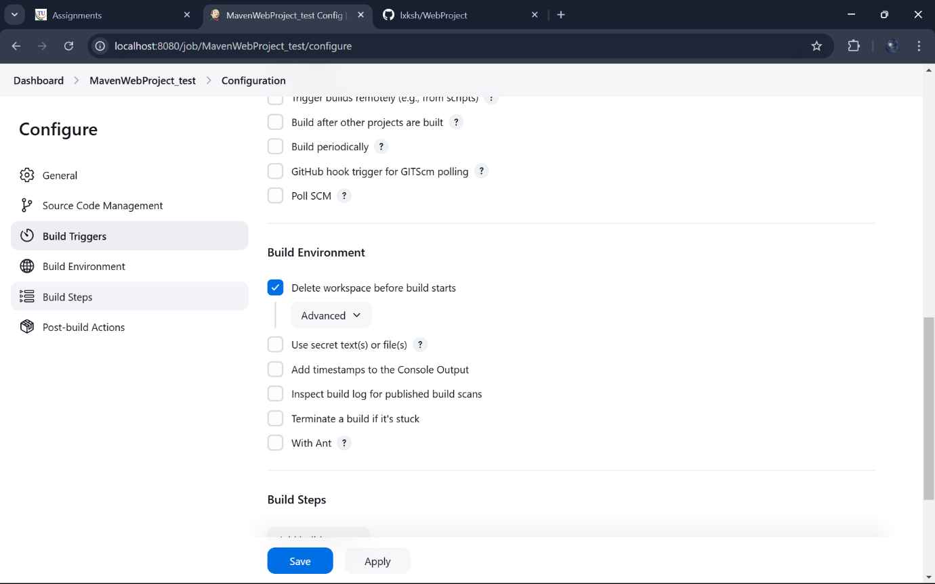 Add Build Steps and copy artifacts from build project: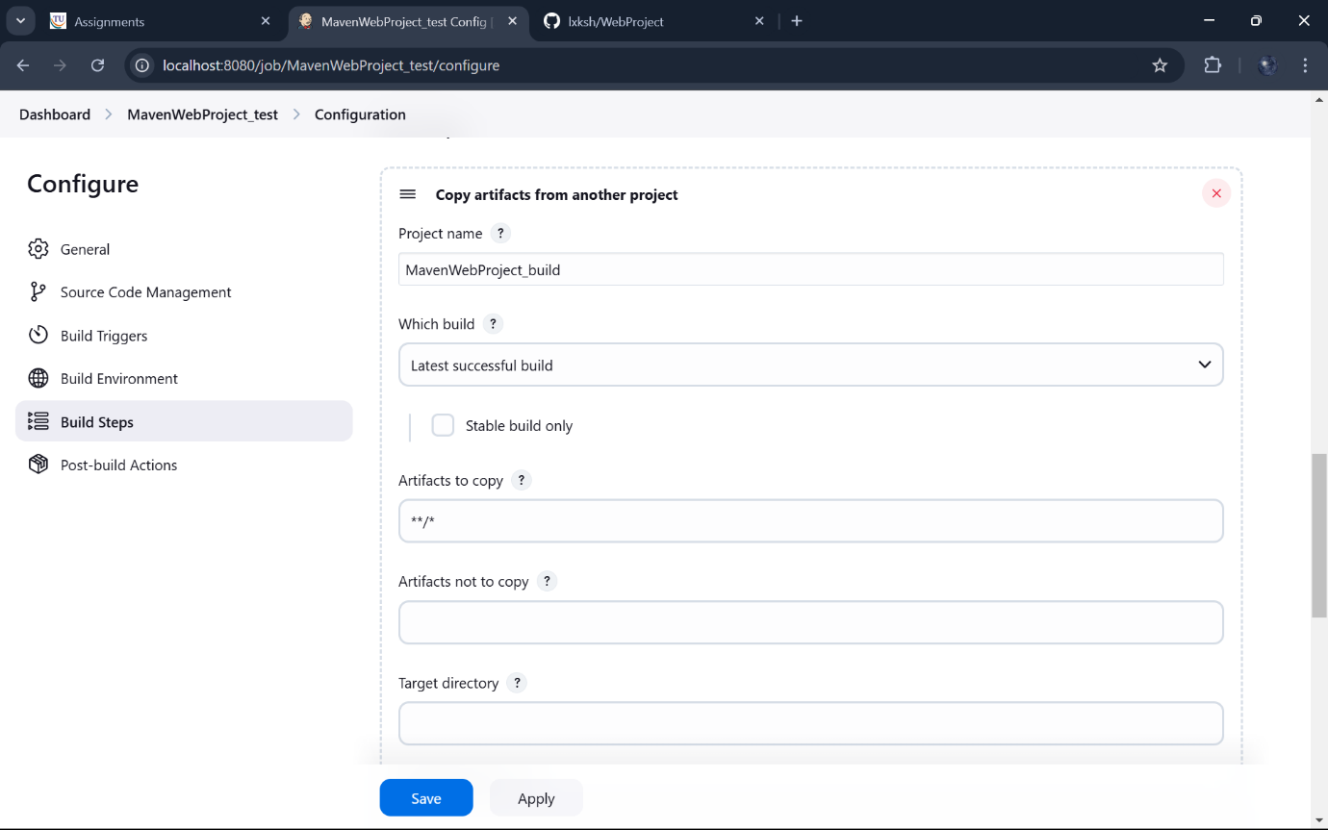

Select Invoke top _ level Maven targets and add test in Goals :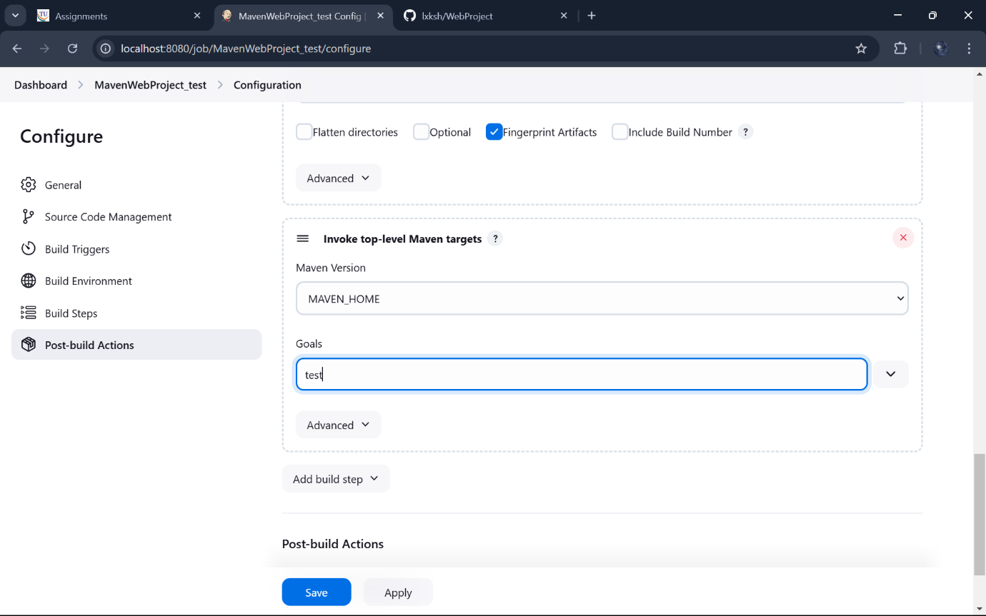 In post build actions -> select Archive the artifacts :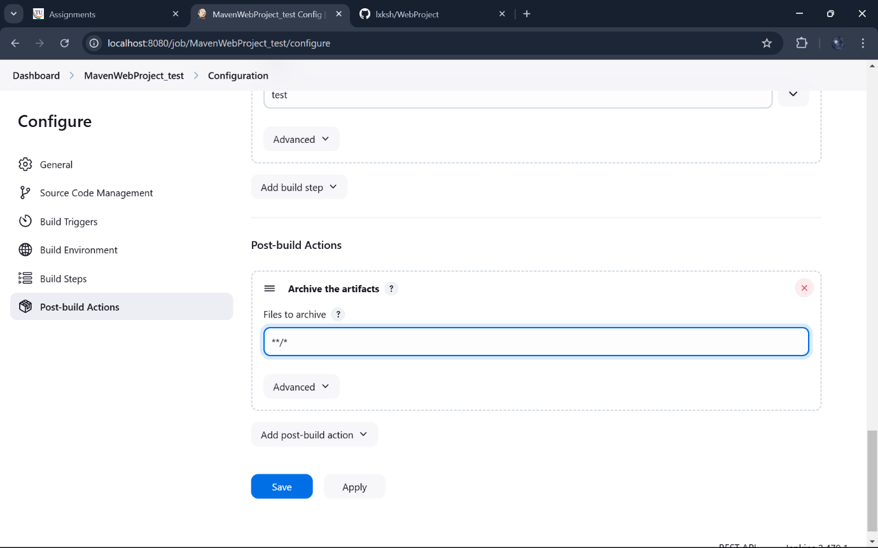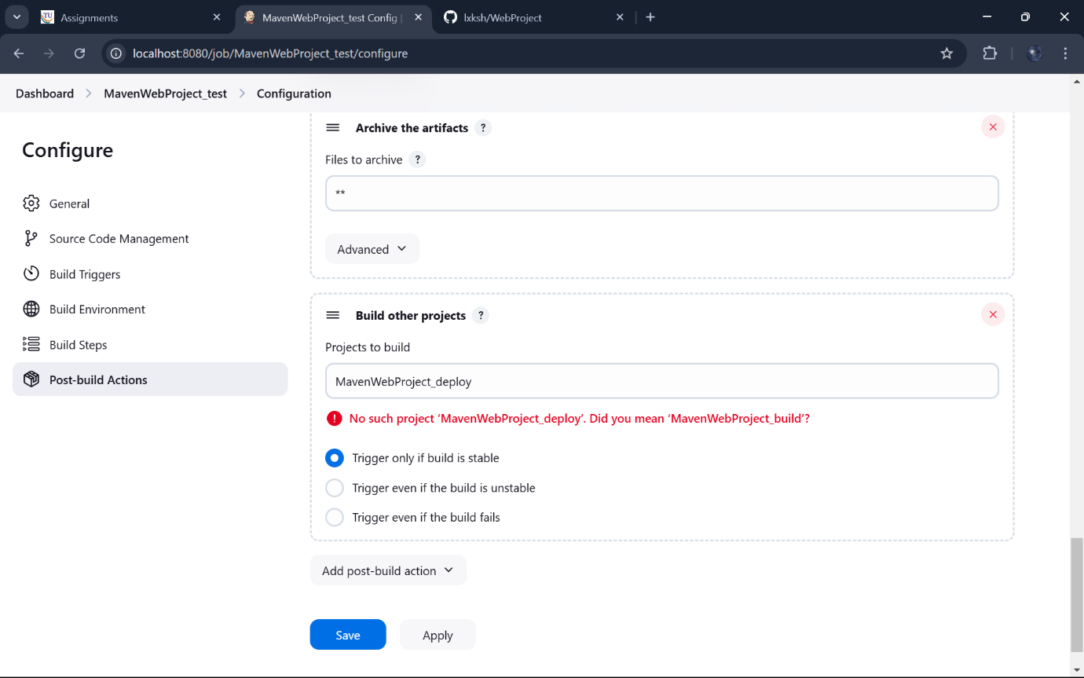Create new freestyle project: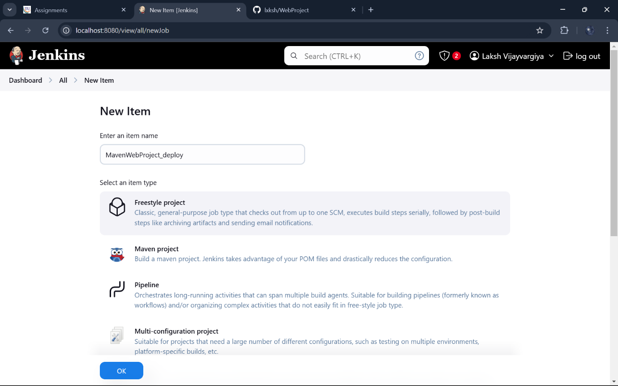Add Build Steps and copy artifacts from build project :P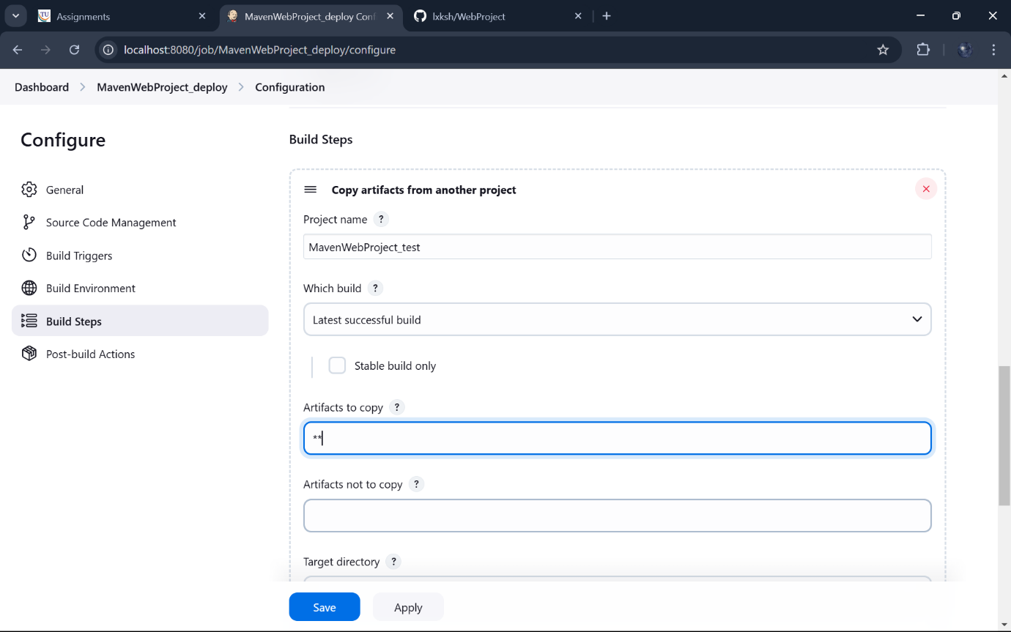Create war files and add tomcat in containers: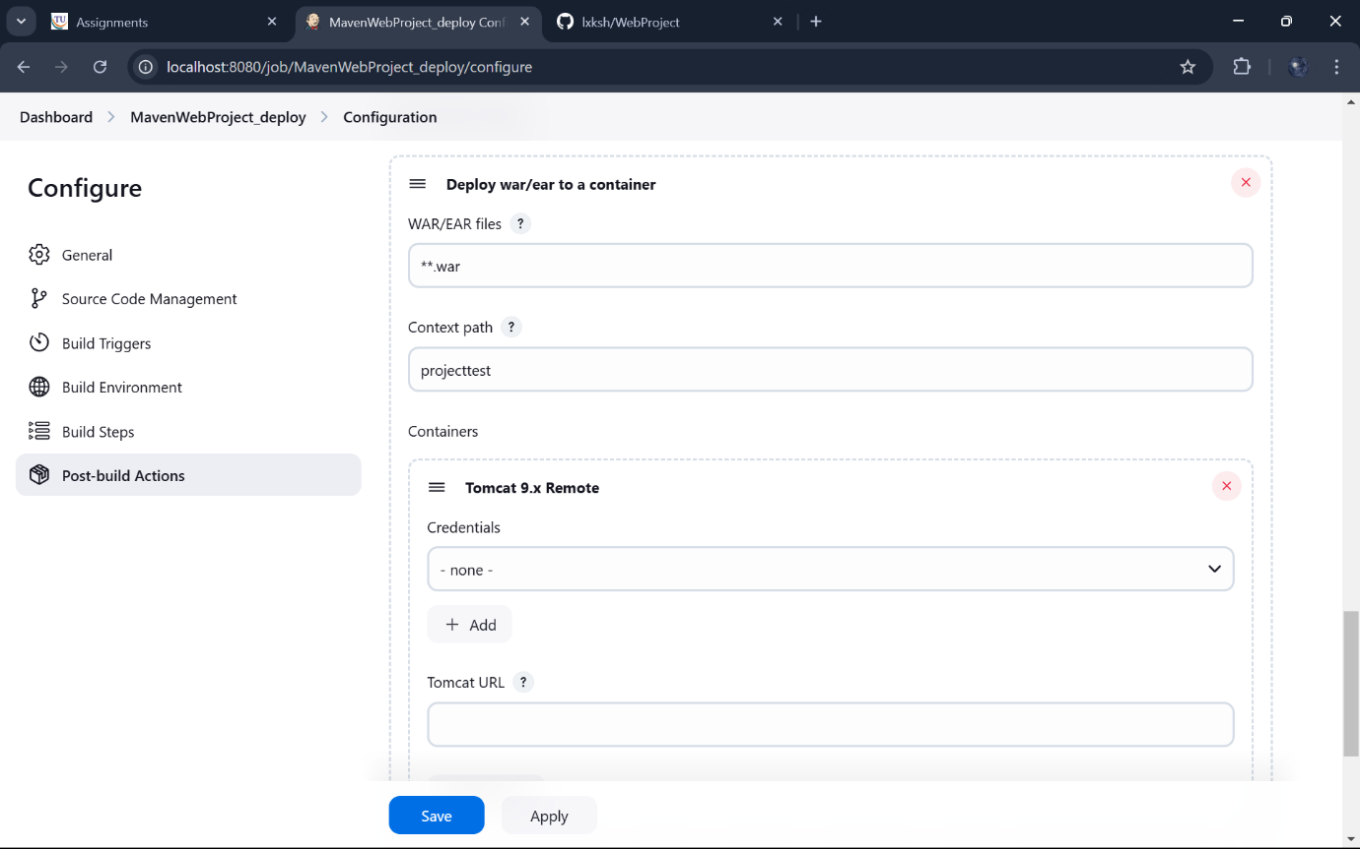

Add jenkins credentials: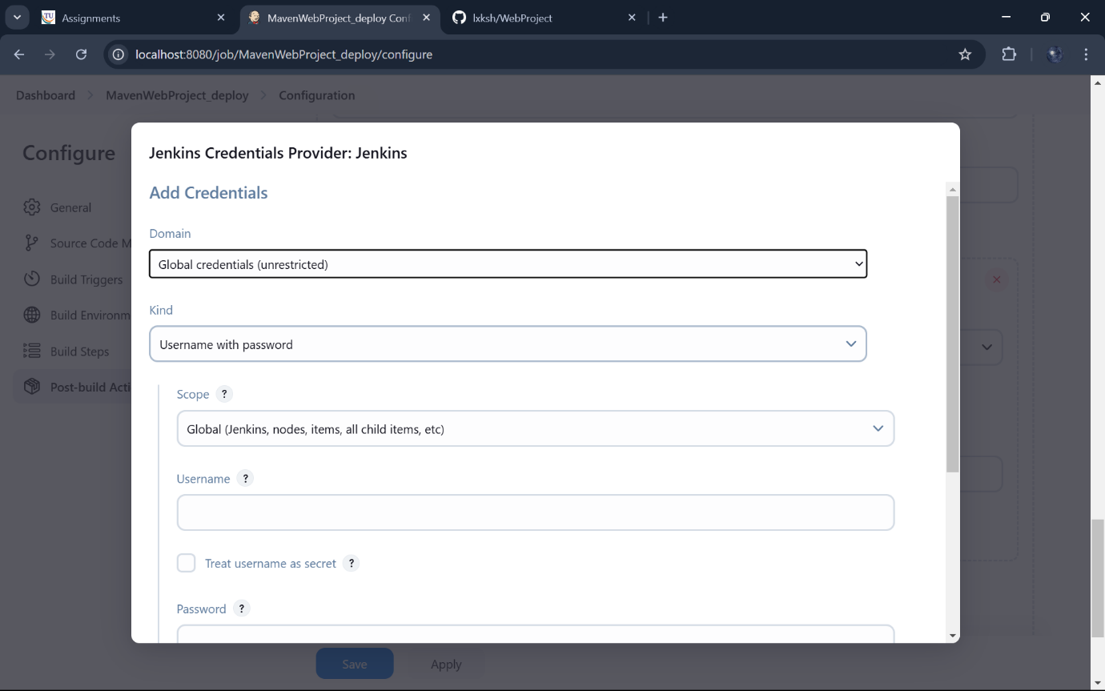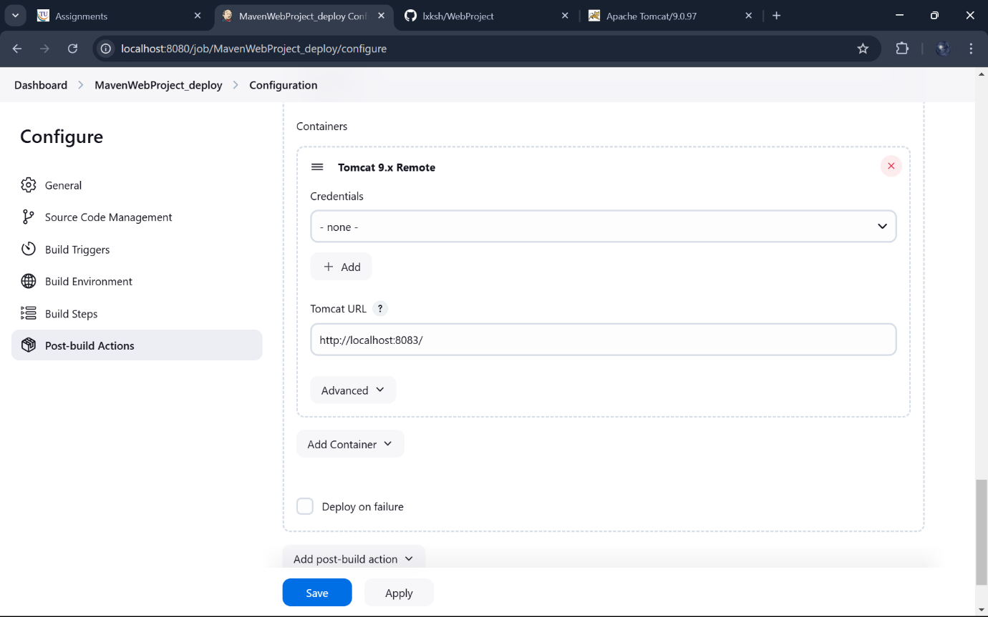

Create a pipeline by clicking on + symbol in the dashboard ->a pipeline is a collection of events or jobs which are interlinked with one another in a sequence 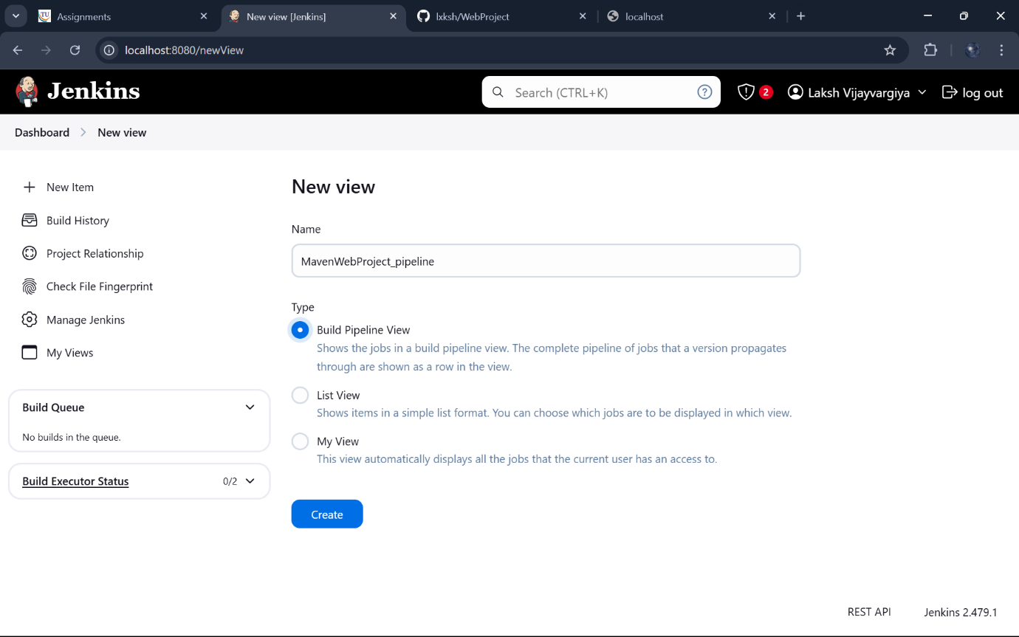 Select the first project to trigger the execution->build project: 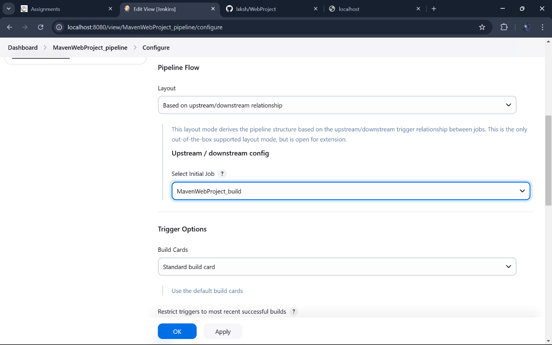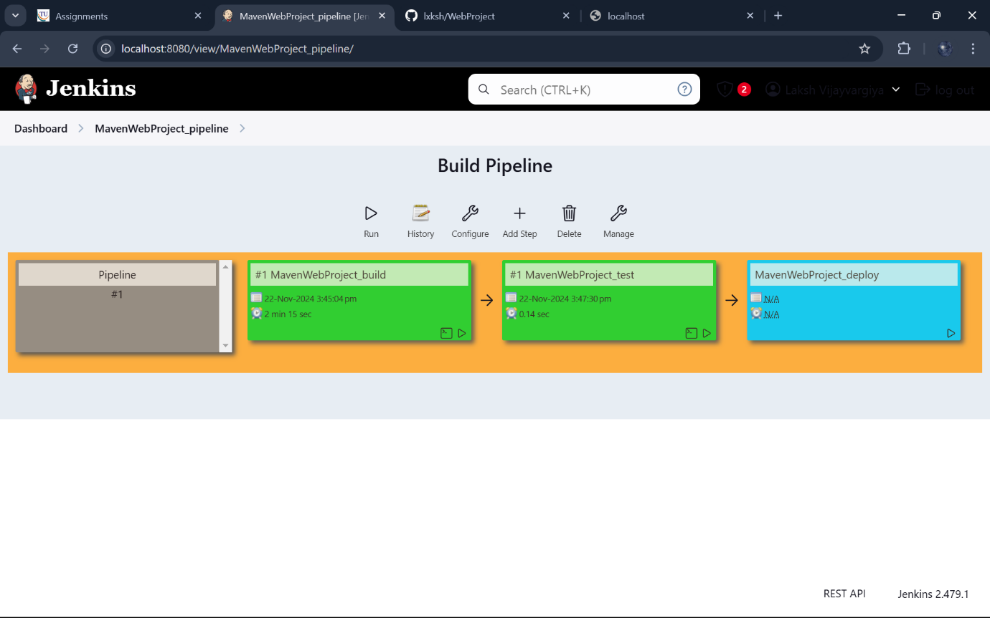 The pipeline is successful if it is in green color as shown ->check the console of the test project 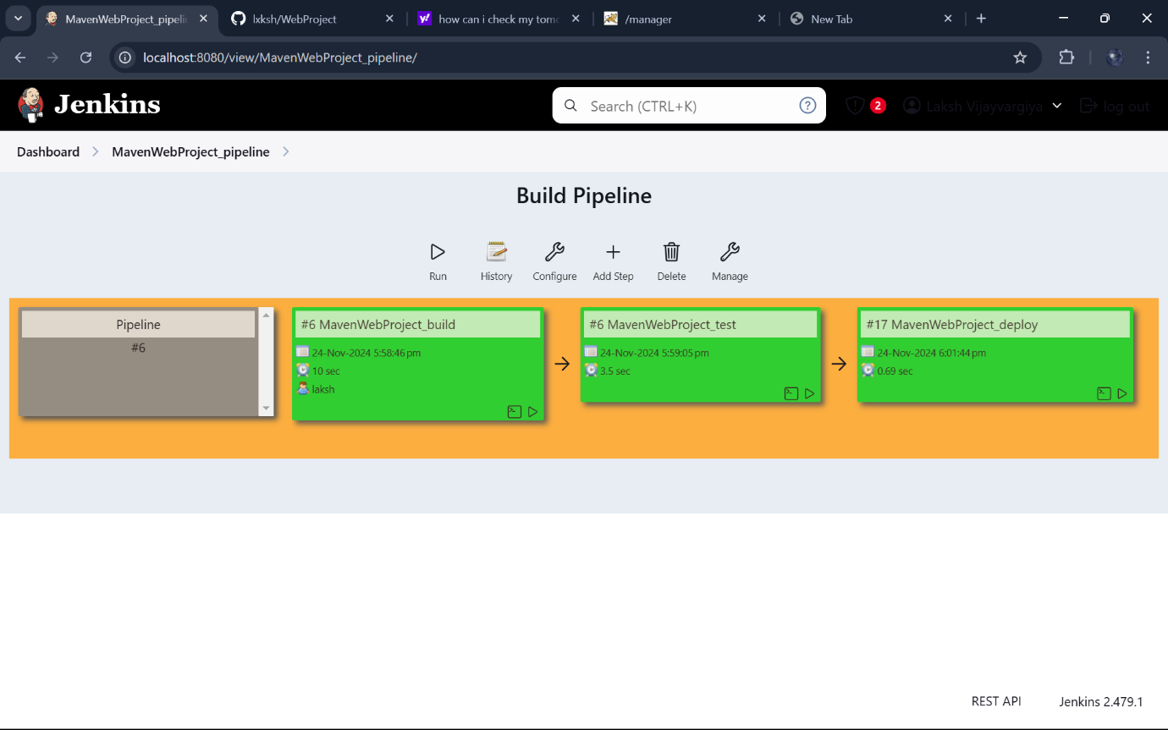

Here go to projecttest and you can see the output: