Create a Maven project -> File -> New -> Maven -> Maven Project:

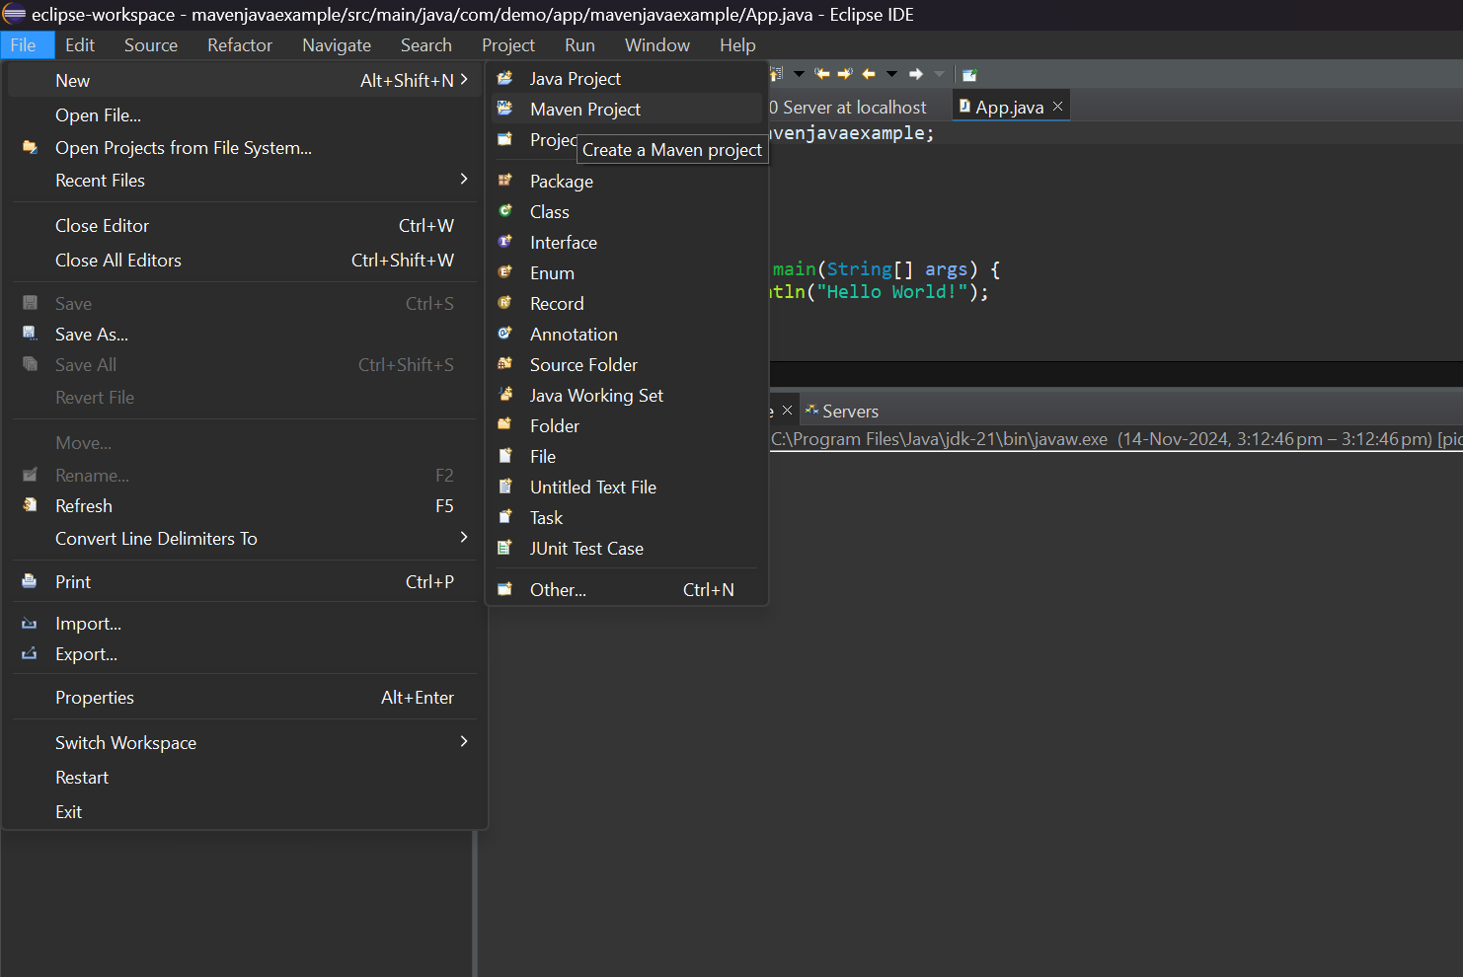

Click on Next

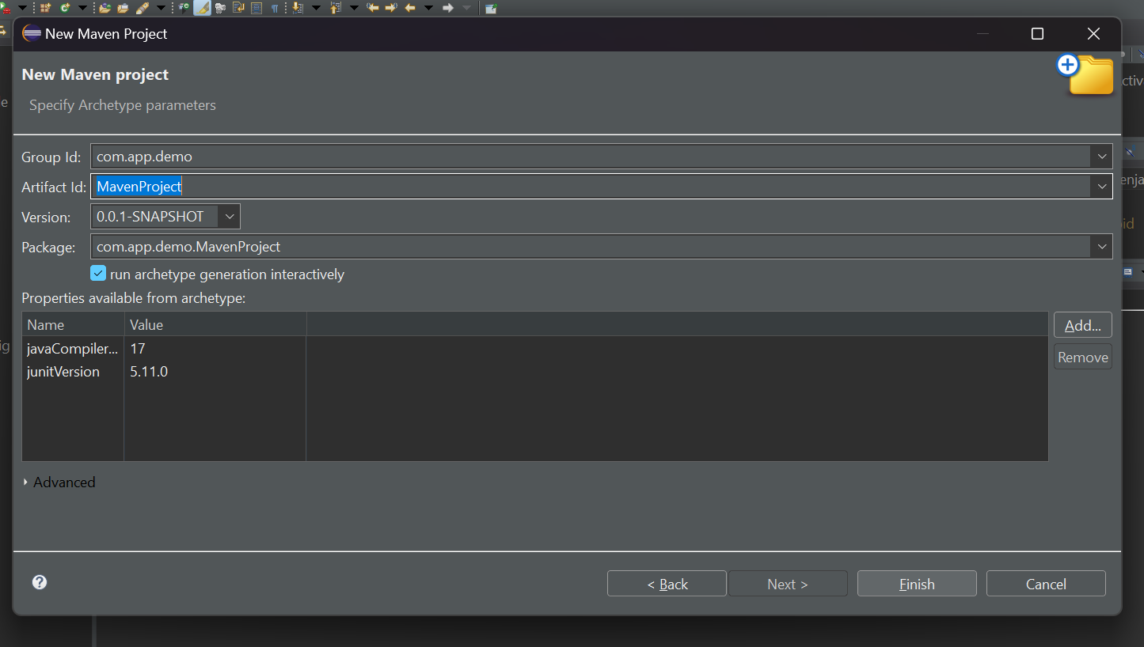

Select the quickstart archetype under org.apache.maven.archetypes and next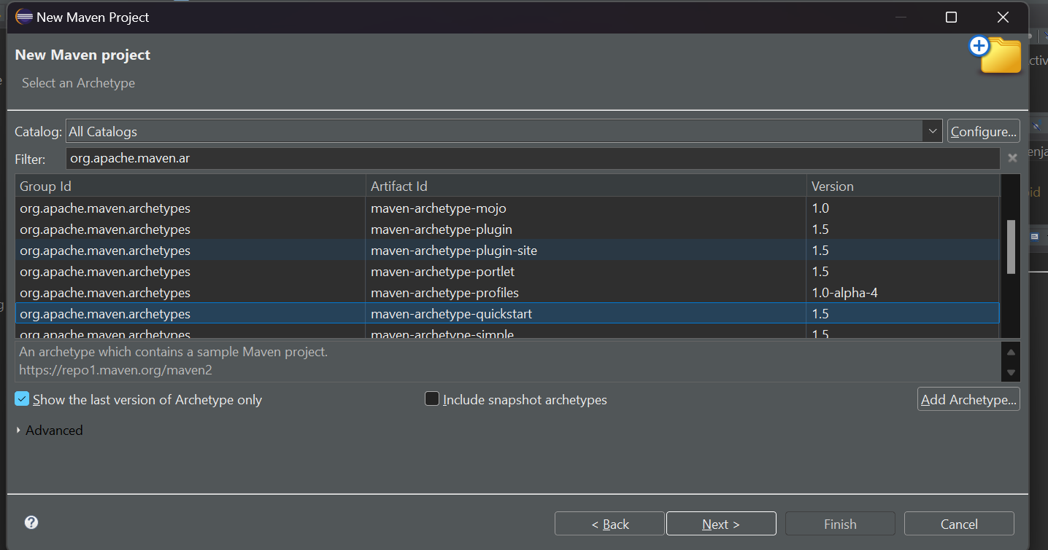

Type Y to create a project and check for App.java

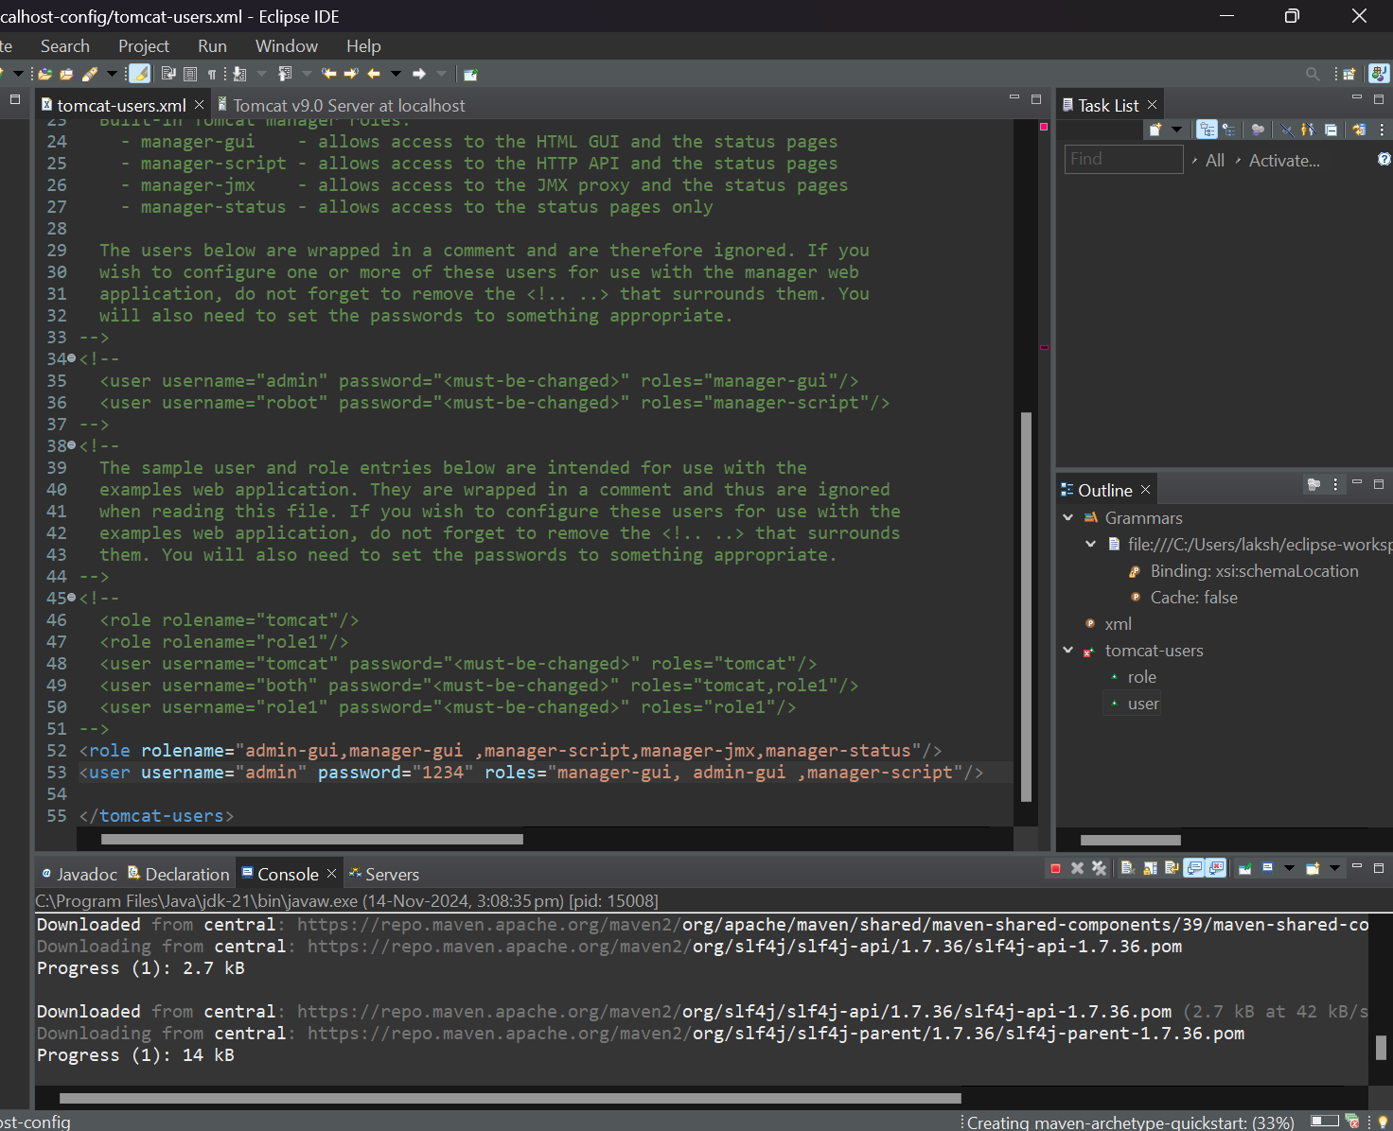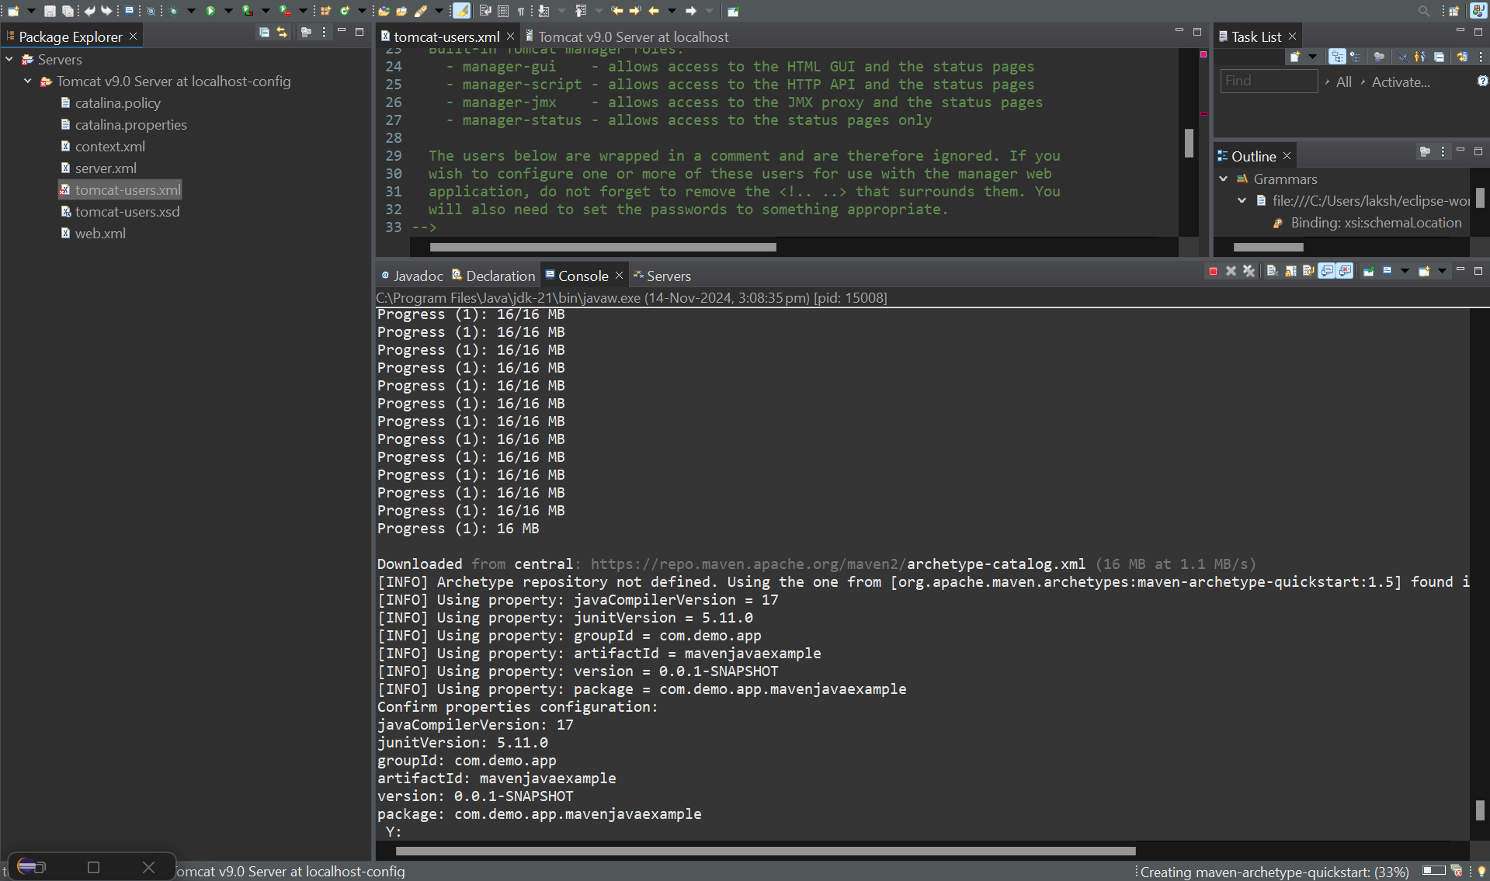

Right click on your project to run as maven clean :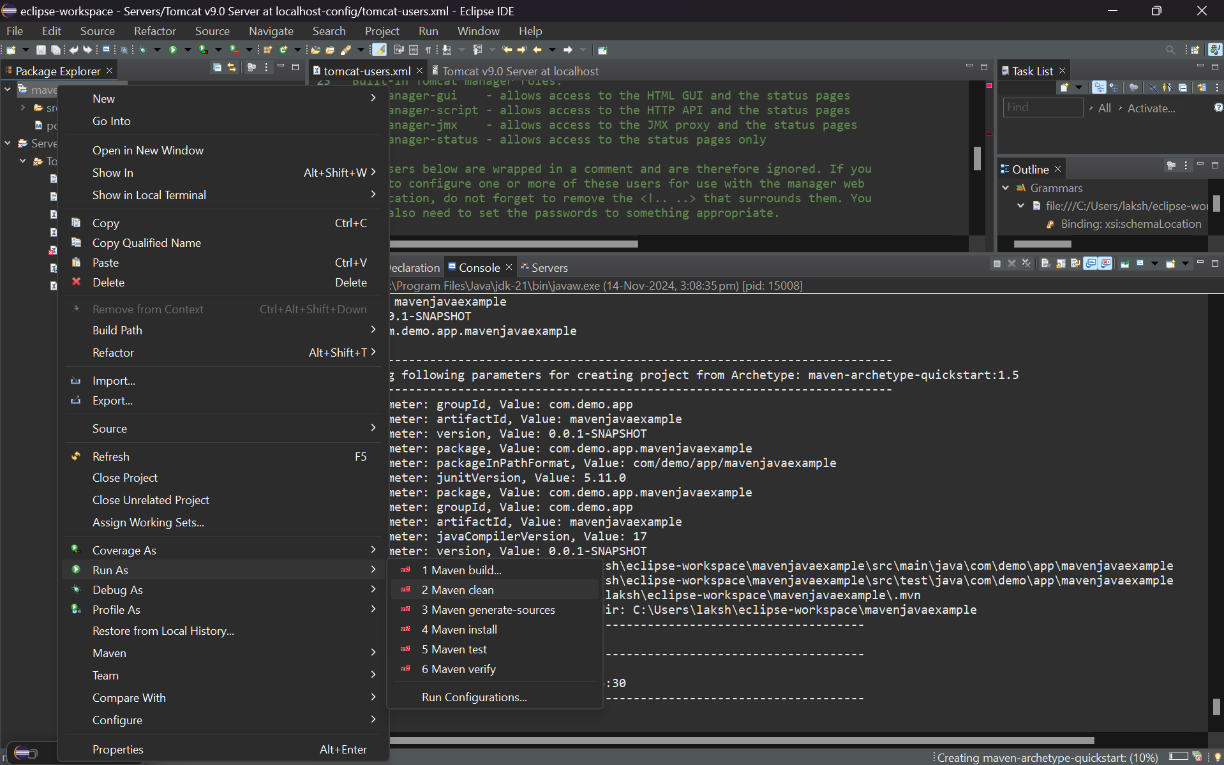

Check the console for Maven Build Success: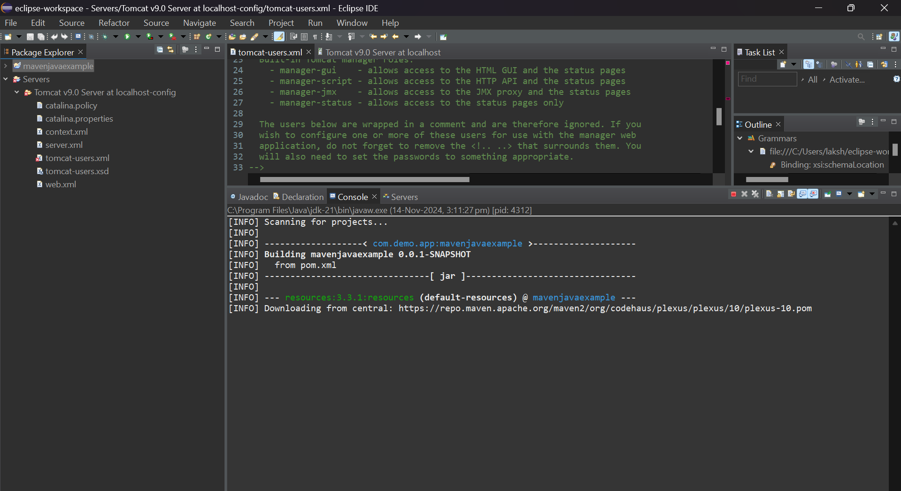

Right Click and Run as Maven Install: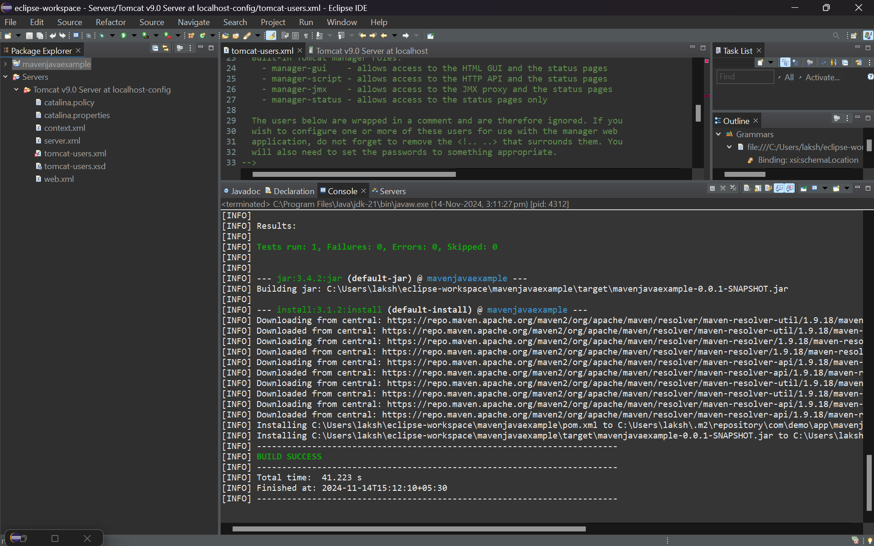

Right click on project and click on Run as Maven Test: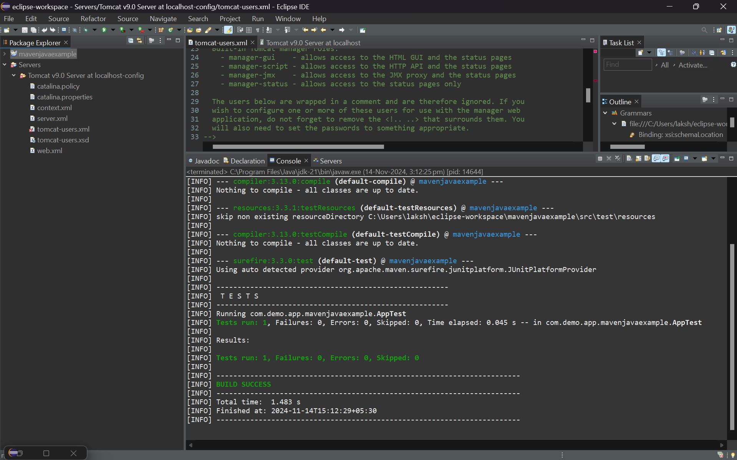

Run the Project as Java Application and see thee output in the Console: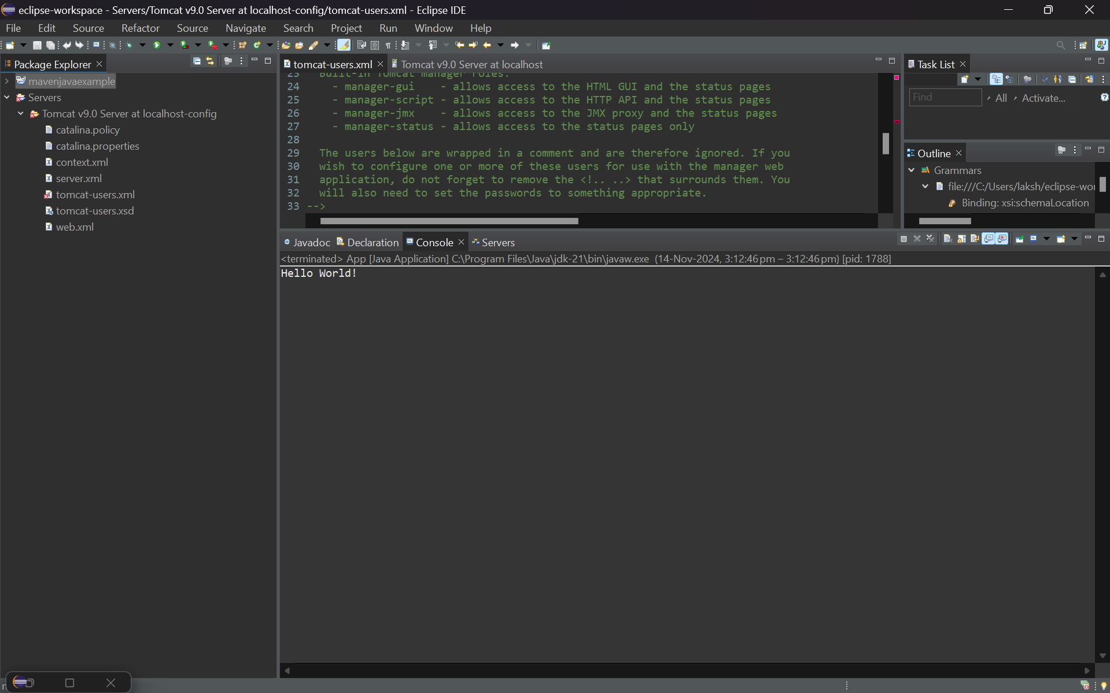

Creating a new Repository in the git hub with checklisting gitignore to ignore unwwwanted target files and it 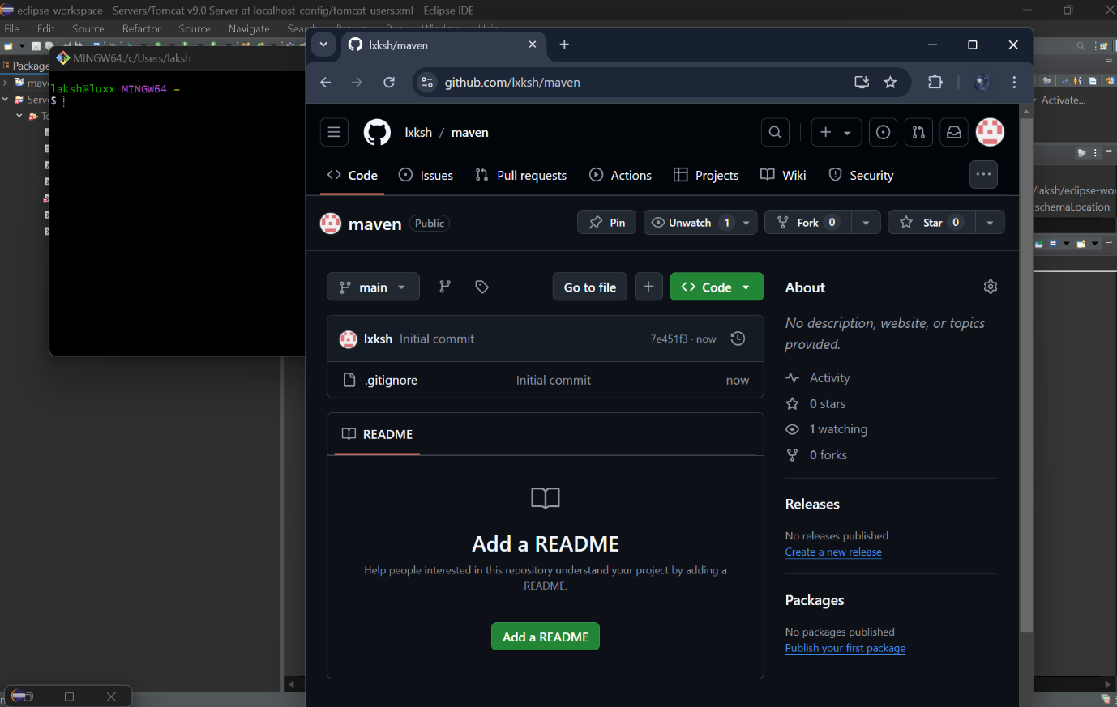

Clone the GitHub repository into the local System: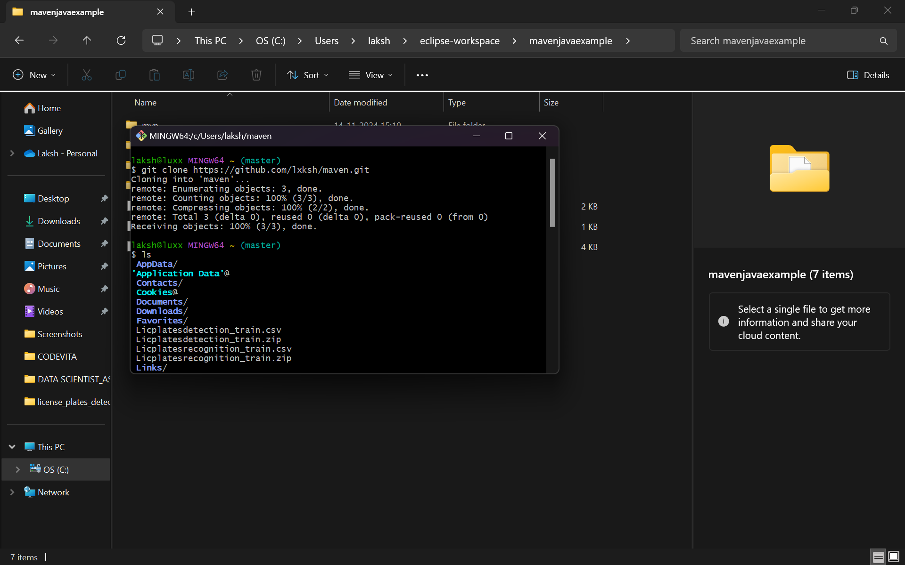

Cloning local and global Projects to copy contents from eclipse workspace to local cloned Repository: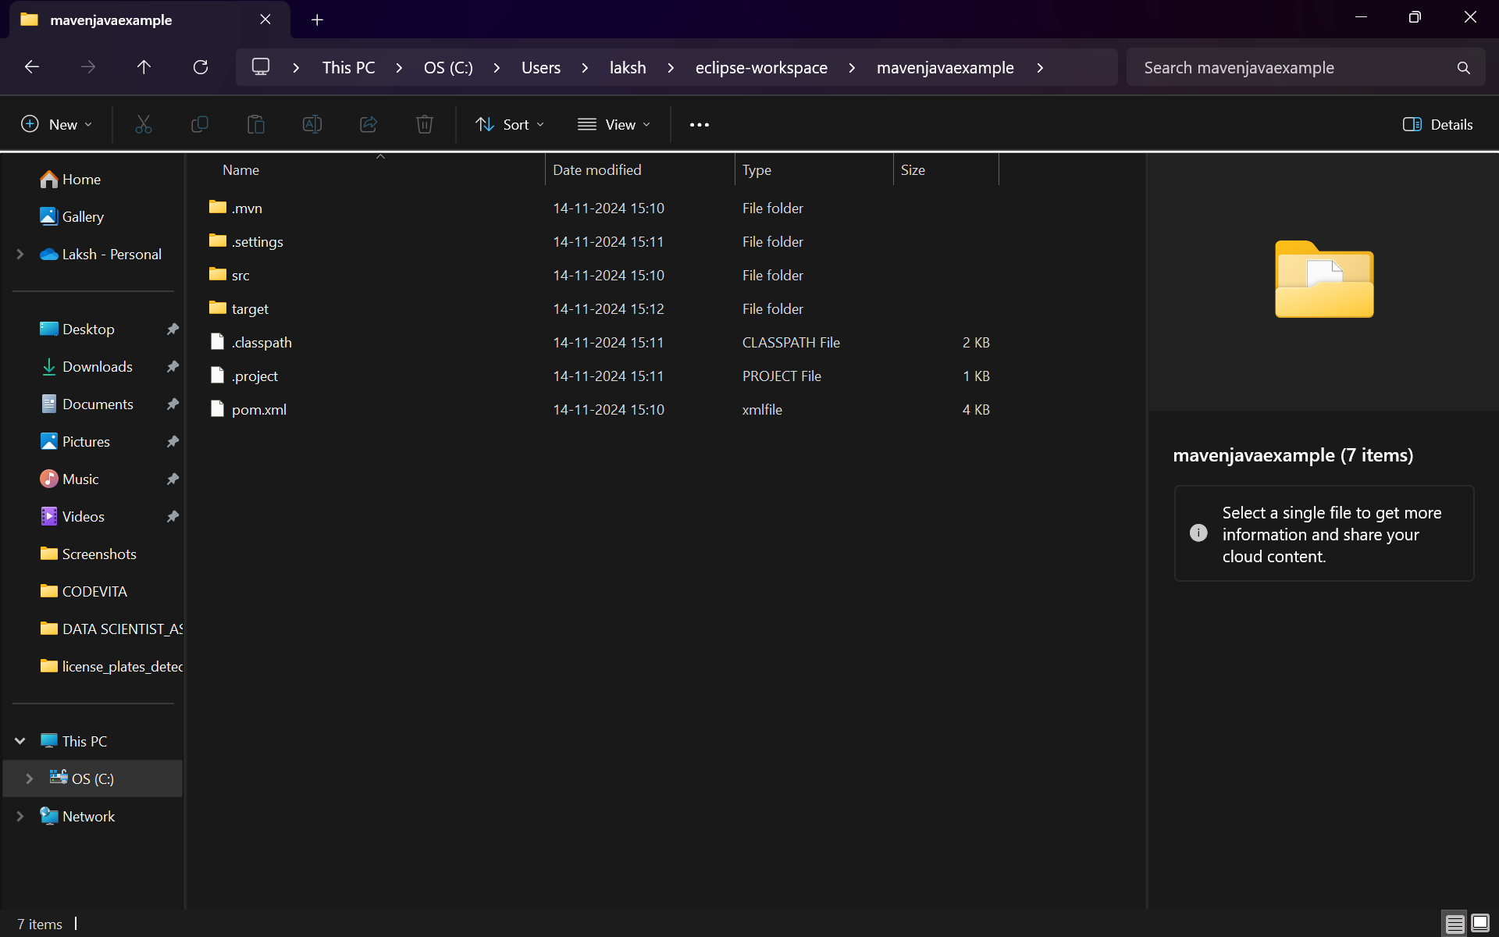

The project files are successfully copied into Maven Repository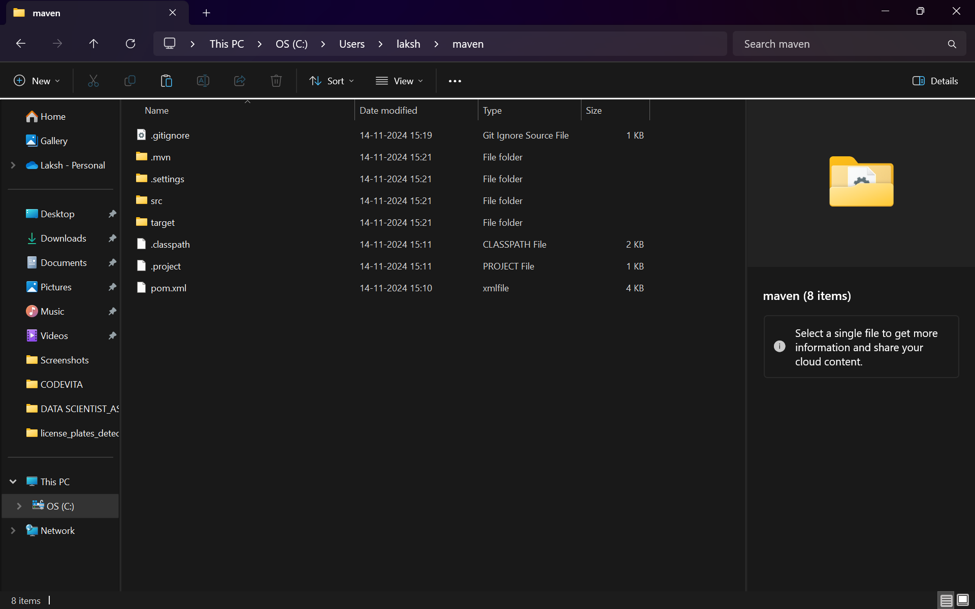

Using Gitbash add and commit the changes Made: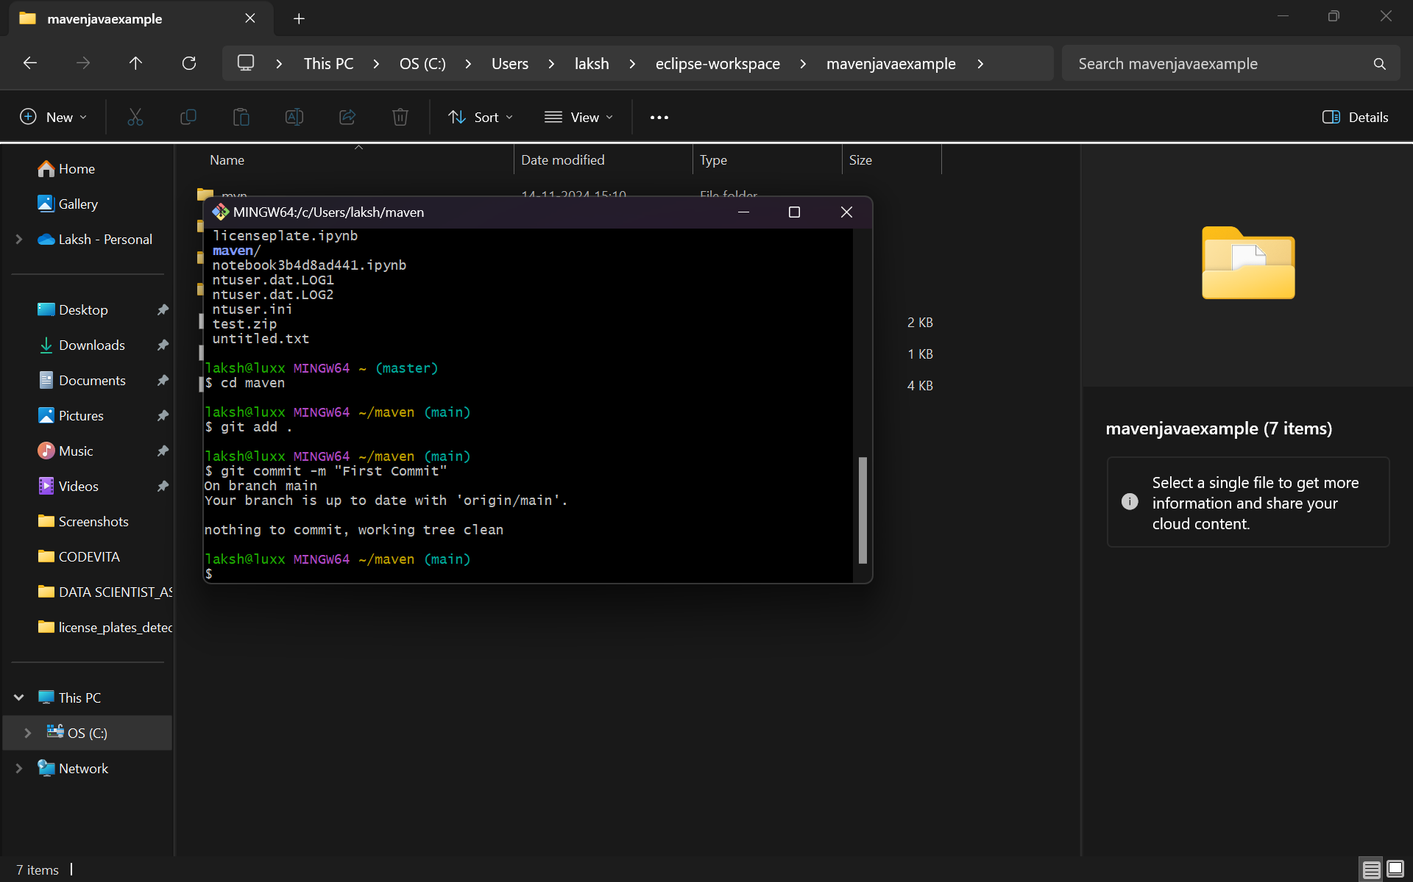

Push the Changes into the Github as shown: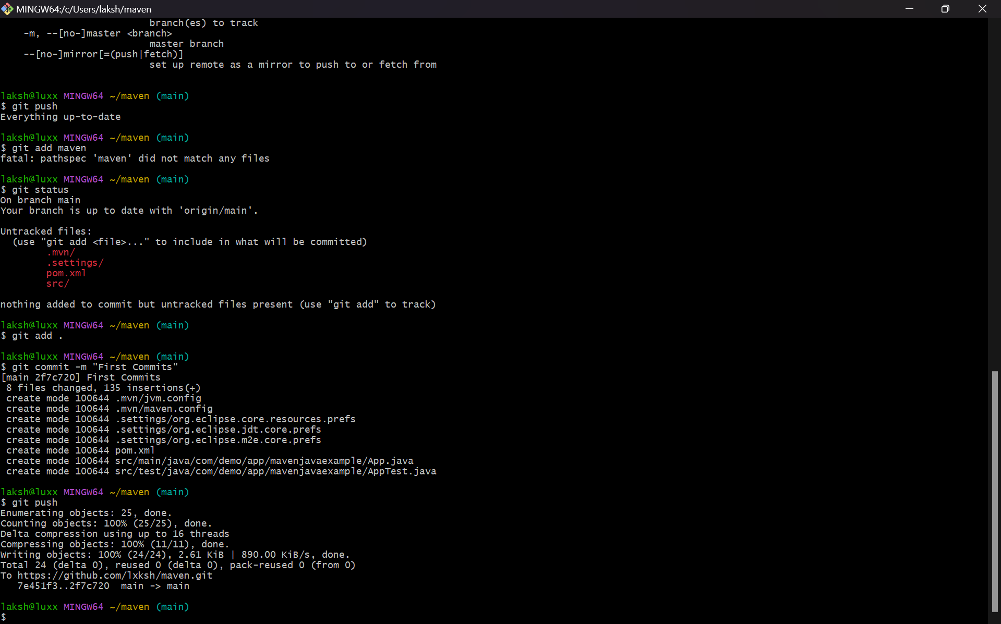

Refresh the GitHub to see the updated repository: