Create a Maven project -> File -> New -> Maven -> Maven Project:

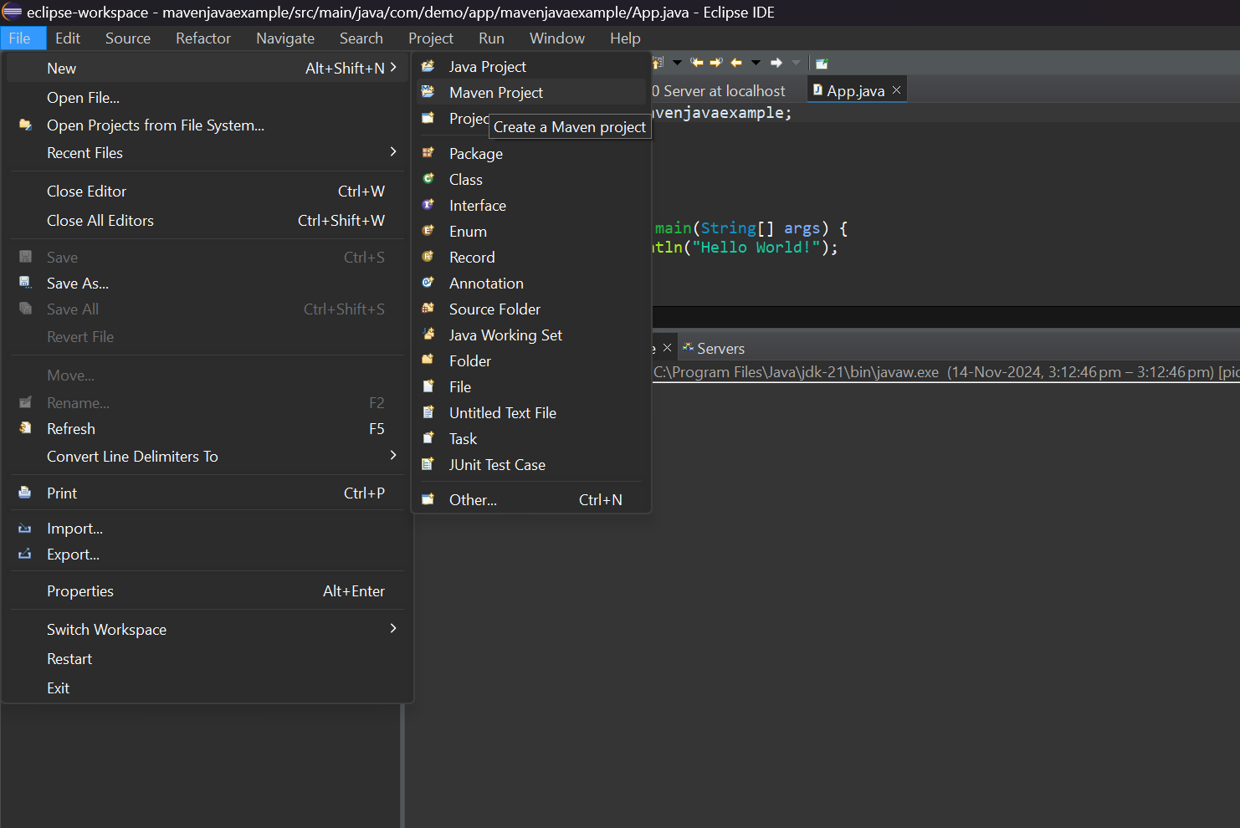

Click on Next: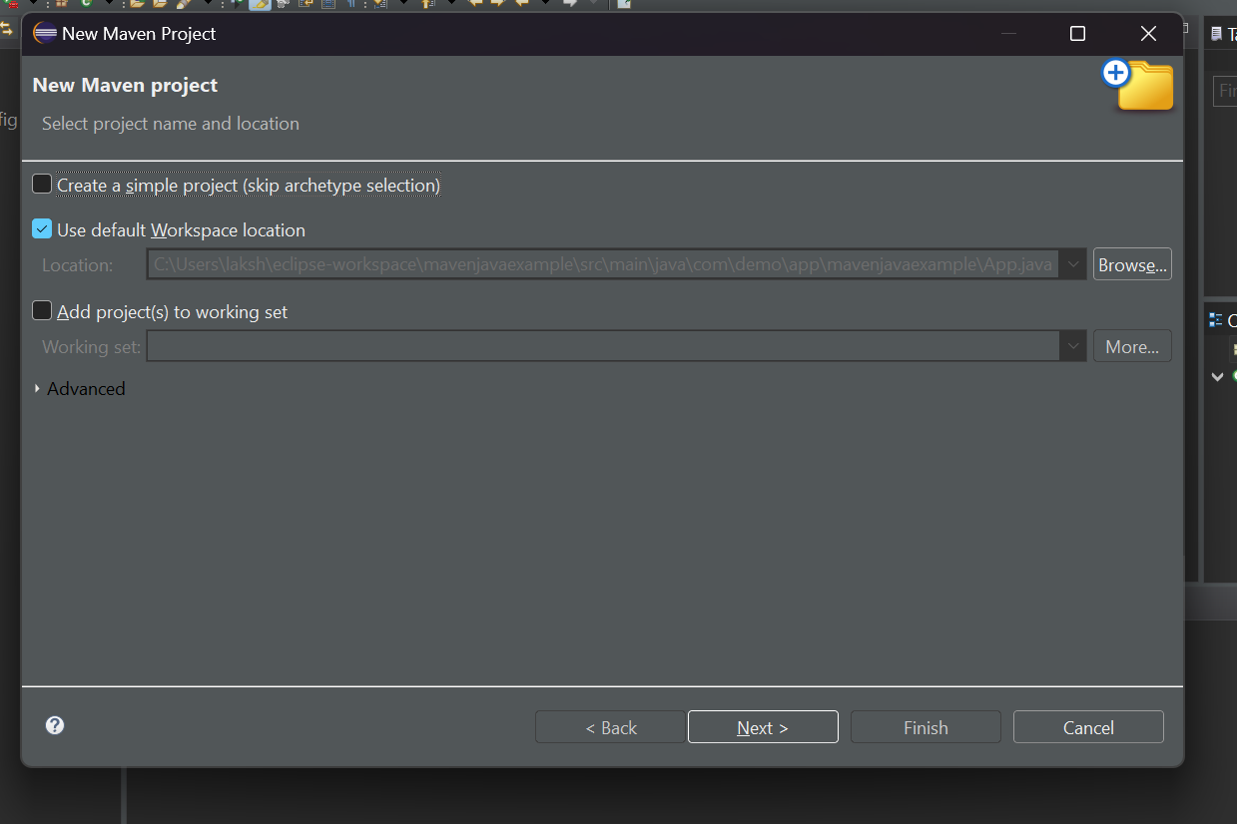

Select the webapp archetype under org.apache.maven.archetypes and next: 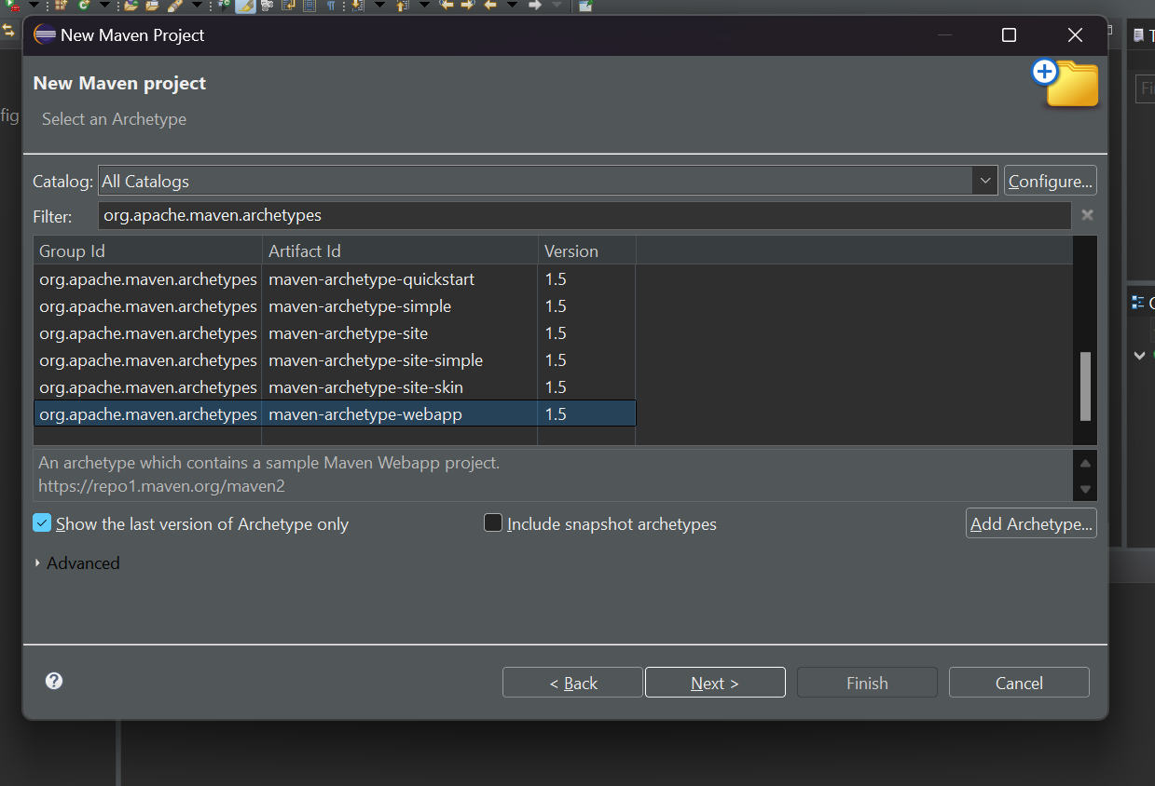

WebProject is Successfully build: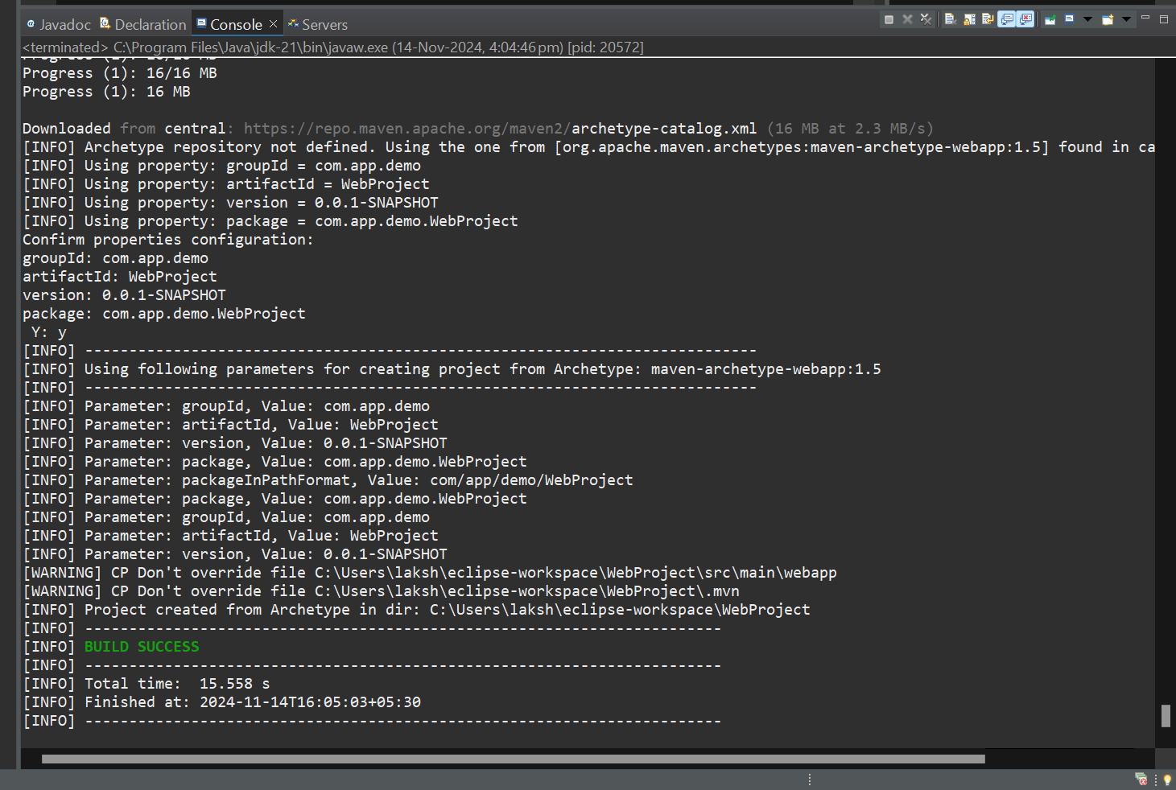

Go to mvnrepository for java servlet: 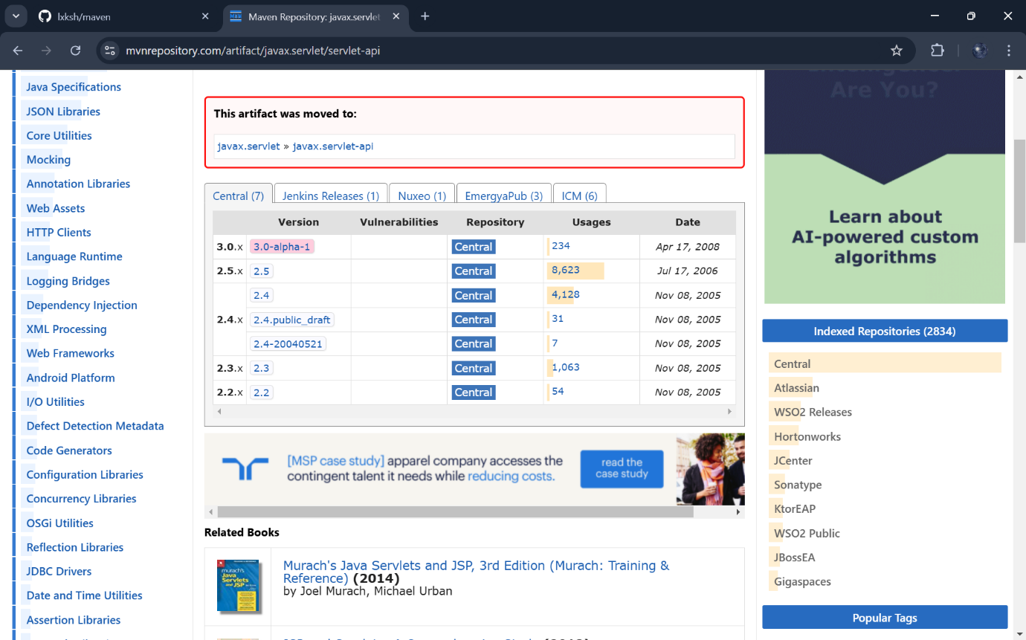Add the depedency to the pom.xml file: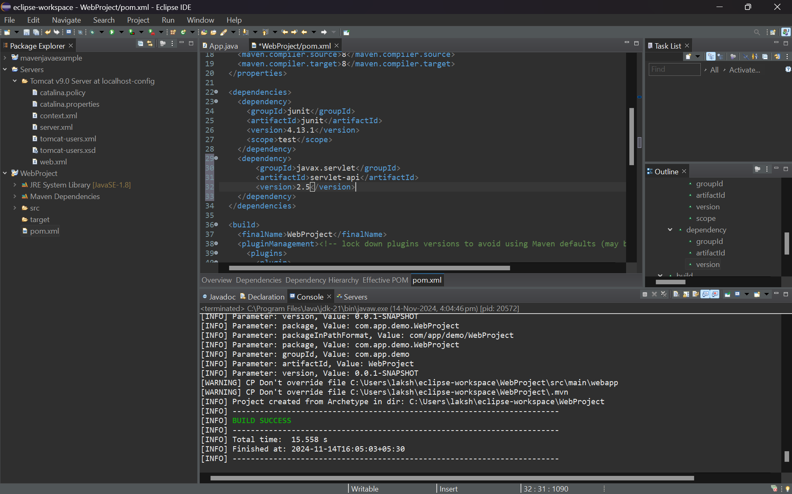

Start the server :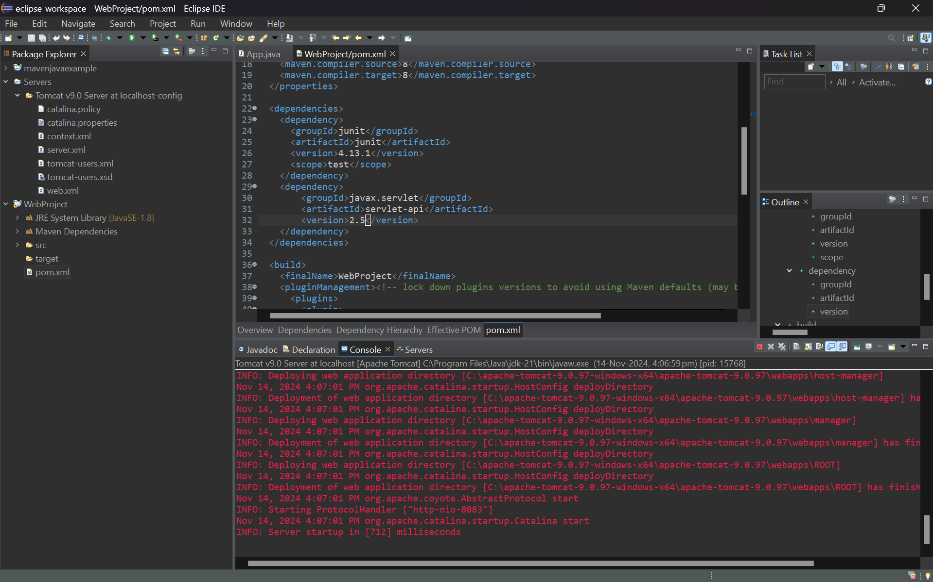

Once the server is on go to WebProject-> src-> main->webapp-> index.jsp: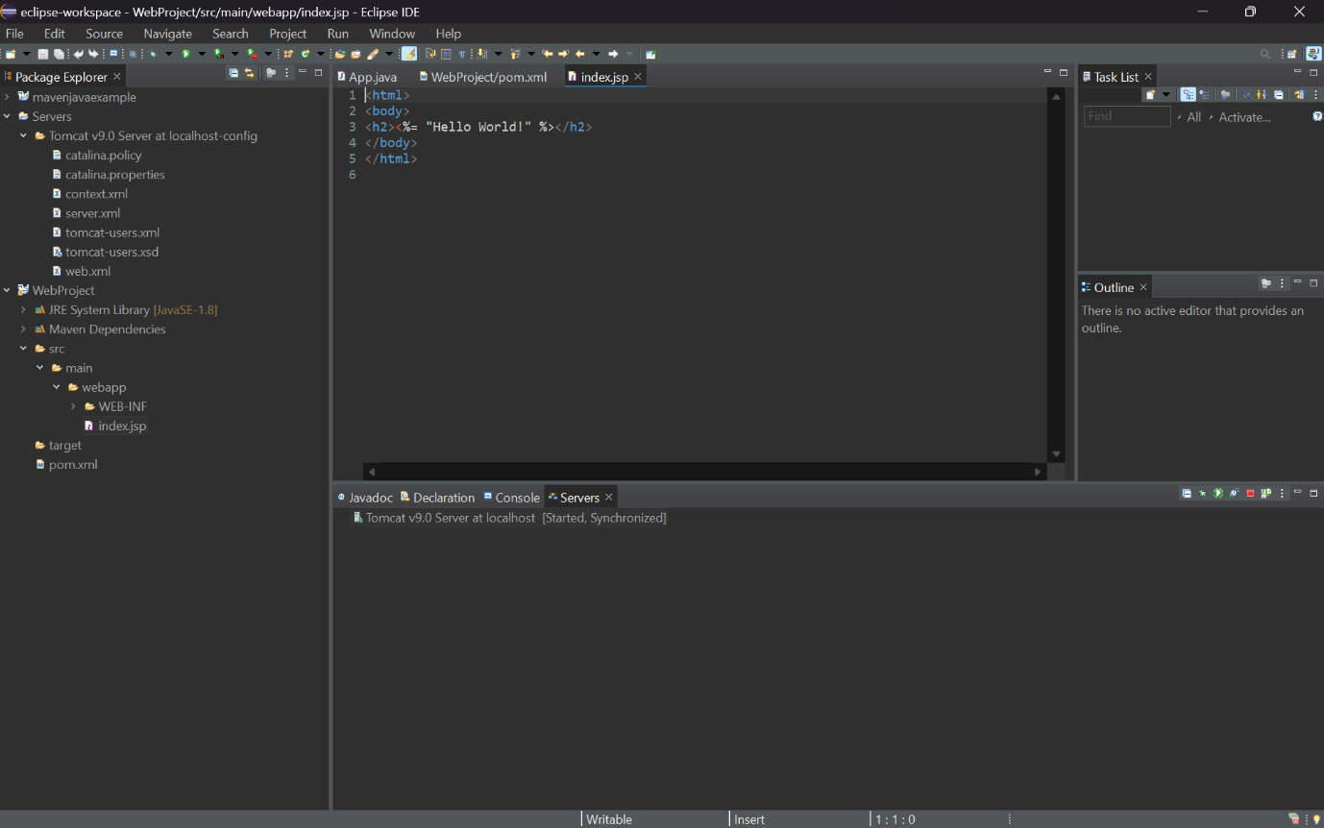

Right click on it and inn menu click on Run as Server: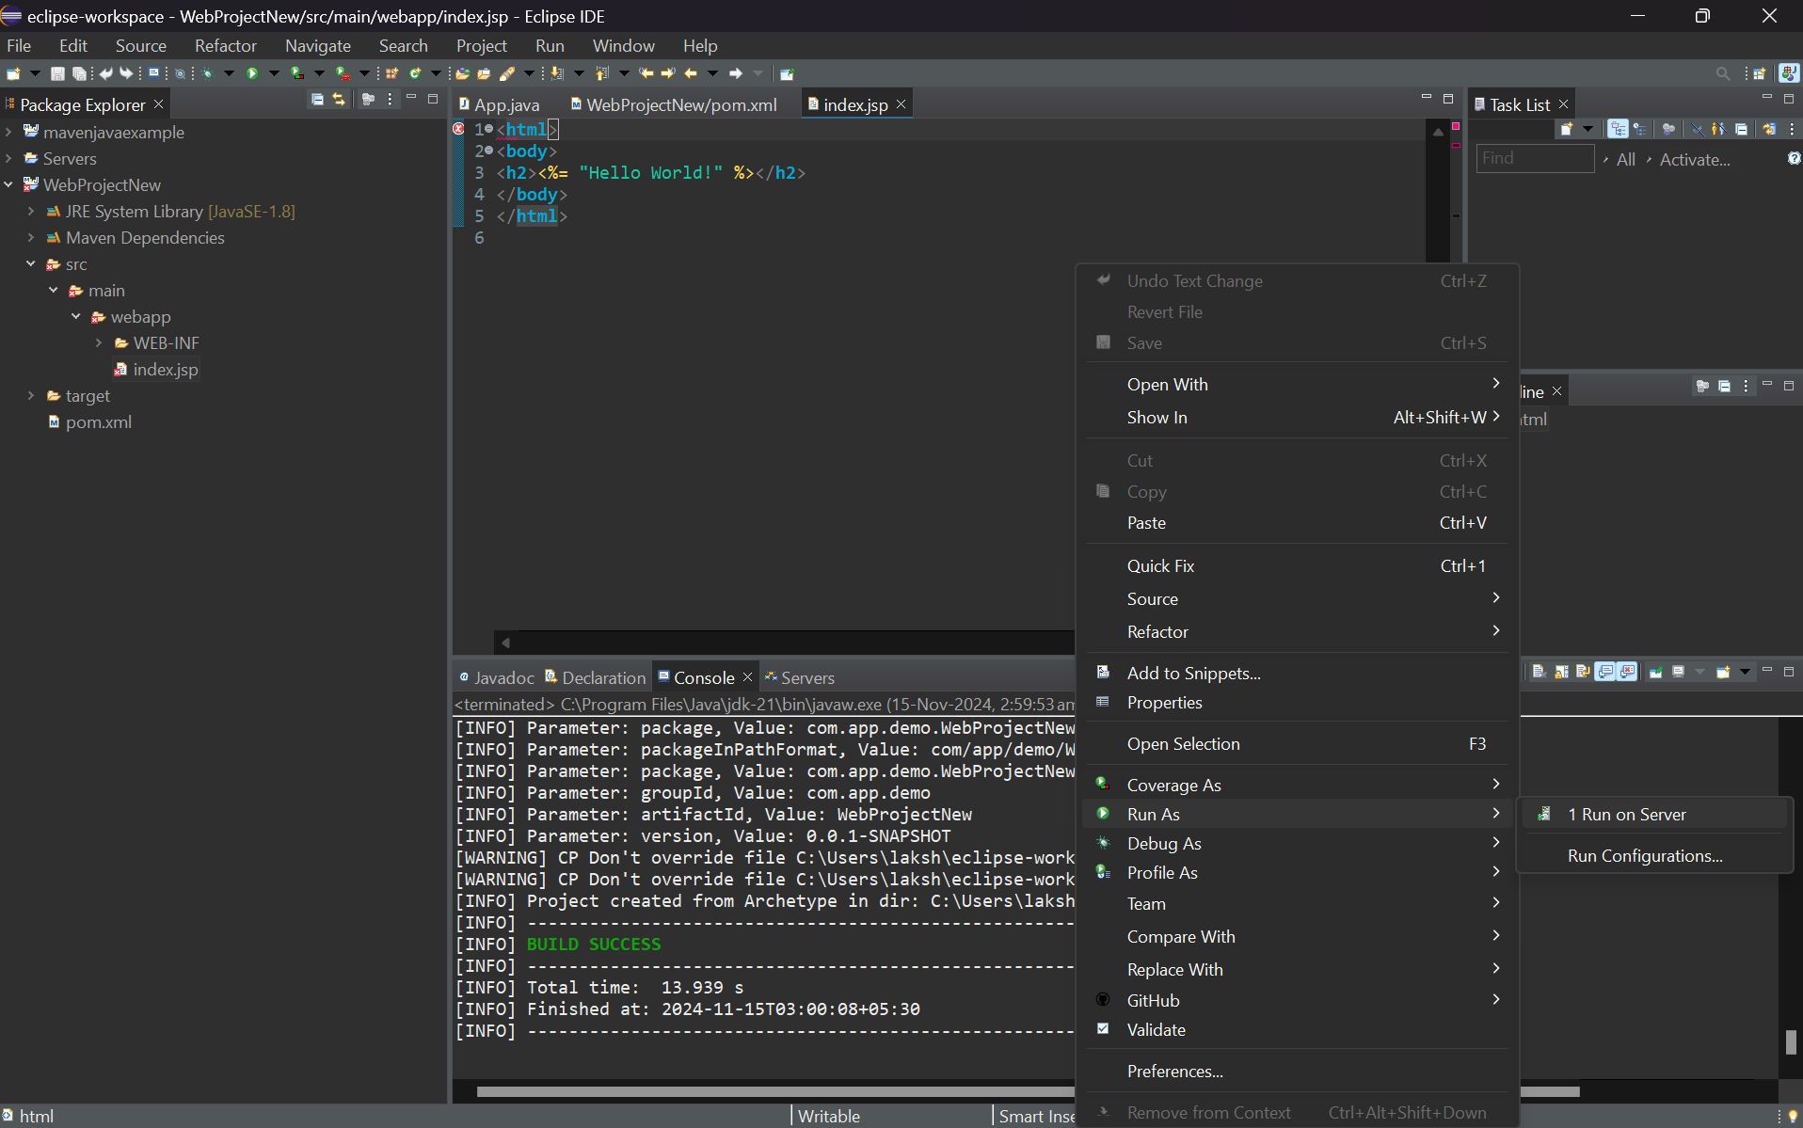

Select the Tomcat v9.0 server and click on next: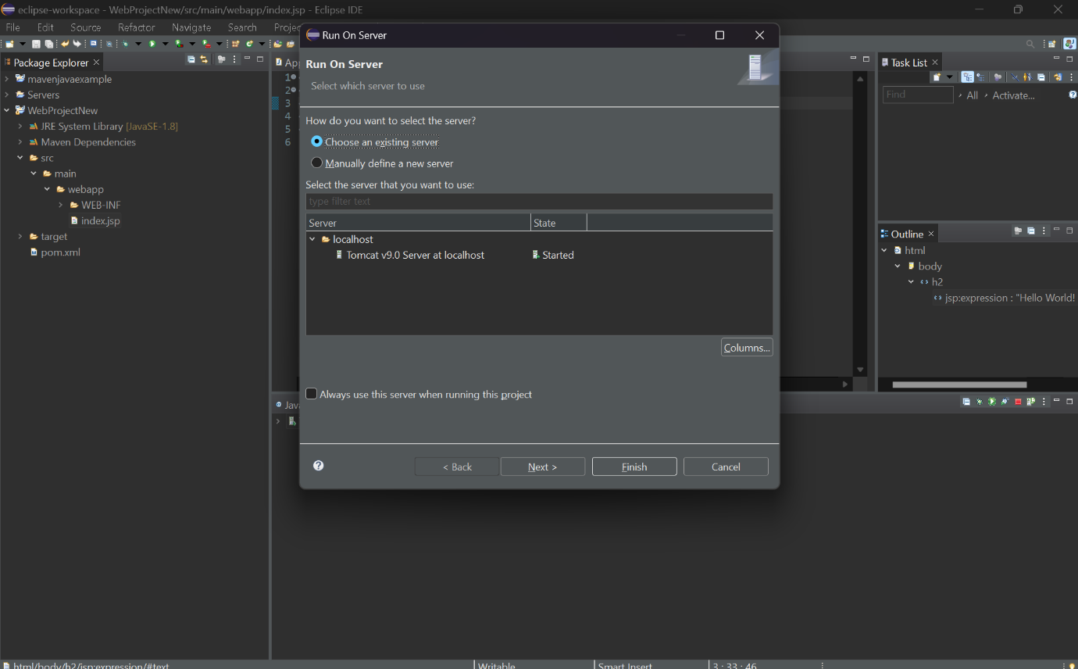

Click on next: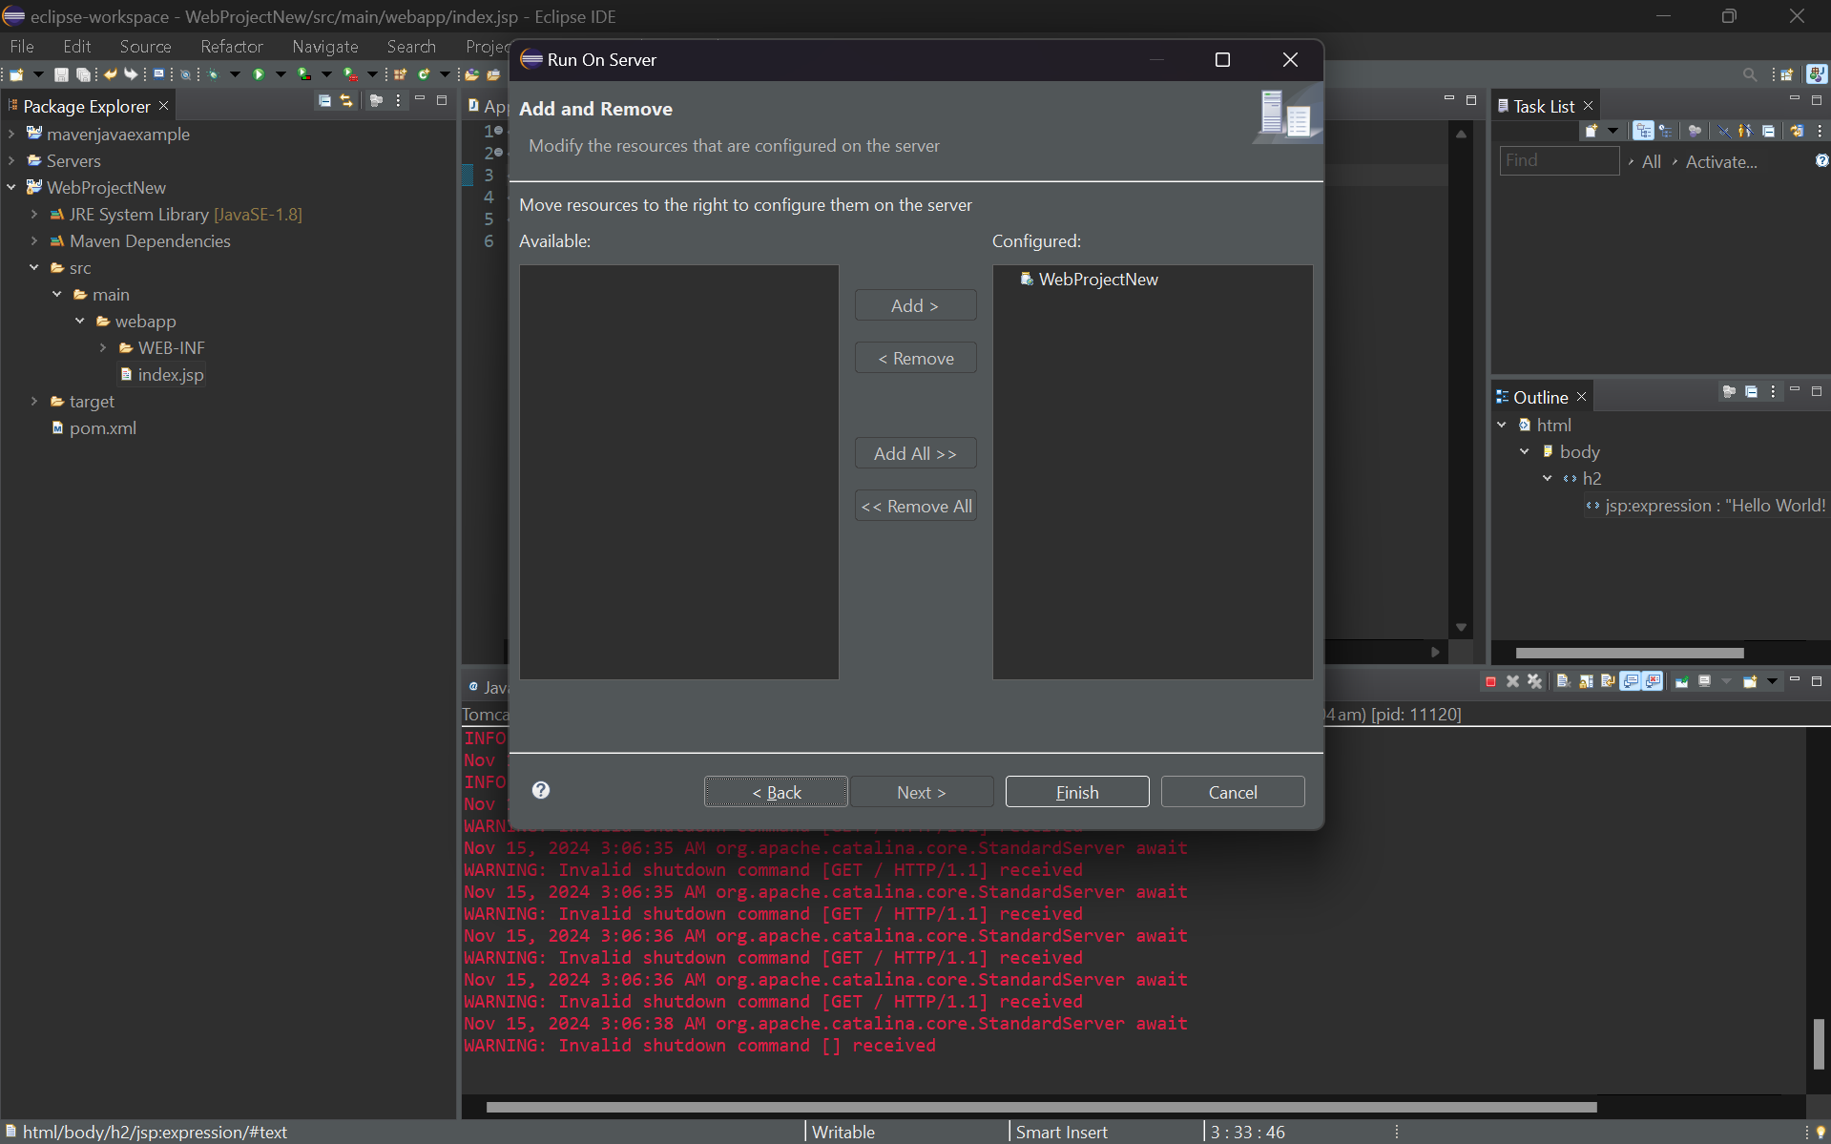

Restart server by clicking on OK: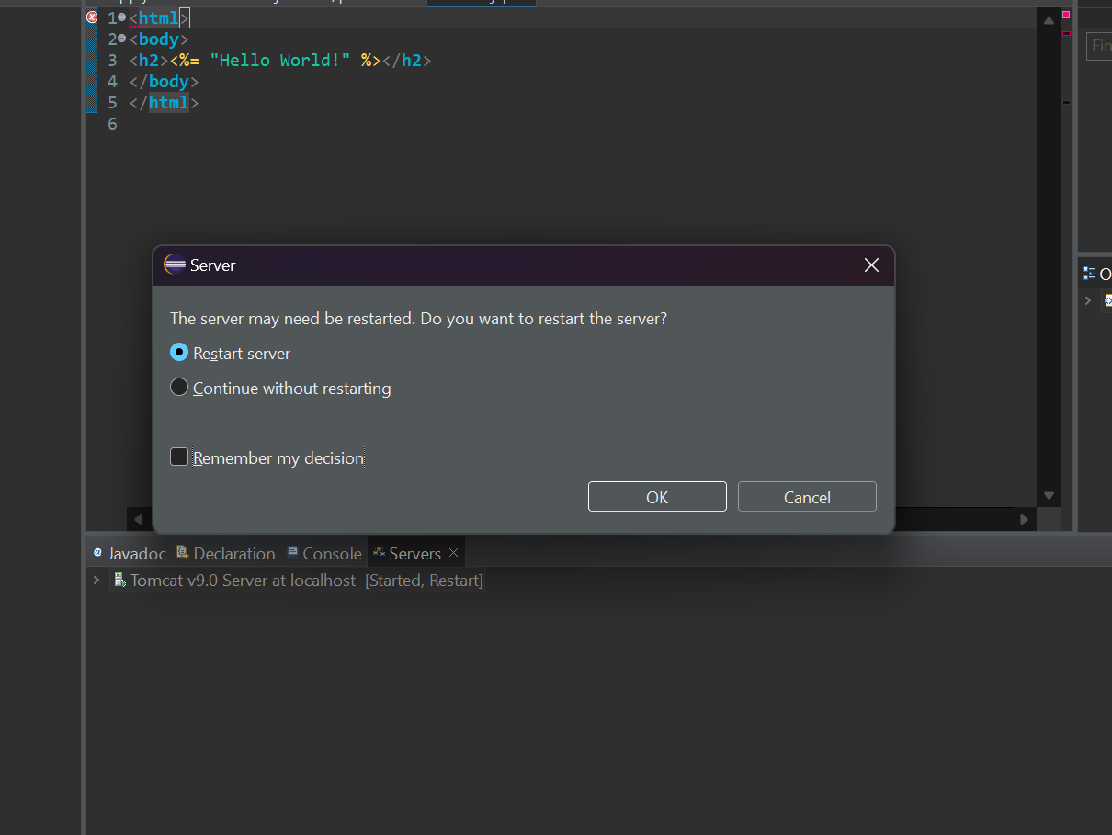

Web Server is running and the prompt is shown: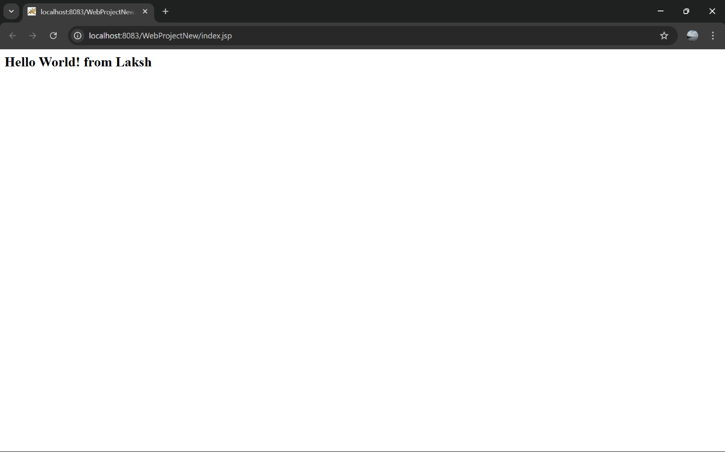

Open tomcat manager to see running sessions: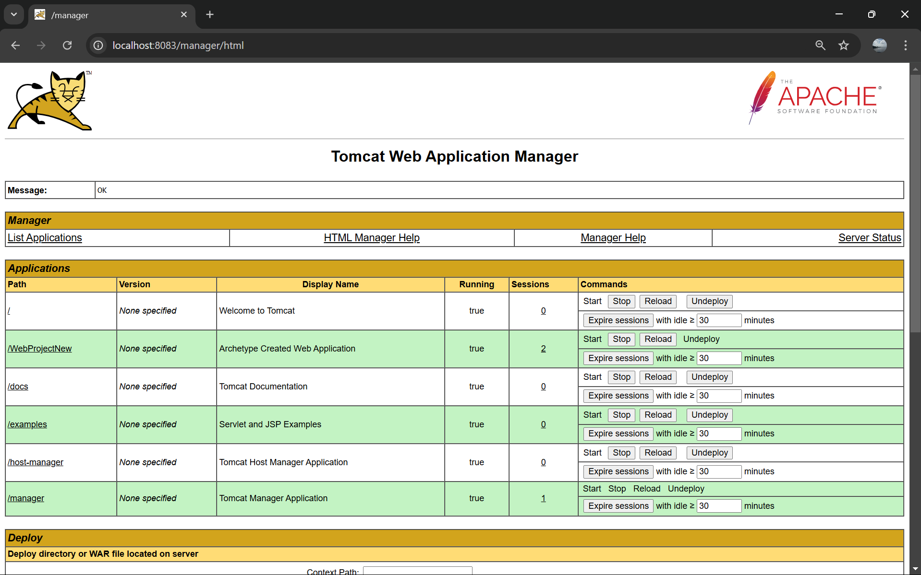

Create a new Repository and add a readme file in it: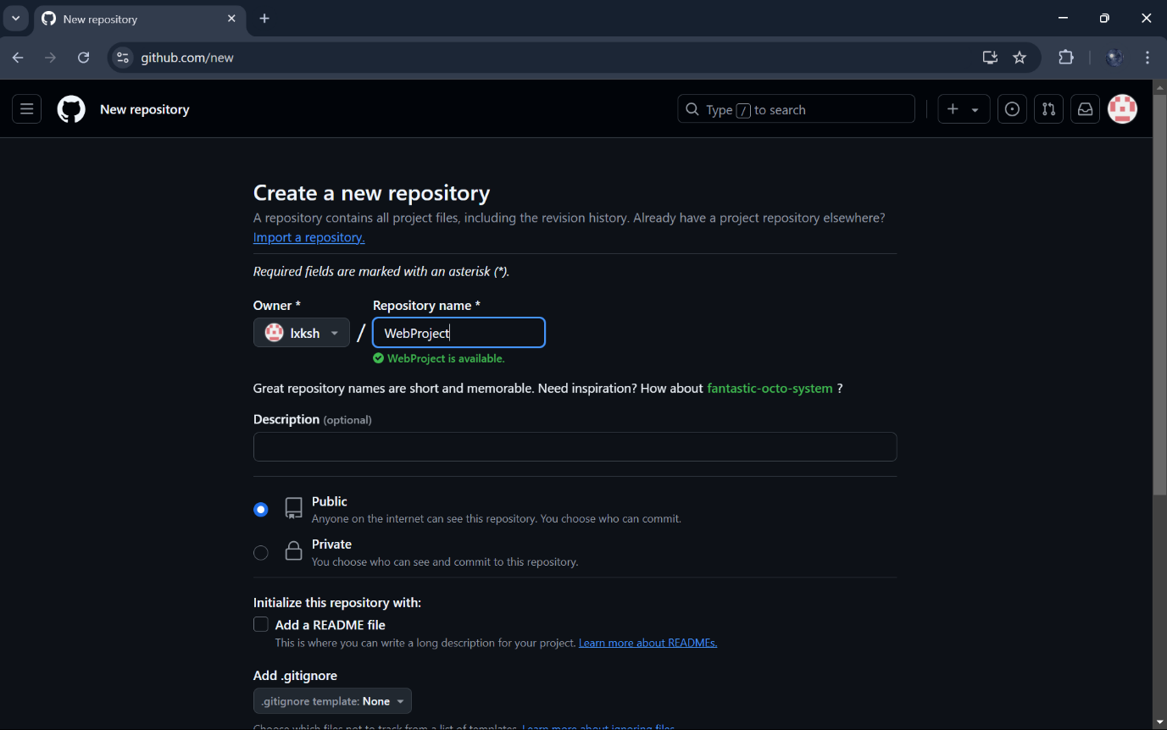

Repository is created with readme file: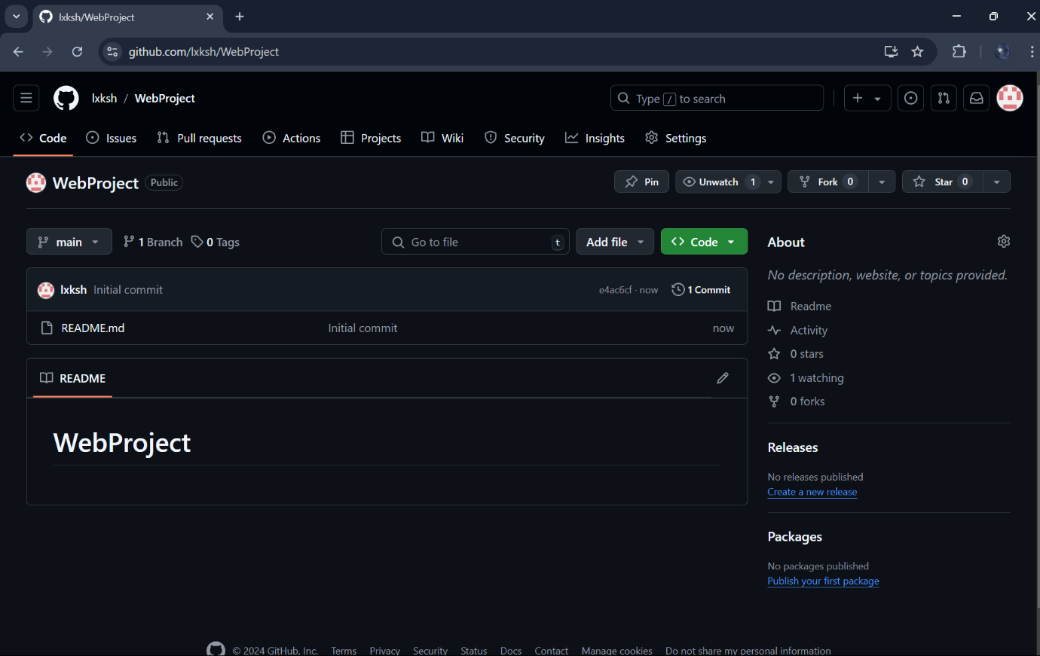

Open git bash and clone the repository into your local System: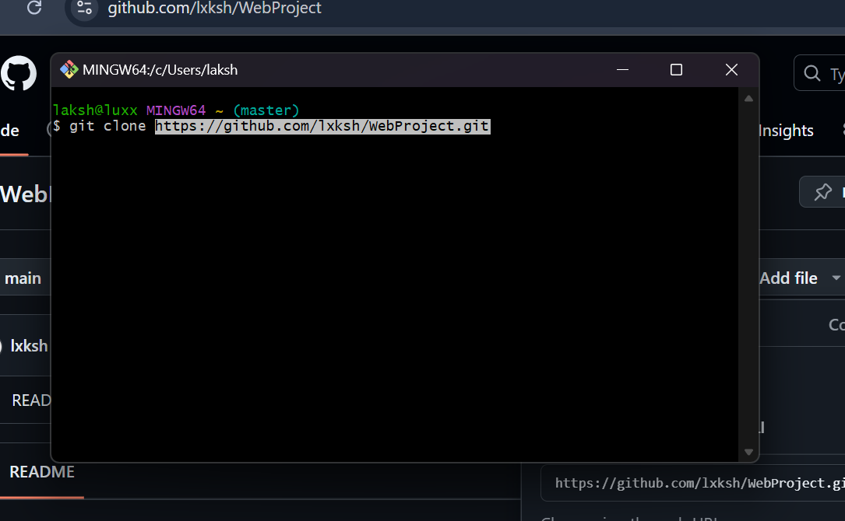

Cloning local and global Projects to copy contents from eclipse workspace to local cloned Repository 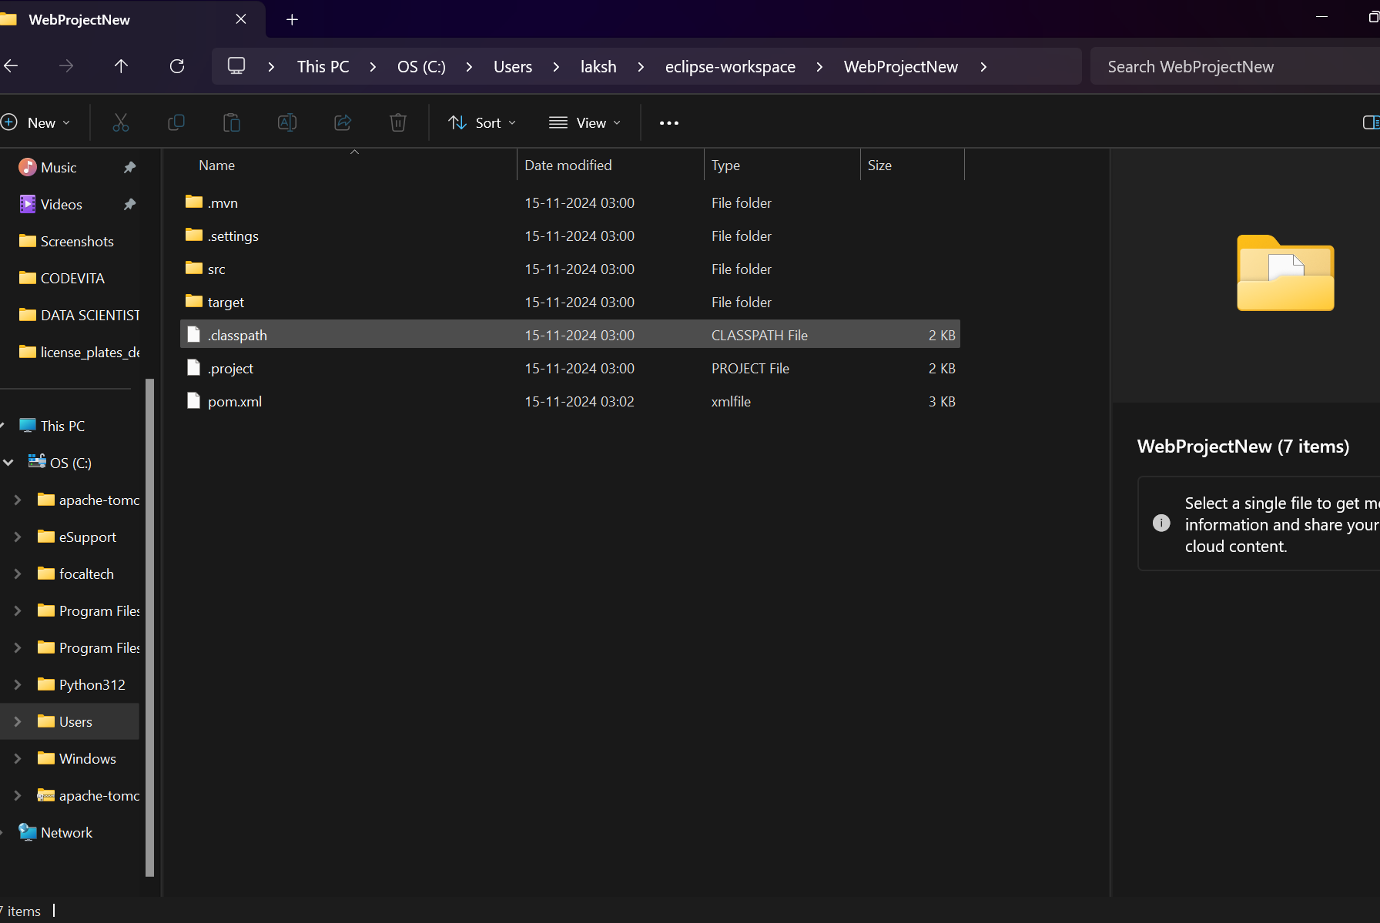

The project files are successfully copied to WebProject repository: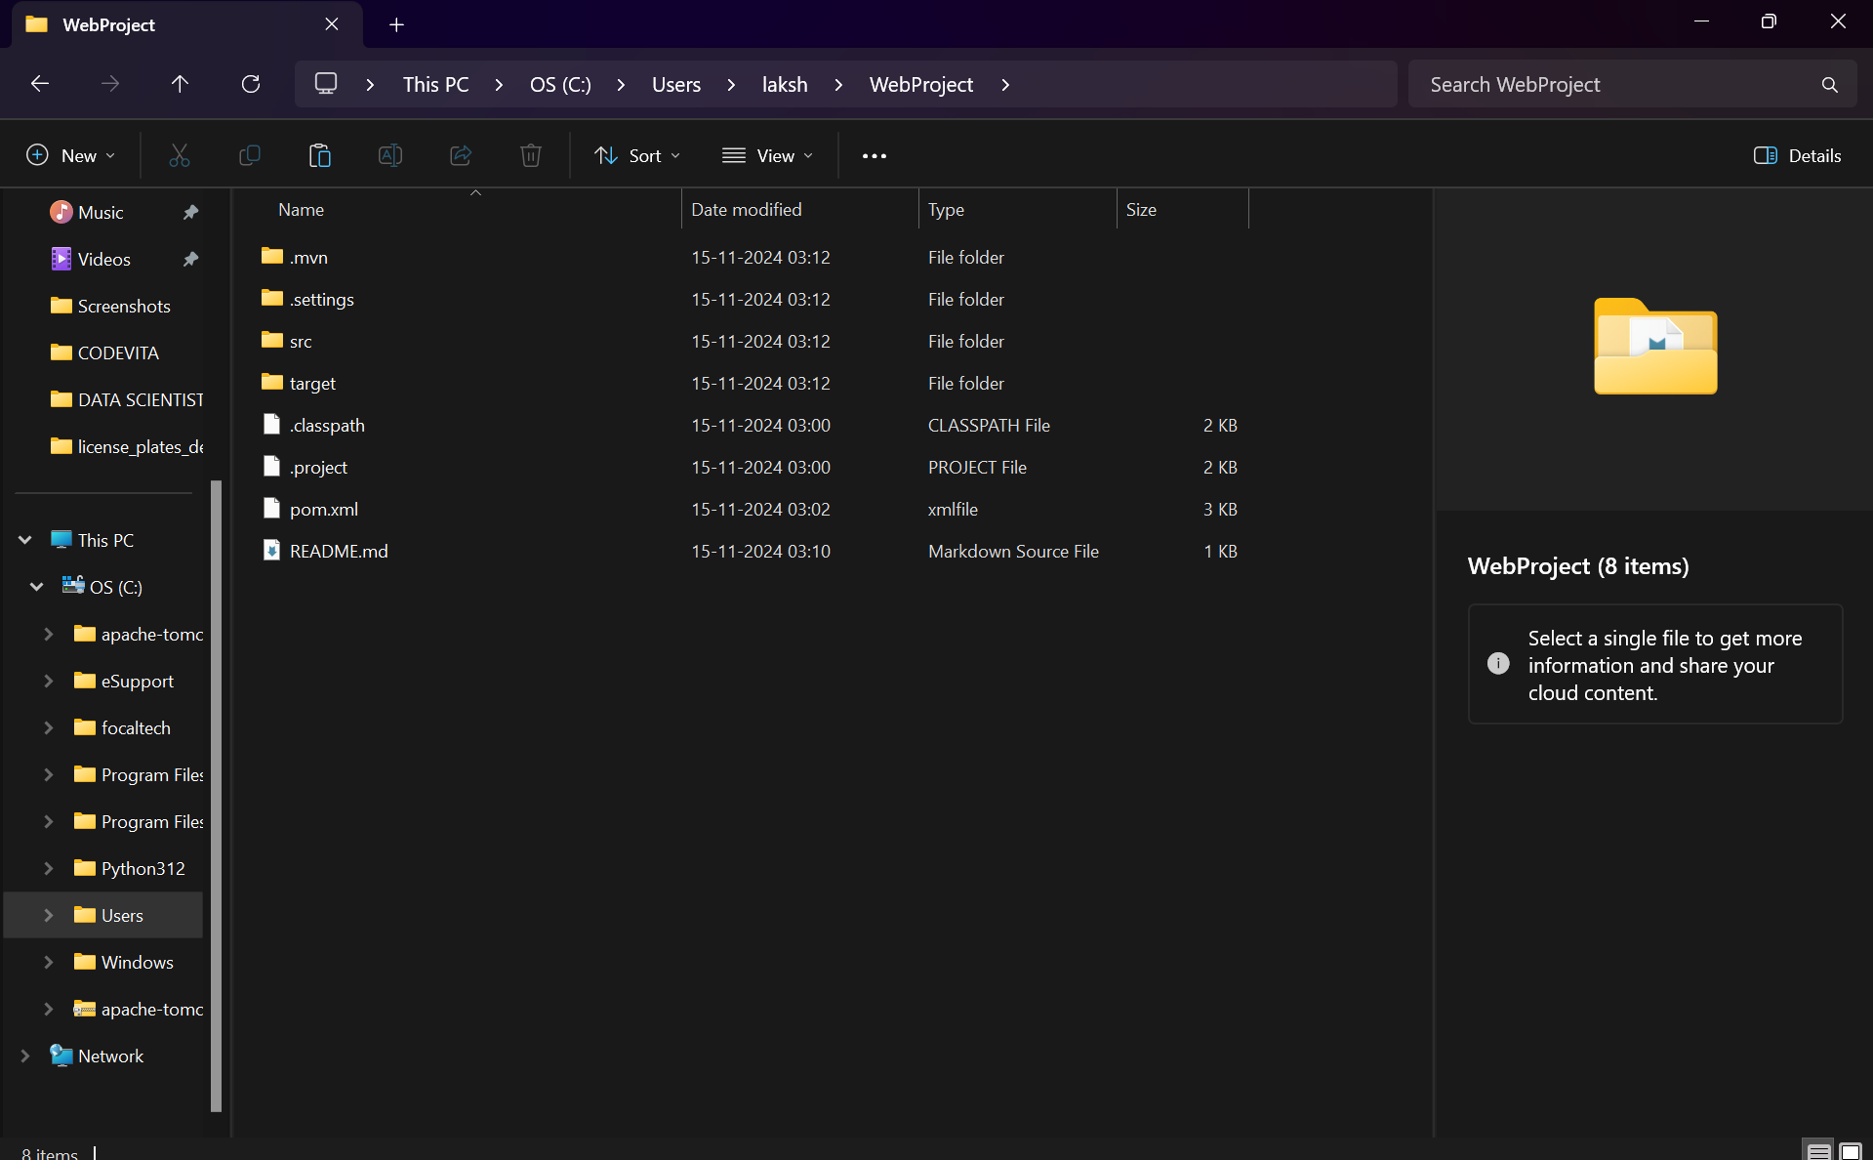

Open git bash and add the repository: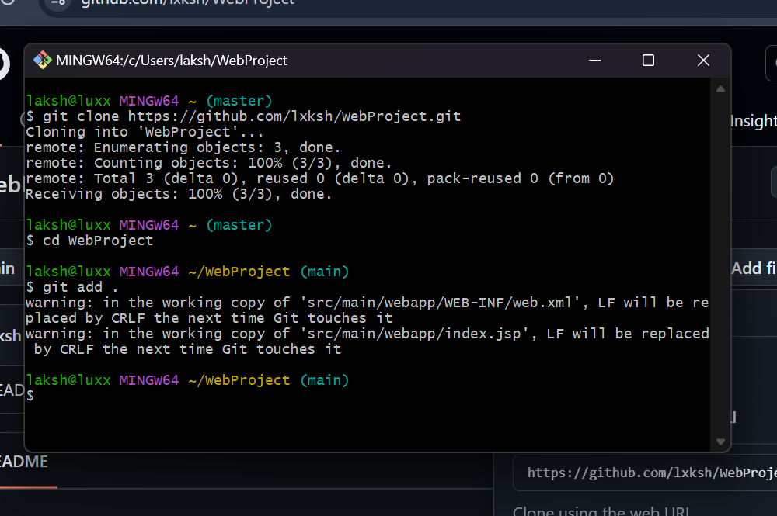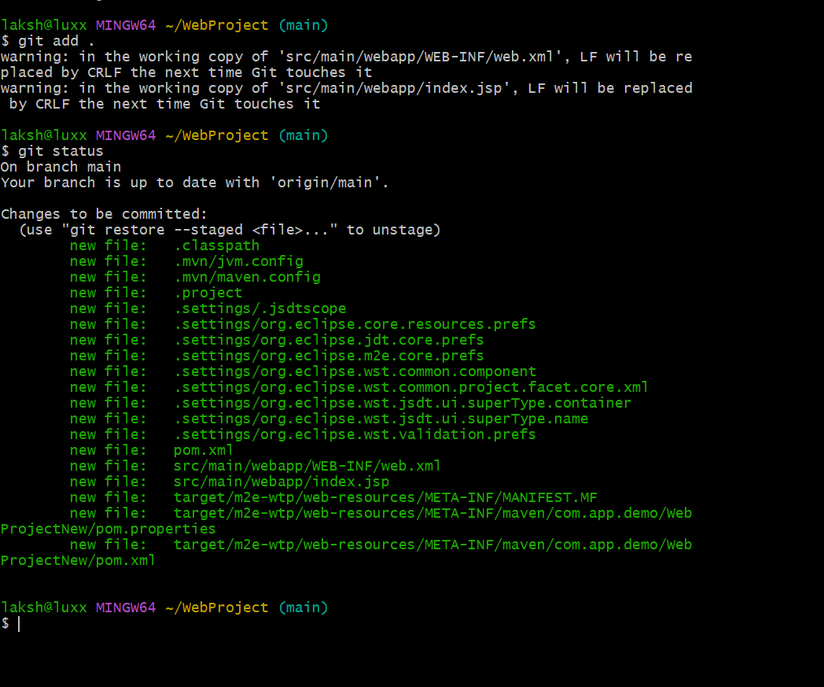

Commit all the changes made to your Project: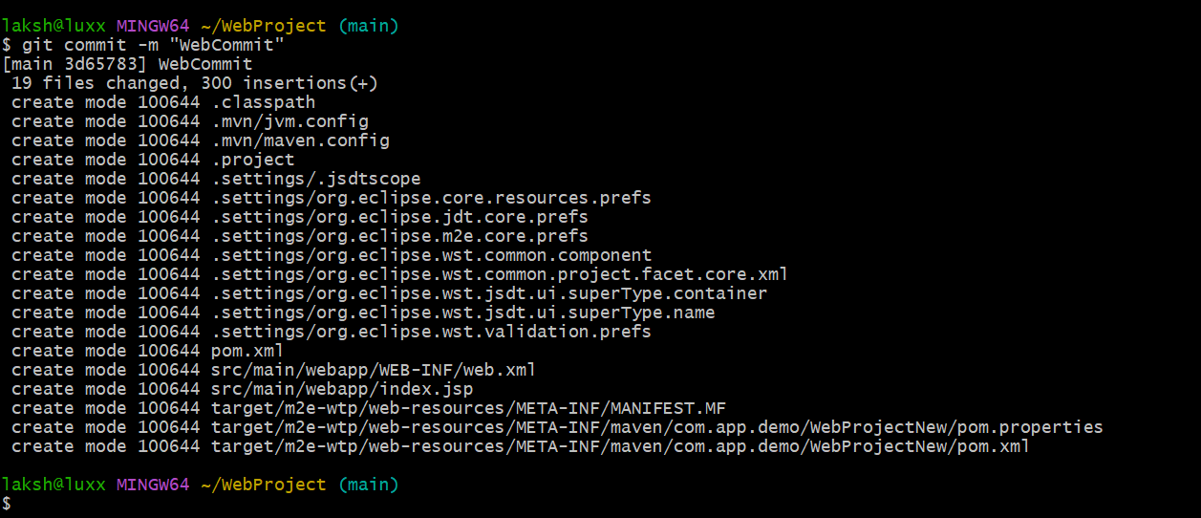

Push the changes into GitHub: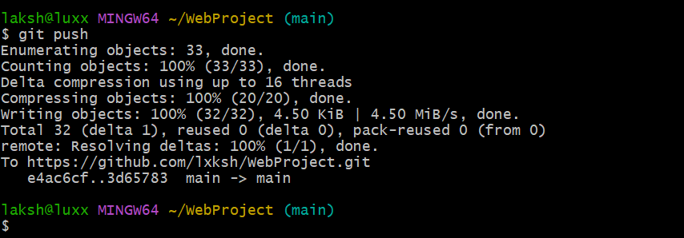

Refresh GitHub to see The Updated Repository: