**DEPLOYING AND SCALING APPLICATIONS USING MINIKUBE**

Setting Up Minikube and Kubernetes

Start minukube in terminal

Create the Nginx Deployment

You can verify if the Nginx deployment was created correctly by running this command

Expose the Service

Scale the Deployment

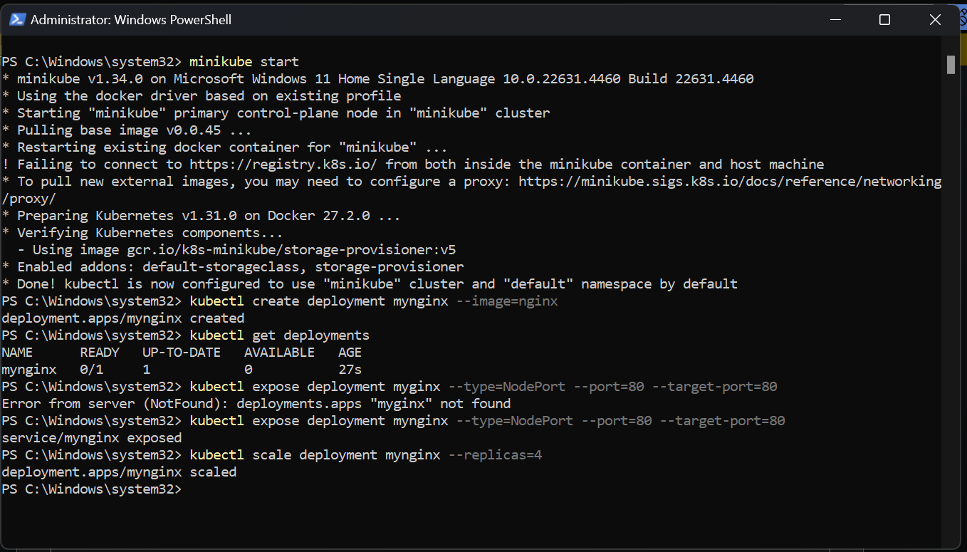

Accessing the Nginx App

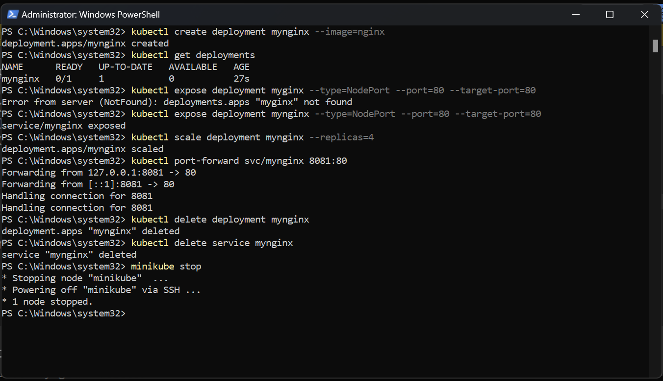

Open your browser and search for <http://localhost/8081>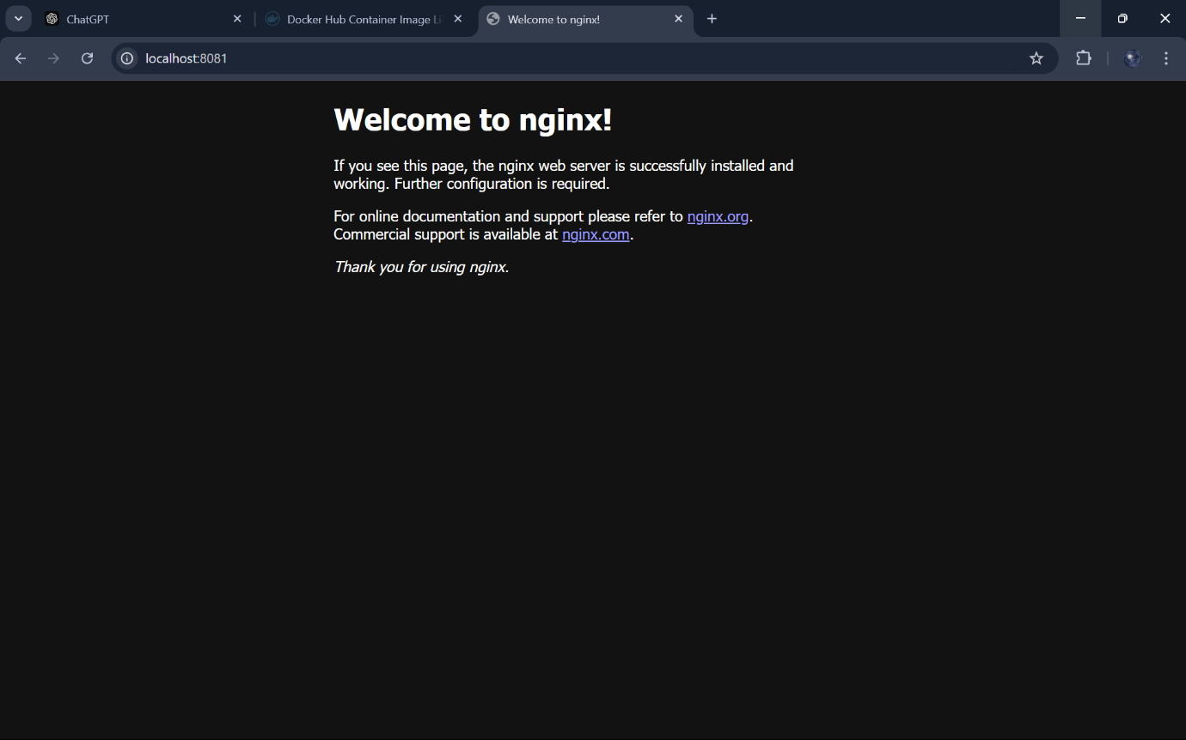

Stop the Nginx Deployment and Service

If you’re done with Minikube, stop it to free up system resources

