数据库设计模型

陆小鹿 MF1232050
赵晔 MF1232103

概念模型描述

图Diagram_1
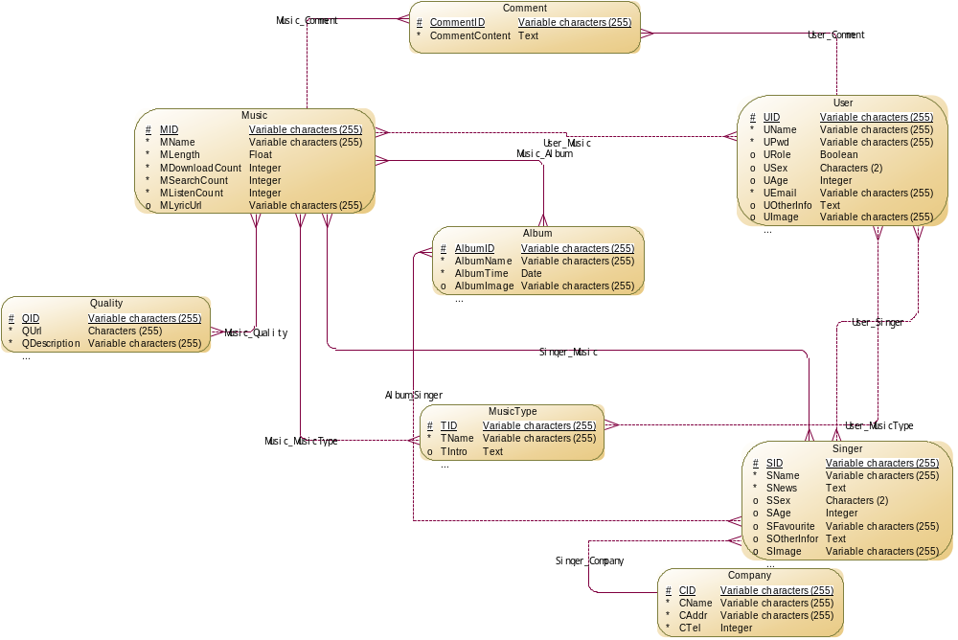

数据项清单
名称 | 代码 | 数据类型 | 长度
AlbumID | AlbumID | Variable characters (255) | 255
AlbumImage | AlbumImage | Variable characters (255) | 255
AlbumName | AlbumName | Variable characters (255) | 255
AlbumTime | AlbumTime | Date
CAddr | CAddr | Variable characters (255) | 255
CID | CID | Variable characters (255) | 255
CName | CName | Variable characters (255) | 255
CommentContent | CommentContent | Text
CommentID | CommentID | Variable characters (255) | 255
CTel | CTel | Integer
MDownloadCount | MDownloadCount | Integer
MID | MID | Variable characters (255) | 255
MLength | MLength | Float
MListenCount | MListenCount | Integer
MLyricUrl | MLyricUrl | Variable characters (255) | 255
MName | MName | Variable characters (255) | 255
MSearchCount | MSearchCount | Integer
MUrl | MUrl | Variable characters (255) | 255
QDescription | QDescription | Variable characters (255) | 255
QID | QID | Variable characters (255) | 255
QUrl | QUrl | Characters (255) | 255
SAge | SAge | Integer
SFavourite | SFavourite | Variable characters (255) | 255
SID | SID | Variable characters (255) | 255
SImage | SImage | Variable characters (255) | 255
SName | SName | Variable characters (255) | 255
SNews | SNews | Text
SOtherInfor | SOtherInfor | Text
SSex | SSex | Characters (2) | 2
TID | TID | Variable characters (255) | 255
TIntro | TIntro | Text
TName | TName | Variable characters (255) | 255
UAge | UAge | Integer
UEmail | UEmail | Variable characters (255) | 255
UID | UID | Variable characters (255) | 255
UImage | UImage | Variable characters (255) | 255
UName | UName | Variable characters (255) | 255
UOtherInfo | UOtherInfo | Text
UPwd | UPwd | Variable characters (255) | 255
URole | URole | Boolean
USex | USex | Characters (2) | 2

实体清单
名称 | 代码 | 父 | 生成
Album | Album | Conceptual Data Model 'OnlineMusicConceptModel' | TRUE
Comment | Comment | Conceptual Data Model 'OnlineMusicConceptModel' | TRUE
Company | Company | Conceptual Data Model 'OnlineMusicConceptModel' | TRUE
Music | Music | Conceptual Data Model 'OnlineMusicConceptModel' | TRUE
MusicType | MusicType | Conceptual Data Model 'OnlineMusicConceptModel' | TRUE
Quality | Quality | Conceptual Data Model 'OnlineMusicConceptModel' | TRUE
Singer | Singer | Conceptual Data Model 'OnlineMusicConceptModel' | TRUE
User | User | Conceptual Data Model 'OnlineMusicConceptModel' | TRUE

关系清单
名称 | 代码 | 父 | 生成 | 实体 2 | 实体 1 | 依附角色 | 实体 1 -> 实体 2 角色的基数 | 实体 2 -> 实体 1 角色的基数
Album_Singer | Album_Singer | Conceptual Data Model 'OnlineMusicConceptModel' | TRUE | Album | Singer | <None> | 0,n | 1,n
Music_Album | Music_Album | Conceptual Data Model 'OnlineMusicConceptModel' | TRUE | Album | Music | <None> | 1,n | 1,n
Music_Comment | Music_Comment | Conceptual Data Model 'OnlineMusicConceptModel' | TRUE | Comment | Music | <None> | 0,n | 1,1
Music_MusicType | Music_MusicType | Conceptual Data Model 'OnlineMusicConceptModel' | TRUE | MusicType | Music | <None> | 1,n | 0,n
Music_Quality | Music_Quality | Conceptual Data Model 'OnlineMusicConceptModel' | TRUE | Quality | Music | <None> | 1,n | 0,n
Singer_Company | Singer_Company | Conceptual Data Model 'OnlineMusicConceptModel' | TRUE | Company | Singer | <None> | 0,1 | 1,n
Singer_Music | Singer_Music | Conceptual Data Model 'OnlineMusicConceptModel' | TRUE | Music | Singer | <None> | 1,n | 1,n
User_Comment | User_Comment | Conceptual Data Model 'OnlineMusicConceptModel' | TRUE | Comment | User | <None> | 0,n | 1,1
User_Music | User_Music | Conceptual Data Model 'OnlineMusicConceptModel' | TRUE | Music | User | <None> | 0,n | 0,n
User_MusicType | User_MusicType | Conceptual Data Model 'OnlineMusicConceptModel' | TRUE | MusicType | User | <None> | 0,n | 0,n
User_Singer | User_Singer | Conceptual Data Model 'OnlineMusicConceptModel' | TRUE | Singer | User | <None> | 0,n | 0,n

物理模型描述

图Diagram_1
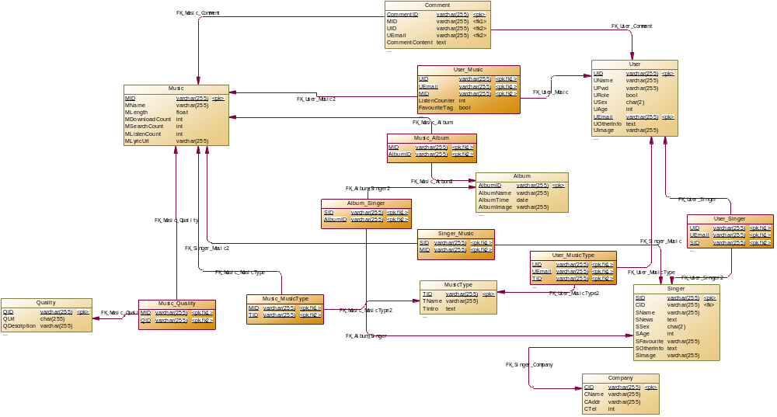

表格清单
名称 | 代码
Album | Album
Album_Singer | Album_Singer
Comment | Comment
Company | Company
Music | Music
Music_Album | Music_Album
Music_MusicType | Music_MusicType
Music_Quality | Music_Quality
MusicType | MusicType
Quality | Quality
Singer | Singer
Singer_Music | Singer_Music
User | User
User_Music | User_Music
User_MusicType | User_MusicType
User_Singer | User_Singer

参考清单
名称 | 代码 | 父表格 | 子表格 | 外键列 | 父角色 | 子角色
Album_Singer | Album_Singer | Singer | Album_Singer | SID
Album_Singer | Album_Singer2 | Album | Album_Singer | AlbumID
Music_Album | Music_Album | Music | Music_Album | MID
Music_Album | Music_Album2 | Album | Music_Album | AlbumID
Music_Comment | Music_Comment | Music | Comment | MID
Music_MusicType | Music_MusicType2 | MusicType | Music_MusicType | TID
Music_MusicType | Music_MusicType | Music | Music_MusicType | MID
Music_Quality | Music_Quality | Music | Music_Quality | MID
Music_Quality | Music_Quality2 | Quality | Music_Quality | QID
Singer_Company | Singer_Company | Company | Singer | CID
Singer_Music | Singer_Music | Singer | Singer_Music | SID
Singer_Music | Singer_Music2 | Music | Singer_Music | MID
User_Comment | User_Comment | User | Comment | UID; UEmail
User_Music | User_Music2 | Music | User_Music | MID
User_Music | User_Music | User | User_Music | UID; UEmail
User_MusicType | User_MusicType | User | User_MusicType | UID; UEmail
User_MusicType | User_MusicType2 | MusicType | User_MusicType | TID
User_Singer | User_Singer | User | User_Singer | UID; UEmail
User_Singer | User_Singer2 | Singer | User_Singer | SID

SQL脚本
/*==============================================================*/
/* DBMS name: MySQL 5.0 */
/* Created on: 2012/11/27 15:05:26 */
/*==============================================================*/

drop table if exists Album;

drop table if exists Album_Singer;

drop table if exists Comment;

drop table if exists Company;

drop table if exists Music;

drop table if exists MusicType;

drop table if exists Music_Album;

drop table if exists Music_MusicType;

drop table if exists Music_Quality;

drop table if exists Quality;

drop table if exists Singer;

drop table if exists Singer_Music;

drop table if exists User;

drop table if exists User_Music;

drop table if exists User_MusicType;

drop table if exists User_Singer;

/*==============================================================*/
/* Table: Album */
/*==============================================================*/
create table Album
(
AlbumID varchar(255) not null,
AlbumName varchar(255) not null,
AlbumTime date not null,
AlbumImage varchar(255),
primary key (AlbumID)
);

/*==============================================================*/
/* Table: Album_Singer */
/*==============================================================*/
create table Album_Singer
(
SID varchar(255) not null,
AlbumID varchar(255) not null,
primary key (SID, AlbumID)
);

/*==============================================================*/
/* Table: Comment */
/*==============================================================*/
create table Comment
(
CommentID varchar(255) not null,
MID varchar(255) not null,
UID varchar(255) not null,
UEmail varchar(255) not null,
CommentContent text not null,
primary key (CommentID)
);

/*==============================================================*/
/* Table: Company */
/*==============================================================*/
create table Company
(
CID varchar(255) not null,
CName varchar(255) not null,
CAddr varchar(255) not null,
CTel int not null,
primary key (CID)
);

/*==============================================================*/
/* Table: Music */
/*==============================================================*/
create table Music
(
MID varchar(255) not null,
MName varchar(255) not null,
MLength float not null,
MDownloadCount int not null,
MSearchCount int not null,
MListenCount int not null,
MLyricUrl varchar(255),
primary key (MID)
);

/*==============================================================*/
/* Table: MusicType */
/*==============================================================*/
create table MusicType
(
TID varchar(255) not null,
TName varchar(255) not null,
TIntro text,
primary key (TID)
);

alter table MusicType comment '音乐类型。';

/*==============================================================*/
/* Table: Music_Album */
/*==============================================================*/
create table Music_Album
(
MID varchar(255) not null,
AlbumID varchar(255) not null,
primary key (MID, AlbumID)
);

/*==============================================================*/
/* Table: Music_MusicType */
/*==============================================================*/
create table Music_MusicType
(
MID varchar(255) not null,
TID varchar(255) not null,
primary key (MID, TID)
);

/*==============================================================*/
/* Table: Music_Quality */
/*==============================================================*/
create table Music_Quality
(
MID varchar(255) not null,
QID varchar(255) not null,
primary key (MID, QID)
);

/*==============================================================*/
/* Table: Quality */
/*==============================================================*/
create table Quality
(
QID varchar(255) not null,
QUrl char(255) not null,
QDescription varchar(255) not null,
primary key (QID)
);

/*==============================================================*/
/* Table: Singer */
/*==============================================================*/
create table Singer
(
SID varchar(255) not null,
CID varchar(255),
SName varchar(255) not null,
SNews text not null,
SSex char(2),
SAge int,
SFavourite varchar(255),
SOtherInfo text,
SImage varchar(255),
primary key (SID)
);

/*==============================================================*/
/* Table: Singer_Music */
/*==============================================================*/
create table Singer_Music
(
SID varchar(255) not null,
MID varchar(255) not null,
primary key (SID, MID)
);

/*==============================================================*/
/* Table: User */
/*==============================================================*/
create table User
(
UID varchar(255) not null,
UName varchar(255) not null,
UPwd varchar(255) not null,
URole bool,
USex char(2),
UAge int,
UEmail varchar(255) not null,
UOtherInfo text,
UImage varchar(255),
primary key (UID, UEmail)
);

alter table User comment '包括管理员和用户两种身份
';

/*==============================================================*/
/* Table: User_Music */
/*==============================================================*/
create table User_Music
(
UID varchar(255) not null,
UEmail varchar(255) not null,
MID varchar(255) not null,
ListenCounter int not null,
FavouriteTag bool not null,
primary key (UID, UEmail, MID)
);

/*==============================================================*/
/* Table: User_MusicType */
/*==============================================================*/
create table User_MusicType
(
UID varchar(255) not null,
UEmail varchar(255) not null,
TID varchar(255) not null,
primary key (UID, UEmail, TID)
);

/*==============================================================*/
/* Table: User_Singer */
/*==============================================================*/
create table User_Singer
(
UID varchar(255) not null,
UEmail varchar(255) not null,
SID varchar(255) not null,
primary key (UID, UEmail, SID)
);
alter table Album_Singer add constraint FK_Album_Singer foreign key (SID)
references Singer (SID) on delete restrict on update restrict;
alter table Album_Singer add constraint FK_Album_Singer2 foreign key (AlbumID)
references Album (AlbumID) on delete restrict on update restrict;
alter table Comment add constraint FK_Music_Comment foreign key (MID)
references Music (MID) on delete restrict on update restrict;
alter table Comment add constraint FK_User_Comment foreign key (UID, UEmail)
references User (UID, UEmail) on delete restrict on update restrict;
alter table Music_Album add constraint FK_Music_Album foreign key (MID)
references Music (MID) on delete restrict on update restrict;
alter table Music_Album add constraint FK_Music_Album2 foreign key (AlbumID)
references Album (AlbumID) on delete restrict on update restrict;
alter table Music_MusicType add constraint FK_Music_MusicType foreign key (MID)
references Music (MID) on delete restrict on update restrict;
alter table Music_MusicType add constraint FK_Music_MusicType2 foreign key (TID)
references MusicType (TID) on delete restrict on update restrict;
alter table Music_Quality add constraint FK_Music_Quality foreign key (MID)
references Music (MID) on delete restrict on update restrict;
alter table Music_Quality add constraint FK_Music_Quality2 foreign key (QID)
references Quality (QID) on delete restrict on update restrict;
alter table Singer add constraint FK_Singer_Company foreign key (CID)
references Company (CID) on delete restrict on update restrict;
alter table Singer_Music add constraint FK_Singer_Music foreign key (SID)
references Singer (SID) on delete restrict on update restrict;
alter table Singer_Music add constraint FK_Singer_Music2 foreign key (MID)
references Music (MID) on delete restrict on update restrict;
alter table User_Music add constraint FK_User_Music foreign key (UID, UEmail)
references User (UID, UEmail) on delete restrict on update restrict;
alter table User_Music add constraint FK_User_Music2 foreign key (MID)
references Music (MID) on delete restrict on update restrict;
alter table User_MusicType add constraint FK_User_MusicType foreign key (UID, UEmail)
references User (UID, UEmail) on delete restrict on update restrict;
alter table User_MusicType add constraint FK_User_MusicType2 foreign key (TID)
references MusicType (TID) on delete restrict on update restrict;
alter table User_Singer add constraint FK_User_Singer foreign key (UID, UEmail)
references User (UID, UEmail) on delete restrict on update restrict;
alter table User_Singer add constraint FK_User_Singer2 foreign key (SID)
references Singer (SID) on delete restrict on update restrict;

