Use Case Scenario Report

Package: 系统用例

Diagram: AutoCase
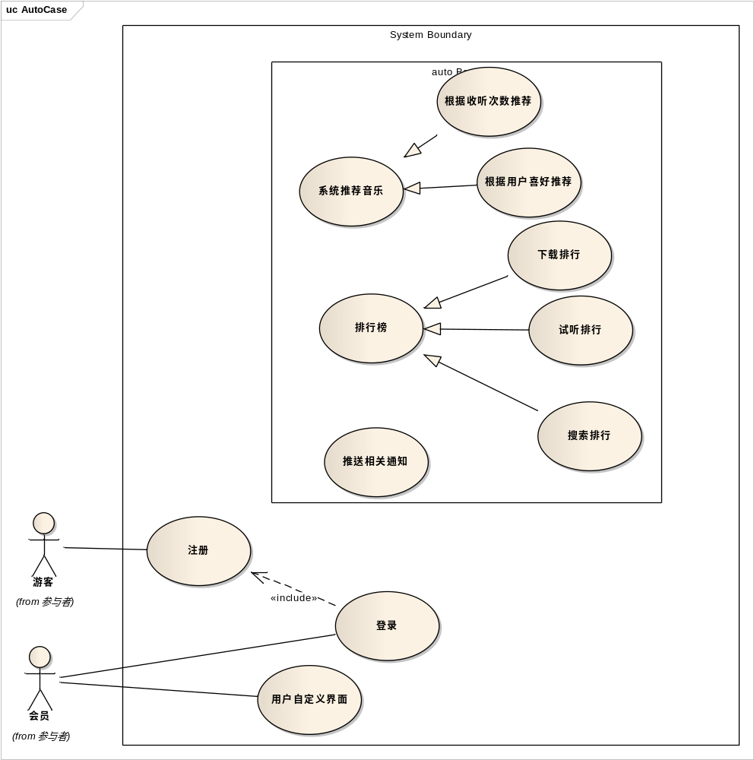

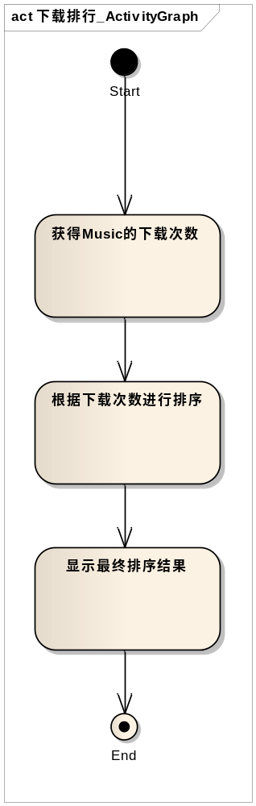
图 1 下载排行活动图
Use Case: | 下载排行 |  | Use Case Id:
Status: | Proposed | Version: 1.0 | Phase: 1.0
Author: | HIMIKO | Created: 2012/11/4 | Modified: 2012/11/26
Notes: | 系统提供下载排行榜，供用户参考

Related To: | Source | Connector | Target
 | 系统用例.下载排行 | Dependency | 管理.音乐下载
 | 系统用例.下载排行 | Generalization | 系统用例.排行榜

Precondition: | Name | Status | Notes
 | 有用户进行下载 | Approved

Scenarios:
Basic Path
Basic Path
1. 获得Music的下载次数 , Uses:
2. 根据下载次数进行排序, Uses:
3. 显示最终排序结果, Uses:

Constraints: | Name | Status | Notes
 | 系统根据数据库中音乐的下载次数进行排序 | Approved

Post-Conditions: | Name |  | Status | Notes
 | 输出下载排行信息 | Approved

Use Case: | 排行榜 |  | Use Case Id:
Status: | Proposed | Version: 1.0 | Phase: 1.0
Author: | HIMIKO | Created: 2012/11/4 | Modified: 2012/11/26
Notes: | 该用例为父用例，包括下载排行、搜索排行、试听排行

Related To: | Source | Connector | Target
 | 系统用例.试听排行 | Generalization | 系统用例.排行榜
 | 系统用例.下载排行 | Generalization | 系统用例.排行榜
 | 系统用例.搜索排行 | Generalization | 系统用例.排行榜

Precondition: | Name | Status | Notes
 | 无 | Approved

Scenarios:
Basic Path
Basic Path
1. 获得相关操作次数, Uses:
2. 对该次数进行排序, Uses:
3. 显示最终结果, Uses:

Constraints: | Name | Status | Notes
 | 系统根据数据库中相关信息进行排序 | Approved

Post-Conditions: | Name |  | Status | Notes
 | 输出排行榜 | Approved

Use Case: | 推送相关通知 |  | Use Case Id:
Status: | Proposed | Version: 1.0 | Phase: 1.0
Author: | futurezt | Created: 2012/11/5 | Modified: 2012/11/26
Notes: | 用户需要关注某个明星或是某张专辑，系统推送该明星或专辑更新信息

Related To: | Source | Connector | Target
 | 系统用例.推送相关通知 | Extend | 管理.歌星关注

Precondition: | Name | Status | Notes
 | 用户需关注某个明星或某张专辑 | Approved

Scenarios:
Basic Path
Basic Path
1. 系统查询用户关注的明星或专辑, Uses:
2. 系统接收外部新闻, Uses:
3. 系统筛选用户关注信息, Uses:
4. 将筛选出信息返回个用户, Uses:

Constraints: | Name | Status | Notes
 | 系统在数据库中搜索与用户关注的明星或专辑信息 | Approved

Post-Conditions: | Name |  | Status | Notes
 | 输出与该用户关注的明星或专辑相关的信息 | Approved

Use Case: | 搜索排行 |  | Use Case Id:
Status: | Proposed | Version: 1.0 | Phase: 1.0
Author: | HIMIKO | Created: 2012/11/4 | Modified: 2012/11/26
Notes: | 系统提供搜索排行榜，供用户参考

Related To: | Source | Connector | Target
 | 系统用例.搜索排行 | Dependency | 管理.音乐搜索
 | 系统用例.搜索排行 | Generalization | 系统用例.排行榜

Precondition: | Name | Status | Notes
 | 有用户进行搜索 | Approved

Scenarios:
Basic Path
Basic Path
1. 获得music的搜索次数, Uses:
2. 根据搜索次数进行排序, Uses:
3. 显示最终排序结果, Uses:

Constraints: | Name | Status | Notes
 | 系统根据用户对各音乐的搜索次数进行排序 | Approved

Post-Conditions: | Name |  | Status | Notes
 | 输出搜索排行 | Approved

Use Case: | 根据收听次数推荐 |  | Use Case Id:
Status: | Proposed | Version: 1.0 | Phase: 1.0
Author: | futurezt | Created: 2012/11/5 | Modified: 2012/11/27
Notes: | 系统根据用户收听音乐的次数进行排序，推荐用户常听的音乐。就是收听排行

Related To: | Source | Connector | Target
 | 系统用例.根据收听次数推荐 | Generalization | 系统用例.系统推荐音乐

Precondition: | Name | Status | Notes
 | 用户收听歌曲 | Approved

Scenarios:
Basic Path
Basic Path
1. 系统查询用户收听每首歌曲的次数, Uses:
2. 系统对收听次数进行排序，找出前n个歌曲, Uses:
3. 将结果推荐给用户, Uses:

Constraints: | Name | Status | Notes
 | 系统通过用户对不同歌曲收听的次数进行排序 | Approved

Post-Conditions: | Name |  | Status | Notes
 | 推荐收听次数排在前列的歌曲 | Approved

Use Case: | 根据用户喜好推荐 |  | Use Case Id:
Status: | Proposed | Version: 1.0 | Phase: 1.0
Author: | futurezt | Created: 2012/11/5 | Modified: 2012/11/26
Notes: | 系统根据用户的性格爱好推荐相关音乐

Related To: | Source | Connector | Target
 | 系统用例.根据用户喜好推荐 | Generalization | 系统用例.系统推荐音乐

Precondition: | Name | Status | Notes
 | 用户填写调查表 | Approved

Scenarios:
Basic Path
Basic Path
1. 系统查找用户兴趣爱好信息, Uses:
2. 找出与该用户性格相近的用户正喜欢收听的歌曲, Uses:
3. 将结果推荐给用户, Uses:

Constraints: | Name | Status | Notes
 | 系统找出符合用户性格的歌曲，或者找出与该用户性格相近的用户正在收听的歌曲 | Approved

Post-Conditions: | Name |  | Status | Notes
 | 输出这些歌曲并推荐给用户 | Approved

Use Case: | 注册 |  | Use Case Id:
Status: | Proposed | Version: 1.0 | Phase: 1.0
Author: | futurezt | Created: 2012/11/5 | Modified: 2012/11/26
Notes: | 游客可进行注册成为用户

Related To: | Source | Connector | Target
 | 系统用例.登录 | Include | 系统用例.注册
 | 参与者.游客 | Association | 系统用例.注册

Precondition: | Name | Status | Notes
 | 用户1、填写注册表2、点击注册按钮 | Approved

Scenarios:
Basic Path
Basic Path
1. 填写注册表, Uses:
2. 点击注册按钮, Uses:
3. 系统添加该用户信息include添加用户, Uses:
4. 注册成功，给出登陆界面, Uses:
Exception: 4a. 如果注册失败，返回注册页面

Alternate
如果注册失败，返回注册页面

Constraints: | Name | Status | Notes
 | 系统在数据库中新增该用户信息 | Approved

Post-Conditions: | Name |  | Status | Notes
 | 显示注册成功或注册失败。若成功，给出登陆链接 | Approved

Use Case: | 用户自定义界面 |  | Use Case Id:
Status: | Proposed | Version: 1.0 | Phase: 1.0
Author: | futurezt | Created: 2012/11/5 | Modified: 2012/11/26
Notes: | 用户可通过自定义界面来制定自己的界面

Related To: | Source | Connector | Target
 | 参与者.会员 | Association | 系统用例.用户自定义界面

Precondition: | Name | Status | Notes
 | 用户点击自定义界面按钮 | Approved

Scenarios:
Basic Path
Basic Path
1. 用户点击自定义界面按钮, Uses:
2. 给出相应自定义界面选择, Uses:
3. 用户进行相应选择完成自定义界面, Uses:

Constraints: | Name | Status | Notes
 | 系统在数据库中搜索相应自定义界面信息 | Approved

Post-Conditions: | Name |  | Status | Notes
 | 给出用户自定义界面的选择 | Approved

Use Case: | 登录 |  | Use Case Id:
Status: | Proposed | Version: 1.0 | Phase: 1.0
Author: | futurezt | Created: 2012/11/5 | Modified: 2012/11/27
Notes: | 用户通过登录获得相应权限

Related To: | Source | Connector | Target
 | 系统用例. | Include | 系统用例.注册
 | 参与者.会员 | Association | 系统用例.登录

Precondition: | Name | Status | Notes
 | 用户或管理员1、输入登陆信息2、点击登陆按钮 | Approved

Scenarios:
Basic Path
Basic Path
4a. 如果登录失败，返回登陆界面
1. 输入登陆信息, Uses:
2. 点击登录按钮, Uses:
3. 系统验证, Uses:
4. 登陆成功，显示主界面, Uses:
Exception: 4a. 如果登录失败，返回登陆界面

Alternate
如果登录失败，返回登陆界面
1. 若登录失败返回登录界面, Uses:

Constraints: | Name | Status | Notes
 | 系统验证登陆信息是否正确，即查看数据库中是否有该用户记录。若存在，登陆成功，否则，登陆失败。 | Approved

Post-Conditions: | Name |  | Status | Notes
 | 显示登陆成功或登陆失败。若登陆成功，进入主界面，若登陆失败，返回登陆界面 | Approved

Use Case: | 系统推荐音乐 |  | Use Case Id:
Status: | Proposed | Version: 1.0 | Phase: 1.0
Author: | HIMIKO | Created: 2012/11/4 | Modified: 2012/11/26
Notes: | 该用例为父用例，包括根据收听次数推荐和根据用户喜好推荐

Related To: | Source | Connector | Target
 | 系统用例.系统推荐音乐 | Extend | 音乐播放器.设置播放音质
 | 系统用例.系统推荐音乐 | Extend | 音乐播放器.标记为喜欢
 | 系统用例.根据用户喜好推荐 | Generalization | 系统用例.系统推荐音乐
 | 系统用例.根据收听次数推荐 | Generalization | 系统用例.系统推荐音乐

Precondition: | Name | Status | Notes
 | 系统录入用户相关信息 | Approved

Scenarios:
Basic Path
Basic Path
1. 系统根据用户相关信息生成推荐, Uses:
2. 将推荐结果返回给用户, Uses:

Constraints: | Name | Status | Notes
 | 系统根据用户相关信息进行推荐 | Approved

Post-Conditions: | Name |  | Status | Notes
 | 输出推荐音乐 | Approved

Use Case: | 试听排行 |  | Use Case Id:
Status: | Proposed | Version: 1.0 | Phase: 1.0
Author: | HIMIKO | Created: 2012/11/4 | Modified: 2012/11/26
Notes: | 系统提供试听排行榜，供用户参考

Related To: | Source | Connector | Target
 | 系统用例.试听排行 | Generalization | 系统用例.排行榜
 | 系统用例.试听排行 | Dependency | 音乐播放器.音乐播放、暂停

Precondition: | Name | Status | Notes
 | 有用户进行试听 | Approved

Scenarios:
Basic Path
Basic Path
1. 获得music的试听次数, Uses:
2. 根据试听次数进行排序, Uses:
3. 显示最终排序结果, Uses:

Constraints: | Name | Status | Notes
 | 系统根据用户对各音乐的试听次数进行排序 | Approved

Post-Conditions: | Name |  | Status | Notes
 | 输出试听排行 | Approved

