**Kacper Latoszewski - 368002**

**Algorytmy i złożoność**

**Projekt dodatkowy**

**Temat:** Zbadać zależność między wysokością, a ilością elementów w drzewie BST i AVL dla losowych liczb z przedziału:

1. 0 - RAND_MAX
2. 0 - 9

Programy użyte w projekcie poza generowaniem wyników, rysowały również drzewa, dzięki czemu można było zweryfikować ich poprawność.

Objaśnienia co do tabelki z wynikami:

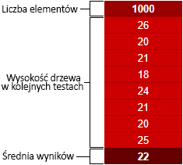

**BST:**

1. 0 - RAND_MAX:

|  |  |  |  |  |  |  |  |  |  |
| --- | --- | --- | --- | --- | --- | --- | --- | --- | --- |
| **1000** | **2000** | **3000** | **4000** | **5000** | **6000** | **7000** | **8000** | **9000** | **10000** |
| 26 | 28 | 29 | 29 | 30 | 31 | 31 | 32 | 32 | 32 |
| 20 | 23 | 24 | 25 | 26 | 27 | 28 | 28 | 29 | 30 |
| 21 | 24 | 25 | 25 | 25 | 26 | 27 | 27 | 27 | 28 |
| 18 | 21 | 22 | 23 | 23 | 23 | 25 | 25 | 26 | 32 |
| 24 | 28 | 29 | 31 | 32 | 33 | 35 | 35 | 35 | 36 |
| 21 | 24 | 27 | 27 | 28 | 29 | 30 | 31 | 32 | 32 |
| 20 | 24 | 25 | 26 | 27 | 29 | 29 | 29 | 29 | 30 |
| 25 | 27 | 29 | 30 | 30 | 31 | 31 | 32 | 32 | 32 |
| **22** | **25** | **26** | **27** | **28** | **29** | **30** | **30** | **30** | **32** |

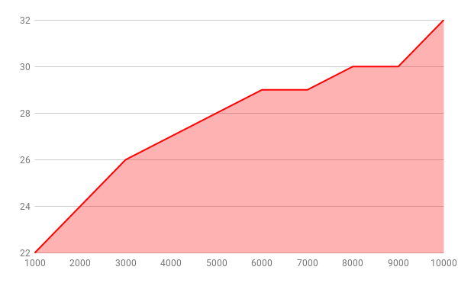

2) 0 - 9:

|  |  |  |  |  |  |  |  |  |  |
| --- | --- | --- | --- | --- | --- | --- | --- | --- | --- |
| **1000** | **2000** | **3000** | **4000** | **5000** | **6000** | **7000** | **8000** | **9000** | **10000** |
| 116 | 218 | 312 | 417 | 518 | 638 | 722 | 822 | 934 | 1023 |
| 114 | 227 | 345 | 448 | 561 | 659 | 754 | 852 | 956 | 1055 |
| 123 | 225 | 330 | 427 | 538 | 645 | 752 | 843 | 926 | 1037 |
| 119 | 233 | 327 | 422 | 516 | 628 | 737 | 841 | 931 | 1038 |
| 123 | 232 | 337 | 454 | 552 | 655 | 750 | 854 | 953 | 1052 |
| 115 | 222 | 330 | 422 | 527 | 628 | 723 | 822 | 923 | 1024 |
| 122 | 230 | 330 | 440 | 548 | 646 | 752 | 862 | 959 | 1049 |
| 119 | 234 | 360 | 468 | 576 | 683 | 783 | 860 | 955 | 1049 |
| **119** | **228** | **334** | **437** | **542** | **648** | **747** | **845** | **942** | **1041** |

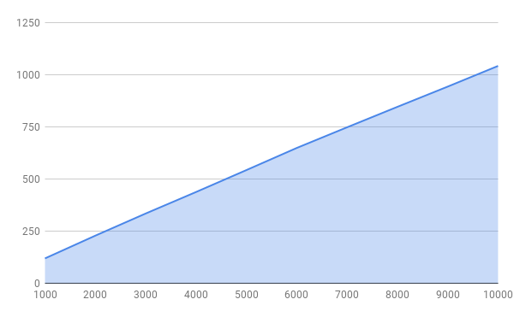

**AVL:**

1. 0 - RAND_MAX:

|  |  |  |  |  |  |  |  |  |  |
| --- | --- | --- | --- | --- | --- | --- | --- | --- | --- |
| **1000** | **2000** | **3000** | **4000** | **5000** | **6000** | **7000** | **8000** | **9000** | **10000** |
| 12 | 13 | 14 | 14 | 15 | 15 | 15 | 16 | 16 | 16 |
| 12 | 13 | 14 | 14 | 15 | 15 | 16 | 16 | 15 | 16 |
| 12 | 13 | 14 | 14 | 15 | 15 | 15 | 15 | 16 | 16 |
| 12 | 13 | 14 | 14 | 15 | 15 | 15 | 15 | 16 | 16 |
| 12 | 14 | 14 | 14 | 15 | 15 | 15 | 16 | 16 | 16 |
| 12 | 13 | 14 | 14 | 14 | 15 | 15 | 16 | 16 | 16 |
| 12 | 13 | 14 | 15 | 15 | 15 | 15 | 15 | 16 | 16 |
| 12 | 13 | 14 | 14 | 15 | 15 | 15 | 16 | 16 | 16 |
| **12** | **13** | **14** | **14** | **15** | **15** | **15** | **16** | **16** | **16** |

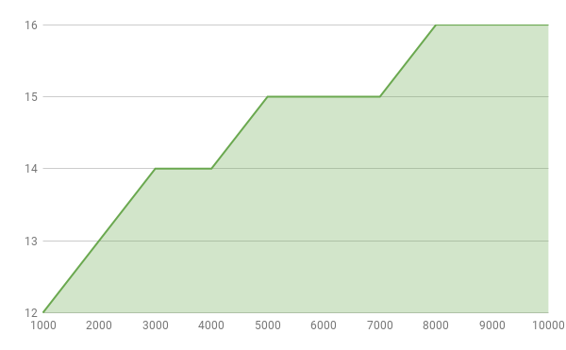

2) 0 - 9:

|  |  |  |  |  |  |  |  |  |  |
| --- | --- | --- | --- | --- | --- | --- | --- | --- | --- |
| **1000** | **2000** | **3000** | **4000** | **5000** | **6000** | **7000** | **8000** | **9000** | **10000** |
| 11 | 12 | 13 | 13 | 13 | 14 | 14 | 14 | 14 | 15 |
| 11 | 12 | 13 | 13 | 14 | 14 | 14 | 14 | 14 | 15 |
| 11 | 12 | 13 | 13 | 13 | 14 | 14 | 14 | 14 | 14 |
| 11 | 12 | 13 | 13 | 13 | 14 | 14 | 14 | 14 | 14 |
| 11 | 12 | 13 | 13 | 14 | 14 | 14 | 14 | 14 | 15 |
| 11 | 12 | 13 | 13 | 13 | 14 | 14 | 14 | 14 | 14 |
| 11 | 12 | 13 | 13 | 14 | 14 | 14 | 14 | 14 | 14 |
| 11 | 12 | 13 | 13 | 14 | 14 | 14 | 14 | 15 | 14 |
| **11** | **12** | **13** | **13** | **14** | **14** | **14** | **14** | **14** | **14** |

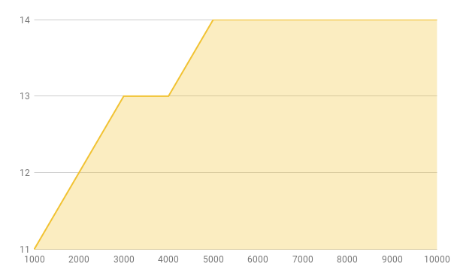

Porównanie wykresów drzew:

1. BST:

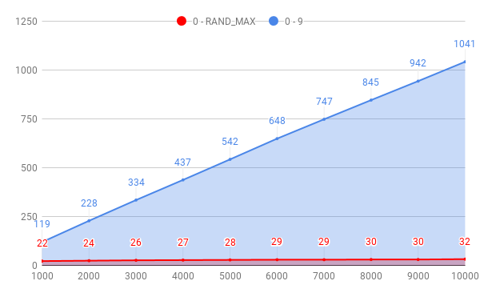

1. AVL:

