1. Main screen

In Main Screen, it includes the following menus:

**Method, Calibrate, Test, Data Analysis, Report, Library**

1. Under “**Method**” menu, it includes the following submenus:
2. Create a method. The method includes the following changeable parameters:

Pressure (psi):

Lowest Temperature (ᵒC):

Low Holding Time (min):

Temperature 1 (ᵒC):

Temp 1 Holding Time (min)

Ramp Speed 1 (ᵒC/min)

Temperature 2 (ᵒC):

Temp 2 Holding Time (min):

Ramp Speed 2 (ᵒC/min):

1. Choose a method: choose an existing method
2. Modify a method: modify an existing method
3. Save as
4. Save
5. Under “**Calibrate**” menu, it includes the following submenus:
6. Create a calibration curve

After choosing this submenu, it will show a table, take BTEX as an example:

|  |  |  |  |
| --- | --- | --- | --- |
| Standard gas name | | BTEX 1ppmv | |
| Calibration point | Compound Name | | Sampling time, min |
| 1 | Benzene | | 0.2 |
| Toluene | |
| Ethylbenzene | |
| m, p-xylene | |
| o-xylene | |
| 2 | Benzene | | 0.5 |
| Toluene | |
| Ethylbenzene | |
| m, p-xylene | |
| o-xylene | |

The user can type in the standard gas name

The user can choose the number of calibration point.

The user can choose the number of compounds to be calibrated

The user will manually type in the sampling time

1. Generate calibration curve

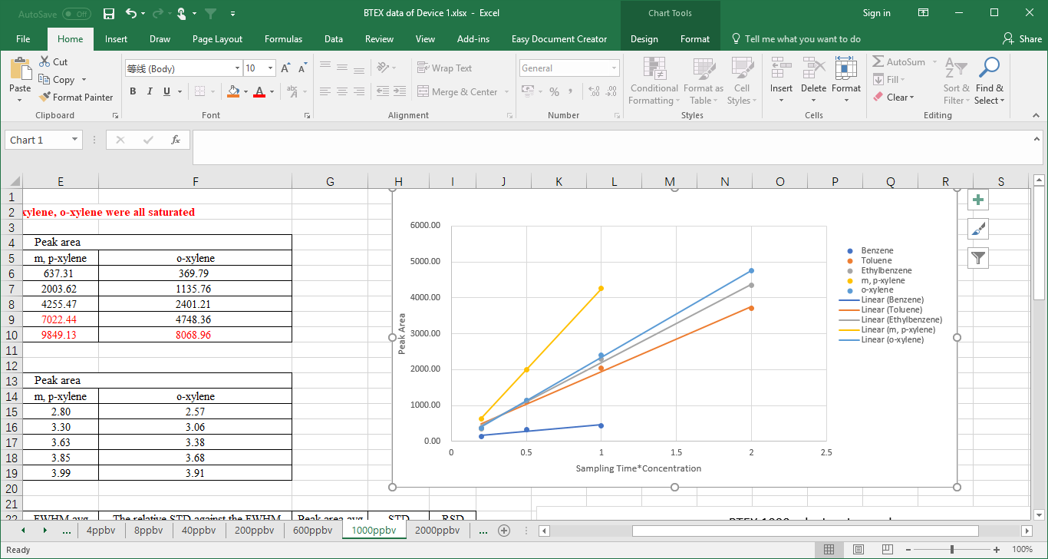

|  |  |  |  |  |
| --- | --- | --- | --- | --- |
| Compound Name | Calibration Equation | R2 | Calibration range | Retention time |
| Benzene | y1=kx1+b |  |  |  |
| Toluene | y2=kx2+b |  |  |  |
| Ethylbenzene | y3=kx3+b |  |  |  |
| m, p-xylene | y4=kx4+b |  |  |  |
| o-xylene | y5=kx5+b |  |  |  |

1. Save/save as the calibration as user defined name
2. Under the “**Test**” menu, the user chooses certain method to run tests

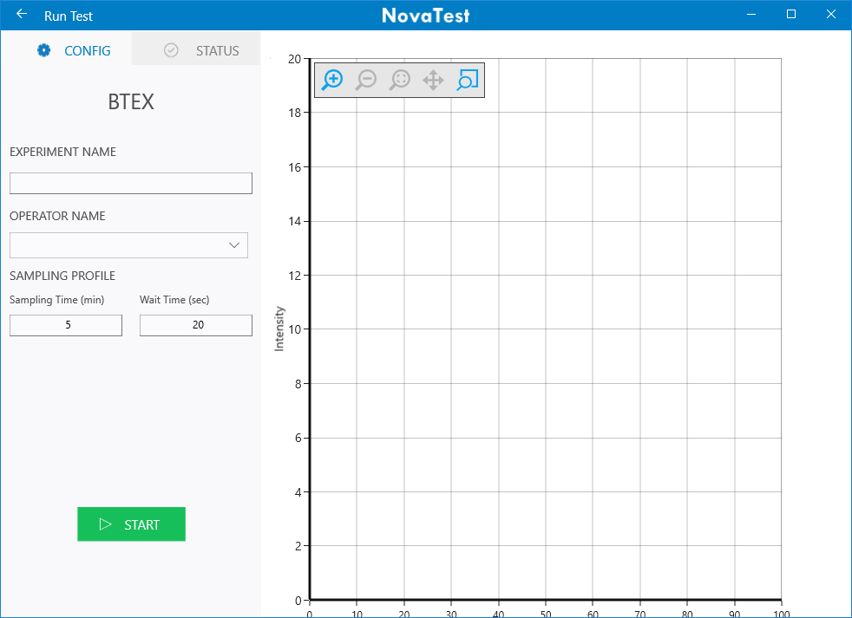

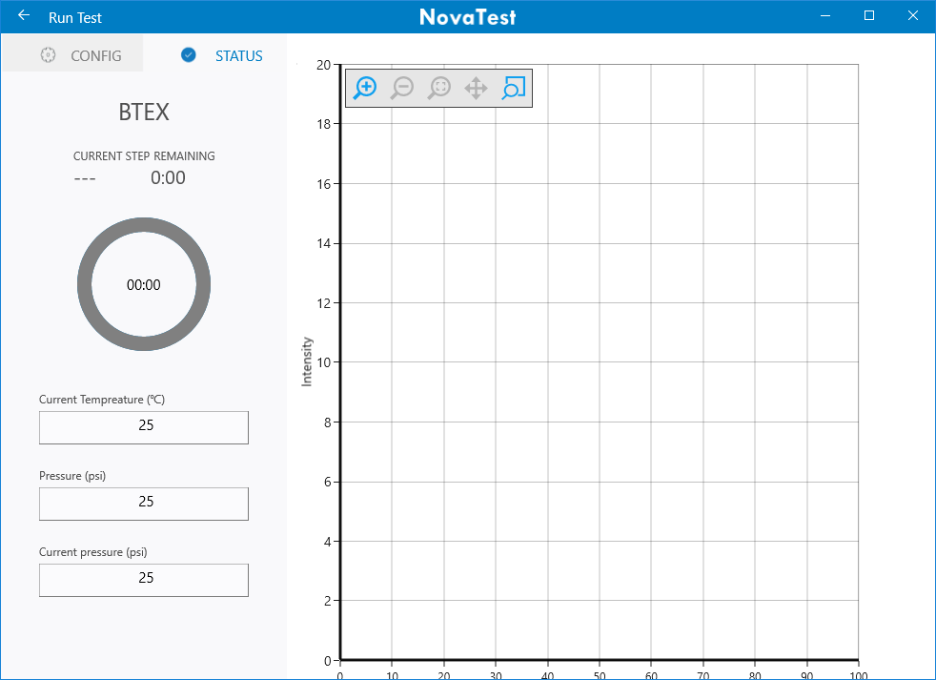

When test is finished, one data file will be created and named the same as the “experiment name”

1. Under the “**Data Analysis**” menu, the user can select certain data file to process the data:

When open a data file, a chromatogram will show.

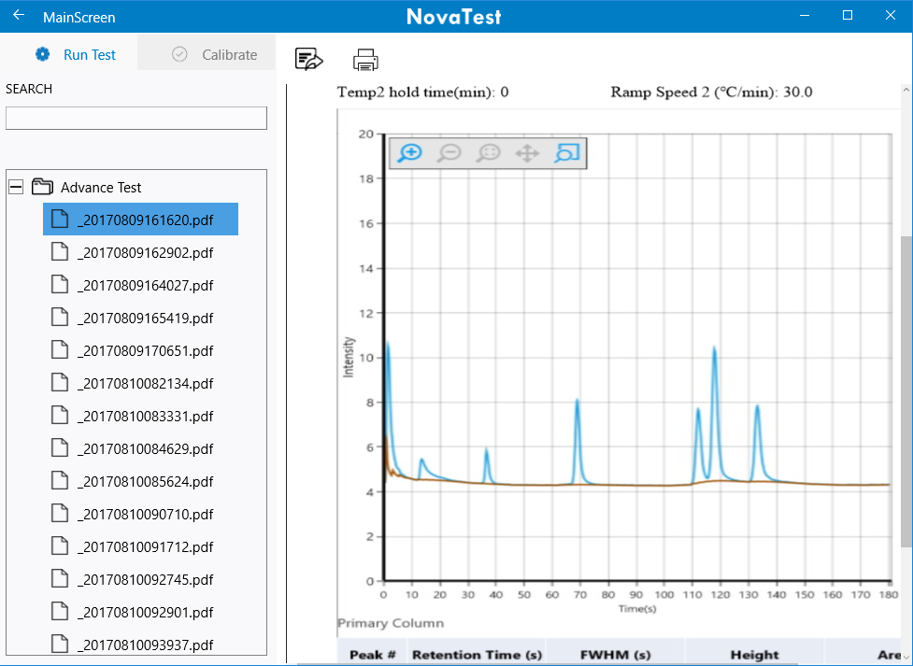

The user can use the following functions to process the data on the chromatogram:

1. Zoom in and zoom out
2. Back to original
3. Manually select peak, and then the software will integrate the select peak with user defined baseline.
4. Auto integrate peaks with height higher than certain value. The value can be adjusted by the user.
5. Change X range and show the graph
6. Change Y range and show the graph
7. Auto smoothing
8. Show the signal to noise ratio for selected peak to selected baseline

A table will show and the result in the table will change simultaneously when user process the data.

Here is a template for the table:

|  |  |  |  |  |  |  |  |  |
| --- | --- | --- | --- | --- | --- | --- | --- | --- |
| Peak # | Compound Name | Retention time, second | Peak area | Peak Height | FWHM | Calibration curve, R2 | Method detection limit | Concentration |
|  |  |  |  |  |  |  |  |  |
|  |  |  |  |  |  |  |  |  |
|  |  |  |  |  |  |  |  |  |
|  |  |  |  |  |  |  |  |  |
|  |  |  |  |  |  |  |  |  |

In the table, user can choose certain calibration curve and the concentration will be calculated.

After data processing, the user can select what result to show in the report file and save/save as the report file as certain name. This data file will be saved under the “**Report**” menu as two formats: one is pdf format; one is data file format which can be selected under the “Data Analysis” menu and re-analyzed if needed.

1. Under the “Report” menu:

There are two formats for each report: one is pdf format; one is data file format which can be selected under the “Data Analysis” menu and re-analyzed if needed.

Here is a Report template:



NovaTest Report

Experiment Name: Operator Name:

Date: 08/22/2017 6:00 pm

Method: Sampling/Pumping Time (min): Waiting Time (second):

Pressure (psi):

Lowest Temperature (ᵒC): Low Holding Time (min):

Temperature 1 (ᵒC): Temp 1 Holding Time (min)

Ramp Speed 1 (ᵒC/min) Temperature 2 (ᵒC):

Temp 2 Holding Time (min): Ramp Speed 2 (ᵒC/min):



|  |  |  |  |  |  |  |
| --- | --- | --- | --- | --- | --- | --- |
| Peak# | Compound | Retention Time(s) | FWHM(s) | Height | Area | Concentration(ppb) |
| 1 |  |  |  |  |  |  |
| 2 |  |  |  |  |  |  |
| 3 |  |  |  |  |  |  |
| 4 |  |  |  |  |  |  |
| 5 |  |  |  |  |  |  |