Continuous Development with Jenkins

|  |  |
| --- | --- |
|  | **Student** |
|  | Alexandru-Ionuț NIȚU |

Summary

1. Introducere 3

# Introduction

I build a simple C# banking application. The user can load money into their account, make a payment or transfer into another account. The form is presented in

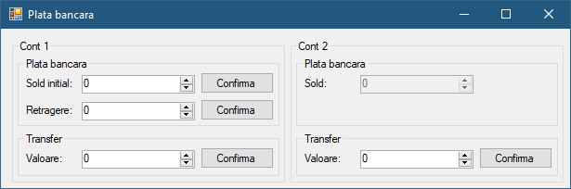

Figure 1 - Main form