(1)

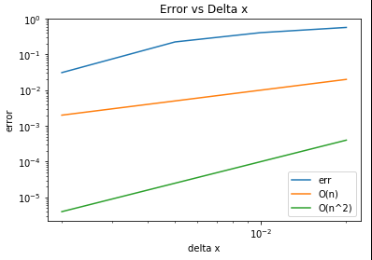

From the plot above, it is order O(n^2). Because when dx is small, the slope of log-log line is 2, same with the slope of log-log line for O(n^2).

(2)

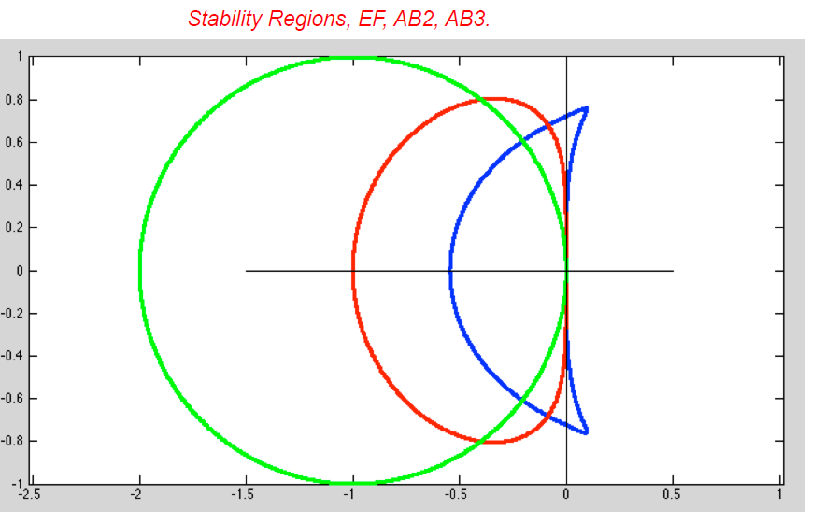

For centered difference method, the eigenvalue of matrix C is pure imaginary. Also, for AB3 method, the stability region curve encompasses part of the imaginary axis near the origin of λ\*dt plane (In the plot above). Specificity, in order to be stable, |λ\*dt| or CFL should be smaller than 0.72. Therefore, in the previous problem, it’s stable when CFL=0.7 and unstable when CFL=0.75.