Q1 part(a)

Number of missing value for each ETF close price:

SPY 0

XLB 0

XLE 0

XLF 0

XLI 0

XLK 0

XLP 0

XLU 0

XLV 0

XLY 0

dtype: int64

Q1 part(b)

annualized return of each ETF: {'SPY': 0.13539866663100142, 'XLB': 0.089006474895187537, 'XLE': 0.047695984914760237, 'XLF': 0.15920356408384473, 'XLI': 0.14559886800891708, 'XLK': 0.16066972916196764, 'XLP': 0.11437610907277018, 'XLU': 0.10548634498268949, 'XLV': 0.15065815208645184, 'XLY': 0.18492989550714212}

standard deviation of each ETF: {'SPY': 870.18853759980334, 'XLB': 156.10425095620278, 'XLE': 156.13339064532065, 'XLF': 104.57952539345307, 'XLI': 244.95878604244655, 'XLK': 231.5853703807216, 'XLP': 177.5638148365899, 'XLU': 156.88587610530806, 'XLV': 318.1423766420786, 'XLY': 375.78929350548128}

Q1 part(c)

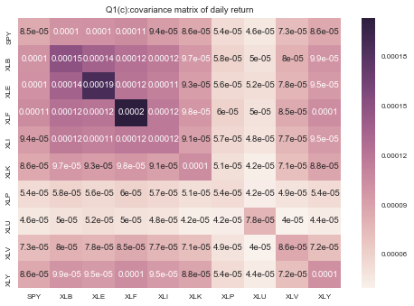

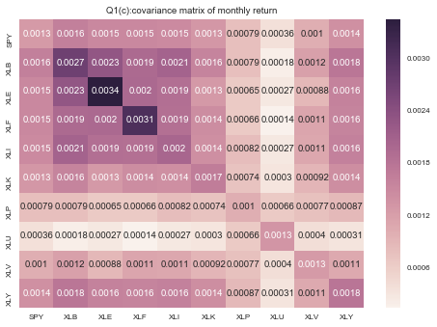

Covariance of monthly return is higher than daily return

Corr

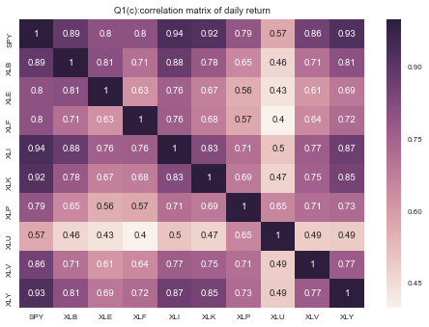

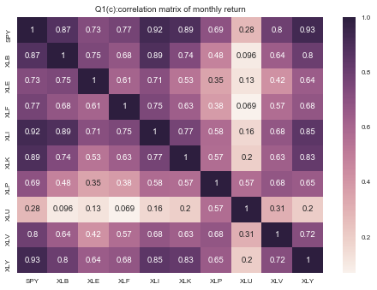

Q1 part(d)

Rolling correlation is unstable over time

In certain season, correlation varies significantly: like XLU and XLE, their correlation with S&P moves to negative value during the certain season of year

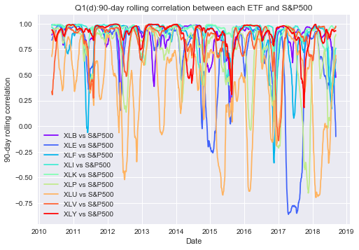

Q1part(e)

beta of each ETF for entire historical data: {'XLB': 1.1766264253262857, 'XLE': 1.1892980099695496, 'XLF': 1.2377935841668779, 'XLI': 1.1035312842736271, 'XLK': 1.0158988930516917, 'XLP': 0.63340048616270683, 'XLU': 0.54335915539990043, 'XLV': 0.86337208393927412, 'XLY': 1.0148531304079023}

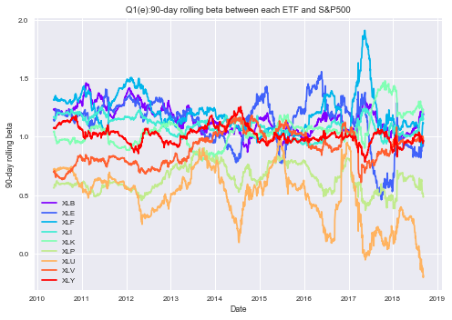

No intercept:

beta of each ETF for entire historical data: {'XLB': 0.6689090229755524, 'XLE': 0.540487377520036, 'XLF': 0.5175424489908945, 'XLI': 0.7967036376963401, 'XLK': 0.8327247768059536, 'XLP': 0.9900394604666714, 'XLU': 0.5933603657234907, 'XLV': 0.8506979028854421, 'XLY': 0.8434876591463598}



Rolling beta is unstable over time

Rolling beta and rolling correlation move together with time: like XLU, when correlation move to negative value, the beta become lower.

Q1 part(f)

alpha of each ETF by auto-correlation: {'SPY': -0.045399546648521902, 'XLB': -0.021568230857811749, 'XLE': -0.0063028944277838421, 'XLF': -0.080212288740883889, 'XLI': -0.018492128542731537, 'XLK': -0.0177075273354667, 'XLP': -0.04493567057112053, 'XLU': -0.040138406179640596, 'XLV': -0.044704633289618122, 'XLY': -0.025580080434976608}

The alphas of ETF are between -0.01 and -0.1, which means auto correlation is weak

Q2 part(a)

mean of terminal underlying value: 100.409921075

variance of terminal underlying value: 639.772068793

As mean is close to 100 and variance is close to 25^2, it's consistent with the assumption

Q2part(b) 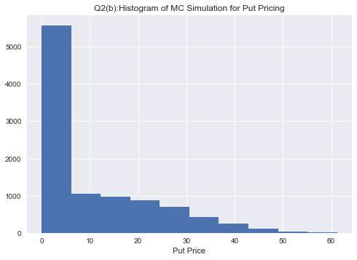

mean of put: 9.69847583183

standard deviation of put: 12.4396777084

Q2 part(c)

price of a European put option by taking the average discounted payoff across all path: 9.69847583183

Q2 part(d)

Put price by BS formula is: 9.94764496602

Put price by MC simulation is closed to the price by BS formula

Q2 part(e)

Price of a lookback put option by taking the average discounted payoff across all path: 17.448970371

Q2 part(f)

Premium that the buyer is charged for the extra optionality embedded in the lookback is: 7.7504945392

Premium is highest when the option contract starts and is lowest when it's at the maturity. It will never be negative since the buyer can choose the lowest underlying price.

Q2 part(g)

Europe Put with vary sigma: {0.1: 3.8936418195303868, 0.5: 19.645626510075154, 1.0: 38.348648322225735}

Lookback Put with vary sigma: {0.1: 7.1364840076655893, 0.5: 32.180566510918503, 1.0: 55.5226177085042}

Premium with vary sigma: {0.1: 3.2428421881352025, 0.5: 12.534940000843349, 1.0: 17.173969386278465}

When sigma increases from 0.1 to 1, Europe put price increases, lookback price increases and its premium increases as well