Question 1

(a)

Read data from ‘F-F_Research_Data_Factors_daily.CSV’ as dataframe.

Select the data from 2010.

Number of missing value for Fama-French factors data:

Mkt-RF: 0

SMB: 0

HML: 0

RF: 0

(b)

Covariance matrix for Fama-French factors:

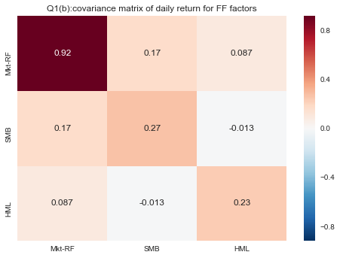

Correlation matrix for Fama-French factors:

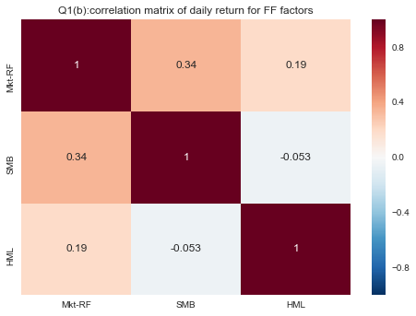

Correlation matrix for sector ETFs:

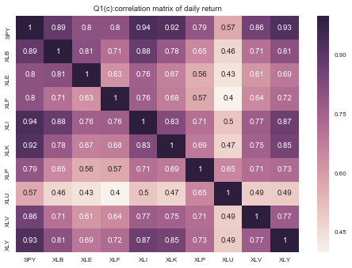

Correlation for Fama-French factors is not highly correlated and less than correlation for ETFs, since the factors in F-F model are more orthonormal.

(c)

90-day rolling correlation among Fama-French factors:

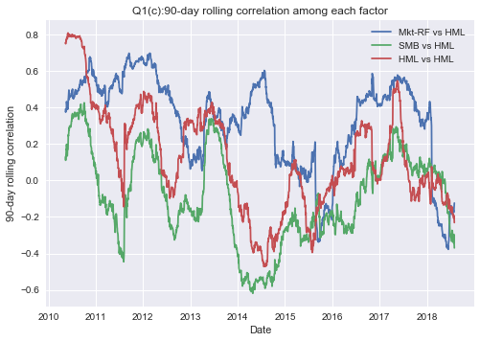

90-day rolling correlation between each ETF and S&P500:

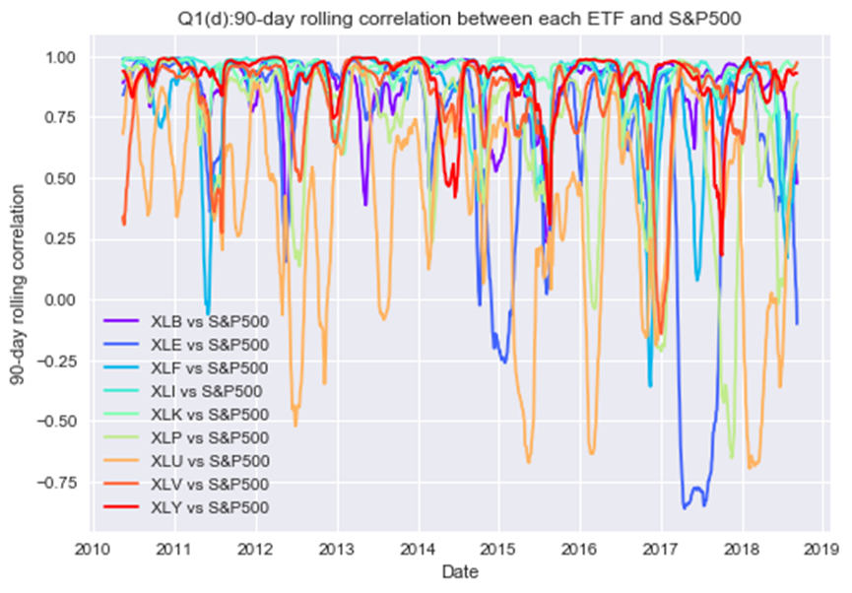

90-day rolling correlations among Fama-French factors are stable than 90-day rolling correlations between each ETF and S&P500

(d)

Perform the Kolmogorov-Smirnov test for goodness of normality.

H0: factor return follows normal distribution

p value for normality test of Mkt – Rf: 1.35106684365e-46, H0 is rejected

p value for normality test of SMB: 0.00195311401706, H0 is rejected

p value for normality test of HML: 9.97824856139e-10, H0 is rejected

Therefore, all three factors don’t follow normal distribution

(e)

Betas of entire historical data for each ETF

XLB : beta1 : 0.01111, beta2 : 0.00047, beta3 : 0.00237

XLE : beta1 : 0.01101, beta2 : -0.00010, beta3 : 0.00569

XLF : beta1 : 0.01129, beta2 : -0.00037, beta3 : 0.00804

XLI : beta1 : 0.01055, beta2 : 0.00007, beta3 : 0.00140

XLK : beta1 : 0.01047, beta2 : -0.00162, beta3 : -0.00392

XLP : beta1 : 0.00672, beta2 : -0.00329, beta3 : -0.00152

XLU : beta1 : 0.00566, beta2 : -0.00320, beta3 : -0.00011

XLV : beta1 : 0.00903, beta2 : -0.00196, beta3 : -0.00403

XLY : beta1 : 0.01006, beta2 : -0.00022, beta3 : -0.00176

90-day rolling **beta1** between each ETF and Fama-French Factors:

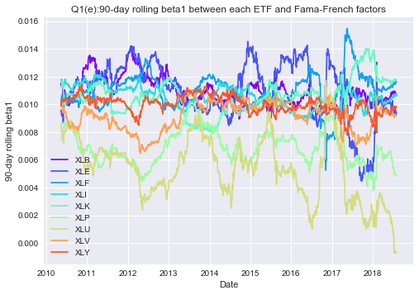

90-day rolling **beta2** between each ETF and Fama-French Factors:

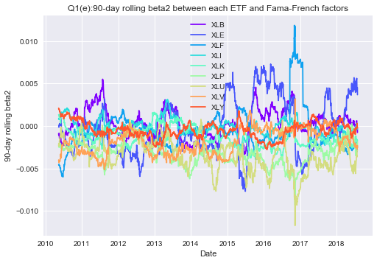

90-day rolling **beta3** between each ETF and Fama-French Factors:

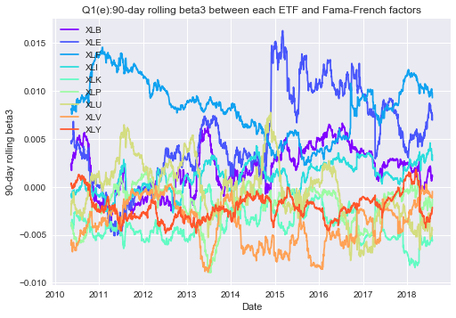

90-day rolling beta between each ETF and S&P500

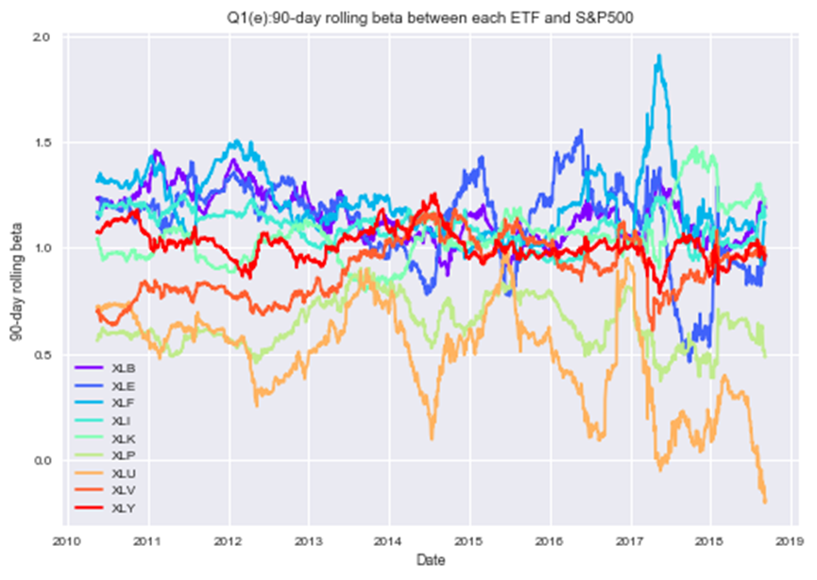

Compare 3 betas of Fama-French model with beta in CAPM model in HW1, it seems that betas in F-F model are more consistent, especially for beta2.

(f)

mean and variance of residual for each ETF F-F model

XLB : mean: -3.00503279303e-19 var: 2.94856140414e-05

XLE : mean: -7.71345315858e-20 var: 5.87796601035e-05

XLF : mean: -1.28557552643e-19 var: 5.85859299785e-05

XLI : mean: -2.79612676999e-19 var: 1.31481650989e-05

XLK : mean: -2.44259350022e-19 var: 1.27262694491e-05

XLP : mean: 7.71345315858e-20 var: 1.90090641581e-05

XLU : mean: 3.69602963849e-20 var: 5.22157504038e-05

XLV : mean: -7.07066539537e-20 var: 2.00544628593e-05

XLY : mean: -4.82090822411e-20 var: 1.31486203109e-05

QQ plot for residuals of each ETF F-F model

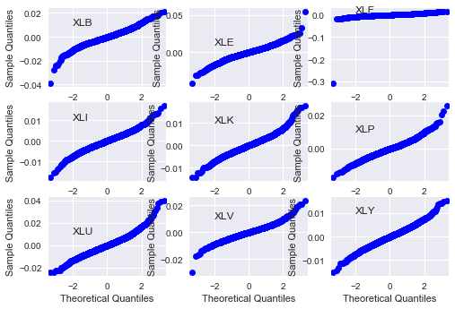

By QQ plot, these lines skew a lot, which means the residuals are not normal and model is not appropriate.

Also, by Kolmogorov-Smirnov test for residuals

XLB : p-value: 3.68975082099e-08

XLE : p-value: 2.29752145554e-10

XLF : p-value: 1.84555903204e-195

XLI : p-value: 7.84779589286e-05

XLK : p-value: 1.69217040983e-06

XLP : p-value: 3.10160370307e-08

XLU : p-value: 6.61089130071e-09

XLV : p-value: 3.61528409859e-08

XLY : p-value: 0.00502141493127

It means residuals are not normal and models are not appropriate.

Question 2

(b)

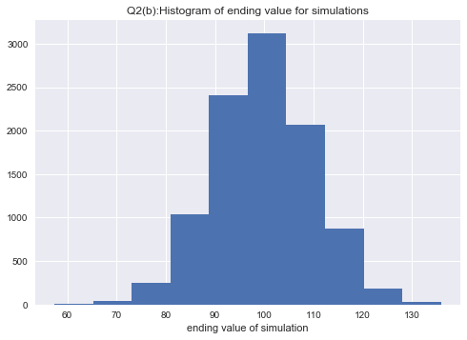

By histogram, ending values follow the normal distribution.

Also, p value of Kolmogorov-Smirnov test for ending value of simulations: 0.2551, which means H0 (value follow normal distribution) is not rejected.

(c)

Lookback put option price with strike 100 under the Bachelier model is 7.4585, which is less than put price by BS formula in HW1

(d)

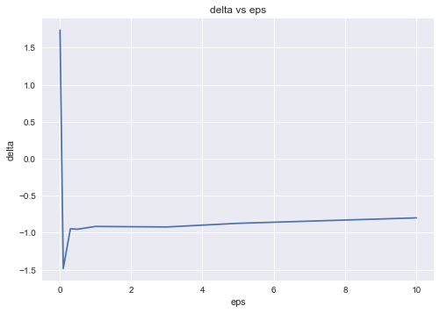

When eps is small, smaller or equal to 0.1, the approximate delta is far away from the [-1,0] and has large error. Because the effect on put price by small eps is less than the volatility of simulation.

When eps is around 0.5 - 1, I believe the approximation is optimum.

When eps increase from 1, the delta will keep increasing.