(b)

ACF plot:

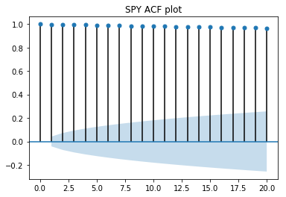

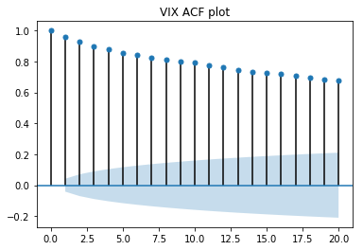

By ACF plot, the autocorrelation of SPY and VIX price is significantly high and it’s not a stationary data. And, SPY has a higher autocorrelation than VIX. When number of lags is low, autocorrelation is higher.

(c)

daily correlation between SPY and VIX is -0.56

daily correlation between SPY and VIX is -0.61

S&P 500 price has a significant negative relationship with implied volatility on daily and monthly basis. When implied volatility is high, which implies price will go down later, people are afraid of decreasing of market price. And people are more willing to hedge risk by buying options, therefore option price will increase. In another view, by BS formula, option price is higher when sigma is higher. Therefore, implied volatility has a positive relationship with option price.

(d)

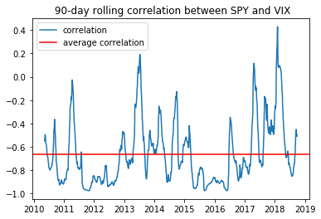

When in year 2018, correlation deviate most from its long run average.

(e)

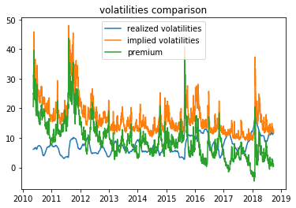

Premium is generally positive.

When: 2018-01-26 00:00:00 premium has the minimum value: -4.60020234569

When: 2011-08-08 00:00:00 premium has the maximum value: 43.6589327527

(f)

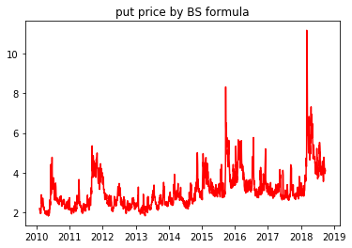

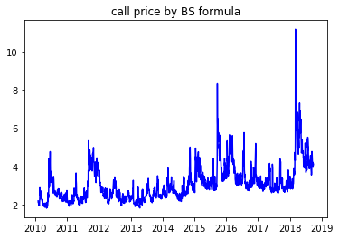

(g)

average P&L is: -1.62

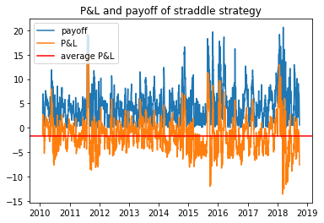

(g)

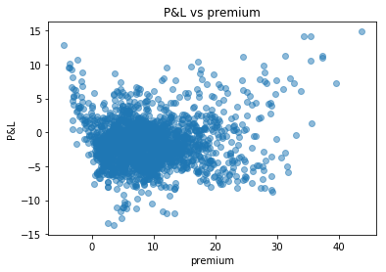

correlation between P&L and premium is:0.07

I believe that there is no strong relationship between P&L and premium in general. When premium is high, P&L and premium may have a positive relationship, which means there is more profit of straddle strategy caused by higher implied volatility.