(a)

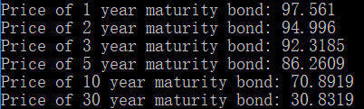

Price of 1-year maturity bond is the highest. It’s reasonable since the longer the time to maturity, the higher the interest rate tends to be, and price of bond should be lower.

(b)

By approximated Macauly duration formula:

$$Approximate Macauly Duration= \frac{P_{-}-P_{+}}{2×P_{0}×∆Yield}(1+Yield)$$

And I set $∆Yield$ as 0.001.

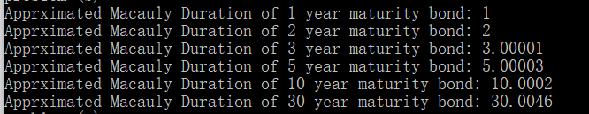

For zero coupon bond, duration is equal to the maturity of bond.

Price has a negative relationship with bond yields.

(c)

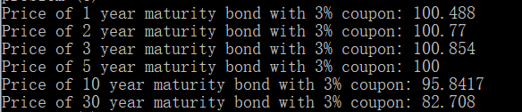

If yield is smaller than coupon rate (3%), that are 1-year, 2-year, 3-year maturity bond, prices are below 100.

If yield is equal to coupon rate (3%), that is 5-year maturity bond, price is equal to 100.

If yield is above coupon rate (3%), that are 10-year, 30-year maturity bond, prices are above 100.

Bond price has a negative relationship with yield to maturity. A bond will trade at a premium when it offers a coupon (interest) rate that is higher than the current interest rate. It will trade at a discount when it offers a coupon rate that is lower than current interest rates. When coupon rate is equal to interest rate, it will trade at a par value.

(d)

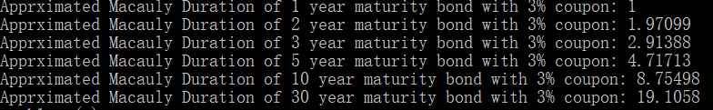

Same approximated Macauly duration formula and $∆Yield$ as part(b)

Bond with coupon has a lower duration compared with zero coupon bond. When a coupon is added to the bond, sensitivity of bond price over yield decrease and the bond's duration will always be less than the maturity date. The larger the coupon, the shorter the duration becomes.

(e)

By approximated convexity formula:

$$Approximate Convexity = \frac{P_{-}+P_{+ }- {2×P}_{0}}{P_{0}×{(∆Yield)}^{2}}$$

And I set $∆Yield$ as 0.001.

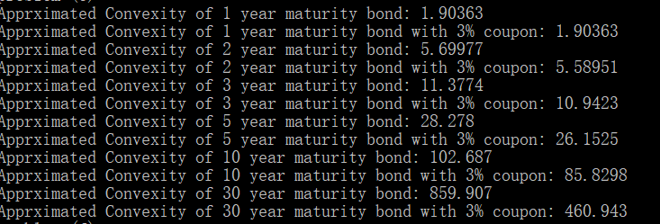

These convexities are positive.

(f)



(g)



Convexity is negative, and its absolute value is higher than duration

(h)



(i)



I may not want to own this portfolio since its value is lower

(j)

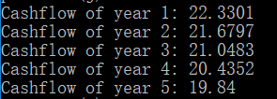

(k)



Amortizing bond’s price is higher than (zero) coupon bond and its duration is lower than (zero) coupon bond.

The primary advantage of amortized bond is that with each payment, the borrower builds equity in the asset. After the final payment, the borrower owns the asset. If the loan has a fixed interest rate, the borrower’s payment amount never varies. The main disadvantage is that the monthly payments can be high since both principal and interest are paid. If the amortized bond has a high interest rate and interest rates drop, the borrower is stuck with an excessively high rate.