(a)(b)(c)

1 year forward rate is: 0.02864

2 year forward rate is: 0.03303

3 year forward rate is: 0.03285

4 year forward rate is: 0.03224

5 year forward rate is: 0.03199

7 year forward rate is: 0.03242

10 year forward rate is: 0.03333

30 year forward rate is: 0.03277

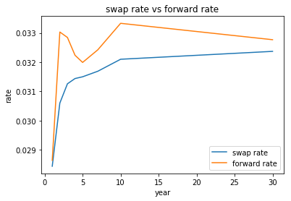

Forward rate and swap rate increase when year increase and forward rate is higher than swap rate.

(d)

breakeven swap rate of 15 year swap is: 0.03223

(e)

1 year zero rate is: 0.02864

2 year zero rate is: 0.03083

3 year zero rate is: 0.0315

4 year zero rate is: 0.03169

5 year zero rate is: 0.03175

7 year zero rate is: 0.03194

10 year zero rate is: 0.03236

30 year zero rate is: 0.03263

1 year discount factor is: 0.97216

2 year discount factor is: 0.94107

3 year discount factor is: 0.91114

4 year discount factor is: 0.88269

5 year discount factor is: 0.85533

7 year discount factor is: 0.80245

10 year discount factor is: 0.72727

30 year discount factor is: 0.38162

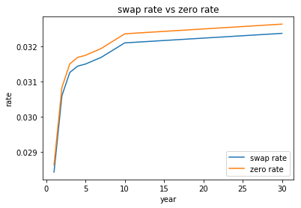

Zero rate and swap rate increase when year increase and Zero rate is higher than swap rate.

(f)

1 year breakeven swap rate is: 0.03827

2 year breakeven swap rate is: 0.04043

3 year breakeven swap rate is: 0.04108

4 year breakeven swap rate is: 0.04126

5 year breakeven swap rate is: 0.04132

7 year breakeven swap rate is: 0.04151

10 year breakeven swap rate is: 0.04192

30 year breakeven swap rate is: 0.04219

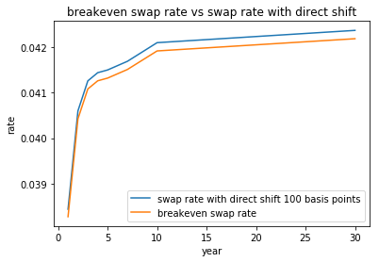

Shift forward rate by 100 basis points, these breakeven swap rates don’t shift directly. They have less shift than direct shift 100 basis points.

(g)

1 year bear swap rate is: 0.02844

2 year bear swap rate is: 0.0306

3 year bear swap rate is: 0.03126

4 year bear swap rate is: 0.03194

5 year bear swap rate is: 0.0325

7 year bear swap rate is: 0.03319

10 year bear swap rate is: 0.0346

30 year bear swap rate is: 0.03737

(h)

1 year bear forward rate is: 0.02864

2 year bear forward rate is: 0.03303

3 year bear forward rate is: 0.03285

4 year bear forward rate is: 0.03427

5 year bear forward rate is: 0.03504

7 year bear forward rate is: 0.03522

10 year bear forward rate is: 0.03825

30 year bear forward rate is: 0.03913

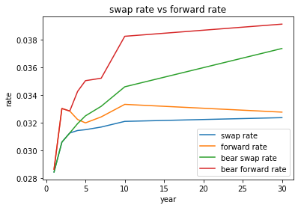

With a bearish steepener, forward rate curves shift up with a large degree when swap rate increase.

(i)

1 year bull swap rate is: 0.02344

2 year bull swap rate is: 0.0281

3 year bull swap rate is: 0.02976

4 year bull swap rate is: 0.03044

5 year bull swap rate is: 0.031

7 year bull swap rate is: 0.03169

10 year bull swap rate is: 0.0321

30 year bull swap rate is: 0.03237

(j)

1 year bull forward rate is: 0.02358

2 year bull forward rate is: 0.03304

3 year bull forward rate is: 0.03336

4 year bull forward rate is: 0.03275

5 year bull forward rate is: 0.03352

7 year bull forward rate is: 0.0337

10 year bull forward rate is: 0.03333

30 year bull forward rate is: 0.03277

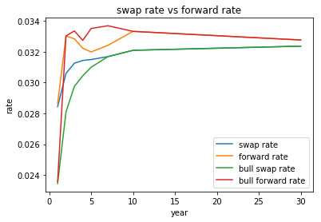 With a bull steepener, forward rate curves shift up a bit when swap rate decreases.