1.

(b)

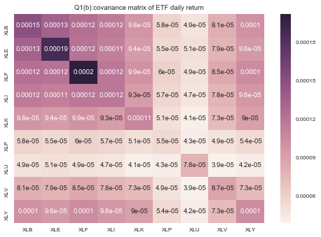

(c)

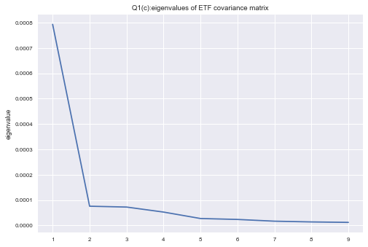

All of eigenvalues are positive. But, 8 out of 9 eigenvalues are smaller that 0.0001, which are very closed to 0 and not statistically significant. Only the largest eigenvalue is significant.

(d)

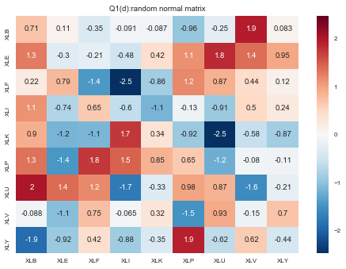

(e)

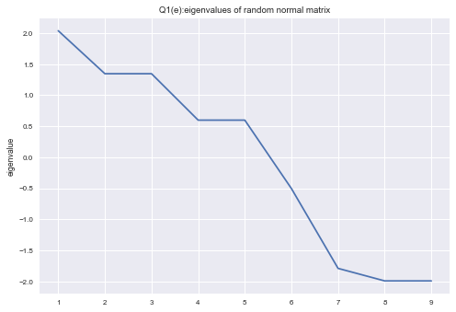

For eigenvalues of random matrix, 5 out of 9 are positive and 4 out of 9 are negative. Compared with eigenvalues from historical covariance matrix, eigenvalues from random matrix distribute more smoothly.

2.

(a)

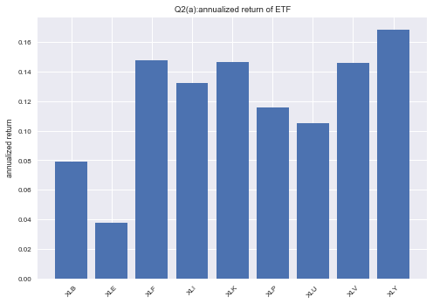

(b)

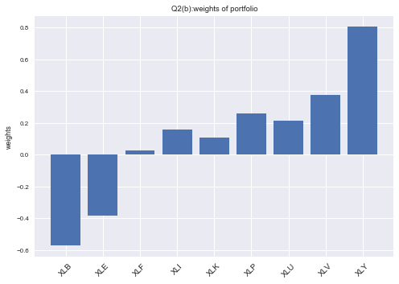

(c)

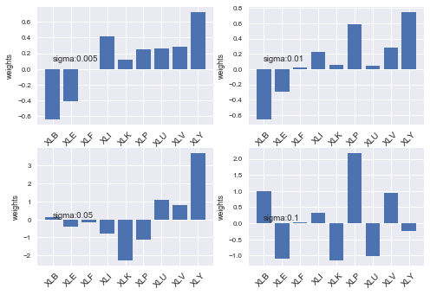

When sigma increase, weights change significantly, which is unstable.

(e)

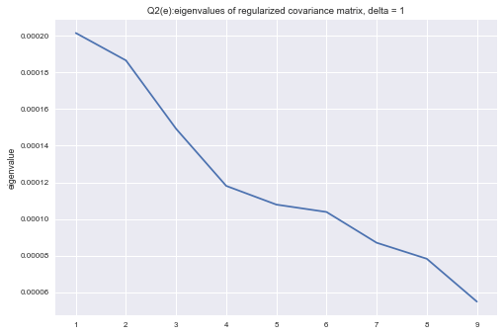

Since regularized covariance matrix is diagonal matrix, its rank is 9.

(f)

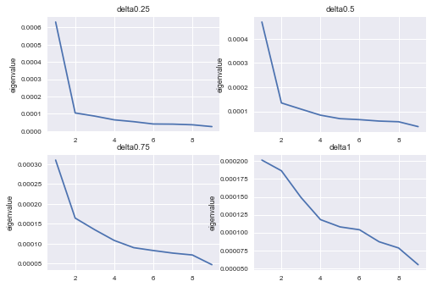

When delta change from 0.25 to 1, all eigenvalues are still positive for each delta. But, when delta increase, eigenvalues distribute more smoothly, like eigenvalues from random normal matrix. And, more eigenvalues are higher than 0.0001 (more significant), compared with eigenvalues from low delta regularized covariance matrix.

(g)

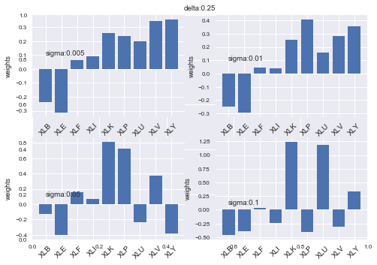

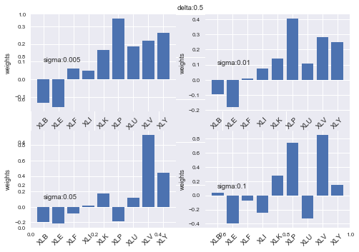

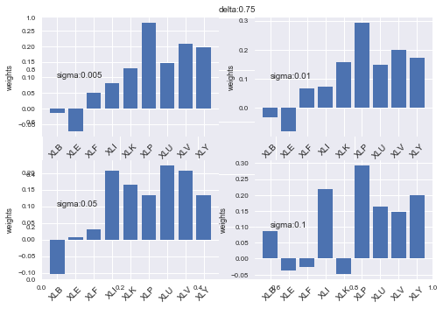

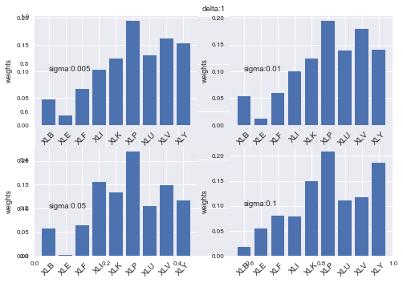

When delta increase, weights are more stable if sigma change. Especially, when delta is 0 in part c, regularized matrix is just historical covariance matrix and weights are the most unstable for sigma’s change. When delta is 1, regularized matrix is diagonal matrix and weights are the most stable for sigma’s change.