Reliability-Bounded Selective Vision-Language Reasoning
for Industrial Anomaly Detection
Integrated Final Draft of SRB-QCR

Anonymous Author(s)
Affiliation: [To be completed]
E-mail: [To be completed]
Target venue: [To be determined]
Integrated draft date: 26 July 2026

Draft status | INTEGRATED FINAL DRAFT — Experimental evidence through Stage 23-C2 is incorporated. Author identity, affiliation, target-venue formatting, and final bibliography style remain author-supplied.

Abstract
Industrial anomaly detectors provide strong localization and image-level evidence, whereas vision-language models (VLMs) offer complementary semantic cues. However, direct detector-VLM fusion is unreliable: a crop may be poorly localized, and a VLM score may conflict with a strong detector. This paper introduces SRB-QCR, a reliability-bounded selective extension of quality-calibrated reasoning. A detector first produces an anomaly score and top-k candidate regions. Candidate quality controls a pre-gate, and detector-VLM agreement continuously attenuates the maximum fusion weight. When the gate is closed, the final score is exactly the detector score, enabling a strict safe fallback and skipping the VLM call in deployment. The configuration is selected using VisA PatchCore category leave-one-out validation and then frozen for transfer. Under the VisA QCR protocol, candidate quality calibration improves mean AUROC from 0.9652 for naive fusion to 0.9748; adaptive consistency adds only 0.0004, confirming that quality is the primary effective component. On all 15 MVTec AD categories, frozen SRB-QCR reaches a macro image AUROC of 0.98848. It is non-inferior to the detector within a predeclared 0.002 tolerance, while outperforming naive fusion by 0.04485 and old Quality-QCR by 0.03761; both improvements have bootstrap confidence intervals fully above zero. Actual selective execution skips 431 of 1,725 VLM calls (24.99%), reduces median wall-clock time by 21.21%, and achieves 1.269× median speedup while reproducing offline scores to numerical precision. These results position SRB-QCR as a detector-preserving and deployable mechanism for selective vision-language augmentation rather than a replacement for industrial anomaly detectors. On the AD2 four-category transfer, SRB-QCR improves macro AUROC over the detector by 0.0086 with 3/4 category wins. Actual selective execution reduces 243 calls to 182 (25.10%) and median time from 287.431 s to 240.746 s (18.95%), yielding 1.234× speedup.
Keywords: industrial anomaly detection; vision-language model; selective inference; reliability calibration; safe fallback; PatchCore; CLIP

Table of Contents
1. Introduction
2. Related Work
3. Problem Formulation and Design Goals
4. Proposed Method: SRB-QCR
5. Experimental Setup
6. Experimental Results
7. Efficiency and Deployment Analysis
8. Qualitative and Failure-Boundary Analysis
9. Discussion
10. Limitations
11. Conclusion
Declarations
References
Appendices A-E

List of Figures and Tables
- Figure 1. Overview of SRB-QCR.
- Figure 2. Experimental development and frozen-transfer protocol.
- Figure 3. Macro AUROC comparison on MVTec AD 15 classes.
- Figure 4. Measured full-versus-selective runtime.
- Figure 5. Four representative reliability-boundary cases.
- Figure 6. Measured full-versus-selective runtime on the AD2 four-category protocol.
- Figure A1. Full eight-case qualitative audit grid.
- Table 1. Notation and design roles.
- Table 2. Dataset roles and transfer protocol.
- Table 3. System-level baseline comparison.
- Table 4. QCR primary-protocol ablation.
- Table 5. Robustness of quality and consistency components.
- Table 6. AD2 AnomalyCLIP comparison.
- Table 7. MVTec AD frozen-transfer results.
- Table 8. Bootstrap and non-inferiority analysis.
- Table 9. Actual selective runtime.
- Table 10. AD2 actual selective runtime.
- Appendix tables: reproducibility and claim boundaries.

1. Introduction
Industrial visual anomaly detection aims to identify defects using predominantly normal training data. Modern feature-memory, flow-based, and teacher-student detectors have achieved strong localization and image-level recognition on benchmarks such as MVTec AD and VisA [1–5]. Their strength lies in distributional modeling and local feature comparison. Nevertheless, detector scores are typically not expressed in semantic terms, and they do not directly reason about whether a localized pattern resembles a crack, contamination, scratch, missing part, or another human-interpretable abnormal state.
Vision-language models provide a complementary capability. CLIP-style pretraining aligns images and natural-language descriptions in a shared representation space [6], motivating anomaly-detection methods such as WinCLIP and AnomalyCLIP [7,8]. Yet industrial anomalies are often small relative to the full image. Full-image VLM inference can therefore be dominated by object identity, background, texture, or acquisition conditions rather than by the local defect. Detector-guided candidate crops improve focus, but this change creates a new reliability question: not every candidate crop is trustworthy, and not every VLM score should influence a strong detector.
Our experiments expose the severity of this problem. In early localization-guided reasoning tests, candidate crops substantially improved VLM anomaly reasoning over full-image inference. However, once the VLM branch was fused with a detector, naive score averaging was not consistently safe. On the complete 15-class MVTec AD transfer, naive detector-crop fusion reduced macro AUROC from 0.98821 for PatchCore to 0.94363. Old quality-weighted fusion recovered part of the loss but remained at 0.95087. These findings motivate a method whose primary objective is not unconstrained score maximization, but reliability-bounded augmentation: VLM evidence should be used only when the candidate and the cross-modal evidence are sufficiently trustworthy, and otherwise the system must preserve the detector exactly.
We introduce SRB-QCR, a selective reliability-bounded extension of Quality-Calibrated QCR. The detector provides an image-level anomaly score, an anomaly map, and top-k candidate regions. Candidate quality forms a pre-gate, while detector-VLM agreement continuously modulates the fusion weight. The final score is a convex movement from the detector score toward the VLM score. Crucially, when the pre-gate is closed the weight is zero and the output is exactly the original detector score. This mechanism creates both a reliability boundary and an execution boundary: rejected images do not require a VLM call during selective deployment.
To avoid target-set overfitting, we select the configuration using category leave-one-out validation on VisA with PatchCore, then freeze the maximum fusion weight, quality quantile, and agreement scale. The same configuration is transferred to VisA FastFlow, an AD2 four-category protocol, and the full 15-category MVTec AD benchmark without using target labels for parameter selection. The strongest external validation is MVTec AD, where SRB-QCR is non-inferior to the detector under a predeclared 0.002 tolerance, while significantly outperforming naive fusion and old Quality-QCR. A measured runtime experiment further confirms that selective execution reduces VLM calls and wall-clock time without changing scores.

1.1 Contributions
- We formulate detector-guided VLM augmentation as a reliability-bounded selective inference problem. The formulation explicitly separates candidate validity, cross-modal agreement, fusion, and safe fallback.
- We propose SRB-QCR, which combines an unlabeled candidate-quality gate with a bounded agreement-modulated weight. The detector score is strictly preserved when the gate is closed.
- We provide a multi-stage evidence chain covering VisA development, cross-backbone transfer, AD2 transfer, full MVTec AD 15-class frozen transfer, bootstrap analysis, and measured runtime.
- We demonstrate deployable efficiency: 431 of 1,725 VLM calls are skipped, median wall-clock time is reduced by 21.21%, and output scores are reproduced to numerical precision.
- We document both successful and failed gate behavior, and explicitly constrain the claims to image-level recognition and candidate-level evidence calibration.

1.2 Scope and paper organization
The method is intended to augment, not replace, a strong anomaly detector. It does not claim pixel-level segmentation state of the art or general causal explanation of manufacturing defects. Section 2 reviews related work; Sections 3 and 4 define the problem and method; Section 5 specifies the frozen experimental protocol; Sections 6–8 present effectiveness, efficiency, and qualitative boundaries; Sections 9–11 discuss implications, limitations, and conclusions. Detailed reproducibility and claim-boundary material is provided in the appendices.

2. Related Work

2.1 Industrial anomaly detection
Industrial anomaly detection has progressed from reconstruction-based methods to discriminative, feature-memory, flow-based, and teacher-student approaches. MVTec AD established a widely used real-world benchmark [1], while VisA expanded category and image diversity [2]. PatchCore stores representative normal patch features and performs nearest-neighbor anomaly scoring [3]. FastFlow models normal feature distributions with 2-D normalizing flows [4]. EfficientAD emphasizes fast and accurate teacher-student detection [5]. DRAEM and reverse distillation provide additional reconstruction-discrimination and one-class transfer perspectives [9,10].
Our work treats these detectors as localization and confidence providers. The contribution is not a new pixel-level detector backbone. Instead, detector anomaly maps define where a VLM should look, and detector scores anchor the final output. This distinction is important because replacing the detector would remove the strong safety reference that enables strict fallback.

2.2 Vision-language anomaly detection
CLIP learns transferable visual representations from natural-language supervision [6]. WinCLIP adapts CLIP features and prompt ensembles for zero-/few-shot anomaly classification and segmentation [7], and AnomalyCLIP learns object-agnostic normal and abnormal prompts [8]. These works demonstrate that language-conditioned features can recognize anomalous states across objects.
SRB-QCR addresses a narrower and complementary problem. It does not claim to outperform all dedicated VLM anomaly detectors. Instead, it studies when detector-guided crop evidence should be allowed to alter a strong detector score. Full-image, crop-only, WinCLIP, and AnomalyCLIP results are included as protocol-specific baselines, while the central comparisons are detector-only, naive detector-crop fusion, old Quality-QCR, and SRB-QCR.

2.3 Reliability calibration and selective prediction
Conventional score fusion often assumes comparable and equally reliable modalities. In industrial imagery this assumption is fragile: the detector can be near-certain while the VLM is distracted by texture, or the detector can be uncertain while a localized crop provides useful semantic evidence. Selective prediction offers a natural principle: perform an expensive or risky operation only when a confidence criterion is satisfied.
SRB-QCR differs from a hard reject-only classifier because the detector remains active for every image. The gate controls the auxiliary VLM branch, not whether a prediction is produced. The method thus combines three desirable properties: every image receives a detector score; the VLM call can be skipped; and any accepted VLM evidence is bounded by both quality and agreement.

2.4 Relation to our earlier Quality-QCR
The earlier Quality-Calibrated QCR formulation established that candidate quality is a useful reliability signal for crop-based VLM evidence. Its quality-weighted score improves over naive fusion under the VisA primary protocol. However, it always evaluates the VLM and does not guarantee strict detector preservation. Fixed consistency terms can also improve peak AUROC but are unstable across categories.
The present work advances that formulation in three ways: a pre-gate enables actual selective execution, agreement produces a bounded interpolation instead of an additive bonus, and gate-off cases exactly recover the detector score. The resulting SRB-QCR objective is therefore detector-preserving and deployment-oriented.

3. Problem Formulation and Design Goals
Let x denote a test image and y ∈ {0,1} its unknown normal/anomaly label. A pretrained unsupervised anomaly detector produces an image-level anomaly score D_raw(x), an anomaly map H(x), and candidate regions R(x) = {r1,…,rk}. A VLM compares each crop with normal and abnormal text descriptions, yielding a crop margin. All method decisions must be made without using the target label y.

3.1 Notation
Symbol | Meaning | Range / role
D | Normalized detector anomaly score | [0,1], always available
M | Normalized crop-based VLM anomaly score | [0,1], available only when VLM is evaluated
Q | Normalized candidate quality | [0,1], unlabeled reliability proxy
τq | Target quality threshold | Unlabeled 25th percentile
A | Detector-VLM agreement | [0,1]
Gpre | Selective pre-gate | {0,1}
wmax | Maximum VLM interpolation weight | 0.35
w | Actual per-image VLM weight | [0,wmax]
S | Final SRB-QCR anomaly score | Detector-preserving output

3.2 Design requirements
- Detector preservation: if auxiliary evidence is rejected, the output must equal D exactly rather than a separately calibrated approximation.
- Target-label-free transfer: target labels may be used only for final evaluation, not for threshold or hyperparameter selection.
- Bounded influence: accepted VLM evidence must never receive an unbounded or dominant weight.
- Actual selectivity: the gate must be computable before running the VLM so that rejected calls can be skipped.
- Auditability: each score component, gate state, and weight should be logged for failure analysis.
Core distinction
SRB-QCR is not a new anomaly detector. It is a selective reliability layer placed between a detector and a crop-based VLM branch.

4. Proposed Method: SRB-QCR
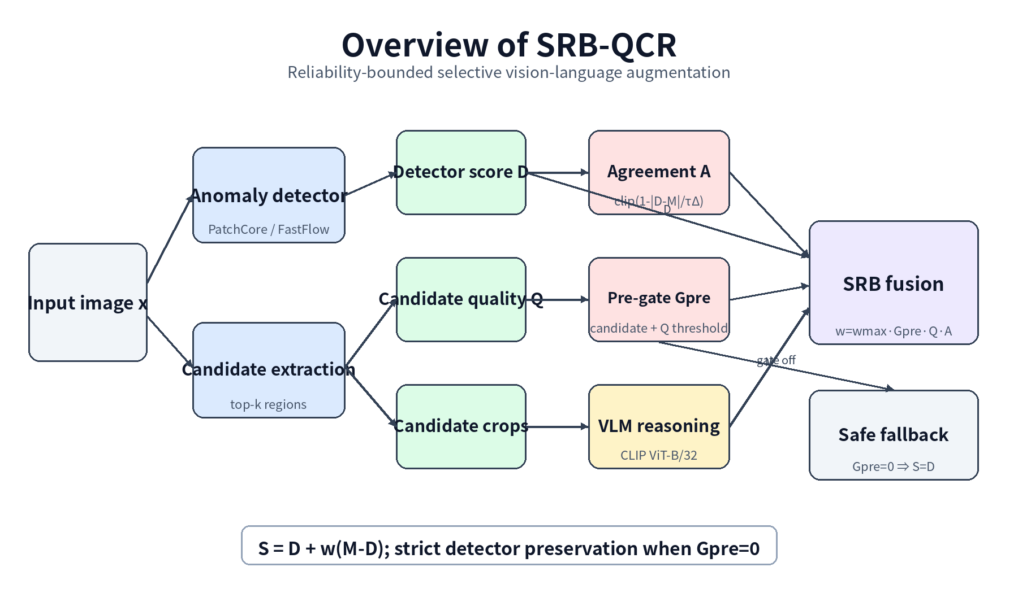
Figure 1. Overview of SRB-QCR.
The method has two stages. A cheap detector stage produces D, H, candidate boxes, and Q. A selective stage evaluates the VLM only for images passing a quality-based pre-gate. Agreement is computed after M is available and attenuates the interpolation weight. The computation is intentionally asymmetric: the detector is always trusted as the fallback anchor, whereas the VLM is optional.

4.1 Detector-guided candidate extraction
PatchCore or FastFlow is trained using normal data. For each test image, the anomaly map is normalized and thresholded to form connected components. The MVTec 15-class protocol uses the per-image 97th percentile of the normalized map, retains at most three components, and removes components smaller than 20 map pixels. Candidate extraction never reads the ground-truth mask or test label. Coordinates are transformed into the original-image space for crop construction.
This top-k formulation is important because a single largest component can be unstable on textured surfaces. Multiple candidate crops provide limited spatial diversity while keeping VLM cost bounded. In crop-top-k ensemble inference, each crop is scored independently and the most anomalous margin is used as M_raw.

4.2 Candidate quality calibration
Candidate quality Q represents whether the detector-proposed crop is suitable for semantic evaluation. In the original VisA QCR pipeline, a cached candidate_quality_norm field is used. For the newly rerun MVTec pipeline, the quality adapter was frozen before metrics were computed: a direct quality column is preferred; otherwise the maximum candidate_score_mean across an image’s candidate regions is used and min-max normalized within category. This adapter uses no target labels.
Q(x) = Normalize_c( max_r mean_score(r) ) (1)
A target quality threshold τq is obtained from the 25th percentile of eligible unlabeled target quality values. The quantile level, rather than the numeric threshold, is transferred. This allows the same policy to accommodate detector-score scale changes without supervised target tuning.

4.3 Crop-based vision-language score
CLIP ViT-B/32 encodes each candidate crop and two prompt groups describing normal and abnormal states. Prompt embeddings are averaged within each group. For candidate r, the raw anomaly margin is the abnormal similarity minus the normal similarity. The image-level crop score is the maximum margin over the retained candidates.
m(r) = sim(f_v(r), f_t(abnormal)) − sim(f_v(r), f_t(normal)) (2)
M_raw(x) = max_{r ∈ R(x)} m(r), M = Normalize_c(M_raw) (3)

4.4 From Quality-QCR to selective reliability bounds
The old quality-calibrated core uses Q to attenuate VLM evidence but still evaluates the VLM for every image:
S_quality = 0.5D + 0.5M(0.5 + 0.5Q) (4)
The adaptive variant adds a small consistency-gated bonus. VisA ablation shows that this term contributes only +0.0004 mean AUROC beyond the quality core, while a fixed quality-plus-consistency score can be unstable. SRB-QCR therefore changes the mathematical role of agreement: agreement does not add a new score; it limits how far the output may move away from D.

4.5 Selective pre-gate
G_pre = I(candidate exists) · I(not fallback) · I(Q ≥ τ_q) (5)
The pre-gate is computable before the VLM branch. In the actual runtime implementation, an image with G_pre=0 is not sent to CLIP. For retrospective audits, an M value may still be displayed from a separate full-inference run, but it is not available or used during selective deployment.

4.6 Agreement-bounded interpolation
A = clip(1 − |D − M| / τ_Δ, 0, 1) (6)
w = clip(w_max · G_pre · Q · A, 0, w_max) (7)
S_SRB = D + w(M − D) (8)
The frozen configuration is wmax=0.35, q-quantile=0.25, and τΔ=0.75. Because w≤0.35, the VLM cannot dominate the detector. If D and M disagree strongly, A approaches zero. If Q is low, the pre-gate closes or the weight is small. The interpolation is monotonic between D and M and is therefore easier to audit than an unrestricted additive fusion.
The strict fallback follows directly: G_pre=0 ⇒ w=0 ⇒ S_SRB=D. This identity is both the reliability guarantee used in the paper and the mechanism that enables actual call skipping.

4.7 Computational complexity and logging
Detector inference and candidate extraction are performed for every image. VLM cost is incurred only on the fraction ρ=E[Gpre]. If detector cost is Cd and per-image VLM cost is Cv, the expected selective cost is Cd+ρCv rather than Cd+Cv. The method records D, Q, gate state, M when available, A, w, and S, enabling complete image-level audits.

5. Experimental Setup
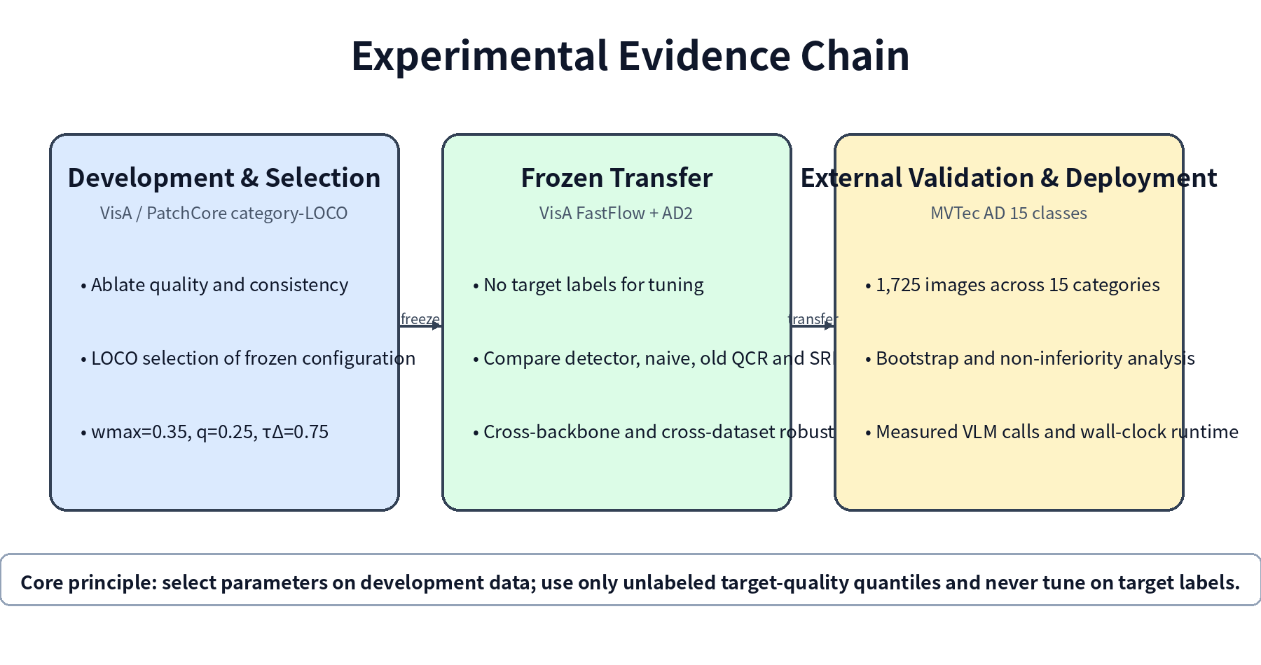
Figure 2. Development, frozen transfer, and measured deployment protocol.

5.1 Datasets and experimental roles
Dataset | Scope | Role | Fairness constraint
VisA | 12 categories | Main QCR ablation; PatchCore category-LOCO selection; FastFlow frozen transfer | Parameters selected only on PatchCore LOCO development folds
AD2 study protocol | fruit_jelly, sheet_metal, vial, walnuts | Four-category detector/VLM transfer and strong-baseline checks | Protocol-specific subset used in this study
MVTec AD | 15 categories, 1,725 test images | Full external transfer, bootstrap, runtime, qualitative analysis | No target-label parameter tuning

VisA contains 10,821 high-resolution images across 12 objects, including 9,621 normal and 1,200 anomalous images [2]. MVTec AD contains 15 object and texture categories [1]. The present MVTec rerun processes all 1,725 test images. AD2 is described as the four-category study protocol used in this project rather than as a general public benchmark claim.

5.2 Baselines and comparison panels
Two comparison panels are maintained because their protocols differ. The system-level panel compares detector and VLM systems under the project’s primary category set. The QCR panel compares score variants using identical detector, crop, prompt, and normalization signals. Merging the panels into one ranking would be misleading.
- Detector only: PatchCore or FastFlow score D.
- Full-image VLM and crop-only VLM.
- Naive detector-crop fusion: 0.5D+0.5M.
- Old Quality-Calibrated QCR and old adaptive QCR.
- SRB-QCR frozen transfer.
- EfficientAD-30 fixed-budget baseline and 100-epoch sensitivity checks.
- WinCLIP fixed protocol and official AnomalyCLIP execution on the AD2 four-category protocol.

5.3 Metrics and statistical protocol
- Effectiveness: image AUROC, average precision (AP), and best F1; pixel metrics are auxiliary detector evidence only.
- Reliability: delta relative to the detector, category win count, worst-category delta, 95% stratified bootstrap confidence interval, and a predeclared non-inferiority tolerance of 0.002.
- Efficiency: VLM call count, call-saving rate, paired wall-clock time, speedup, and peak allocated GPU memory.
- Runtime correctness: maximum difference in raw M, normalized M, and final SRB score between offline and live selective execution.

5.4 Implementation details
Item | Setting
Detector | PatchCore: Wide-ResNet-50-2, layer2+layer3, coreset ratio 0.1, 9 neighbors
Preprocessing | 256×256 resize, 224×224 center crop
Candidate rule | Per-image 97th percentile; top-3 components; minimum area 20
VLM | OpenCLIP ViT-B/32, OpenAI weights; inspection_binary prompts; crop-top-k ensemble
Frozen SRB | wmax=0.35; q-quantile=0.25; τΔ=0.75
Hardware | Single NVIDIA GeForce RTX 4090; paired runtime repeated three times
Reproducibility | Target labels excluded from parameter and quality-threshold selection

5.5 Claim and fairness controls
- Same-set fusion is reported only as an upper-bound diagnostic; category-LOCO is the primary fair fusion claim.
- EfficientAD is described as a fixed-budget baseline, not a comprehensive defeat of all training budgets.
- AnomalyCLIP and WinCLIP statements are restricted to the implemented protocols.
- MVTec detector comparison is framed as non-inferiority, not statistically significant superiority.
- No claim of pixel-level segmentation state of the art or general defect-cause understanding is made.

6. Experimental Results

6.1 Supporting evidence: localization improves VLM focus
Before introducing reliability calibration, we verify that detector-guided crops provide meaningful VLM evidence. On VisA, the full-image binary VLM AUROC is 0.5950. Candidate crop-top-k reasoning reaches 0.8844 with PatchCore proposals and 0.9222 with FastFlow proposals, gains of 0.2894 and 0.3272. On the early MVTec defect-type reasoning protocol, top-1 accuracy improves from 0.2850 to 0.3388. These results justify the localization-to-reasoning route, but they do not by themselves justify fusion.
Dataset | Proposal | Reasoning mode | Metric
VisA | PatchCore | Full-image binary VLM | 0.5950
VisA | PatchCore | Crop-top-k VLM | 0.8844
VisA | FastFlow | Crop-top-k VLM | 0.9222
MVTec support protocol | PatchCore | Full-image defect type top-1 | 0.2850
MVTec support protocol | PatchCore | Crop defect type top-1 | 0.3388

6.2 System-level baseline comparison
Method | Image AUROC | Paper role
PatchCore + context VLM, same-set | 0.8453 | Upper-bound diagnostic
PatchCore + context VLM, category-LOCO | 0.8210 | Primary fair system result
PatchCore | 0.7853 | Detector baseline
EfficientAD-30 | 0.7604 | Fixed-budget modern detector
Context-aware VLM | 0.7101 | VLM baseline
Full-image VLM | 0.6459 | Global-image baseline
WinCLIP fixed protocol | 0.6138 | Protocol-specific CLIP baseline

The LOCO result is the fair system-level claim. The same-set result is retained only as an upper-bound diagnostic. This table is not directly comparable with the QCR ablation below because category composition and score construction differ.

6.3 QCR primary-protocol ablation on VisA
ID | Method | FastFlow | PatchCore | Mean AUROC | Role
V0 | Detector only | 0.8955 | 0.9131 | 0.9043 | Anchor
V2 | Crop VLM only | 0.9269 | 0.8846 | 0.9057 | Crop baseline
V3 | Naive detector-crop fusion | 0.9688 | 0.9616 | 0.9652 | Naive baseline
V4 | Quality-Calibrated QCR | 0.9778 | 0.9718 | 0.9748 | Main quality core
V5 | Fixed Q+C fusion | 0.9842 | 0.9740 | 0.9791 | Diagnostic only
V6 | Quality QCR + adaptive consistency | 0.9783 | 0.9722 | 0.9752 | Conservative refinement

Quality-Calibrated QCR improves mean AUROC by 0.0096 over naive fusion in the aggregate table and by 0.0119 when category-protocol deltas are averaged. Adaptive consistency reaches 0.9752, only 0.0004 above the quality core. The highest mean in this panel is the fixed Q+C diagnostic (0.9791), but category-level analysis shows unstable negative cases; it is therefore not the final method.

6.4 Robustness of quality and consistency components
Comparison | Mean Δ | Wins | Min | Max | Interpretation
Quality-QCR − Naive | +0.0119 | 13/24 | −0.0132 | +0.0908 | Main reliable gain
Adaptive − Quality-QCR | +0.0003 | 14/24 | +0.0000 | +0.0014 | Small refinement
Fixed Q+C − Quality-QCR | +0.0027 | 18/24 | −0.0506 | +0.0202 | Peak but unstable
Adaptive − Fixed Q+C | −0.0024 | 3/24 | −0.0189 | +0.0508 | Robustness trade-off

6.5 Strong VLM baseline on the AD2 four-category protocol
Category | Pixel AUROC | Pixel AUPRO | Image AUROC | Image AP
fruit_jelly | 62.4 | 50.1 | 66.8 | 88.0
sheet_metal | 65.2 | 12.3 | 53.3 | 84.2
vial | 65.4 | 54.2 | 54.0 | 81.9
walnuts | 87.5 | 44.2 | 41.3 | 54.5
Mean | 70.1 | 40.2 | 53.9 | 77.1

Official AnomalyCLIP code and checkpoint execution produces 0.539 mean image AUROC on the four categories. The project’s fair LOCO system result is 0.8210, a protocol-specific difference of +0.2820. This comparison demonstrates competitiveness under the implemented AD2 protocol, not broad superiority over all AnomalyCLIP settings.

6.6 Frozen transfer to all 15 MVTec AD categories
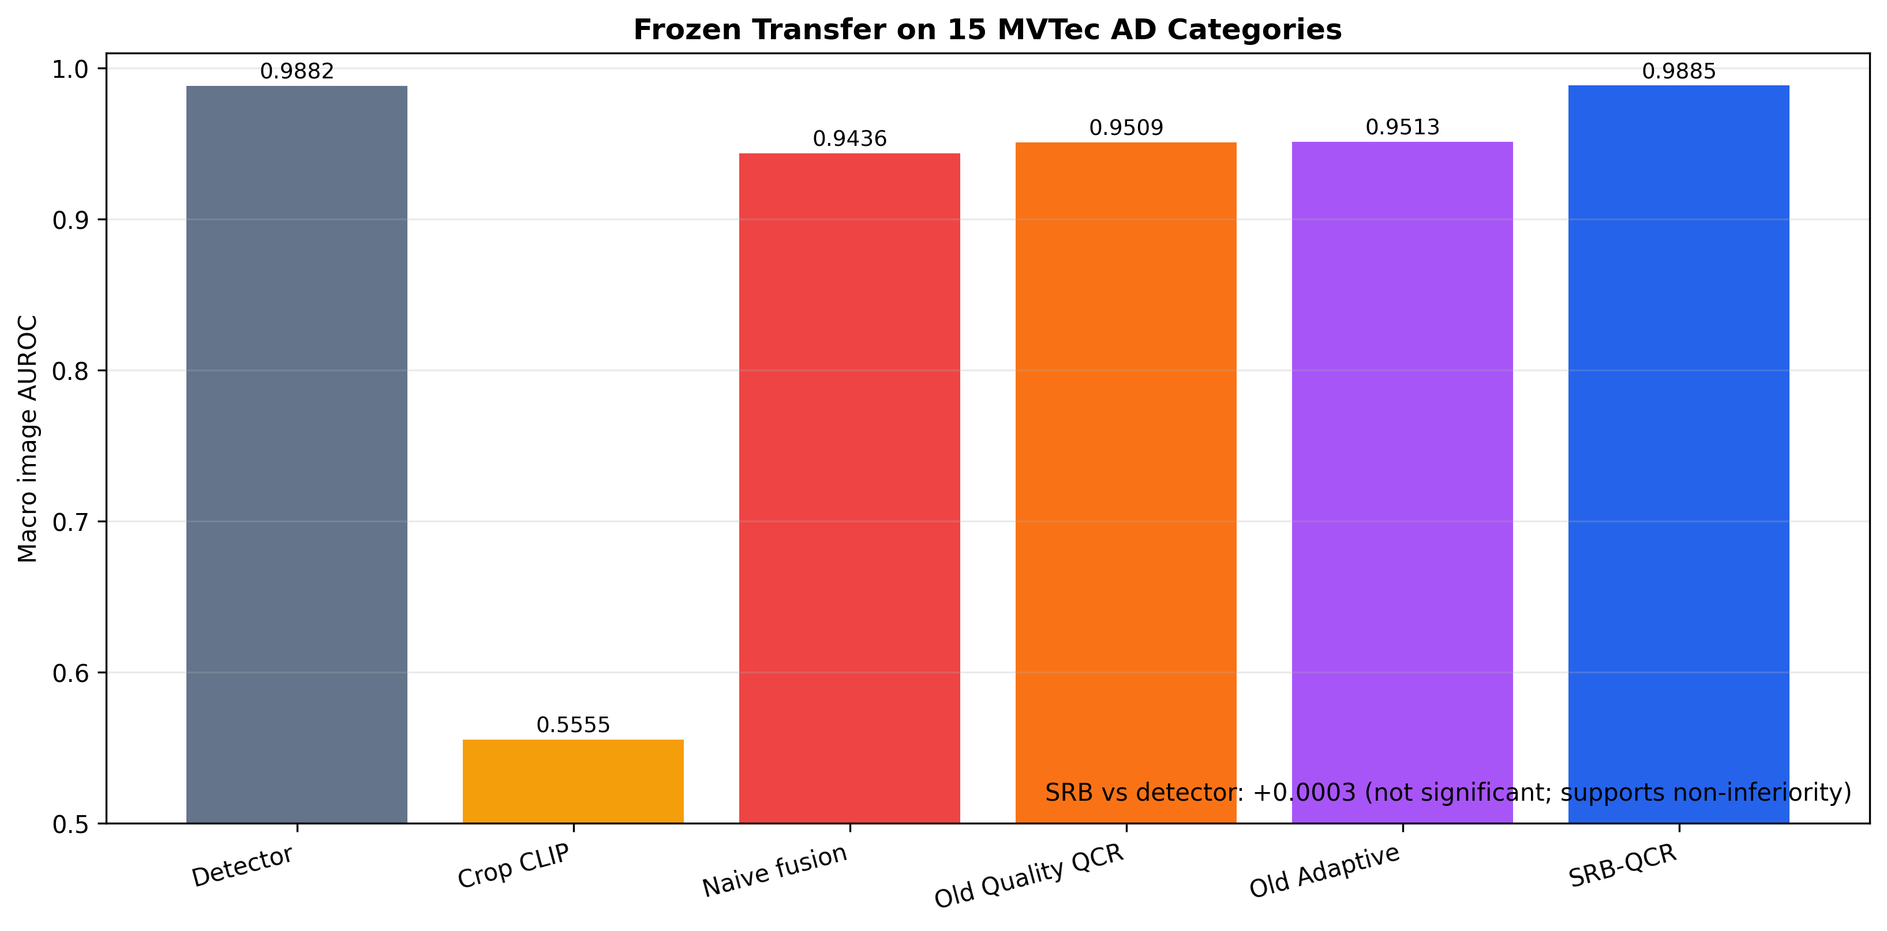
Figure 3. Macro image AUROC on the MVTec AD 15-class frozen-transfer protocol.
ID | Method | Macro AUROC | Macro AP | Macro best F1 | Role
D0 | Detector only | 0.988212 | — | — | Reference
M0 | Crop CLIP only | 0.555538 | 0.790105 | 0.847042 | Weak standalone
V3 | Naive detector-crop fusion | 0.943627 | 0.980173 | 0.942091 | Severe AUROC degradation
V4 | Old Quality-QCR | 0.950871 | 0.982961 | 0.945667 | Partial recovery
V6 | Old Adaptive QCR (diagnostic) | 0.951332 | 0.983143 | 0.945978 | Diagnostic reconstruction
S1 | SRB-QCR frozen transfer | 0.988478 | 0.996819 | 0.985522 | Final method

SRB-QCR matches the strong detector while the unconstrained fusion methods remain far below it. SRB improves over the detector in 6 of 15 categories, and the worst category delta is only −0.0012. The result supports bounded preservation rather than universal per-category improvement.

6.7 Bootstrap and non-inferiority analysis
Comparison | Point Δ | 95% CI | P(Δ>0) | Two-sided p | Conclusion
SRB vs detector | +0.000265 | [−0.000870, +0.001414] | 0.686 | 0.628 | Non-inferior; not significantly superior
SRB vs naive fusion | +0.044851 | [+0.034143, +0.056123] | 1.000 | 0.000 | Significant improvement
Quality-QCR vs naive | +0.007244 | [+0.003519, +0.011321] | 1.000 | 0.000 | Quality is beneficial
SRB vs old Quality-QCR | +0.037607 | [+0.027904, +0.048161] | 1.000 | 0.000 | Significant reliability gain

The detector confidence interval crosses zero, so the paper does not claim significant superiority. However, its lower bound (−0.000870) is above the predeclared non-inferiority margin of −0.002, supporting detector non-inferiority. In contrast, the intervals for comparisons against naive and old Quality-QCR are entirely positive.

6.8 Frozen transfer behavior across targets
Target | SRB−Detector | Category wins | Worst category | Calls saved | Interpretation
VisA PatchCore category-LOCO | +0.0058 | 12/12 | −0.0000 approx. | 58.83% | Development/selection source
VisA FastFlow | +0.0048 | 8/12 | −0.0029 | 58.42% | Cross-backbone frozen transfer
AD2 four-category protocol | +0.0086 | 3/4 | −0.0037 | 25.10% | Cross-dataset transfer; below naive/old QCR
MVTec AD 15 classes | +0.0003 | 6/15 | −0.0012 | 24.99% | Full external validation; above naive/old QCR

The transfer table shows that SRB-QCR is not universally the highest-scoring fusion. On VisA and AD2, more aggressive fusion can score higher, whereas on MVTec the same aggressive strategies fail badly. The stable objective is detector preservation plus controlled opportunity for semantic gain, not guaranteed maximization on every target.

6.9 EfficientAD budget sensitivity
Metric | EfficientAD-30 | EfficientAD-100 | Δ (100−30)
Image AUROC | 0.8433 | 0.8267 | −0.0167
Image F1 | 0.8571 | 0.8438 | −0.0134
Pixel AUROC | 0.7894 | 0.8424 | +0.0531
Pixel F1 | 0.5395 | 0.5561 | +0.0166

The fruit_jelly sensitivity check does not show image-level undertraining at 30 epochs; pixel metrics improve while image metrics decrease. A later four-category check gives only a modest +0.0052 mean image-AUROC change and improves one of four categories. EfficientAD therefore remains explicitly labeled as a fixed-budget baseline.

7. Efficiency and Deployment Analysis
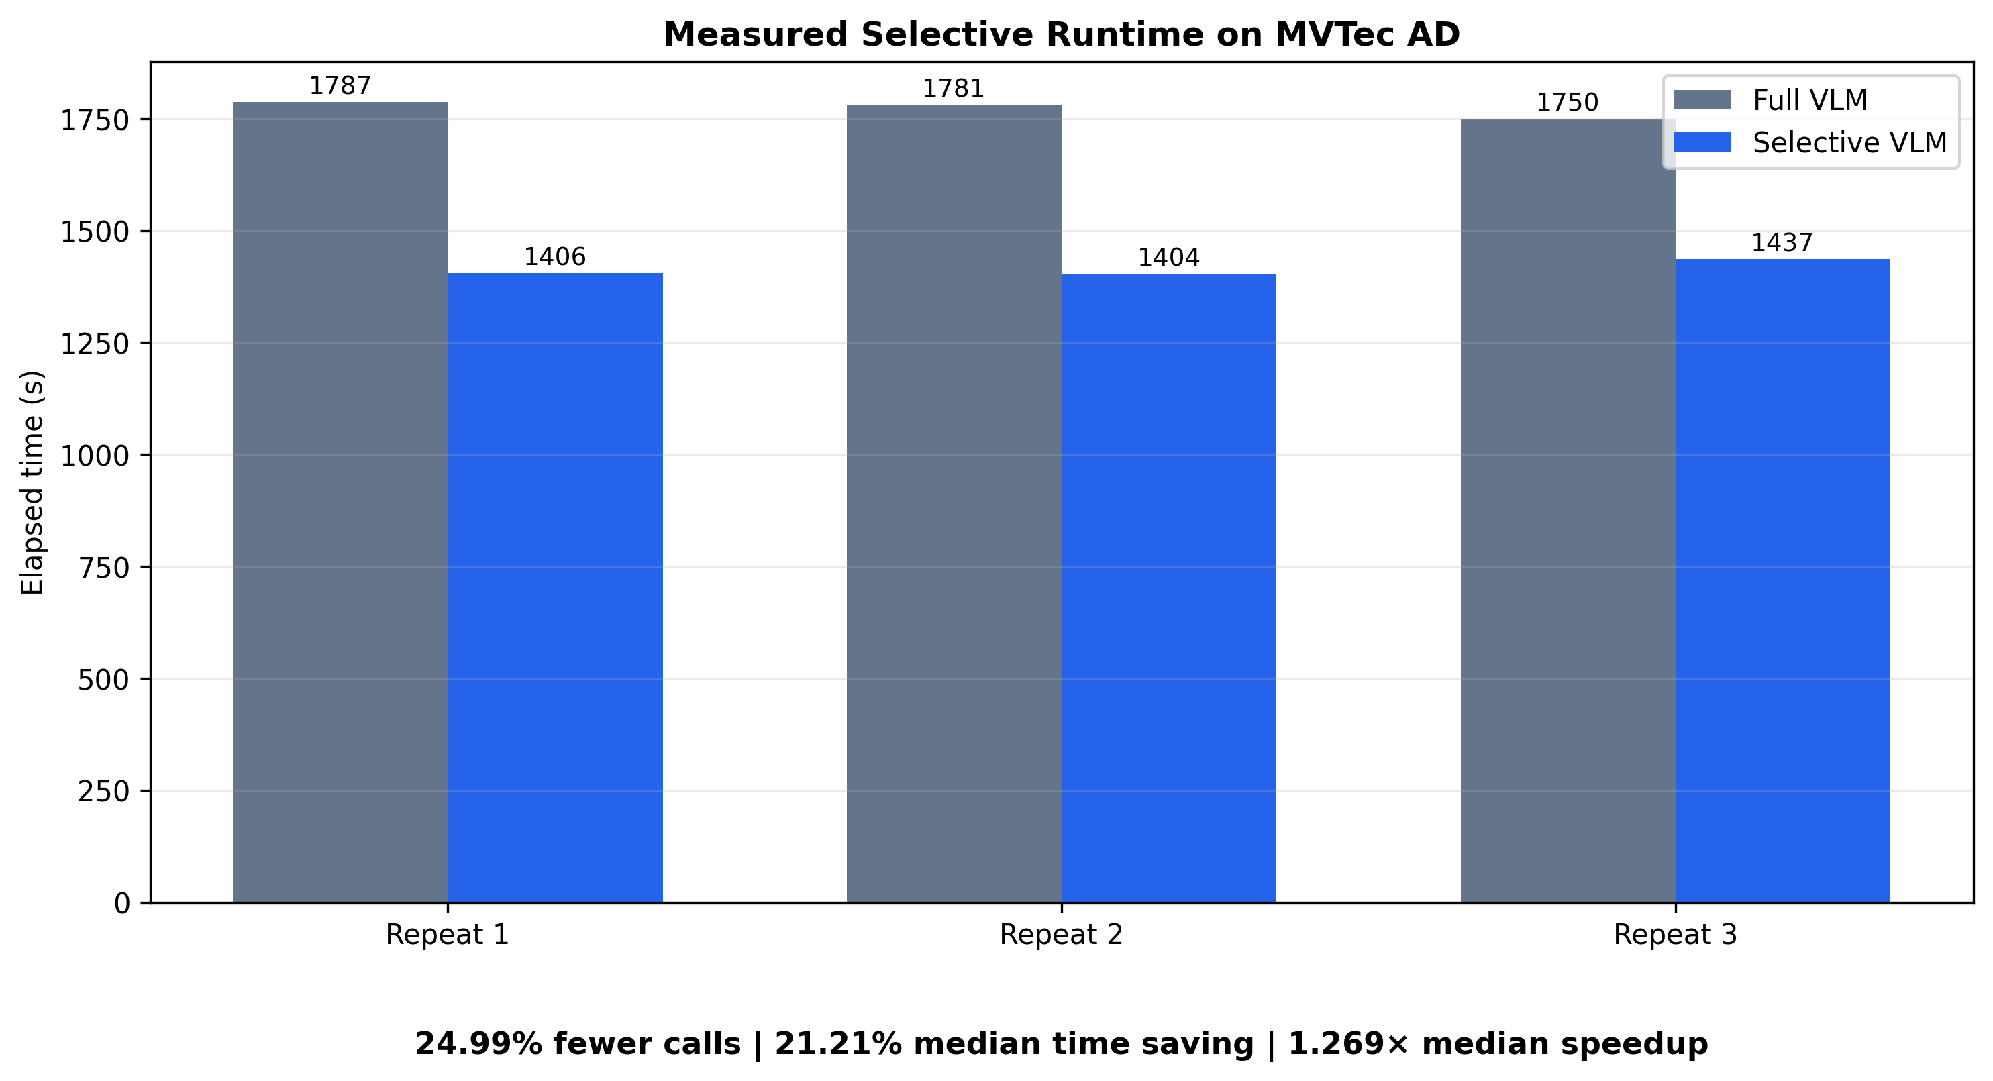
Figure 4. Measured full and selective VLM runtime on all 1,725 MVTec AD test images.
Potential call saving computed offline is only useful if it translates into a real execution path. We therefore implement two paired modes using the same CLIP model, prompts, crops, preprocessing, and per-image inference code. Full mode evaluates all 1,725 images; selective mode evaluates only the 1,294 pre-gate-positive images. Model loading, text encoding, and candidate-box loading are excluded from timing, while image loading, crop construction, preprocessing, and CLIP image inference are included. Execution order alternates across three repeats.
Repeat | Full calls | Selective calls | Full sec | Selective sec | Saved sec | Saving | Speedup | Peak MiB full/sel
1 | 1725 | 1294 | 1787.330 | 1405.595 | 381.735 | 21.36% | 1.272× | 603.09 / 603.09
2 | 1725 | 1294 | 1781.435 | 1403.632 | 377.803 | 21.21% | 1.269× | 603.09 / 603.09
3 | 1725 | 1294 | 1750.147 | 1436.916 | 313.230 | 17.90% | 1.218× | 603.09 / 603.09
Median | — | — | 1781.435 | 1405.595 | — | 21.21% | 1.269× | —

7.1 Call reduction and wall-clock gain
The frozen gate skips 431 calls, corresponding to a 24.99% call reduction. Median full execution is 1,781.435 s (29.69 min) and median selective execution is 1,405.595 s (23.43 min), saving approximately 6.26 min per complete benchmark pass. The 21.21% time reduction is slightly smaller than the call reduction because file I/O, Python control flow, synchronization, and other fixed costs remain.

7.2 Output equivalence
Audit item | Result
Max raw M difference | 9.97×10⁻¹⁷
Max normalized M difference | 1.04×10⁻¹⁴
Max final SRB score difference | 2.28×10⁻¹⁵
Fallback count | 0

The differences are floating-point rounding noise. Thus, speedup is obtained by skipping calls rather than approximating the model, lowering image resolution, changing prompts, or altering the fusion equation.

7.3 Memory behavior and deployment interpretation
Peak allocated memory remains 603.09 MiB in both modes because the same CLIP model and single-image/crop batch are used. Selectivity reduces the number of calls and total time, not the maximum memory required by one call. For a memory-constrained deployment, model quantization or batching changes would be complementary optimizations.
The measured speedup is specific to the RTX 4090, software stack, image-crop protocol, and per-image execution path. The robust claim is the call reduction; wall-clock speedup should be remeasured on each target system.

7.4 Actual selective runtime on the AD2 four-category transfer
To verify that the frozen pre-gate also yields a measurable deployment benefit on the AD2 transfer, we execute paired full and selective modes on the same 243 images and cached context-crop assets. Full mode evaluates every image, whereas selective mode evaluates only the 182 pre-gate-positive images. Across three paired repeats, the gate saves 61 logical VLM calls (25.10%) and 105 crop evaluations (20.92%). Median wall-clock time decreases from 287.431 s to 240.746 s, corresponding to an 18.95% reduction and a 1.234× speedup. Peak allocated GPU memory remains approximately 602.2 MiB because both modes load the same CLIP model and use the same per-image execution path.
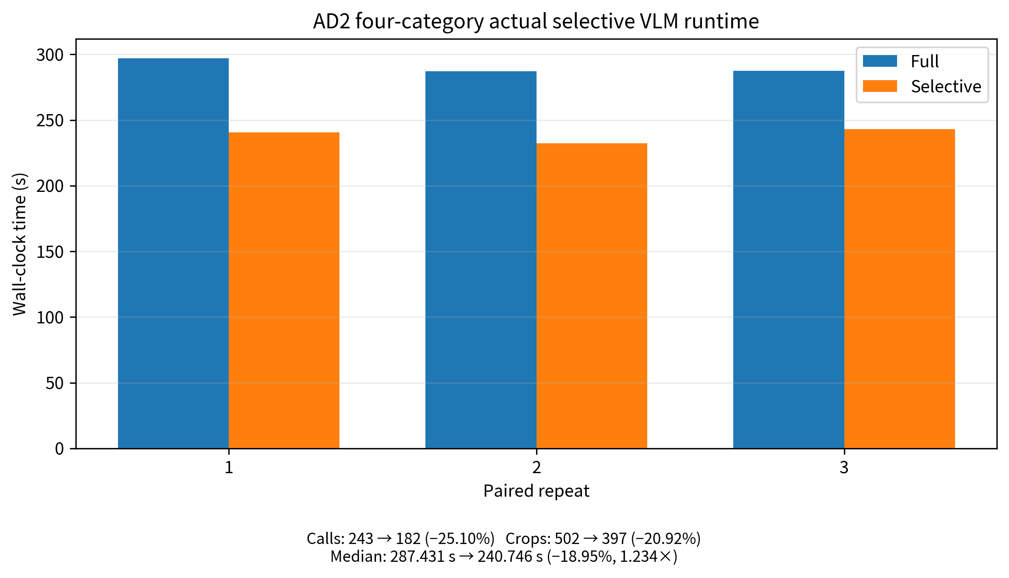
Figure 6. Measured full and selective VLM runtime on the AD2 four-category protocol.
Table 10. AD2 actual selective runtime over three paired repeats.
Repeat | Full calls | Sel. calls | Full crops | Sel. crops | Full sec | Sel. sec | Saving | Speedup
1 | 243 | 182 | 502 | 397 | 297.023 | 240.746 | 18.95% | 1.234×
2 | 243 | 182 | 502 | 397 | 287.022 | 232.422 | 19.02% | 1.235×
3 | 243 | 182 | 502 | 397 | 287.431 | 243.133 | 15.41% | 1.182×
Median | — | — | — | — | 287.431 | 240.746 | 18.95% | 1.234×
Accuracy and efficiency use separate locked evidence sources. AD2 accuracy and Bootstrap claims use the Stage 23-B1 frozen prediction cache, whereas runtime claims use the Stage 23-C2 re-executed CLIP path. The crop inventory and gate decisions are locked, but exact sample-wise replay of the historical Stage 11 VLM margins is not claimed because the original category-specific prompt metadata was not fully preserved. This provenance limitation does not change the measured call counts or wall-clock comparison.

8. Qualitative and Failure-Boundary Analysis
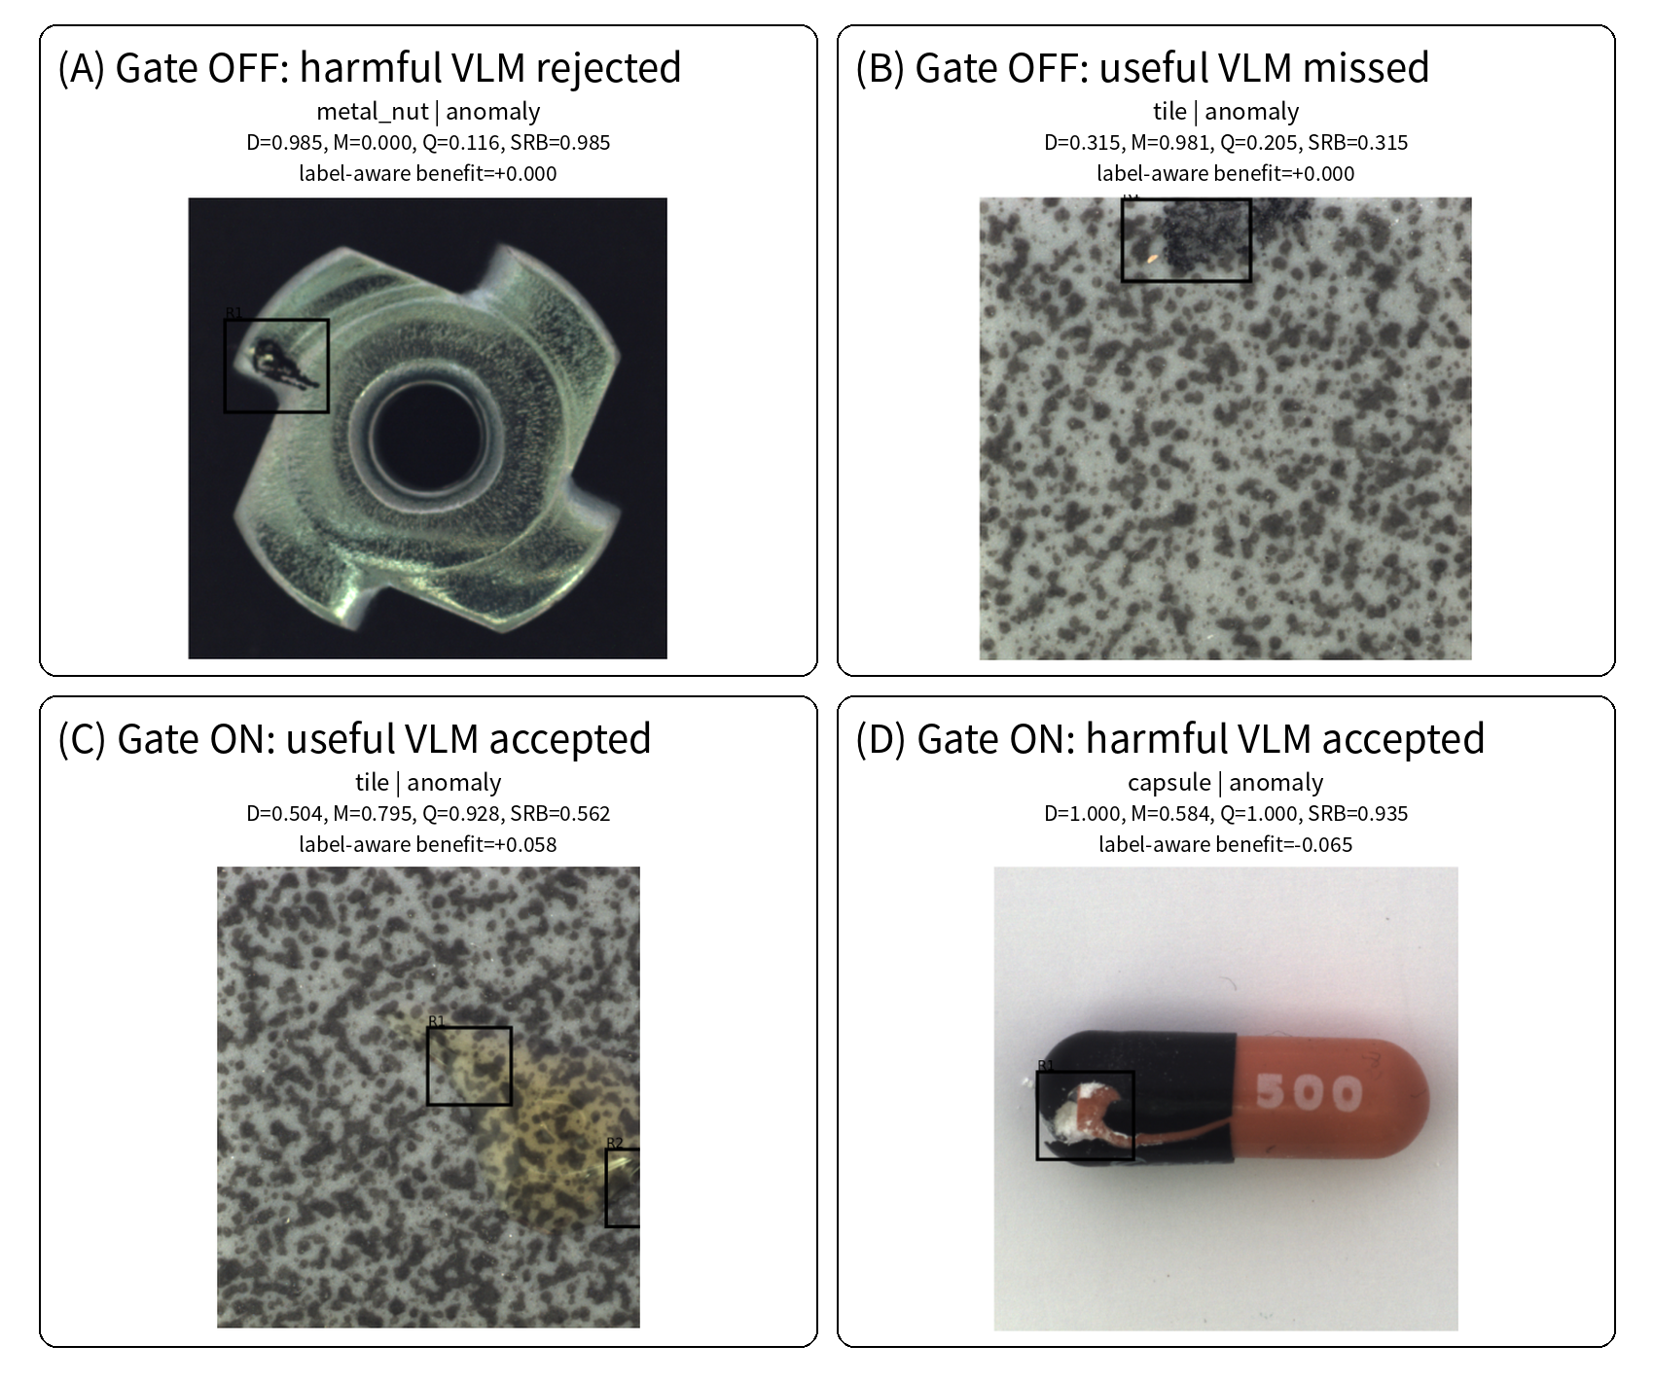
Figure 5. Representative reliability-boundary cases of the frozen SRB-QCR gate.
Figure 5 is label-aware: a score increase is beneficial for an anomalous image and harmful for a normal image. Panel A shows a metal_nut anomaly for which the detector is already highly confident and the VLM is strongly misleading. The gate is closed, so SRB equals the detector and avoids the harm that naive averaging would introduce. Panel B shows a tile anomaly with a much stronger retrospective VLM score but low candidate quality; the gate remains closed, illustrating a conservative missed opportunity.
Panel C shows a tile anomaly with high quality and useful VLM evidence. The gate opens and raises the score by about 0.058. Panel D shows a capsule anomaly for which the detector is saturated at 1.0 but the VLM score is lower. Despite high Q, the gate accepts the VLM and lowers the final score by about 0.065. This is a genuine failure case and demonstrates that Q and agreement are reliability proxies rather than guarantees.
For gate-off cases, M is displayed retrospectively from the full-inference audit. It is not computed in actual selective deployment. Candidate boxes are detector proposals and do not use the ground-truth mask.

8.1 Failure taxonomy
Failure mode | Mechanism | Observed boundary
Quality false positive | Q is high although the crop is semantically misleading. | Gate-on harmful case
Quality false negative | Q is low although the VLM would help. | Gate-off missed opportunity
Detector saturation | D is near 1, so even bounded movement toward a lower M can reduce ranking margin. | Capsule/toothbrush cases
Texture ambiguity | Background texture resembles anomaly prompts or candidate patterns. | Tile/grid cases
Prompt/domain mismatch | Normal/abnormal text is insufficiently category-specific. | Potential across all categories

8.2 What the qualitative analysis supports
- The gate can prevent large errors from aggressive fusion.
- The gate is intentionally conservative and can miss useful semantic evidence.
- High candidate quality is necessary but not sufficient for correct VLM reasoning.
- Strict detector fallback makes gate-off behavior easy to verify.
- The method’s contribution is calibrated evidence use, not universal semantic understanding.

9. Discussion

9.1 Why naive fusion fails
Naive averaging assumes D and M are equally calibrated and equally reliable. This is violated when detector scores are near the top of their range and VLM margins are compressed, when a crop captures an irrelevant region, or when prompts do not describe the defect. Because AUROC depends on ranking, even moderate score movement can reorder normal and anomalous samples. The 0.04485 macro-AUROC gap between SRB and naive fusion on MVTec quantifies this risk.
The failure is not evidence that VLMs are useless. Crop-only VLM scores have high AP on some categories and provide large gains in selected cases. The problem is deciding when to use them.

9.2 Why candidate quality is the main effective component
Quality captures whether the detector has produced a coherent local region. VisA ablation shows a stable mean gain over naive fusion and positive wins in 13 of 24 category-protocol comparisons. In contrast, fixed consistency can produce a high aggregate score while suffering a −0.0506 minimum delta. Candidate quality is therefore the more transferable first-line reliability signal.
Nevertheless, the MVTec gate-on harmful examples show that quality cannot guarantee semantic correctness. It measures crop suitability, not prompt validity or VLM epistemic uncertainty.

9.3 Role of agreement
Agreement should be treated as an attenuator rather than as an independent positive score. A high-high consistency indicator can reward mutually wrong predictions. The SRB agreement term only reduces the permitted VLM influence as |D−M| increases. This design sacrifices some peak fusion gains but improves interpretability and protects the detector anchor.

9.4 Non-inferiority as an appropriate objective
When a detector already reaches 0.988 macro AUROC, the room for statistically significant improvement is small. A deployment-oriented objective is to preserve detector performance, exploit safe semantic opportunities, and reduce costly calls. The predeclared non-inferiority test prevents post-hoc reinterpretation: the detector comparison is accepted because the lower bootstrap bound remains above −0.002, not because the point estimate happens to be positive.

9.5 Deployment modes
SRB-QCR can operate in offline-audit mode, where M is computed for every image to analyze gate decisions, or selective mode, where M is computed only after the pre-gate. Offline audit is useful for method development; selective mode is the deployable path. The score-equivalence audit confirms that the two modes agree on all evaluated images and that skipped rows retain D exactly.

9.6 Generalization and future extensions
The same reliability layer can be placed on other detectors and VLMs. Potential extensions include learned but label-free quality estimators, conformal or risk-controlling thresholds, prompt uncertainty, batched selective execution, pixel-level semantic refinement, and hardware-aware scheduling. Any extension should preserve the explicit fallback identity and be evaluated under frozen transfer.

10. Limitations
1. SRB-QCR does not guarantee improvement over the detector on every category or image. It is reliability-bounded, not risk-free.
2. Candidate quality is a heuristic reliability proxy. It cannot detect all prompt-domain mismatches or semantically misleading crops.
3. The target quality threshold uses unlabeled target statistics. Although no labels are used, a strict source-only deployment may require a source-derived or online-calibrated alternative.
4. MVTec normalization is performed within category. Cross-category open-world deployment would require a shared calibration strategy.
5. The old adaptive QCR result on MVTec is diagnostic because the original consistency signal was unavailable and was reconstructed with a fixed high-high rule.
6. Peak GPU memory is unchanged. The current efficiency benefit concerns call count and wall-clock time.
7. Runtime results are hardware- and implementation-specific and were measured with per-image execution on a single RTX 4090.
8. The method is evaluated primarily for image-level anomaly recognition. Pixel-level segmentation and defect-cause explanation remain outside the main claim.
9. System-level baselines, QCR ablations, and cross-dataset transfer use different protocols; only within-panel comparisons are direct.
10. The current VLM branch uses CLIP ViT-B/32 and fixed prompt templates. Broader VLM backbones and learned uncertainty estimates remain future work.
11. Exact historical AD2 VLM-margin replay is not claimed because the original Stage 11 category-specific prompt metadata was not fully preserved. AD2 accuracy uses the locked prediction cache, whereas efficiency uses the re-executed runtime path.

11. Conclusion
This paper studies how to safely introduce localized vision-language evidence into strong industrial anomaly detectors. Experiments show that candidate crops improve VLM focus, but naive score fusion can sharply degrade detector performance. SRB-QCR responds with a quality-based selective pre-gate, an agreement-bounded interpolation weight, and a strict detector-only fallback. Candidate quality is confirmed as the primary effective component, while consistency is used conservatively.
With parameters selected on VisA PatchCore category-LOCO and frozen thereafter, SRB-QCR transfers to new backbones and datasets. On all 15 MVTec AD categories it is non-inferior to the detector and substantially better than naive and old quality-calibrated fusion. MVTec selective execution skips 24.99% of VLM calls and reduces median wall-clock time by 21.21%. On the AD2 four-category transfer, SRB improves macro AUROC over the detector by 0.0086 with 3/4 category wins; actual execution skips 25.10% of calls and reduces median time by 18.95% (1.234×). The central conclusion is therefore not that a VLM replaces an anomaly detector, but that semantic evidence can be used selectively within explicit reliability, provenance, and deployment boundaries.

Declarations

Data availability
MVTec AD and VisA are available from their official project pages. The AD2 study uses the project's local MVTec AD 2 preparation under datasets/MVTec_AD_2_anomalib_all and the four categories fruit_jelly, sheet_metal, vial, and walnuts. Raw datasets and model weights are not redistributed.

Code availability
Experiment scripts, frozen protocol files, result summaries, figure manifests, and the integrated draft package are maintained at https://github.com/lxs2271237473wq/iad-vlm-anomaly. The Stage 23-C2 integration is anchored to main commit bf049d750898c793211fdda3bf6aff30bf483f07.

Funding
[To be completed.]

Author contributions
[To be completed using the target venue taxonomy.]

Conflict of interest
The authors declare no conflict of interest. [Confirm before submission.]

Ethics statement
The study uses industrial object images and does not involve human participants or personal data.

Use of AI-assisted tools
[Disclose language or coding assistance according to venue policy.]

References
[1] P. Bergmann, M. Fauser, D. Sattlegger, and C. Steger, “MVTec AD—A comprehensive real-world dataset for unsupervised anomaly detection,” Proc. CVPR, 2019.
[2] Y. Zou et al., “SPot-the-Difference self-supervised pre-training for anomaly detection and segmentation,” Proc. ECCV, 2022.
[3] K. Roth et al., “Towards total recall in industrial anomaly detection,” Proc. CVPR, 2022.
[4] J. Yu et al., “FastFlow: Unsupervised anomaly detection and localization via 2D normalizing flows,” arXiv:2111.07677, 2021.
[5] K. Batzner, L. Heckler, and R. König, “EfficientAD: Accurate visual anomaly detection at millisecond-level latencies,” Proc. WACV, 2024.
[6] A. Radford et al., “Learning transferable visual models from natural language supervision,” Proc. ICML, 2021.
[7] J. Jeong et al., “WinCLIP: Zero-/few-shot anomaly classification and segmentation,” Proc. CVPR, 2023.
[8] Q. Zhou, G. Pang, Y. Tian, S. He, and J. Chen, “AnomalyCLIP: Object-agnostic prompt learning for zero-shot anomaly detection,” Proc. ICLR, 2024.
[9] V. Zavrtanik, M. Kristan, and D. Skočaj, “DRAEM—A discriminatively trained reconstruction embedding for surface anomaly detection,” Proc. ICCV, 2021.
[10] H. Deng and X. Li, “Anomaly detection via reverse distillation from one-class embedding,” Proc. CVPR, 2022.
[11] D. Gudovskiy, S. Ishizaka, and K. Kozuka, “CFLOW-AD: Real-time unsupervised anomaly detection with localization via conditional normalizing flows,” arXiv:2107.12571, 2021.
Bibliography note
The final submission should convert these references to the target venue style and verify volume, pages, DOI, and URLs.

Appendix A. Experimental Inventory
Evidence block | Dataset | Purpose | Status
Localization-to-reasoning | VisA + early MVTec | Verify crop evidence improves VLM focus | Complete
System baseline panel | Primary category protocol | PatchCore, EfficientAD, WinCLIP, full/context VLM | Complete; protocol-limited
QCR ablation | VisA; PatchCore + FastFlow | Identify quality and consistency roles | Complete
Frozen selection | VisA PatchCore category-LOCO | Select wmax, q-quantile, τΔ | Complete and locked
Cross-backbone transfer | VisA FastFlow | No-label frozen transfer | Complete
AD2 transfer | Four categories | Cross-dataset behavior and AnomalyCLIP baseline | Complete
MVTec 15-class rerun | 1,725 test images | Unified detector, candidates, CLIP, SRB transfer | Complete
Bootstrap | MVTec 15 classes | Uncertainty and non-inferiority | 2,500 repeats
Actual runtime | MVTec AD 15 classes + AD2 four categories | Full vs selective execution and deployment provenance | 3 paired repeats on each target
Qualitative boundaries | MVTec 15 classes | Gate success/failure taxonomy | Complete

All core experiments are treated as frozen for drafting. New parameter tuning on MVTec or AD2 would invalidate the transfer narrative and should not be performed without redefining the protocol.

Appendix B. Score Variant Definitions
ID | Formula | Meaning
D0 | D | Detector-only anchor
M0 | M | Crop VLM only
V3 | 0.5D+0.5M | Naive fusion
V4 | 0.5D+0.5M(0.5+0.5Q) | Old quality-calibrated core
V6 | V4+0.05·Q·K·agreement | Old adaptive diagnostic/refinement
S1 | D+w(M−D) | SRB-QCR; w=wmax·Gpre·Q·A

Important protocol note
V6 on MVTec is diagnostic because K was reconstructed from the fixed high-high rule. S1 is the final frozen method.

Appendix C. Reproducibility Checklist
1. Record exact dataset paths, category lists, and normal/anomaly directory mappings.
2. Use PatchCore Wide-ResNet-50-2 with layer2 and layer3; record anomalib and PyTorch versions.
3. Use per-image 97th-percentile candidate threshold, top-3 components, and minimum area 20.
4. Use OpenCLIP ViT-B/32 with OpenAI weights and the inspection_binary prompt strategy.
5. Normalize D, M, and Q within category for the MVTec transfer table.
6. Select τq as the 25th percentile of unlabeled eligible target Q values.
7. Keep wmax=0.35 and τΔ=0.75; do not tune on target labels.
8. For runtime, preload CLIP/text/boxes; include image I/O, crop construction, preprocessing, and image inference.
9. Alternate full/selective execution order and report all repeats.
10. Audit score equivalence and fallback count before reporting speedup.
11. Separate system baselines from QCR ablations in all tables.
12. Preserve logs, CSVs, JSON protocol files, and figure manifests in the artifact package.

Appendix D. Full Qualitative Audit Grid
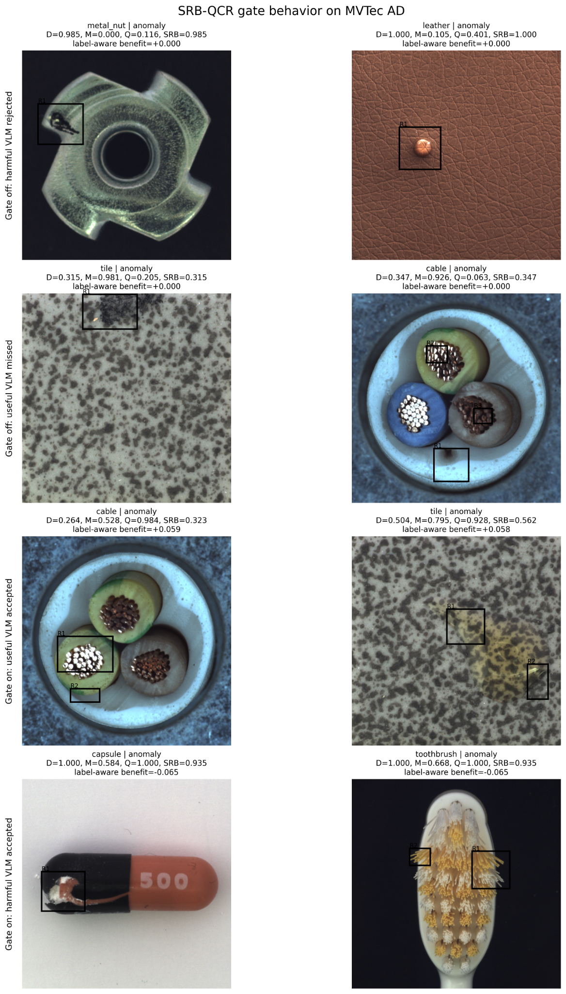
Figure A1. Eight-case gate behavior audit on MVTec AD.
This appendix figure is retained for auditing rather than used as the main-paper layout. Gate-off M values are retrospective full-inference values.

Appendix E. Claim-Boundary Guide
Topic | Allowed wording | Forbidden wording
Detector comparison | SRB-QCR is non-inferior to PatchCore within the predeclared tolerance. | SRB-QCR significantly beats PatchCore.
Fusion comparison | SRB-QCR significantly outperforms naive fusion and old Quality-QCR on MVTec. | SRB-QCR is always the best fusion on every dataset.
VLM baseline | Under the implemented AD2 protocol, the fair LOCO system exceeds official AnomalyCLIP execution. | We comprehensively outperform AnomalyCLIP/CLIP methods.
EfficientAD | EfficientAD-30 is a fixed-budget baseline with sensitivity checks. | We fully defeat EfficientAD.
Localization | Detector localization supports candidate reasoning. | We achieve pixel-level segmentation SOTA.
Semantics | VLM provides complementary anomaly evidence. | The system understands manufacturing causes.
Runtime | MVTec: 24.99% fewer calls and 21.21% lower median time. AD2: 25.10% fewer calls, 18.95% lower median time, and 1.234× median speedup on the measured setup. | The same speedup or exact historical margin replay is guaranteed on all targets.
Same-set | Same-set is an upper-bound diagnostic. | Same-set is the primary fair comparison.

Appendix F. Anticipated Reviewer Questions

Why not simply use the detector?
The detector is the safest anchor; SRB adds semantic evidence only when it is reliable and reduces unnecessary VLM computation. The goal is bounded augmentation, not replacement.

Why does SRB not beat the detector significantly?
The detector already reaches 0.988 macro AUROC. The predeclared objective is non-inferiority plus selective efficiency. The confidence interval supports that objective.

Is Q tuned on MVTec labels?
No. The adapter and quantile rule are frozen before metrics; τq uses only unlabeled target quality values.

Does gate-off require M?
No. The actual selective implementation computes the pre-gate from candidate availability and Q. Retrospective M is shown only in audits.

Why is peak memory unchanged?
The same model and per-call batch are used. Selectivity reduces frequency, not the memory footprint of one CLIP call.

Could a learned gate perform better?
Possibly, but it would introduce training and calibration risks. The present deterministic gate is transparent and supports frozen transfer; learned alternatives are future work.

