Det = 30, n = 100, w0 = 1, sigma_n = sigma_f = 1e3

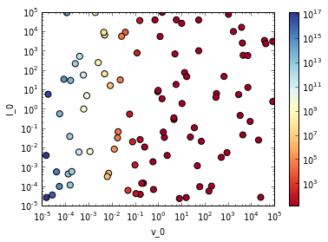

Det = 30, n = 100, w0 = 1, sigma_n = sigma_f = 1e1

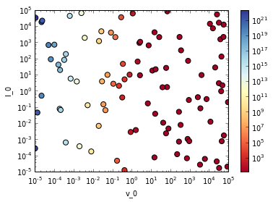

Det = 30, n = 100, w0 = 1, v_0 = l_0 = 1

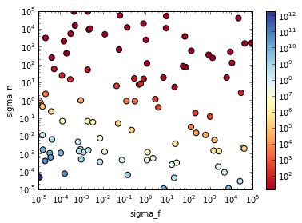

Det = 30, n = 100, w0 = 1e2, v_0 = l_0 = 1

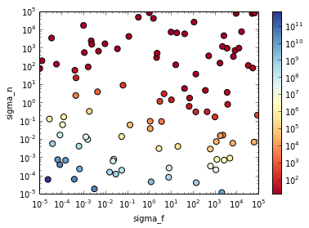

Det = 30, n = 100, w0 = 1e -2, v_0 = l_0 = 1

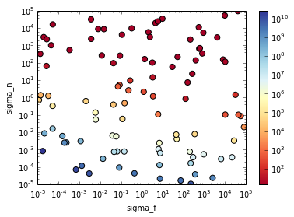

Det = 30, n = 100, l_0 = 1 , sigma_n = sigma_f = 1e1

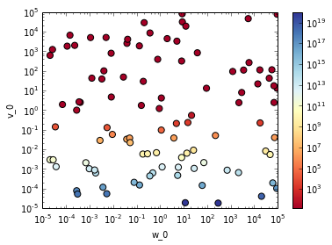

Det = 30, n = 100, l_0 = 1e2 , sigma_n = sigma_f = 1e1

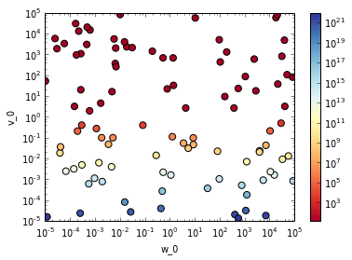

Det = 30, n = 100, l_0 = 1e-2 , sigma_n = sigma_f = 1e1

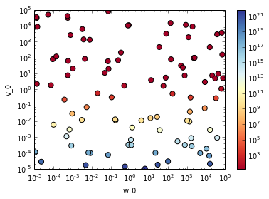

Det = 30, n = 100, l_0 = 1 , sigma_n 1e3, sigma_f = 1e1

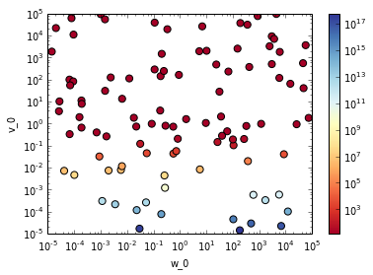

Det = 30, n = 100, l_0 = 1 , sigma_n 1e1, sigma_f = 1e3

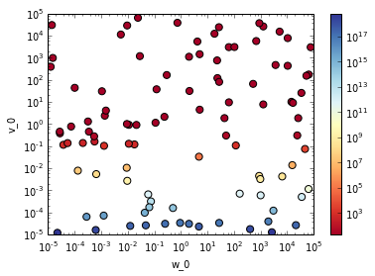

Det = 30, n = 100, l_0 = 1 , sigma_n 1e3, sigma_f = 1e3

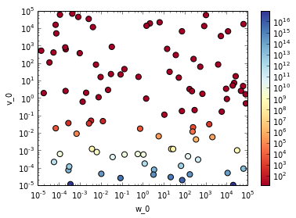

Det = 30, n = 100, l_0 = 1e2 , sigma_n 1e3, sigma_f = 1e3

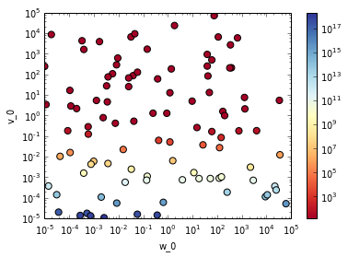

Det = 30, n = 100, l_0 = 1e-2 , sigma_n 1e3, sigma_f = 1e3

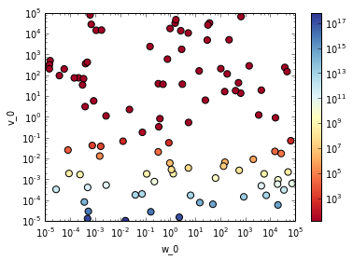

Det = 30, n = 100, v_0 = 1 , sigma_n 1e3, sigma_f = 1e3

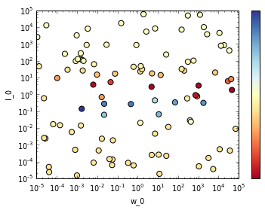

Det = 30, n = 100, w_0 = l_0 = 1 , sigma_f = 1e3

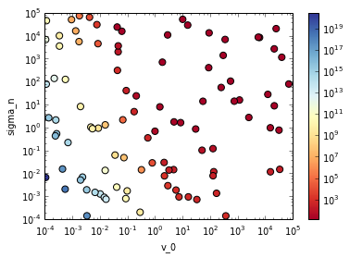

conclusie: v_0: hoger beter (vanaf 1)

w_0 maakt ni veel uit

l_0 maakt ni veel uit maar best rond 1

sigma_n en f hoger beter (vanaf 10)