# Gaussian Processes

theta0 = np.array((1e-3,10,1,10,10)) #w0,v0, l0,sigmaf,sigman

thetaL =np.array((1e-5,1e-1,1e-1,1e-4,1e-3))

thetaU =np.array((1e2,1e4,1e4,1e2,1e4))

# determinanten: 15 yalsdet

de red lik waarde, -14.4138296131

geoptimaliseerde parameters theta zijn [ 1.28733040e-04 3.28253688e+01 2.90834032e+00 3.36928782e+02
2.38697303e+02 1.91788693e+01 6.83406490e+01 2.23110839e+02
2.28794695e+02 3.38392990e+00 1.90193090e+01 7.80600062e+01
1.11086921e+00 1.18220167e+01 5.24841615e+00 1.91741359e+01
3.14491711e+01 4.74635050e+00 4.42498904e+01 3.03646985e+01
3.07616640e+00 2.89321578e+01 4.89000964e+01 2.11940335e+00
2.25589966e+00 5.15332804e+01 7.44750776e+00 2.95511609e+00
2.70639798e+01 3.29146428e+00 2.00214348e+01 1.74514361e+01
9.06371656e+00]

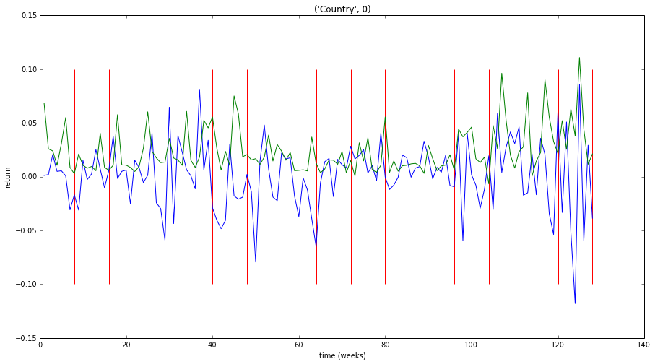

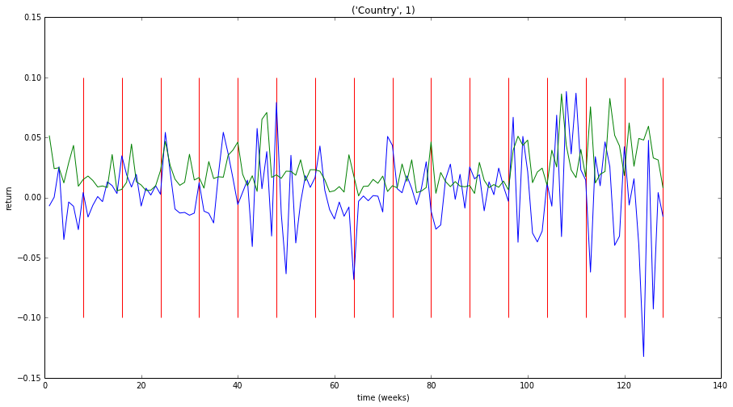

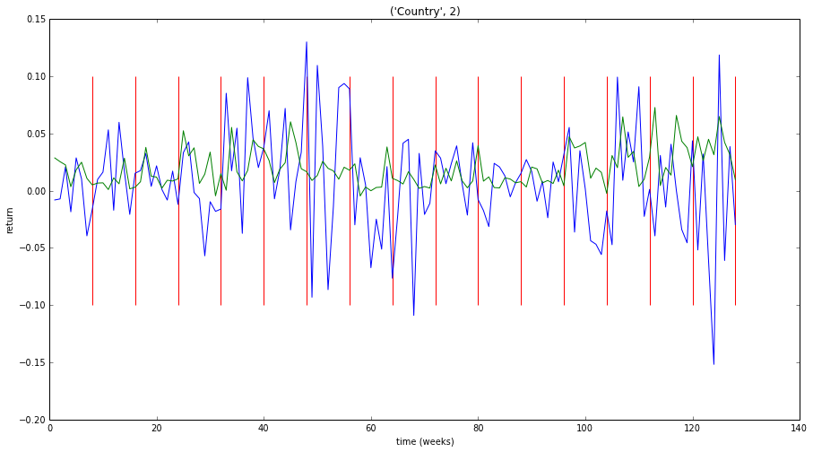

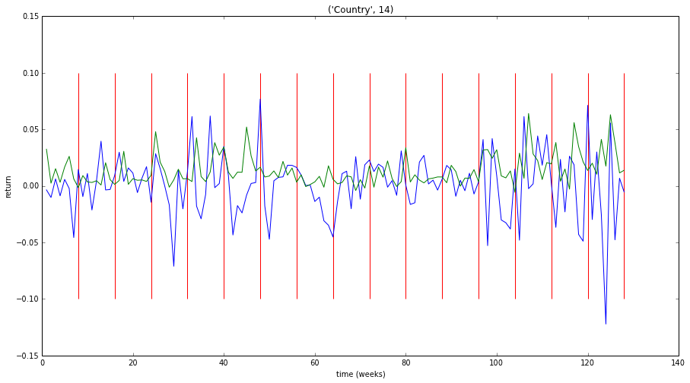

Country 0 NMSE : 2.01324415683
Country 0 hitrate : 0.5546875

Country 1 NMSE : 1.74150303225
Country 1 hitrate : 0.5703125

Country 2 NMSE : 1.19437678229
Country 2 hitrate : 0.59375

Country 3 NMSE : 1.56778369927
Country 3 hitrate : 0.5078125

Country 4 NMSE : 1.49410894496
Country 4 hitrate : 0.5625

Country 5 NMSE : 1.12167024528
Country 5 hitrate : 0.5625

Country 6 NMSE : 1.18635433688
Country 6 hitrate : 0.5

Country 7 NMSE : 1.00356612684
Country 7 hitrate : 0.6171875

Country 8 NMSE : 1.27715926571
Country 8 hitrate : 0.4765625

Country 9 NMSE : 1.88981255688
Country 9 hitrate : 0.6015625

Country 10 NMSE : 1.81972750781
Country 10 hitrate : 0.5

Country 11 NMSE : 1.53490613114
Country 11 hitrate : 0.5234375

Country 12 NMSE : 1.51478395513
Country 12 hitrate : 0.546875

Country 13 NMSE : 1.30568074517
Country 13 hitrate : 0.5078125

Country 14 NMSE : 1.4718608738
Country 14 hitrate : 0.53125

total NMSE : 22.1365383602
total hitrate : 0.54375

# determinanten = eerste 99 (15 yalsdet + 2*42 DSdet)

de red lik waarde, -14.2932357016

geoptimaliseerde parameters theta zijn [ 7.21257619e-04 1.62074369e+03 3.10003791e+00 4.10735738e+01
6.03899038e+00 7.14926219e+00 5.67404305e+01 1.80522409e+02
2.62037193e+01 4.44918909e+00 8.38025902e+00 5.62321817e+00
5.32132126e+00 8.59250060e+00 4.04188269e+00 6.25874319e+01
5.06298772e+01 9.87957336e+00 8.81932605e+01 3.68736741e+00
3.24580499e+00 5.08962726e+00 1.94602925e+02 2.71196192e+01
3.39582260e+01 1.96384412e+00 1.57221135e+02 5.91754804e+00
3.90357498e+01 1.36159616e+01 5.55870979e+01 3.38275450e-01
9.28090653e+01 2.20834145e+01 2.74066556e+02 8.60924345e+01
2.92168082e+01 1.18595579e+01 2.08172787e+01 6.04192434e+01
2.79102154e+01 1.70076373e+01 8.84910961e+01 1.70076373e+01
2.68113463e+01 9.03591264e+00 3.48340364e+01 9.03591264e+00
1.97874628e+01 1.13672329e+00 8.48712955e+01 1.13672329e+00
3.64408723e+01 1.12432232e+00 8.55414446e+00 1.00000000e+01
4.77009417e+00 1.00000000e+01 2.88215642e+01 5.82713302e+00
9.71974687e+01 1.66293692e+02 3.38454518e+02 1.00000000e+01
1.00568093e+02 1.00000000e+01 9.18009659e+01 9.37947069e-01
1.34522355e+02 9.37947069e-01 1.08700119e+01 3.42366302e+02
3.38659882e+01 1.31909918e+01 4.86591256e+01 4.25068945e+00
7.36062404e+01 1.28894681e+01 6.06820796e+01 1.00000000e+01
7.63956817e+01 1.00000000e+01 3.21261278e+01 1.00000000e+01
6.07600351e+01 1.00000000e+01 3.48855444e+00 6.13614718e+01
7.88116507e+01 1.37594560e+01 6.66700960e+02 1.45022823e+01
7.74290798e+01 7.86475316e+01 3.26938469e+02 1.24262991e+01
3.57285329e+02 3.32659944e+00 2.49419825e+02 5.20359253e+01
3.34095068e+00 5.10192746e-01 3.06598114e+00 1.59946011e+00
1.13145116e+01 1.80428815e+01 1.07984769e+01 3.48788887e-01
1.59987473e+00 4.38846654e+01 1.54236415e+00 3.42778085e+01
1.50868556e+01 1.52564102e+00 4.90264496e-01 2.63939150e+01
1.00000000e+00 1.03631662e+01 1.00000000e+00 1.39964193e+01
1.00000000e+00 1.41107127e+01 6.29045089e+00 7.18019876e+00
1.00000000e+00 6.76319234e+00 4.05469667e+00 4.25874443e+01
1.00000000e+00 1.06367184e+01 9.52441001e-01 3.68252791e+00
1.00000000e+00 5.34123674e+00 1.00000000e+00 4.74180337e+00
5.39785241e-01 9.86073536e-01 5.39785241e-01 4.92204875e-01
4.68949430e-01 6.61219749e+00 1.00000000e+00 9.79697003e-01
2.02738377e-01 2.06253545e+00 1.00000000e+00 1.07930999e+01
1.00000000e+00 1.13194995e+01 1.00000000e+00 1.73674145e+01
8.74761812e-01 9.47707709e-01 1.71705036e-01 2.79444064e+00
2.16808011e-01 7.65061011e+00 7.45005485e+00 2.81650398e+01
3.28914488e+01 1.57773664e+00 1.00000000e+00 1.16565024e+00
1.00000000e+00 6.17733004e-01 1.00000000e+00 2.88868210e+00
1.00000000e+00 9.37439235e-01 1.00000000e+00 2.50250571e+01
4.69073316e+00 5.06924297e+01 2.09971619e-01 3.01341309e-01
1.05302254e+00 2.38024825e+01 1.06746931e+00 5.00820908e+01
2.93208601e-01 4.54483386e+01 1.00000000e+00 4.16224088e+00
1.00000000e+00 8.45175518e+00 1.00000000e+00 1.87268246e+01
1.00000000e+00 4.51529382e+01 4.48421148e-01 1.63047507e+00
2.28450897e+00 1.94838415e+01 1.00000000e+00 2.55424254e+01
2.02251797e-01 9.84064656e-01 4.80163951e-01 8.57666174e+00
3.19198900e-01]

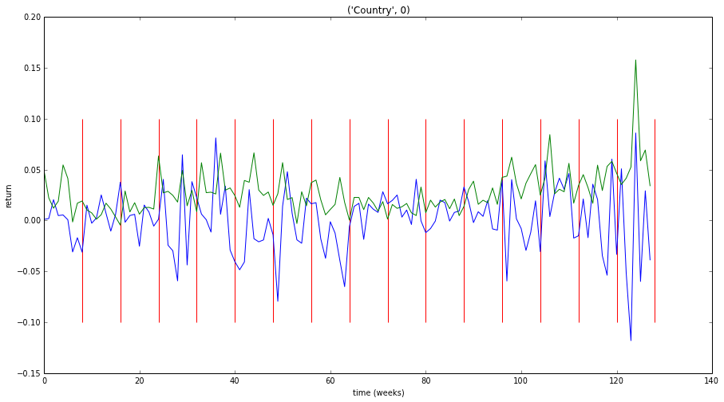

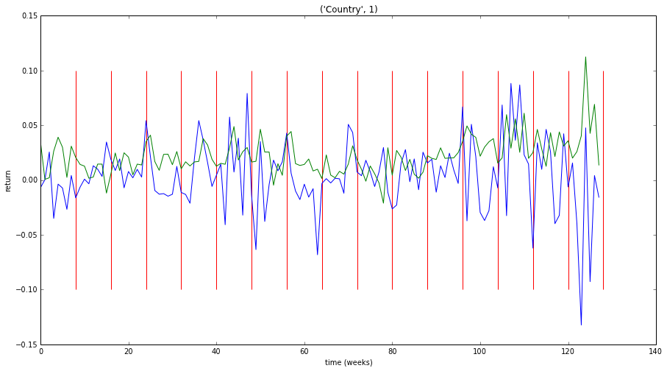

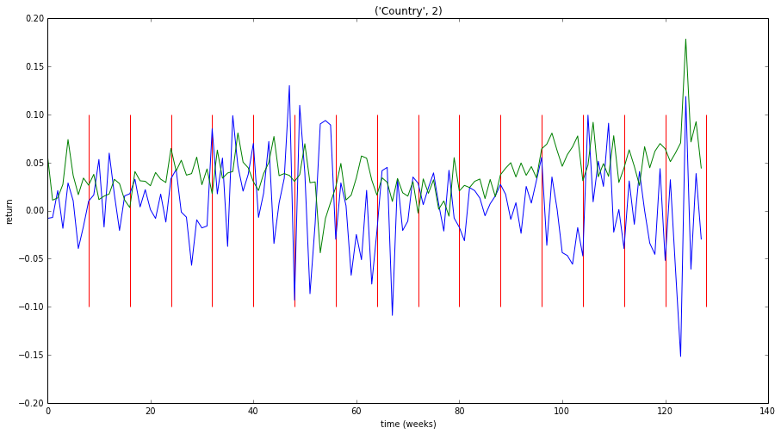

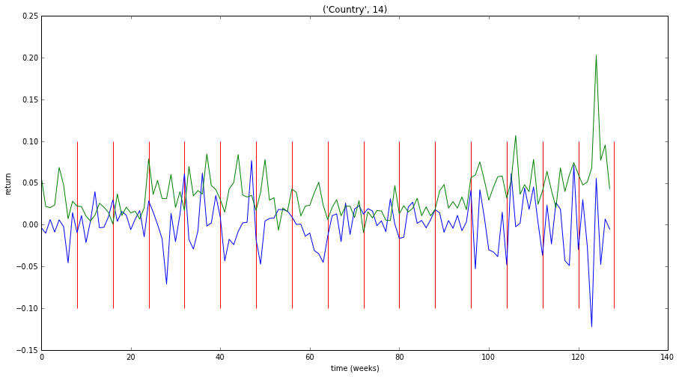

Country 0 NMSE : 1.99011466818
Country 0 hitrate : 0.5703125

Country 1 NMSE : 1.53436031703
Country 1 hitrate : 0.53125

Country 2 NMSE : 1.80953752782
Country 2 hitrate : 0.5546875

Country 3 NMSE : 1.94683263476
Country 3 hitrate : 0.5078125

Country 4 NMSE : 1.61143694119
Country 4 hitrate : 0.5234375

Country 5 NMSE : 1.60641805056
Country 5 hitrate : 0.5390625

Country 6 NMSE : 2.40059289485
Country 6 hitrate : 0.4765625

Country 7 NMSE : 1.00376247152
Country 7 hitrate : 0.6171875

Country 8 NMSE : 2.76167787247
Country 8 hitrate : 0.4921875

Country 9 NMSE : 1.03977882404
Country 9 hitrate : 0.546875

Country 10 NMSE : 1.27040070577
Country 10 hitrate : 0.546875

Country 11 NMSE : 2.55845814015
Country 11 hitrate : 0.5078125

Country 12 NMSE : 1.73046978583
Country 12 hitrate : 0.5390625

Country 13 NMSE : 3.72910559299
Country 13 hitrate : 0.5546875

Country 14 NMSE : 3.30374744471
Country 14 hitrate : 0.5546875

total NMSE : 30.2966938719
total hitrate : 0.5375

# Determinanten = 191

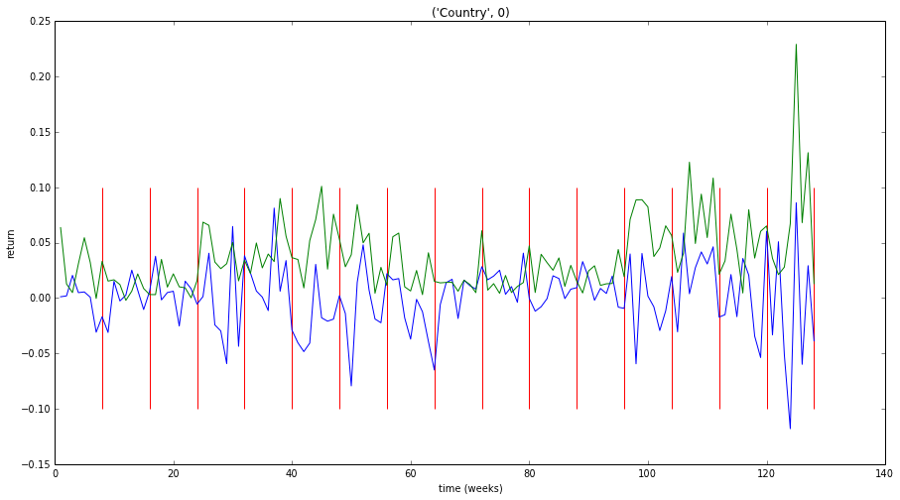

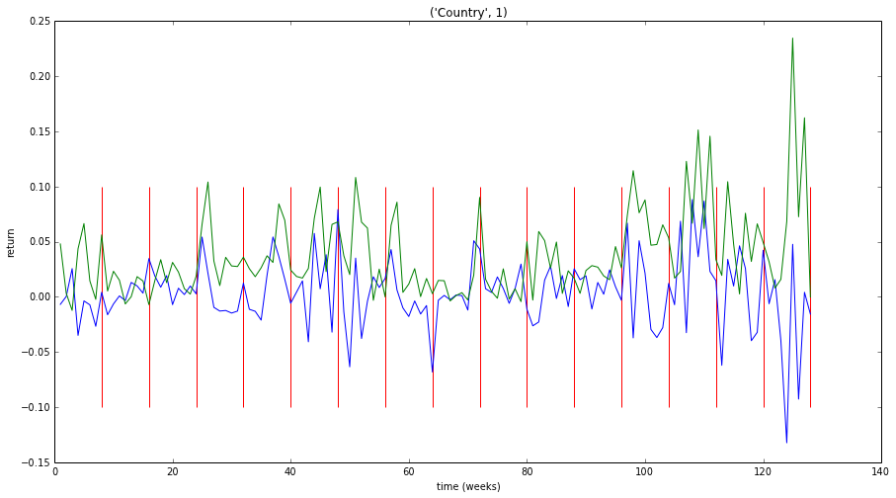

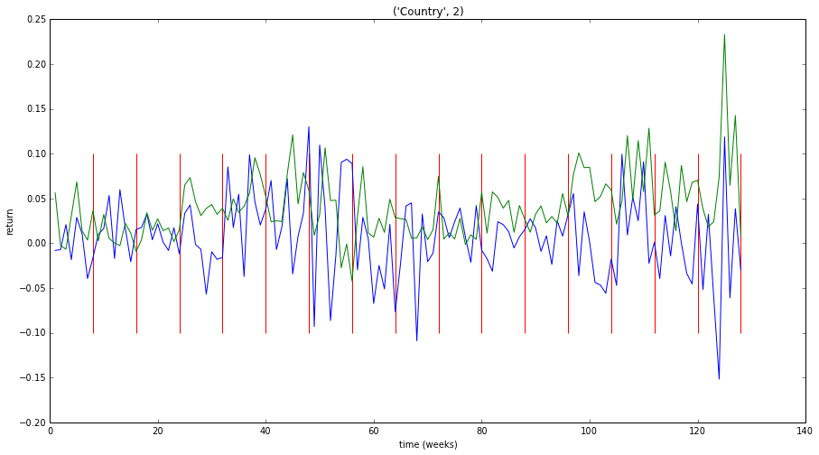

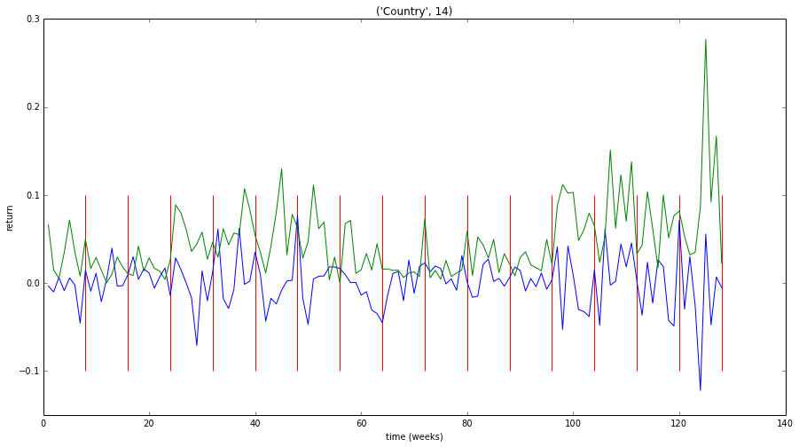

Country 0 NMSE : 2.94343110231
Country 0 hitrate : 0.5625

Country 1 NMSE : 3.20157060949
Country 1 hitrate : 0.578125

Country 2 NMSE : 1.99456861117
Country 2 hitrate : 0.5390625

Country 3 NMSE : 2.68545390978
Country 3 hitrate : 0.5078125

Country 4 NMSE : 2.68569407395
Country 4 hitrate : 0.546875

Country 5 NMSE : 2.49577206422
Country 5 hitrate : 0.5234375

Country 6 NMSE : 4.20460797576
Country 6 hitrate : 0.4921875

Country 7 NMSE : 1.62642718818
Country 7 hitrate : 0.578125

Country 8 NMSE : 4.57913318433
Country 8 hitrate : 0.5

Country 9 NMSE : 1.71368905732
Country 9 hitrate : 0.5546875

Country 10 NMSE : 1.23724979226
Country 10 hitrate : 0.5078125

Country 11 NMSE : 4.55264313982
Country 11 hitrate : 0.5078125

Country 12 NMSE : 2.90493330971
Country 12 hitrate : 0.546875

Country 13 NMSE : 5.09070752178
Country 13 hitrate : 0.5625

Country 14 NMSE : 5.21791769617
Country 14 hitrate : 0.5625

total NMSE : 47.1337992363
total hitrate : 0.538020833333

# Linear Regression

# determinanten: 15 yalsdet

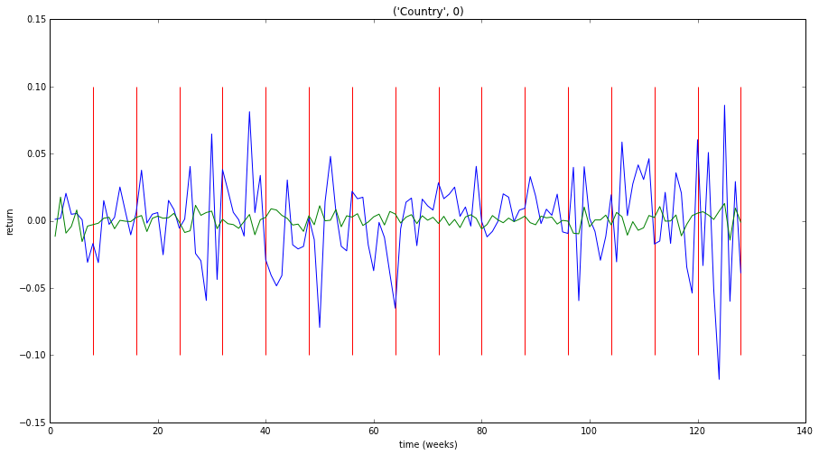 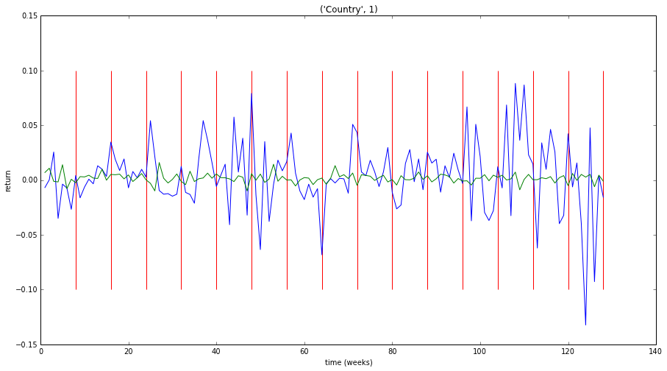 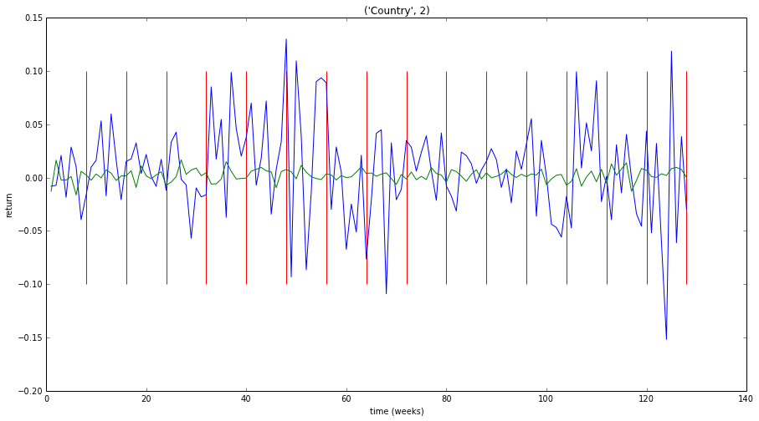 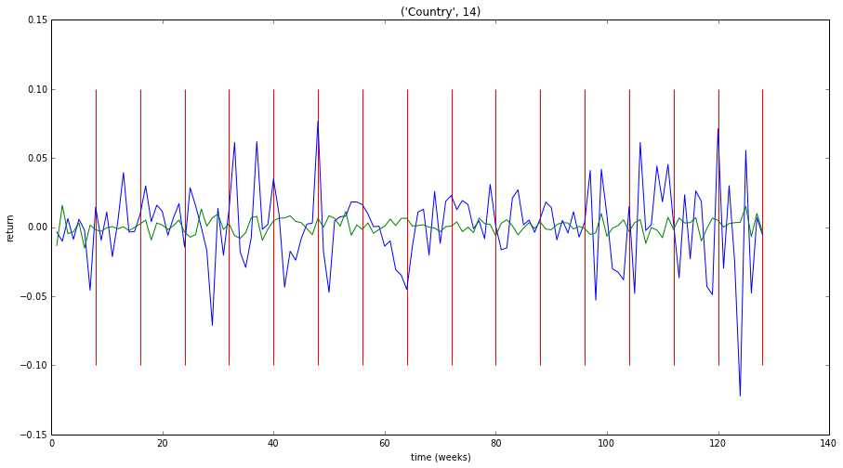

Country 0 NMSE : 1.03370872433
Country 0 hitrate : 0.5390625

Country 1 NMSE : 1.02018233649
Country 1 hitrate : 0.5234375

Country 2 NMSE : 1.04491189039
Country 2 hitrate : 0.4140625

Country 3 NMSE : 1.03203824934
Country 3 hitrate : 0.4765625

Country 4 NMSE : 1.06849905677
Country 4 hitrate : 0.4609375

Country 5 NMSE : 1.03007376805
Country 5 hitrate : 0.578125

Country 6 NMSE : 1.04732483599
Country 6 hitrate : 0.515625

Country 7 NMSE : 1.01607887439
Country 7 hitrate : 0.5390625

Country 8 NMSE : 1.05867672693
Country 8 hitrate : 0.453125

Country 9 NMSE : 1.03176046777
Country 9 hitrate : 0.4921875

Country 10 NMSE : 1.0303945476
Country 10 hitrate : 0.4921875

Country 11 NMSE : 1.0033498513
Country 11 hitrate : 0.5078125

Country 12 NMSE : 1.01414693516
Country 12 hitrate : 0.4609375

Country 13 NMSE : 1.0459819449
Country 13 hitrate : 0.4765625

Country 14 NMSE : 1.03705717184
Country 14 hitrate : 0.4921875

total NMSE : 15.5141853813
total hitrate : 0.494791666667

# determinanten = eerste 99 (15 yalsdet + 2*42 DSdet)

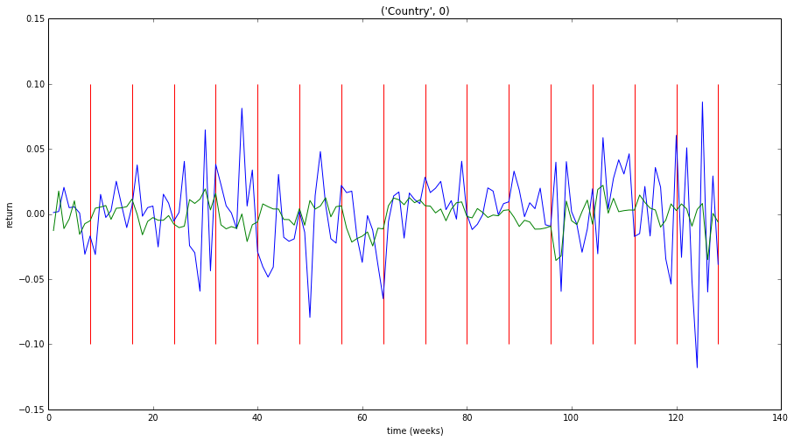 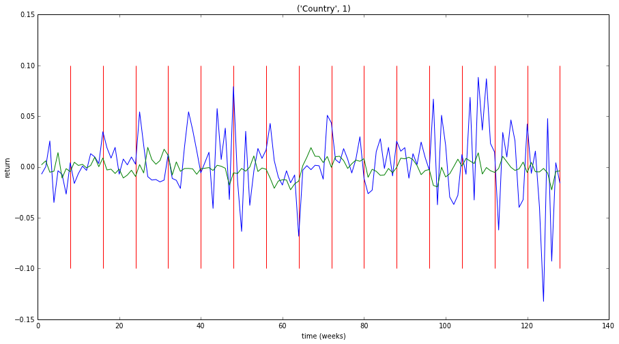 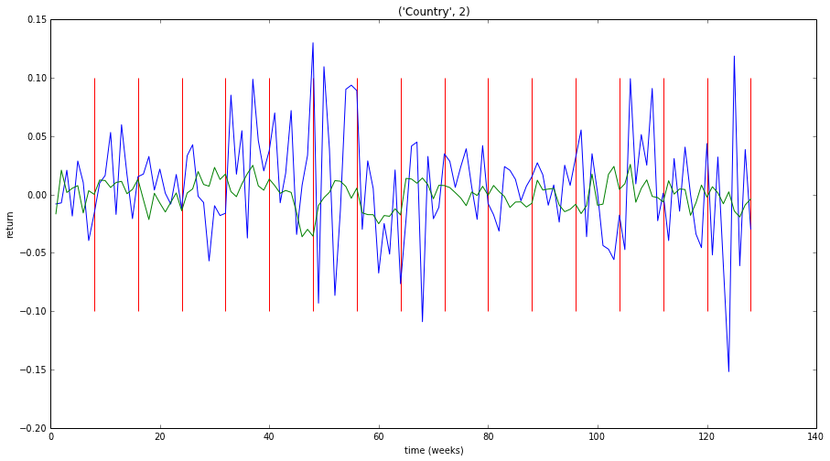

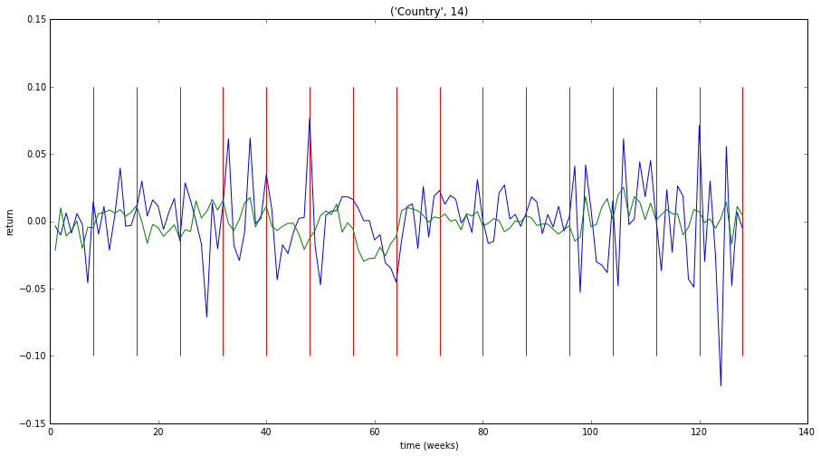

Country 0 NMSE : 1.00296774748
Country 0 hitrate : 0.5546875

Country 1 NMSE : 1.01818381827
Country 1 hitrate : 0.46875

Country 2 NMSE : 1.09105919226
Country 2 hitrate : 0.5

Country 3 NMSE : 1.04112022835
Country 3 hitrate : 0.4921875

Country 4 NMSE : 1.088637815
Country 4 hitrate : 0.4765625

Country 5 NMSE : 1.00623565422
Country 5 hitrate : 0.5859375

Country 6 NMSE : 1.15044664116
Country 6 hitrate : 0.5390625

Country 7 NMSE : 1.16164491607
Country 7 hitrate : 0.5234375

Country 8 NMSE : 1.04833524557
Country 8 hitrate : 0.5234375

Country 9 NMSE : 1.00556532251
Country 9 hitrate : 0.53125

Country 10 NMSE : 1.21481967357
Country 10 hitrate : 0.4609375

Country 11 NMSE : 1.03133440456
Country 11 hitrate : 0.5859375

Country 12 NMSE : 1.04671748955
Country 12 hitrate : 0.484375

Country 13 NMSE : 1.07597265009
Country 13 hitrate : 0.5

Country 14 NMSE : 1.01458155381
Country 14 hitrate : 0.5703125

total NMSE : 15.9976223525
total hitrate : 0.519791666667

# determinanten = alle 1505

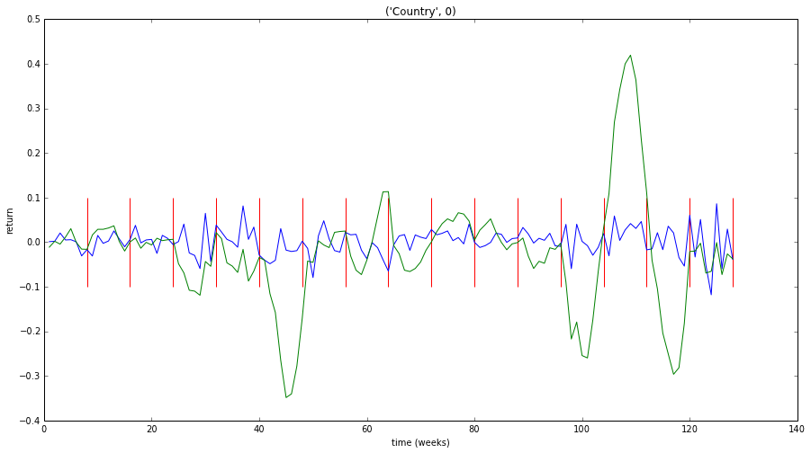 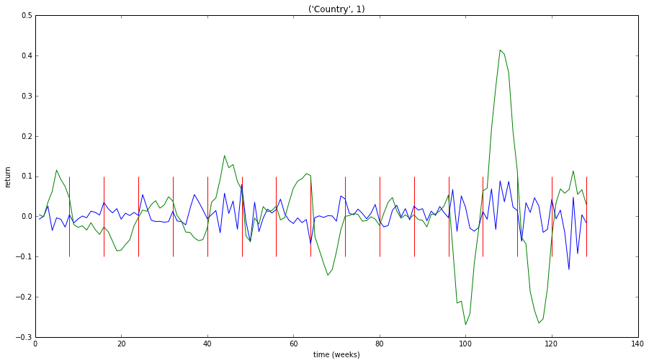 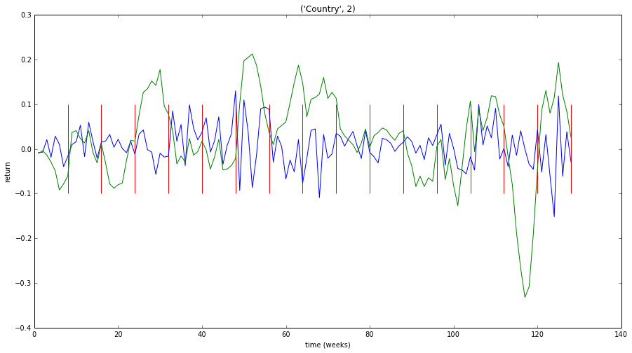

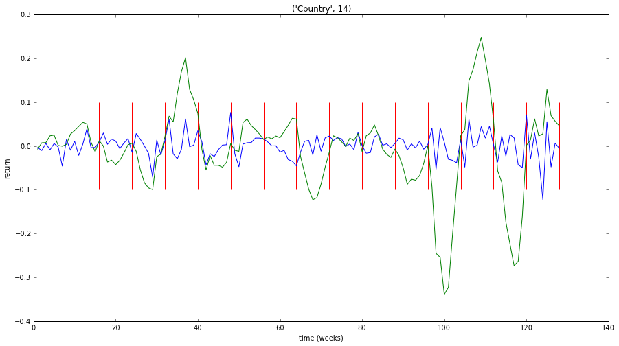

Country 0 NMSE : 14.490422604
Country 0 hitrate : 0.546875

Country 1 NMSE : 11.5406228737
Country 1 hitrate : 0.46875

Country 2 NMSE : 5.24429086944
Country 2 hitrate : 0.5078125

Country 3 NMSE : 15.2224064019
Country 3 hitrate : 0.546875

Country 4 NMSE : 15.4830994554
Country 4 hitrate : 0.4765625

Country 5 NMSE : 13.0074466874
Country 5 hitrate : 0.46875

Country 6 NMSE : 12.9407980039
Country 6 hitrate : 0.5546875

Country 7 NMSE : 8.00305664638
Country 7 hitrate : 0.546875

Country 8 NMSE : 15.0578518984
Country 8 hitrate : 0.546875

Country 9 NMSE : 10.6277272821
Country 9 hitrate : 0.5390625

Country 10 NMSE : 10.360106983
Country 10 hitrate : 0.4765625

Country 11 NMSE : 15.6897243975
Country 11 hitrate : 0.453125

Country 12 NMSE : 6.56122583131
Country 12 hitrate : 0.5

Country 13 NMSE : 13.7775132712
Country 13 hitrate : 0.4921875

Country 14 NMSE : 11.1865369995
Country 14 hitrate : 0.5546875

total NMSE : 179.192830205
total hitrate : 0.511979166667

# Ridge Regression

# Determinanten = 15 yalsdet

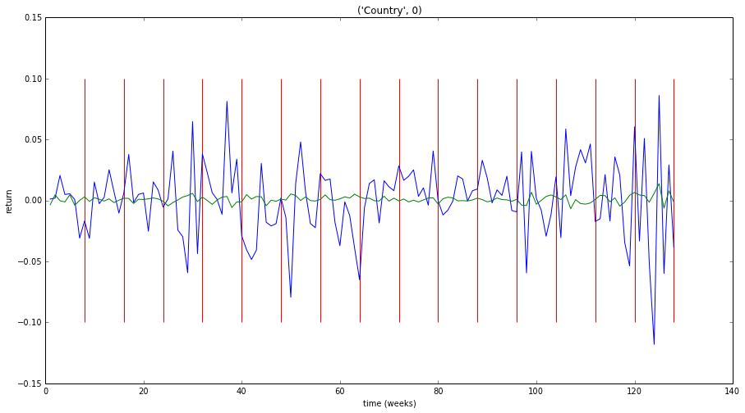

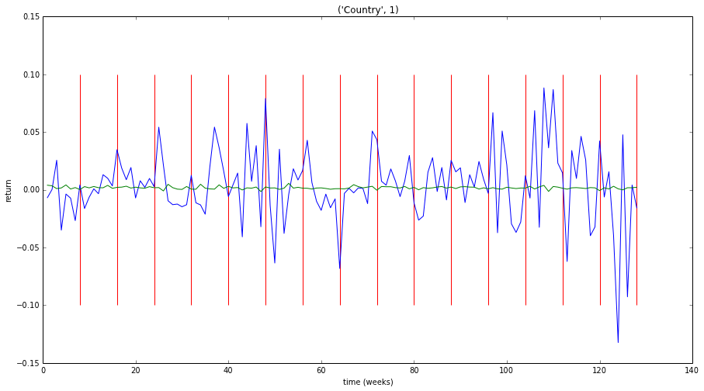

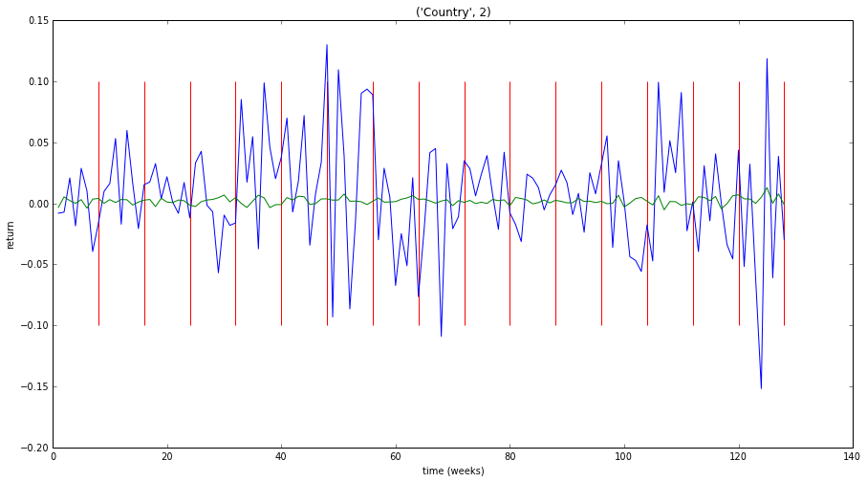

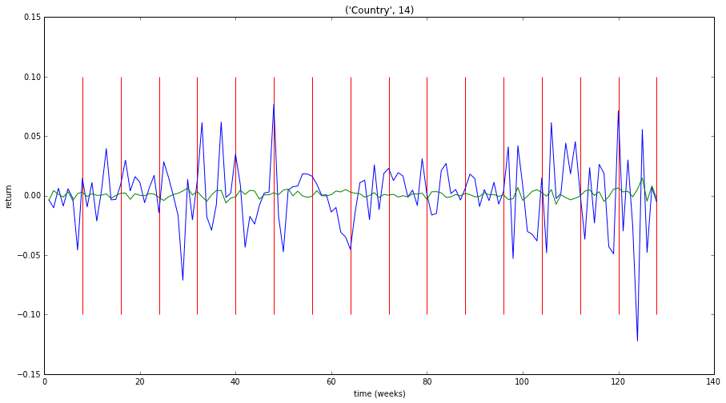

Country 0 NMSE : 0.988589501638
Country 0 hitrate : 0.5

Country 1 NMSE : 1.00322530178
Country 1 hitrate : 0.5546875

Country 2 NMSE : 1.01183207414
Country 2 hitrate : 0.5078125

Country 3 NMSE : 0.996614780054
Country 3 hitrate : 0.4921875

Country 4 NMSE : 1.0157057129
Country 4 hitrate : 0.515625

Country 5 NMSE : 0.994870946346
Country 5 hitrate : 0.59375

Country 6 NMSE : 1.0048772976
Country 6 hitrate : 0.4921875

Country 7 NMSE : 0.999588693868
Country 7 hitrate : 0.59375

Country 8 NMSE : 1.00993606311
Country 8 hitrate : 0.46875

Country 9 NMSE : 0.999981132822
Country 9 hitrate : 0.515625

Country 10 NMSE : 1.00183288902
Country 10 hitrate : 0.5234375

Country 11 NMSE : 0.999466077989
Country 11 hitrate : 0.546875

Country 12 NMSE : 0.993544428964
Country 12 hitrate : 0.546875

Country 13 NMSE : 0.998949100906
Country 13 hitrate : 0.5703125

Country 14 NMSE : 1.00543309487
Country 14 hitrate : 0.546875

total NMSE : 15.024447096
total hitrate : 0.53125

# Determinanten = 99

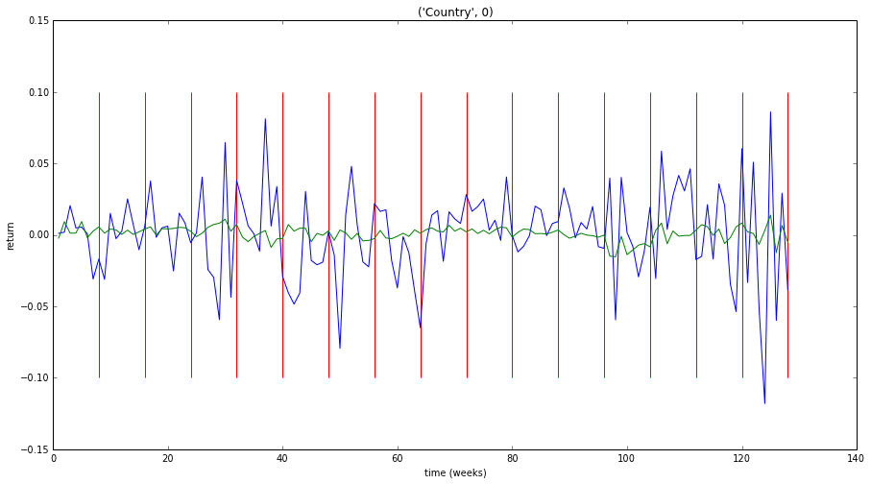

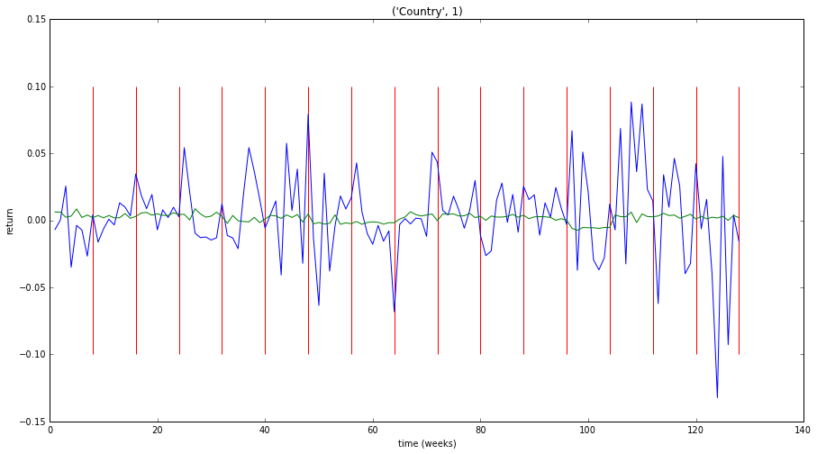

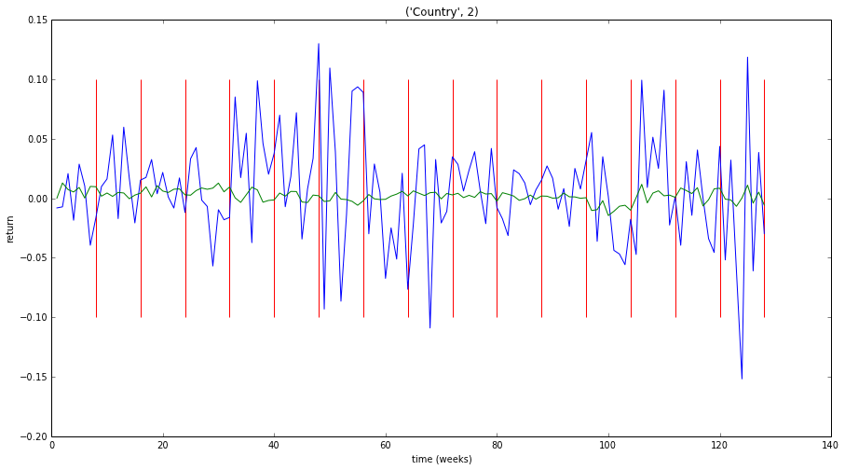

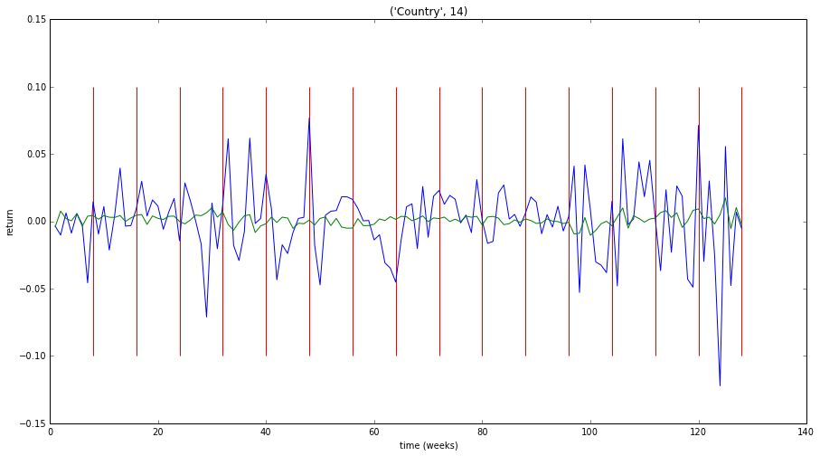

Country 0 NMSE : 0.966810465903
Country 0 hitrate : 0.5625

Country 1 NMSE : 0.987714219246
Country 1 hitrate : 0.5859375

Country 2 NMSE : 0.997222713147
Country 2 hitrate : 0.5546875

Country 3 NMSE : 0.981885672388
Country 3 hitrate : 0.515625

Country 4 NMSE : 1.01113099598
Country 4 hitrate : 0.5390625

Country 5 NMSE : 0.969792842652
Country 5 hitrate : 0.609375

Country 6 NMSE : 0.991144890523
Country 6 hitrate : 0.59375

Country 7 NMSE : 0.983365325918
Country 7 hitrate : 0.625

Country 8 NMSE : 0.993129030203
Country 8 hitrate : 0.5390625

Country 9 NMSE : 0.981780975504
Country 9 hitrate : 0.5625

Country 10 NMSE : 1.00781856351
Country 10 hitrate : 0.515625

Country 11 NMSE : 0.984732212973
Country 11 hitrate : 0.515625

Country 12 NMSE : 0.974646711004
Country 12 hitrate : 0.515625

Country 13 NMSE : 0.982535684149
Country 13 hitrate : 0.5

Country 14 NMSE : 0.986938525506
Country 14 hitrate : 0.5546875

total NMSE : 14.8006488286
total hitrate : 0.552604166667

# Determinanten = alle 1505

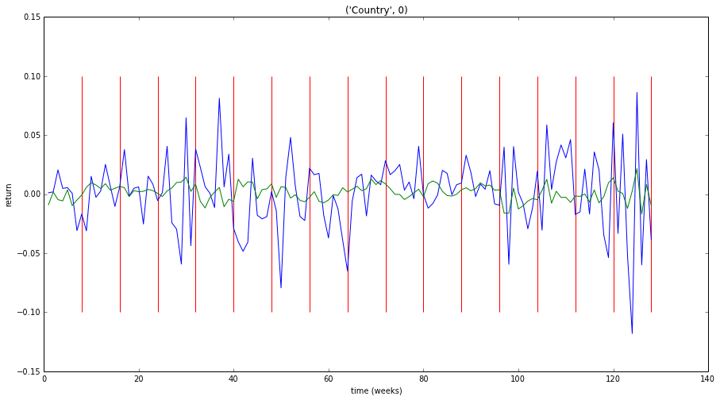

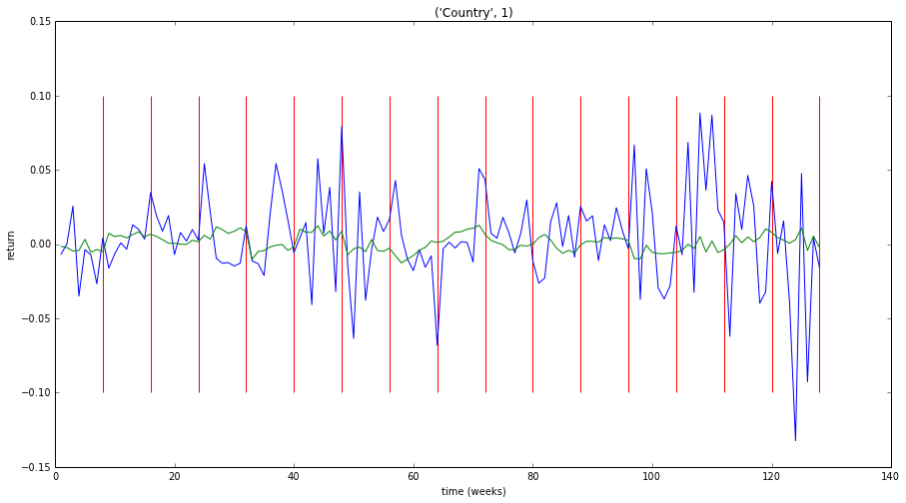

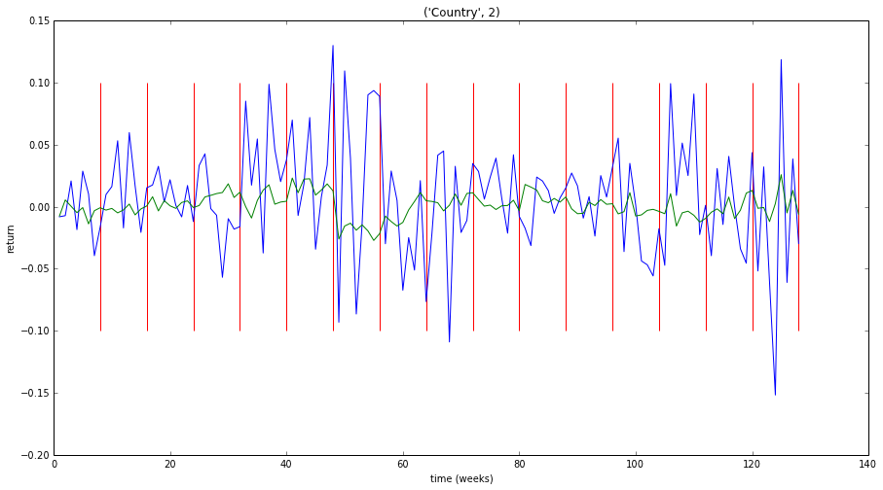

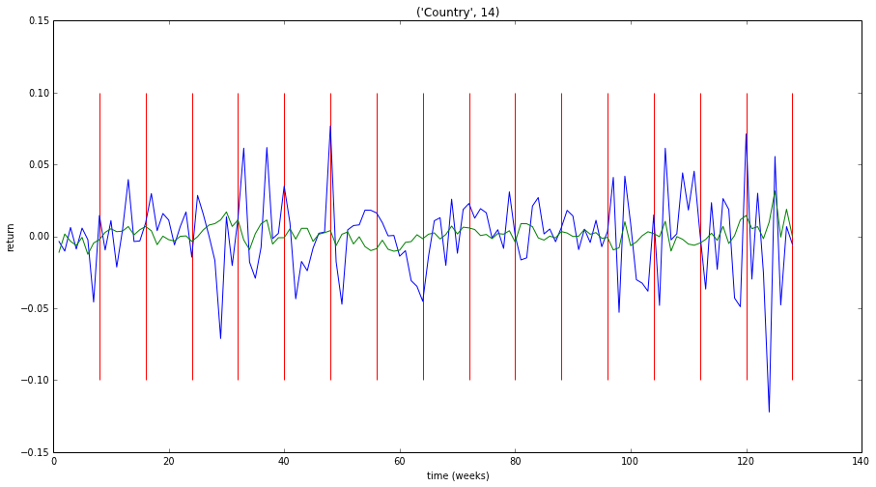

Country 0 NMSE : 0.959558385812
Country 0 hitrate : 0.5390625

Country 1 NMSE : 0.983761036318
Country 1 hitrate : 0.5546875

Country 2 NMSE : 0.999933482761
Country 2 hitrate : 0.578125

Country 3 NMSE : 0.966852142151
Country 3 hitrate : 0.5703125

Country 4 NMSE : 1.02258709479
Country 4 hitrate : 0.53125

Country 5 NMSE : 0.945629181104
Country 5 hitrate : 0.6640625

Country 6 NMSE : 0.988438887662
Country 6 hitrate : 0.5703125

Country 7 NMSE : 0.981211220244
Country 7 hitrate : 0.609375

Country 8 NMSE : 0.977708059263
Country 8 hitrate : 0.5859375

Country 9 NMSE : 0.947672517593
Country 9 hitrate : 0.609375

Country 10 NMSE : 1.00599135785
Country 10 hitrate : 0.5390625

Country 11 NMSE : 1.01834669568
Country 11 hitrate : 0.5234375

Country 12 NMSE : 0.967384620274
Country 12 hitrate : 0.5546875

Country 13 NMSE : 0.996351831114
Country 13 hitrate : 0.5078125

Country 14 NMSE : 0.989575523418
Country 14 hitrate : 0.53125

total NMSE : 14.751002036
total hitrate : 0.564583333333