Nathan Pish
Midterm 3 Section 1 Solutions
December 6, 2007

1.
 | Value of game = 5  An optimal strategy for Row Player is: (0,0,1,0,0,0)  An optimal strategy for Column Player is: (0,1,0,0,0,0,0)
  1 | 2 | 3 | 4 | 1 | 2 | 6
  6 | 3 | 4 | 5 | 4 | 6 | 5
  5 | 5 | 6 | 5 | 5 | 7 | 6
  0 | 0 | 1 | 1 | 4 | 2 | 0
  1 | 1 | 4 | 3 | 2 | 4 | 0
  4 | 1 | 2 | 1 | 3 | 6 | 0

2.
 | Value of game = 2  An optimal strategy for Row Player is: (,0,,,0)  An optimal strategy for Column Player is: (0,0,0,0,1,0,0)
  1 | 2 | 3 | 1 | 2 | 4 | 5
  3 | 1 | 4 | 4 | 2 | 5 | 4
  3 | 3 | 2 | 5 | 2 | 3 | 1
  5 | 1 | 4 | 5 | 2 | 3 | 2
  4 | 1 | 2 | 4 | 2 | 1 | 3

3.
 | Value of game = 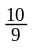  An optimal strategy for Row Player is: (0,,)  An optimal strategy for Column Player is: (0,,0,)
  2 | 0 | 2 | -2
  2 | -2 | 0 | 5
  4 | 2 | 5 | 0

4. Find the least-squares solutions 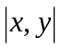 for the system
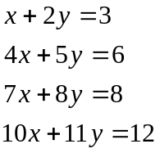
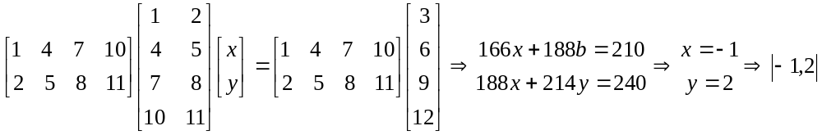

5. Find the mean, the midrange, and the central value for the following numbers:
0,-1,3,4,5,-1,7,8,9,10,0,-1
We can order this set from least to greatest: -1, -1, -1, 0, 0, 3, 4, 5, 7, 8, 9, 10
Mean = 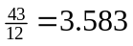
Midrange = 4.5
Central Value = 3.5

