Ken Czuprynski 2-5, LV 1.
1. Restricted Nim. Last move wins. Players alternate and can take 1,5, or 6 stones in a move from a pile. Initial position: 2 piles, 10 and 20 stones.
First we do one pile
stones | 0 | 1 | 2 | 3 | 4 | 5 | 6 | 7 | 8 | 9 | 10 | 11 | 12 | 13 | 14 | 15 | 16 | 17 | 18 | 19 | 20 | 21 | 22
value  take | L | W  1 | L | W  1 | L | W  1 or 5 | W  6 | W  5 | W  6 | W 5 | W  6 | L | W  1 | L | W  1 | L | W  1 or 5 | W  6 | W  5 | W  6 | W 5 | W  6 | L
Period is 11. A winning strategy:
reduce modulo 11 and then use the table.
Now we consider two piles:
10 |  |  |  |  |  |  |  |  |  |  | L
9 | W |  |  |  |  |  |  |  |  | L | 1
8 |  |  |  |  |  |  | L |  | L | 1 | L
7 |  |  |  | L |  |  |  | L | 1 | 6 | 1s
6 |  |  |  |  |  |  | L | 1 | L | 1 | L
5 |  | L |  | L |  | L | 1or 5 | 6 | 5 | 6 | 5
4 | L |  | L |  | L | 1 | 6 | 5 or 1s | 6 | 5 | 6
3 | 1s | L |  | L | 1 or 1s | L | 1 | L | 1 | 6 | 5
2 | L |  | L | 1 or 1s | L | 1,1s,or 5 | 6 | 1s | 6 | 5 | 6
1 | 1 | L | 1 or 1s | L | 1 or 1s | L | 1 | 6 | 1 or 1s | 6 | 5
0 | L | 1 | L | 1 | L | 1or 5 | 6 | 5 | 6 | 5 | 6
 | 0 | 1 | 2 | 3 | 4 | 5 | 6 | 7 | 8 | 9 | 10
1s means that we take 1 from a smaller pile (going 1 step south).
A winning strategy at (10,20): we take 1 stone from pile of 10.
Now we have (9, 20) which are congruent modulo 11.
Then we keep the numbers congruent modulo 11 if possible.
Let in position (m,n) with m, n congruent modulo 11 the second player takes x from m. Then, if possible we either take x from n or 11- x from m.
It remains to consider the case when we cannot take x from the other pile nor we can take 11-x from the same pile.
Then n < 6 and m <11, hence m = n. therefore we can take x from the other pile.

2)

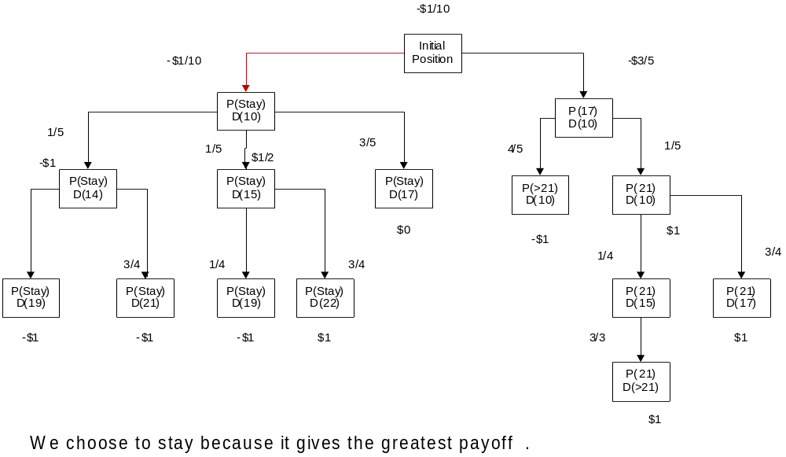
3) On the first line of solution, replace
column row
by
row,
- D.S.
