
МИНИСТЕРСТВО НАУКИ И ВЫСШЕГО ОБРАЗОВАНИЯ РФ

ФЕДЕРАЛЬНОЕ ГОСУДАРСТВЕННОЕ БЮДЖЕТНОЕ ОБРАЗОВАТЕЛЬНОЕ УЧРЕЖДЕНИЕ ВЫСШЕГО ОБРАЗОВАНИЯ «ЛИПЕЦКИЙ ГОСУДАРСТВЕННЫЙ ТЕХНИЧЕСКИЙ УНИВЕРСИТЕТ»

Институт компьютерных наук
Кафедра автоматизированных систем управления

Лабораторная работа №6
по дисциплине «Теория обработки больших массивов данных»

Студент М-РИТ-25 ____________________ Станиславчук С. М.
(подпись, дата)

Руководитель
Доцент, к.т.н. ____________________ Тюрин А. С.
(подпись, дата)

Липецк 2025
Содержание
1. Задание кафедры 2
2. Ход работы 3
3. Вывод 5
Приложение 1. docker-compose.yml 5

1. Задание кафедры
Запустите Superset, используя Docker и выведите дэшборды (WebUI).

2. Ход работы
** В ходе выполнения работы использовалось ядро GNU/Linux v6.15.4, Docker v28.3.0, Superset v5.0.0 **

Клонировал репозиторий Superset (https://github.com/apache/superset)
docker-compose.yml был уже настроен и содержал все необходимые зависимости для корректной работы. В том числе готовые базы данных.

Все контейнеры были запущены иуспешно функционируют (UP 11 minutes status)

Для того, чтобы запустить эти контейнеры пришлось сначала:
sudo docker compose up db — запустить контейнер с БД (иначе краш из-за того что контейнер superset-init будет требовать базы данных из examples, которых еще нет. Чтобы это исправить автоматически, можно было добавить «depends-on» для контейнера superset-init в docker-compose.yml, потому что из-за мягкого ограничивающего условия на моей системе все равно DB не успевал встать).
depends_on:
db:
condition: service_started # Это условие мешало полноценной инициализации DB

Когда я разобрался с одной проблемой, получил вторую.
Вторая проблема была с загрузкой webpack — он просто не мог загрузить зависимости
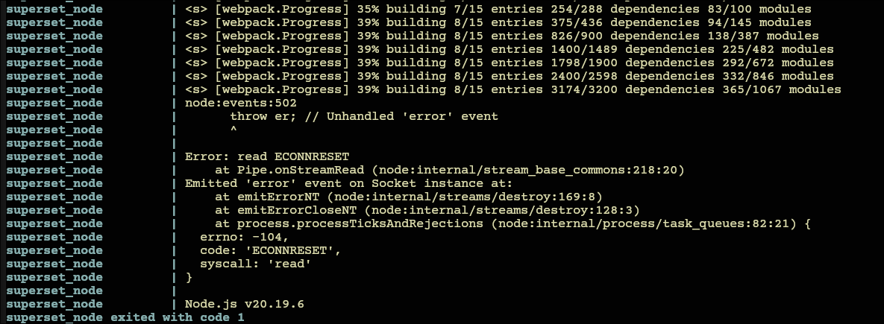
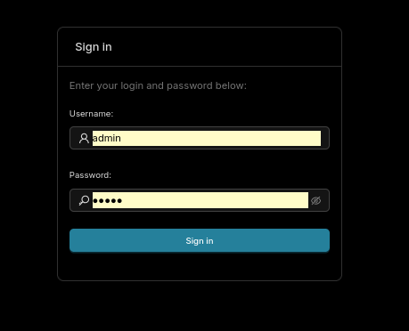
Чтобы это исправить достаточно было смены IP адреса системы, на которой запускался контейнер, на адрес из другого региона.
И, наконец, теперь localhost:8088 обновился: вместо бесконечно крутящегося логотипа Superset, меня встретил экран авторизации пользователя.
Дешборд Video Game Sales:
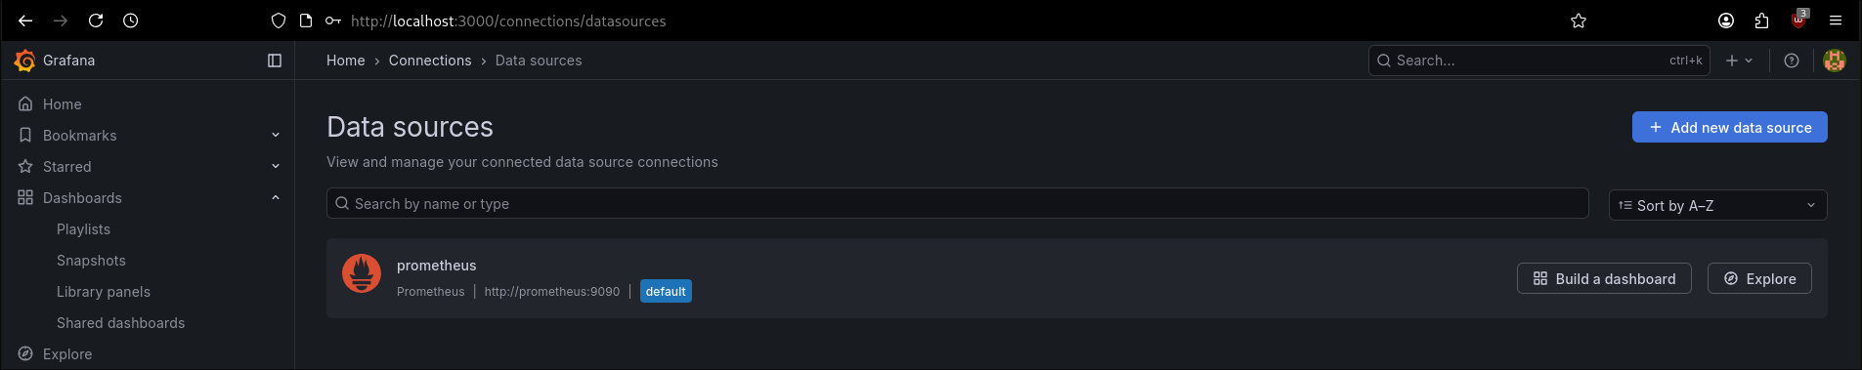
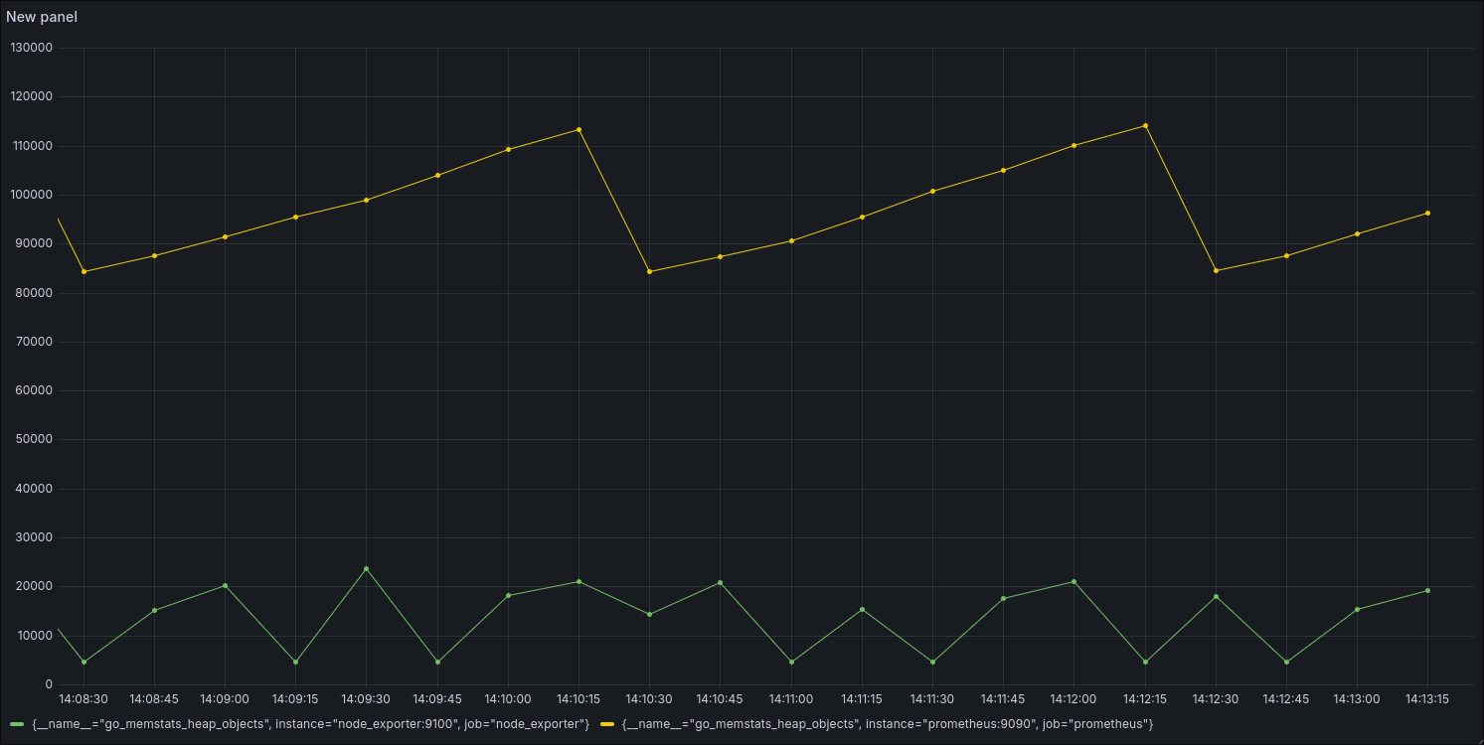
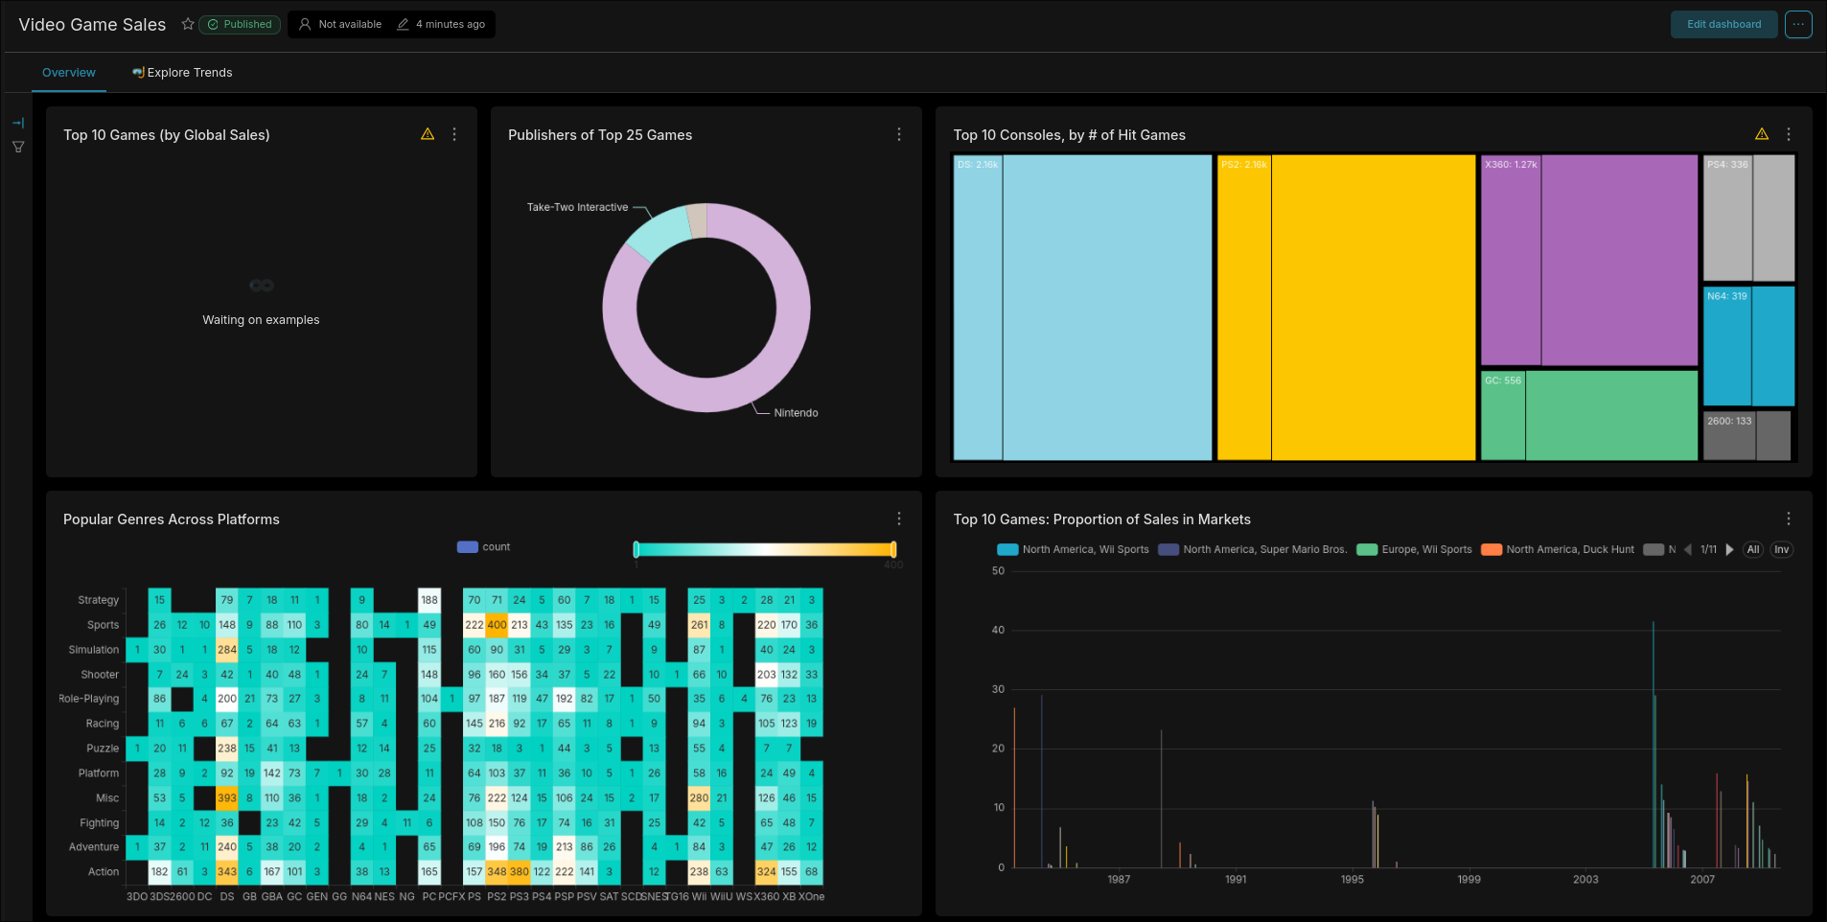
Чарт Unicode Cloud:
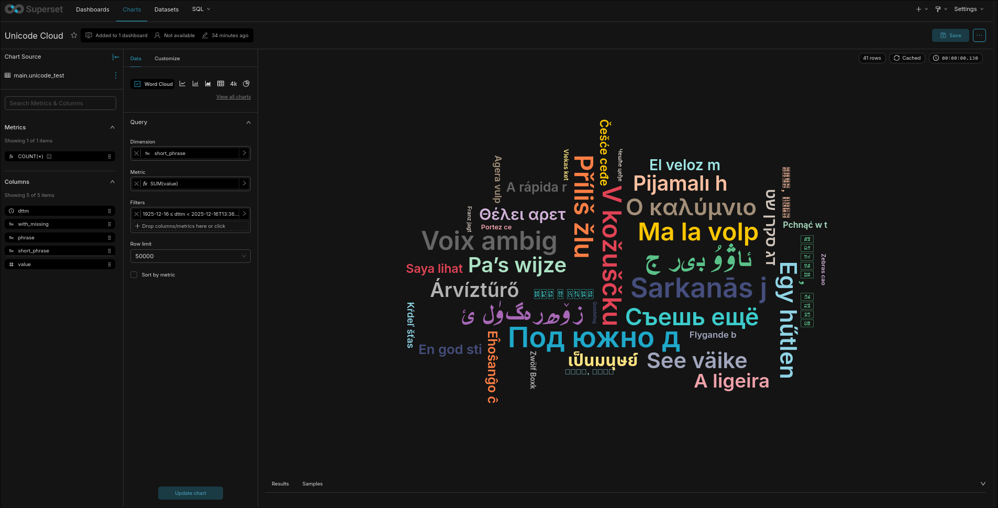

3. Вывод
В ходе выполнения лабораторной работы было запущен комлекс контейнеров для работы Superset.

Приложение 1. docker-compose.yml
#
# Licensed to the Apache Software Foundation (ASF) under one or more
# contributor license agreements. See the NOTICE file distributed with
# this work for additional information regarding copyright ownership.
# The ASF licenses this file to You under the Apache License, Version 2.0
# (the "License"); you may not use this file except in compliance with
# the License. You may obtain a copy of the License at
#
# http://www.apache.org/licenses/LICENSE-2.0
#
# Unless required by applicable law or agreed to in writing, software
# distributed under the License is distributed on an "AS IS" BASIS,
# WITHOUT WARRANTIES OR CONDITIONS OF ANY KIND, either express or implied.
# See the License for the specific language governing permissions and
# limitations under the License.
#

# -----------------------------------------------------------------------
# We don't support docker compose for production environments.
# If you choose to use this type of deployment make sure to
# create you own docker environment file (docker/.env) with your own
# unique random secure passwords and SECRET_KEY.
#
# For verbose logging during development:
# - Set SUPERSET_LOG_LEVEL=debug in docker/.env-local for detailed Superset logs
# -----------------------------------------------------------------------
x-superset-user: &superset-user root
x-superset-volumes: &superset-volumes
# /app/pythonpath_docker will be appended to the PYTHONPATH in the final container
- ./docker:/app/docker
- ./superset:/app/superset
- ./superset-core:/app/superset-core
- ./superset-frontend:/app/superset-frontend
- superset_home:/app/superset_home
- ./tests:/app/tests
- superset_data:/app/data
x-common-build: &common-build
context: .
target: ${SUPERSET_BUILD_TARGET:-dev} # can use `dev` (default) or `lean`
cache_from:
- apache/superset-cache:3.10-slim-trixie
args:
DEV_MODE: "true"
INCLUDE_CHROMIUM: ${INCLUDE_CHROMIUM:-false}
INCLUDE_FIREFOX: ${INCLUDE_FIREFOX:-false}
BUILD_TRANSLATIONS: ${BUILD_TRANSLATIONS:-false}
LOAD_EXAMPLES_DUCKDB: ${LOAD_EXAMPLES_DUCKDB:-true}

services:
nginx:
env_file:
- path: docker/.env # default
required: true
- path: docker/.env-local # optional override
required: false
image: nginx:latest
container_name: superset_nginx
restart: unless-stopped
ports:
- "80:80"
extra_hosts:
- "host.docker.internal:host-gateway"
volumes:
- ./docker/nginx/nginx.conf:/etc/nginx/nginx.conf:ro
- ./docker/nginx/templates:/etc/nginx/templates:ro

redis:
image: redis:7
container_name: superset_cache
restart: unless-stopped
ports:
- "127.0.0.1:6379:6379"
volumes:
- redis:/data

db:
env_file:
- path: docker/.env # default
required: true
- path: docker/.env-local # optional override
required: false
image: postgres:16
container_name: superset_db
restart: unless-stopped
ports:
- "127.0.0.1:5432:5432"
volumes:
- db_home:/var/lib/postgresql/data
- ./docker/docker-entrypoint-initdb.d:/docker-entrypoint-initdb.d

superset:
env_file:
- path: docker/.env # default
required: true
- path: docker/.env-local # optional override
required: false
build:
<<: *common-build
container_name: superset_app
command: ["/app/docker/docker-bootstrap.sh", "app"]
restart: unless-stopped
ports:
- 8088:8088
# When in cypress-mode ->
- 8081:8081
extra_hosts:
- "host.docker.internal:host-gateway"
user: *superset-user
depends_on:
superset-init:
condition: service_completed_successfully
volumes: *superset-volumes
environment:
SUPERSET__SQLALCHEMY_EXAMPLES_URI: "duckdb:////app/data/examples.duckdb"

superset-websocket:
container_name: superset_websocket
build: ./superset-websocket
ports:
- 8080:8080
extra_hosts:
- "host.docker.internal:host-gateway"
depends_on:
- redis
# Mount everything in superset-websocket into container and
# then exclude node_modules and dist with bogus volume mount.
# This is necessary because host and container need to have
# their own, separate versions of these files. .dockerignore
# does not seem to work when starting the service through
# docker compose.
#
# For example, node_modules may contain libs with native bindings.
# Those bindings need to be compiled for each OS and the container
# OS is not necessarily the same as host OS.
volumes:
- ./superset-websocket:/home/superset-websocket
- /home/superset-websocket/node_modules
- /home/superset-websocket/dist

# Mount config file. Create your own docker/superset-websocket/config.json
# for custom settings, then point to it here. Do not use this example in production.
- ./docker/superset-websocket/config.example.json:/home/superset-websocket/config.json:ro
environment:
- PORT=8080
- REDIS_HOST=redis
- REDIS_PORT=6379
- REDIS_SSL=false

superset-init:
build:
<<: *common-build
container_name: superset_init
command: ["/app/docker/docker-init.sh"]
env_file:
- path: docker/.env # default
required: true
- path: docker/.env-local # optional override
required: false
depends_on:
db:
condition: service_started
redis:
condition: service_started
user: *superset-user
volumes: *superset-volumes
environment:
SUPERSET__SQLALCHEMY_EXAMPLES_URI: "duckdb:////app/data/examples.duckdb"
healthcheck:
disable: true

superset-node:
build:
context: .
target: superset-node
args:
# This prevents building the frontend bundle since we'll mount local folder
# and build it on startup while firing docker-frontend.sh in dev mode, where
# it'll mount and watch local files and rebuild as you update them
DEV_MODE: "true"
BUILD_TRANSLATIONS: ${BUILD_TRANSLATIONS:-false}
environment:
# set this to false if you have perf issues running the npm i; npm run dev in-docker
# if you do so, you have to run this manually on the host, which should perform better!
BUILD_SUPERSET_FRONTEND_IN_DOCKER: true
NPM_RUN_PRUNE: false
SCARF_ANALYTICS: "${SCARF_ANALYTICS:-}"
# configuring the dev-server to use the host.docker.internal to connect to the backend
superset: "http://superset:8088"
ports:
- "127.0.0.1:9000:9000" # exposing the dynamic webpack dev server
container_name: superset_node
command: ["/app/docker/docker-frontend.sh"]
env_file:
- path: docker/.env # default
required: true
- path: docker/.env-local # optional override
required: false
volumes: *superset-volumes

superset-worker:
build:
<<: *common-build
container_name: superset_worker
command: ["/app/docker/docker-bootstrap.sh", "worker"]
env_file:
- path: docker/.env # default
required: true
- path: docker/.env-local # optional override
required: false
environment:
CELERYD_CONCURRENCY: 2
restart: unless-stopped
depends_on:
superset-init:
condition: service_completed_successfully
user: *superset-user
volumes: *superset-volumes
extra_hosts:
- "host.docker.internal:host-gateway"
healthcheck:
test: ["CMD-SHELL", "celery -A superset.tasks.celery_app:app inspect ping -d celery@$$HOSTNAME"]
# Bump memory limit if processing selenium / thumbnails on superset-worker
# mem_limit: 2038m
# mem_reservation: 128M

superset-worker-beat:
build:
<<: *common-build
container_name: superset_worker_beat
command: ["/app/docker/docker-bootstrap.sh", "beat"]
env_file:
- path: docker/.env # default
required: true
- path: docker/.env-local # optional override
required: false
restart: unless-stopped
depends_on:
- superset-worker
user: *superset-user
volumes: *superset-volumes
healthcheck:
disable: true

superset-tests-worker:
build:
<<: *common-build
container_name: superset_tests_worker
command: ["/app/docker/docker-bootstrap.sh", "worker"]
env_file:
- path: docker/.env # default
required: true
- path: docker/.env-local # optional override
required: false
profiles:
- optional
environment:
DATABASE_HOST: localhost
DATABASE_DB: test
REDIS_CELERY_DB: 2
REDIS_RESULTS_DB: 3
REDIS_HOST: localhost
CELERYD_CONCURRENCY: 8
network_mode: host
depends_on:
superset-init:
condition: service_completed_successfully
user: *superset-user
volumes: *superset-volumes
healthcheck:
test: ["CMD-SHELL", "celery inspect ping -A superset.tasks.celery_app:app -d celery@$$HOSTNAME"]

volumes:
superset_home:
external: false
db_home:
external: false
redis:
external: false
superset_data:
external: false

