# 源代码

#include <iostream>

#include <string.h>

using namespace std;

#define password "12345678"

bool VerifyPwd(char *pwd){

int flag;

flag = strcmp(password,pwd);

return flag==0;

}

int main(){

bool bFlag;

char pwd[1024];

cout<<"Please input your password:"<<endl;

while(1){

cin>> pwd;

bFlag = VerifyPwd(pwd);

if(bFlag){

cout<<"Passed"<<endl;

break;

}

else{

cout<<"Wrong Password,please input again;"<<endl;

}

}

return 0;

}

# LordPE 查看

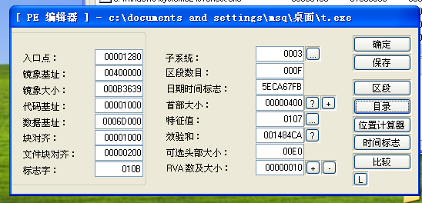

## 关键信息

入口点 RVA---00001280

镜像基址 ImageBase 00400000

代码入口点 RVA+ImageBase = 00401280

# OD运行过程

1. 从0040D5F0开始运行