Mimic Me Explained

# Feature Points

Based on my research and testing, there is a *featurePoints* json objet for each and every detected face object. The *featurePoints* has 34 key-value pairs, each one has index as the key and *featurePoint* object as the value. The coordinates of a feature point are the *x* and *y* properties of that *featurePoint* object.

In this project, I used blue circles to show the feature points. Illustration as below.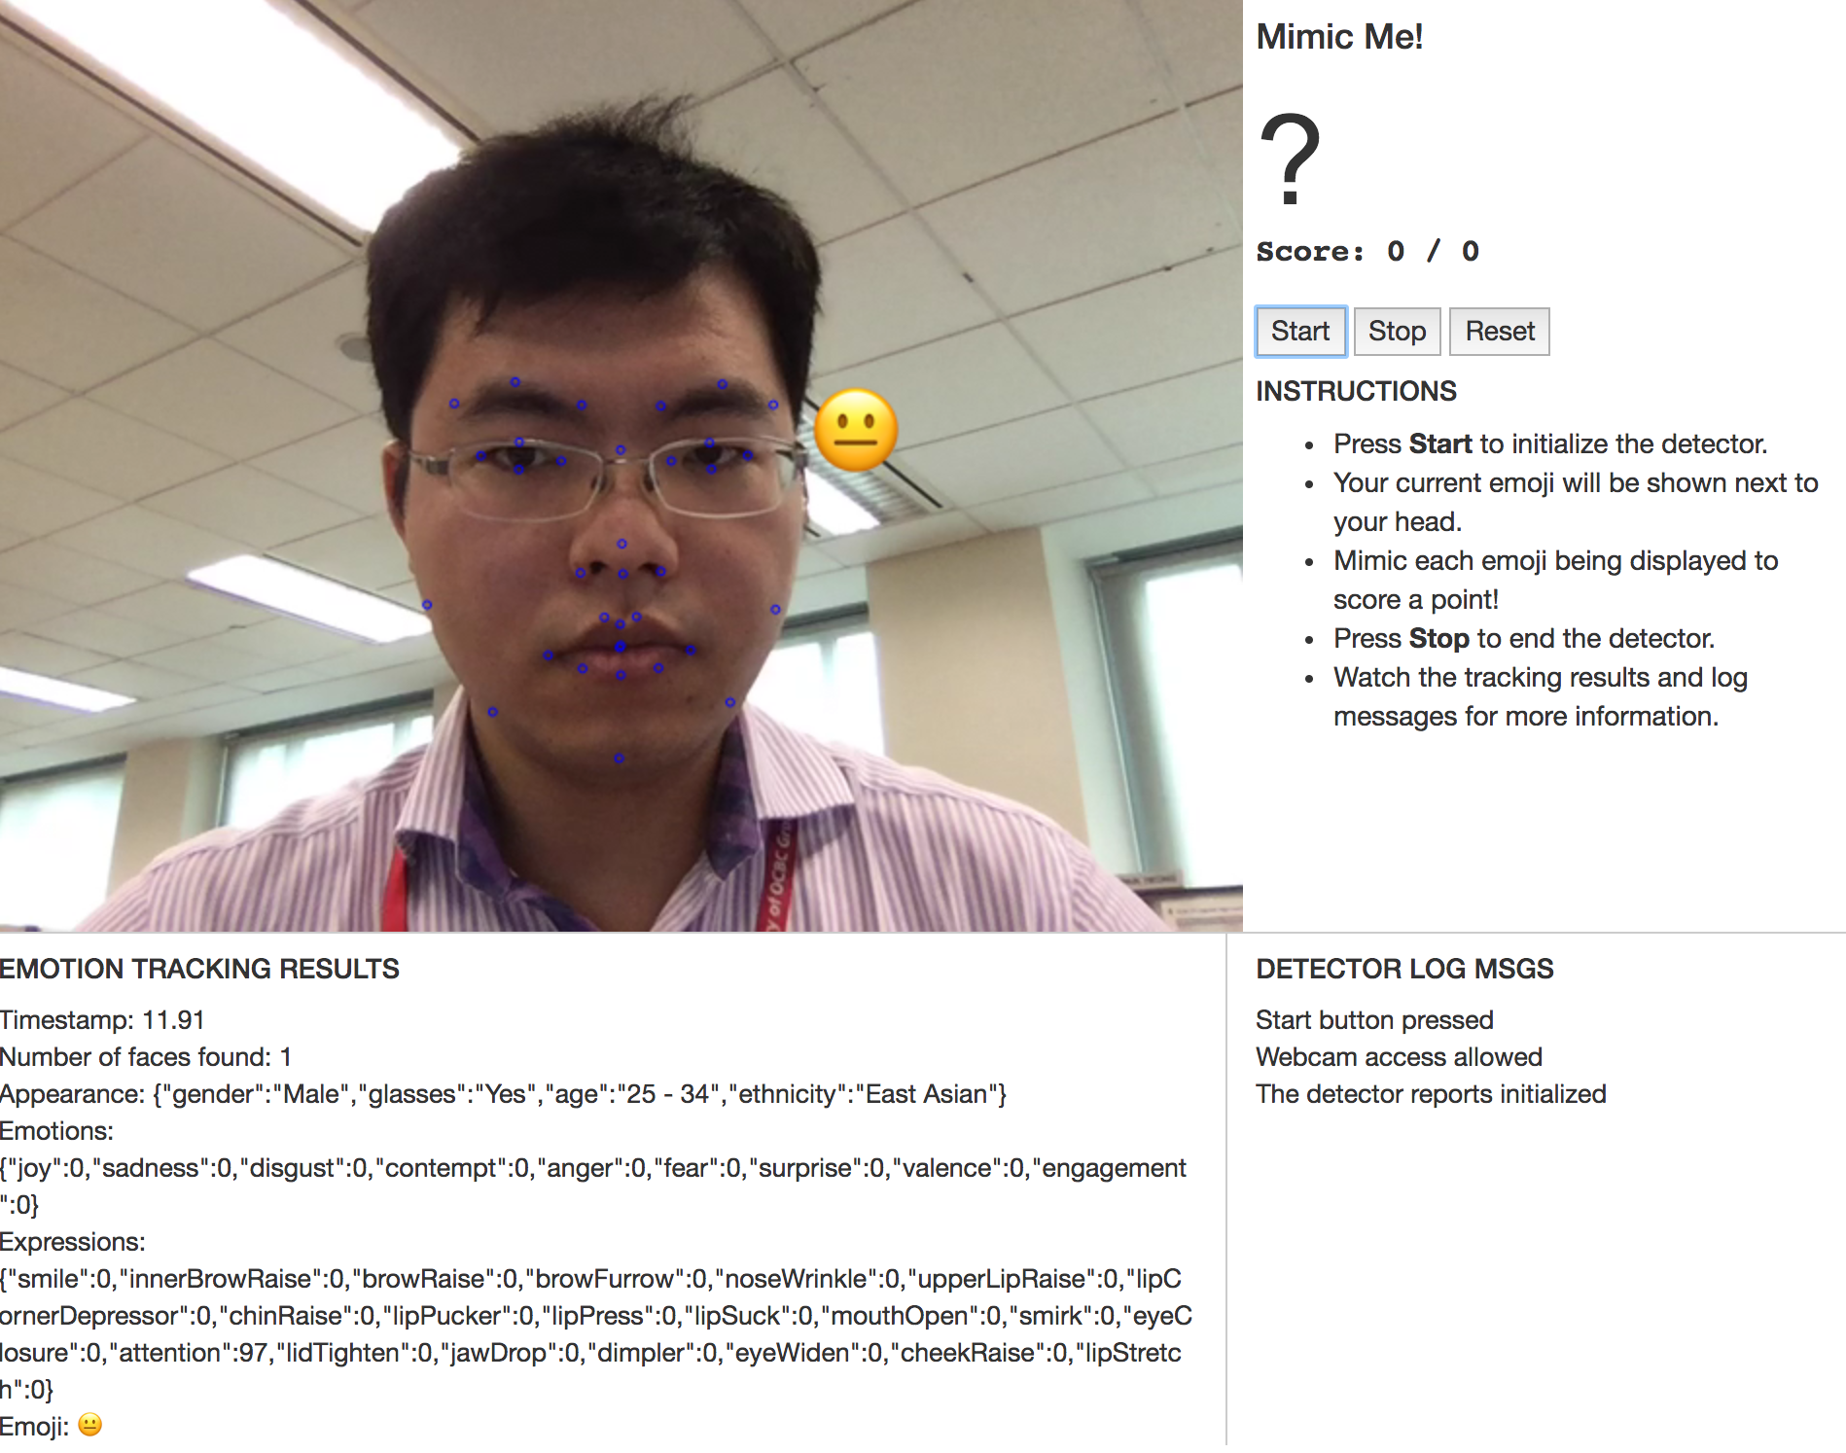

Figure . Feature Points and Dominant Emoji

# Dominant Emoji

The dominant emoji text can be retrieved from *face.emojis.dominantEmoji*.

The location of the emoji shown on the picture is 50 px to the right of feature point 33. So it’ll always be somewhere to the right of my eyebrow. See Figure 1 for illustration.

# Mimic Game

In the game, I set it to show a new random emoji every 10 seconds. I noticed the first successful face detection really varied depending on my network speed. Hence, I used quite few global variables to track the state of the game. For example, I definitely cannot start the scoring when the webpage is first loaded because the real game may start 40 seconds after I click the “Start” button.

The program keeps detecting the face and once there is a match to the given emoji, a text “You got it! Wait for the next emoji” will be shown. The text will be reverted back to “Mimic Me!” when showing the next emoji. Reset will just reset the score and continues. See below illustration.

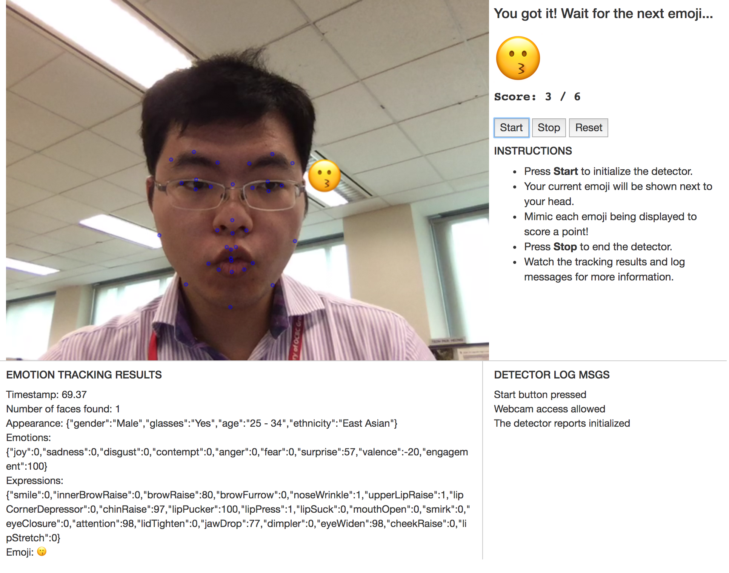

Figure . Mimic Me