# Principal Investigator

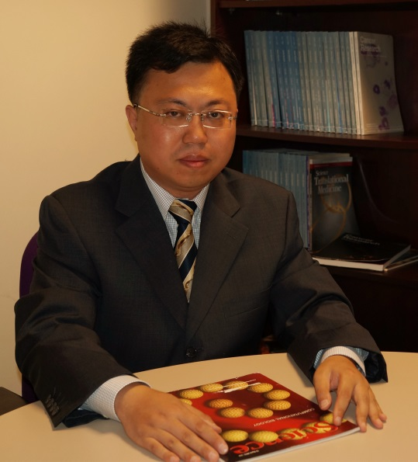**Dr. Jun Wu (CV)**

**Professor**

**PhD, Cornell University**

**Postdoc, MIT | Harvard Medical School**

[**wujun29@mail.sysu.edu.cn**](mailto:wujun29@mail.sysu.edu.cn)

# Research Associate Professor



**Dr. Zhipeng Gu**

**PhD, Sichuan University**

**Postdoc,** **Sichuan University,** **West China Hospital**

[**zhipenggusysu@gmail.com**](mailto:zhipenggusysu@gmail.com)

# Research assistant

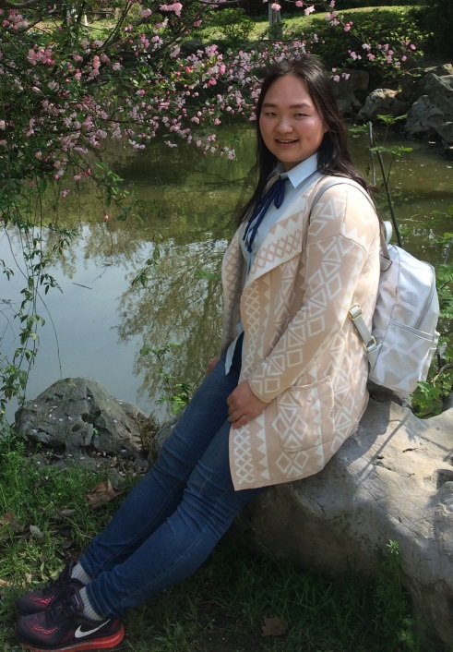**Yuying Zhao**

[**yyzhaoyuying@163.com**](mailto:yyzhaoyuying@163.com)

**不忘初心，方得始终。**

# Doctoral Candidates

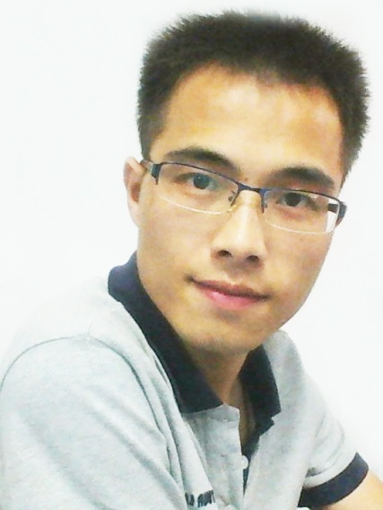

**Jun Huang**

[**hjnature@163.com**](mailto:hjnature@163.com)

**To save time is to lengthen life**

**C:\Users\Administrator.MICROSO-5N8LK0H\Desktop\网站资料\张少瀚2016071181236.tif**

**Shaohan Zhang**

[**blair0608@163.com**](mailto:blair0608@163.com)

**有趣的人：读书，行路，见人，历事，经世。**

# Master Candidates

**Xinru You**

[**youxr5@163.com**](mailto:youxr5@163.com)

**God helps those who help themselves.**

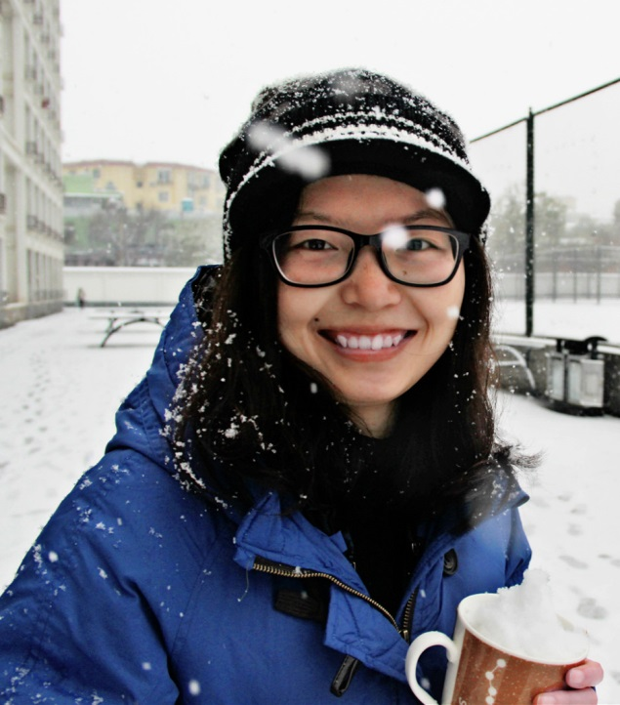**Keqing Huang**

[**13718733069@163.com**](mailto:13718733069@163.com)

**Everything will be okay in the end. If it's not okay, it's not the end.**

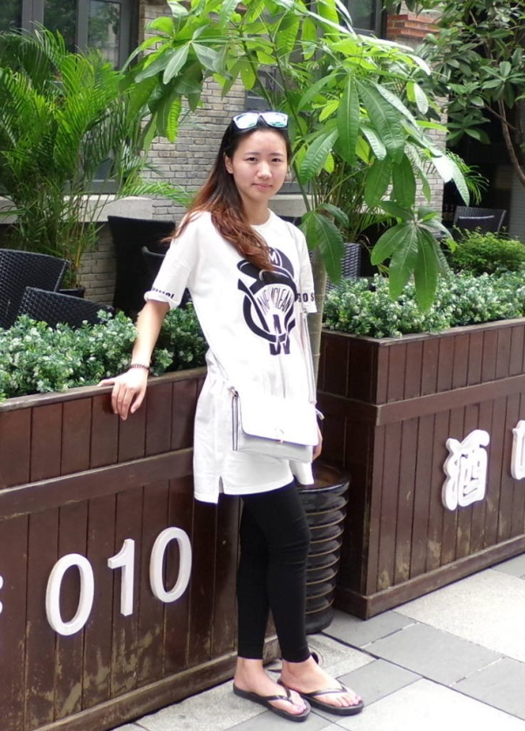**Xing Chen**

[**cgeminix@163.com**](mailto:cgeminix@163.com)

**你不能改变事实，但可以改变态度～你不能改变结局，但可以改变心境～**

**Tianqi Yi**

[**674189015@qq.com**](mailto:674189015@qq.com)

**穷则独善其身，达则兼济天下**