Your Paper Title, Capitalize Each Letter

First Author and Second Author^{2, *}

Abstract: Please type your abstract here. Abstract of a research paper is typically 200 to 400 words in length, and 150 to 300 words for a review paper. Abstract shall be running continuously (not structured) and shall not include reference citations. Abbreviations that appear only once in the abstract should be defined in full. If abbreviations appear more than once, the full definitions should be provided first before they can be used elsewhere.

Keywords: Manuscript, preparation, typeset, format.
1 Introduction
Authors are encouraged to use the template for Microsoft Word, to prepare the final version of their manuscripts and facilitate typesetting. Authors may elect to submit two versions of their manuscript, one for the printed version of the journal, and the other for the on-line version of the journal. Illustrations in color are allowed only in the on-line version of the journal.
2 Structure
A paper for publication can be subdivided into multiple sections: a title, full names of all the authors and their affiliations, a concise abstract, a list of keywords, main text (including figures, equations, and tables), acknowledgements, references, and appendix. Running title is optional.
2.1 Text Layout
Acceptable paper size is US Letter (8.5″ x 11″ or 21.59 cm×27.94 cm) All margins — top, bottom, left, and right — are set to 1.5″ (3.81 cm). The paper must be single column,single spaced, except for the headings as outlined below. Acceptable font is Times New Roman, 11 pt., except for writing special symbols and mathematical equations.
2.2 Headings
Level one headings for sections should be in bold, and be flushed to the left. Level one heading should be numbered using Arabic numbers, such as 1, 2, ….
Level two headings for subsections should be in bold-italic, and be flushed to the left. Level two headings should be numbered after the level one heading. For example, the second level two heading under the third level one heading should be numbered as 3.2.
Level three headings should be in italic, and be flushed to the left. Similarly, the level three headings should be numbered after the level two headings, such as 3.2.1, 3.2.2, etc.
3 Equations and mathematical expressions
Equations and mathematical expressions must be inserted into the main text. Two different types of styles can be used for equations and mathematical expressions. They are: in-line style, and display style.
3.1 In-line style
In-line equations/expressions are embedded into the paragraphs of the text. For example, 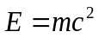. In-line equations or expressions should not be numbered and should use the same/similar font and size as the main text.
3.2 Display style
Equations in display format are separated from the paragraphs of the text. Equations should be flushed to the left of the column. Equations should be made editable. Displayed equations should be numbered consecutively, using Arabic numbers in parentheses. See Eq. 1 for an example. The number should be aligned to the right margin.
(1)
4 Figures and tables
Figures and tables should be inserted in the text of the manuscript.
4.1 Figures
Figures should have relevant legends but should not contain the same information which is already described in the main text. Figures (diagrams and photographs) should also be numbered consecutively using Arabic numbers. They should be placed in the text soon after the point where they are referenced. Figures must be submitted in digital format, with resolution higher than 300 dpi.
4.1.1 Figure format
Figures should be centered, and should have a figure caption placed underneath. Captions should be centered in the column, in the format ``Figure 1. The text caption …'', where the number of the figure follows the key word Figure, and the text caption comes right after that.
The size of the figure is measured in centimeters and inches. Please prepare your figures at the size within 17 cm (6.70 in) in width and 20 cm (7.87 in) in height. Figures should be in the original scale, with no stretch or distortion.
4.1.2 Figure labels and captions
Figure labels must be sized in proportion to the image, sharp, and legible. Label size should be no smaller than 8-point and no larger than the font size of the main text. Labels must be saved using standard fonts (Arial, Helvetica or Symbol font) and should be consistent for all the figures. All labels should be in black, and should not be overlapped, faded, broken or distorted. A space must be inserted before measurement units. The first letter of each phrase, NOT each word, must be capitalized.
One-line Caption should be centered in the column, in the format of “Figure 1. The text caption …” That is, the number of the figure follows the keyword Figure, and next to it, the text caption. For one example, see Fig. 1 below.

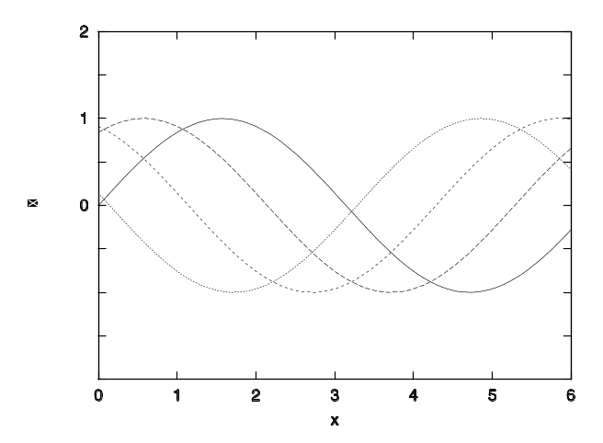
Figure 1: Some functions of
4.2 Tables
Tables should also be numbered consecutively using Arabic numbers. They should be placed in the text soon after the point where they are referenced. Tables should be centered and should have a table caption placed above. Captions should be centered in the format “Table 1. The text caption …”. For one example, see Tab. 1.

Table 1: Table caption
1 | 2 | 3
11 | 12 | 13
21 | 22 | 23

5 Citations
The author-year format of the citation must be used for the references. You need to cite the authors’ last names. Our requirements for citations are listed as follow:
If the cited reference has one author, please see the example, [Atluri (2004)]. If the cited reference has two authors, please see the example, [Sun and McIntosh (2018)]. If the cited reference has three authors, please see the example, [Ozisik, Mehdiyev and Akbarov (2018)]. If the cited reference has more than three authors Please cite all first 3 authors' last names, and followed by "et al", for example, [Cheng, Xu, Tang et al. (2018)]. When cite more than one reference, separate them with a semicolon, see [Farhan (2017); Sun and McIntosh (2018); Ozisik, Mehdiyev and Akbarov (2018); Yang, Dong, Tang et al. (2018)]. No citation to the page number should be used.

Acknowledgement: Acknowledgements and Reference heading should be left justified, bold, with the first letter capitalized but have no numbers. Text below continues as normal.

References
All references should be listed at the end of the paper. The names of the authors should be in bold, with the last name(s) first. The year in which the paper is published follows the name (s) of the author(s). Journal and book titles should be in italic. A full name of journal cited in reference should be used followed by a comma before the volume, issue and page number. Please see the examples below:

References (References at the end should be listed in alphabetical order):
Farhan, A. M. (2017): Effect of rotation on the propagation of waves in hollow poroelastic circular cylinder with magnetic field. Computers, Materials & Continua, vol. 53, no. 2, pp. 129-156.
Sun, H.; McIntosh, S. (2018): Analyzing cross-domain transportation big data of New York City with semi-supervised and active learning. Computers, Materials & Continua, vol. 57, no. 1, pp. 1-9.
Ozisik, M.; Mehdiyev, M. A.; Akbarov, S. D. (2018): The influence of the imperfectness of contact conditions on the critical velocity of the moving load acting in the interior of the cylinder surrounded with elastic medium. Computers, Materials & Continua, vol. 54, no. 2, pp.103-136.
Akbarov, S. D.; Guliyev, H. H.; Sevdimaliyev, Y. M.; Yahnioglu, N. (2018): The discrete-analytical solution method for investigation dynamics of the sphere with inhomogeneous initial stresses. Computers, Materials & Continua, vol. 55, no. 2, pp. 359-380.
Cheng, J.; Xu, R. M.; Tang, X. Y.; Sheng, V. S.; Cai, C. T. (2018): An abnormal network flow feature sequence prediction approach for DDoS attacks detection in big data environment. Computers, Materials & Continua, vol. 55, no. 1, pp. 095-119.
Yang, W. J.; Dong, P. P.; Tang, W. S.; Lou, X. P.; Zhou, H. J. et al. (2018): A MPTCP scheduler for web transfer. Computers, Materials & Continua, vol. 57 no. 2, pp. 205-222.
Atluri, S. N. (2004): The Meshless Local Petrov-Galerkin (MLPG) Method. Tech Science Press.
Darius, H. (2014): Savant Syndrome-Theories and Empirical Findings (Ph.D. Thesis). University of Turku, Finland.
Vanegas-Useche, L. V.; Abdel-Wahab, M. M.; Parker, G. A. (2018): Determination of the normal contact stiffness and integration time step for the finite element modeling of bristle-surface interaction.
http://www.techscience.com/doi/10.3970/cmc.2018.901.827.html.

Appendix A. Example of appendix
Authors that need to include an appendix section should place it before the References section. Multiple appendices should all have headings in the style used above. They will be ordered A, B, and C etc.

Attention注意力机制英文说一下原理然后，加上一个实验表格图，然后稍加分析

When people notice at a specific scene，We have different attention distributions at each location of the scene. When we look somewhere else, our attention shifts as our eyes move. There are also something else like this in our daily life, this phenomenon is called attention mechanism that is frequently discussed not only in academia but also in industry at recent years. To some extent, we can divide attention mechanism into Soft Attention and Hard Attention according to the format of its output vectors, the hard attention has the output of one-hot vectors while the soft attention weight each part in the input vectors of attention by learning the parameters of each element from back-propagation. And also, we can divide attention into spatial attention and channel attention. The spatial attention gives different weights to different space feature regions [Woo, Park, Lee et al. (2018)], and the channel attention gives various weights to feature of various channels [Hu, Shen, Sun et al. (2017)]. Essentially, the purpose of attention is to learn a weight distribution, and then apply it to the input feature vectors of attention. The learned weight distribution can be applied to the original input images or the convolution feature map

CBAM: Convolutional Block Attention Module ECCV 2018 (空间注意力)

Squeeze-and-Excitation Network: CVPR 2017(通道注意力)
Woo, S. , Park, J. , Lee, J. Y. , & Kweon, I. S. . (2018). Cbam: convolutional block attention module. 空间注意力

Hu, J. , Shen, L. , & Sun, G. . (2017). Squeeze-and-excitation networks. IEEE Transactions on Pattern Analysis and Machine Intelligence. 序列注意力
将attention应用到blstm和fc之间，使blstm的输出随着迭代不断地学习合理的权重分布，这样能够更好地预测当前的16 pixels的proposal是否为文字，从而能够进一步提高最终的场景文本检测效果。

像图1所示那样，To get more accurate context sequence information, We apply the attention mechanism between the BLSTM and the FC layer. 并且得到了一些实验数据。如表X所示，我们对比了使用resnet101提取特征时在有无attention情况下的场景文本检测效果。可以看出，在加入attention机制后，我们的最终检测F1值有了约1%的提升，但另一方面，由于和之前相比加入了多余的步骤，模型的训练和测试速度也相应降低了一些。

实验表格包括两行对比 即有无attention 另外还包括两项：即检测速度和精度。

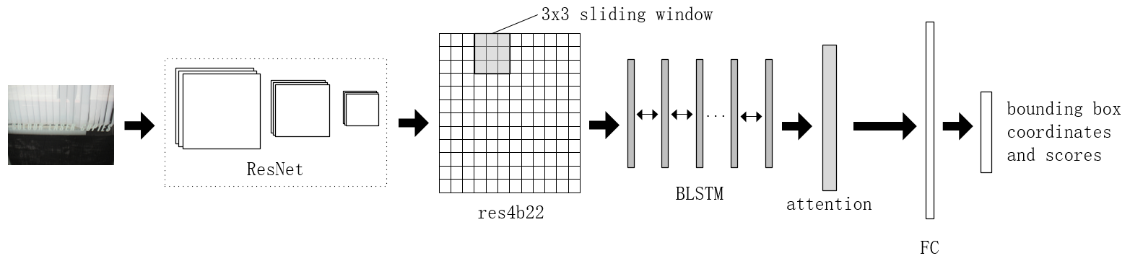

 | F | Speed
无attention | 0.
有attention

 | P | R | F | Average Speed（s）
无attention | 0.87 | 0.78 | 0.82 | 0.172
有attention | 0.86 | 0.80 | 0.83 | 0.184

Table 3: Test result of ICDAR2013(using backbone of ResNet 101)
 | P | R | F | Average Speed(s)
With attention | 0.87 | 0.78 | 0.82 | 0.167
No attention | 0.86 | 0.80 | 0.83 | 0.183

First affiliation, Address, City and Postcode, Country. ²Second affiliation, Address, City and Postcode, Country. *Corresponding Author: Author’s Name. Email: author@institute.xxx.

