A Modified Method for Scene Text Detection by ResNet

Shaozhang Niu^{1, *} ，Xiangxiang Li²，Maosen Wang³

Abstract: Scene text detection has always been the hot spot in the domain of computer vision. We presented a modified text detection network based on further research and improvement of CTPN proposed by previous researchers. To extract deeper features that are less affected by different images, ResNet is used to take the place of VGG16 in the original network. Simultaneously, to enhance the robustness of the model to multiple languages, we use the datasets for training from multi-lingual scene text detection and script identification datasets (MLT) of ICDAR2017 Robust Reading competitions, and the attention mechanism is used to get more reasonable weight distribution as well. Finally the proposed model achieves 0.91 F1-score on ICDAR2011 test, better than CTPN trained on the same datasets about 5%.

Keywords: CTPN, scene text detection, ResNet，attention.
1 Introduction
Because of the high application value in reality, scene text detection technology in computer vision has become the research focus of researchers for many years. For instance, researchers have used text detection technology to help people with visual impairment communicate with the outside world by detecting and recognizing the text information and then turning it into speech [Ezaki, Bulacu and Schomaker (2004)]. Besides, with the continuous development of intelligent terminals, there are more and more instant photo translation and recognition APPs appearing in people's life, the base of which is also the text detection of the captured scenes. However, we will find in reality that the result of scene text detection is often not so ideal due to the difference between scenes themselves, the high complexity of the scene background, the various light intensity and other situations. Therefore, it is still a challenging task to get more accurate results. Inspired by the Region Proposal Network (RPN) presented in Faster-RCNN [Ren, He, Girshick et al. (2015)], Tian, Z et al. [Tian (2016)] proposed CTPN using vertical

1 School of Computer Science and Technology, Beijing University of Posts and Telecommunications, Beijing, 100876, China.
2 School of Computer Science and Technology, Beijing University of Posts and Telecommunications, Beijing, 100876, China.
3 School of Computer Science and Technology, Beijing University of Posts and Telecommunications, Beijing, 100876, China.
* Corresponding Author: Shaozhang Niu. Email: szniu@bupt.edu.cn.
anchor mechanism, which detects text with fixed-width multi-size proposals and then connects them with text line construction. In this work, we decide to utilize vertical anchor mechanism to detect text as well, but the difference is that we extract the features of the images with ResNet[He, Zhang, Ren et al. (2015) ] rather than VGGNet[Simonyan and Zisserman (2014)]. Because of the shortcut connection, ResNet can improve the performance in the process of deepening the number of network layers, thus having an obvious advantage compared with VGGNet. The deeper convolutional neural network can provide more abstract feature and stronger semantic information, which enables our neural network less affected by the difference between different images compared to the low-level features from previous networks. Besides, due to the bottleneck design itself, the number of parameters of ResNet is also less than that of VGGNet. And specifically, according to the paper of ResNet, while with almost the same performance in the meantime, the number of weight parameters for ResNet-50 and ResNet-101 is within acceptable range compared to ResNet-152, so finally we decide to use ResNet-50 and ResNet-101 to implement the specific experiment. In addition, we also use the attention mechanism to get more accurate weight distribution of context sequence information. And we train our model with the datasets of MLT from ICDAR2017 competition, which is beneficial to enhance the robustness of our trained model for multiple languages. Besides, the number of images in this datasets is obviously higher than that of CTPN (3000 images), which could make the extracted image features more diverse, thus, to some extent, beneficial to improve the text detection ability of the model that we trained later.
2 Related Work
2.1 Object detection
R-CNN [Girshick, Donahue, Darrelland et al. (2014)] is a classic to object detection in deep learning. The model combined the features extracted by convolutional neural network and the region proposals generated by Selective Search [Uijlings and Van de sande (2013)], whose performance on Pascal VOC2012 datasets improved by 30% compared to the state of the art at that time, promoting the emergence of subsequent Fast-RCNN[Girshick (2015)] and Faster-RCNN. Updated from Fast-RCNN, rather than the Selective Search using before, Faster-RCNN uses RPN to generate proposals, and the other parts such as feature extraction and classification also follow the usage in Fast-RCNN, so we can approximately regard Faster-RCNN as the combination of RPN and Fast-RCNN. Specifically, Faster-RCNN extracts the features of the images utilizing VGG16, and then generates proposals by sliding a small 3×3 window on the feature map, and finally, classifies these proposals. But according to the paper [Ren, He, Girshick et al. (2015)], the processing speed of Faster-RCNN can only reach 17fps even with the smaller ZF model [Zeiler and Fergus (2014)] to extract image features, which is still somewhat slower contrast with 30fps required by real-time systems. However, the problem has been solved with the appearance of SSD [Liu, Anguelov, Erhanet et al. (2016)]. SSD is close to Faster-RCNN in precision while much faster in the speed of object detection. The main contribution of SSD lies in its use of multilayer network features. And then, the situation has changed a lot since the emergence of ResNet. ResNet has solved the problem of vanishing gradient in the processing of back-propagation by means of the shortcut connection design, and therefore enables the convolution neural network to achieve continuous performance improvement when deepening the number of network layers. Meanwhile, this gave ResNet the first place in some subprojects of ILSVRC 2015. Moreover, the original version of Faster-RCNN has also taken on new developments due to ResNet. The researchers presented R-FCN [Dai, Li, He et al. (2016)], which has changed VGG16 to ResNet for image feature extraction, because of its deeper network layers and stronger ability to get semantic features. R-FCN is a region-based fully convolutional networks for object detection, because of the share of computing, the size of the parameters is small. All of these make the test results improve distinctly in precision and speed. For instance, it is proposed in [Dai, Li, He et al. (2016)] that the test speed of R-FCN is 170ms/image, 2.5 to 20 times faster than Faster-RCNN.
2.2 Scene text detection
In some degree, scene text detection can be taken as a special case of object detection. But, in fact, there is still some difference between them. Generally, object detection is required to find out the location of the targets in the input image and give out their respective categories, while scene text detection needs to figure out the text in the input image with the precision of word-level or text-line-level .So It can be seen that the precision of scene text detection is much higher than that of object detection. In addition, the text lines or words to be detected are often a sequence that is composed of one or multiple characters, which may suffer from a large difference or a long distance between them. It is obviously more difficult than objects detection in this regard as well. In a word, the general approach of object detection cannot be directly utilized in scene text detection, we should make some improvements for specific text detection situations.
In recent years, plenty of scholars and researchers have contributed to the field of scene text detection in computer vision. EAST [Zhou, Yao, Wen et al. (2017)] can produce detection results of word-level or text-line-level directly with only two stages, by sending the first stage prediction to non-maximum suppression(NMS), we can get the final F1-score of 0.7820 (0.8072when using multi-scale) in ICDAR 2015. Seglink [Shi, Bai and Belongie (2017)] detects the text using a combination of segment and link, where the segment part can detect a part of a word or text line and the link part connects those adjacent segments that belong to the same word or text line, then the final detection results come into being. Different from methods such as Seglink, in Ref. [Deng, Liu, Li et al. (2018)], researchers proposed a new type of method of scene text detection based on instance segmentation called PixelLink, the model is inspired by SegLink but has achieved the link of pixel-level, this approach doesn’t use the bounding box regression that employed in many other preceding algorithms while getting the comparable results with less training data and iterations, it is a great breakthrough in scene text detection. Pengyuan et al. [Pengyuan (2018)] has proposed the model that could detect multi-oriented scene text by using corner localization and region segmentation while averting their weakness at the same time. With VGG16 to extract feature, it achieves the F1-score of 0.843 on ICDAR2015 and 0.815 on MSRA-TD500. TextBoxes [Liao, Shi, Bai et al. (2017)] is an end-to-end scene text detector utilizing fully convolutional network. The method improves the aspect ratio of the default boxes based on SSD and introduces a relatively long kernel to adapt the large aspect ratio in scene text, thus finally achieving the F1-score of 0.86 in ICDAR2013. As an extension of the TextBoxes, Textboxes++ [Liao, Shi and Bai (2018)] has developed the scope of text detection from horizontal to arbitrary orientations, which enables the network more robust in scene text detection. Furthermore, the TextBoxes series also has a scene text recognition part based on CRNN [Shi, Bai and Yao (2015)] after detection, the integration of detection and recognition is also a highlight of TextBoxes and TextBoxes++.
2.3 Attention mechanism
When people notice at a specific scene，We have different attention distribution at each location of the scene. When we look somewhere else, our attention shifts as our eyes move. There are also something else like this in our daily life, this phenomenon is called attention mechanism that is frequently discussed not only in academia but also in industry at recent years. To some extent, we can divide attention mechanism into soft attention and hard attention according to the format of its output vectors, the hard attention has the output of one-hot vectors while the soft attention weight each part in the input vectors of attention by learning the parameters of each element from back-propagation. And also, we can divide attention into spatial attention and channel attention. The spatial attention gives different weights to different space feature regions [Woo, Park, Lee et al. (2018)], and the channel attention gives various weights to feature of various channels [Hu, Shen, Sun et al. (2017)]. Essentially, the purpose of attention is to learn a weight distribution, and then apply it to the input feature vectors of attention. The learned weight distribution can be either applied to the original input images or the convolution feature map.
3 Our proposed network
As mentioned before，our newly proposed network replaces the VGG16 used in CTPN to extract image features with the more powerful ResNet. The specific replacement process of the network is as follows. It is implied in the previous [Simonyan and Zisserman (2014)] that the conv5_3 of VGG16 has a feature map of 14×14 and a stride of 16. So when we slide a small window in conv5_3 with the stride of 1, actually we have pass through 16 pixels on the original input image, which corresponds well to the fixed width of the anchor (16 pixels) set in CTPN. And the ResNet, which is diverse from VGG16, can be divided into conv1, conv2_x, conv3_x, conv4_x and conv5_x. According to the detailed data in [He, Zhang, Ren et al. (2015)], the size of feature map in conv4_x is 14×14, and the stride is 16, which is consistent with that of VGG16. This means in principle that we can replace VGG16 used in CTPN with ResNet and implement further experiments without changing the preceding fixed width of the anchors. So we finally use the convolutional part of ResNet(from input to conv4_x) to take the place of VGG16(from input to conv5_3), in the light of the performance of ResNet in Ref. [Kaiming (2015); Jifeng (2016)], it is believed that the newly proposed network should also be able to get a better result on scene text detection.
The structure of our network is shown in Figure 1(using ResNet101). First, the training images are sent to ResNet for feature extraction, to get the anchors, we slide a 3×3 window through the res4b22 layer of conv4_x, it should be noted that each time a window sliding can generated various sizes of anchors, whose generation mechanism is listed as follows: the width of the anchors is fixed at 16 pixels (the size in the input images) in the horizontal direction, while the height varies between 11-273 (each time divided by 0.7, a total of 10 size changes) in the vertical direction to fit the diverse sizes of text in actual scene. In additional, we use the Long Short Term Memory (LSTM) [Hochreiter and Schmidhuber (1997)] to fully utilize the contextual association between isolated characters in images. LSTM is a special case of Recurrent Neural Network (RNN), there is an important feature of RNN that it can use the input of the current moment and the output of the layer at the previous moment as the input of this layer, which is beneficial for the network to make a comprehensive judgment by using some information before. But sometimes, some information in the future may be used as an aid to make a more accurate judgment to decide the output of current moment. For example, if there are two or more interpretations of the characters or words currently to be recognized in some speech recognition tasks, it may be necessary to judge the output of current content according to the voice information input to the network afterwards. Then it is the exact time for us to use bidirectional RNN (BRNN), but as we all know that one of the major flaws of RNN is the long-term dependency problem, which makes it impossible to synthesize information far from the current moment. However, by introducing the input gate, output gate, forget gate and the special structural combination between them, LSTM has solved the problem skillfully. Therefore, the BLSTM is applied to the network to connect the isolated proposals from the context information. And apart from that, we also use the attention mechanism to get more accurate context sequence information by applying it between the BLSTM and the FC layer, so the output of BLSTM could learn a more reasonable weight distribution and thus we can better predict the classification of current 16 pixels proposals (text or not text), this operation further improve the final scene text detection effect.

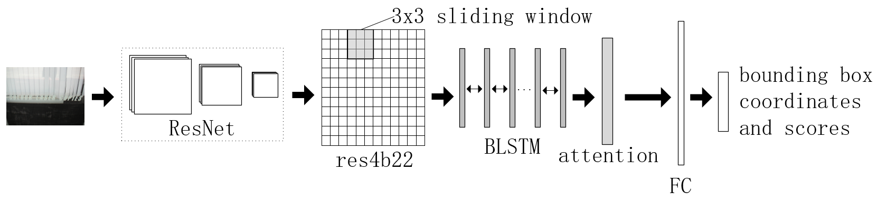
Figure 1: The structure of the network
Besides, there are some other requirements when connecting and merging these predicted proposals: firstly, the merged proposals should have a text/non-text score greater than 0.9, then the two adjacent proposals can be merged when the distance is less than 50 pixels; finally, the overlap between two adjacent proposals in the vertical direction should be greater than 0.7. As shown in Figure 2, we can see the detection result of the input images before and after the merging. The upper part of the image shows the result before merging, while the lower part shows the result after merging.
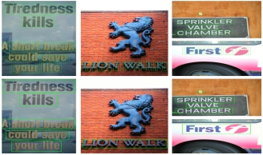
Figure 2: The detection result of the input images before and after the merging.
4 Experiments
4.1 Experiments about text localization
We evaluate the test results of our network proposed in the third chapter by the benchmark of ICDAR2011 (Born-Digital Images (Web and Email)) and ICDAR2013 (Task 2.1: Text Localization), the following is an example to illustrate the test datasets and test process of ICDAR2013: the datasets downloaded from the official website including 233 natural images with text information to be detected. But in fact, in order to better test the detection effect of our model under different scenarios (as shown in Figure 3), the clarity, the background lighting conditions and the size of the text in images are still different from each other to increase the diversity of test samples. We use the trained model to generate predicted proposals on these test images and save them with visible information to observe the specific detection effect. Additionally, we have saved the coordinates with the format of (Xmin, Ymin, Xmax, Ymax). The four straight lines corresponding to the above x, y coordinates can be enclosed in a rectangle on the coordinate axis, which is exactly the proposals predicted by our model. When the coordinates of the proposals are saved, a proposal corresponds to one line in the above format, and a file corresponds to all coordinates on an image, that is, how many proposals are predicted on an image, and how many lines are there in one file. Finally, the predicted 233 files containing coordinate information are packaged and compressed into a .zip format file and uploaded to the official website to verify the test result of our model.
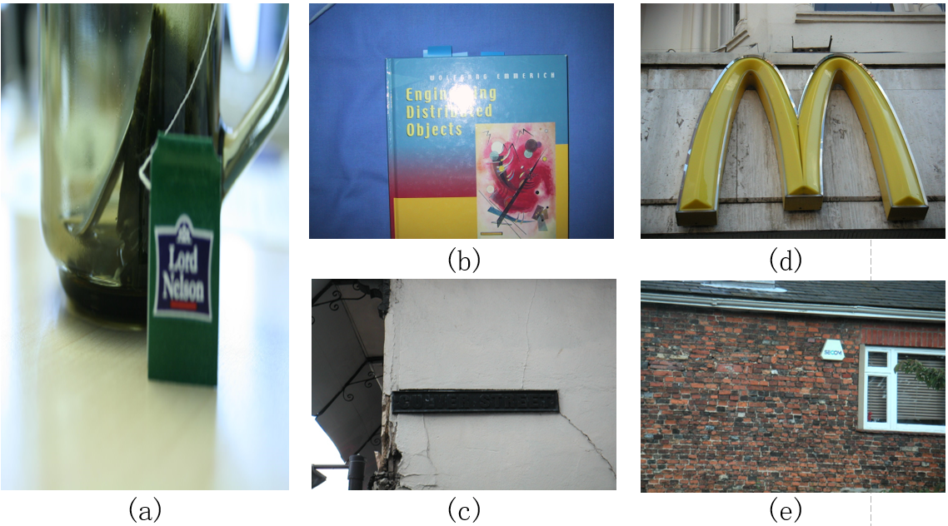
Figure 3: Images of extreme scene
We can learn from Figure 3 that: picture (a) represents the fact that the text information to be detected is very vague，picture(b) represents the case where the text information to be detected is illuminated by strong light, picture (c) represents the extremely dim background of the text to be detected under weak illumination, picture (b) is contrasted with picture (c). And picture (d) represents the case where the text in the scene is large, picture (e) represents the case where the text in the scene is very small, picture (d) is contrasted with picture (e).
The test result of ICDAR 2011 is shown in Table 1. The “model” column represents the different models proposed in different papers to be compared, “P”, “R”, and “F” in the header represents precision, recall, and F1-score respectively. The value of F1-score combines the values of precision and recall, which is a comprehensive judgment to test the models. The ours (ResNet101) and ours (ResNet50) in Table 1 are the experimental data of our new proposed network, and CTPN* represents the results of training CTPN under the same datasets as our new network. It can be seen from Table 1 that CTPN* and ours(ResNet50) have got the F1-score of 0.86 and 0.88 respectively, when replacing VGG16 with ResNet50,the result has improved by 2%, and when we use the deeper ResNet101 for training, the result is 0.91, improved by 3% compared to ResNet50, 5% compared to CTPN* trained on the same datasets. Moreover, we have tested our models on ICDAR2013 benchmark, which is shown in Table 2, under the premise of same training datasets for CTPN*, ResNet50 and ResNet101, the data in Table 2 also shows an experimental phenomenon similar to that in Table 1. In a word, the test results of CTPN*, ours (ResNet50) and ours (ResNet101) on ICDAR2011 and ICDAR2013 should be able to explain that compared with VGG16, ResNet has stronger ability for feature extraction of images, thus getting better results on scene text detection.

Table 1: Test results of ICDAR2011
Model | P | R | F
TextFlow[Tian, Pan, Huang et al. (2015)] | 0.86 | 0.76 | 0.81
Text-CNN[He, Huang, Qiao et al. (2015)] | 0.91 | 0.74 | 0.82
USTB_TexStar | 0.94 | 0.87 | 0.90
CTPN* | 0.81 | 0.92 | 0.86
ours(ResNet50) | 0.85 | 0.90 | 0.88
ours(ResNet101) | 0.91 | 0.90 | 0.91

Table 2: Test results of ICDAR2013
Model | P | R | F
SegLink | 0.87 | 0.83 | 0.85
Fastext[He, Huang, Qiao et al. (2015)] | 0.84 | 0.69 | 0.77
Text-CNN | 0.93 | 0.73 | 0.82
Multi-Oriented-  FCN | 0.88 | 0.78 | 0.83
TextBoxes | 0.89 | 0.83 | 0.86
BayesText | 0.85 | 0.67 | 0.75
ours(ResNet50) | 0.81 | 0.80 | 0.80
CTPN* | 0.78 | 0.81 | 0.79
ours(ResNet101) | 0.87 | 0.78 | 0.82

As shown in Table 3, we utilize ResNet101 as the backbone to extract the feature of images to implement anther experiment, and the difference is that we have used attention this time. We carry out our experiments using the test datasets of ICDAR 2013, and we have also tested the average processing speed of these 233 images, the final result of comparison is shown below. It is indicated that the F1-score has improved by 1% with the use of attention. On the other hand, due to the additional steps compared to previous network, the average processing speed of images has also slowed down accordingly, and this situation is to be expected.
Table 3: Test result of ICDAR2013 (using backbone of ResNet 101)
Network | P | R | F | Average Speed(s)
No attention | 0.87 | 0.78 | 0.82 | 0.167
With attention | 0.86 | 0.80 | 0.83 | 0.183

We finally use 6000 images downloaded from official website of ICDAR2017 Competition. It should be noted the labels given in the datasets are word-level, but we can know from the network architecture presented in Part 3 and the description of the experiments in Part 4 that the experiment uses the vertical anchor mechanism proposed in CTPN to fix the width of the anchor to 16 pixels, therefore, the label should be scaled to 16 pixels in advance before training as well. So our experimental work also includes converting the word-level labels to fixed-width 16 pixels anchor labels, and we regard it as 16 pixels when the width is less than 16 pixels.
4.2 Experiments by post-processing
Because of the limitations of the network itself, our model can only detect text in horizontal direction. However, by doing some transformation and fitting to the proposals predicted by the network, we can detect the text information in images with less inclined. As shown in Figure 4, when the text is not in the horizontal direction, we fit a slanted line according to the center point of the adjacent proposals, the upper and the lower borders of the merged rectangle are parallel to the line we got, and the height after merged is related to the average height of all proposals, then the coordinates of the four corners for the merged rectangle are related to the maximum and minimum x, y coordinates of the top and bottom borders of all proposals. Although the treatment is slightly backward compared with the current cutting-edge methods, it still has significance as an improvement to CTPN to some extent.
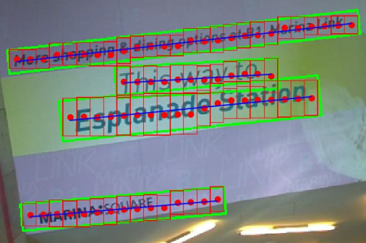
Figure 4: The detect result of multi-orientation text with small tilt.
As part of our work, we expanded our model to text recognition by post-processing on the current basis. We extracted the merged predicted proposals from the input images according to the corresponding coordinates and sent them to a scene text recognition network CRNN, which utilizes Connectionist Temporal Classification (CTC) to get the final predicted sequences, this method is first proposed in [Graves, Santiago and Gomez (2006)], the advantage of which is that we don't need to know in advance how many characters are there that need to be identified in the sequence. CTC mainly solves the problem of label alignment, the principle of CTC can be described as follows: we use a sequence 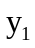, 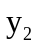,…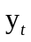 as the input, where “t” is the length of the sequence, thus, 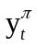means that we get “π” as the output of time stamp t, if we use p (π | x) represents the probability that the input is x and the output is π, since the output of every time stamp is independent of each other, the p (π | x) can be expressed as follows:
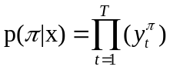 (1)
Then we define a function “F” maps from “π” to label sequence “l” by removing the repeated labels and removing the blanks. For instance, by means of mapping function F, we can map “ss-c--h-o-o-l” to “school” naturally (“-” represents blank), so the p (l | x) can be represented as follows:
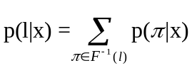 (2)
And finally we can get the most possible output sequence “l*” by the following formulation (3):
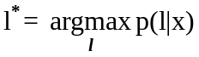 (3)
We display the results identified by CRNN in the upper left corner of the detected rectangular (as shown in Figure 5). It can be found that when the conditions of light, background and other conditions are relatively good, we can see a certain recognition effect.
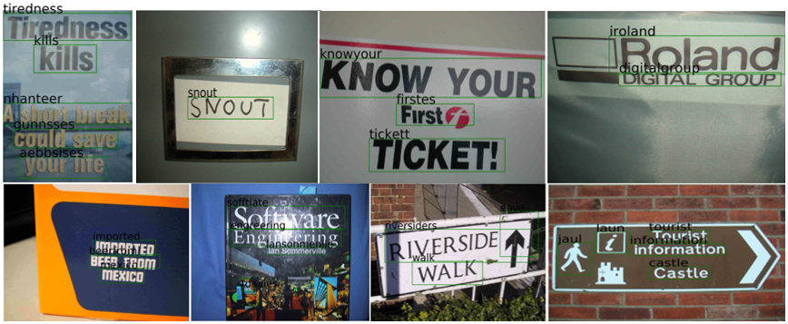
Figure 5: The recognition results of text by post-processing
5 Conclusion
We have presented a modified scene text detection network which replace VGG16 with deeper ResNet in CTPN to extract stronger semantic feature, and at the same time, we have used attention mechanism to get more accurate context information. Besides, the datasets of MLT from ICDAR2017 is used to improve the robustness of our model to multiple languages. At present, the model can only detect scene text with horizontal or small tilt, but we get unsatisfactory result on darker text or characters with large font. Although we initially combine the scene text detection with recognition, this is not a real end-to-end network in fact, and the current recognition results need to be further optimized and improved. Overall, these problems may be gradually solved by us in the future work, and we will try to develop scene text detection to arbitrary orientation or establish a real end-to-end scene text detection and recognition network based on the improvement of detection accuracy.
Acknowledgement: This work was supported by National Natural Science Foundation of China (No. U1536121，61370195).

References
Dai, J.; Li, Y.; He, K.; Sun, J. (2016). R-FCN: object detection via region-based fully convolutional networks. International Conference on Neural Information Processing Systems, pp.379-387.
Deng, D.; Liu, H.; Li, X.; Cai, D. (2018). Pixellink: detecting scene text via instance segmentation. Association for the Advancement of Artificial Intelligence, pp.6773-6780.

Ezaki, N.; Bulacu, M.; Schomaker, L. (2004). Text detection from natural scene images: towards a system for visually impaired persons. International Conference on Pattern Recognition, pp.683-686.
Girshick, R. (2015). Fast r-cnn. IEEE International Conference on Computer Vision, pp. 1440-1448.
Girshick, R.; Donahue, J.; Darrelland, T.; Malik, J. (2014). Rich feature hierarchies for accurate object detection and semantic segmentation. IEEE Conference on Computer Vision and Pattern Recognition, pp.580-587.
Graves, A.; Santiago Fernández.; Gomez, F. (2006) Connectionist temporal classification: Labelling unsegmented sequence data with recurrent neural networks. International Conference on Machine Learning. ACM, pp.369-376.
He, K.; Zhang, X.; Ren, S.; Sun, J. (2015). Deep residual learning for image recognition. IEEE Conference on Computer Vision and Pattern Recognition, pp. 770-778.
He, T.; Huang, W.; Qiao, Y.; Yao, J. (2015). Text-attentional convolutional neural network for scene text detection. IEEE Transactions on Image Processing, vol. 25, no. 6, pp. 2529.
He, T.; Huang, W.; Qiao, Y.; Yao, J. (2015). Fastext: efficient unconstrained scene text detector. IEEE International Conference on Computer Vision, pp. 1206-1214.
Hochreiter, S.; and Schmidhuber, Jürgen. (1997). Long short-term Memory. Neural Computation, vol. 9, no. 8, pp. 1735-1780.
Hu, J.; Shen, L.; and Sun, G. (2017). Squeeze-and-excitation networks. Proceedings of the IEEE conference on computer vision and pattern recognition. pp. 7132-7141.
Liao, M.; Shi, B.; Bai, X.; Wang, X.; Liu, W. (2017). Textboxes: a fast text detector with a single deep neural network. Association for the Advancement of Artificial Intelligence, pp. 4161-4167.
Liao, M.; Shi, B.; Bai, X. (2018). Textboxes++: a single-shot oriented scene text detector. IEEE Transactions on Image Processing, vol. 27, no. 8, pp. 3676-3690.
Liu, W.; Anguelov, D.; Erhan, D.; Szegedy, C.; Reed, S. et al. (2016). SSD: single shot multibox detector. European Conference on Computer Vision, pp. 7310-7319.
Lyu, P.; Yao, C.; Wu, W.; Yan, S.; Bai, X. (2018). Multi-Oriented Scene Text Detection via Corner Localization and Region Segmentation. IEEE Conference on Computer Vision and Pattern Recognition, pp. 7553-7563.
Ren, S.; He, K.; Girshick, R.; Sun, J. (2015). Faster r-cnn: towards real-time object detection with region proposal networks. International Conference on Neural Information Processing Systems, pp.91-99.
Simonyan, K.; Zisserman, A. (2014). Very deep convolutional networks for large-scale image recognition. International Conference on Learning Representations, arXiv preprint arXiv: 1409.1556.

Shi, B.; Bai, X.; Belongie, S. (2017). Detecting oriented text in natural images by linking segments. IEEE Conference on Computer Vision and Pattern Recognition, pp. 2550-2558.
Shi, B.; Bai, X.; Yao, C. (2015). An end-to-end trainable neural network for image-based sequence recognition and its application to scene text recognition. IEEE Transactions on Pattern Analysis & Machine Intelligence, vol. 39, no. 11, pp. 2298-2304.
Tian, S.; Pan, Y.; Huang, C.; Lu, S.; Yu, K. et al. (2015). Text flow: a unified text detection system in natural scene images. IEEE International Conference on Computer Vision, pp. 4651-4659.
Tian, Z.; Huang, W.; He, T.; He, P.; Qiao, Y. (2016). Detecting text in natural image with connectionist text proposal network. The 14th European Conference on Computer Vision, pp.56-72.
Uijlings, J. R. R.; K. E. A. van de Sande. (2013). Selective search for object recognition. International Journal of Computer Vision, vol. 104, no. 2, pp. 154-171.
Woo, S.; Park, J.; Lee, J. Y.; and Kweon, I. S. (2018). Cbam: convolutional block attention module. European Conference on Computer Vision, pp.3-19.
Zeiler, M. D.; Fergus, R. (2014). Visualizing and understanding convolutional networks. European Conference on Computer Vision, pp. 818-833.
Zhou, X.; Yao, C.; Wen, H.; Wang, Y.; Zhou, S. et al. (2017). EAST: an efficient and accurate scene text detector. IEEE Conference on Computer Vision and Pattern Recognition, pp. 5551-5560.

