Assignment 2 Part 1: SSIS Case Background and Questions

Introduction: Design Data Warehouse for OzMart
OzMart is a rapidly growing Australian online retail platform offering a wide range of products to customers nationwide. The platform offers a range of product categories, including home goods, electronics, lifestyle products, and everyday essentials. OzMart operates as a fully digital shopping platform, allowing customers to browse, purchase, and receive products through an online system.

Unlike traditional brick-and-mortar retailers, OzMart does not maintain physical stores. Instead, it focuses entirely on its online presence to reach customers nationwide. The platform allows both local manufacturers and retail businesses, as well as individual sellers, to register and offer products to customers. At present, the majority of its products available on OzMart are supplied by established retailers, although the company has observed a gradual increase in participation from individual sellers.

As a young, growing business, OzMart has experienced significant growth in customer numbers and transaction volume, serving thousands of customers across Australia. The company collects data on customer demographics, order transactions, delivery details, product information, and seller (product provider) details through its operational systems.

Despite this rapid growth, OzMart currently relies heavily on transactional databases for day-to-day operations. These systems are efficient for processing orders but are not designed to support advanced analytical queries. As a result, the management team faces several challenges, including:

- Limited understanding of customer profile and purchasing behaviour
- Lack of visibility into product performance across different regions
- Inability to analyse sales trends over time effectively
Recently, OzMart’s management has set a strategic goal to attract and retain new customers while strengthening its market position. To support this goal, the company aims to better understand which product types are most popular and how purchasing behaviour varies across different customer demographics, and most importantly, business suppliers. These insights will help OzMart design targeted marketing strategies and identify opportunities to expand its product offerings. Further, the company wants to identify the profitable market segment and focus on the profitable region with strong supplier presence. However, OzMart currently lacks the analytical capability to generate such insights. Data is stored across multiple transactional tables and external files, making it difficult to perform integrated analysis or support decision-making.
Emma, the newly appointed Head of Business Analytics, has been tasked with addressing this issue. After reviewing the existing systems, she proposed developing a data warehouse to consolidate data and enable effective analysis of customer behaviour and product performance. The management team has approved this initiative and decided to engage a business analytics consultant to design and demonstrate a prototype solution.
You have been hired as a business analytics consultant to support OzMart in this initiative. Your role is to develop a data warehouse solution that enables the company to analyse customer behaviour, identify popular product categories, and support data-driven marketing and growth strategies. Emma has specifically requested a) a Data Model for the Data Warehouse, b) a Description of the data integration process (ETL), and c) Sample Analytical queries.

- Dimensional model: Your first task is to design and report a dimensional model. The solution should include a dimensional model (image or visual, for example, a screenshot) that has the quality of a good dimensional model. (Hint: You need to use Kimball’s four-step process to design your dimensional model. No need to use snowflake schema for your dimensional model.) Additionally, please articulate the details and rationale for the dimensional model.
- Data Integration: Once you have designed your dimensional model, you should implement the model by performing data integration and transformation using Microsoft SQL Integration Services (i.e., SSIS project in Visual Studio and SQL Server Management Studio). Your implementation will involve creating the fact and dimension tables. The solution includes screenshots demonstrating the process of creating dimensional and fact tables (see the additional details below) and a short description of the process.
- Analytical Queries: Once the dimension model is implemented, you can run the SQL queries to generate business insights for OzMart. The insights should answer questions with respect to the customer segment and product performance as follows:
  - Identify the most important (by revenue) customer profile (age) of OzMart in each state?
  - What are the top 5 best-selling types of products in each state of Australia?
  - Who are the 5 largest suppliers (in terms of quantity of items sold) in New South Wales each year?

Additional Information:
- All the information you need for Assignment 2 is available inside the assignment folder in Blackboard.
- The ER model of the sales system is given as a separate file, “ozmart_db_EDR”.
- Definition of attributes is provided in the data dictionary in the Assignment folder in the Blackboard folder.
- The Sales Database is provided to you as a backup file, “ozmart_db_bism2202.bak”. You need to load through the SQL Server Management Studio.
- Some of the data may be available as CSV files. You need to integrate data, where necessary, from these files to complete your solution.
- Students working in the “UQ digital workspace”, please save your work to the “H:” drive. All the data stored in the C: drive will be wiped out when you log out.
- Use of any generative AI tools should be declared with prompts and all the outputs. Any undeclared use of any generative will be handled as per the course and UQ guidelines for violation of academic integrity and student conduct.
- Students are highly encouraged not to use AI other than for proofreading as the assessment is the opportunity to learn and put your learning into practice. We expect students to be responsible and take control of the learning rather than delegating it to a tool.

Submission Instructions:
- Naming the output file: For your visual studio project file, data warehouse backup file, and screenshot, please use your student id, case name, and file name as follows accordingly (Visual studio: “studentid_ssis”, data warehouse backup: “studentid_dw”, dimension model image: “studentid_dm”, SSIS process image: studentid_fact”). For instance, if your student id is “s1234567” your database name should be “s1234567_dw” and the database backup file should be named “s1234567_dw.bak”.

- Dimensional Model: You need to make decisions on the number of dimension tables, types of fact measures, and number of fact measures (metrics). And the inclusions of any attributes should be based on what you have learned so far in the course and be relevant to the case. Your dimensional model should include all relevant dimensions and their attributes, fact measures, and all relevant components to meet the analytics need.

- Data Integration task: All the data integration tasks for all dimensions and fact tables must be completed using SSIS data flow tasks. Data integration without using the SSIS data flow steps will not be graded. In the SSIS, the use of SQL queries should be minimal, and your screenshot of the process should show any queries you have written within the process. It is important to note that heavy SQL use or skipping the data flow steps will result in a point deduction. Please take screenshots of your data flow tasks. All screenshots should have green ticks, column names, and the number of rows and data displayed (as shown in the Assignment folder).

- Data Warehouse: Your data warehouse tables must conform to the dimensional model you have created. Any inconsistencies will result in a point deduction.

- Submission:
- SSIS Process Submission Box: ZIP your SSIS project folder (“s1234567_ssis”) and submit it to the SSIS process submission box before the deadline.
- Data Warehouse Backup File Submission Box: Submit your data warehouse backup file (“s1234567_dw”).
- Turnitin: Please submit your report document through Turnitin with your student number as the file name.

Please note that it is the student’s responsibility to make sure the correct files are submitted. The database file needs to be backed up correctly. Once you have created a backup file, please verify that the database can be restored correctly. Submitting the database backup files that cannot be restored correctly will result in point deductions for the analytical queries section.

Please use the template (see the next pages) to answer the questions. Upload the images between the angle brackets (<<< >>>) and your answers inside the box.

Assignment 2 Template

1. Executive Summary (2 Marks):
An executive summary is a highlight of the key information in the document and is written for a businessperson. It should contain a clear, well-structured, evidence-based summary of your findings. Provide a clear, concise summary of the key findings and insights derived from both dashboards (part I) and predictive analytics (part II). Summarise how these insights can assist banks in what to consider in order to effectively address the problem of customer loan default.

<< Enter your executive summary here (max. 250 words) >>

2. Dimensional model (6 Marks):
You are required to design a star schema and describe and justify it. In the report, include a diagram of your star schema, justifications for the design choices that you make, and a short description of data grains, dimensions, and fact measures.

2.1 Dimension Model Image
<<<< Insert your Images Here >>>>

2.2 Description of Dimensional Model (No more than 400 Words):

3. Implementation of the Dimensional Model (6 Marks):
You are required to implement the dimensional model using the SQL Server Integration Services (SSIS) to integrate and transform data. In the report, add a screenshot of your SSIS transformations and briefly explain your transformations and steps.

3.1 Dimensional tables implementation (Images from ETL data flow design: One image of data flow process for one dimension table. Please use the tasks from the SSIS toolbox and don’t use SQL queries.)
<<< Your Images Here (*multiple images, one per dimension table)>>>>

3.2 Fact table implementation (Image from ETL data flow design: one image from the fact table)
<<< Your Image Here >>>>

3.3 Description of the implementation process (No more than 300 Words)

4. Analytical Queries (6 Marks)
Once the dimension model is implemented, you can run the SQL queries to generate business insights for Ozmart. You are required to query the dimensional model to answer the analytical queries. Please run SQL queries to answer the analytical questions and report the screenshot of the outputs of your query and the SQL statement.

4.1 Identify the most important (by revenue) customer profile (age) of OzMart in each state

SQL query:

Result from the above query:

<<< Your Result from the above query (Image) >>>>

4.2 What are the top 5 best-selling types of products in each state of Australia?

SQL query:

Result from the above query:

<<< Your Result from the above query (Image) >>>>

4.3 Who are the 5 largest suppliers (in terms of quantity of items sold) in New South Wales each year?

SQL query:

Result from the above query:

<<< Your Result from the above query (Image) >>>>

Assignment 2 Part 2: Rapid Miner Case Background and Questions
Following the development of the OzMart data warehouse and the analysis of customer, product, and supplier performance, management is now interested in using predictive analytics to support the company's next stage of growth.
As OzMart expands its customer base, the company is considering introducing additional financial services to support customers' purchases, such as consumer financing and instalment-based payment options. These services could provide customers with greater purchasing flexibility while also creating new opportunities for customer engagement and retention. However, offering credit-related services also introduces additional financial risk. Customers who are unable to repay their loans may create financial losses and increase the company's overall risk exposure.
To support this potential expansion, Emma, the Head of Business Analytics, has proposed using predictive analytics to better understand the characteristics associated with loan default. Rather than relying only on descriptive analysis of existing customers and transactions, OzMart would like to investigate whether customer demographic, socioeconomic, and financial information can be used to predict the likelihood of loan default.
For this purpose, you are provided with the dataset “BISM2202_A2_Loan_Data_Set_RapidMiner2026S2.csv”. The dataset contains demographic, socioeconomic, and financial information about bank customers, together with a target variable indicating whether a customer has defaulted on a loan. Variables include characteristics such as age, education, marital status, occupation, income, bank balance, debt, credit history, previous bankruptcy, and loan information.
Although the loan dataset is based on financial customers rather than OzMart's existing retail transactions, it represents a related business analytics problem that OzMart may face when expanding into consumer financing. The analysis therefore demonstrates how predictive analytics can complement the descriptive analytics developed in Part 1 and support more informed customer and risk management decisions.
Predictive Analytics Task
Using RapidMiner, perform predictive analysis on the loan dataset to investigate the factors associated with loan default and develop a model for predicting whether a customer is likely to default.
Your analysis should address the following:
- Explore the dataset and identify meaningful patterns and relationships among customer demographic, socioeconomic, and financial variables.
- Develop an appropriate predictive model to classify customers according to whether they are likely to default on a loan.
- Evaluate the performance of the predictive model using appropriate classification performance measures.
- Identify the variables that appear to be important in predicting loan default and explain their potential business significance.
- Discuss how the findings could support OzMart's potential consumer financing strategy, including customer risk assessment and risk management.
The purpose of this task is to demonstrate how predictive analytics can extend the descriptive analytics undertaken in Part 1. While Part 1 focuses on understanding what has happened in OzMart's customer and sales data, Part 2 focuses on using customer and financial information to investigate what may happen and how predictive analytics can support business decision-making.
For this task, the use of automated functions or tools to generate visuals is not permitted.
Based on your analysis, submit the RapidMiner process file (.rmp) using your student ID:
s1234567_rapidminer.rmp
In this part, you are required to use RapidMiner to conduct a predictive analysis of loan default using a dataset of customer financial and demographic information. The dataset includes variables such as customer characteristics, financial status, credit history, and a target variable indicating whether a customer has defaulted on a loan (1) or not (0). You are required to build and compare at least two supervised machine learning models (e.g., Decision Tree, Logistic Regression, Random Forest) to predict loan default. You can also use any other model as long as you are familiar with and know how to use and interpret correctly, but report only the two best-performing models. Also, use RapidMiner to split data into “train set” and “test set”.
5. Modelling (10 Marks):
Based on the lectures and tutorials, develop and evaluate two different models for classifying loan status (defaulted vs. not defaulted). You are expected to switch between models in RapidMiner by connecting the respective operators and temporarily disabling those you do not wish to run (i.e., uncheck “enable operator”):
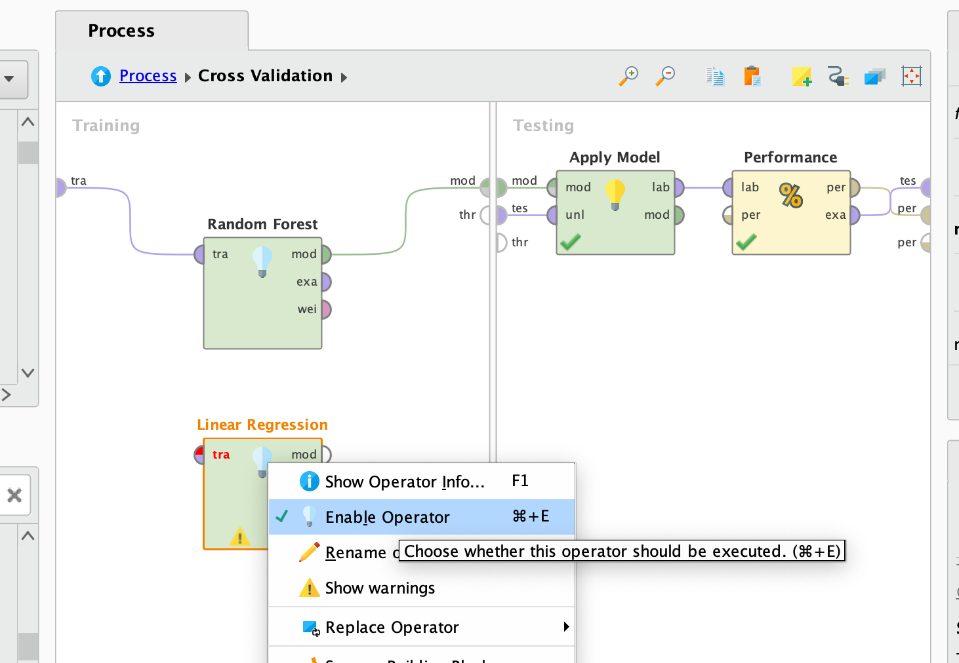

After developing your process, please document any data preparation steps you performed. Note: You may choose models covered in this course or other models beyond the tutorial exercises, provided you can use and interpret them appropriately.
- Deliverable: Screenshot of Analytical Process – model 1
<< Insert screenshots of the analytical process for the first model you choose. This should include: 1) One screenshot of the overall RapidMiner process; 2) One screenshot of the sub-process within Cross-Validation. >>

- Deliverable: Screenshot of Analytical Process – model 2
<< Insert screenshots of the analytical process for the second model you choose. This should include: 1) One screenshot of the overall RapidMiner process; 2) One screenshot of the sub-process within Cross-Validation. >>

- Deliverable: description of process
Briefly describe the data preparation steps and the process.

<< Enter your answer here, maximum 100 words in total>>

- Deliverable: Screenshot of the Results – model 1

<< Insert screenshot of the outcomes of the first model>>

- Deliverable: Screenshot of the Results – model 2

<< Insert screenshot of the outcomes of the second model>>
- Deliverable: Interpretation of the results of models
Explain the choice and impact of the most decisive predictors in the above models.

<< Enter your answer here, maximum 100 words in total>>
6. Model Comparison (5 Marks):
After evaluating your models, compare the performance of the two selected models and justify which model should be recommended for use by banks. Your comparison should clearly explain the strengths and limitations of each model and support your recommendation with appropriate evaluation metrics.

  - Deliverable: Screenshots of the model performance of the two models that you chose.

<< Insert two screenshots >>

  - Deliverable: Interpretation and justification of model performance
Interpret the performance of the two selected models and determine which model is more suitable for this analytical task. Clearly justify your choice by referring to relevant evaluation metrics and model characteristics. You may also draw on concepts related to prediction, classification, and model selection, and support your justification with relevant academic articles, blogs, or other credible sources. Your response should follow an academic writing style and include appropriate referencing.
<< Enter your answer here, maximum 150 words in total>>
7. Generate Business Insights and Strategies (3 Marks):
Following your analysis of loan default within a banking context, provide a brief reflection on the value of business analytics for financial institutions. Consider how data-driven approaches can support credit risk assessment, lending decisions, and overall risk management strategies. You may refer to credit risk practices, financial decision-making, ethical considerations in predictive modelling, and other relevant academic articles, blogs, news sources, or publications to support your discussion. Your response should be written in an academic style and include appropriate referencing.
7.1 Recommendations and Further Analysis
Propose specific actions that financial institutions can take to address the key factors contributing to loan default identified in your analysis. Additionally, suggest further analyses or additional data that could help better understand or validate these risk factors.

<< Enter your answer here, maximum 200 words in total>>

7.2 Ethical Considerations
Based on your selected model, discuss the ethical implications of using predictive analytics in loan default prediction.

<< Enter your answer here, maximum 250 words in total>>

8. Writing, Communication and References (2 Marks)
Communication plays a vital role in business analytics. Writing and communication skills will be evaluated. Please include all the references (minimum 10 references (5 per task) that you have cited in your report (APA 7th Format).
<< Add your references here >>

You can use ERDPlus (https://erdplus.com/ ) online or draw your design using MS Word or other tools.

