DATA VISUALIZATION USING
MICROSOFT POWER BI
BISM2202 Assessment Report
Student Name: __________
Student ID: __________
Total Questions: 20
Total Points: 20
This report presents the completed Power BI visualisation and evidence for each assessment question.

Q1 | 0.5 points
What is the top 20 locations based on count of order number?
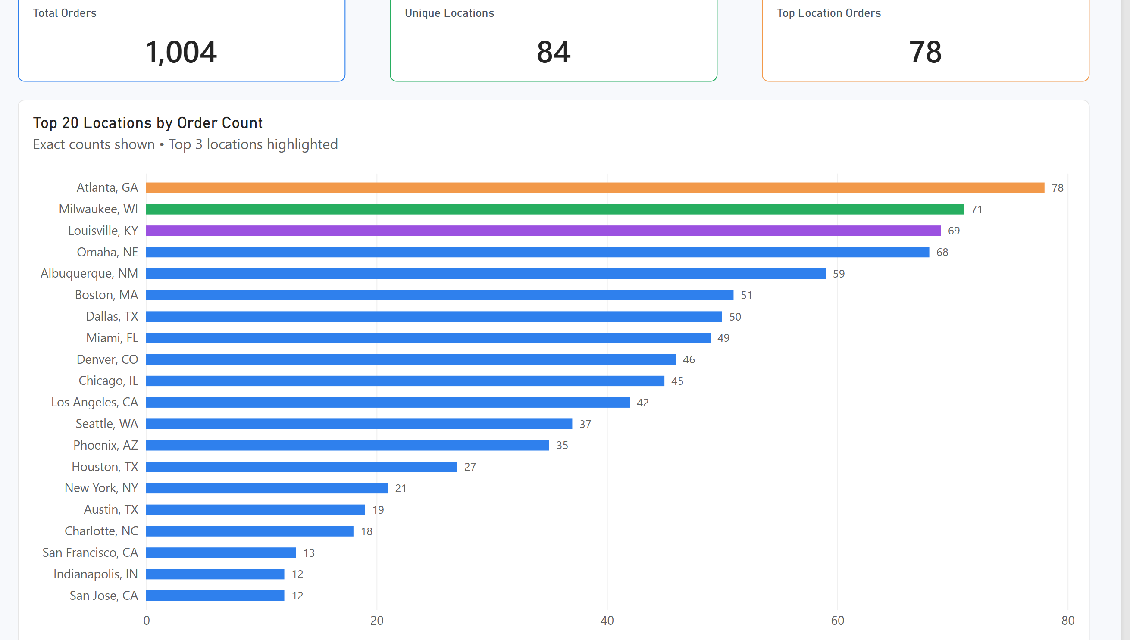
Figure Q1. Power BI visualization.
Observation / answer / explanation
Atlanta, GA had the highest order count at 78, with Milwaukee, WI on 71 and Louisville, KY on 69. The top three are fairly close, with only nine orders separating first and third place.

Q2 | 0.5 points
What is the average Delivery Duration (min) by Pizza Size?
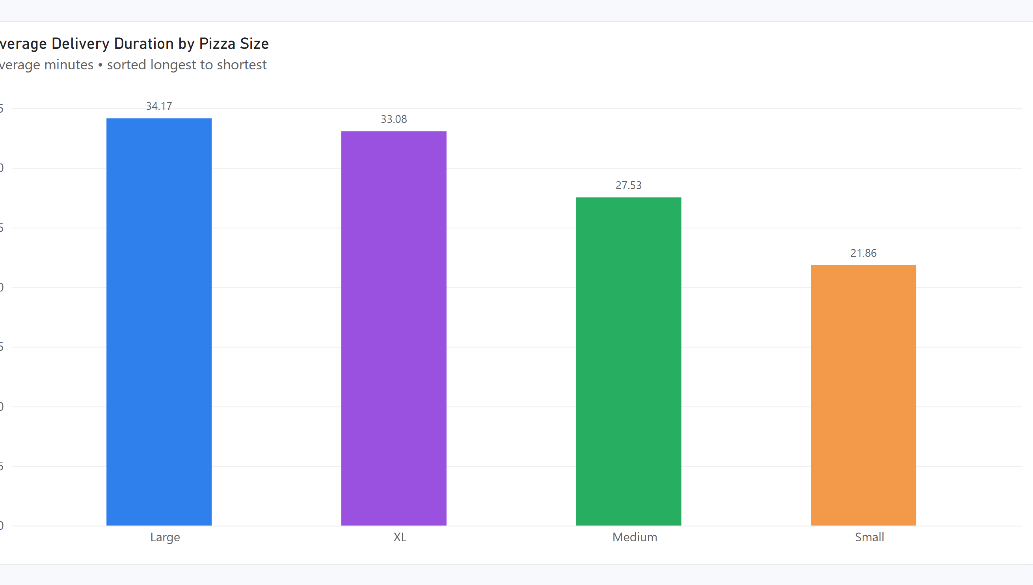
Figure Q2. Power BI visualization.
Observation / answer / explanation
Large pizzas had the longest average delivery time at 34.17 minutes, followed closely by XL at 33.08. Medium averaged 27.53 minutes and Small was lowest at 21.86, giving a 12.31-minute gap between the highest and lowest size groups.

Q3 | 0.5 points
What is the share of orders by Pizza Size?
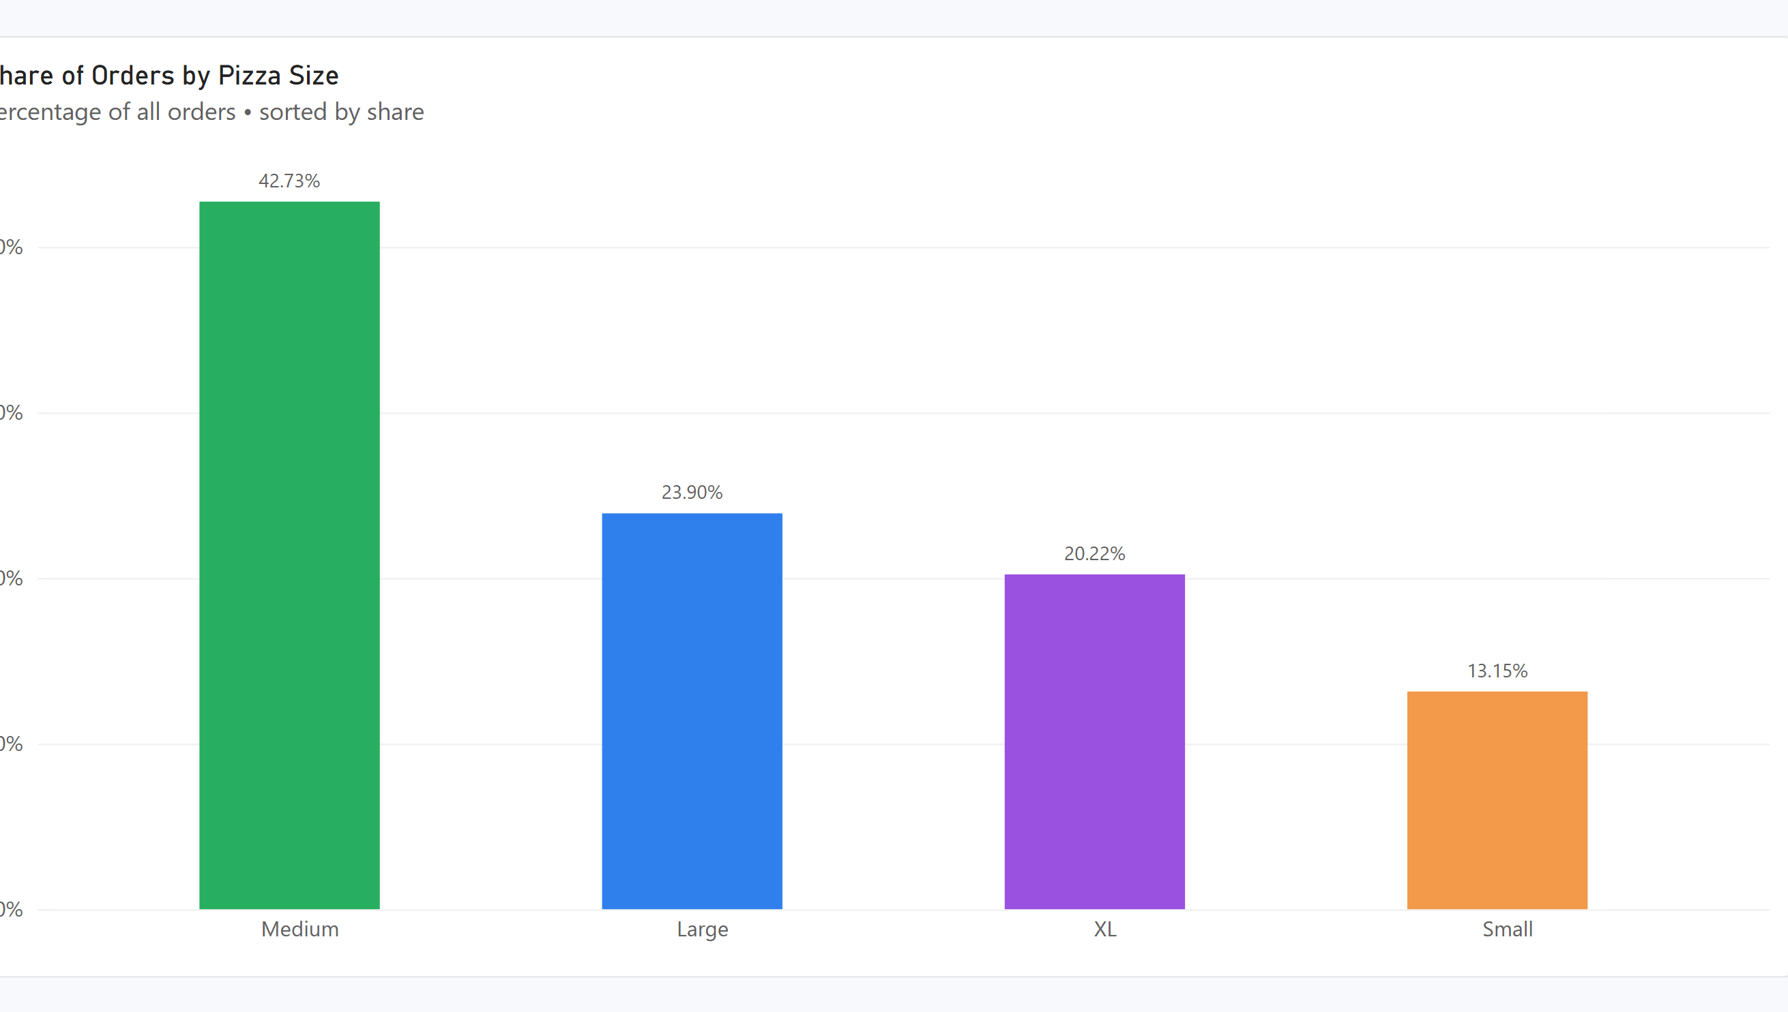
Figure Q3. Power BI visualization.
Observation / answer / explanation
Medium pizzas made up the largest share of orders, with 429 orders or 42.73% of the total. Small pizzas were the least common at 132 orders or 13.15%.

Q4 | 0.5 points
How many orders were placed with each Payment Method?
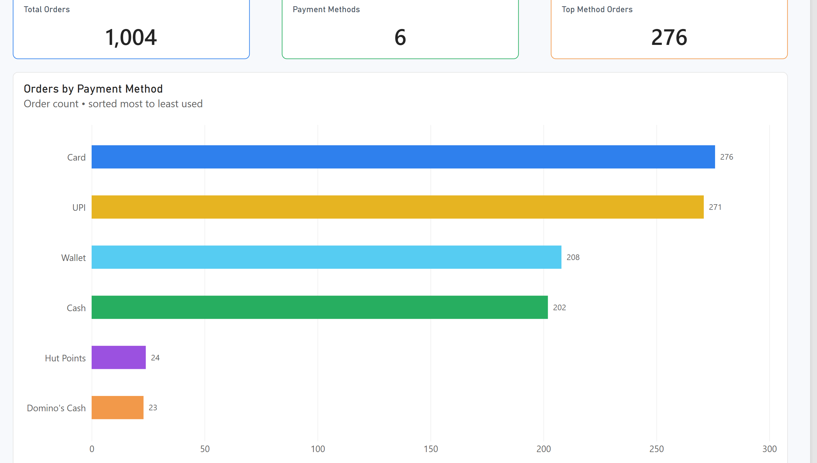
Figure Q4. Power BI visualization.
Observation / answer / explanation
Card was the most used payment method with 276 orders, only five ahead of UPI at 271. Wallet and Cash were also common at 208 and 202, while Hut Points and Domino's Cash were rare at 24 and 23 orders.

Q5 | 0.5 points
What is the share of orders by Traffic Level?
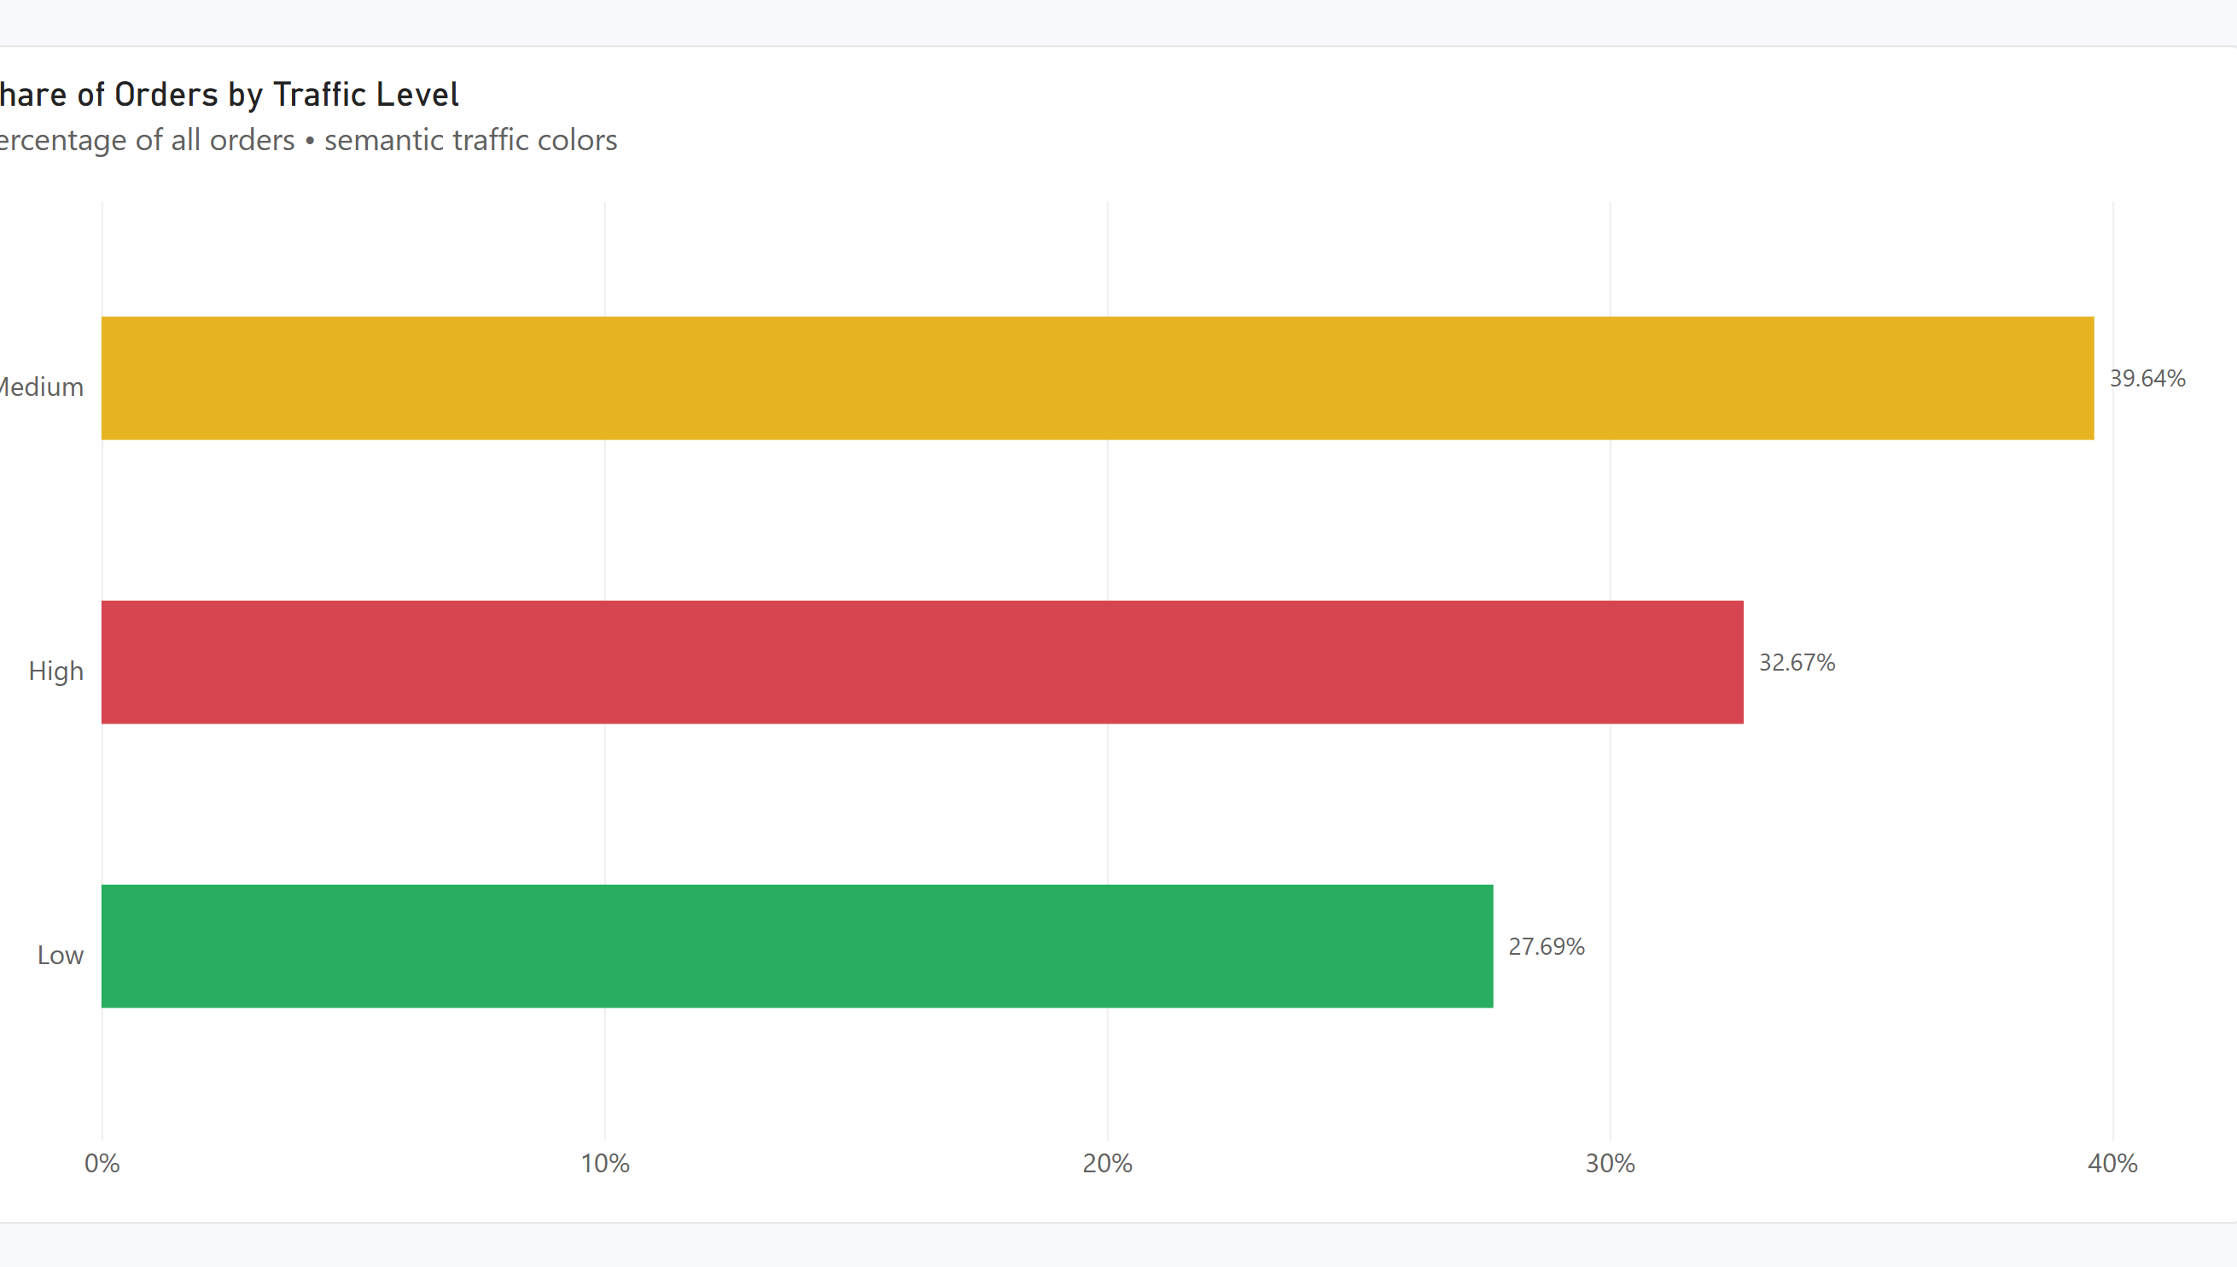
Figure Q5. Power BI visualization.
Observation / answer / explanation
Medium traffic accounted for the largest share of orders at 39.64% or 398 orders. High traffic represented 32.67% and Low traffic 27.69%, so most orders occurred under Medium or High traffic conditions.

Q6 | 0.5 points
What is the average Toppings Count for weekend vs. weekday orders?
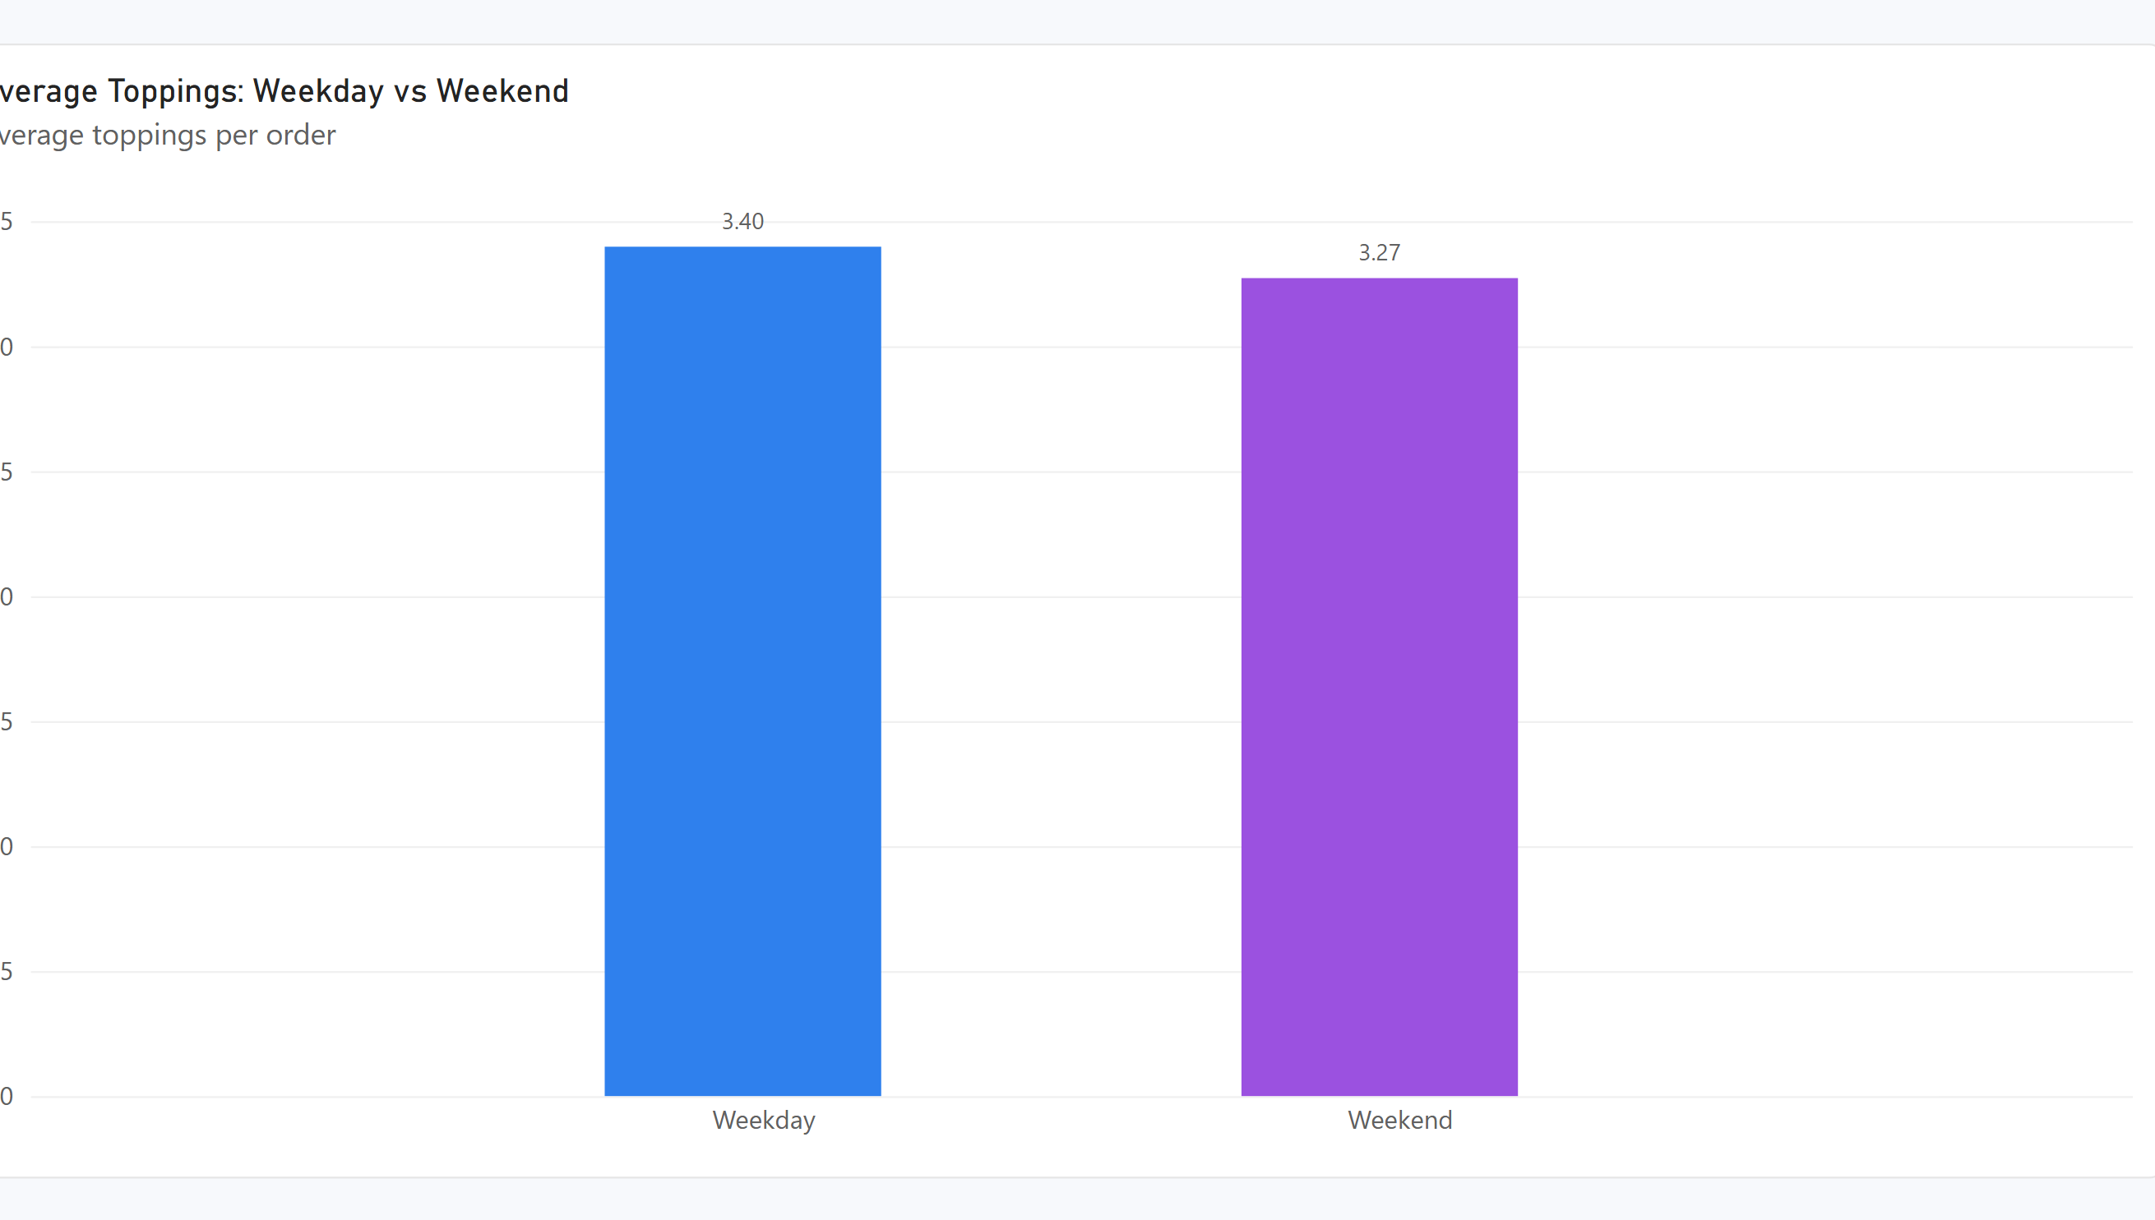
Figure Q6. Power BI visualization.
Observation / answer / explanation
Weekday orders averaged 3.40 toppings compared with 3.27 on weekends. The difference is only 0.13 toppings per order, so the two groups are very similar.

Q7 | 0.5 points
Which locations have the highest average Delivery Duration (min)?
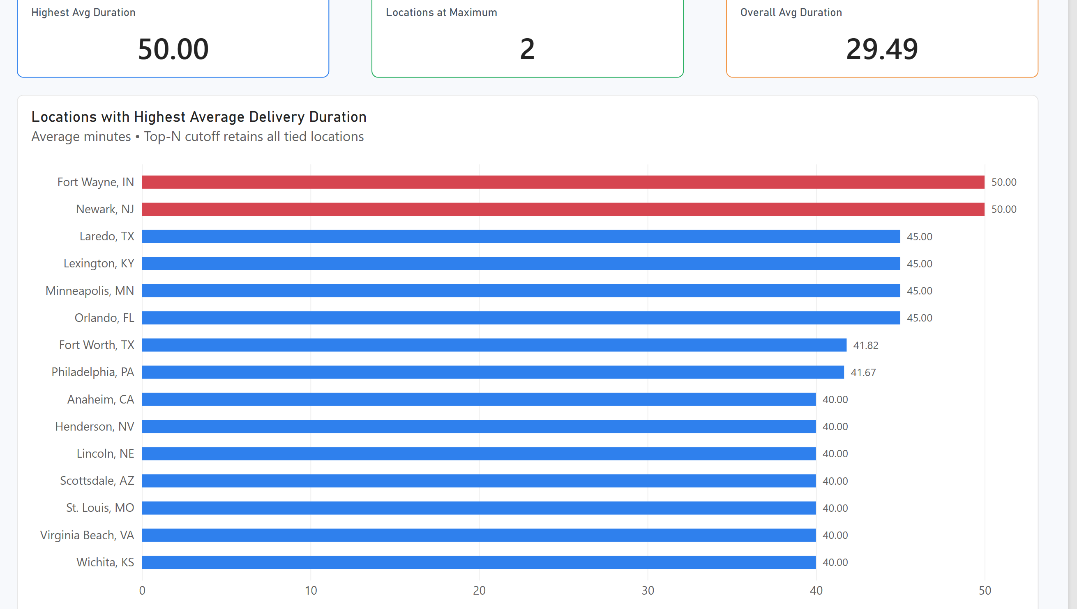
Figure Q7. Power BI visualization.
Observation / answer / explanation
Fort Wayne, IN and Newark, NJ had the highest average delivery duration at 50.00 minutes. Laredo, Lexington, Minneapolis and Orlando were tied next at 45.00 minutes, making the tied results important when reading the ranking.

Q8 | 0.5 points
How many orders were placed during peak hours vs. non-peak?
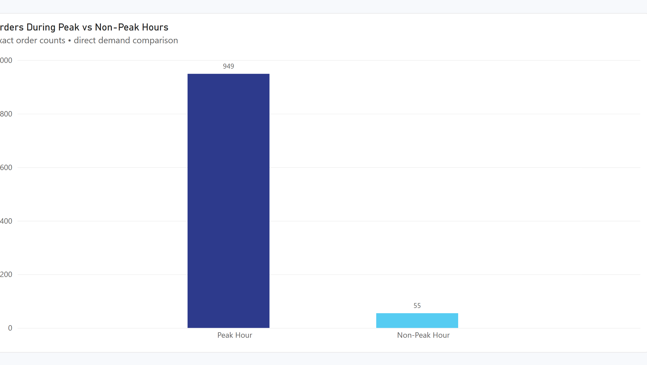
Figure Q8. Power BI visualization.
Observation / answer / explanation
Peak hours contained 949 orders, equal to 94.52% of the dataset, while only 55 orders or 5.48% were non-peak. Order activity is therefore heavily concentrated in the defined peak period.

Q9 | 1 point
How does order volume trend across Order Month?
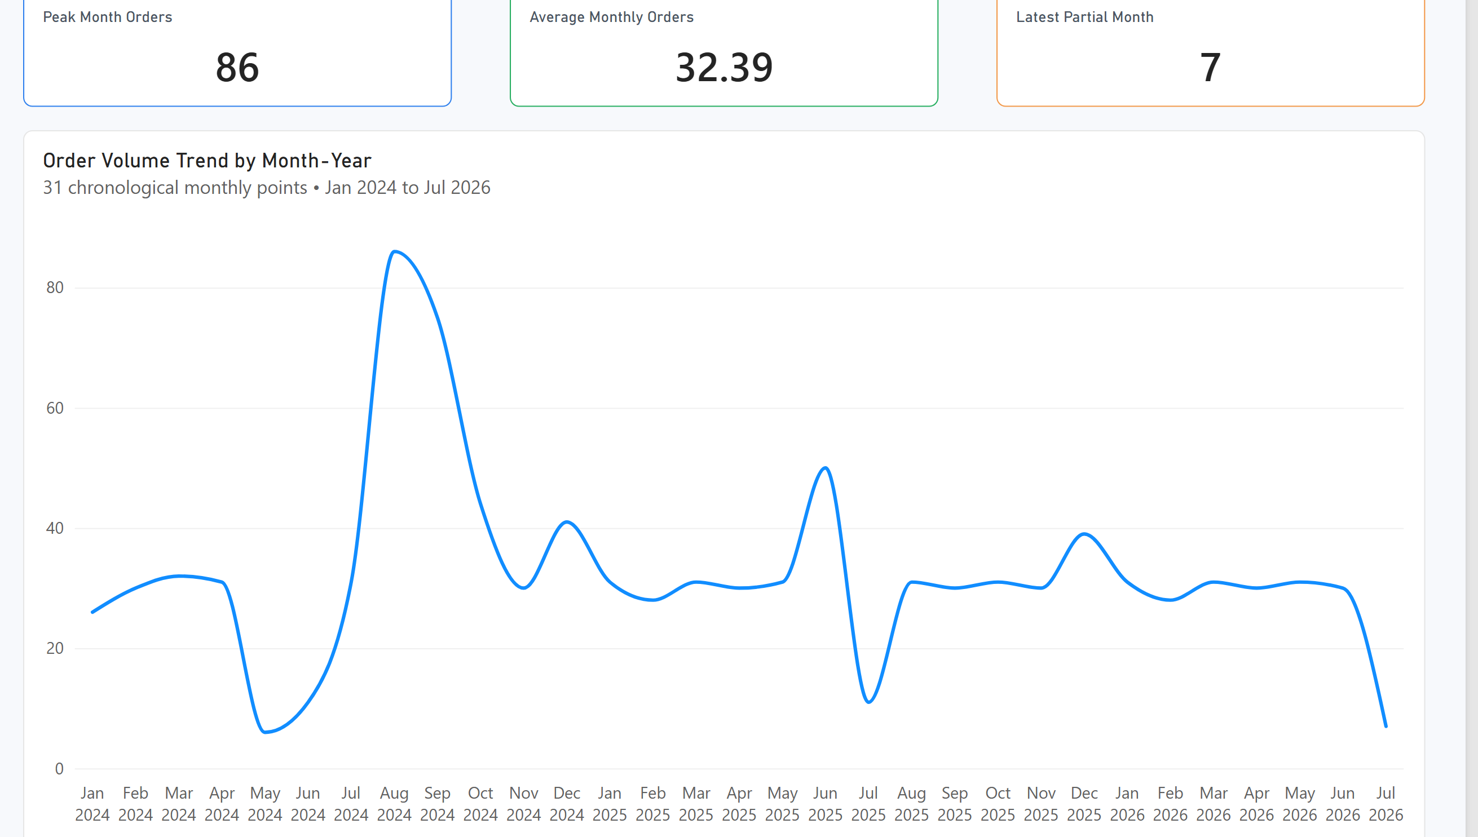
Figure Q9. Power BI visualization.
Observation / answer / explanation
Order volume is shown across 31 Month-Year points from 2024-01 to 2026-07. The highest month was 2024-08 with 86 orders, followed by 75 in 2024-09 and then 44 in 2024-10. The lowest full month was 2024-05 with 6 orders; the last point, 2026-07, contains 7 orders and only covers data through 7 July.

Q10 | 1 point
What is the average Toppings Count by Pizza Size?
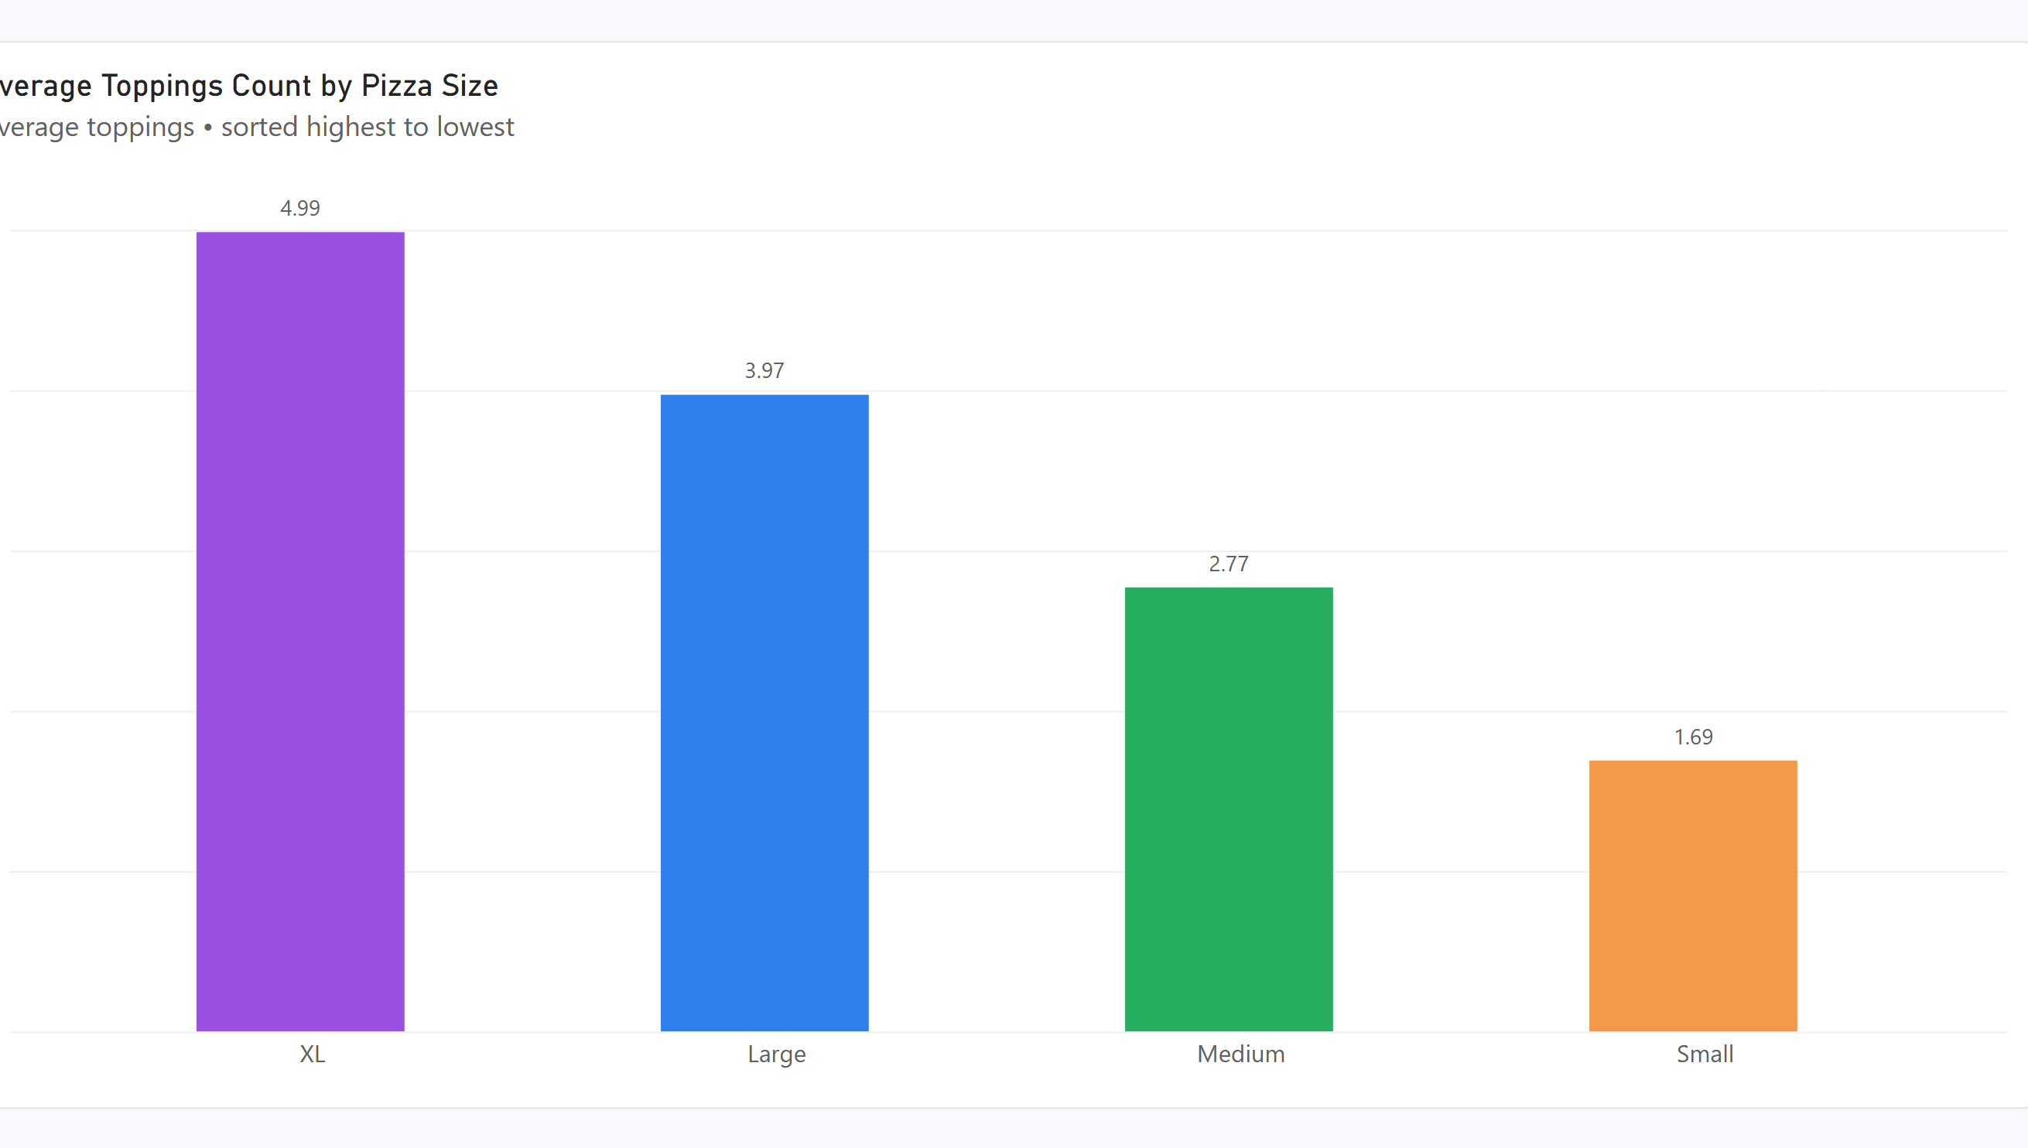
Figure Q10. Power BI visualization.
Observation / answer / explanation
Average topping count increased with pizza size in this dataset. XL was highest at 4.99 toppings, followed by Large at 3.97, Medium at 2.77 and Small at 1.69.

Q11 | 1 point
Which 2 restaurants have the lowest average Delay (min) i.e., the fastest, most reliable performers?
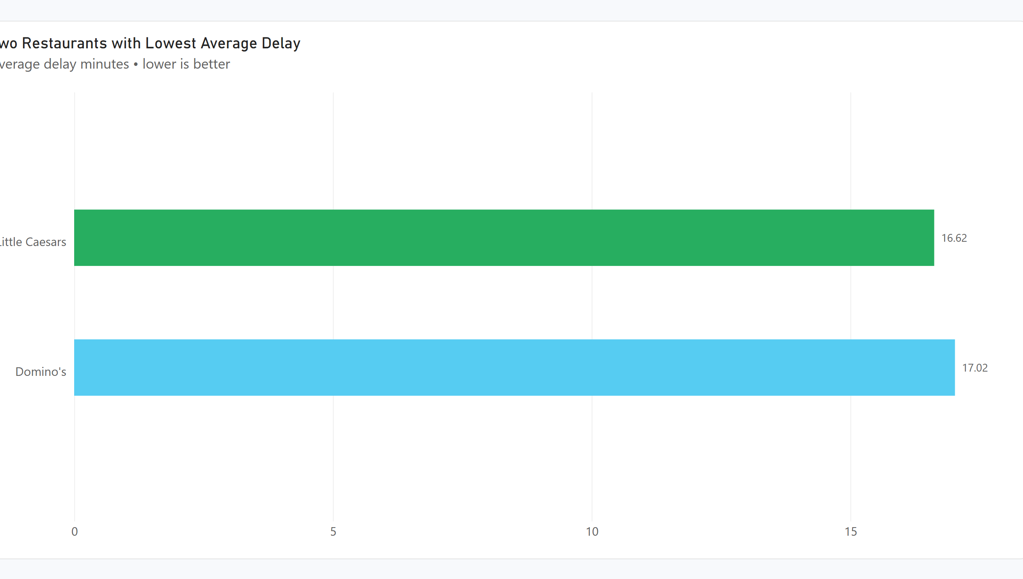
Figure Q11. Power BI visualization.
Observation / answer / explanation
Little Caesars had the lowest average delay at 16.62 minutes, with Domino's second at 17.02 minutes. The difference between the two lowest-delay restaurants is just 0.40 minutes.

Q12 | 1 point
Which 5 Pizza Types have the highest average Delivery Duration (min)?
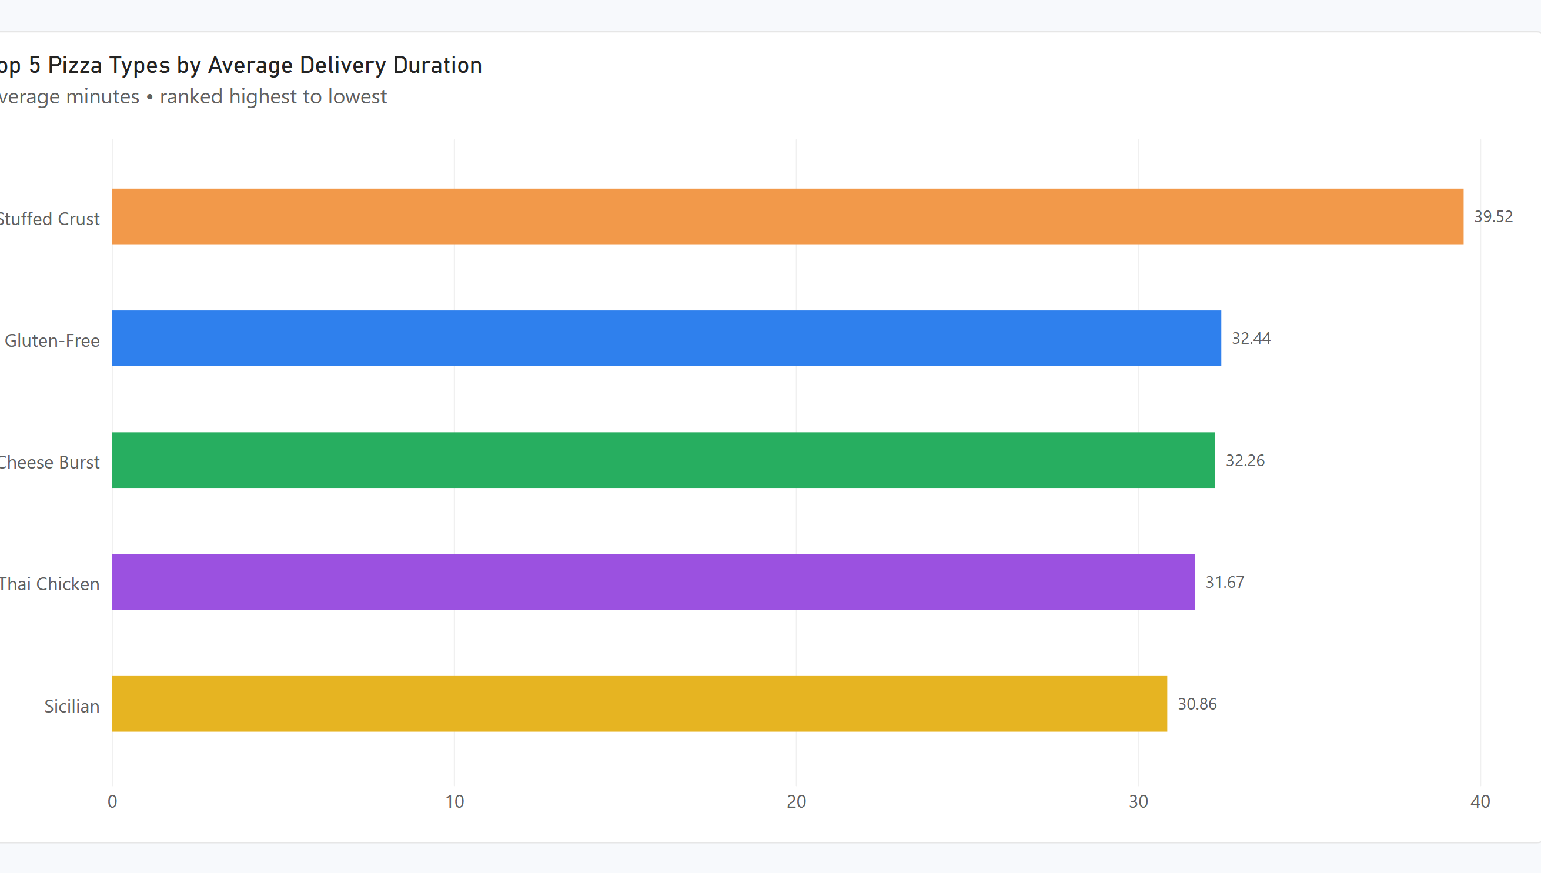
Figure Q12. Power BI visualization.
Observation / answer / explanation
Stuffed Crust had the longest average delivery duration at 39.52 minutes. The rest of the top five were Gluten-Free at 32.44, Cheese Burst at 32.26, Thai Chicken at 31.67 and Sicilian at 30.86 minutes.

Q13 | 1 point
How does order volume vary by Order Hour across a typical day?
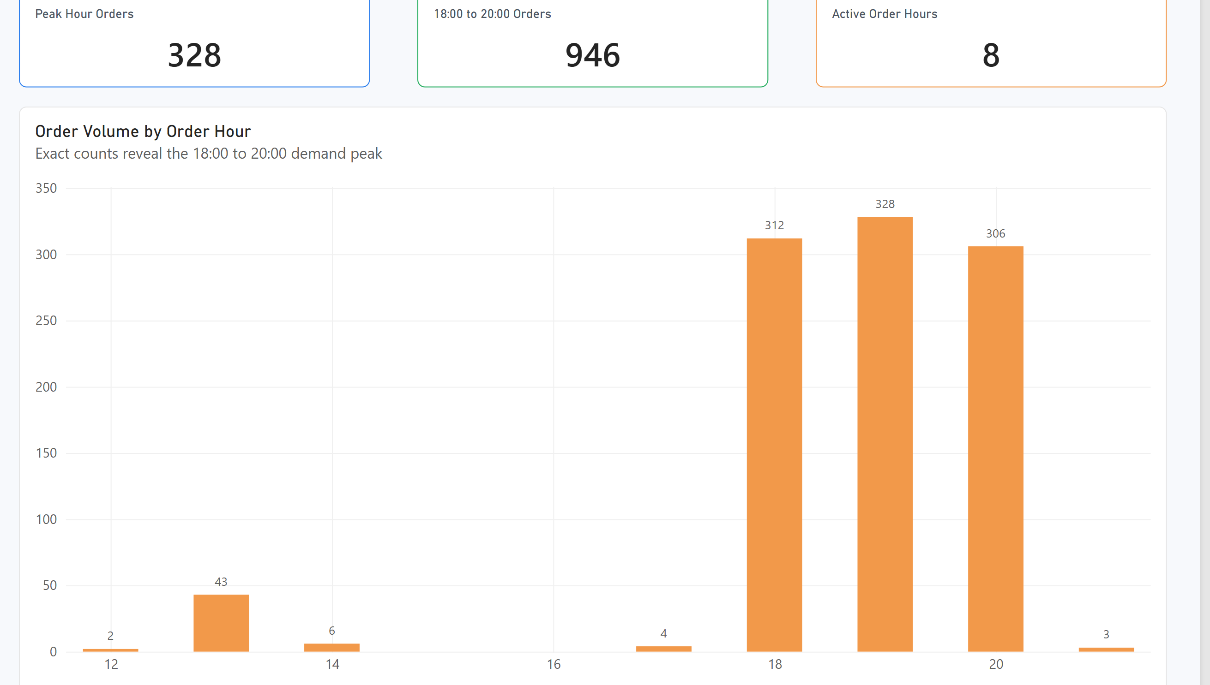
Figure Q13. Power BI visualization.
Observation / answer / explanation
The busiest hour was 19:00 with 328 orders. The adjacent hours were also very busy, with 312 orders at 18:00 and 306 at 20:00, showing a strong evening concentration in order volume.

Q14 | 1 point
What is the average delay (min) by Traffic Level?
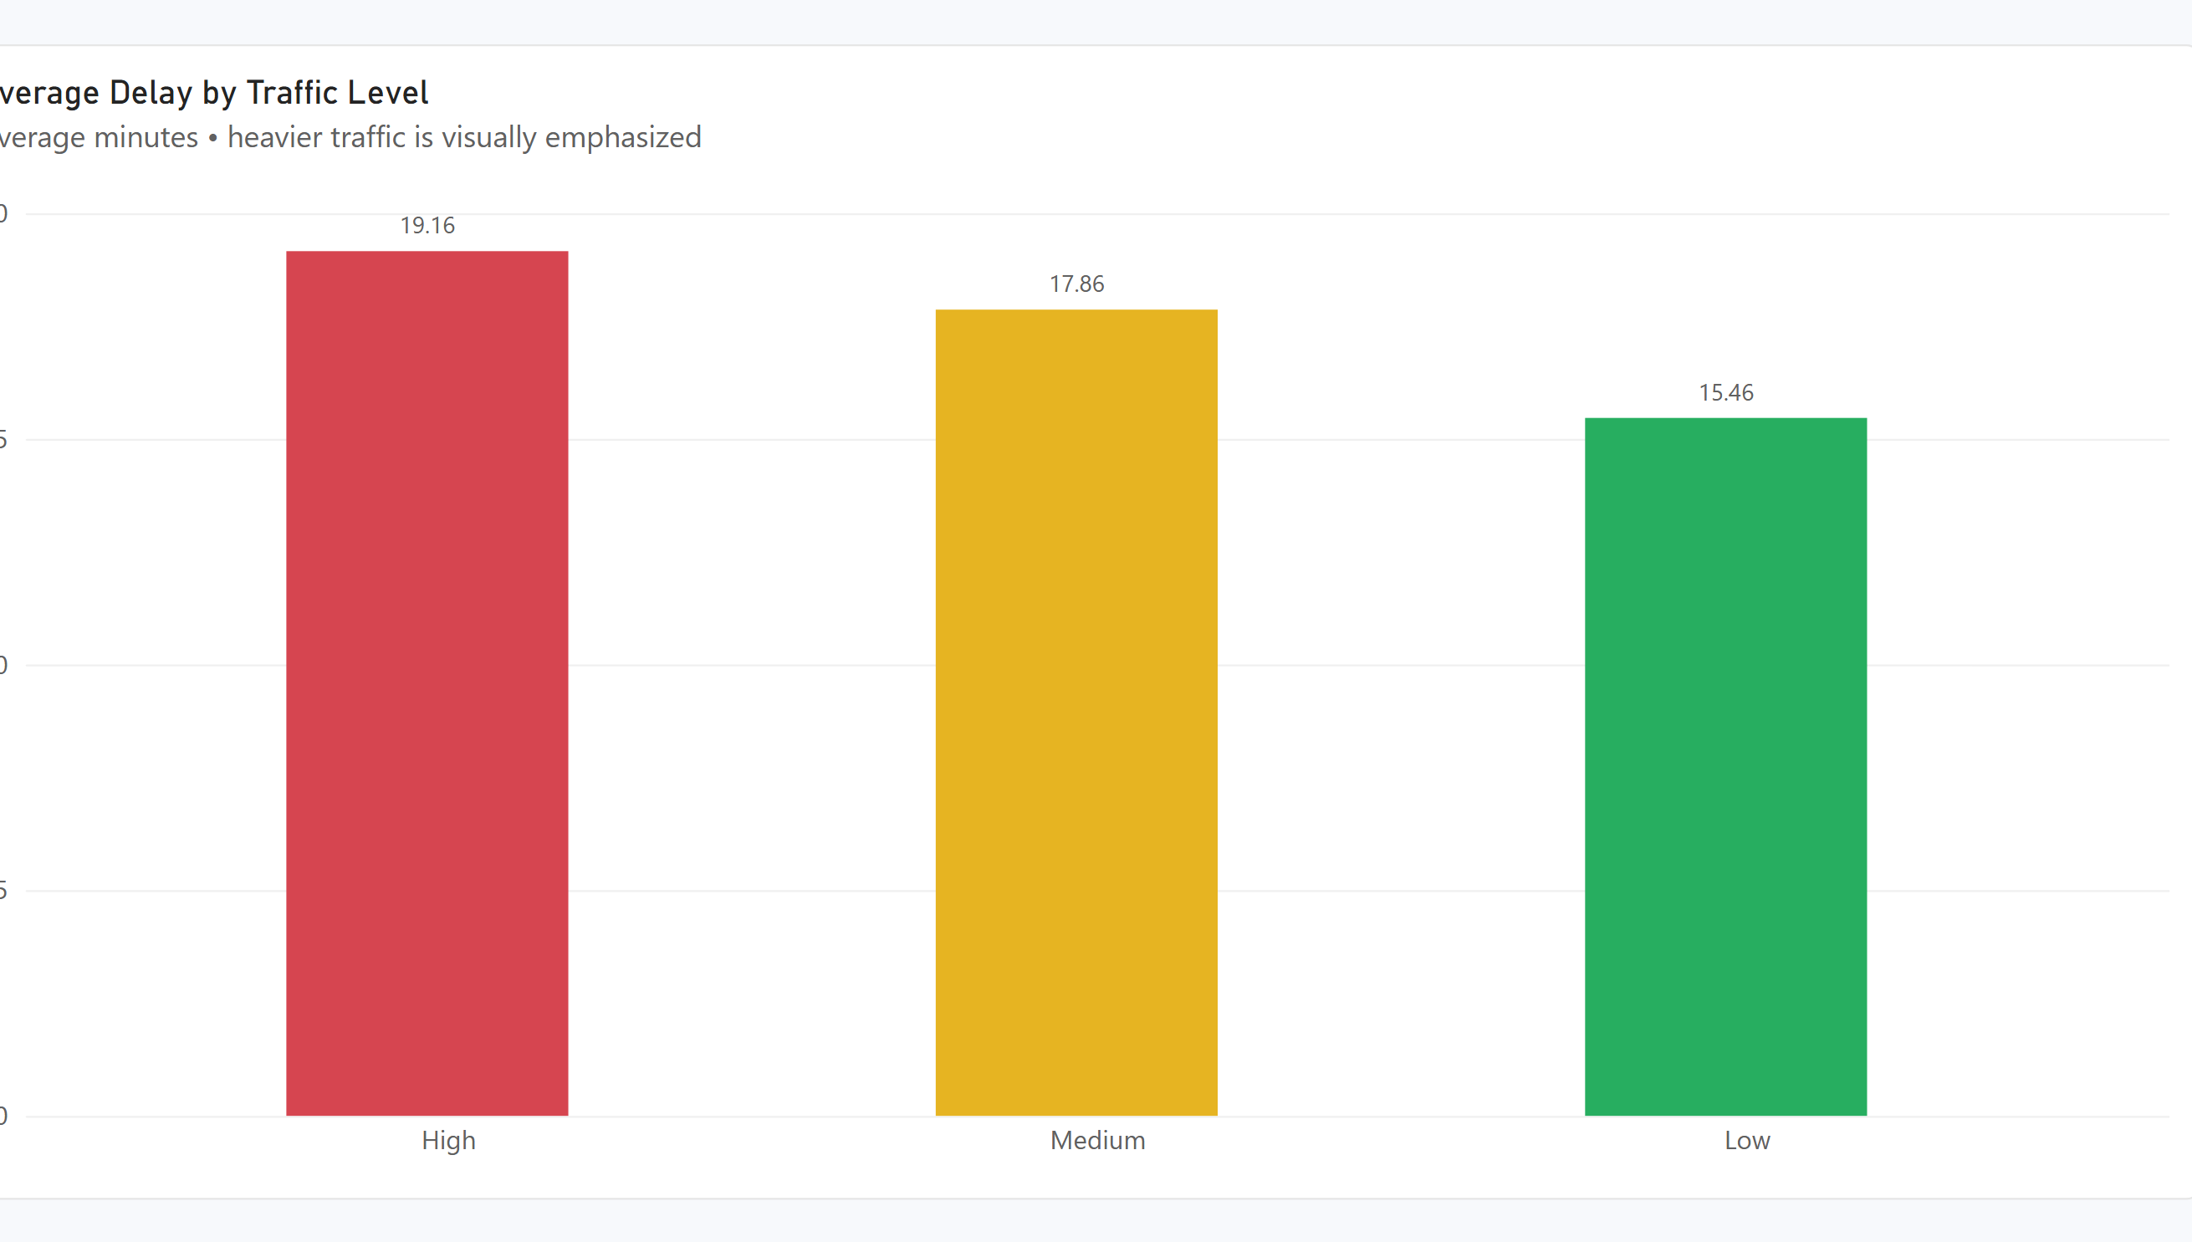
Figure Q14. Power BI visualization.
Observation / answer / explanation
Average delay rose from 15.46 minutes in Low traffic to 17.86 in Medium and 19.16 in High traffic. The High-traffic average is 3.70 minutes above the Low-traffic average.

Q15 | 1 point
What proportion of orders fall into each Pizza Complexity category?
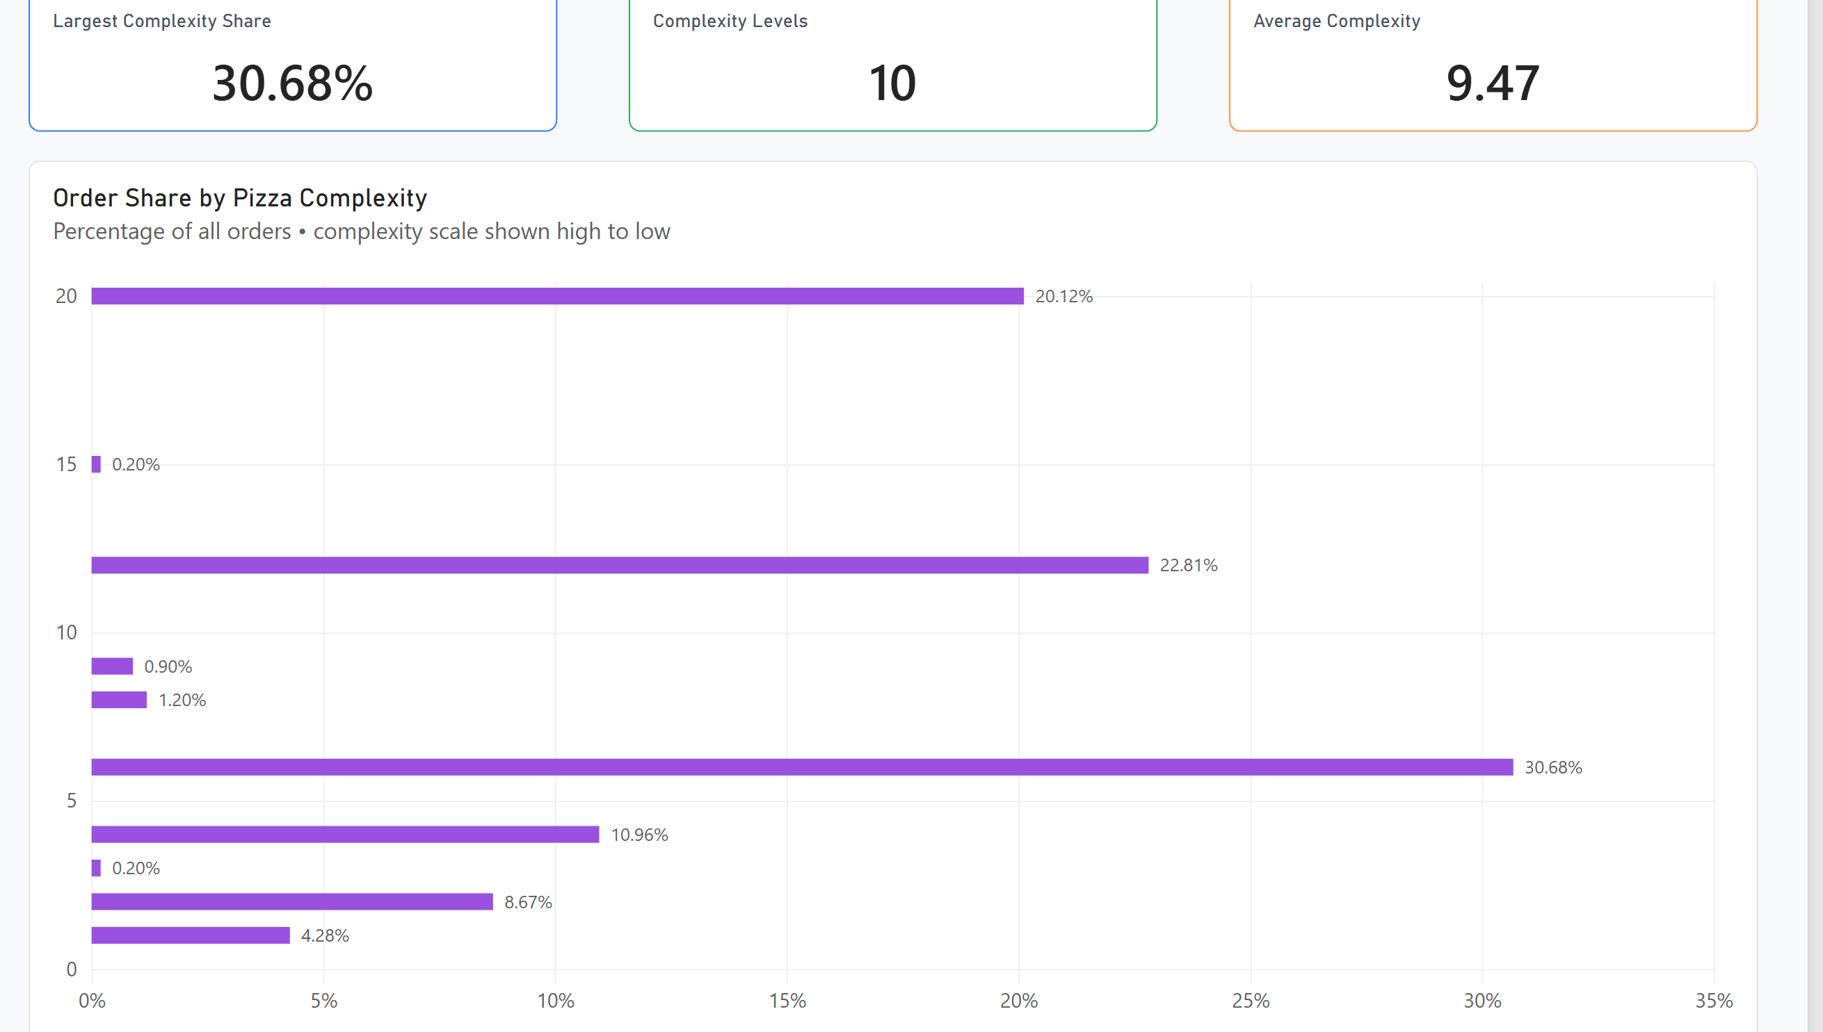
Figure Q15. Power BI visualization.
Observation / answer / explanation
Complexity 6 was the largest category at 30.68% of orders, followed by Complexity 12 at 22.81% and Complexity 20 at 20.12%. Together these three categories account for 73.61% of all orders, while Complexity 3 and 15 contain only two orders each.

Q16 | 1 point
Build a table of average Delivery Duration and Delay by Restaurant Name and use the Fx (Format by field value) button to visually highlight the fastest and slowest restaurants.
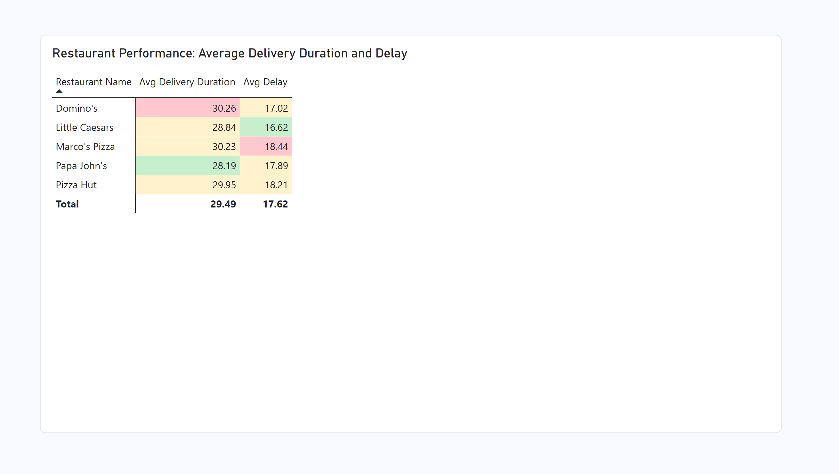
Figure Q16. Power BI visualization.
Observation / answer / explanation
The two performance measures identify different leaders. Papa John's had the shortest average delivery duration at 28.19 minutes, while Little Caesars had the lowest average delay at 16.62. Domino's had the longest average delivery duration at 30.26 minutes and Marco's Pizza had the highest average delay at 18.44.

Q17 | 2 points
How does order volume vary by Order Hour, alongside average Delay (min)?
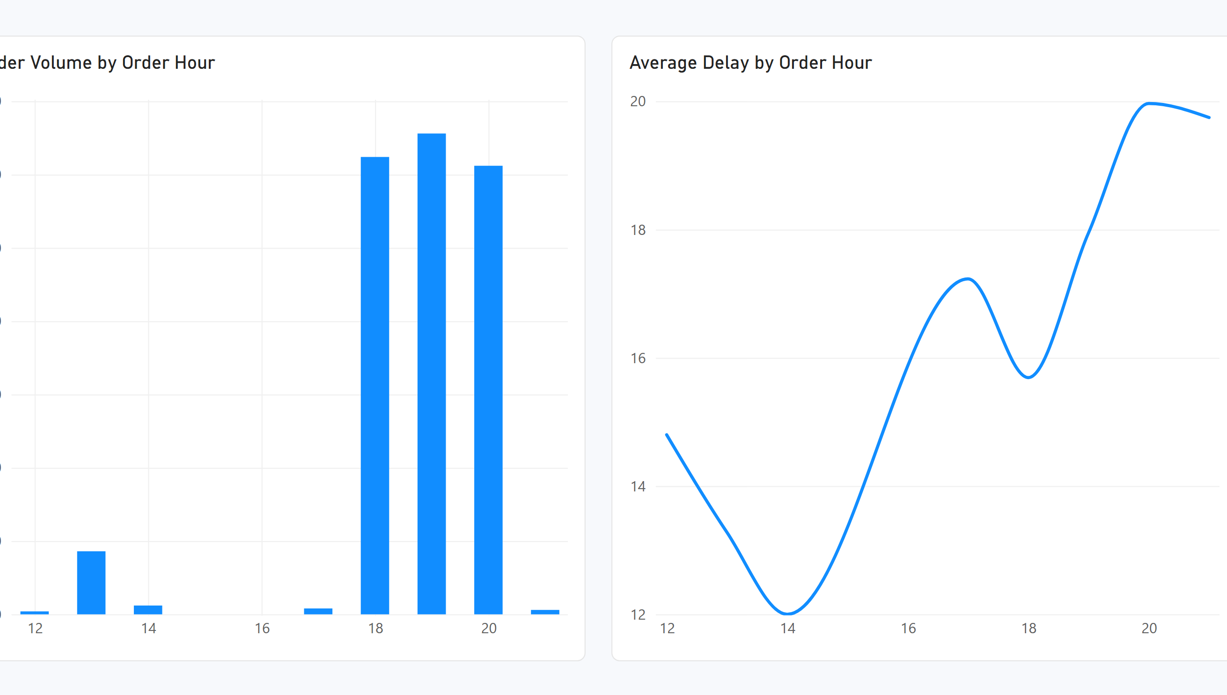
Figure Q17. Power BI visualization.
Observation / answer / explanation
Order volume reached its maximum at 19:00 with 328 orders, while average delay peaked one hour later at 20:00 with 19.97 minutes. The 21:00 delay was also high at 19.75 minutes, though that value comes from only three orders and carries much less weight than the main evening peak.

Q18 | 2 points
How does average Topping Density vary by Pizza Type, alongside order volume?
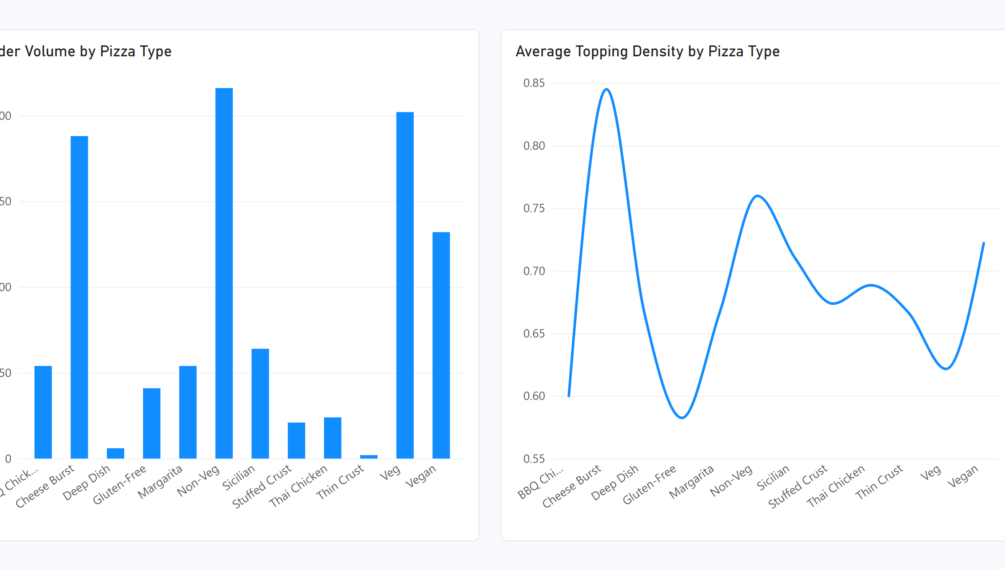
Figure Q18. Power BI visualization.
Observation / answer / explanation
Non-Veg had the highest order volume at 216 with an average topping density of 0.760. Cheese Burst had 188 orders and the highest average density at 0.845. The supplied Topping Density field is based on toppings per kilometre, so it should be read as the provided dataset measure rather than a pure pizza-size indicator.

Q19 | 2 points
What is the percentage breakdown of orders by Traffic Level within each Payment methods, filterable by order time?
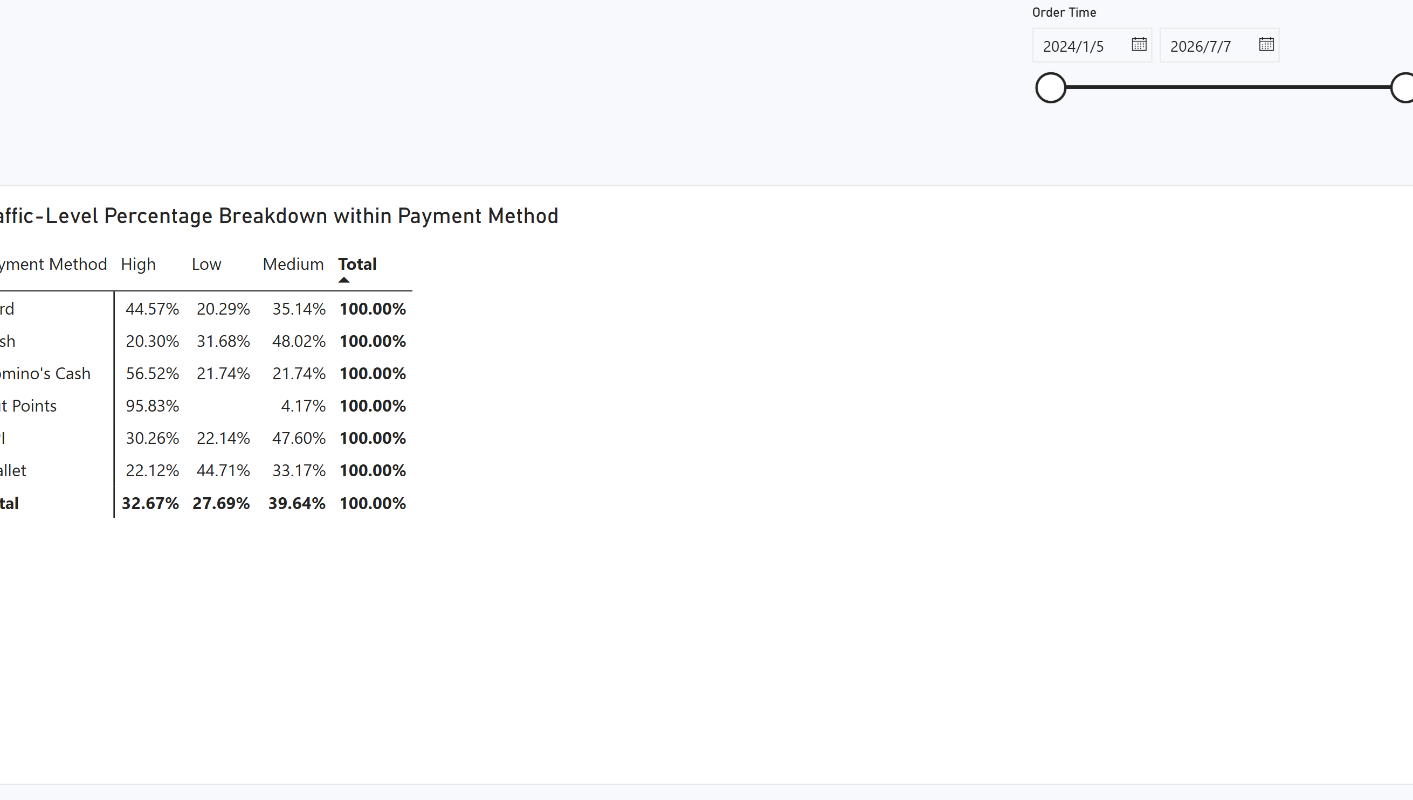
Figure Q19. Power BI visualization.
Observation / answer / explanation
Traffic mix varies across payment methods. High traffic represented 44.57% of Card orders, Medium traffic was largest for Cash at 48.02% and UPI at 47.60%, while Low traffic was largest for Wallet at 44.71%. Hut Points is 95.83% High traffic, but that payment method has only 24 orders, so the percentage comes from a small base.

Q20 | 2 points
Design three different charts or tables that use conditional formatting (or highlight them by using different colors) in a single dashboard. Explain why each one matters, what it represents, how they should be read together, and what insights emerge from viewing them as a whole.
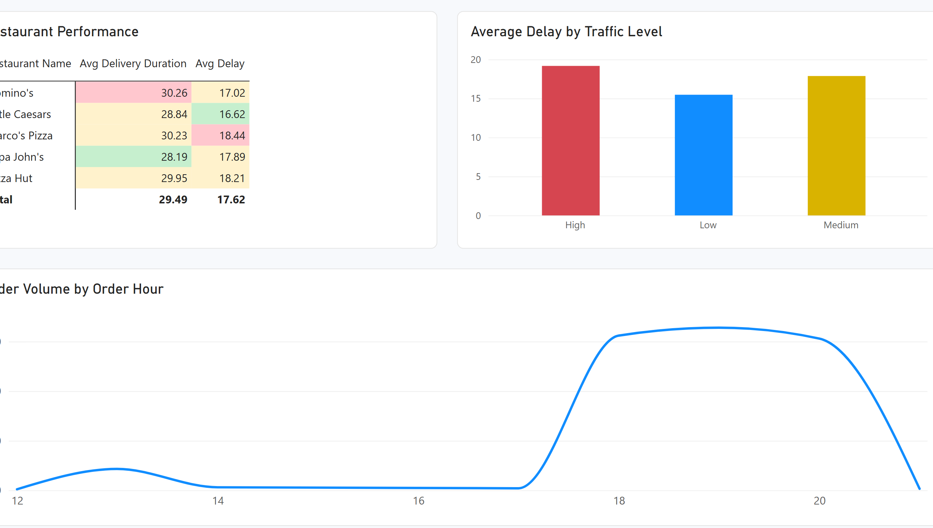
Figure Q20. Power BI visualization.
Observation / answer / explanation
The dashboard brings together restaurant performance, traffic-related delay and hourly demand. Papa John's had the shortest average delivery duration at 28.19 minutes, while Marco's Pizza had the highest average delay at 18.44. High traffic produced the highest average delay at 19.16 minutes, and demand reached 328 orders at 19:00. Looking at the three views together points to evening demand and high-traffic conditions as the main areas where delivery performance deserves attention.

