DATA VISUALIZATION USING
MICROSOFT POWER BI
BISM2202 Assessment Report
Student Name: __________
Student ID: __________
Total Questions: 20
Total Points: 20
This report presents the completed Power BI visualisation and evidence for each assessment question.

Q1 | 0.5 points
What is the top 20 locations based on count of order number?
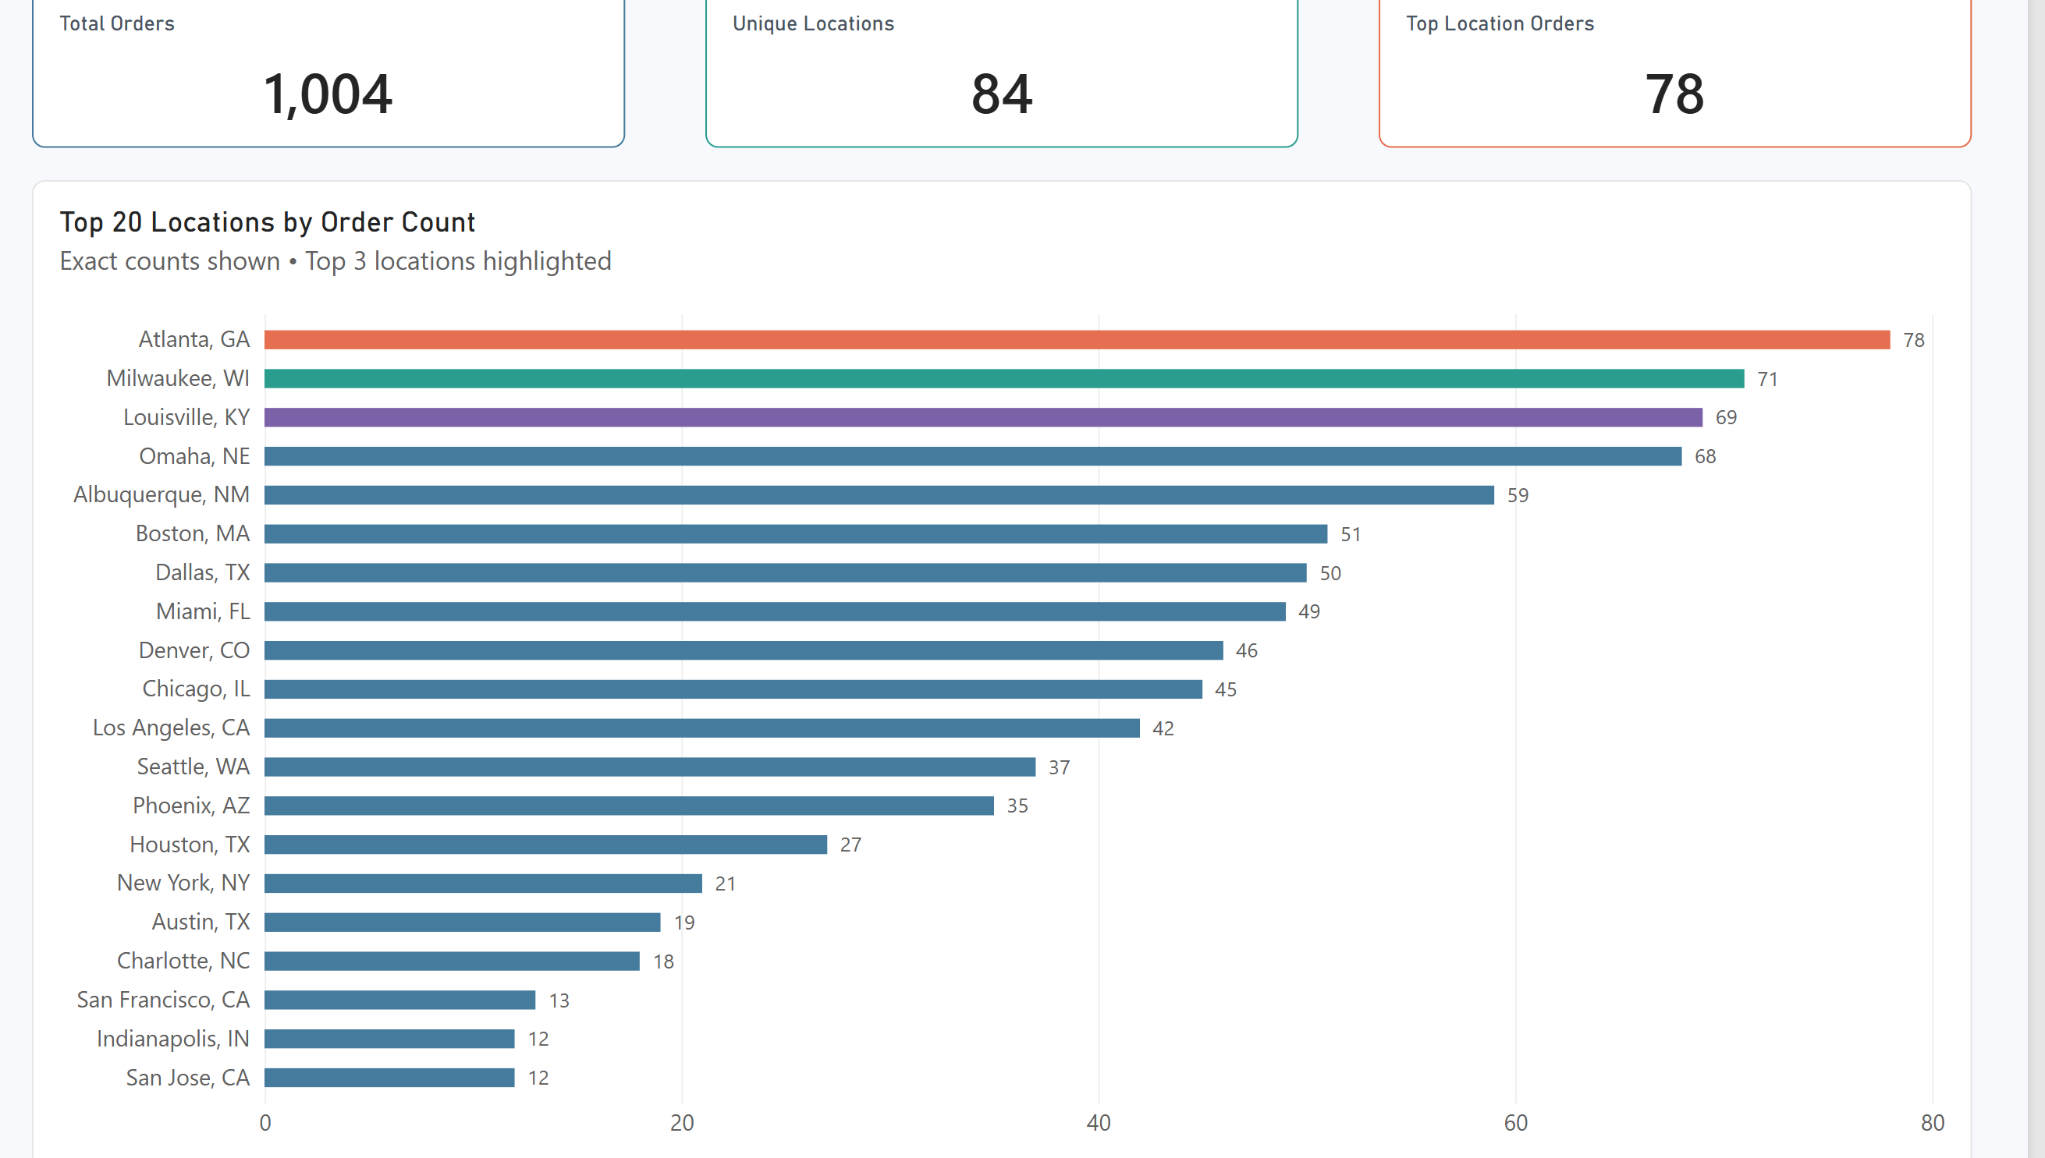
Figure Q1. Power BI visualization.
Observation / answer / explanation
Atlanta, GA leads the location ranking with 78 orders. Milwaukee, WI follows with 71 and Louisville, KY with 69, so the first three locations are separated by only nine orders and there is no large gap at the top.

Q2 | 0.5 points
What is the average Delivery Duration (min) by Pizza Size?
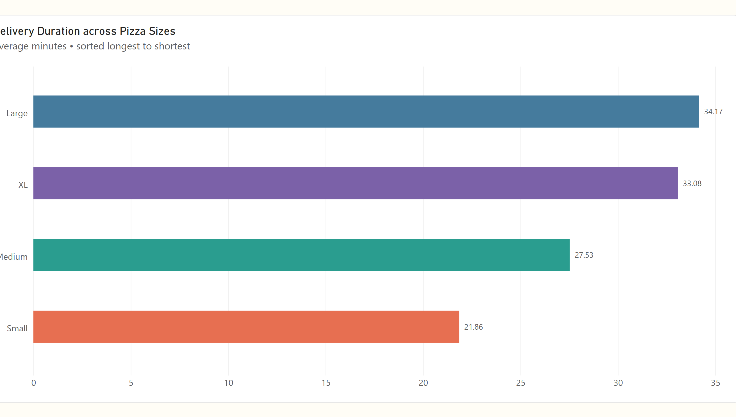
Figure Q2. Power BI visualization.
Observation / answer / explanation
Large and XL pizzas form the slower-delivery pair, averaging 34.17 and 33.08 minutes respectively. Small pizzas average 21.86 minutes, which is more than eleven minutes below XL and over twelve minutes below Large.

Q3 | 0.5 points
What is the share of orders by Pizza Size?
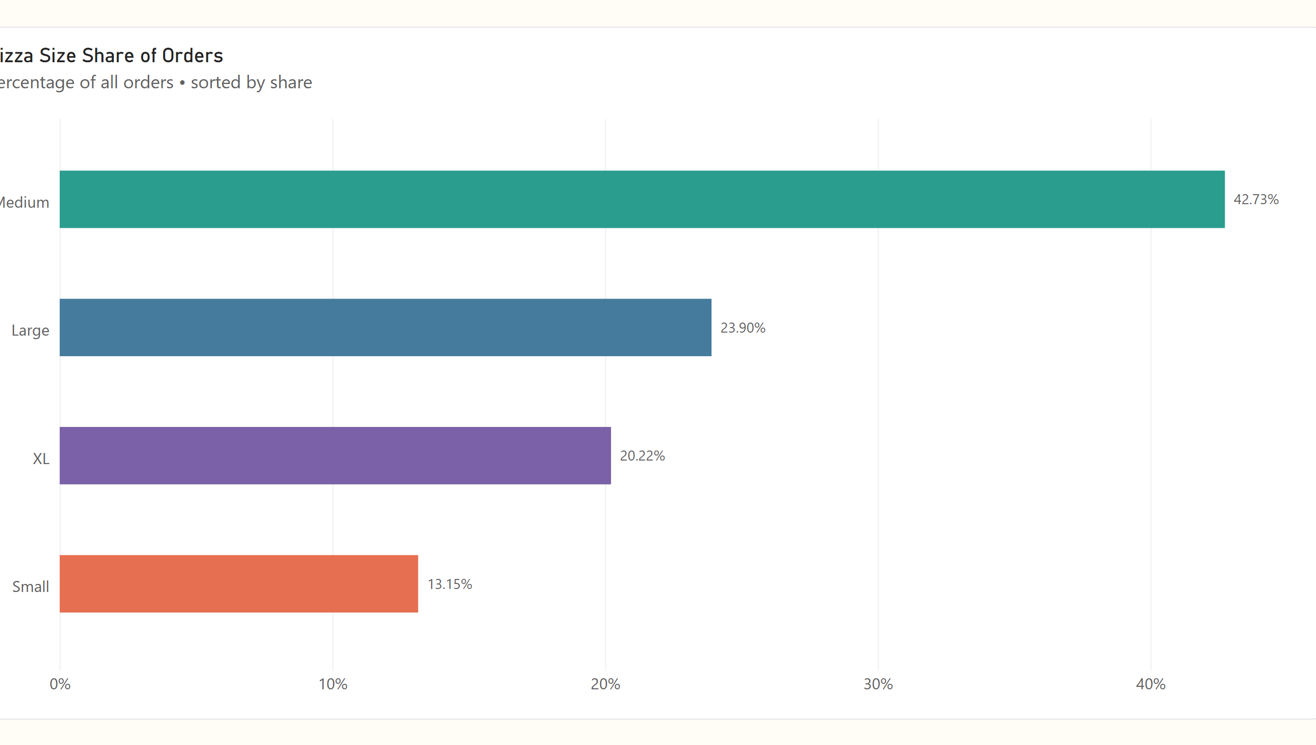
Figure Q3. Power BI visualization.
Observation / answer / explanation
Medium pizzas account for 42.73% of all orders, with 429 orders. Small pizzas account for 13.15% with 132 orders, so the Medium share is more than three times the Small share.

Q4 | 0.5 points
How many orders were placed with each Payment Method?
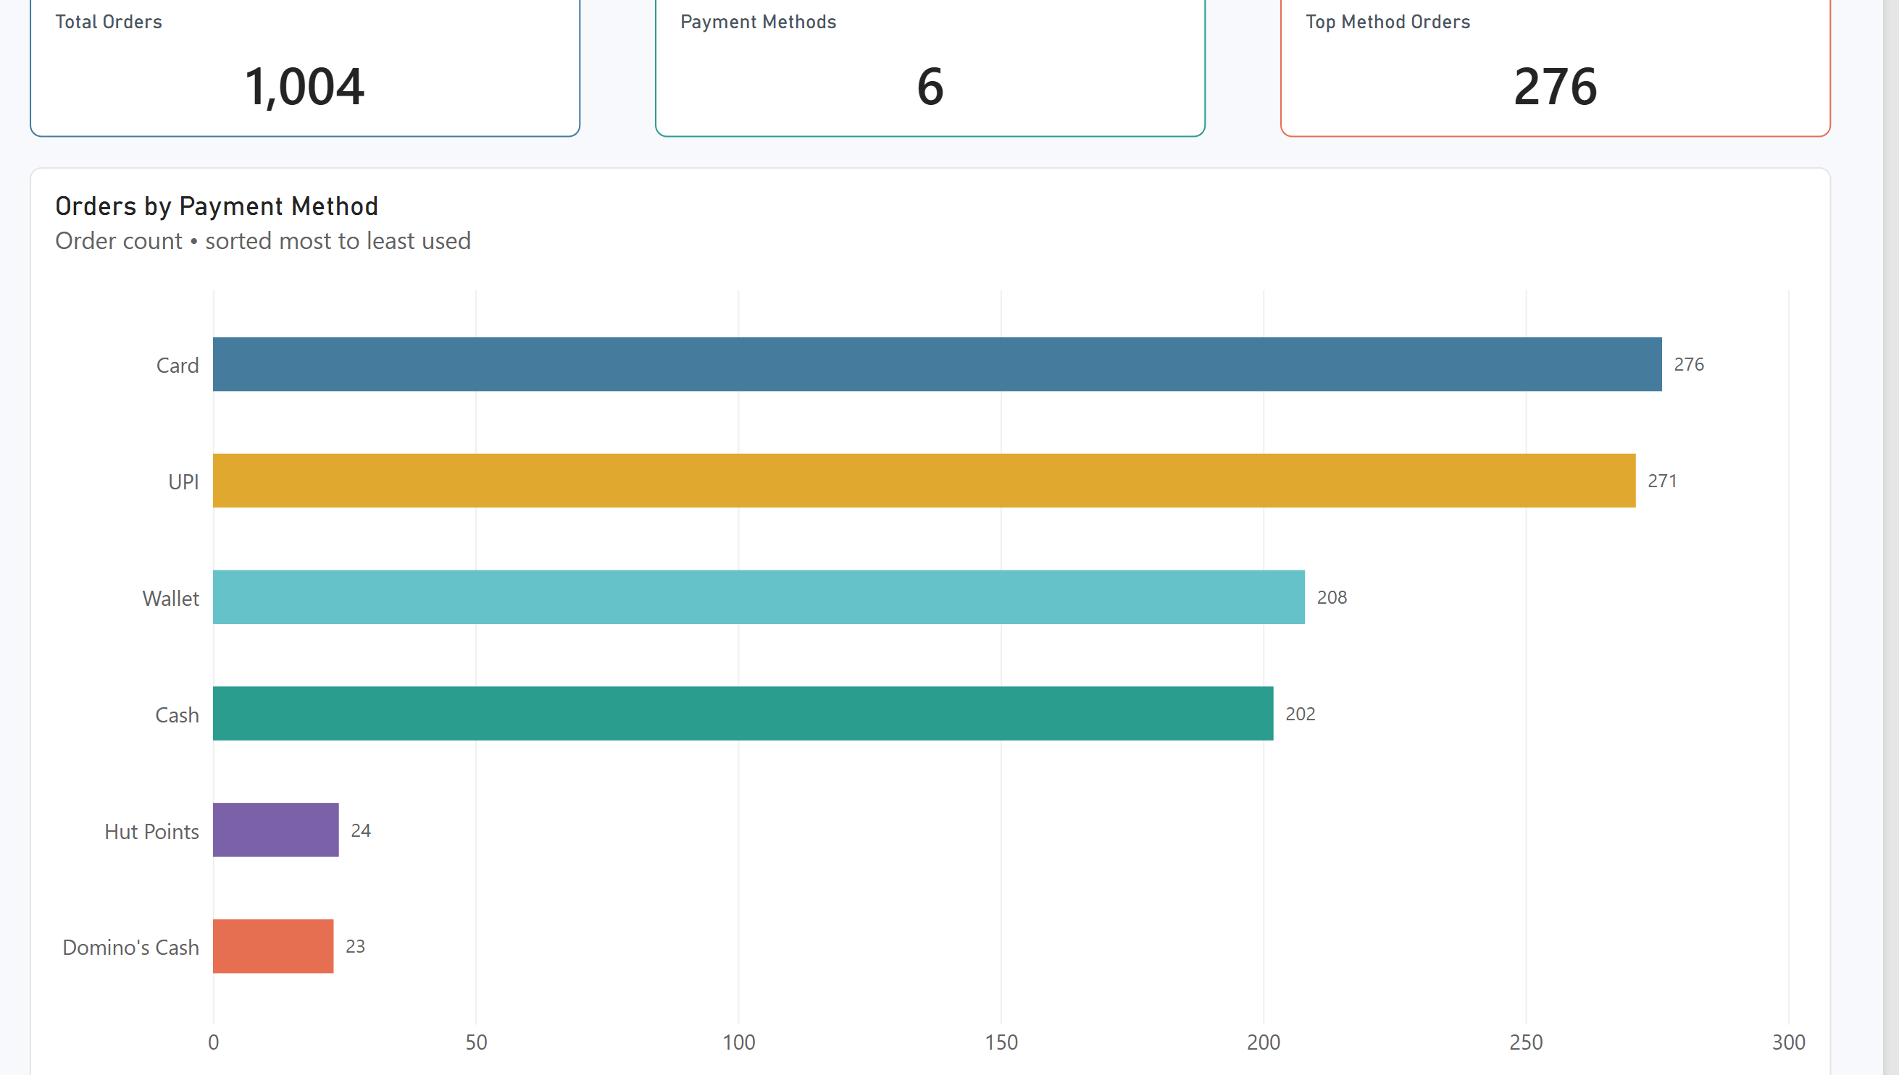
Figure Q4. Power BI visualization.
Observation / answer / explanation
Card and UPI dominate payment activity with 276 and 271 orders. Combined they represent 547 of the 1,004 orders, while Wallet and Cash contribute 208 and 202; Hut Points and Domino's Cash remain small categories with 24 and 23.

Q5 | 0.5 points
What is the share of orders by Traffic Level?
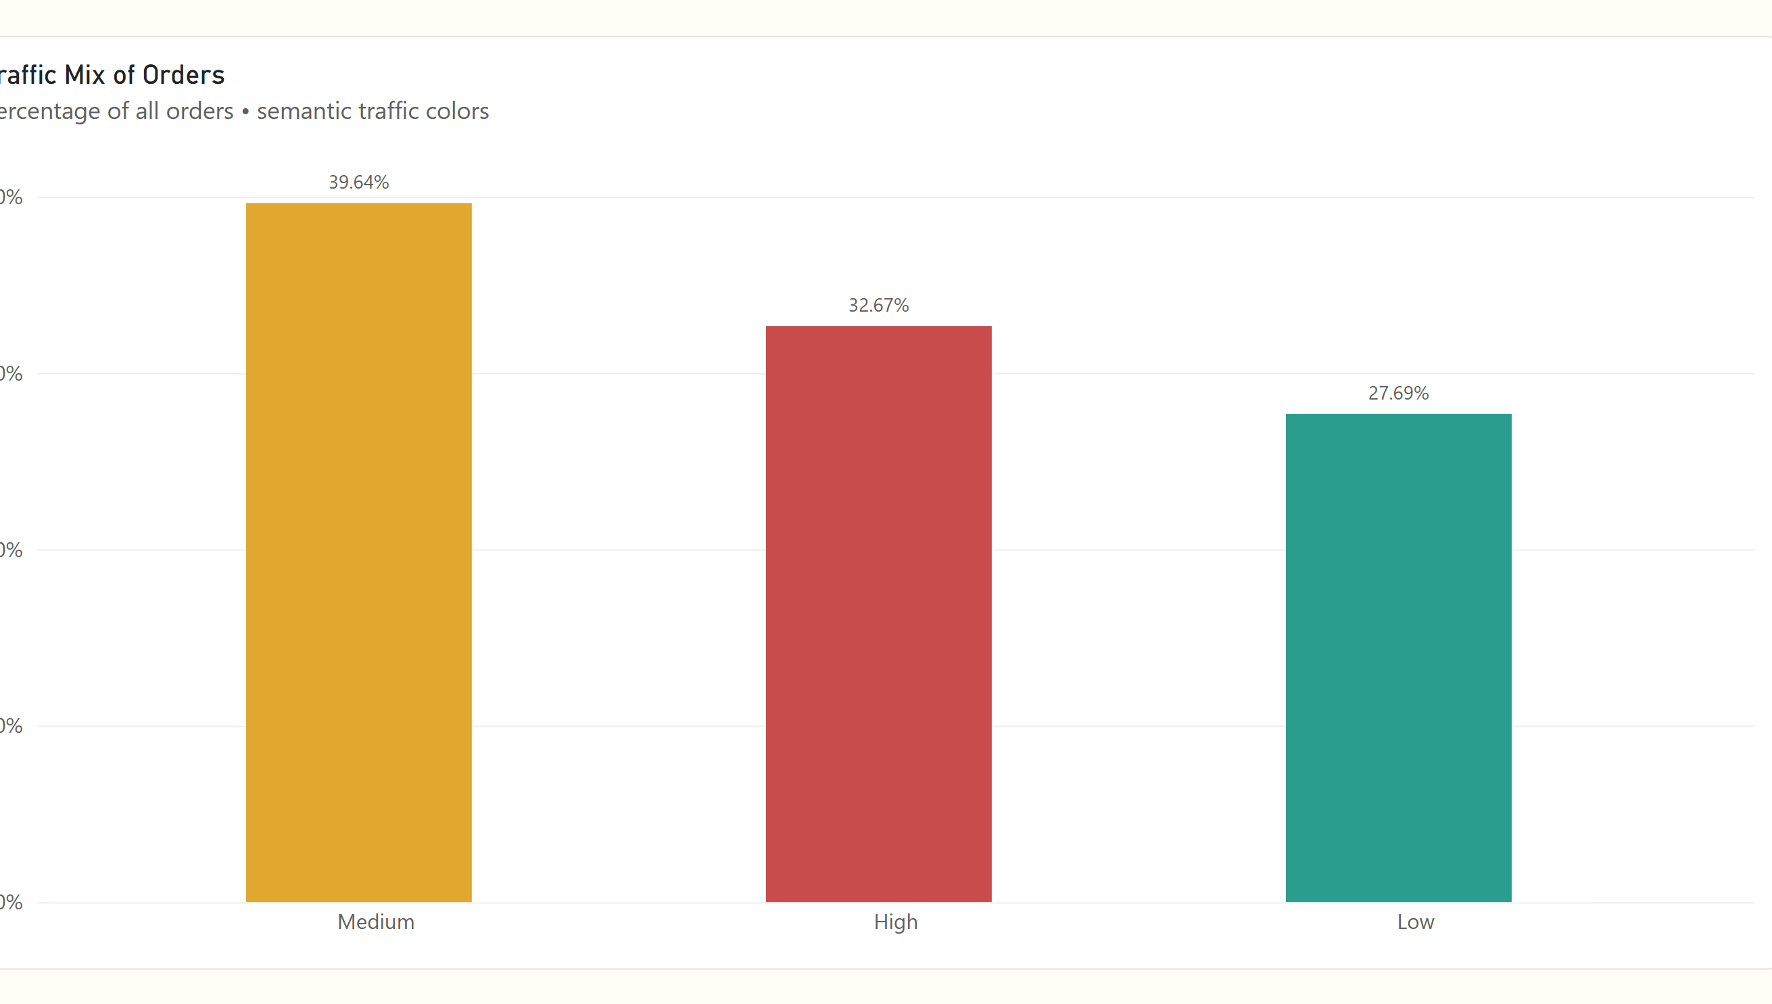
Figure Q5. Power BI visualization.
Observation / answer / explanation
Medium traffic is the largest group at 39.64%, followed by High at 32.67% and Low at 27.69%. Medium and High together account for 72.31% of orders, so most deliveries took place outside the Low-traffic category.

Q6 | 0.5 points
What is the average Toppings Count for weekend vs. weekday orders?
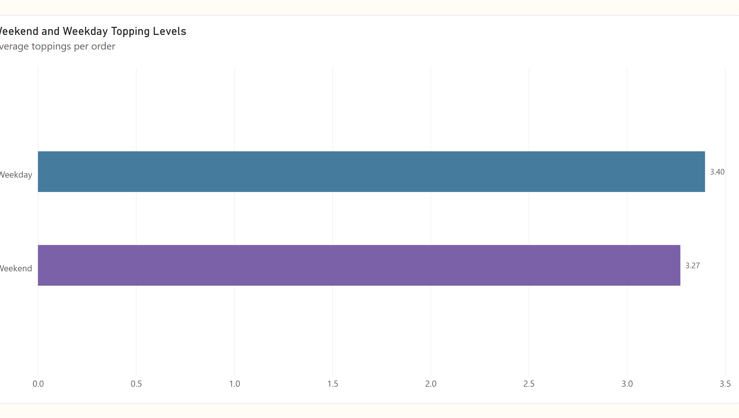
Figure Q6. Power BI visualization.
Observation / answer / explanation
Average toppings are almost unchanged between the two day types: 3.40 on weekdays and 3.27 on weekends. The 0.13 gap leaves the two observed averages very close in this sample.

Q7 | 0.5 points
Which locations have the highest average Delivery Duration (min)?
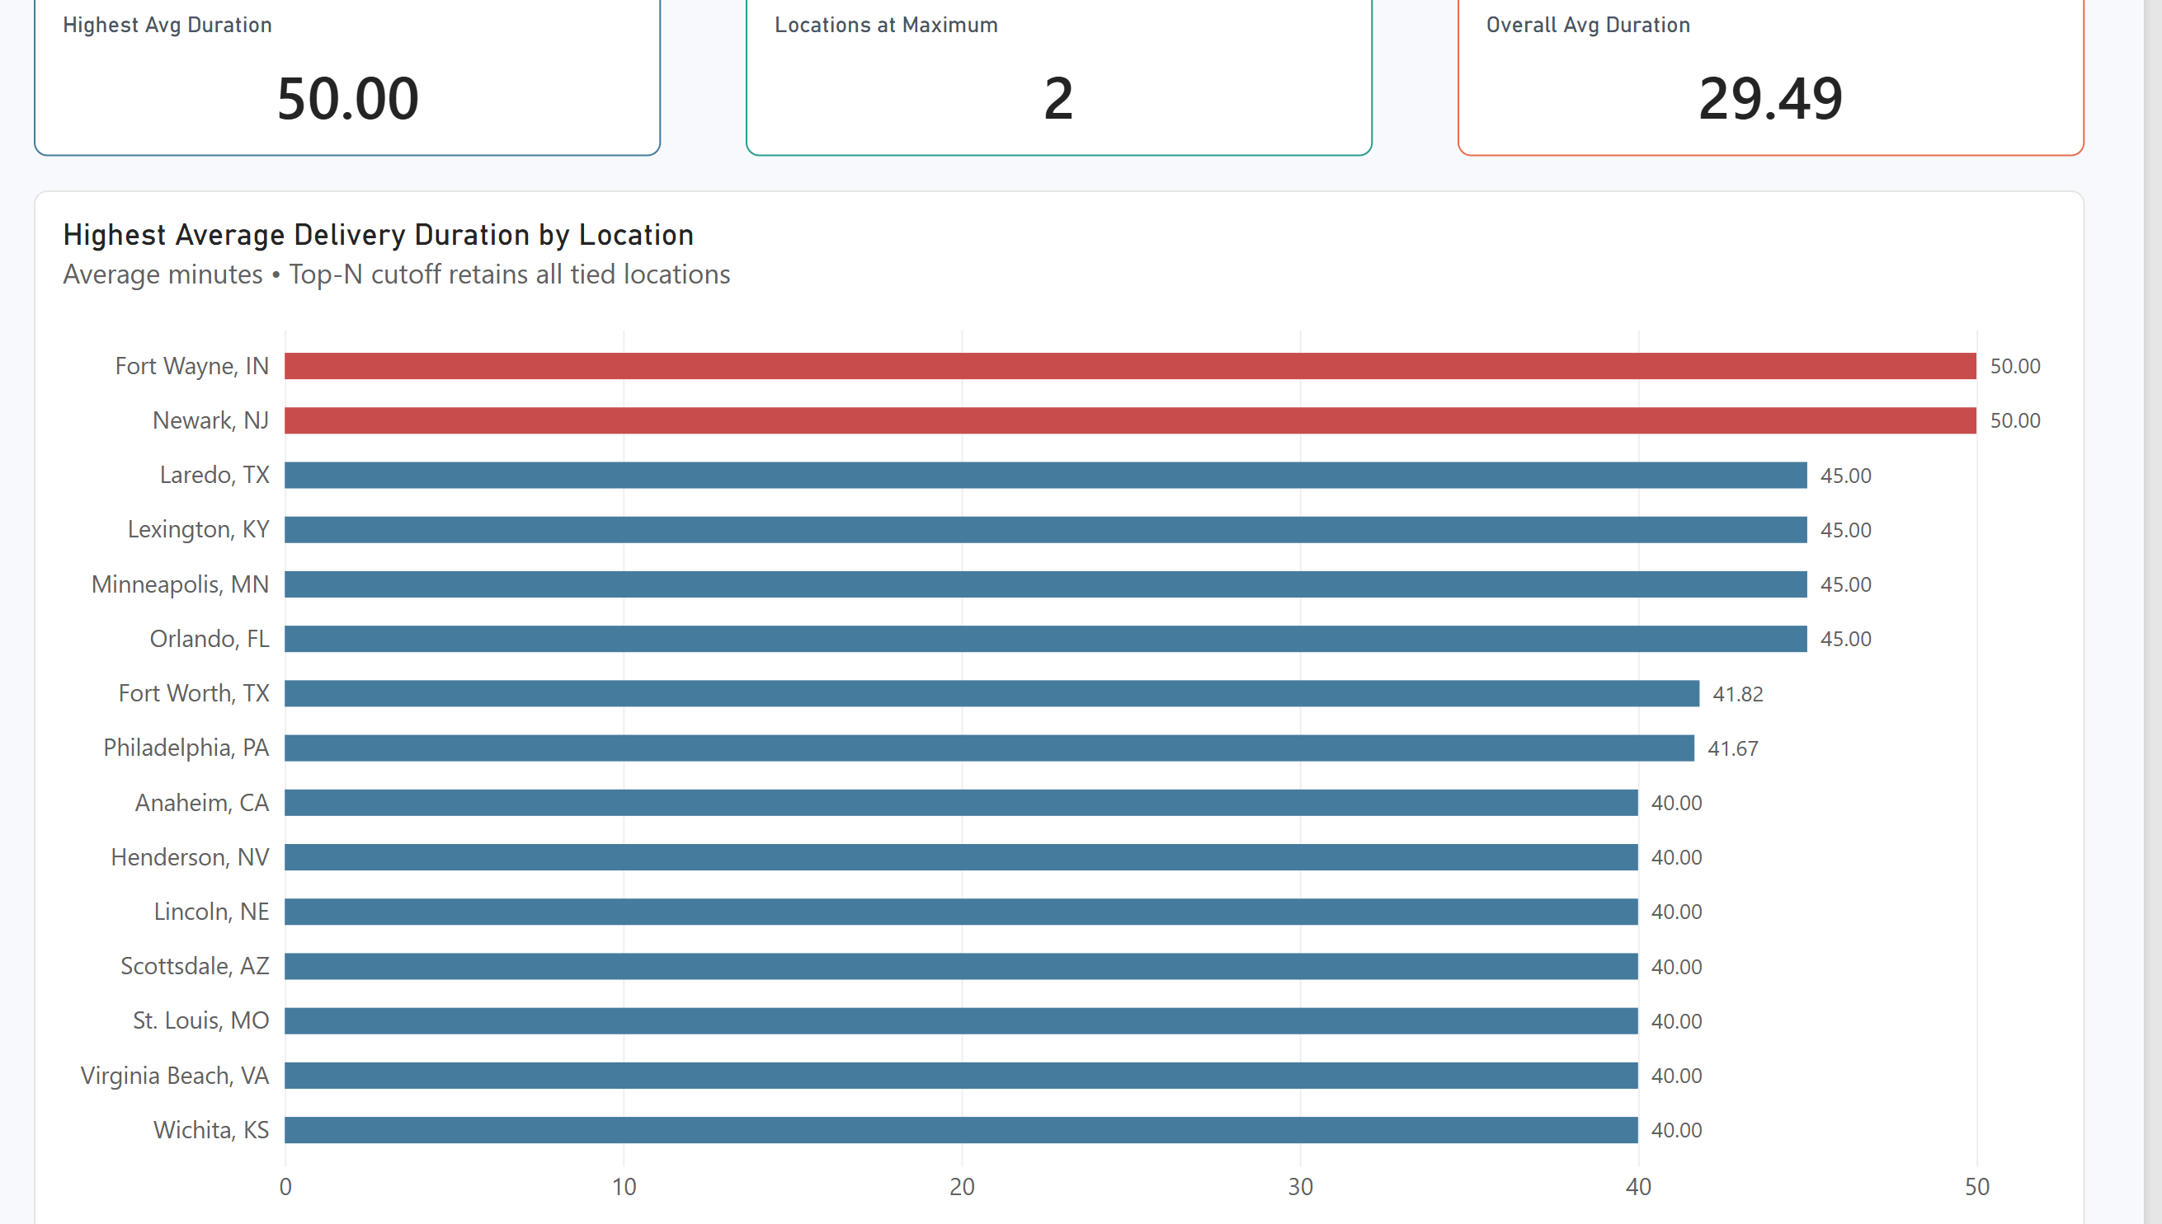
Figure Q7. Power BI visualization.
Observation / answer / explanation
Fort Wayne and Newark are tied at the highest average delivery duration of 50.00 minutes. The next group sits at 45.00 minutes across four locations, leaving a five-minute gap between the first tier and the next tied tier.

Q8 | 0.5 points
How many orders were placed during peak hours vs. non-peak?
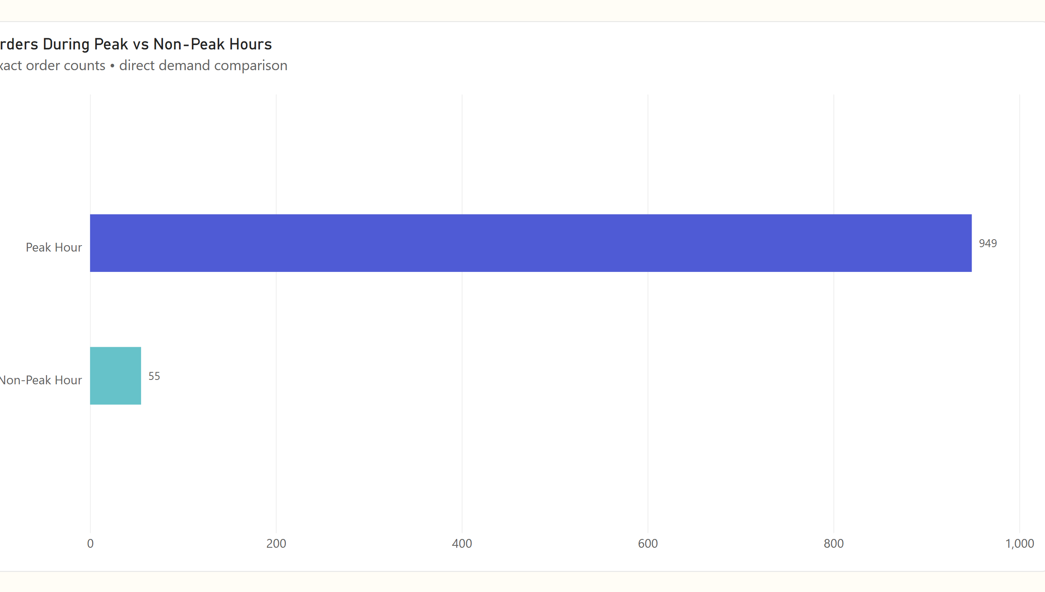
Figure Q8. Power BI visualization.
Observation / answer / explanation
There are 949 Peak Hour orders compared with 55 Non-Peak Hour orders. Peak activity is therefore roughly seventeen times the non-peak count and represents 94.52% of the dataset.

Q9 | 1 point
How does order volume trend across Order Month?
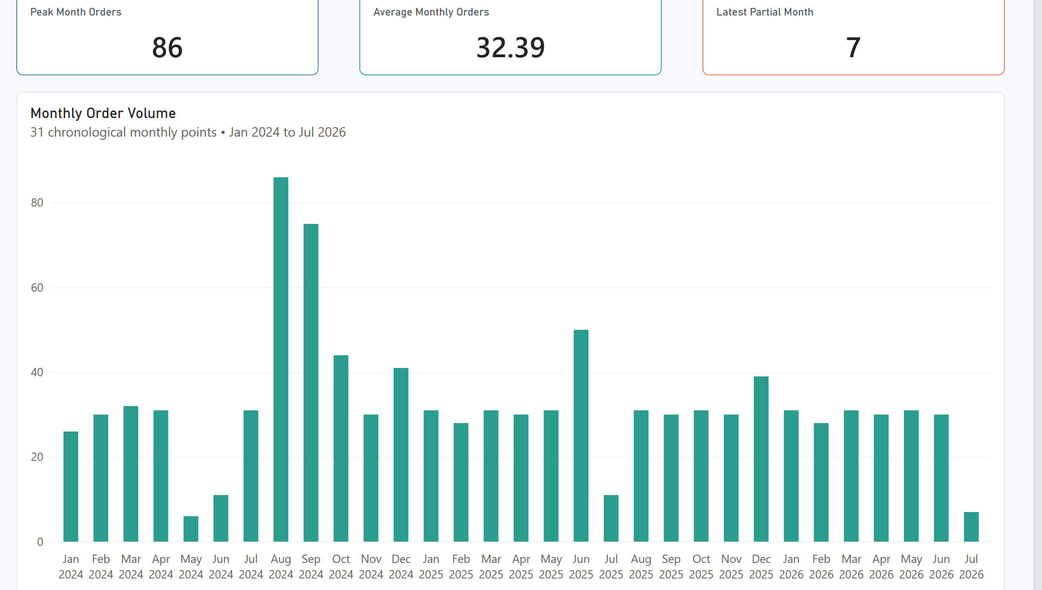
Figure Q9. Power BI visualization.
Observation / answer / explanation
Monthly volume reaches 86 orders in 2024-08 and 75 in 2024-09 before dropping to 44 in 2024-10. Across the full 31-point sequence, 2024-05 is the lowest complete month at 6 orders; 2026-07 has 7 orders but covers only the first seven days of July.

Q10 | 1 point
What is the average Toppings Count by Pizza Size?
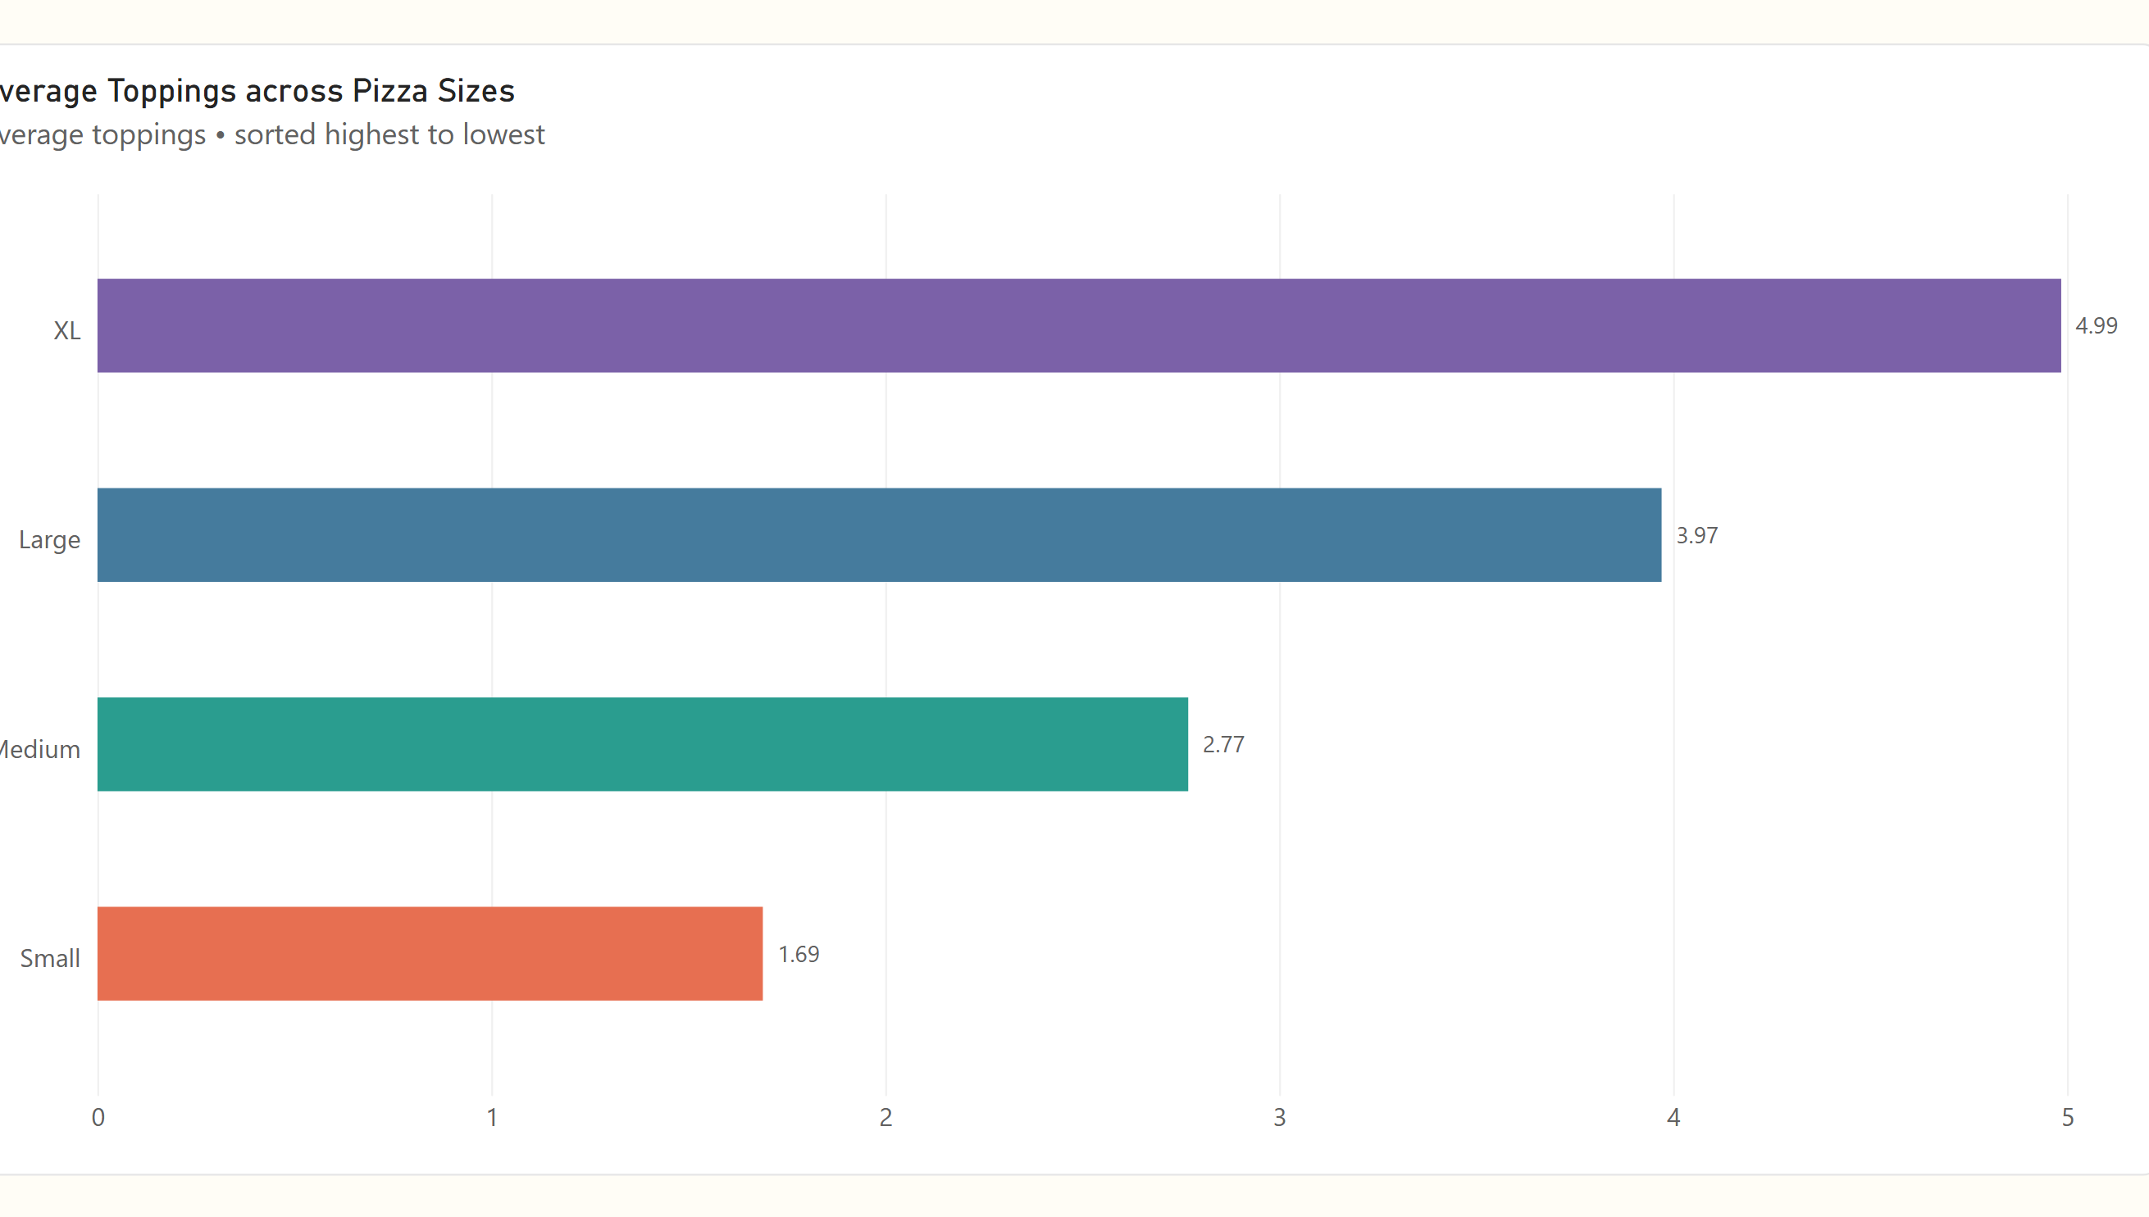
Figure Q10. Power BI visualization.
Observation / answer / explanation
XL pizzas average 4.99 toppings, almost three times the Small average of 1.69. Large sits at 3.97 and Medium at 2.77, giving a clear step-up in topping count across the size categories.

Q11 | 1 point
Which 2 restaurants have the lowest average Delay (min) i.e., the fastest, most reliable performers?
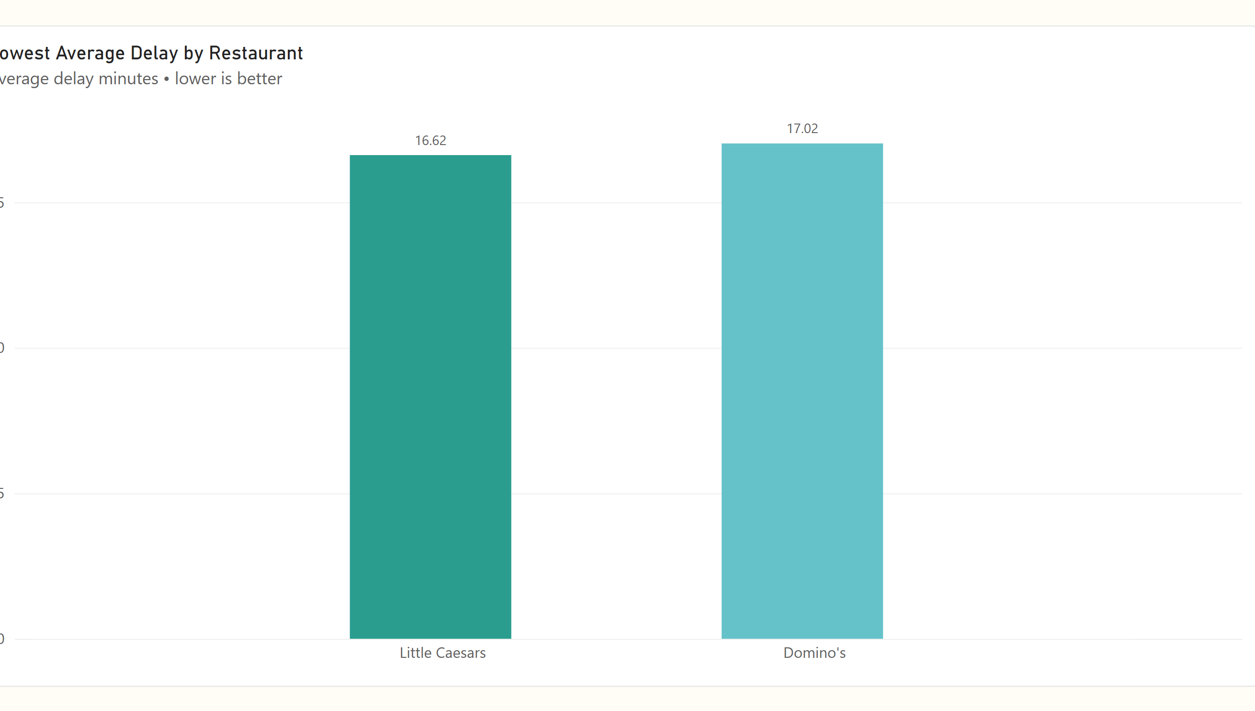
Figure Q11. Power BI visualization.
Observation / answer / explanation
Little Caesars and Domino's are the two lowest-delay restaurants at 16.62 and 17.02 minutes. Their averages are only 0.40 minutes apart, so both perform similarly on this measure.

Q12 | 1 point
Which 5 Pizza Types have the highest average Delivery Duration (min)?
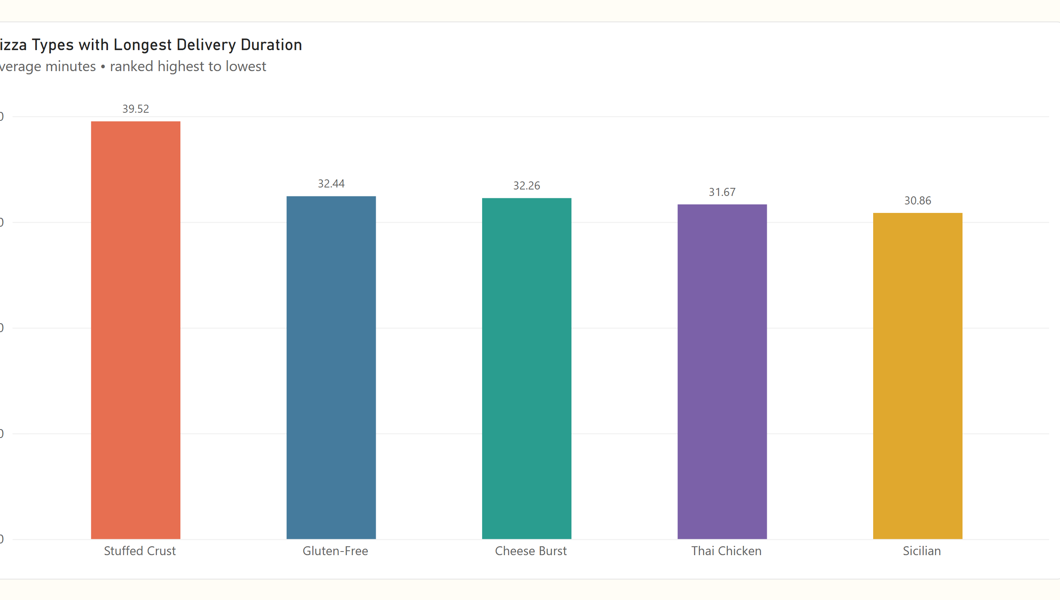
Figure Q12. Power BI visualization.
Observation / answer / explanation
Stuffed Crust stands well above the other top-five pizza types at 39.52 minutes. Gluten-Free is next at 32.44, a difference of 7.08 minutes, followed closely by Cheese Burst, Thai Chicken and Sicilian.

Q13 | 1 point
How does order volume vary by Order Hour across a typical day?
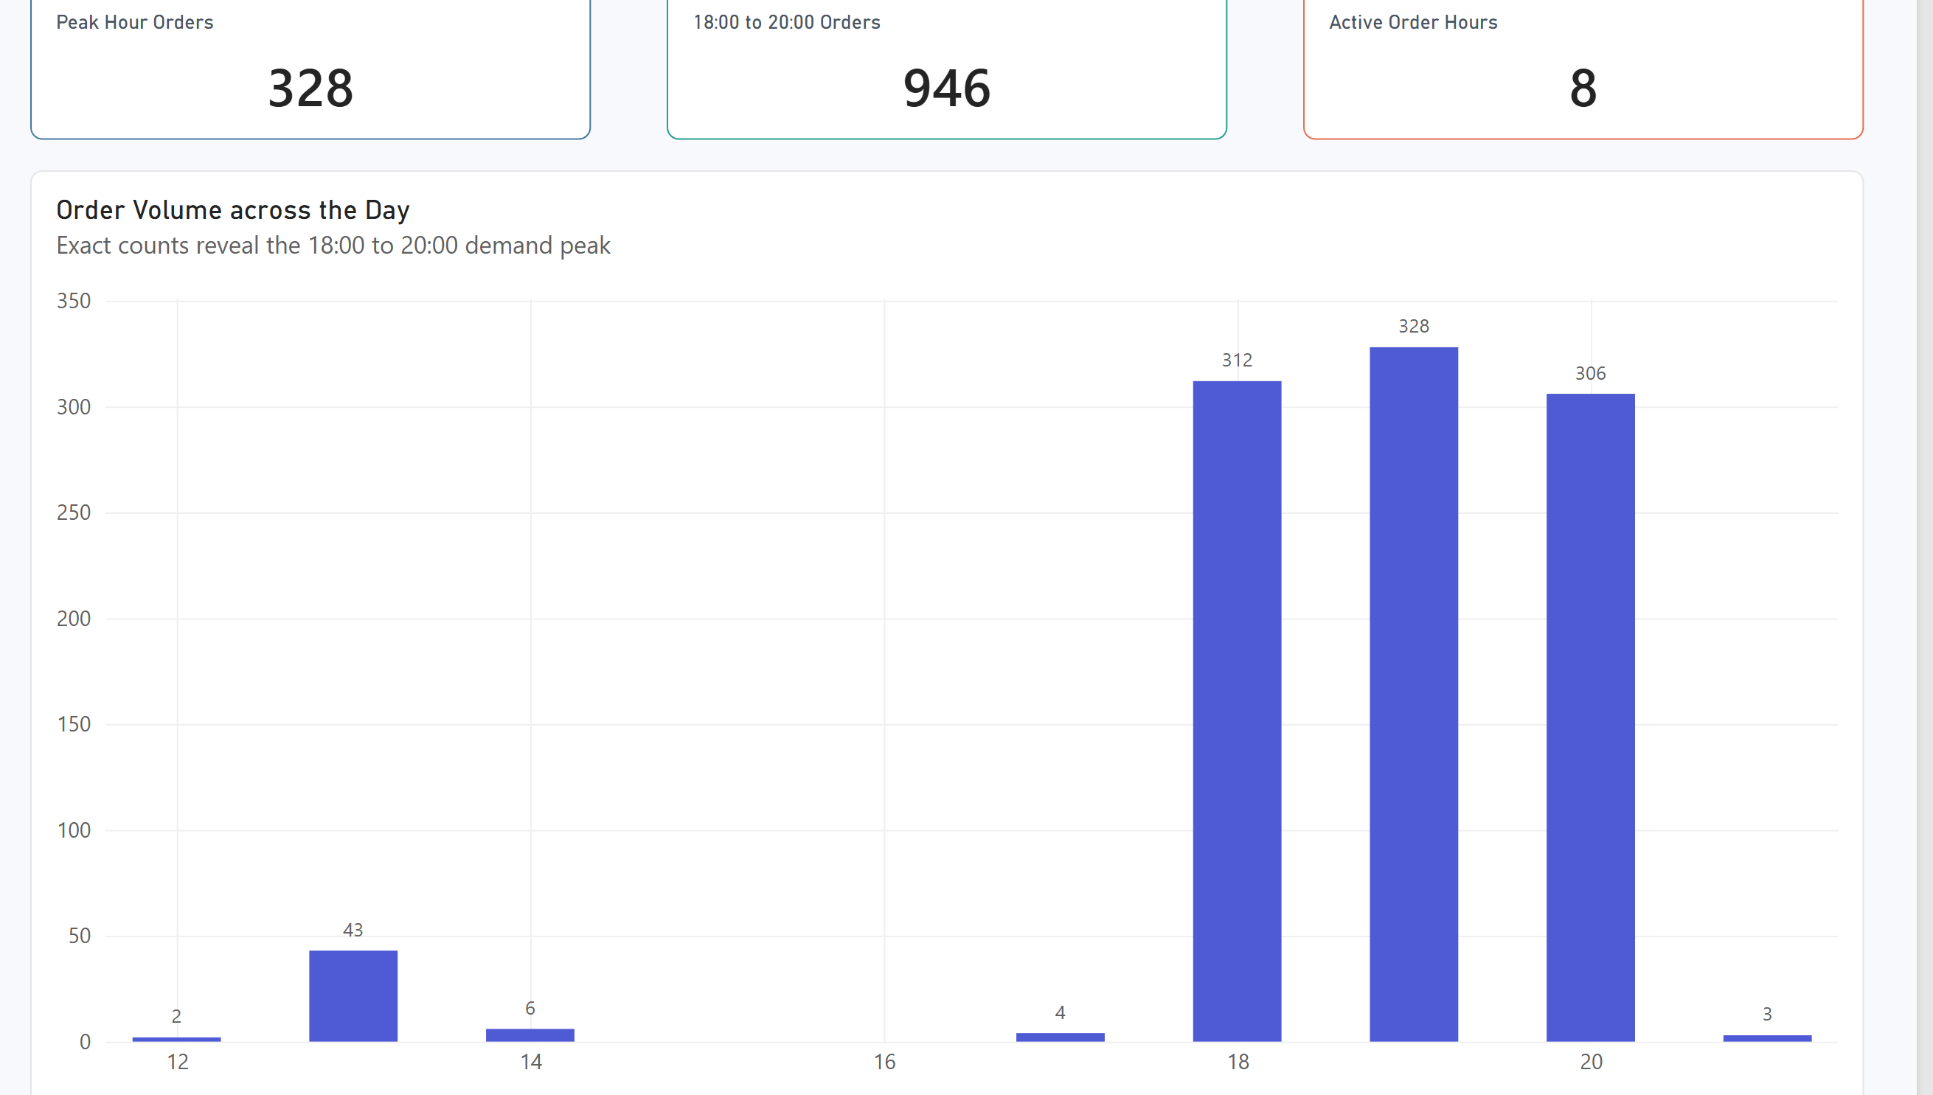
Figure Q13. Power BI visualization.
Observation / answer / explanation
Demand is concentrated in the 18:00 to 20:00 window: 312 orders occur at 18:00, 328 at 19:00 and 306 at 20:00. Those three hours contain 946 orders, leaving very little volume across the remaining observed hours.

Q14 | 1 point
What is the average delay (min) by Traffic Level?
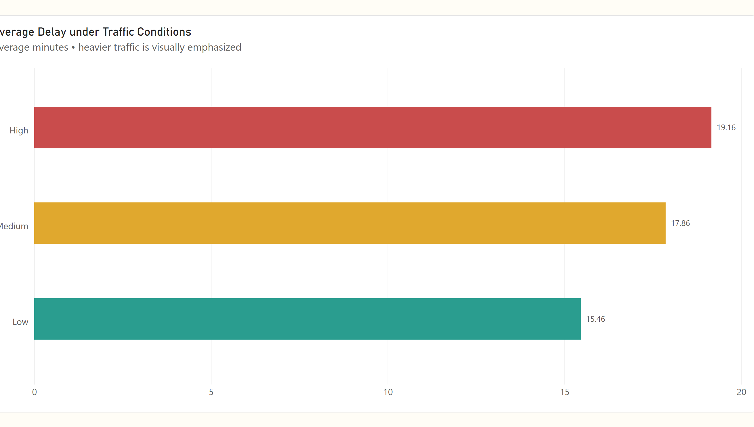
Figure Q14. Power BI visualization.
Observation / answer / explanation
High traffic has an average delay of 19.16 minutes, compared with 17.86 for Medium and 15.46 for Low. The High-traffic average is 3.70 minutes, about 24%, above the Low-traffic average.

Q15 | 1 point
What proportion of orders fall into each Pizza Complexity category?
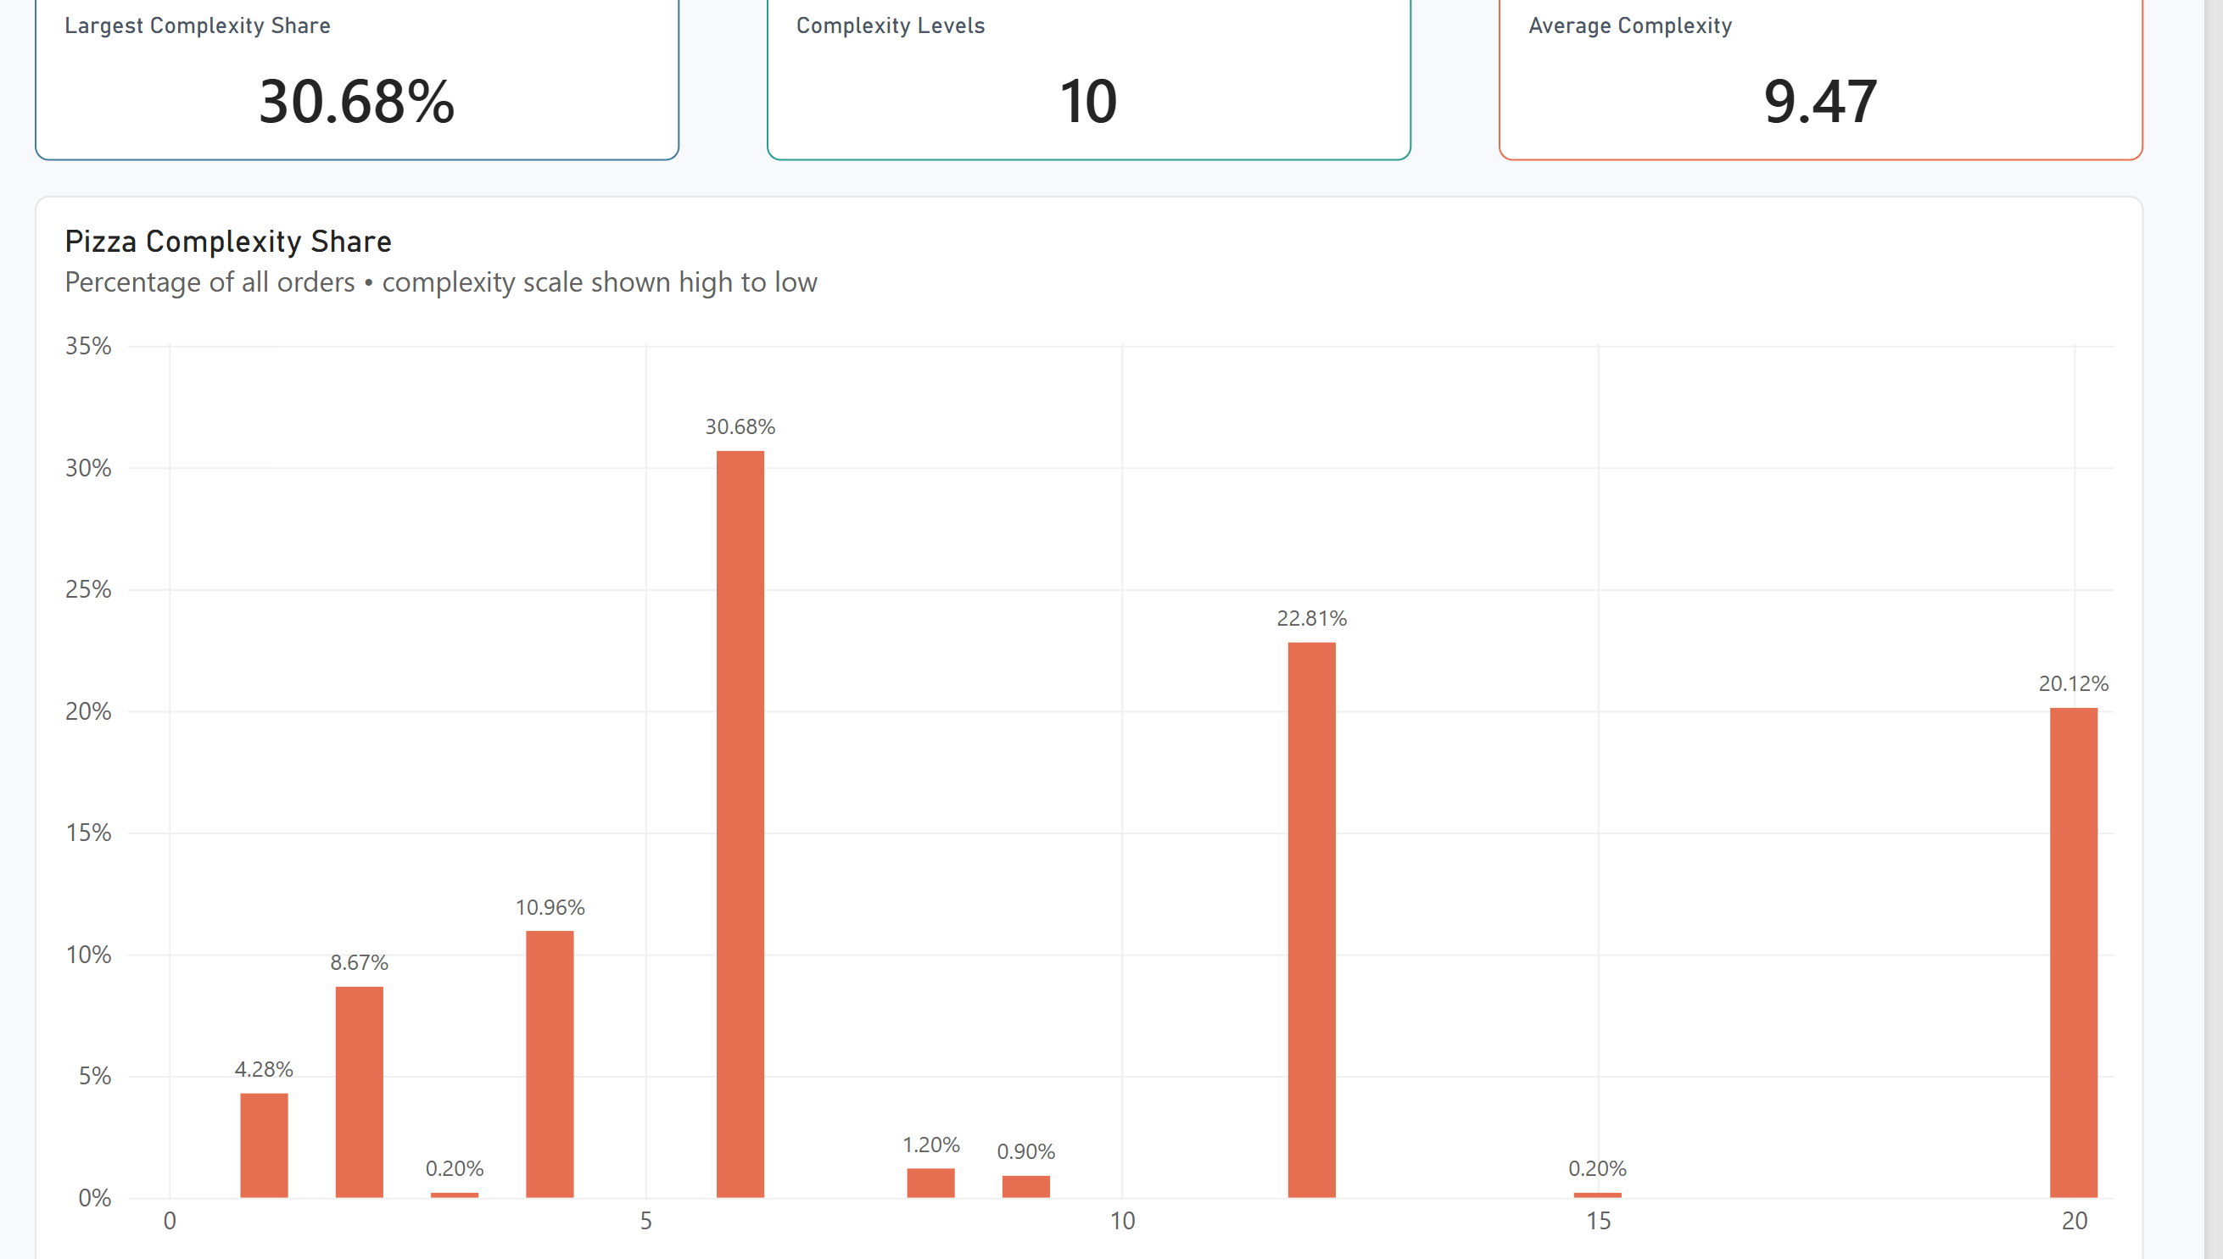
Figure Q15. Power BI visualization.
Observation / answer / explanation
Complexity 6 contributes 30.68% of orders, with Complexity 12 at 22.81% and Complexity 20 at 20.12%. These three levels together make up 73.61% of the order mix, showing that the distribution is concentrated in a few complexity categories.

Q16 | 1 point
Build a table of average Delivery Duration and Delay by Restaurant Name and use the Fx (Format by field value) button to visually highlight the fastest and slowest restaurants.
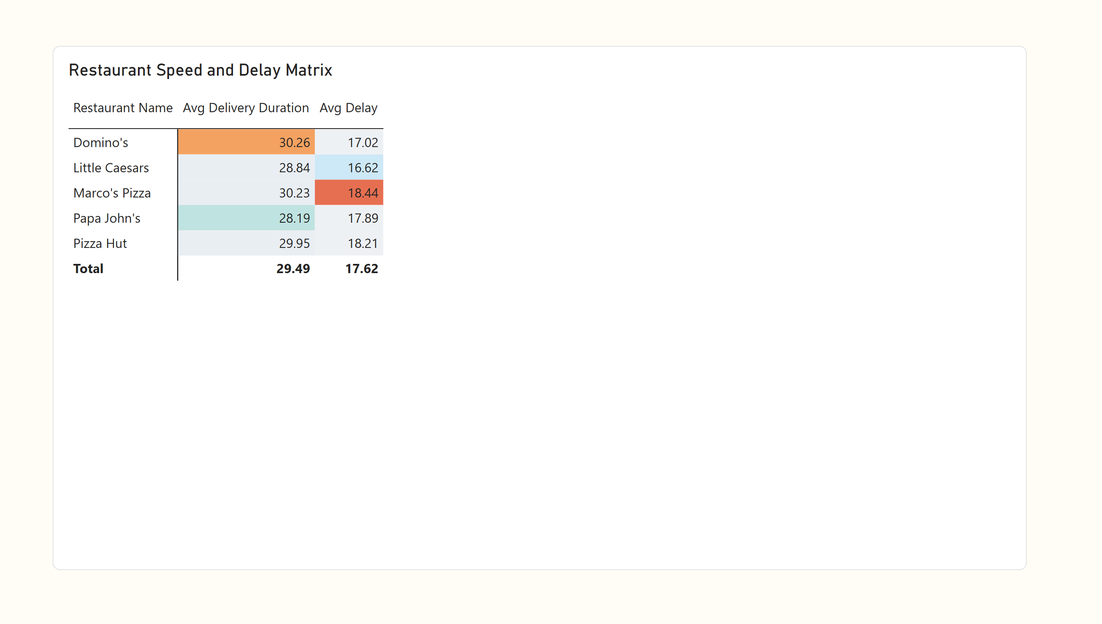
Figure Q16. Power BI visualization.
Observation / answer / explanation
Restaurant rankings change depending on the measure used. Papa John's is quickest on average delivery duration at 28.19 minutes, while Little Caesars has the lowest average delay at 16.62. At the other end, Domino's records the longest average duration at 30.26 and Marco's Pizza the highest average delay at 18.44.

Q17 | 2 points
How does order volume vary by Order Hour, alongside average Delay (min)?
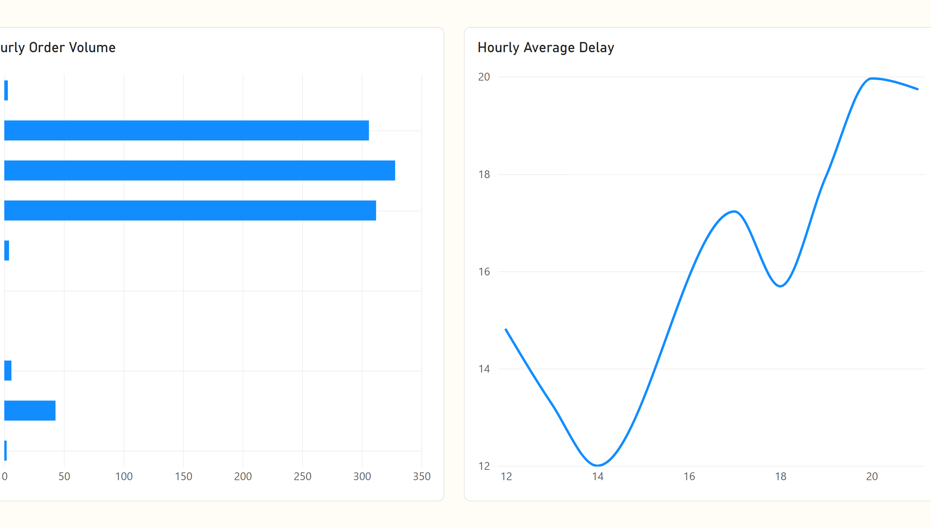
Figure Q17. Power BI visualization.
Observation / answer / explanation
The demand peak and delay peak occur at different times. Orders are highest at 19:00 with 328, then average delay reaches its maximum at 20:00 with 19.97 minutes. The one-hour shift suggests the busiest period may be followed by the greatest delivery pressure; the 21:00 delay of 19.75 is based on only three orders.

Q18 | 2 points
How does average Topping Density vary by Pizza Type, alongside order volume?
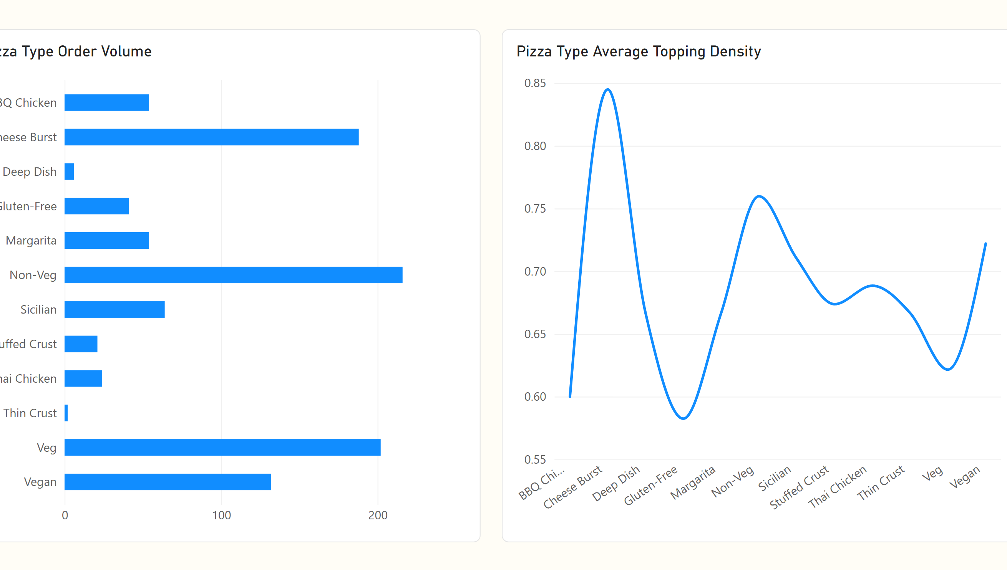
Figure Q18. Power BI visualization.
Observation / answer / explanation
The pizza type with the most orders is not the one with the highest topping density. Non-Veg leads volume with 216 orders and a density of 0.760, while Cheese Burst reaches the highest density at 0.845 with 188 orders. This separation shows that order popularity and the supplied density measure do not move together consistently.

Q19 | 2 points
What is the percentage breakdown of orders by Traffic Level within each Payment methods, filterable by order time?
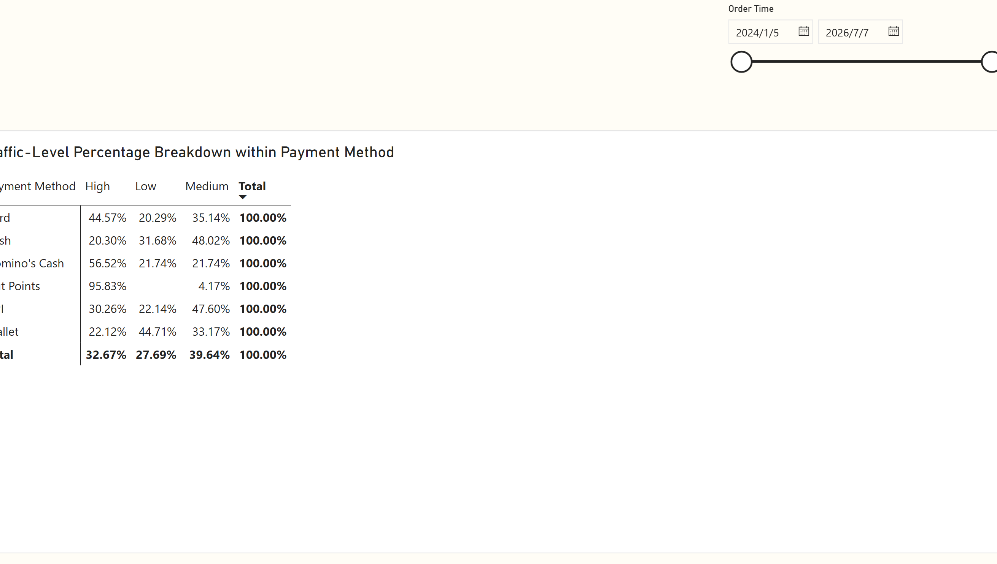
Figure Q19. Power BI visualization.
Observation / answer / explanation
Each payment-method row represents its own 100% traffic mix. Card has its largest share in High traffic at 44.57%; Cash and UPI lean toward Medium at 48.02% and 47.60%; Wallet leans toward Low at 44.71%. The very high High-traffic share for Hut Points should be treated carefully because that method has only 24 orders.

Q20 | 2 points
Design three different charts or tables that use conditional formatting (or highlight them by using different colors) in a single dashboard. Explain why each one matters, what it represents, how they should be read together, and what insights emerge from viewing them as a whole.
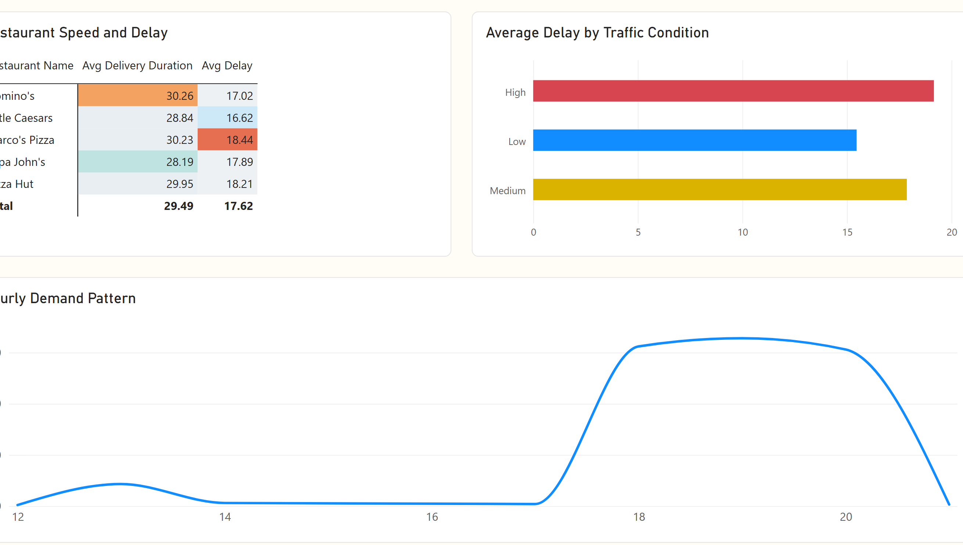
Figure Q20. Power BI visualization.
Observation / answer / explanation
The three views highlight different parts of the delivery process. Restaurant results show where average speed and delay differ, the traffic view shows delay rising to 19.16 minutes under High conditions, and the hourly view shows demand peaking at 328 orders at 19:00. Taken together, the strongest operational pressure appears around the evening demand peak and under heavier traffic, while restaurant performance still varies depending on whether duration or delay is used as the benchmark.

